Powertrain Design & Efficiency
Ford Sigma 1.6L Valve dynamics Analaysis
Thomas Lynn | M5X02200 | 17/02/20

Contents
1. Introduction Page. 4
2. Background Page. 5
2.1 Flowbench Page. 5
2.2 Ford Sigma 1.6 Litre Engine Page. 5
3. Methodology Page. 6
3.1 Workshop Safety and PPE Page. 6
3.2 Equipment Page. 6
3.3 Measuring Page. 6
3.4 Flowbench Page. 7
4. Analysis Page. 8
4.1 Valve Lift Against Crank Angle Page. 8
4.2 CFM against Valve Lift Page. 9
4.3 CFM per square inch against Valve Lift (Bare Head and Inlet) Page. 10
4.4 Flow Coefficient (CF) against Valve Lift for all tests Page. 11
4.5 Inlet Flow Coefficient (CF) against Crank Angle for all tests Page. 13
4.6 Engine speed for maximum power Page. 14
4.7 Mean Flow Coefficient needed to raise the RPM of maximum power by 50% Page. 16
4.8 Current Inlet to Exhaust Ratio and Scope of Modification Page. 18
4.9 CAD Drawing of Cam Lobe Page. 20
5. Conclusion Page. 21
6. References Page. 22
7. Appendices Page.23

List of Table and Figures
Table 1: Ford 1.6 Sigma Engine Specifications Page. 5

Figure 1: Graph showing Valve Lift vs Crank Angle Page. 8
Figure 2: Graph showing Cylinder Head Flow Rate vs Valve Lift Page. 9
Figure 3: Graph showing CFM per Square inch vs Valve Lift Page. 10
Figure 4: Graph Showing Flow Coefficient (CF) vs Valve Lift Page. 11
Figure 5: Graph Showing Inlet Flow Coefficient (CF) against Crank Angle Page. 13
Figure 6: Flared Entry Port on Ford Sigma Engine Page. 13
Figure 7: Graph Showing Modified Valve Lift vs Crank Angle Page. 16
Figure 8: Graph Showing Modified CF vs Crank Angle Page. 17
Figure 9: Ford Sigma Cylinder Head Page. 18
Figure 10: CAD Drawing of Theoretical Cylinder Head Page. 18
Figure 11: Ford Sigma Intake Ports Page. 19
Figure 12: CAD Drawing of Actual Intake Ports Page. 19
Figure 13: CAD Drawing of Modified Intake Ports Page. 19
Figure 14: 3D model of Ford Sigma Cam Lobe Page. 20

1. Introduction
This report details the outcomes of an investigation into the intake and exhaust systems of a Ford 1.6 Sigma Engine, the factors which influence the design and, operation of induction and exhaust manifolds and evaluation of the flow characteristics of a cylinder head are heavily discussed.
The valvetrain components were weighed and measure along with the bore/stroke and compression ratio if the cylinder head. These measurements were then used in calculations along with the data gathered from putting the cylinder head on a Flowbench to plot various graphs. The Cylinder head was flowed 3 times (standard, with intake, with flared port) to help determine its flow.
Multiple graphs are plotted and analyzed such as:
Valve lift against Crank Angle
CFM against Valve Lift
CFM per sq. inch against Lift for Inlet, with and without inlet manifold
(CF) against Valve Lift for all tests (standard, with intake, with flared port)
(CF) against Crank Angle
Along with these graphs and an analysis into various other factors that influence the induction operation are discussed and analyzed. CAD is used to help illustrate the scope of modifications that are possible to be made to help increase flow as well as calculations to determine other benchmarks. These benchmarks include:
Ratio of Inlet to Exhaust diameter
Loss in Flow Coefficient for inlet System caused by adding Inlet Manifold
Mean Inlet Flow Coefficient for the Bare Head and for the Head and Inlet Manifold.
Engine speed for maximum power
Finally, a graph is produced of the required inlet valve lift profile needed to achieve the required mean flow coefficient to raise the RPM of maximum power by 50%.

2. Background
2.1 Flowbench
The Flowbench used was a Superflow SF-600E. Superflow manufactures test equipment for drivelines. Since the 1970’s they have been a trusted company by many engineers. Technical schools and militaries. The Flowbench was Superflow’s first product. The purpose of a Flowbench is to measure the amount of airflow through various components such as cylinder heads and intake manifolds. (PMW Magazine, n.d)
The SF-600 is “The benchmark among professional engine builders worldwide” according to Assurich Industries (Assurich, n.d). The SF-600 can handle engines up to 180hp per cylinder, which is capable enough but if a bigger engine is required to be tested such as a Commercial Diesel Engine then the bigger SF-1020 is needed as it can handle up to 240hp per cylinder (Flowbench Manual, 2019)
The Flowbench can handle a maximum flow of 600 CFM at 20” of water. The SF-600 is capable of testing intake and exhaust flow which is a great benefit as it can save having to have 2 machines. The Flowbench has 6 phases which are controlled via a handle on the machine orifices situated at the top of the machine to allow for 6 different machine configurations from <38 CFM up to 600 CFM. The phases allow for a greater resolution, creating an accurate and reliable reading. (Assurich, n.d) The machine boasts an accuracy resolution of ±0.5% at full scale and a repeatability resolution of ±0.1%. The machine features a high temperature cut off switch which operates between (52°C-91°C) (Assurich, n.d)
2.2 Ford Sigma 1.6 Litre Engine
The Engine tested was a 2010 Ford Focus 1.6 Sigma Engine the specs can be seen in Table 1.
Part | Specification
Cylinders | 4
Capacity | 1596cc or 399cc per cylinder
Bore | 79mm
Stroke | 81.4mm
Bore/stroke ratio | 0.97
Compression Ratio | 11:1
Valve Gear | Double Overhead Camshaft (DOHC)  4 valves per cylinder
Maximum Power Output | 125 PS (123 bhp) (92 kW) at 6000 rpm
Maximum Torque | 145 Nm (107 ft·lb) (14.8 kgm) at 4100 rpm
Table 1: Ford 1.6 Sigma Engine Specifications (Ford Authority, n.d)
3. Methodology
This section details the complete methodology of the tasks undertaken as well as a list of equipment and why it was chosen.
3.1 Workshop Safety and PPE
Testing can be a very dangerous activity if safety procedures aren’t followed correctly. Before any testing can be carried out on the systems need to be checked over to ensure that there are no exposed wires or any faults with the system.
PPE - Steel toe cap boots and overalls are required when entering any workshop on campus. Failure to do so will result in dismissal from the workshop. In addition to this everyone entering the workshops are required to complete a Workshop Induction on Moodle which outline all the general safety risk of the workshop as well as the fire safety routine.
3.2 Equipment
DTI Gauge – DTI Gauges were used to measure the cam profile as well as the valve lift during the Flowbench testing. The gauges were in mm which was perfect as there was no unit conversion needed.
Weighing Scale – A weighing scale was used to determine the weight of the moving parts on the valve train.
Vernier Calipers and Measuring Sticks - Vernier Calipers were used to take most of the measurements on the head. The calipers were essential in the completion of the task as they have 4 methods of measuring in one tool; internal, external, height and depth. The only possible drawback to the calipers would be the fact that they are not digital, which would have made for a faster read time of the output.
Flowbench – The SF-600 was used to Flow the bare cylinder head; Flow bare head plus standard intake and Flow bare cylinder head through intake with “flared” entry to port.
Solidworks (CAD) – For certain parts of the investigation Computer Aided Design was used to help understand and illustrate benchmarks and possible modifications. CAD has many advantages over hand drafting such as its speed and flexibly to create changes. (Stewart, n.d)
3.3 Measuring
Inlet Cam profile – The camshaft was removed from the head and placed into a lathe. It was supported on one end by the chuck and the other end via a stabilizer. A DTI gauge was set up and placed on the bottom of the cam lobe. The Lathe was then turned 1 degree at a time until a full ca, profile was achieved. This was done twice to validate our results.
Weighing of Components – All the Valvetrain components were removed from the head. They were separated and weighed. Only 1 component was weighed from 1 cylinder. To increase validity all components should have been weighed and an average taken.
Bore/Stroke/Compression Ratio/Valve Diameter – A selection of measuring tools (calipers, measuring sticks) were used in order to measure the Bore/Stroke/Compression Ratio of the engine. This was then compared to the manufacturers specification to validate the results.
3.4 Flowbench
3 separate tests were performed on the cylinder head. All test followed the same methodology.
Bare Cylinder Head – The Bare Cylinder Head was Flowed with no auxiliaries.
Cylinder Head with Manifold – The Cylinder Head was flowed with the OEM Intake Manifold attached.
Cylinder Head with Flare Entry Port - The Cylinder Head was flowed with a makeshift Flared port using White tack in order to break the harsh edge of the Standard Intake port.
- The test cylinder head was clamped on top the modified test head. A gasket needs to be formed in order to ensure there are no are leaks. The bolts need to be tightened in a cross pattern in order to ensure the gasket is seated properly.
- The Gauge on the Flowbench was checked for zero before the test cylinder head and the modified test head was clamped to the flow bench. Again, with a gasket and tightened correctly.
- A DTI gauge was then attached to the cylinder head on the intake side. Each full rotation of the DTI Gauge is 1mm.
- Ensure that both flow handle is in the off position and then adjust the handle until the vertical flow gauge reads 25” of Water.
- Each valve is opened 0.5mm which is half a turn of the DTI Gauge
- After each valve opening the flow is turned on and the handle is turned until the gauge reads 25” of Water.
- The Horizontal gauge is then read out analyzed for its value. That value is then plotted onto the Flowbench chart

4. Analysis
4.1 Valve Lift Against Crank Angle
The Cam was measured on a DTI Gauge in order to obtain its profile. The Cam Profile allows the Valve lift to be calculated as the Lift is directly proportionate to the Cam Profile. Figure 1 shows The Valve Lift against Crank Angle of the Sigma Engine.
Figure 1: Graph showing Valve Lift vs Crank Angle
The Raw data gathered was entered into a data smoother. The purpose of this was to reduce any outside factors affecting the cam profile. Camshafts are very smooth and with the relatively high resolution of the DTI Gauge used along with the chance of human error a data smoother is very beneficial (Dhir, n.d.) The maximum Valve Lift measured was 7.68mm at TDC with the total valve open time being ~95 degrees.

4.2 CFM against Valve Lift

Figure 2: Graph showing Cylinder Head Flow Rate vs Valve Lift
This graph displays the CFM value of each test against Valve lift. CFM stands for Cubic Feet per Minute which is a measurement of the velocity of air moving into a space. ((Beal, n.d.) The graph has 3 data sets; CFM against Valve Lift with a Bare Cylinder Head; Cylinder Head with Intake Manifold a Cylinder Head with a flared Entry Port.
In order to calculate the CFM, the following equation was used:
$$CFM=\frac{Flowbench Output x Corection}{100} x 2.11888$$
The data gathered from Flowbench was in Litres per second, in order to convert the figure to CFM it was multiplied by 2.11888.
At 0.5mm of Valve Lift all 3 data sets start at round the same CFM of 17. But around 1mm of Valve Lift later there is a gap opening between the Bare Cylinder Head and both other tests of ~10 CFM. This trend is seen up to around the midway point where the Flare Entry port matched the Bare Cylinder Head until they both reach their maximum CFM of 143 CFM. The Cylinder Head with Manifold only reaches a maximum of 128CFM which is to be expected. The added distance that the manifold adds to the intake are means that the air has a further distance to travel allowing it to slow down before reaching the cylinder. The Equation L = D/4 is referred to the saturation point. This is where the valve no longer becomes a restriction on the flow rate but the intake port. Therefore, there is no point in opening the valve beyond this point.
The validity of this data can be question as the test was only performed once and there were some aspects of Human error as seen as dips in the graph. In order to remove these the test would have had to be performed multiple times and averages taken. The Flowbench had previously been broken so a calibration would need to be performed after the repair in order to 100% validate any results afterwards.
4.3 CFM per square inch against Valve Lift (Bare Head and Inlet)

Figure 3: Graph showing CFM per Square inch vs Valve Lift
In order to calculate CFM per Square Inch the flowing equations were used
$$Valve Area=\frac{πD^{2}}{4} x 2$$
D = 1.1811 Inches
$$CFM per Square Inch=\frac{CFM}{Valve Area}$$
The Lines follow the same trend as the CFM vs Valve lift as both data sets have the same calculations applied to them. Again, both data sets follow each other closely up until 1mm of Valve lift where a gap starts to from and a consistent difference of around 4 CFM per square Inch separates the 2 until a max CFM per square inch of 65.48 is achieved on the Bare Cylinder Head and 58.65 CFM per Square inch is achieved for the Cylinder Head with Manifold.
According to the Superflow Operators Manual Page. 37 (Superflow Manual, n.d), perfect flow of an orifice at 25” of water is 138 CFM per square inch. The maximum flow seen during testing was 65.48 CFM per square inch, almost half of the Maximum Potential Orifice flow rate. Superflow defines this as “A perfectly streamlined orifice (coefficient of velocity equals 1) (Superflow Manual, n.d) Any combustion engine would struggle to achieve perfect flow as most manufacturing methods create impurities on the materials surface (Reliance Foundry Co. Ltd, n.d.) meaning that turbulence is created lowering the flow rate (Courses.lumenlearning.com, n.d.). Laminar flow or a low Reynolds number would be needed to achieve a perfect flow. The Reynolds Number is a ratio of inertial forces to viscous forces of a fluid. It is defined as:
$N_{Re}=\frac{Diameter of the Flow Channel x Average Velocity x Fluid Density}{Viscosity of the fluid}$ (Rehm et al., 2013)
4.4 Flow Coefficient (CF) against Valve Lift for all tests

Figure 4: Graph Showing Flow Coefficient (CF) vs Valve Lift
As stated in section 4.4 Superflow states that perfect flow is 138 CFM per square inch at 25” of water. To calculate the Flow Coefficient the following equation is used:
$$Flow Coefficient=\frac{Measured Flow}{Perfect Flow}$$
Where Perfect Flow at 25” of water = 138 (Superflow Manual, n.d)
Perfect flow has a coefficient of 1 (Superflow), whereas the maximum coefficient seen during testing was 0.47 from the Bare Head with the flared entry showing 0.46. This indicates that the head is only ~47% efficient in pulling in the maximum amount of air possible. However, as stated previously Laminar flow would be needed to achieve a flow coefficient of 1 but this is extremely difficult in an automotive application for several reasons. As stated above, manufacturing processes have an effect. Another effect causing a lower CF value are Boundary Layers.
A Boundary Layer is stationary fluid or gas that is surrounded by a moving gas or fluid (www-mdp.eng.cam.ac.uk, n.d.) Boundary layers may be classified as laminar or turbulent, the main difference is the size of the turbulence. Laminar boundary layers happen at a microscopic scale whereas turbulent boundary layers happen at a macroscopic scale. This layer has a velocity of 0 which in turn lowers the amount of air able to pass into the cylinder of the engine. (Rehm et al., 2013)
Turbulent Boundary Layers are very sensitive to wall roughness, as any roughness that protrudes through the viscous sublayer (0.1 to 1% of the boundary layer) modifies the law of the wall. (Cebeci, 2013) The exact effect wall roughness has on the boundary layer is determined by its properties (size, shape and spacing of the protrusions). There are 3 categories of wall roughness:
Hydraulically Smooth: All the roughness elements lie in the viscous sublayer thus having no effect to the velocity of the fluid
Completely Rough: All the roughness elements protrude the viscous sublayer thus having the most effect on the velocity of the fluid
Transitional Roughness: More complex where some elements lie inside the viscous sublayer and some protrude past it. (Houghton, 2013)
A Hydraulically Smooth profile would be required to obtain a Flow Coefficient ~1 which is extremely hard to achieve with mass production and casting (Reliance Foundry Co. Ltd, n.d.)

4.5 Inlet Flow Coefficient (CF) against Crank Angle for all tests

Figure 5: Graph Showing Inlet Flow Coefficient (CF) against Crank Angle
The Inlet Flow Coefficient is where the benefit of a flared inlet port is seen. The maximum CF seen for all tests is seen at 0 degrees with the Bare Head peaking at 0.41; the Head with Manifold peaking at 0.34 and the Flared Entry Port Peaking at 0.47. However, the Flared Entry Port has the lowest mean CF (Ci) with 0.036 (Bare Head 0.033 and Head with Manifold 0.051)
The peak in the Flared Entry Port graph can be attributed to the lower amount of turbulence created by smoothing out the harsh edge of the intake port. As discussed in section 4.5. However, the data is not 100% accurate as when the flared entry port was created the intake port area was decreased significantly as the substance used to create it was quite thick (Figure 6) This was not considered when testing and the Flowbench pressure may have had to be adjusted to compensate, which it wasn’t.
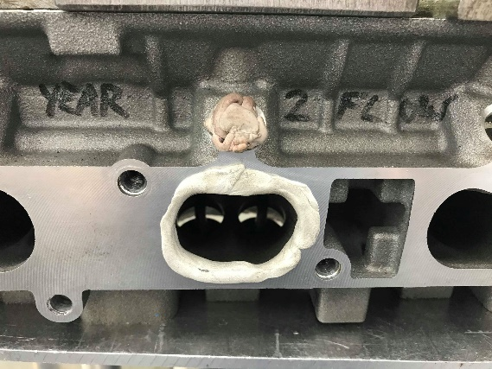
Figure 6: Flared Entry Port on Ford Sigma Engine
4.6 Engine speed for maximum power
In this section the Engine Speed for Maximum Power is calculates. This will indicate the validity of several variables that were measured. It will validate the measurement of the bore and stroke of the engine along with the validity of the cam profiling measured. The calculated data will be compared against the manufacturers specification in order to validate the findings.
The Calculation for Engine Speed for Maximum Power is as follows:
$$RPM= Effective Mean Area x Mean Velocity x Valve Opening Time x\frac{60}{Cylinder Displacement}$$
In order to calculate the Effective Mean Area, the Mean Inlet Flow Coefficient is needed. The following equation was used:
$$Mean Inlet Flow Coefficent=\frac{Sum of CF Value}{Number of Points}$$
This was then used in this equation:
$$Effective Mean Area=Mean Inlet Flow Coefficient x Number of Valves x\frac{πD²}{4}$$
Mean Velocity was calculated via the assumption that peak gas velocity is = 330 m/s (speed of sound) (Courses.lumenlearning.com, n.d.)
$$Mean Velocity=\frac{2}{π} x Peak Gas Velocity$$
Multiplying the Mean Velocity by the Effective Mean Area calculates the Flow Rate of air in 1 second. The amount of air entering in that time depends on the valve opening time. This is calculated using this equation:
$$Valve Opening Time=\frac{Duration in Degrees}{360} x\frac{60}{RPM}$$
The Cylinder displacement is calculated via:
$$Cylinder Displacement= Stroke x π x (\frac{1}{2}Bore)²$$

In the case of the Sigma Engine the equation is as follows:
$$Mean Inlet Flow Coefficent \left(Bare\right)=\frac{23.76}{720}= 0.033$$
$$Mean Inlet Flow Coefficent \left(Manifold\right)=\frac{10.77}{720}= 0.015$$

$$Effective Mean Area \left(Bare\right)=0.033 x 2 x\frac{π{0.3}^{2}}{4}=0.0047m^{2}$$
$$Effective Mean Area \left(Bare\right)=0.015 x 2 x\frac{π{0.3}^{2}}{4}=0.0021 m^{2}$$

$$Mean Velocity=\frac{2}{π} x 330=210.08 m/s$$
$$Cylinder Displacement= 0.814 x π x {\left(\frac{1}{2}0.79\right)}^{2}=0.399 m^{3}$$

$$Cylinder Head \left(Bare\right) RPM= 0.0047 x 210.08 x\frac{95}{360} x\frac{60}{0.399}=3878 RPM$$
$$Cylinder Head \left(Manifold\right)RPM= 0.0021 x 210.08 x\frac{95}{360} x\frac{60}{0.399}=5989 RPM$$
The manufacture states the peak power is at 6000 RPM. The calculated figure is 5989 RPM giving a margin of error of around 1.67%

4.7 Mean Flow Coefficient needed to raise the RPM of maximum power by 50%
In order to achieve a higher mean coefficient, the camshaft profile needs to be altered. The maximum lift for the valve cannot be altered as it would require changing the stroke of the engine. So, the valve opening time needs to be altered in order to keep the valve open at max lift for longer.
The profile was altered in excel to give a Mean Flow Coefficient of 0.051 an increase of 0.18 from the original 0.033 measured (an increase of ~59%). The data was entered into a data smoother in order to create a smoother profile without steps.
The 2 graphs below display the Theoretical Flow Coefficient of the engine and the Theoretical Valve Lift vs Crank angle.

Figure 7: Graph Showing Modified Valve Lift vs Crank Angle
It’s important to note that the max lift of the valve hasn’t change only the amount of time that it is open. The total vale open time increases from 95 degrees to 145 degrees which in turn allows for the Flow coefficient to increase.

Figure 8: Graph Showing Modified CF vs Crank Angle
The Flow coefficient follows a similar trend to the valve lift with the max flow coefficient not increasing due to the valve lift staying the same, but the mean is increased as the valve is open for longer. The mean coefficient is 0.0051.
Utilizing the Calculation for Engine Speed for Maximum Power this change can be validated by seeing ~50% increase in RPM at max power. The only variable that has changed is the total valve open time. Therefore:
$$RPM= 0.0047 x 210.08 x\frac{140}{360} x\frac{60}{0.399} = 5716 RPM$$

4.8 Current Inlet to Exhaust Ratio and Scope of Modification
The Current ratio of Inlet Valves to Exhaust Valves is 1.2 The inlet Valve has a Diameter of 30mm, and the Exhaust Valve has a Diameter of 25mm
This section features, drawings and pictures of the current Cylinder Head with reference to the valve seats and intake ports. 3D CAD Models were then produced to theorize the scope of modifications possible to improve the flow coefficient.
Valve Seats
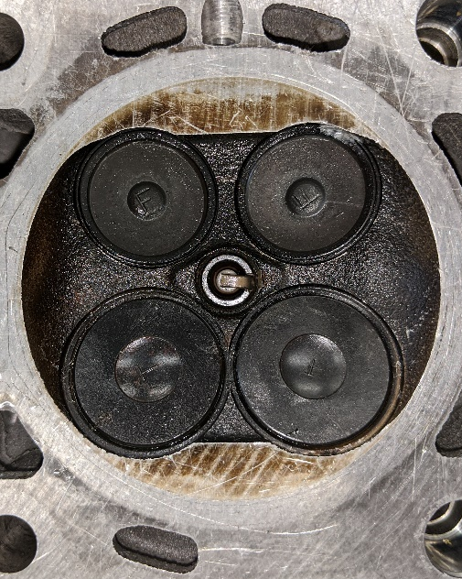
After inspecting the cylinder head there is not a lot of scope for improvement with regards to changing the current inlet diameter. The Valves have a diameter of 30mm, but the valve seat surround them has a diameter of 32mm. The diameter of the cylinder is 78.85mm which only leaves ~12.85mm of room either side of the valve if they were positioned dead center. However, the spark plug orifice has a diameter of 12.2mm which means that the valves are positioned closer to the edge of the cylinder leaving <1mm of room.
In order to increase the size, the valves would need to be repositioned further apart and closer to the centre. This isn’t practical though as the Camshaft and Piston would need to be redesigned.
Figure 9: Ford Sigma Cylinder Head
After drawing the Cylinder Head in Solidworks its seen that there is very minimal room for an increase in inlet valve size. 30mm valves are the largest valves for this cylinder head setup.
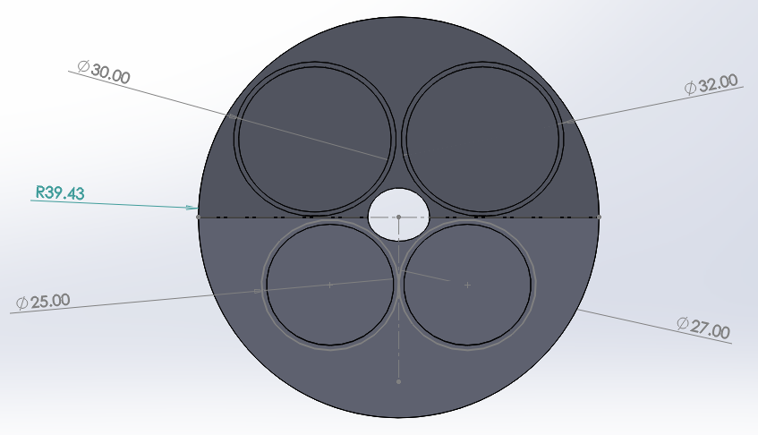
Figure 10: CAD Drawing of Theoretical Cylinder Head
Intake Ports
After close inspection of the intake ports there is some room for improvement. There is a lot of room on both the top and bottom of the ports. The total height of the area is 47mm with each intake port having a height of at 28mm and a width of ~43mm. At first glance there is room for expansion on either side of the ports. However, between ports 2 and 3 there is a void which only has around 22mm of clearance which limits the lateral expansion of the ports.
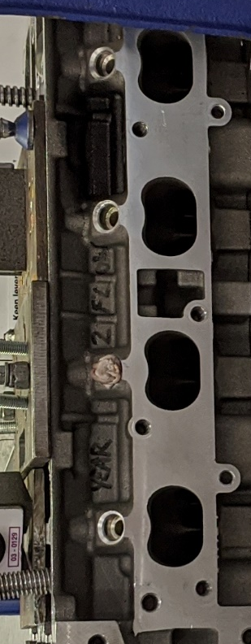
Figure 11: Ford Sigma Intake Ports
The current intake manifold was modelled in Solidworks.
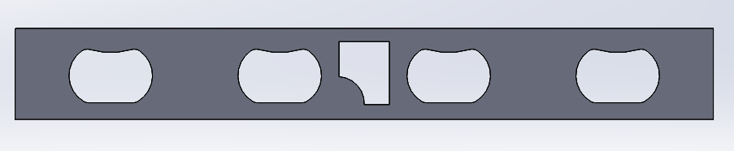
Figure 12: CAD Drawing of Actual Intake Ports
Utilizing the “Scale Entities” feature in Solidworks, the original intake ports were scaled to a ratio of 1.4:1 giving a 40% increase to intake port size. A manifold mounting hole would need to be relocated if this were to be implemented.
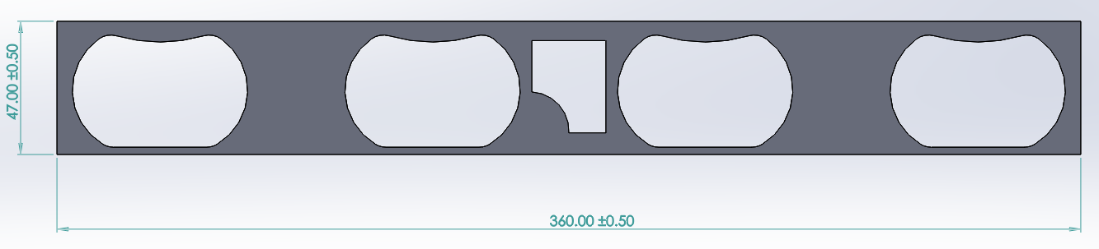Figure 13: CAD Drawing of Modified Intake Ports
A larger intake port allows for more air to enter the cylinder head but at a lower velocity. Which leads to more air at high RPMs but less air at low RPMs.
4.9 CAD Drawing of Cam Lobe
The Cam profile was entered in to an excel spreadsheet which allowed for a 2D model of the Cam Lobe to be created. In order to import the 2D model into solid works X, Y and Z axis had to be created.
The X axis consisted of:
$$X Axis=(Sin x Radians) x Base Circle Radius$$
Y Axis:
$$Y Axis=(\left(Cos x Radians\right)x Base Circle Radius))+Cam Profile$$

The Z axis is 0mm as this will be extruded in Solidworks.
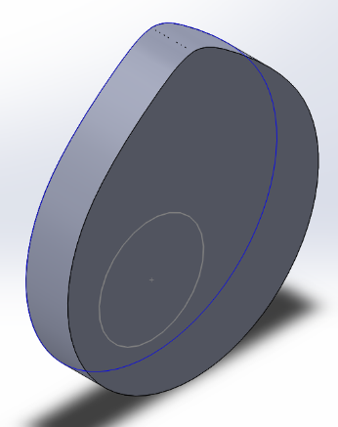
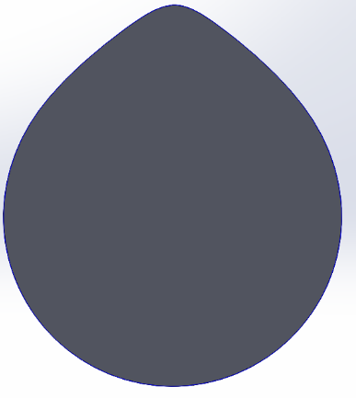

Figure 14: 3D model of Ford Sigma Cam Lobe
Some validation has been performed as the Cam Lobe has a similar profile to the real one which would indicate that the measurements taken were correct. However, in order to fully validate the data, motion simulation would need to be performed using the 3D model of the Cam Lobe

5. Conclusion
In conclusion, the testing process carried out was straight forward however the results can be questioned. Most of the data gathered had little validity. The Flowbench process was only carried out once instead of multiples times. Performing more than 1 test would allow for averages to be taken to allow for a more reliable data set. Another flaw was that the valve lift was only measure in 0.5mm increments. Having more increments would allow for a better trendline to be fitted to the graphs and allow for more accurate calculations.
The measuring process was validated with the help of CAD. The Cylinder Head, Cam Lobe and intake ports were all recreated in Solidworks which allowed for some validation and accuracy confirmation. Ideally some motion simulation analysis would have been performed on the Cam Lobe in order to increase the validity of the data or offer an argument as to why the data sets are different.
The CFM of all 3 tests had quite similar results which at first glance would indicate that the manifold and flared entry modifications do not affect the flow of air into the cylinder head. However, once the CFM per square inch was calculated a gap of around 10% was seen between the Cylinder Head and Cylinder Head with Manifold which indicates a restriction being applied by the manifold which is to be expected.
This is emphasized once the Flow Coefficient of all 3 tests was plotted against Valve Lift with the peak flow coefficient of the Bare Head and Flared Entry port having similar results and the Cylinder Head with Manifold falling behind the mark.
The Benefits of a Flared Entry Port are seen when the Flow Coefficient were plotted against crank angle with the Bare Head peaking at 0.41; the Head with Manifold peaking at 0.34 and the Flared Entry Port Peaking at 0.47. However, the Flared Entry Port has the lowest mean CF (Ci) with 0.036.

6. References
Assurich.com.my. (n.d.). SuperFlow Flowbenches - SF-600 The Professional's Workhorse - ASSURICH. [online] Available at: http://www.assurich.com.my/Engine-Dynamometer-System-Superflow-SF-600.htm [Accessed 23 Jan. 2020].
Beal, V. (n.d.). CFM - cubic feet per minute. [online] webopedia. Available at: https://www.webopedia.com/TERM/C/CFM.html [Accessed 14 Feb. 2020].
Cebeci, T. (2013). Analysis of turbulent flows with computer programs, third edition. 3rd ed. Kidlington, Oxford, U.K.: Butterworth-Heinemann.
Company, F. (n.d.). Ford 1.6L Sigma Engine Info, Power, Details, Specs, Wiki. [online] Ford Authority. Available at: https://fordauthority.com/fmc/ford-motor-company-engines/ford-sigma-engine-family/ford-1-6l-sigma-engine/ [Accessed 14 Feb. 2020].
Courses.lumenlearning.com. (n.d.). 14.7 Viscosity and Turbulence | University Physics Volume 1. [online] Available at: https://courses.lumenlearning.com/suny-osuniversityphysics/chapter/14-7-viscosity-and-turbulence/ [Accessed 14 Feb. 2020]
Courses.lumenlearning.com. (n.d.). 14.7 Viscosity and Turbulence | University Physics Volume 1. [online] Available at: https://courses.lumenlearning.com/suny-osuniversityphysics/chapter/14-7-viscosity-and-turbulence/ [Accessed 14 Feb. 2020].
Dhir, R. (n.d.). How Data Smoothing Works. [online] Investopedia. Available at: https://www.investopedia.com/terms/d/data-smoothing.asp [Accessed 14 Feb. 2020].
Events, U. (n.d.). SuperFlow Dynamometers & Flowbenches | Professional Motorsport World. [online] Professional Motorsport World. Available at: https://www.pmw-magazine.com/supplier-spotlight/superflow-dynamometers-flowbenches [Accessed 14 Feb. 2020].
Houghton, E. (2013). Aerodynamics for engineering students, sixth edition. Waltham, Mass.: Butterworth-Heinemann.
Rehm, B., Haghshenas, A., Paknejad, A., Al-Yami, A. and Hughes, J. (2013). Underbalanced Drilling. Burlington: Elsevier Science.
Reliance Foundry Co. Ltd. (n.d.). Metal Casting Methods: Life of a Casting Series. [online] Available at: https://www.reliance-foundry.com/blog/metal-casting-methods [Accessed 14 Feb. 2020].
Stewart, D. (n.d.). Hand Drafting vs. CAD. [online] Techwalla. Available at: https://www.techwalla.com/articles/hand-drafting-vs-cad [Accessed 14 Feb. 2020].
Www-mdp.eng.cam.ac.uk. (n.d.). Boundary Layer Flow. [online] Available at: http://www-mdp.eng.cam.ac.uk/web/library/enginfo/aerothermal_dvd_only/aero/fprops/introvisc/node7.html [Accessed 14 Feb. 2020].

7. Appendices
Appendix A
The full Excel Spreadsheet Used and Solidworks files can be found here.

