Business skills for International Hotel Industry
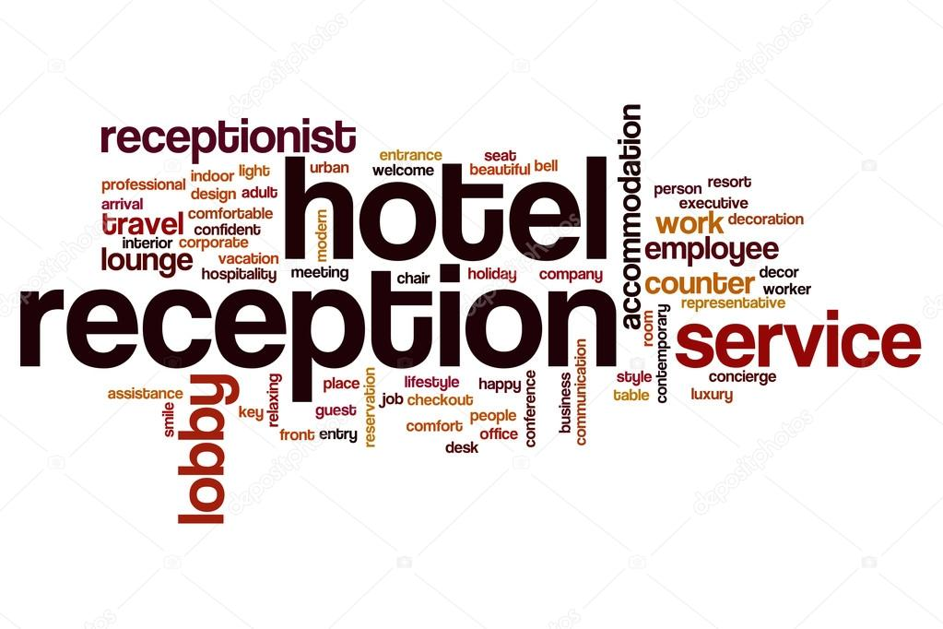
Module code: B4X01917
Rumen Grozdanov
Student number 1815102
Lecturers name: Dale Clark
Written assignment Part 1

Contents
Introduction 3
Current Skills 3
Current Academic Skills 3
Academic Skills I Want to Develop: 4
Leadership Skills 4
Employability skills 4
Employability skills that need to develop 5
SWOT Analysis 5
Strengths 5
Weaknesses 5
Opportunities 6
Threats 6
Professional Personal Plan 6
Objectives 8
Conclusion 9
References 10

Introduction
As part of the Hospitality business my intention is to strive in achieving managerial position in the near future. As part of this process, I will evaluate myself and explore my current Academic and Employability skills.
For this assignment, I have been asked to create a SWOT and Personal development plan which analyse my current academic and employability skills, including the skills which I will apply to find future employment.

Current Skills
I’m currently working with Tony Page/Bespoke Events and Kosher Caterer, as a Silver Service waiter and I have been working for the Agency for the last 3 years.
My current role gives me opportunities to demonstrate my Academic and Employability skills in variety of tasks at different places, and I’m determined to utilize these skills to my full potential to reach my goals, where I can be more influential and be able and inspire my-self to move on to other positions in the Hotel Industry(Baum, 2002).
In order to develop my Academic and Employability qualities I have visualized and framed my current skills, and where to put my effort to improve and strengthen my knowledge, to allow me progress gradually, as student and employee.
Creating a SWOT report will outline and classified my qualities and skills, and will allow me to look close at which skills to improve, which weakness to overcome, and how to face future opportunities and threats.

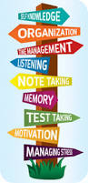

Current Academic Skills
● Organisation Skills
- setup realistic schedule
-minimizing distraction,
-active in groups/classroom due to different projects or tasks.
●Time management
-aware of deadlines
-meeting challenges/goals,
-decision making
●Self-discipline
-avoid interruptions
-change perception
-effective listening
-being prepared.
●Note taking
-analysing lecturer questions
-be aware of key and bold words and sentences, that will help me organize my work on forthcoming tasks and projects

Academic Skills I Want to Develop:
●Presentation Skills
-to be able to present products, ideas, services in front of public
-to be able to keep the audience engaged for the entire presentation (10-30 min)
●IT Skills
- be able to use Microsoft office, Word processing, Excel
- be able to conduct documents
- be able to make presentations using Power point
●Academic writing
- be able to write essays, reports,
- be able to make a documents

Leadership Skills
I would like to manage a team, sector and a brand.
To have broad knowledge of the Industry is vitally important for one’s who wants to go up the ladder of management, and the qualities and skills I possess has inspired me to strive for more. By knowing that learning is a continuous process throughout one’s professional career and having been aware and always keep an eye for new opportunities for professional development, it would give me advantage against my competitors (Baum, 2002).

Employability skills
Autonomous, Team Player, Passionate and compassionate Able to think outside the box, Interpersonal respectful skills, Peoples believer, Collaborative, Influential for achieving new goals, Moral, Inspirational for new idea, Optimistic Problem solving (Kriegl, 2000).

Employability skills that need to develop
●Presentation skills- where I can identify my mistakes speaking in front of public / audience and overcome shame / blush, redevelop my verbal presentation on business plans, reports, seminars.
• Enthusiasm- after negative reports / complains
●Leadership Skills
● IT skills
A man can master other skills and qualities that I mentioned above, but is extremely important to work on his existing ones and redevelop them , as nowadays Multicultural and International Companies relay on their employees to have; solid knowledge of the Industry (experience), functional and effective multicultural communication (learning),and non the last deep human ethic self-consciousness (background).
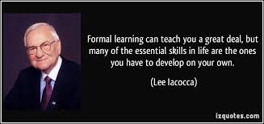

Competitive strategy is about being different. It means deliberately choosing different sets of activities to deliver a unique mix of value.

SWOT Analysis

Strengths
Good experience in International Hospitality
Strong control over sub-sectors
Switching/overlapping roles
Great team player
Excellent communication

Weaknesses
Weak in Presentations
Limited technical IT knowledge
Weak in sharing responsibilities
Weak in Self-criticism

Opportunities
The network of professionals at the University I’m surrounded by, as well as the time and the finance which I’m lucky to have, are the main resources to achieve my goals. The University will give me chance to take part of some other activities and expand my knowledge even further, and help me even further. I see big opportunities in front of me, to get my dream job in future (Baum, 2002).

Threats
Having seen that some of my competitors updating their knowledge occasionally, I personally count this as threat for my future, and made me think of my current situation and how to upgrade my knowledge (Eisele, Grohnert, Beausaert & Segers, 2013). The fact, that Hospitality Industry is changing its quality standards in fast pace, and realising how important is to be with the latest technologies, services and products up to date, has changed my plan, outlook and perspectives and has drove my passion to get better qualification by enrolling in University and acquire with a Diploma in the Hospitality Industry (Kriegl, 2000).

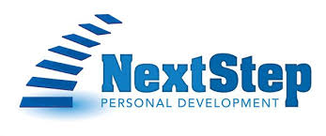
From my SWOT report, I have identified that there is still much work to do in terms of improving. The todays self-assessment, has giving me no options, but to work even harder to be more beneficial in future (Eisele, Grohnert, Beausaert & Segers, 2013).
I’m enough motivated and sensible not to find reason for excuses, but continue developing my skillsets, as I have the all sources to achieve my goals.

Professional Personal Plan

GOAL | Objectives | Resource | Deadline date
Improving my IT Skills would boost my Professional career undoubtedly | Spend additional hours after class activities at the Library in the University, To take home work over today’s tasks | To be able to use  Word Processing,  Microsoft Office,  Excel,  PowerPoint | Daily
 | To get online courses or attend IT sessions | To gain qualification | By the end of the year 2019 I have intention to get a Certificate in Computing
Writing Skills | Practice writing at class, home, work,  attend workshops,  library, online using Team viewer | Get feedback from tutors, managers, family/colleges by write a newsletters,  reports, | Daily
 | Look up close on basic principles of writing / grammar spelling / punctuation
 | Reading books for effective writing skills | To get qualification | Until been apprised by my lecturer /tutor / manager
Presentation skills | Learn possible techniques on  presentations online by watching videos on You tube, Social media networks, Read books vocally at home and practise | Would benefit from colleges and classmates practising together, exchanging details | Daily - Weekly
 | Building up self-confidence, find the right attitude | Get an instant feedback from them/ lecturer/ family/ friends
Leadership Skills | Read Managerial and Leadership Books, Magazine articles, | Get feedback from tutor, colleagues, manager | Get managerial position by 2021
 | Find the right balance  Adopting the idea,  Learn on how to know other peoples. Take more responsibilities.  Monitor the progress in achieving objectives | Taking a placement at Marriott on all sectors at the Hotel will help me immensely to achieve all I need for Management
Observe and learn from other managers,
use a range of forecasting tools

Objectives

Mid Term Time Frame (3 to 6months)
My first aim is to improve my Time Management, re-develop my Studying skills, and understand core elements of Business Marketing, the concept and the principles of Management from class lectures, computing classes, practical experience.
Pass all the assignments on time.

Mid Term Time Frame (6 months to 2 years)
My aim is, by attending classes at University and have a placement at Marriott London Heathrow on divers sectors to acquire good knowledge and confidence of computing, hiring employees, and possess excellent planning skills. Developed to use finest marketing strategies, to offer high quality customer services, creating more value for them, handling practical approach of successfully selling goods and ideas and be profitable and beneficial, to be able to Identify relevant stakeholders, to be able to recognise risks promptly. To Pass my exams and assignments and be ready for the next step.

Long Term Time Frame (2years- 5years)
Feel personally satisfied with having accomplish my target by completing numerous of projects, I would like to lead a team of professionals in a World known Chain of Hotels, laying all the skills from the program on different sectors at the work place, applying successful strategies and methods for the interest of the Brand.
I’m interested in General Manager and CEO positions too, and if I succeed Level 4 Project, I would like take additional 2 years of studying to gain Master Level Degree in Management in the future

Conclusion

Been able to make an extensive research on my Academic and Employability skills, and the purpose of these skills for future employability I have found my Advantages and Disadvantages through my SWOT analysis based on Strength Weakness Opportunities and Threats.
Detailing my skillsets has made me think how my performance can be improve and how to act more wisely and take reasonable steps taking new challenges in future , where I described in my Personal Development Plan (Beausaert, Segers, Fouarge & Gijselaers, 2013).
The Employability market it-self has expand to it limits and is still growing day-by-day, as company’s demands has narrowing the qualities for their employees (Littlejohn & Watson, 2004).
Though, I believe that I’m on the right way of find the best opportunities for me, and if I carry on improving my qualities and continue with considered steps I will be able to be competitive on the job Market.

References

Baum, T. (2002). Skills and training for the hospitality sector: a review of issues. Journal of Vocational Education and Training, 54(3), 343-364.
Kriegl, U. (2000). International Hospitality Management: Identifying Important Skills and Effective raining. Cornell Hotel and Restaurant Administration Quarterly, 41(2), 64-71.
Littlejohn, D., & Watson, S. (2004). Developing graduate managers for hospitality and tourism. International Journal of Contemporary Hospitality Management, 16(7), 408-414.
Beausaert, S., Segers, M., Fouarge, D., & Gijselaers, W. (2013). Effect of using a personal development plan on learning and development. Journal of Workplace Learning, 25(3), 145-158.
Eisele, L., Grohnert, T., Beausaert, S., & Segers, M. (2013). Employee motivation for personal development plan effectiveness. European Journal of Training and Development, 37(6), 527-543.

