Problem Solving and Decision Making
Student name: Ioana Stefania Ursu
Student ID: (2013620)
Course code: BMSW4004
Lecturer : Balendran Kandasamy

Word count

Executive Summary: Employee satisfaction within the company determined the success or the failure of the business. A then satisfied employee will effectively provide the business with the most important asset that the business could ask for, which is human labour. Changing business atmosphere where the social, economic, political factors are making a huge change in the business management the retention of the employees give the organization strength to gather the effective workforce that will help the business to grow even in the oddest of the times.

Table of Contents
Task 1: Role-play dialogue for MS team 3
Task 2: Individual Report 8
1.0 Introduction 8
2.0 Describing a complex problem along with its impact and scope 9
3.0 Analysis of the information about the identified problem to help the decision-making process by informing 10
4.0 Proposing different alternative problems for the solution 11
5.0 A decision-making technique used to identify and evaluate the possible solution to select one from the group 12
6.0 Implementation plan development 14
7.0 Gantt Chart 16
8.0 Communicating the solution to the stakeholders 16
9.0 Assessing suitable review and monitoring techniques 17
10.0 Conclusion 17
References 18

Task 1: Role-play dialogue for MS team
[Scenario: This is a section that has been designed to work as role play. The questions and the answered prepared are done to assess the satisfaction of the employee who is working under immense pressure after the impact of both Covid-19 and Brexit. The businesses are trying to combat the situation with the extra workload but that has not been reported to have contributed to making the business profited much. Employee satisfaction is the major factor that is associated with this. The dissatisfaction of the employee and the reason behind that has been tried to figure out by the management consultant. The motive behind doing this for him is to find out the reasons and the relevant solutions behind that].
Management Consultant: Hello there! Thank you so much for agreeing to be a part of this session. I am much delighted to get the opportunity to talk to you and listen to your experiences. However, I ensure that I will not record any of your voices and opinion. Your identity will be kept anonymous forever. At any point, if you find that this session is something that you would not want to be engaged with, please tell and I will stop it. I will like to know about your job satisfaction and plans.
Employee: thank you so much for the concern. I have noted what you.
Management Consultant: so, shall we begin?
Employee: Yes, please!
Management Consultant: So, tell me about yourself and your professional life. What is the nature of your work and how has impacted you? Do you feel satisfied with the role that has been offered to you?
Employee: I am a Marketing Manager in one of the leading hospitality agencies in the UK. I have been working quite happily in my workplace but in the last couple of years, things have changed a lot?
Management Consultant: How are feeling the difference?
Employee: The impact of Covid-19 and the background event of Brexit have caused the hospitality sectors to have completely lost ground. The organization I am working for has lost its loyal customer base and currently it is looking for any possible method to get that strength in the market back.
Management Consultant: I see, so what is your job role in business management and how are contributing to it? Are you satisfied with the overall performance of the organization?
Employee: Well, as a marketing manager you can understand how much pressure it is on us to develop and distribute the brand image in the market to gain the trust of the workers. Compared to the pre-pandemic situation we are currently working under a lot of external pressure. I feel the job satisfaction is getting even tougher.
Management Consultant: Yes, I can understand that.
Employee: On the other hand, the company does not understand the limitation under which we are working. We have been limited by the marketing resources and creating intelligent content that will both create an impact and make the services favourite to the customers is a matter of very crucial choice and to some extent luck as well. The company is pressuring us the marketing managers for instant results. That is not possible.
Management Consultant: How do you feel about the extra workload that your company is pushing you to?
Employee: I think they are chasing something that is not yet possible to get. I have often made to work outside my working hours as the whole day has not been producing any fruitful strategies. However, I have not been able to make them understand the fact that working outside the hours is not the solution that will bring prosperity. The company requires to develop strategies that will suit the business project.
Management Consultant: are you not invited in making marketing decisions for the company as you are the marketing manager? Do find the implementation plan successful from the organization?
Employee: Yes, they do engage in dialogue with me but that is after the strategy has been created. I have noticed that in most cases the upper management makes decisions and strategically moved without considering the practicality of the task for me.
Management consultant: Then, when are you engaged in the dialogue?
Employee: I am engaged only when I require communicating my strategic moves that have the mandate to match with the strategic move they have already created. The decisions are not matching with the possible moves that I can take according to the need of the hour.
Management Consultant: So, how are you planning to make the decisions?
Employee: I try to make plans that will target the strategic decision making of the business to the best of my abilities. Based on the political and social order it is difficult for me to target the issue with dept. But, in most cases, the moves have failed since the pre-planned expectations have been too tough or high for me to suit with the marketing plan.
Marketing Consultant: Have you not been engaged with making the major decisions? How will it be socially acceptable to you?
Employee: not! What is the major problem lies in this situation? I am being forced to work in an already designed system that requires my significant contribution to make it a success but the practicality of the plan has not been verified by me. Funnily enough, I am the one who is required to bring the results out of the situation.
Marketing Consultant: Do you feel satisfied with the work? How does that pressure make you feel?
Employee: miserable! On some days I want to get out of the mess and think of either joining a different company or start my own business. The social and political effects of the business make the situation even tougher for the management to handle. The effects of the impractical plans are reflected on my work performance and I do not feel motivated enough to work at all. I have lost my work-life balance completely and that seems to affect the board of directors the least.
Marketing Consultant: Do you think this is impacting your mental and physical health?
Employee: Absolutely! I am a marketing manager. I love to connect with people and sell the product that our company is having. Designing new marketing strategies is the passion that keeps me strengthened and motivated to continue with my work. As a marketing manager, my job is to create plans that will be as practical to the current situation as possible. The recognition of the political factors is a must to understand the required strategies. In this company the team has created a burden for me that am not letting me use the maximum of my capabilities to address the problem. This is rupturing my job satisfaction level. I have tried my best to get accustomed to the situation but this constant pressure is tearing down my mental peace.
Marketing Consultant: How do you propose that your organization should handle the situation?
Employee: The organization is required to make major changes in the strategy building board. The improvement of market research is one of the major factors that are absolutely necessary but introducing people who will make the outcomes of the decision realistic are required to be included in the body. The Social and technological changes are very evident in the business atmosphere after covid.
Marketing Consultant: Do you feel that your voice is properly heard?
Employee: No, I am never asked about the applicability of the plans give alone to sit and make plans with them. I understand that they are doing it under pressure to develop the business and recover the losses that have been created by the impact of Corona and business but they also need to understand that implementing the plans that are not relevant are not going to bring instant results. The business strategies should be made after they have fully understood the situation and given importance to the marketing manager’s ideas.
Marketing Consultant: So, what do you think are the reasons for your dissatisfaction?
Employee: The Company is failing to keep me motivated to the task as I am not allowed to voice my issues with working in certain frameworks. The macro-environment is failing to achieve the target market. That is impacting my performance and that can highly impact the relationship of me and the company as well. I have tried to communicate with the officials but they are stressed and they think that whatever they are doing is okay and they do not need any feedback.
Marketing Consultant: In other words, you mean to say that engaging with dialogues, feedbacks to discuss the practicality of the decisions made is an absolute necessity to understand the real working condition and the proposed outcome of the situation.
Employee: The motivation is generated when I could be made to feel that I am part of the team and just someone to make work for fourteen hours a day to get the best results. Job satisfaction is indispensable in the job role. This way neither the problem could be identified nor the employee attention and performance could be improved.
Marketing Consultant: Yes, I absolutely agree with you. The situation has pressurized everybody but keeping faith and compassion is the only way out. So what are your plans now? If you do not mind sharing?
Employee: My plans are to try and reach the upper management with the reasons for the plan failures next time come and charge me. If some kind of settlement happens well and good otherwise I will have to quiet here and look for better alternatives. I might begin my own business at some point as well.
Marketing Consultant: That is amazing! All the best for your future endeavours and thank you so much for spending some of your valuable time and trust on us!
Employee: You are welcome. (smiles sheepishly)

Task 2: Individual Report

1.0 Introduction
Employee retention is one of the major factors that businesses need to consider after the collection of revenue. Employees are human forces who work day in and out to achieve a certain goal. Businesses often face issues when they have tried to identify the employees as the work generating body only and refused to identify them as human beings. This has resulted in situations when the employees have felt unsatisfied and their performance, as well as the commitment to the company, has decreased. This report will try to identify the complexity of the problem by referring to different literary sources. Then, the report will analyze the acquired information about the problem and find methods in which the decision making could be facilitated. Different alternative solutions to the problem have been identified next. Then, using a decision making technique has been used to select to identify and evaluate one solution from the proposed decision making. Then, an implementation plan has been introduced, after that communication to the stakeholders has been described finally; a suitable assessment for monitoring the technique has been identified.
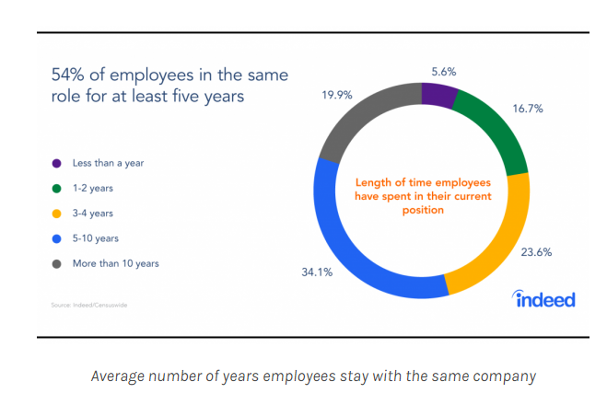
Figure 1: Average number of years’ employees stay in the organization
(Source: Handrick, 2018)

2.0 Describing a complex problem along with its impact and scope
The employees are the biggest asset of the company. Retaining the profitability of the company is something that is closely related to the workforce and the management of employees. The employees are the ones who will run the business with full consideration and commitment to the business (Cloutier et al., 2015). The commitment cannot be generated without satisfaction. The employees are sometimes stabilized with the current situation that involves the work-life balance, job roles, responsibilities, duties, salaries and relationships (Hudson, 2014). However, the changed marketing situation might require the business to take different advantages from the employees.
The complexity lies when the expectation of the employees does not match with the expectation with the employees. In some cases, like the case above in task 1 the employee wants to do his work with the participants but the business is not letting him take decisions to contribute properly (Guérin-Marion et al., 2018). The lack of trust from the company is evident. On the other hand, the businesses try to get the best performance from the employees but the amount of salary and the recognition provided is not satisfying the employee. As inspired by the viewpoints of Kossivi and Kalgora (2016), for mitigating the issue companies are trying to use retention strategies like promotion, interesting work, and decision making authority and recognized statuses. However, even then all the employee would want is a hike in salary. Hence, maintaining a sustainable population that will trust the business and will be engaged with the business through thick and thin is a complex curriculum and only through best communication that could be achieved.
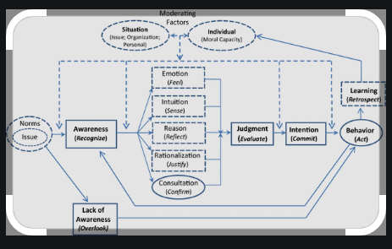
Figure 2: Factors influencing the decision making
(Source: Schwartz, 2016)

3.0 Analysis of the information about the identified problem to help the decision-making process by informing
The global market shifts and the pandemic have pushed many of the businesses to make decisions that will help the businesses to get the grasp in the market as before. The management of the changing business atmosphere is the challenge that the businesses face. Employee retention becomes difficult when the business is unable to communicate the requirement from the employee in the correct method (Leder et al., 2016). Otherwise, the employees are offered something that could be salary, work culture or anything else that does not match with their expectations. In other words, miscommunication is the major factor that has created the major issues with the employee retention factors.
Workplace discrimination is something that has the potential to break teams and set an example for a company that does not match with the ethical conditioning of the employees. The treatment does not only limit the treatment that he/she might be receiving of their own but witnessing activities that are either discriminatory, unsatisfactory or unethical might make the employee not wanting work in that company anymore. Sometimes the businesses are not wanting to hire any more employees to save money (Barakat et al., 2016). The result reflects the work pressure on the existing employees. 80% of the businesses lose their employees because of excessive work pressure (Younge and Marx, 2016). The equal distribution of the work pressure in the organization might be absent. The stressful condition might result in unhealthy competition within the business. The decision making needs to address the situation with the most important factor. The business will make the analysis of the macro–economic factors to a deep factor. The recognition of the right strategic move is the key to retain the employees as well as the best market results (Lal, 2015).
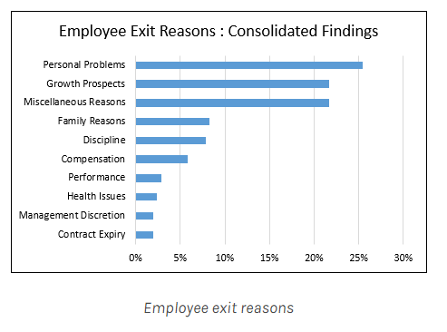
Figure 3: Employee exit reasons
(Source: Handrick, 2018)

4.0 Proposing different alternative problems for the solution
Employee retention is majorly a result of miscommunication and non-recognition. The best method to understand the different factors that are making the business struggle to keep the employees is by getting the reviews of the employees. The stakeholder of the business has different requirements from the organization (Bode et al., 2015). It is the increased revenue from the business and job satisfaction for the employees. Work pressure, cultural discrimination, salary discrimination and many other factors make coordination difficult. Some of the possible solutions to the issue have been identified.
- Regularly reviewing the employee’s satisfaction is something that needs to be considered. Reviewing the performance of the employees should be a twofold exercise (Haider et al., 2015). It will be definitely required to ask the employees about their feedback in case their performance has been lacking.
- Recognizing the employee unsatisfaction possibilities is something that will help the business to combat unrecognized employee unsatisfaction. The employees are required to add their performance indicator every month but they have been given an opportunity to rate the company as well. This will increase the employee confidence and they will feel valued (Reem et al., 2014).
- Maintaining the workplace culture is absolutely necessary to gain confidence regarding the workplace. The culture in the organization should be structured in such a way that the reviewing and accepting of the mistakes are made a habit of everybody (Tomaževič et al., 2014). The business should encourage the employees to commit mistakes and similarly engage in dialogue to mitigate those mistakes.
- Engaging only with those employees who are committed to the task should be the best method to avoid a lack in the performance metric of the employees. The business will be able to make difference only when the right workforce is working for the benefit of the company (Shakeel and But, 2015). It is also very important and that the company finds out what are the exact dream of the employee is and situate him/her only in those departments.
- Having trust in the employee that will help them make decisions in the controlled method of the business management is the most effective method to maintain trustworthy relationships. However, as opined by Chen (2014), keeping the balance in the decision making with the authority is also very important to be noticed. The retention of the employee is not necessarily about losing authority.

5.0 A decision-making technique used to identify and evaluate the possible solution to select one from the group
Decision making is a process that will require recognition of the most logical factors and then deciding to do something that will be most beneficial for everybody (Gerding et al., 2020). Pattern recognition, locating similar activities and then arranging the information with the requirement to arrive at the desired point is called decision making. No matter what model has been used to arrive at the desired end it is important that the logical flow of the information set up has been kept intact (Ma et al., 2018). A single decision is not supposed to meet the requirement of all the possible outcomes. Hence selecting the decision-making model that will help to arrive at the desired position is required.
The Vroom-Yetton Decision-making Model has been used in this part for the benefit of the organization. The business will be most benefitted from the asking of the seven thorough questions that require locating the ideal position of the business (Tanwar and Prasad, 2016). The model is extremely flexible that could be used for any decision making. The best solution recognized from the above sections is keeping the work culture functional and receptive towards recognizing personal problems. Keeping the work culture active and open is the best method to identify the required unsatisfaction indicators of the individual employees.

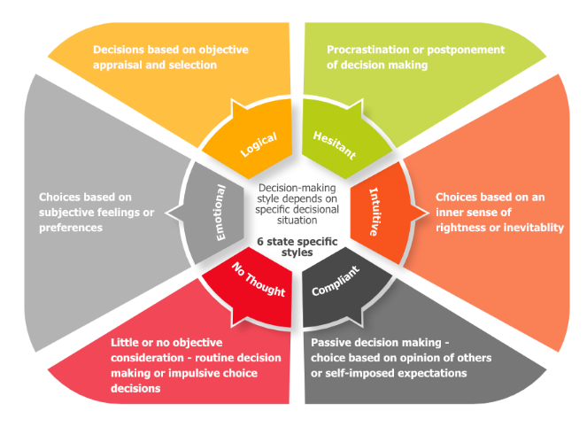
Figure 4: Decision-making steps
(Source: Shakeel and But, 2015)

6.0 Implementation plan development
Task | Start date | End date | Duration
Monitoring the factors leading to the problems | 05/08/2021 | 09/08/2021 | 4
Collection of information from different sources for initiating strategies | 09/08/2021 | 12/08/2021 | 3
Identification of problems and sources | 12/08/2021 | 16/08/2021 | 4
Searching for the appropriate strategy | 16/08/2021 | 20/08/2021 | 4
Assessing advantages and disadvantages of the solution | 20/08/2021 | 22/08/2021 | 2
Selecting the appropriate strategies for employee retention | 22/08/2021 | 27/08/2021 | 5
Communicating with the stakeholders | 27/08/2021 | 30/08/2021 | 3
Practically implementing the strategy and decisions | 30/08/2021 | 20/09/2021 | 21
Providing positive feedback | 20/09/2021 | 25/09/2021 | 5
Conducting interviews of employee | 25/09/2021 | 28/09/2021 | 3
Interacting with the employees | 28/09/2021 | 01/10/2021 | 3
Monitoring the results for further planning | 01/10/2021 | 05/10/2021 | 4

7.0 Gantt Chart

8.0 Communicating the solution to the stakeholders
Communicating the solution with the stakeholders is an integral part of the whole strategy that can appropriately measure the effectiveness of the solution. The most important stakeholders in such a situation will be the human resource executive as they are the ones responsible for initiating policies that can contribute to employee retention. The management should communicate effectively with the department to state the policies as per the mission and vision of the organisation. They should take every decision related to the process with the human resource executives and also should take feedback from the employees to assess its effectiveness. Employees, on the other hand, are other important stakeholders under such circumstances and the management should also communicate with them to know their needs and demands which will contribute to assessing the problems crucially and overcoming them appropriately. Employee rewards and recognition process should also be used properly by communicating with the policymakers and aspects such as salary, promotion, compensation, incentives and pensions should be set out with discussion with the head of human resources and finance department.

9.0 Assessing suitable review and monitoring techniques
Stakeholders play an important role for the purpose of achieving the highest level of employee satisfaction and communicating to them is the utmost priority for the management of the organisations. The main stakeholders in such scenarios will be human resources executives and managers. Thus, communicating with them the management should focus on the rate of employee satisfaction within the work culture of the organisation. The management should also take regular feedbacks of employees from the human resource department and should focus on assessing their needs and demands. Moreover, they should also create a comfortable work culture and management should make regular reports of the performance of the employees and through it, they need to identify the problems (Lewis and Sequeira, 2016).

10.0 Conclusion
In this study, the problem related to employee retention within organizations had been the main focus. Several aspects have been described in the context of employee retention along with its scope and impact. The analysis of the information of the problem has been also provided along with its role in the decision-making process. Some of the other alternative problems that arise due to lack of employee retention have also been identified. The implementation of the solution to the problem has also been provided with time scales of the activities along with the Gantt chart. The importance of communicating the problem to the stakeholders has also been given along with the necessity of reviewing and monitoring techniques.

References
Cloutier, O., Felusiak, L., Hill, C. and Pemberton-Jones, E.J., 2015. The importance of developing strategies for employee retention. Journal of Leadership, Accountability & Ethics, 12(2).
Kossivi, B., Xu, M. and Kalgora, B., 2016. Study on determining factors of employee retention. Open Journal of Social Sciences, 4(05), p.261.
Leder, S., Newsham, G.R., Veitch, J.A., Mancini, S. and Charles, K.E., 2016. Effects of office environment on employee satisfaction: a new analysis. Building research & information, 44(1), pp.34-50.
Barakat, S.R., Isabella, G., Boaventura, J.M.G. and Mazzon, J.A., 2016. The influence of corporate social responsibility on employee satisfaction. Management decision.
Bode, C., Singh, J. and Rogan, M., 2015. Corporate social initiatives and employee retention. Organization Science, 26(6), pp.1702-1720.
Tomaževič, N., Seljak, J. and Aristovnik, A., 2014. Factors influencing employee satisfaction in the police service: the case of Slovenia. Personnel review.
Chen, M., 2014, January. The effect of training on employee retention. In International Conference on Global Economy, Commerce and Service Science (Vol. 1, No. 2, pp. 356-359).
Ma, Q.K., Mayfield, M. and Mayfield, J., 2018. Keep them on-board! How organizations can develop employee embeddedness to increase employee retention. Development and Learning in Organizations: An International Journal.
Tanwar, K. and Prasad, A., 2016. Exploring the relationship between employer branding and employee retention. Global Business Review, 17(3_suppl), pp.186S-206S.
Shakeel, N. and But, S., 2015. Factors influencing employee retention: An integrated perspective. Journal of Resources development and Management, 6(2015), pp.32-49.
Haider, M., Rasli, A., Akhtar, S., Yusoff, R.B.M., Malik, O.M., Aamir, A., Arif, A., Naveed, S. and Tariq, F., 2015. The impact of human resource practices on employee retention in the telecom sector. International Journal of Economics and Financial Issues, 5(1S).
Younge, K.A. and Marx, M., 2016. The value of employee retention: Evidence from a natural experiment. Journal of Economics & Management Strategy, 25(3), pp.652-677.
Lal, P., 2015. Transforming HR in the digital era: Workforce analytics can move people specialists to the center of decision-making. Human Resource Management International Digest.
Hudson Jr, S.W., 2014. Diversity in the Workforce. Journal of Education and Human Development, 3(4), pp.73-82.
Reem, A.D., Kitsantas, P. and Maddox, P.J., 2014. The impact of residency programs on new nurse graduates' clinical decision-making and leadership skills: A systematic review. Nurse Education Today, 34(6), pp.1024-1028.
Guérin-Marion, C., Manion, I. and Parsons, H., 2018. Leading an intergenerational workforce: an integrative conceptual framework. International Journal of Public Leadership.
Gerding, J.A., Brooks, B.W., Landeen, E., Whitehead, S., Kelly, K.R., Allen, A., Banaszynski, D., Dorshorst, M., Drager, L., Eshenaur, T. and Freund, J., 2020. Identifying needs for advancing the profession and workforce in environmental health. American journal of public health, 110(3), pp.288-294.
Handrick, L. 2018 5 Reasons Your Retention Rate Is So Low | Hppy, Hppy. [online] Available at: <https://gethppy.com/employee-turnover/5-reasons-your-retention-rate-is-so-low> [Accessed: 9 August 2021]
Schwartz, M.S., 2016. Ethical decision-making theory: An integrated approach. Journal of Business Ethics, 139(4), pp.755-776.
Lewis, A. and Sequeira, A.H., 2016. Effectiveness of employee retention strategies in industry. Available at SSRN 2733517.

