Alexandru Mihail Conac
2025656
the decline of john lewis
Problem Solving and Decision Making BMSK4004

Contents
Introduction 2
Main Findings 3
Background of organisation 3
Impacts of the main problem 3
Nature 3
Scope 3
Impact 4
SWOT (internal) analysis 4
PESTLE (external) analysis 5
Conclusion 6
References 7
Appendices 9
SWOT Analysis 9
PESTLE Analysis 10

Introduction

The importance of this report is to outline the main problem that led to the decline of John Lewis. The report will focus on the nature, scope, and the impact of the problem, to determine exactly what are the consequences of the problem. After those will be determined and explained, a SWOT analysis and a PESTLE analysis will be conducted to identify all the factors that affected John Lewis and caused the decline of the company.

Main Findings

Background of organisation
John Lewis Partnership started in 1864 with a small shop on Oxford Street in London, and it started to grow year by year until they became a successful partnership that has two businesses under its name: John Lewis and Waitrose (John Lewis Partnership, 2021). John Lewis is a store with multiple brands and many departments such as home, garden, fashion, beauty etc., while Waitrose is a supermarket. Both are successful and known within the United Kingdom. Apart from its brands, the organization is well-known for the fact that it is owned by its employees, considering them members, and sharing all the profits with them (John Lewis Partnership, 2021). Recently, the company started to face a series of problems that affected the business’ revenue and reputation. The first one is the decreasing sales, which was not expected for the company. The other problem will be the fact that the company had to permanently close 8 stores, which made a number of employees vulnerable and without job. The other two problems are the branding which is inconsistent and the fact that the business wants to enter into the financial services at an uncertain time (Pratley, 2020).

Impacts of the main problem
With all the problems that the company has at the moment, it seems like the source of all of them and the main problem is represented by the constantly decreasing sales. This is the most important point to consider because the sales are what keep a business alive, without them or with them constantly decreasing puts the business at risk of further closure.

Nature
The nature of the problem is represented by the sales that are decreasing and the decreased revenue. In numbers, it is reported that the annual loss for the financial year 2020 - 2021 was about £517 million (Jahshan, 2021). This is a big issue for the company because even though Waitrose was listed as an essential shop during the lockdown and it remained open, it was not enough to cover the loss from the closure of John Lewis during the lockdown. In addition to that, the company also benefited from the Government’s Furlough Scheme for the employees, but the loss was still huge, showing that John Lewis Partnership was affected directly by the external factors.

Scope
As every retail business, John Lewis Partnership was affected by multiple factors such as the COVID-19 pandemic, drivers shortage and Brexit (Springham, 2021). The pandemic came with a lot of restrictions and lockdowns, meaning that businesses that were considered to be non-essential for people were closed to protect the population and to stop spreading the virus, and while Waitrose remained open, John Lewis had to move its entire business online, making the sales to decrease as people were focused more on house essential and food and were cautious with their spending. At the same time, there was a shortage of drivers which affected the possibility to complete every order in time, and this was a problem on its own, but it has also to do with the Brexit and with the deliveries from overseas.

Impact
The impact was huge on the business because while the Brexit was in discussions for a couple of years, the pandemic came by surprise and everything change in a couple of days, and no one could’ve taken any action in advance to minimise the loss (Davies, 2021). The results of that was that the business was forced to close 8 John Lewis stores because they couldn’t afford to keep them open (Sillars, 2021). The impact of this decision was that many people found themselves without having a place of work in a difficult time. The decision was huge and difficult to take but the business is positive that this will help in the long term. The people affected by this decision might have a difficult time finding another job with the current situation. In addition to that, the actual employees are concerned that other stores will have the same faith, as the bonus and the salaries were cut (BBC, 2021).

SWOT (internal) analysis
The SWOT analysis highlights the internal factors that contributed to the actual situation of the company. The weaknesses of the company added to the decline, making the company even more vulnerable in front of the external factors. The most recent weakness is the poor reputation after some recent events, where they received strong backlash after their most recent advert where they were accused of microaggression (Baska, 2021). This situation is a weakness at the moment because it can make the remaining customers to not want to buy anymore from John Lewis Partnership, which will affect the sales. Another weakness is the price cut, because the business was forced to cut the prices to match the competition, which made the company lose even more money only to be able to keep up with the competition (Ruddick, 2015). Another weakness is the loss of the employees, which, at John Lewis Partnership, are even more important because the company is owned by them (Radojev, 2021), and losing employees can make the other feel insecure at the workplace, not motivated to work, which can make the productivity to decrease, directly affecting the sales.
Opposite to that, the company has strengths that, if used properly, can reduce the decline. The most noticeable is the fact that the company still has a strong position on the market, especially in locations where only John Lewis and Waitrose are available (Chambers, 2021). This allows the company to dominate certain locations, which are beneficial for the sales. In addition, the company offers a various range of products and departments, for all budgets and needs, which makes it easier for the customer to shop, as they have everything the need in only one place (Nazir, 2021). This has a lot of potential to increase the sales, as the company offers comfort and has all the products necessary to satisfy every customer. Lastly, the good relationship with the employees, which are considered partners, is an important strengths, even though now is in danger from the store closures. It is important for the company to have satisfied people working within the company, because they will be loyal and will want for the company to do good and be profitable because they will benefit as well, especially because they are the ones that own the company in different percentages (MacDonald, 2021).
The opportunities and the threats are deducted from the PESTLE analysis. The opportunities are the shift to online shopping, which can reduce the costs significantly and, at the same time, grow the profits, the partnership with other companies, which will make the company be even more accessible and gain a new range of customers, and new businesses to invent into, such as the financial market, which can increase the sales, and can create additional jobs. The threats are the competition with whom a partnership wouldn’t be possible because they make the company reduce its costs to price match, the weak currency which can increase the price of the wholesale buying, the Brexit which can introduce new taxes and regulations and a decline in department stores, which means that the loss of a source of income.

PESTLE (external) analysis
There are a couple of external factors that contributed to John Lewis Partnerships’ decreasing sales. The Brexit is a threat for the business because it made the British pound be weaker in front of other currencies, making the prices increase and the profits to decrease (Kollewe, 2018). Apart from that, Brexit makes the trades become problematic, because a new series of regulations are in place, along with new taxes to be paid (Cross, 2021). The Brexit affects in a negative way multiple factors: political, economic, and legal. All of the three factors have consequences such as price increase, more taxes to be paid by the company, and it is constantly decreasing the company’s opportunities to sell more and to recover from this financial loss.
The national lockdowns imposed by the government as a response to the Coronavirus pandemic brought both opportunities and threats for many businesses, including John Lewis Partnership. The opportunities brought by the lockdowns are the shift to online shopping and new businesses to invest into (Ojea, 2021). The shift to online shopping is a great opportunity for the company to save money from renting a space and paying staff to be on the physical store, and instead they could have a storage where they keep all the products that are showing online. There are also new businesses to invest into that the customers are interested in, such as sanitary products or financial solutions. Both of them represent great ways to attract new customers and increase the sales. On the other side though, the threat is coming for the decreased interest in department stores, which means that a source of income might be at risk to be lost forever in some locations. The lockdowns had impact over the political and the social element.
The last important relevant factor for the decline of John Lewis Partnership is the competition. This factors comes as both opportunity and threat (Shakespeare, 2021). The opportunity that it brings is that the company can work with its competitors to use same spaces or create partnerships with deliveries, which would be beneficial for all the parts as they would save money and will attract a new range of customers. As a threat though, John Lewis Partnership is already having difficult times to price match, because it makes the company lose even more money than before. This factor affects the most the economic element.
The company has potential to use their strengths to maximize its opportunities. For example, the fact that the organisation has a wide range of products and departments can be used in online, to make the customer order everything from their website, to maximise the possibility of extra income.

Conclusion
John Lewis Partnership is known as a strong leader on the market but recently it has been affected by many factors which created the big problem of loss of revenue. This problem has a wide impact, with the company being forced to close a couple of its stores and to cut jobs. It was identified that both internal and external factors contributed to the escalation of this problem. The SWOT analysis clearly showed that the price cut and the lost of their employees represent a weakness, while the fact that they have a strong position on the market and offer a wide range of product are being seen as strengths. The PESTLE analysis showed that factors such as Brexit, Lockdown and competition can be seen as opportunities and threats, but the most important action that will determine the future of John Lewis Partnership will be the company’s aptitude to use its strengths to overcome the difficult time and to take on board all the opportunities to reduce the decline.

References
- Baska, M. (2021) John Lewis issues lukewarm response to backlash over ‘playful’ new advert. Available at: https://www.pinknews.co.uk/2021/10/15/john-lewis-statement-advert-controversy/ (Accessed: 23rd of October 2021).
- BBC (2021) John Lewis and Waitrose plan to cut 1,000 jobs. Available at: https://www.bbc.co.uk/news/business-57837864 (Accessed: 23rd of October 2021).
- Chambers, S. (2021) John Lewis plans hundreds of mini-stores in Waitrose. Available at: https://www.thetimes.co.uk/article/john-lewis-plans-hundreds-of-mini-stores-in-waitrose-xfdp999r0 (Accessed: 24th of October 2021).
- Cross, G. (2021) Brexit delivery issues: How Amazon, John Lewis, Dunelm, and other companies have been affected by Irish Sea border. Available at: https://www.belfasttelegraph.co.uk/business/northern-ireland/brexit-delivery-issues-how-amazon-john-lewis-dunelm-and-other-companies-have-been-affected-by-irish-sea-border-39934086.html (Accessed: 25th of October 2021).
- Davies, R. (2021) John Lewis considering fresh store closures in response to Covid. Available at: https://www.theguardian.com/business/2021/feb/21/john-lewis-considering-fresh-store-closures-in-response-to-covid (Accessed: 23rd of October 2021).
- Jahshan, E. (2021) John Lewis Partnership slumps to £517m loss; warns on more store closures. Available at: https://www.retailgazette.co.uk/blog/2021/03/john-lewis-partnership-slumps-to-517m-loss-warns-on-more-store-closures/ (Accessed: 23rd of October 2021).
- John Lewis Partnership (2021) Employee Ownership. Available at: https://www.johnlewispartnership.co.uk/work/employee-ownership.html (Accessed: 23rd of October 2021).
- John Lewis Partnership (2021) Our history. Available at: https://www.johnlewispartnership.co.uk/about/who-we-are/our-history.html (Accessed: 23rd of October 2021).
- Kollewe, J. (2018) Five reasons why John Lewis profits have dived. Available at: https://www.theguardian.com/business/2018/sep/13/five-reasons-why-john-lewis-profits-have-dived (Accessed: 25th of October 2021).
- MacDonald, G. (2021) John Lewis and Waitrose raise drivers’ pay to combat shortage. Available at: https://www.retail-week.com/supply-chain/john-lewis-and-waitrose-raise-drivers-pay-to-combat-shortage/7040389.article?authent=1 (Accessed: 25th of October 2021).
- Nazir, S. (2021) John Lewis launches new value range ahead of reopening. Available at: https://www.retailgazette.co.uk/blog/2021/04/john-lewis-launches-new-value-range-ahead-of-reopening/ (Accessed: 25th of October 2021).
- Ojea, S. (2021) John Lewis Partnership to Lease Warehouse from Tesco to Help Meet Online Demand. Available at: https://www.marketwatch.com/story/john-lewis-partnership-to-lease-warehouse-from-tesco-to-help-meet-online-demand-271628677315 (Accessed: 25th of October 2021).
- Pratley, N. (2020) John Lewis's problems are fixable but partners will need patience. Available at: https://www.theguardian.com/business/nils-pratley-on-finance/2020/sep/17/john-lewis-problems-fixable-partners-need-patience-coronavirus-next-british-airways-ryanair (Accessed: 23rd of October 2021).
- Radojev, H. (2021) False dawn or fresh start: Has John Lewis really got its mojo back? Available at: https://www.retail-week.com/john-lewis-latest-results?authent=1 (Accessed: 24th of October 2021).
- Ruddick, G. (2015) John Lewis profits fall as costs and competition increase. Available at: https://www.theguardian.com/business/2015/sep/10/john-lewis-profits-fall-amid-higher-costs-and-competition (Accessed: 23rd of October 2021).
- Shakespeare, S. (2021) John Lewis’ strong brand key to surviving impact of coronavirus. Available at: https://yougov.co.uk/topics/consumer/articles-reports/2021/03/17/john-lewis-strong-brand-key-surviving-impact-coron (Accessed: 25th of October 2021).
- Sillars, J. (2021) COVID-19: John Lewis warns of more store closures as pandemic drives £517m annual loss. Available at: https://news.sky.com/story/covid-19-john-lewis-warns-of-more-store-closures-as-pandemic-deals-hammer-blow-to-sales-12242423 (Accessed: 23rd of October 2021).
- Springham, S. (2021) Sales volumes are down but don't panic just yet. Available at: https://www.knightfrank.com/research/article/2021-09-17-dont-panic-just-yet (Accessed: 23rd of October 2021).

1.

Appendices

SWOT Analysis

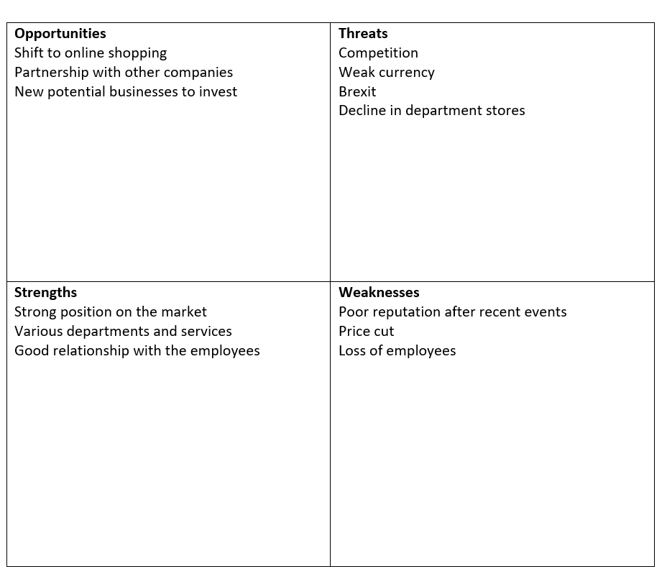

PESTLE Analysis



