Search
  - Name
James Edward Millns

Student No
1708455

Email
1708455@student.uwtsd.ac.uk

Course
BSC (Hons) Software Engineering

Module Name
AI and Machine Learning

Module Code
ACCA6011

Lecturer
Gordon Dickers

Table of Contents

Table of Contents 2
Table of Figures 4
1. Introduction 5
2. Storage Facility Searching AI Agent 6
2.1 Aims and Objectives 6
2.2 Development and implementation 7
2.2.1 Data Structures and Algorithms Used 7
2.2.2 User Guide 13
2.2.3 Run Time Screen Shots 17
2.3 Testing and results 20
3. Hill Climbing 22
3.1 Purpose 22
3.2 Discussion 23
3.3 Improvements 27
4. Eight Tile Problem 28
4.1 Aims and Objectives 28
4.2 Process 29
4.3 Conclusion and Recommendation 34
5. Improved Eight Tile Problem 35
5.1 Aims and Objectives 35
5.2 Process 36
5.3 Conclusion and Recommendation 41
6. Overall Evaluation 42
References 43
Appendices 45
Source.cpp 45
Console.h 46
Console.cpp 47
Maze.h 49
Maze.cpp 51
Node.h 56
Node.cpp 57
DFS.h 58
DFS.cpp 59

Table of Figures
Figure 1: Console Class 7
Figure 2: Algorithm to list available files 7
Figure 3: Algorithm to select a maze file 8
Figure 4: Maze class attributes 9
Figure 5: Algorithm to read file into data structure 9
Figure 6: Algorithm used to create graph 10
Figure 7: Node class attributes and ascociated structs 11
Figure 8: DFS class attributes 11
Figure 9: Algorithm used to traverse graph 12
Figure 10: Example of acceptable text format 13
Figure 11: Instructions to open file directory 14
Figure 12: Instructions to open correct folder 15
Figure 13 Example of files inside correct folder 15
Figure 14: Example of file names being read to console 16
Figure 15: Screenshot of file being selected 17
Figure 16: Screenshot of agent starting its search 17
Figure 17: Screenshot of agent finding an object 18
Figure 18: Screenshot of agent finding the last object 18
Figure 19: Screenshot of agent finishing search and reporting its route 19
Figure 20: Simple Hill Climb Flowchart 23
Figure 21: Search space with multiple local maxima and minima 24
Figure 22: Steepest Ascent Hill Climbing Flowchart 24
Figure 23: Stochastic Hill Climbing Flowchart 25
Figure 24: Example of a plateau in a search space []. 26
Figure 25: Example of a ridge in a search space []. 26
Figure 26: Steepest Ascent Hill Climb with Random Restart Solution 27

Introduction
The purpose of his report is to critically analyse, evaluate and apply artificial intelligence and machine learning methods to solve given problems. It will also analyse practical problems and synthesise appropriate software solutions using selected artificial intelligence and machine learning methods.
The report will be broken down into four tasks, the first being the implementation of an AI agent designed to navigate a given storage facility to find one or more objects on its route. The agent will traverse the facility with the use of the depth first search algorithm which will require the use of several data structures, the most important being a stack which is a first in last out data structure [1][2].
The second task will be a critical evaluation of the hill climbing algorithm, an example of a local search algorithm. A description of the method will be provided which details the steps involved and a discussion of the effectiveness and the fallbacks with suggestions for improvements will be explored [3][4].
The third task will be a practical demonstration of the hill climb being used to solve the eight-tile puzzle game. Screen shots of the steps taken by the algorithm with details of the possible routes it could take, and a description of the method used to evaluate the optimal moves will be shown.
The fourth and final task will be a repeat of task three where a different evaluation method is used at each decision point to explore whether it is more efficient to use different evaluation methods over others.

Storage Facility Searching AI Agent

Aims and Objectives
The first task of this assignment is to create and test a set of C/C++ functions that emulate an AI agent capable of systematically searching a given medical storage facility for one or more objects.
The aims and objectives for the implementation are as follows:
- Read in a text file which contains the layout of the storage facility into the program.
- Represent each space in the storage facility as a character which is stored in memory.
- Represent the map structure file as a graph with each intersection, corner and dead end represented as a vertex and each corridor as an edge.
- Agent can traverse the storage facility with the depth first search algorithm.
- User can load a new storage area map from a different file.
- User can start a new search
- User can quit the application.
- Agent recognises when it has found an object in the map and report it.
- Agent recognises when it has not found an object at the end of its run through the map and reports it.
- Agent reports its route at the end of the search and reports at which points it found any objects.
- The console will display the agent searching the map as the search is executed.

Development and implementation

Data Structures and Algorithms Used
The Console class gives the user the option to read a file from the Mazes folder in the project directory.
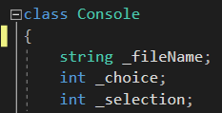
Figure 1: Console Class
The Console class uses the listAvailableFiles method to show the user the files available for them to select. It achieves this with the <filesystem> library giving the functionality to read the file names from a given directory.
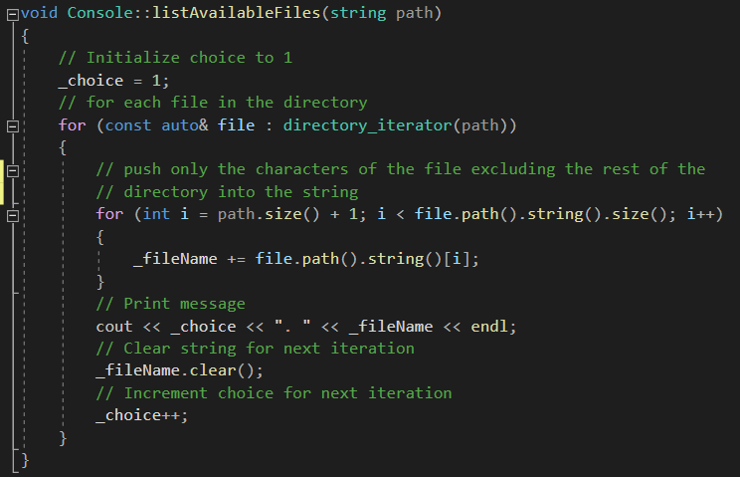
Figure 2: Algorithm to list available files

The selectMazeFile method then allows the user to select a file that is displayed on screen. Exception handling has been used for the user input to prevent improper input of unrecognised characters crashing the program.
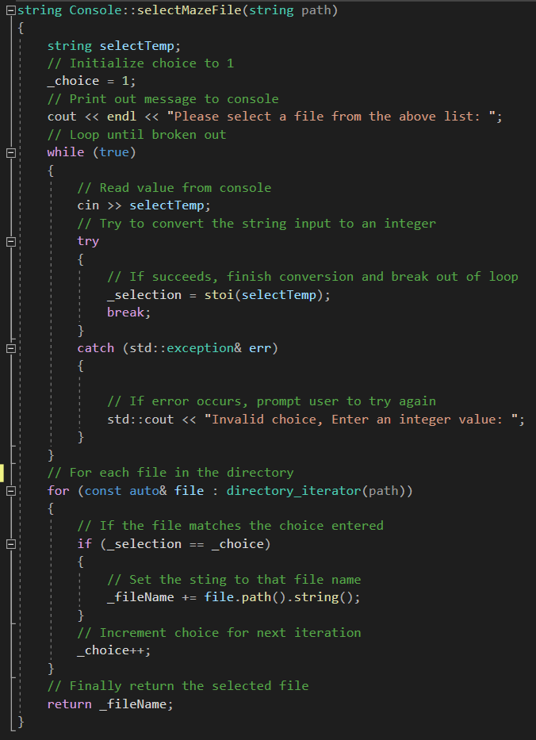
Figure 3: Algorithm to select a maze file
To store the storage facility in memory, the Maze class uses a vector of strings called _mazes, saving each line of the facility. This approach was used with the intention of accessing the characters in the maze with the row and column indexes i.e. _maze[row][col].
The Maze class also contains a vector of node pointers, which will act as the graph which the agent will traverse.
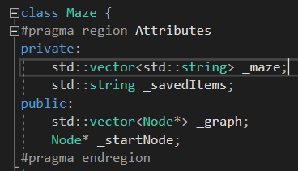
Figure 4: Maze class attributes
The algorithm used to read the file into the data structure, ReadFileIntoMaze, works by reading each line of the file and pushing them onto the container one at a time.
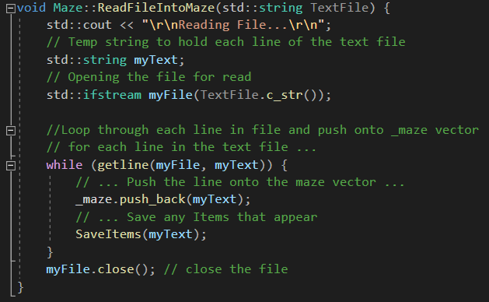
Figure 5: Algorithm to read file into data structure
The algorithm used to create the graph that represents the map, CreateGraph, works by scanning through each character in the _maze container and depending on the character’s neighbouring characters, will create a node holding that position and connect it to the viable nodes around it. Complex Boolean logic has been used and is further elaborated in the code in form of comments.
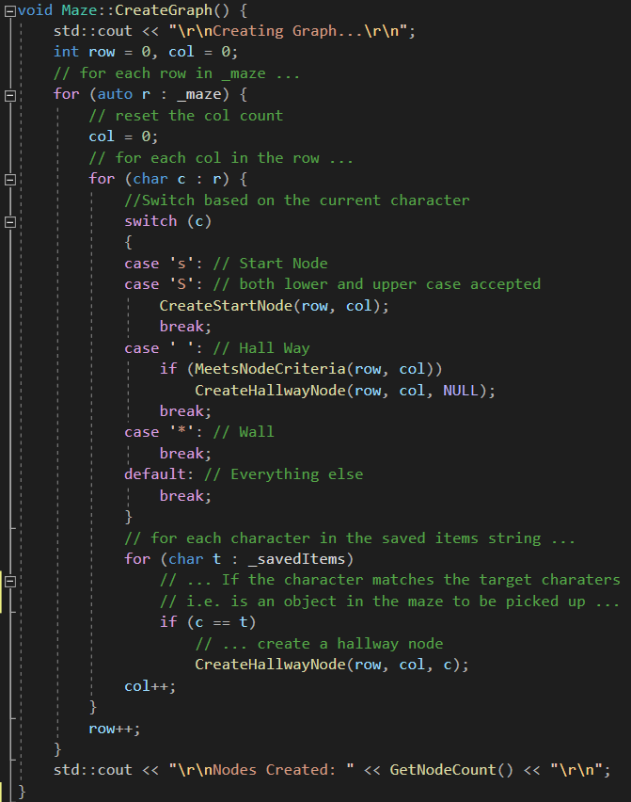
Figure 6: Algorithm used to create graph
The Node class contains a vector for adjacent nodes which indicated the node pointer and the distance to travel. With more time the search could be improved with an A* algorithm approach which uses the distance as a heuristic.
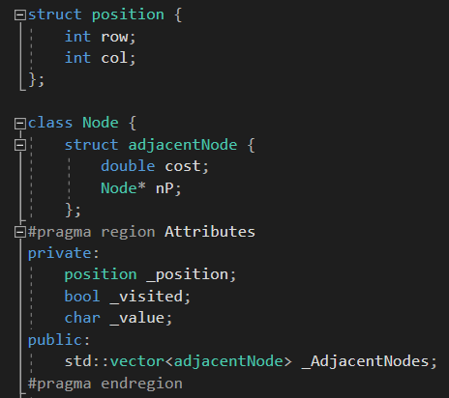
Figure 7: Node class attributes and ascociated structs
The DFS class contains a stack container which will hold Node pointers, this data structure will be used in the depth first search algorithm.
A vector for chars is used to store the items the agent finds as it traverses the map which is then used to check if all the items have been found at the end of its search.
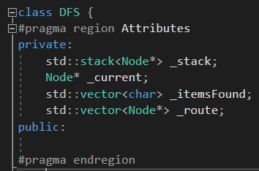
Figure 8: DFS class attributes
The algorithm used to traverse the graph is set up as a depth first search, looping while the stack is not empty, setting the current to the top of the stack and popping the top, then pushing all unvisited adjacent nodes to current onto the stack to then continue to the next iteration of the loop until all nodes have been visited.
When the search has completed, the agent reports if all the items have been found or not, then reports the route it took and at what points it found the items in its journey.
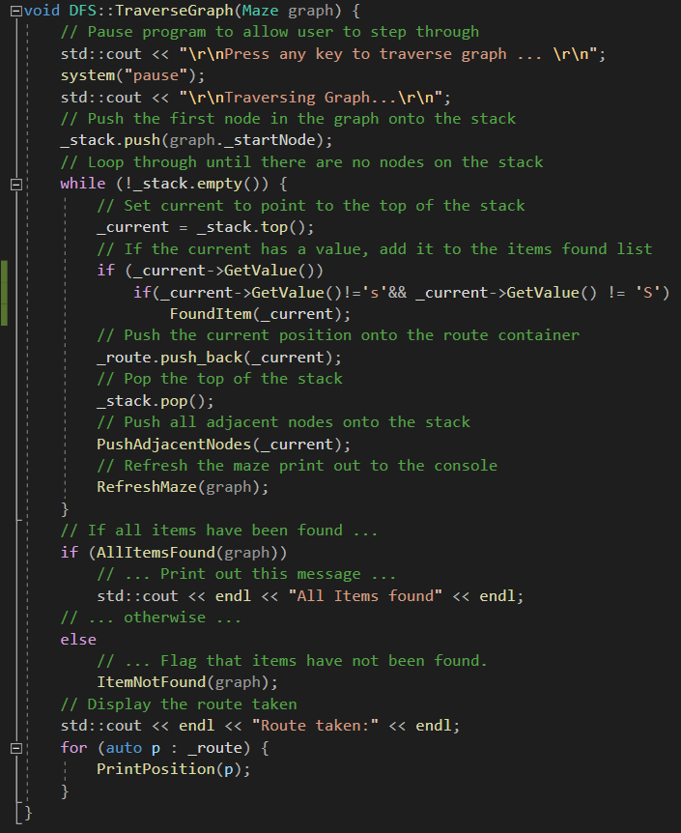
Figure 9: Algorithm used to traverse graph

User Guide
Reading a new file into the program
Before reading a file into the program, first ensure that the walls of the map in the file are made of the * character, that there is a surrounding perimeter wall, and that there is a start position shown by an ‘S’ character, upper or lower case will be suitable. Items inside the map need to be represented by numerical characters.
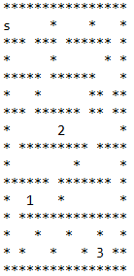
Figure 10: Example of acceptable text format

To read a custom file into the program, one must first navigate to the folder that the files are read from. The easiest way to do this is to first open the solution in Visual Studio and right click on the solution in the solution explorer and select “Open Folder in File Explorer” as shown below:
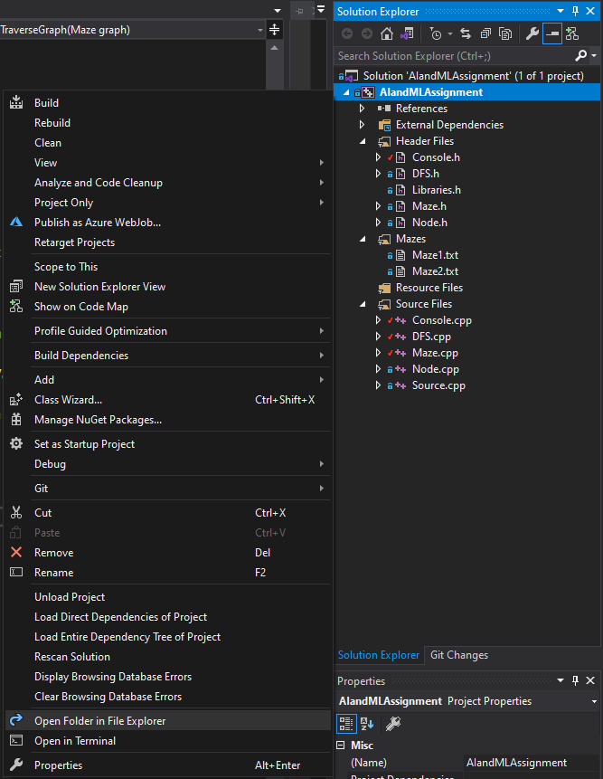
Figure 11: Instructions to open file directory

The next step is to open the Mazes folder inside the directory as shown below:
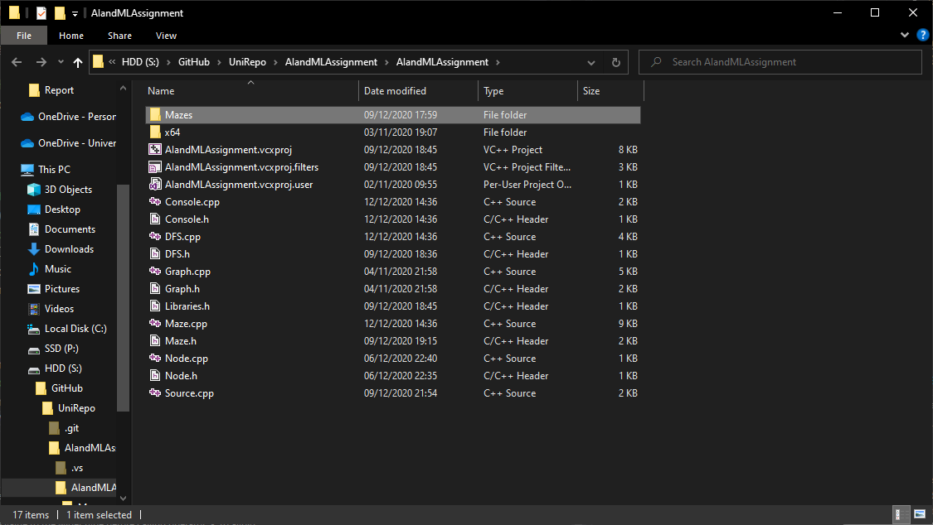
Figure 12: Instructions to open correct folder
Then paste any text files that hold a custom maze into this folder.
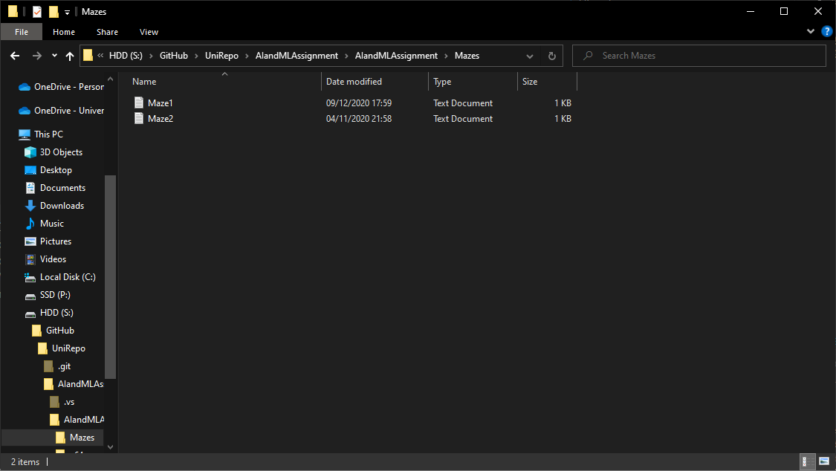
Figure 13 Example of files inside correct folder

The program will read the file to the console and have it as an option when running.
Select the corresponding number to the desired file and the program will run the search on that file.
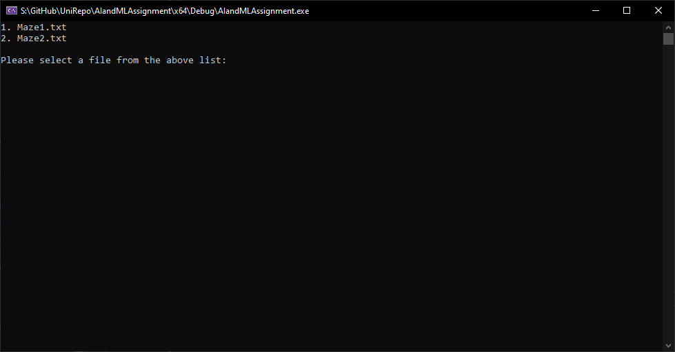
Figure 14: Example of file names being read to console

Run Time Screen Shots
When a file has been selected from the options provided, the program will then read the file and create the graph to traverse. After it has completed the graph, it will report how many nodes were created in the map.
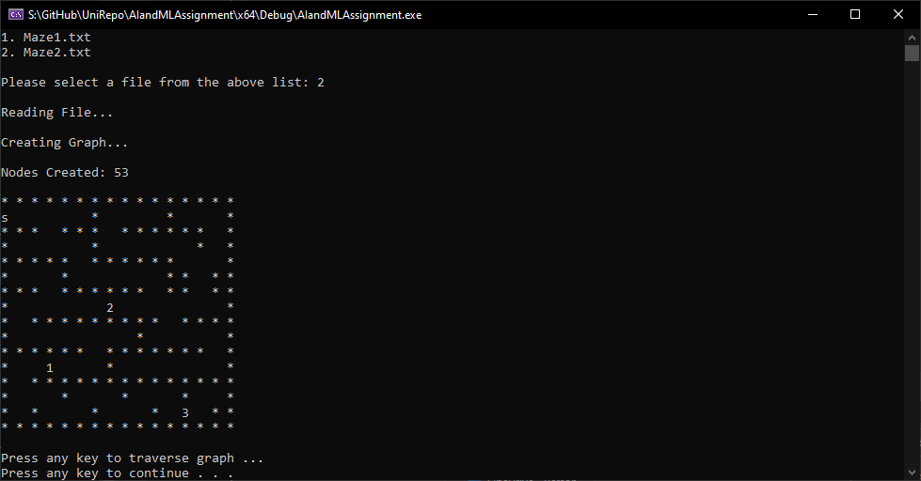
Figure 15: Screenshot of file being selected
Following the onscreen instructions of pressing any key to continue will lead to the search portion of the program, where a graphical representation of the search will be shown, each step pausing the program until the user pressed the enter key.
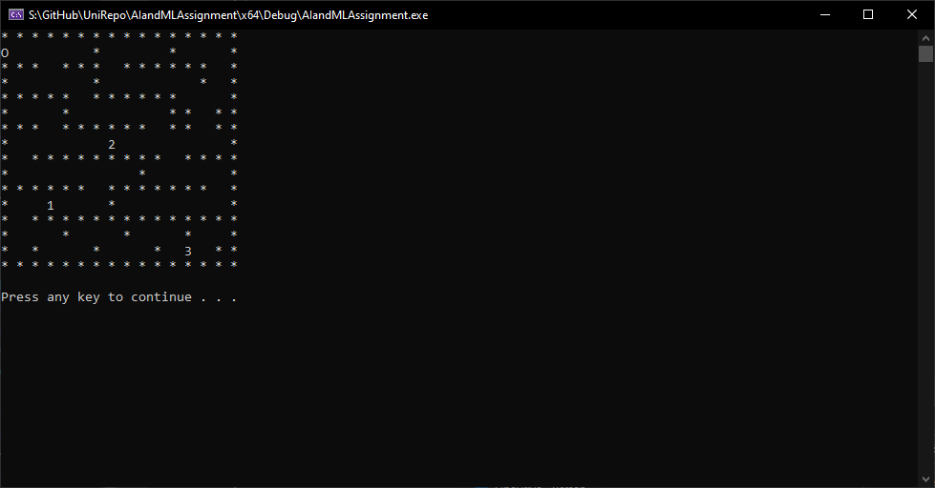
Figure 16: Screenshot of agent starting its search

When the agent encounters an item in the map, it will report that it has found an item to the console.
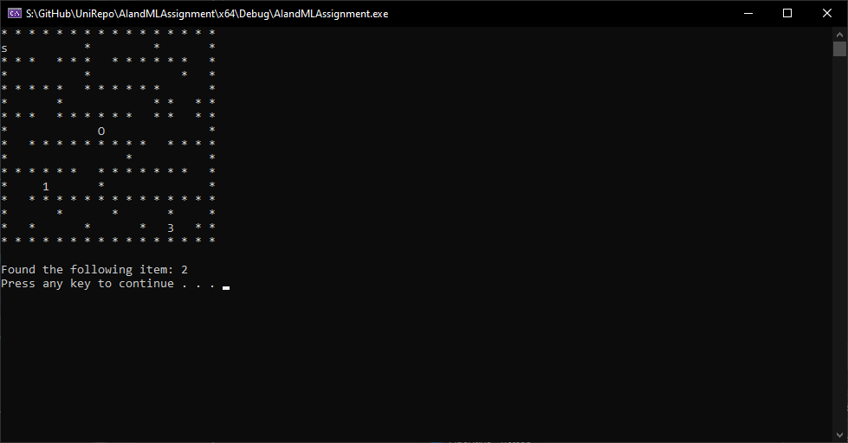
Figure 17: Screenshot of agent finding an object
It will continue to report any subsequent items it finds on its search.
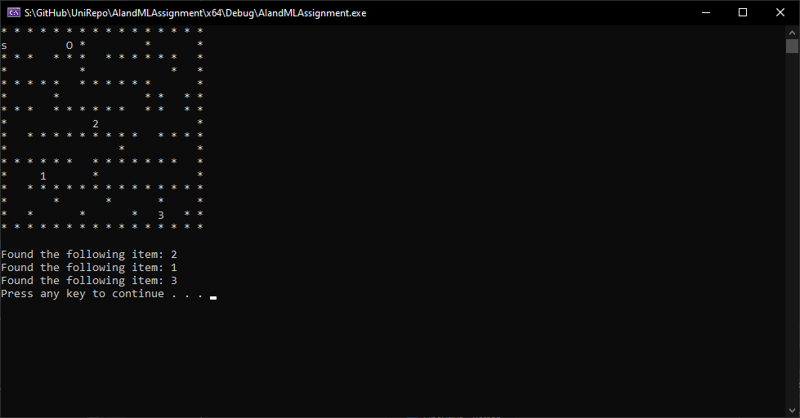
Figure 18: Screenshot of agent finding the last object

Once the search has concluded, the agent will report if all the items were found or not and also the route it took through the map, noting the positions it found the items.
The program will then present the user with the option of quitting or continuing the program. If the user chooses to continue, they will be able to load a new maze.
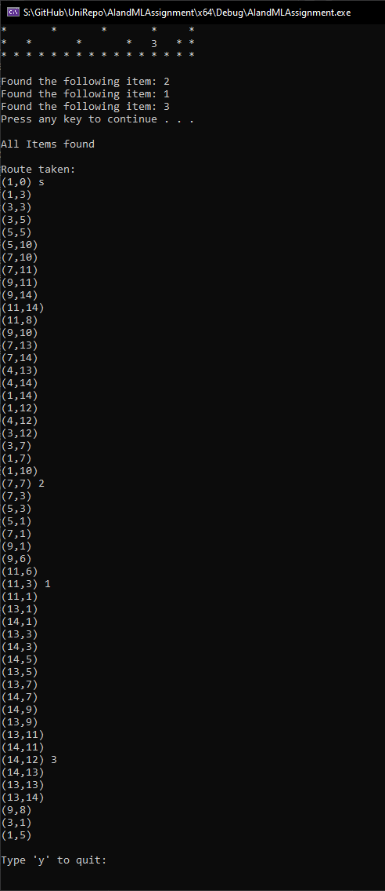
Figure 19: Screenshot of agent finishing search and reporting its route

Testing and results
Tester: James Millns
Test Date: 01/12/2020
Result: Pass
No. | Test Description | Expected Results | Actual Results | Pass/Fail | Comments
1 | Paste text file into Mazes folder.  Run Program | The file should be read out onto the console as an available option. | As expected, | Pass | Directory reader works as intended; no further development required.
2 | Select text file from option | The program should first read the file then convert the file to the graph and report the number of nodes created. | As expected, | Pass | Check the user input only accepts valid inputs.
3 | When selecting text file option, input invalid option. | In the case of an incorrect input, the program will notify the user and request them to try again. | Program crashes. | Fail | Insert exception handling for the user input to prevent the input of invalid characters crashing the program.
4 | Retry test 3 after changes | As test 3 expected results | As expected, | Pass | No further development required.
5 | Load storage facility map.  Run program to point where agent finds item. | Display of agent searching the map is shown on console.  Agent reports item has been found onto the console. | As expected, | Pass | No further development required.
6 | Finish search through a storage facility map. | Agent reports the route taken through the map and notes the points where it found an item. | As expected, | Pass | No further development required.
7 | Run search on map where all items are attainable (no items on unreachable paths) | Agent reports it has found all items when it finishes its search. | As expected, | Pass | Check it reports it hasn’t found an item on a map where all items are not fully attainable.
8 | Run search on map where not all items are attainable (some items on unreachable paths) | Agent reports it was unable to find some items with details to how many it could not find. | As expected, | Pass | No further development required.
9 | Run search on map and select to retry the program. | Program reverts to point where user can choose the text file to load. | As expected, | Pass | Check the program quits when the user chooses to do so.
10 | Run search on map and select to quit afterwards. | Program ends. | As expected, | Pass | No further development required.

Hill Climbing

Purpose
Hill climbing is a local search technique that starts with an arbitrary or random solution to a problem, then looks for an improved solution by making incremental changes. This process is then iterated until the algorithm finds a solution that cannot be improved by any further incremental changes [5], [6].
It can be described as a method of maximizing or minimizing the cost of a target function f(x), where x is the solution vector and f() is a heuristic function that indicates how optimal the solution is [7]. At each iteration, the algorithm will change a single element within x to determine whether that change has a benefit to the cost function. When the loop has reached a point where no more incremental changes produce a more optimal solution, the x solution vector is considered “locally optimal” [8].
One problem that hill climbing can be applied to is the travelling salesman problem, which is a problem that tries to find the shortest path that a salesman can take that will allow them to visit each town in a certain area once. Hill climbing can be used for this problem as it can start off with a solution that it can improve from to find the most optimal solution in its search space [9].

Discussion
There are different approaches that can be taken for hill climbing [10], [11]. Simple hill climbing is the approach of selecting the first improved solution found when making incremental changes. The algorithm’s flow of operations is described in figure 20.
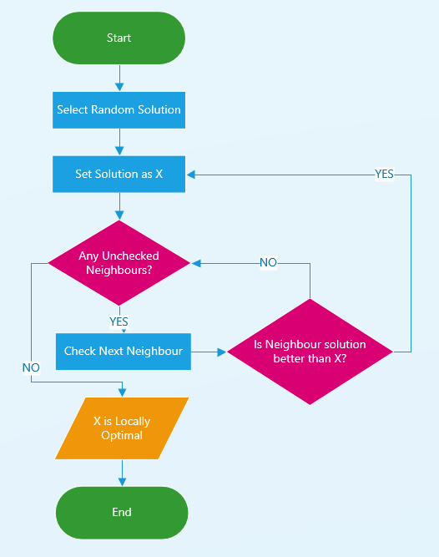
Figure 20: Simple Hill Climb Flowchart
This approach can fail in situations where the search space has a local maximum which is not the global maximum; a solution that is not the most optimal but has no neighbouring solutions which are improvements [12].
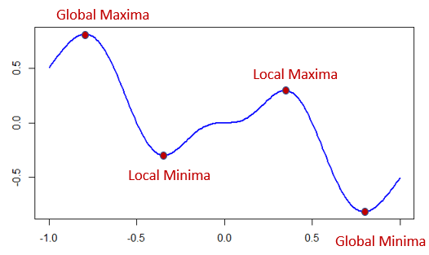
Figure 21: Search space with multiple local maxima and minima
Steepest ascent hill climbing is another approach which first compares all neighbouring solutions before moving to the most optimal successor [13]. This approach also has the same disadvantage of being susceptible to failing in a search space with more than one local maximum or minimum [13]. This approach is described in figure 22.
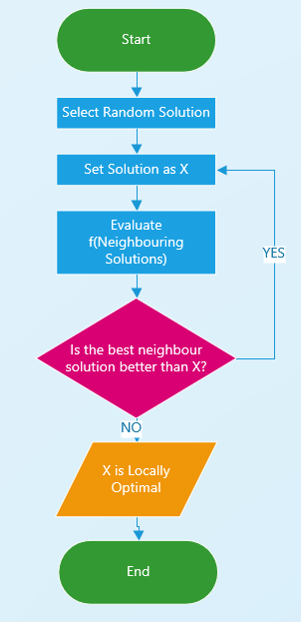
Figure 22: Steepest Ascent Hill Climbing Flowchart
Another approach is the Stochastic hill climb which instead randomly selects a neighbour and evaluates that neighbour’s neighbours based on the improvement they offer before deciding whether to move to it. This approach is better than the previous as the algorithm has a wider scope of view, being able to see an additional level of change before deciding to move [14]. This approach is described in figure 23.
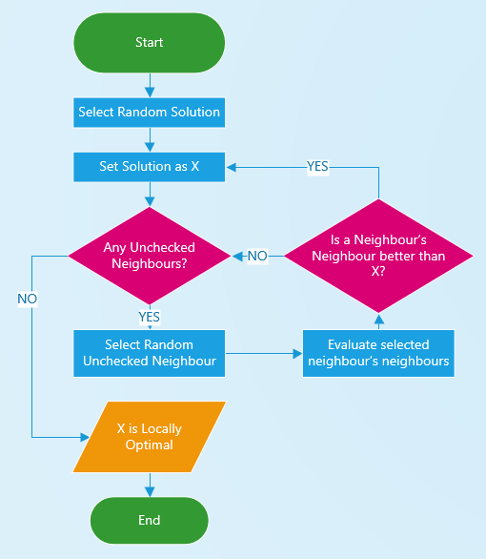
Figure 23: Stochastic Hill Climbing Flowchart
The main drawback of these approaches is they are essentially blind to the global optimal point in any given search space, meaning they are only able to find a local optimal point. This can be improved by providing the search with a goal point to reach i.e. the global optimal point [15].
Other situations that can cause issue for these approaches are when there is a plateau or a ridge in the search space.
A plateau is an area of the search space where the cost function is flat, meaning a point in the middle of the plateau will have the same cost as its neighbours [16].
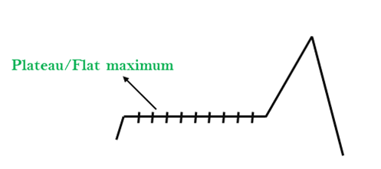
Figure 24: Example of a plateau in a search space [].
A ridge is an area of the search space where there exists a desired local maximum which is surrounded by smaller local maximums, making it impossible to traverse to the desired maximum in one move [17].
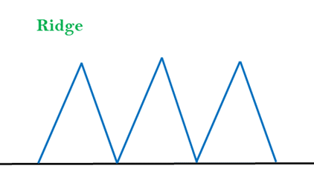
Figure 25: Example of a ridge in a search space [].

Improvements
As previously discussed, the Hill Climbing algorithm can fall short when in a search space with more than one local maxima. To avoid getting stuck in a local maximum that is not equivalent to the global maxima, the algorithm must first know what maximum it is aiming for. If that information is provided, then the method of implementing a fixed Hill Climbing technique is with randomly restarting if the algorithm finds itself stuck in a local maximum [5], [17]. Figure 26 describes the flow of operations with the random restart method implemented into the steepest ascent approach.
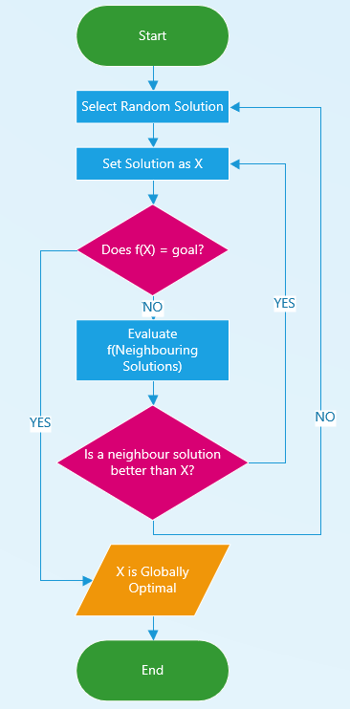
Figure 26: Steepest Ascent Hill Climb with Random Restart Solution

Eight Tile Problem

Aims and Objectives
The eight tiles problem is a puzzle that uses a 3x3 grid with eight tiles labelled 1 through 8. The goal of the puzzle is to move the tiles by utilizing the empty space to a point where all the labelled tiles are in ascending order going from top to bottom [18].
The aim is to start with a position of tiles and use the hill climbing method to evaluate the immediately possible moves to then choose the most optimal option. This method will then be repeated until a local optimal solution has been found[18].
The heuristic that will be used to evaluate the possible steps will be the sum of pieces that are out of place where a lower value is preferred as it means more pieces are in the correct position. A value of zero in this heuristic will indicate that the puzzle has been completed as there are no more pieces out of place. The Heuristic values in the diagrams will be represented by ‘h’[18].

Process
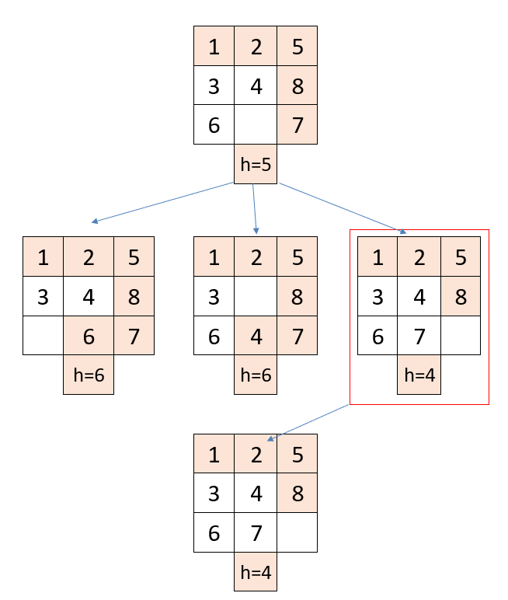

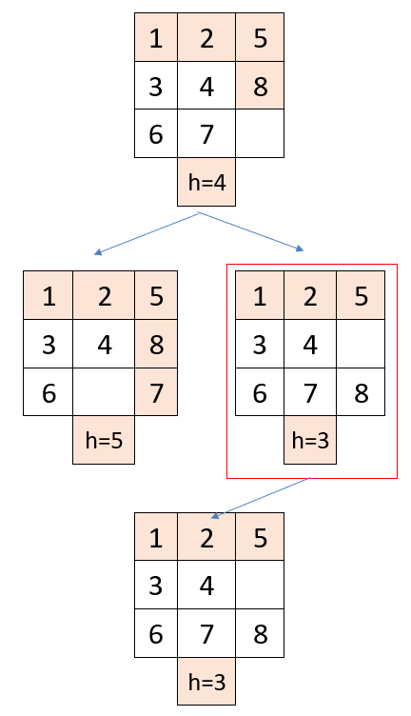

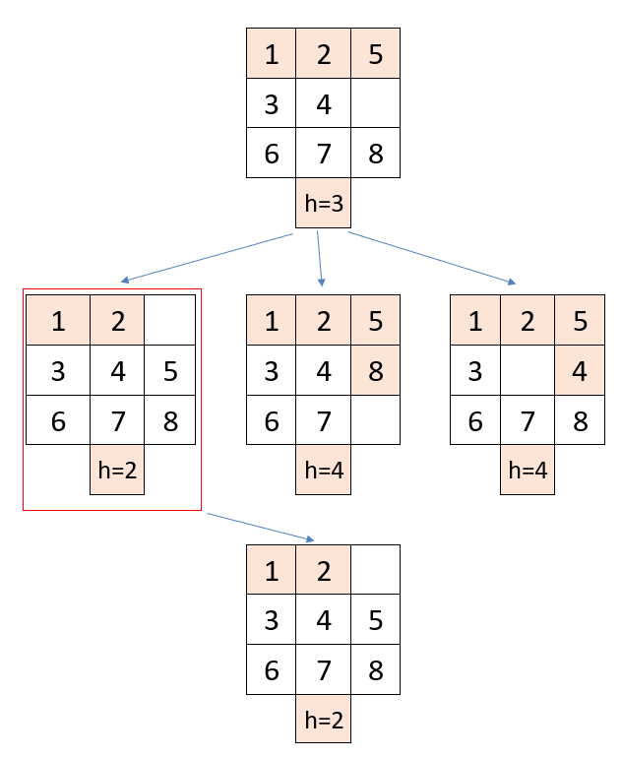

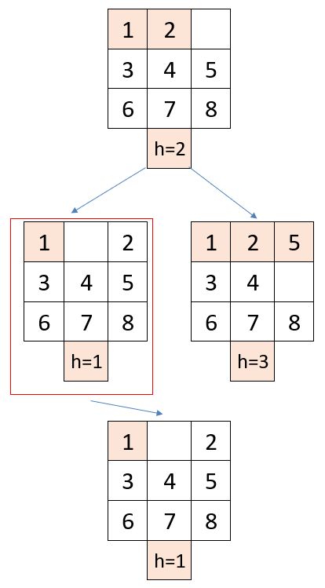

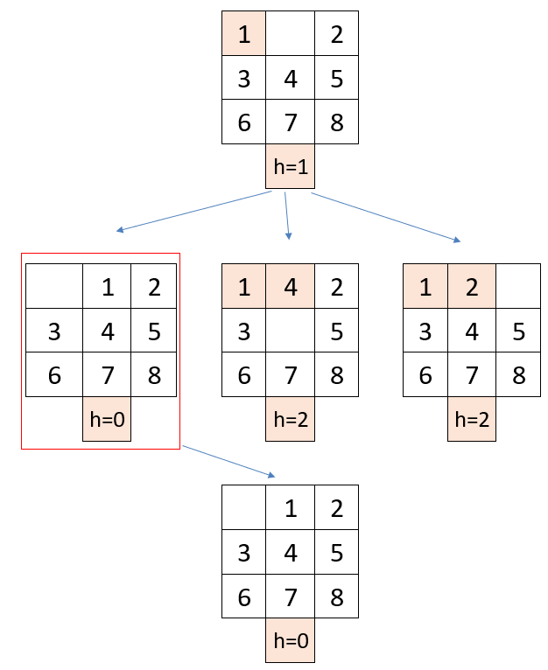

Conclusion and Recommendation
For this initial solution, the heuristic used was able to lead to the optimal solution where h=0. From this example it can be concluded that hill climbing can be suitable in some circumstances, but it is almost certain that it would not be suitable in all starting solutions [5], [18], [19].

Improved Eight Tile Problem

Aims and Objectives
In the previous hill climb exercise, the heuristic value of how many pieces were out of place was used which was successful. Another heuristic value that could be used is the sum of the Manhattan distances each piece is away from its destination. This heuristic would give a more accurate indication to how optimal a solution is [19], [20].
In a situation where a piece is on the other side of the grid to where it should be would give a higher ‘h’ value unlike the previous one used, which indicates the direction the piece needs to move as the ‘h; value would decrease by the piece moving towards its destination [19], [20].

Process

Conclusion and Recommendation
For this example, ironically the heuristic values remained the same despite the calculation being different. This meant that the hill climb took the exact same steps and found the global minimum heuristic value being zero. A different starting position may allow the Manhattan distance measure heuristic to be more useful than the out of place heuristic. With more time an exploration of possible starting positions could be carried out to identify a point where the Manhattan heuristic could find the solution where the out of place heuristic could not [19], [20].

Overall Evaluation
To evaluate, the first task was implemented successfully, producing an AI agent that can traverse a given storage facility to find one or more objects. All the aims and objectives where met and all the tests were successful. With more time it may be possible to implement a different search algorithm such as the A* algorithm to allow the agent to find the shortest path to each object in the facility [20], [21].
The second task successfully evaluated the hill climbing algorithm with detailed examples of the different approaches that can be used when implementing it to solve a problem. The shortcomings were identified, and possible improvements were discussed in detail [14], [19].
Task three and four properly illustrated how hill climbing is used to solve the eight-tile problems one step at a time with the use of their respective heuristic functions. The problem with the latter heuristic function is it did not show any difference to the former, perhaps with a different starting position the Manhattan distance would prove more useful [19]–[21].

References
[1] K. Balog, Entity-Oriented Search, vol. 39. Cham: Springer International Publishing, 2018.
[2] Y. Du, F. Li, T. Zheng, and J. Li, “Fast Cascading Outage Screening Based on Deep Convolutional Neural Network and Depth-First Search,” IEEE Trans. Power Syst., vol. 35, no. 4, pp. 2704–2715, Jul. 2020, doi: 10.1109/TPWRS.2020.2969956.
[3] O. Khan, S. Acharya, M. Al Hosani, and M. S. El Moursi, “Hill Climbing Power Flow Algorithm for Hybrid DC/AC Microgrids,” IEEE Trans. Power Electron., vol. 33, no. 7, pp. 5532–5537, Jul. 2018, doi: 10.1109/TPEL.2017.2779238.
[4] H. Kun and W. Jun, “A botnet detection method based on FARIMA and hill-climbing algorithm,” Int. J. Mod. Phys. B, vol. 32, no. 32, p. 1850356, Dec. 2018, doi: 10.1142/S0217979218503563.
[5] J. L. Joseph, “Optimization techniques : Finding maxima and minima,” no. 1, 2017, Accessed: Nov. 23, 2020. [Online]. Available: https://www.datasciencecentral.com/profiles/blogs/optimization-techniques-finding-maxima-and-minima.
[6] “Artificial Intelligence: A Modern Approach.” http://aima.cs.berkeley.edu/ (accessed Dec. 12, 2020).
[7] B. Alidaee, “A heuristic solution procedure to minimize makespan on a single machine with non-linear cost functions,” J. Oper. Res. Soc., vol. 41, no. 11, pp. 1065–1068, 1990, doi: 10.1057/jors.1990.165.
[8] K. Long, X. Wang, and X. Gu, “Local optimum in multi-material topology optimization and solution by reciprocal variables,” Struct. Multidiscip. Optim., vol. 57, no. 3, pp. 1283–1295, Mar. 2018, doi: 10.1007/s00158-017-1811-4.
[9] M. Hahsler and K. Hornik, “Journal of Statistical Software TSP-Infrastructure for the Traveling Salesperson Problem,” 2007. Accessed: Dec. 12, 2020. [Online]. Available: http://www.jstatsoft.org/.
[10] “The Algorithm Design Manual: Text - Steven S. Skiena - Google Books.” https://books.google.co.uk/books?hl=en&lr=&id=TrXd-gxPhVYC&oi=fnd&pg=PR7&ots=BBr8agA6mG&sig=VUTe_zCkBXPK8WRldbOL4jjFBG4&redir_esc=y#v=onepage&q&f=false (accessed Dec. 12, 2020).
[11] “Elements of Machine Learning - Google Books.” https://www.google.co.uk/books/edition/Elements_of_Machine_Learning/TNg5qVoqRtUC?hl=en&gbpv=1&dq=hill+climbing+approaches&pg=PA50&printsec=frontcover (accessed Dec. 12, 2020).
[12] “Intelligent Problem Solving. Methodologies and Approaches - Google Books.” https://www.google.co.uk/books/edition/Intelligent_Problem_Solving_Methodologie/wgxtc5Th_0QC?hl=en&gbpv=1&dq=hill+climbing+approaches&pg=PA103&printsec=frontcover (accessed Dec. 12, 2020).
[13] “Process Optimization - Google Books.” https://www.google.co.uk/books/edition/Process_Optimization/Y67Y6-h-QMAC?hl=en&gbpv=1&dq=steepest+ascent+search&pg=PA160&printsec=frontcover (accessed Dec. 12, 2020).
[14] “Stochastic Local Search - Google Books.” https://www.google.co.uk/books/edition/Stochastic_Local_Search/3HAedXnC49IC?hl=en&gbpv=1&dq=steepest+ascent+search&printsec=frontcover (accessed Dec. 12, 2020).
[15] “Stochastic Global Optimization - Google Books.” https://www.google.co.uk/books/edition/Stochastic_Global_Optimization/s7Yp7WziYakC?hl=en&gbpv=1&dq=global+optimum&pg=PA3&printsec=frontcover (accessed Dec. 12, 2020).
[16] “Intelligent Data Engineering and Automated Learning – IDEAL 2016 - Google Books.” https://www.google.co.uk/books/edition/Intelligent_Data_Engineering_and_Automat/LjYPDQAAQBAJ?hl=en&gbpv=1&dq=search+space+plateau&pg=PA38&printsec=frontcover (accessed Dec. 12, 2020).
[17] “Parallel Problem Solving from Nature - PPSN IX - Google Books.” https://www.google.co.uk/books/edition/Parallel_Problem_Solving_from_Nature_PPS/IUo9LfKyIjcC?hl=en&gbpv=1&dq=search+space+ridge&pg=PA83&printsec=frontcover (accessed Dec. 12, 2020).
[18] “Artificial Intelligence: A Systems Approach - Google Books.” https://www.google.co.uk/books/edition/Artificial_Intelligence_A_Systems_Approa/ekUHwvRP7nUC?hl=en&gbpv=1&dq=eight+tile+problem&pg=PA59&printsec=frontcover (accessed Dec. 12, 2020).
[19] “Heuristic Search - Google Books.” https://www.google.co.uk/books/edition/Heuristic_Search/3k5MVjKzBP4C?hl=en&gbpv=1&dq=hill+climbing+heuristic&printsec=frontcover (accessed Dec. 12, 2020).
[20] “Artificial Intelligence – Agent Behaviour - Google Books.” https://www.google.co.uk/books/edition/Artificial_Intelligence_Agent_Behaviour/4Hy2QzVK1wAC?hl=en&gbpv=1&dq=manhattan+distance+heuristic&pg=PA121&printsec=frontcover (accessed Dec. 12, 2020).
[21] “A Guide to Algorithm Design - Google Books.” https://www.google.co.uk/books/edition/A_Guide_to_Algorithm_Design/LyHSBQAAQBAJ?hl=en&gbpv=1&dq=a+star+algorithm&pg=PA15&printsec=frontcover (accessed Dec. 12, 2020).

Appendices

Source.cpp
#include "Libraries.h"
#include "DFS.h"
#include "Console.h"

const string PATH = "./Mazes";

int main()
{
// Setup for run loop
string q = "n";
bool quitting = false;
while (!quitting) {
// Create project object
Console project;
// Print out list of maze files in directory
project.listAvailableFiles(PATH);
// Create Lab object with selected file
Maze Lab = Maze(project.selectMazeFile(PATH));
// Create Robot object
DFS Robot = DFS();
// if the graph is not empty ...
if (!Lab._graph.empty())
{
// ... Run the search ...
Lab.PrintMazeToConsole();
Robot.TraverseGraph(Lab);
}
else // ... otherwise ...
{
// ... print out error
cout << endl << "Maze Not Found" << endl;
}
// Give user option to quit
cout << endl << "Type 'y' to quit: ";
cin >> q;
quitting = q == "y";
system("cls");
}
}

Console.h
#pragma once
#include "Libraries.h"

class Console
{
string _fileName;
int _choice;
int _selection;
public:
Console();
~Console();

void listAvailableFiles(string path);
string selectMazeFile(string path);
};

Console.cpp
#include "Console.h"

Console::Console(){
_choice = NULL;
_selection = NULL;
}

Console::~Console(){

}

void Console::listAvailableFiles(string path)
{
// Initialize choice to 1
_choice = 1;
// for each file in the directory
for (const auto& file : directory_iterator(path))
{
// push only the characters of the file excluding the rest of the
// directory into the string
for (int i = path.size() + 1; i < file.path().string().size(); i++)
{
_fileName += file.path().string()[i];
}
// Print message
cout << _choice << ". " << _fileName << endl;
// Clear string for next iteration
_fileName.clear();
// Increment choice for next iteration
_choice++;
}
}

string Console::selectMazeFile(string path)
{
string selectTemp;
// Initialize choice to 1
_choice = 1;
// Print out message to console
cout << endl << "Please select a file from the above list: ";
// Loop until broken out
while (true)
{
// Read value from console
cin >> selectTemp;
// Try to convert the string input to an integer
try
{
// If succeeds, finish conversion and break out of loop
_selection = stoi(selectTemp);
break;
}
catch (std::exception& err)
{

// If error occurs, prompt user to try again
std::cout << "Invalid choice, Enter an integer value: ";
}
}
// For each file in the directory
for (const auto& file : directory_iterator(path))
{
// If the file matches the choice entered
if (_selection == _choice)
{
// Set the sting to that file name
_fileName += file.path().string();
}
// Increment choice for next iteration
_choice++;
}
// Finally return the selected file
return _fileName;
}

Maze.h
#pragma once
#include "Libraries.h"
#include "Node.h"

class Maze {
#pragma region Attributes
private:
std::vector<std::string> _maze;
std::string _savedItems;
public:
std::vector<Node*> _graph;
Node* _startNode;
#pragma endregion

#pragma region Constructors
private:

public:
Maze();
Maze(std::string TextFile);

~Maze();
#pragma endregion

#pragma region Properties
private:

public:
char GetSpace(int row, int col);
std::string GetItems();
void SetItems(std::string value);
#pragma endregion

#pragma region Methods
private:
double CalculateDistance(Node* n1, Node* n2);
void ReadFileIntoMaze(std::string TextFile);
void CreateNode(int row, int col, char value);
void LinkNodes(Node* n1, Node* n2);

void CreateGraph();
void CreateStartNode(int row, int col);
void CreateHallwayNode(int row, int col, int c);
bool MeetsNodeCriteria(int row, int col);
bool HasLeftAdjacent(int row, int col);
bool HasTopAdjacent(int row, int col);
bool HasRightAdjacent(int row, int col);
bool HasDownAdjacent(int row, int col);
Node* FindLeftAdjacentNode(int row, int col);
Node* FindTopAdjacentNode(int row, int col);
void SaveItems(std::string myText);
int GetNodeCount();
public:
void PrintSpaceToConsole(int row, int col);
void PrintMazeToConsole();
void ListGraphToConsole();
void PrintGraphToMaze();
void PrintMazeWithRobot(int row, int col);

#pragma endregion
};

Maze.cpp
#include "Maze.h"

Maze::Maze() {
_startNode = nullptr;
}

Maze::Maze(std::string TextFile) {
// Read file
ReadFileIntoMaze(TextFile);
_startNode = nullptr;
CreateGraph();
}

Maze::~Maze() {

}

void Maze::ReadFileIntoMaze(std::string TextFile) {
std::cout << "\r\nReading File...\r\n";
// Temp string to hold each line of the text file
std::string myText;
// Opening the file for read
std::ifstream myFile(TextFile.c_str());

//Loop through each line in file and push onto _maze vector
// for each line in the text file ...
while (getline(myFile, myText)) {
// ... Push the line onto the maze vector ...
_maze.push_back(myText);
// ... Save any Items that appear
SaveItems(myText);
}
myFile.close(); // close the file
}

char Maze::GetSpace(int row, int col) {
return _maze[row][col];
}

void Maze::PrintSpaceToConsole(int row, int col) {
std::cout << GetSpace(row, col);
}

void Maze::PrintMazeToConsole() {
std::cout << "\r\n";
//loop through each row in the _maze
for (auto r : _maze) {
//loop through each column in the _maze
for (char c : r) {
std::cout << c << " ";
}
std::cout << "\r\n";
}
}

void Maze::ListGraphToConsole() {
// for each node in the graph ...
for (auto n : _graph) {
// ... print out the details ...
std::cout << "\r\n\r\nRow: " << n->GetPos().row << " Col: " << n->GetPos().col << "\r\nAdjacent Nodes: ";
// ... for each adjacent node to the current node ...
for (auto an : n->_AdjacentNodes) {
// ... print out the details
std::cout << "\r\nRow: " << an.nP->GetPos().row << " Col: " << an.nP->GetPos().col;
}

}
}

void Maze::PrintGraphToMaze() {
// for each node in the graph ...
for (auto n : _graph) {
// ... Change the corresponding value in the maze to O
_maze[n->GetPos().row][n->GetPos().col] = 'O';
}
}

void Maze::CreateNode(int row, int col, char value) {
_graph.push_back(new Node(row, col, value));
}

double Maze::CalculateDistance(Node* n1, Node* n2) {
// calculate the distance between two points
return sqrt(((n1->GetPos().col - n2->GetPos().col) ^ 2) + ((n1->GetPos().row - n2->GetPos().row) ^ 2));
}

void Maze::LinkNodes(Node* n1, Node* n2) {
float cost = CalculateDistance(n1, n2);
n1->LinkToNode(cost, n2);
n2->LinkToNode(cost, n1);
}

void Maze::CreateGraph() {
std::cout << "\r\nCreating Graph...\r\n";
int row = 0, col = 0;
// for each row in _maze ...
for (auto r : _maze) {
// reset the col count
col = 0;
// for each col in the row ...
for (char c : r) {
//Switch based on the current character
switch (c)
{
case 's': // Start Node
case 'S': // both lower and upper case accepted
CreateStartNode(row, col);
break;
case ' ': // Hall Way
if (MeetsNodeCriteria(row, col))
CreateHallwayNode(row, col, NULL);
break;
case '*': // Wall
break;
default: // Everything else
break;
}
// for each character in the saved items string ...
for (char t : _savedItems)
// ... If the character matches the target charaters
// i.e. is an object in the maze to be picked up ...
if (c == t)
// ... create a hallway node
CreateHallwayNode(row, col, c);
col++;
}
row++;
}
std::cout << "\r\nNodes Created: " << GetNodeCount() << "\r\n";
}

void Maze::CreateStartNode(int row, int col) {
// Create a new node with s value
CreateNode(row, col, 's');
// Set the start node pointer to the start node
_startNode = _graph.front();
// Leave a breadcrumb on the start node so it does not get revisited
_startNode->IsVisited();
}

void Maze::CreateHallwayNode(int row, int col, int c) {
// Create a new node
CreateNode(row, col, c);
// if there is a node to the left, connect to it
if (HasLeftAdjacent(row, col)) {
LinkNodes(FindLeftAdjacentNode(row, col), _graph.back());
}
// if there is a node above, connect to it
if (HasTopAdjacent(row, col)) {
LinkNodes(FindTopAdjacentNode(row, col), _graph.back());
}
}

bool Maze::MeetsNodeCriteria(int row, int col) {
// set the flag to true by default
bool flag = true;
// if the space is not the start position
if (_maze[row][col] != tolower('S')) {
// if the space is a horizontal hallway set the flag to false
if (!HasTopAdjacent(row, col) && // * * *
HasLeftAdjacent(row, col) && //
!HasDownAdjacent(row, col) && // * * *
HasRightAdjacent(row, col)) flag = false;
// if the space is a vertical hallway set the flag to false
if (HasTopAdjacent(row, col) && // * *
!HasLeftAdjacent(row, col) && // * *
HasDownAdjacent(row, col) && // * *
!HasRightAdjacent(row, col)) flag = false;
}

// for each char in targets
for (char c : _savedItems) {
// if the space is the character ...
if (_maze[row][col] == c)
// ... set the flag to true
flag = true;
}

return flag;
}

bool Maze::HasLeftAdjacent(int row, int col) {
return (_maze[row][col - 1] != '*');
}

bool Maze::HasTopAdjacent(int row, int col) {
return (_maze[row-1][col] != '*');
}

bool Maze::HasRightAdjacent(int row, int col) {
return (_maze[row][col + 1] != '*');
}

bool Maze::HasDownAdjacent(int row, int col) {
return (_maze[row + 1][col] != '*');
}

Node* Maze::FindLeftAdjacentNode(int row, int col) {
Node* result = nullptr;
// loop back through each space on the left until a space that matches the node criteria is found and return that node
for (int i = col - 1; i > -1; i--) {
if (MeetsNodeCriteria(row, i)) {
for (auto n : _graph) {
if (n->GetPos().row == row && n->GetPos().col == i) {
result = n;
break;
}
}
break;
}
}
return result;
}

Node* Maze::FindTopAdjacentNode(int row, int col) {
Node* result = nullptr;
// loop back through each space on the top until a space that matches the node criteria is found and return that node
for (int i = row - 1; i > 0; i--)
{
if (MeetsNodeCriteria(i, col)) {
for (auto n : _graph) {
if (n->GetPos().row == i && n->GetPos().col == col) {
result = n;
break;
}
}
break;
}
}
return result;
}

int Maze::GetNodeCount() {
return _graph.size();
}

void Maze::PrintMazeWithRobot(int row, int col) {
int x = 0, y = 0;
// for each row in the maze
for (auto r : _maze) {
// for each col in the row
for (auto c : r) {
// if the space is where the robot is print out O
if (row==y && col==x) {
std::cout << "O ";
}
else {
// otherwise print out the character
std::cout << c << " ";
}
x++;
}
std::cout << "\r\n";
y++;
x = 0;
}
}

std::string Maze::GetItems() {
return _savedItems;
}

void Maze::SetItems(std::string value) {
_savedItems = value;
}

void Maze::SaveItems(std::string myText){
for (auto c : myText) {
switch (c)
{
case '1':
case '2':
case '3':
case '4':
case '5':
case '6':
case '7':
case '8':
case '9':
{
_savedItems += c;
break;
}
default:
break;
}
}
}

Node.h
#pragma once
#include "Libraries.h"

struct position {
int row;
int col;
};

class Node {
struct adjacentNode {
double cost;
Node* nP;
};
#pragma region Attributes
private:
position _position;
bool _visited;
char _value;
public:
std::vector<adjacentNode> _AdjacentNodes;
#pragma endregion

#pragma region Constructors
public:
Node();
Node(int row, int col, int value);
~Node();
#pragma endregion

#pragma region Properties
private:

public:
//Setters
void SetValue(char value);

//Getters
char GetValue();
bool HasBeenVisited();
position GetPos();
#pragma endregion

#pragma region Methods
private:

public:
void IsVisited();
void LinkToNode(double cost, Node* n);
#pragma endregion

};

Node.cpp
#include "Node.h"

// Default constructor initiating values for attributes
Node::Node() {
_position = { NULL,NULL };
_visited = false;
_value = NULL;
}

// Overloaded constructor initiating values with arguments
Node::Node(int row, int col, int value) {
_position = { row,col };
_value = value;
_visited = false;
}

Node::~Node() {

}

// Properties
void Node::SetValue(char value) {
_value = value;
}

char Node::GetValue() {
return _value;
}

bool Node::HasBeenVisited() {
return _visited;
}

position Node::GetPos() {
return _position;
}
// End of Properties

void Node::IsVisited() {
_visited = true;
}

// Push the node onto the adjacent vector with a traversal cost
void Node::LinkToNode(double cost, Node* n) {
_AdjacentNodes.push_back({ cost, n });
}

DFS.h
#pragma once
#include <stack>
#include "Maze.h"

class DFS {
#pragma region Attributes
private:
std::stack<Node*> _stack;
Node* _current;
std::vector<char> _itemsFound;
std::vector<Node*> _route;
public:

#pragma endregion

#pragma region Constructors
private:
public:
DFS();
~DFS();
#pragma endregion

#pragma region Properties
private:

public:

#pragma endregion

#pragma region Methods
private:
void PushAdjacentNodes(Node* current);
void PrintNode(Node* node);
void LeaveBreadcrumb(Node* node);
void RefreshMaze(Maze graph);
void FoundItem(Node* node);
void PrintItemsFound();
bool AllItemsFound(Maze graph);
void ItemNotFound(Maze graph);
void PrintPosition(Node* p);
public:
void TraverseGraph(Maze graph);

#pragma endregion

};

DFS.cpp
#include "DFS.h"

DFS::DFS() {
// Default Constructor initiating attributes
_current = nullptr;
}

DFS::~DFS() {
// Destructor needs to delete the pointer reference to prevent memory leak
delete _current;
}

void DFS::TraverseGraph(Maze graph) {
// Pause program to allow user to step through
std::cout << "\r\nPress any key to traverse graph ... \r\n";
system("pause");
std::cout << "\r\nTraversing Graph...\r\n";
// Push the first node in the graph onto the stack
_stack.push(graph._startNode);
// Loop through until there are no nodes on the stack
while (!_stack.empty()) {
// Set current to point to the top of the stack
_current = _stack.top();
// If the current has a value, add it to the items found list
if (_current->GetValue())
if(_current->GetValue()!='s'&& _current->GetValue() != 'S')
FoundItem(_current);
// Push the current position onto the route container
_route.push_back(_current);
// Pop the top of the stack
_stack.pop();
// Push all adjacent nodes onto the stack
PushAdjacentNodes(_current);
// Refresh the maze print out to the console
RefreshMaze(graph);
}
// If all items have been found ...
if (AllItemsFound(graph))
// ... Print out this message ...
std::cout << endl << "All Items found" << endl;
// ... otherwise ...
else
// ... Flag that items have not been found.
ItemNotFound(graph);
// Display the route taken
std::cout << endl << "Route taken:" << endl;
for (auto p : _route) {
PrintPosition(p);
}
}

void DFS::PushAdjacentNodes(Node* current) {
// For each adjacent node to the current ...
for (auto n : current->_AdjacentNodes) {
// ... if the node has not been visited ...
if (!n.nP->HasBeenVisited()) {
// ... Push the node onto the stack ...
_stack.push(n.nP);
// ... Leave a breadcrumb on the node so it doesnt get visited again
LeaveBreadcrumb(n.nP);
}
}
}

void DFS::PrintNode(Node* node) {
// If the node has a value ...
if (node->GetValue()) {
// ... Print out the following message
std::cout << "\r\nVisited Node's Value: " << node->GetValue() << "\r\n";
}
}

void DFS::LeaveBreadcrumb(Node* node) {
node->IsVisited();
}

void DFS::RefreshMaze(Maze graph) {
// Clear the screen
system("cls");
// Print the maze with the robot character
graph.PrintMazeWithRobot(_current->GetPos().row, _current->GetPos().col);
// Print out the items that have been found
PrintItemsFound();
// Pause for the user to press a key to continue
system("pause");
}

void DFS::FoundItem(Node* node) {
_itemsFound.push_back(node->GetValue());
}

void DFS::PrintItemsFound() {
// for each item in the itemsFound list ...
for (auto i : _itemsFound)
{
// ... Print out the following message
std::cout << endl << "Found the following item: " << i;
}
std::cout << endl;
}

bool DFS::AllItemsFound(Maze graph) {
return _itemsFound.size() == graph.GetItems().size();
}

void DFS::ItemNotFound(Maze graph) {
std::cout << endl << graph.GetItems().size()-_itemsFound.size() << " Item/s not found" << endl;
}

void DFS::PrintPosition(Node* p) {
// Print out position in (row,col) format
std::cout <<"(" << p->GetPos().row << "," << p->GetPos().col << ") ";
// If the node has a value ...
if (p->GetValue())
// ... Print it to console
std::cout << p->GetValue();
std::cout << endl;
}

