

University of Wales Trinity Saint David School of Engineering
Emission Control Assignment
M5X02202

By: Daniel Davies
Student number: 1801345
Date: 4th February 2020

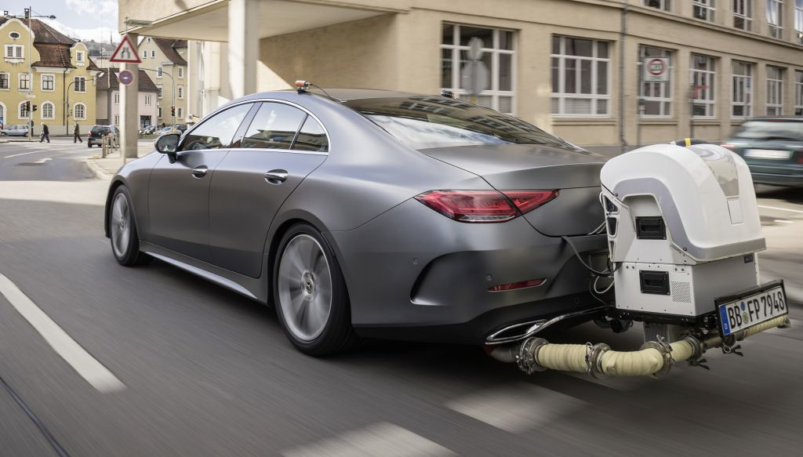
StarCarSifu, 2018. Mercedes Benz Under Real Driving Conditions. [image] [Accessed 4 February 2020].

Contents:

Section 1.0

1.1 Introduction………………………………………………………………………………………………………………... (Page 4)
Section 2.0
2.1 Catalytic Converter Efficiency………………………………………………………………………………………. (Page 5-7)
2.2 EVAP systems in the control of overall vehicle emissions. …………………………………………...... (Page 8)
2.3 ‘EGR on’ and ‘EGR off’ and the control of NOx emissions…………………………………………….(Page 9-10)
2.4 ‘SAIR on’ and ‘SAIR off’ and its various modes of operation…………………………………………… (Page 10)
2.5 PCV on internal combustion engines and fault diagnosis…………………………………………..... (Page 11)
2.6 Air/fuel ratio and its effect on the overall emissions of a vehicle.………………………......(Page 12-13)
2.7 Euro 6.……………………………………………………………………………………………………………………. (Page 13-15)

Section 3.0

3.1 Conclusion……………………………………………………………………………………………………………….. (Page 15-17)

Section 4.0

4.1 References…………………………………………………………………………………………………………….... (Page 17-19)

(Table 1) Abbreviations

EVAP | Evaporative Emission Control System.
EGR | Exhaust Gas Recirculation
NOX | Oxides of Nitrogen (NO and N₂)
SAIR | Secondary Air Injection
PCV | Positive Crankcase Pressure
ECU | Engine Control Unit
OBD | Onboard Diagnostics
MAP | Manifold Absolute Pressure
PM | Particle Matter
DPFE | Delta Pressure Feedback
GDI | Gasoline Direct Injection
ZLEV | Zero Low Emission Vehicles

List of Figs /Tables
Fig 1. Catalytic convertor.
Fig 2. EVAP System
Fig 3. EGR System
Fig 4. SAIR System.

Fig 5. PCV system.

Table 1. Abbreviations.
Table 2. Simultaneous functions of a 3-way catalytic convertor.
Table 3. SAIRS Modes of operation.
Table 4. Brief introduction of Euro emission standards.

Section 1.0

Introduction

Carbon dioxide, Nitrous oxide, Methane and other gas emissions have increased global temperature by nearly double in the last 50 years and have contributed to the geological consequences that are now affecting the environment of our planet.
The emission of hydrocarbons into the atmosphere is one of the main pollutants that breaks down the ozone layer. Similarly, high NO_{x} levels in vehicle emissions has a direct toxic effect on humans during inhalation and impacts on the atmosphere as it forms acid rain and other undesired compounds.
Since 1992 the EU has introduced six vehicle emission legislations; categorised Euro 1 to Euro 6 where the limits of HC, CO, NO_{x} and PM emission been lowered continuously. In addition, Frost & Sullivan confirm that the world's leading economies have developed a wide range of instruments and systems aimed at reducing emissions and lessening their dependence on oil imports. Tighter regulations, harsher penalties, and subsidies for R&D continually drive manufacturers to develop more fuel-efficient vehicles. Creating new engine control systems that offer a reduction in emissions without compromising efficiency and performance. The introduction of catalytic converters, EVAP, EGR, and SAIR matched with enhanced engine management has reduced vehicle emissions to very low levels. Since the initial Euro 1 emission standards were released in 1992, 96% of vehicle emissions have been reduced. Consideration of these emissions and combustion control systems will be covered in this report together with their functionality, fault diagnosis and emission legislation.
Dontu, Y., 2015. Changes in Automobile Control System to Accommodate EURO 6 Emission Standards. [online] [Accessed 4 Feb 2020]. ¹

Section 2.0

2.1 Catalytic Convertor Efficiency.
An efficient catalytic converter is a critical component of the vehicles emission control system. The exhaust gases are passed through heated channels covered by a catalyst material of rhodium, palladium and platinum. The ‘honeycombed’ channels of palladium accelerate the oxidation of hydrocarbons and carbon monoxide whilst the rhodium reduces the level of nitrogen oxide. Unburned nitric oxides, hydrocarbons and carbon monoxide are converted into carbon dioxide, nitrogen and water.

Table 2. Simultaneous functions of a three-way catalytic convertor.
1 | Reduction of nitrogen oxides into elements of nitrogen and oxygen. | NOx→Nx+Ox (1)(1) NOx→Nx+Ox
2 | Oxidation of carbon monoxide into carbon dioxide. | CO+O2→CO2 (2)(2) CO+O2→CO2
3 | Oxidation of hydrocarbons into carbon dioxide and water: | CxH4x+2xO2→xCO2+2xH2O (3)

Source- 2019. Catalytic Converters. [online] Accessed 5 February 2020].
A reduction in their efficiency can be caused by over rich fuel/air mixtures where the excessive heat erodes the inner surface, eventually melting the ceramic substrate. Contamination from engine oil from an over-filled sump, coolant or foreign substances block the channels and reduce the catalyst process.

Know Your Parts. n.d. Catalytic Converter Efficiency | Know Your Parts. [online] [Accessed 5 February 2020].²

The efficiency of a catalytic convertor can be evaluated by carrying out the following tests.
An audible test where an initial gentle tap or knock to the outer wall of the converter with a soft mallet or rubber hammer would identify any rattles of the loose internal ‘honeycomb’ substrates. This signifies a failure of the internals and a need for it to be replaced.
A pressure test would involve using a vacuum gauge to measure back pressure at the lambda probe sensor or EGR positions. Correct back pressure readings should be below 1.5psi at idling speed and below 2.5psi when the engine revs are increased to 2500 rpm. Any drop or reduction in vacuum signifies a blockage or restriction which would affect the efficiency of the unit. (Bosch Technical)¹⁰
A measurement of the temperature difference between the inlet and outlet pipes of the unit. With the engine revving at 2500 rpm for a period of two minutes an infrared pyrometer would be used to measure the temperature of the gases entering and exiting the converter. A correctly functioning unit should show a temperature difference of at least 10%.
A gas analysis test of the O₂ and CO levels. Where a test pipe connected to a gas analyser is inserted into the exhaust of a warm engine. A fully functioning unit should show a reading of below 1.2%. High readings of above 1.2% would show a total failure of the converter whilst a reading of 1.2% signifies that the unit is not fully efficient.
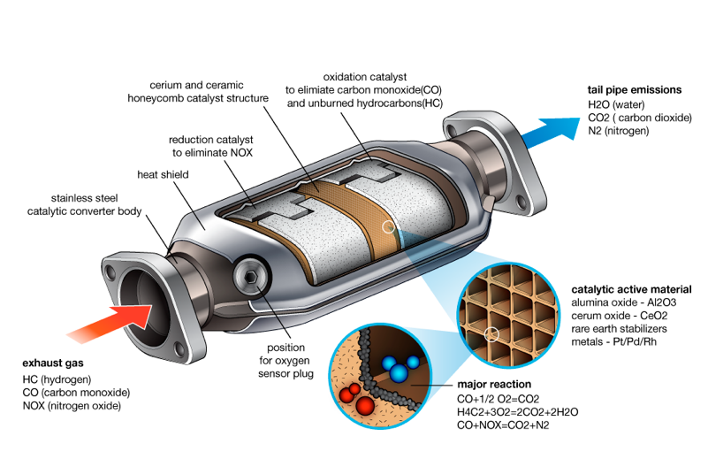
Fig 1. Catalytic convertor cross sectional view

2020. Detailed Image of Catalytic Converter. [image] [Accessed 7 February 2020].

Catalytic converters operate in conjunction with an engine’s management system which controls the fuel injection requirements and constantly monitors the engine’s emissions before entering the catalytic converter. The efficiency is monitored by an oxygen sensor or Lambda probe situated prior to the converter or ‘pre-cat’. This sensor sends signals to the management system to determine the ratio of fuel/air required to deliver the correct amount of oxygen to burn off excess hydrocarbons during the oxidation catalyst stage. A second oxygen sensor is located immediately after the converter or ‘post-cat’ to measure harmful emissions and the information is signal matched to readings from the first sensor.
The converter’s efficiency is dependent on heat and the optimum operating temperatures range from 300 degrees Celsius to 800 degrees Celsius. Prior to reaching this range a cold converter will not prove to be efficient, resulting in higher levels of harmful emissions. Manufacturers overcome this by close coupling the converter to the exhaust manifold, adjusting the ignition timing and raising the engine idle speed which increases the flow of exhaust gas. Although this can lead to premature thermal ageing. (Bosch 2020)
The optimum efficiency of a catalytic converter occurs when the ratio of 14.66 kgs of air to one kg of fuel is attained in the fuel/air mixture and is completely combusted. This ratio cannot generally be achieved in an engine without corrective intervention by the engine management. Excessive fuelling produces excessive carbon monoxide and hydrocarbons and excessive oxygen generates an excess level of nitrogen oxides. The converter works by after-burning theses emissions. According to Bosch, a 90-percent reduction in harmful exhaust emissions can only be achieved if the oxygen sensor identifies errant exhaust gas compositions, passes this information to the engine management system and ensures the necessary corrections in the mixture provided. (Bosch 2020)
2014. Lambda Sensors, Catalogue 2014/2015. [eBook] Denso. Available at: <https://www.denso-am.eu/media/102388/dels14-0001.pdf> [Accessed 8 February 2020].³

2.2 EVAP systems in the control of overall vehicle emissions.

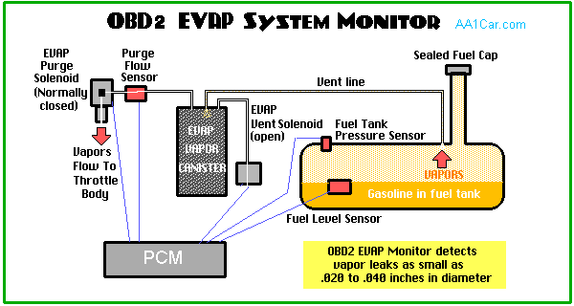Fig 2. EVAP System
AA1Car, 2019. OBD 2 EVAP System Monitor. [image] [Accessed 7 February 2020].

A vehicle’s fuel tank requires venting in order for the air to replace the fuel used. A sealed tank would create negative suction pressure inside and implode. Evaporative emission control or EVAP is a sealed fuel system that allows the tank to vent whilst preventing the escape of harmful vapours into the atmosphere.
The system comprises the liquid-vapour separator, fuel tank, fuel cap, and the EVAP charcoal canister. Fuel vapours are vented in pipes from the tank and fuel system and routed to the EVAP storage canister where they are safely stored until the engine is started. When the vehicle is next used and the engine reaches working temperature, the system opens the purge valve which allows the vapours to be siphoned from the canister into the intake manifold for combustion. The fumes recirculated by the EVAP are combustible.
Carley, L., 2019. EVAP Evaporative Emission Control System. [online] [Accessed 10 February 2020]. ⁴

Since 1996 and the introduction of OBD2 regulation requirements, EVAP systems are monitored and controlled by OBD2 monitors. Usually running when the fuel tank is between 15% to 80% full and once per drive cycle. The system verifies that there is airflow from the storage canister to the engine and that there are no leaks in the fuel system. A ‘purge flow sensor’ is able to detect leaks from 0.5mm diameter by analysing the differences in pressure between the EVAP system and atmospheric pressure. (Bosch Technical 2014)¹⁰
EVAP plays an important role in reducing the number of hydrocarbons entering the atmosphere and affecting the ozone layer. Fuel vapour evaporates easily and contains a variety of hydrocarbons. When released to the atmosphere, elements such as aromatics, aldehydes, higher paraffins and olefins react with air and light to create smog. An unsealed fuel system results in constant pollution through uncontrolled evaporation which can account for as much as 20 percent of the pollution produced by a motor vehicle. (Bosch Technical 2014)¹⁰
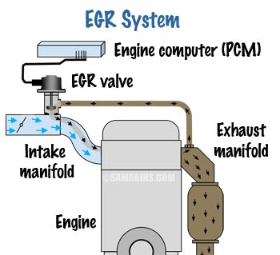2.3 ‘EGR on’ and ‘EGR off’ and the control of NOx emissions.

Fig 3. EGR System.
n.d. EGR System. [image] [Accessed 12 February 2020].

High combustion temperatures of 1600º significantly increase the formation of NO_{x} and can lead to engine damage caused by premature detonation or pre-ignition. Monitored by the manifold absolute pressure sensor, coolant temperature, mass air flow and the air/fuel ratio sensors the EGR system diverts a proportion ranging from 6 to 10% of the exhaust gases into the intake manifold. Controlled by the ECU and the valves that may be digital or vacuum actuated. Normally closed at idling speed or under load/acceleration and opened during moderate normal mid-range cruising speed.
Samarins.com. 2019. How Exhaust Gas Recirculation (EGR) System Works. [online]⁵

EGR systems are primarily fitted to diesel engines to reduce NOx levels resulting from a reduced velocity in combustion and lower cylinder temperatures. On petrol engines, in addition to reducing NO_{x} levels, EGR systems are fitted to improve power, efficiency and fuel consumption. Greater ignition advance settings result in earlier ignition without detonation and an improvement in fuel consumption is gained by reducing the amount of fuel-enrichment required at full load. The recirculated and cooled air from the EGR maintains lower operating turbo and catalytic converter temperatures.
(Bosch, 2014).¹⁰
The EGR valve is ‘off’ or closed when the engine is cold and at idle speed to lessen the cooling effect and to achieve working temperature as soon as possible. It is also closed at full throttle opening in order to attain optimum fuel/air mix for maximum power. Once the engine attains normal temperature the valve is partially open at slightly above idling and fully opened or ‘on’ at mid throttle to reduce emissions. The EGR is integral to the management system and avoids ‘negative’ performance aspects of EGR by programming advanced ignition timing and decreased fuel injection duration during high flow periods.

Vikas, G. and Madhu, D., 2017. DESIGN AND CFD ANALYSIS OF EXHAUST GAS RECIRCULATION HOUSING. [online] [Accessed 17 February 2020].⁶
An engine running with the EGR constantly ‘off’ or closed would suffer from detonation or ‘knock’, a higher operating temperature and high levels of NO_{x.} Should the EGR remain ‘on’ or constantly open the recirculated emission would result in poor running, rough idling and poor response as the exhaust gases recirculated by the EGR are not combustible.

2.4 ‘SAIR on’ and ‘SAIR off’ and its various modes of operation.
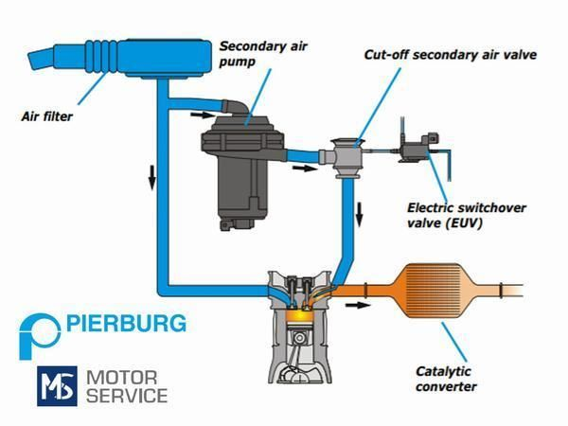

Fig 4. SAIR system
Liberal Dictionary, n.d. Secondary Air Injection. [image] [Accessed 8 February 2020].

Over 80 per cent of a car's driving cycle emissions are typically produced by a cold engine. Rich cold start mixtures cause excessive hydrocarbon and carbon monoxide emissions - both of which are a result of incomplete combustion. Catalytic converters do not become effective until they reach temperatures of around 300 degrees Celsius. This, in conjunction with the rich mixtures, causes high emissions in the initial phase of the driving cycle. (Pierberg 2018) Converters work effectively between approximatley 300°C – 350°C. To achieve lower emissions of HC and CO NO_{x} during the cold start and warm up phases, the secondary air system or SAIR injects cold air into the exhaust flow in the catalytic converter or exhaust manifold. The process assists the catalytic converter to oxidise elements of HC and CO into H₂O and CO₂ and the efficient operating temperature is reached sooner due to the heat generated by the reaction.
HELLA. n.d. Secondary Air Injection System: Faults & Overview | HELLA | HELLA. [online] Accessed 12 February 2020].⁷

SAIR can be passive or active. A passive system uses fluctuations in exhaust system pressure and flow speed to deliver additional air via a timed valve. An active system is managed by the ECU where an electric pump is coupled to a control valve, control relay and a combination relay. The ECU manages the pump while the vacuum from the air intake system signals the combination valve. SAIRS switches off after a period of approximately 100 secs once the lambda probe becomes active.
Table 3. SAIRS Modes of operation.

Engine temp | SAIRS | Air/fuel state | Emissions
Cold | On | Stoichiometric | HC and CO NO_{x}
Hot (300ºC+) | Off | Exothermic | Lower levels of HC and CO NO_{x}  and CO2 and H2O

2.5 PCV on internal combustion engines and fault diagnosis.
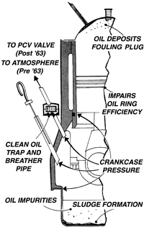FIG 5. PCV system.

During combustion, small amounts of unburnt fuel and vapours can escape past the piston rings into the crank case. Prior to 1963, internal combustion engines vented these vapours directly to the road surface or atmosphere, causing damage to the ozone layer. Increasing environmental pressures brought the introduction of Positive Crankshaft Ventilation or PCV.
n.d. POSITIVE CRANKSHAFT VENTILATION (PCV). [image] [Accessed 14 February 2020].

The higher combustion and oil pressures combined with the higher speeds of modern engines have dictated the demand for effective and reliable crankcase ventilation systems. Regulated by a PCV valve, the crankcase vapours are drawn up into the inlet manifold and burned in the combustion chambers along with the fuel/air mixture. Important aspects of an efficient intake system are a clean air filter, a well-designed inlet manifold and good ‘engine breathing’ where a PCV valve regulates gas evacuation without disruption to the air/fuel mix.
A faulty or blocked valve would result in excessive crankcase pressure causing misfire at idle, poor starting and rough running. Negatively impacting the efficiency of the engine and leading to MOT test failure. The adverse effect on the air/fuel mix would cause poor starting and rough running/idling. A weakened fuel mix would cause pre-ignition, detonation, ‘running on’, black exhaust smoke and power loss. The excess pressure would also cause the oil/air mix to force its way out through the dip stick tube, filler cap, oil seals or cam cover gaskets.
The decreased efficiency of the oil-control rings would result in an increase in oil consumption and a build-up of water vapour and ‘sludge’ in the oil sump, leading to premature engine wear. (Burton 2020)¹⁵
Initial diagnosis of a faulty PCV system would be excessive white or black smoke from the exhaust, ‘rough running’, oil/vapour leaks from the valve, hoses, dipstick or filler cap and a lit dashboard warning light. Further diagnosis of a faulty PCV system, especially on earlier pre-2004 engines would include checking the crankcase vacuum. A small card could be positioned over the oil cap and a vacuum tube used to measure vacuum at the dipstick. A lack of vacuum or a ‘popping’ or ‘pulsing’ pattern of fumes would confirm a blocked valve. On later post-2004 engines the OBD monitors signals from the pressure sensor and diagnoses fuel trim characteristics such as pre-ignition. Gibson, A., 2020. Lecture 5 PCV/SAI.⁸

2.6 Air/fuel ratio and its effect on the overall emissions of a vehicle.
The operation of a four-stroke spark ignition engine permits the controlled combustion of petrol to provide power. Where a mixture of aromatic hydrocarbons and paraffin is combusted with controlled amounts air, producing complete combustion products of CO_{2 and} H2O:
Hydrocarbons in gasoline + O₂ » CO₂ + H₂O + Heat. (Heck, Farrauto and Gulati)
Together with some incomplete combustion products of CO and unburned hydrocarbons UHCs. The amount of pollutants varies with the many operating conditions of the engine but is mainly influenced by the air/fuel ration in the combustion chamber. The term used to describe the air/fuel weight ratio is the Lambda ratio (λ). The air/fuel mix has a direct impact on both the operational efficiency and the emissions created after combustion. According to Heck, Farrauto and Gulati the precise amount of air required to oxidize all of the fuel and gasoline is approximately 14.7:1. Based on 14.7 parts of air required to burn 1kg of fuel.

Fig 8. The effects of air/fuel ratio on gasoline vehicle emissions.
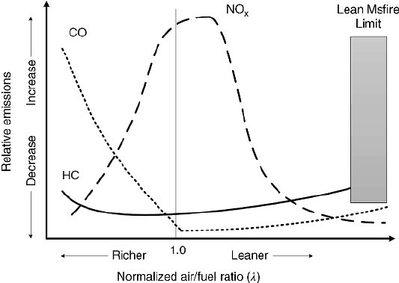

The graph demonstrates the consequences of varying air/fuel mixtures on a gasoline engine. The X axis shows Normalised fuel ratio or lambda ratio whilst the Y axis shows the decrease and increase in relative emissions.

Farrauto, R., Gulati, S. and Heck, R., 2013. [Image] Catalytic Air Pollution Control. 3rd ed. Hoboken, N.J.: Wiley.

Initially, during a rich mixture the hydrocarbon and carbon monoxide values are high and decrease when the mixture is slightly leaner than stoichiometric point 1. In contrast, an increase in the nitrogen oxide levels occurs as the mixture gets leaner, peaking after stoichiometric point 1 then gradually reducing as the mixture weakens.
To summarise, according to Heck, Farrauto and Gulati, when an engine is operated rich of stoichiometric, CO and HC emissions are at their highest. Complete burning of the fuel is prevented by the deficiency in O_{2.} Whereas NO_{x} emissions are depressed because the adiabatic flame temperature is reduced. On the lean side, HC and CO levels are initially reduced since nearly complete combustion dominates, before increasing back to earlier ‘richer’ levels. Just lean of stoichiometric point 1, the NO_{x} is at maximum since the adiabatic flame temperature is at the highest level that can be achieved. When HC and CO are higher in a leaner mix, only two of the three ‘ways’ of the catalytic converter actually function which raises the need for an additional process/system to reduce the level of NO_{x} emissions.
(Catalytic Air Pollution Control. Heck, Farrauto, Gulati)⁹

2.7 Euro 6.

Since Euro 1 emission standards were released in 1992, 96% of vehicle emissions have been reduced.
Table 4. Brief introduction of Euro 1 – 6 emission standards.
Euro | Date of intro | Aims / Actions.
1 | July 1992 | Reduction in CO emissions by the universal fitting of catalytic converters and the switch to unleaded petrol.
2 | Jan 1996 | Reducing the limit of CO emissions and the combined limit for unburned HC and NO_{x} for both diesel and petrol vehicles.
3 | Jan 2000 | Elimination of the engine warm up period in test procedure. Addition of a separate NO_{x} limit for diesel and HC and NO_{x} limits for petrol engines.
4 | Jan  2005 | Reduction of particulate matter (PM) and NO_{x.} Introduction of emissions from diesel cars.
5 | Sep  2009 | Reduction in limits of PM emissions from diesel engines and the need for particulate filters to meet new requirements. Lowering NO_{x} Limits (a 28% reduction to Euro 4) . New particulate limits for direct-injection petrol engines. Reducing the effects of very fine particle emissions through introducing a limit on particle numbers for diesel engines in addition to the particle weight limit. Applying to new vehicle ‘type approvals’ from Sep 2011 and to all new diesel vehicles from Jan 2013.
6 | Sep  2014 | Reduction of 67% in the permitted level of NOx from 0.18g/km (in Euro 5) to 0.08g/km.  Euro 6 diesel cars may be fitted with NOx absorber (lean NOx trap), Selective Catalytic Reduction (SCR) using an additive containing urea injected into exhaust to convert NOx into water and the use of Cerium injected into the fuel tank during refuelling to assist DPF regeneration by lowering the required temperature needed for regeneration.

(AA. Dec 2017)

Euro 6 caters for Petrol and Diesel vehicles differently, reflecting in how they produce different pollutants.
Euro 6 emission standards were introduced in 2014 primarily to reduce diesel engine NOx emissions. The differences for petrol engines from Euro 5 included a lower PM or particle matter standards for GDI direct injection engines.

Table 5. Comparison of Euro 2, 3 and 6.
 | Euro 2 emission limits (petrol)  EC96 | Euro 3 emission limits (petrol)  EC2000 | Euro 6 emission limits (petrol)
CO | 2.2 g/km | 2.3 g/km | 1.0 g/km
HC | 0.5 g/km | 0.20 g/km | 0.10 g/km
NOx | 0.5 g/km | 0.15 | 0.06 g/km
PM | No limit | No limit | 0.005 g/km (direct inj) only)
PM | - | - | 6.0x10 ^11/km (in-direct inj)
(AA. Dec 2017)
When considering the Euro 2/3 engine, the changes necessary to bring it into Euro 6 category would involve a reduction of CO levels from 2.3g/km to 1.0g/km, HC levels from 0.5g/km to 0.10 g/km and NO_{x} levels from 0.5g/km to 0.06g/km. Lower emission levels could be achieved with the addition of SAIR and the fitting of a more modern and efficient catalytic converter. The fitting of an EGR system would improve power, efficiency and fuel consumption. An upgrade to the fuel delivery system would improve the ratio of air/fuel mix improving the operational efficiency and reducing the emissions created after combustion.
Older engines have limited monitoring of emission control systems and therefore any faults may not be apparent until interrogation or ‘fault code retrieval’ by a diagnostic code reader or MOT testing takes place. The Euro 2/3 engine is fitted with a catalytic converter and one lambda or oxygen sensor. Euro 6 compliance would require a second additional ‘post-cat’ lambda to be fitted immediately after the converter. (Hella)⁷
For Euro 5/6 compatibility, OBD2 is required where the on-board monitoring system can immediately detect any faults with the emissions and activate a dashboard warning light. This ensures that the emissions are kept under control within statutory requirements. Although the Euro 2/3 engine is equipped with an EVAP system, its functionality is not monitored. Any failure would result in fuel vapours containing a variety of hydrocarbons being released to the atmosphere and react with the air and light to create smog.
Euro 6 compliance would necessitate a monitoring system controlled by the OBD2. Which would detect leaks from the storage canister or return pipes and signal a warning light on the dashboard and store a fault code within the memory. (Delphi 2016)¹¹
The implication of these changes to the vehicle function and to society as a whole would be substantial. To satisfy Euro 6 requirements, the OBD2 system monitors the engine performance and aftertreatment components responsible for the control of harmful pollutant emissions. The system detects malfunctions that could lead to harmful levels of emissions. The system ensures the correct operation of the emission control equipment, alerting the driver and prompting the need for attention, so that vehicles are properly maintained and meet emissions limits during the whole of lifetime use. (ICCT 2016)¹²

Section 3.0

Conclusion

“Today’s cars have become more sustainable, capable and more exciting than ever before.”

Where the ‘epicentre of transformation’ lies within the opportunities surrounding automated and autonomous vehicles. (Mary Barra, CEO GM. 2016.) Real time software updates on future mass-produced autonomous vehicles will interface with driving conditions, traffic volume and car-sharing. Emissions will decrease as a result of powertrain electrification and the UK Government’s new target announced in Feb 2020 to ban the sale of diesel, petrol and even hybrid cars by 2035.
The ever-increasing amount of harmful emissions made by vehicles has resulted in a serious concern for the toxic effect on humans during inhalation and the need to establish increasingly stringent standards. Euro emission standards has and remains to ‘drive’ manufacturers to seek and develop new control systems to lower emissions without compromising performance and efficiency. It was interesting to discover that the few enhancements required to upgrade the older Euro 2/3 ‘Motronic’ engine to Euro 6 specification could be gained by further developing technology that already existed.
Innovation in technology is crucial for the future sustainability of the global automotive industry where current engine and transmission configurations are changing rapidly with hybridization, electrification and downsizing of model line ups. Electrification of powertrains is now the most important strategy of every OEM in achieving the long-term goal of carbon neutral mobility. According to Frost & Sullivan, OEMs have reduced their dependency on diesel and have introduced plug–in and full hybrid models in their petrol powertrain portfolio and hybridization of their diesel counterparts. (Frost & Sullivan)
The UK government’s announcement 4th February 2020 consulting on ending the sale of new petrol, diesel and hybrid cars and vans in 2035 will drive change at an even faster rate. Pushing manufactures further to find enhance or find other alternatives. (Gov.UK)¹³. Although there is currently no confirmed date nor commitment that the next official stage ‘Euro 7’ standard will be introduced, in April 2019 the European Parliament adopted Reg (EU) 2019/632. Setting CO₂ emission performance standards for new vehicles from 2025. Focusing on ‘real world’ CO₂, emission/energy consumption values, deployment of ZLEV, recharging/refuelling infrastructure, synthetic/advanced alternative fuels production and emission reductions. Phased from 2020 and running from 2021 when the EU fleet-wide average emission target for new cars will be 95 g CO₂/km. (Europa)¹⁴
‘Real time’ systems, software updates, cameras and radar on future mass-produced autonomous vehicles will interface with route planning, driving conditions, traffic volume, car-sharing needs and public transport connectivity. According to Frost & Sullivan’s “Global Autonomous Driving Market Outlook, 2018”, Connected, autonomous, shared, and electric technology or CASE are the central pillars of future mobility systems. Autonomous driving technologies will evolve at a ‘dizzying pace’, and they predict a market in excess of $170 billion by 2030, of which 50% will comprise shared mobility services. They also predict that vehicles will address users transport needs by becoming part of an integrated or ‘connected’ ecosystem that delivers ‘real time’ customised transport solutions. Where shared mobility solutions delivered by autonomous-electric-connected vehicles will offer convenient, cost-effective options compared to conventional single ownership. Frost & Sullivan also state that manufacturers will reinforce the links between electric and autonomous cars by moving towards fully electric powertrains with high-mileage capabilities. Emissions in the long term will further decrease as a result of powertrain electrification and the UK Government’s new target to ban the sale of diesel, petrol and hybrid cars by 2035. Although, this may prove to be counter-intuitive during the short term, as owners might well decide to ‘hold on’ to polluting cars for increasingly longer periods of ownership than normal as new autonomous, electric cars become too expensive for many.
What we may well be witnessing over the next 15 years will be the last stages of life of the combustion engine and the dawn of new era in mobility as we gradually move over to power train electrification and artificial intelligence. This could lead to considerable reduction in harmful emissions will take place, while the industry will temporarily be affected by the ‘knock on’ effects on the current sources of fuel, lubricants and technical support before adopting the new technology. (Frost & Sullivan)

At the time of writing this conclusion the Coronavirus pandemic was escalating and bringing with its serious consequences and risks to the health and lives of many. Many communities and countries going into ‘lock down’ and car manufacturers such as Ferrari and Land Rover Jaguar shutting down production for a temporary period. According to the European Space Agency as the new coronavirus cases resulted in countries going into ‘lock downs’ around the world, the environmental impact could be seen from space. Satellites showed striking reductions in tailpipe emissions from cars and trucks across China and Italy since the outbreak started. According to the ESA, levels of nitrogen dioxide in the atmosphere over China have reduced by 40 per cent.

Columbia University research also found that the air pollution plunged in New York as people stayed at home and traffic was cut by 35% as a result of the coronavirus crisis. Leading to methane levels falling significantly and a 10% drop in the level of carbon monoxide emissions. Researchers stated that the reductions are attributed to lower journeys as people worked from home and a reduction in demand for public transport, therefore significantly reducing the number of vehicles on the road.
As people stayed home, nitrogen dioxide emissions in Italy, particularly the country's northern region, fell dramatically together with reductions in the levels of sulphur dioxide, carbon monoxide and methane. The spread of the Coronavirus disease and the threat to the lives of people is a much more pressing concern and further restrictions and ‘lock downs’ are sure to take place.
In addition to witnessing the serious global consequences leading to the loss of lives, we have also witnessed a significant reduction in vehicle emissions and a realisation of the effect that the internal combustion engine has on our environment and the need to further develop electrification of powertrains.

Section 4.0

4.1 Referencing

Catalytic Air Pollution Control. Farrauto, R., Gulati, S. and Heck, R., 2013. Catalytic Air Pollution Control. 3rd ed. Hoboken, N.J.: Wiley.⁹

Bosch Automotive Handbook Version 9. (Download). By Robert Bosch GmbH.
Emission control and diagnosis legislation. 9th ed. Bosch, R., 2014. Postfach: Robert Bosch GmBH.¹⁰

Catalytic convertor image -
2020. Detailed Image of Catalytic Converter. [image] Available at: <. https://www.cstatic-images.com/original/srvc-gloss/1415725879171.png> [Accessed 7 February 2020].

Functions of a catalytic convertor -
2019. Catalytic Converters. [online] Chemistry Libre Texts. Available at: <https://chem.libretexts.org/Bookshelves/Physical_and_Theoretical_Chemistry_Textbook_Maps/Supplemental_Modules_(Physical_and_Theoretical_Chemistry)/Kinetics/Case_Studies%3A_Kinetics/Catalytic_Converters> [Accessed 5 February 2020].

Catalytic Converter / Lambda Sensors
2014. Lambda Sensors, Catalogue 2014/2015. [ebook] Denso. Available at: <https://www.denso-am.eu/media/102388/dels14-0001.pdf> [Accessed 8 February 2020].³

Bosch Global. n.d. Sensing the Adequate Mixture – The Bosch Lambda Sensor. [online] Available at: <https://www.bosch.com/stories/40-years-of-bosch-lambda-sensor/> [Accessed 10 February 2020].

Carley, L., 2019. EVAP Evaporative Emission Control System. [online] [Accessed 10 February 2020]. ⁴

Know Your Parts. n.d. Catalytic Converter Efficiency | Know Your Parts. [online] [Accessed 5 February 2020].²

SAIRS
My-cardictionary.com. n.d. Secondary Air System | Mein Autolexikon. [online] Available at: <https://www.my-cardictionary.com/cardictionary/products/secondary-air-system.html> [Accessed 14 February 2020].

HELLA. n.d. Secondary Air Injection System: Faults & Overview | HELLA | HELLA. [online] Available at: <https://www.hella.com/techworld/uk/Technical/Car-electronics-and-electrics/Secondary-air-injection-system-3296/> [Accessed 12 February 2020].⁷

Kingston, L., 2018. What Is Secondary Air Injection? PH Explains | Pistonheads. [online] Pistonheads.com. Available at: <https://www.pistonheads.com/news/ph-explains/what-is-secondary-air-injection-ph-explains/38694> [Accessed 16 February 2020].

EGR
Samarins.com. 2019. How Exhaust Gas Recirculation (EGR) System Works. [online] Available at: <https://www.samarins.com/glossary/egr-system.html> [Accessed 16 February 2020].⁵

Vikas, G. and Madhu, D., 2017. DESIGN AND CFD ANALYSIS OF EXHAUST GAS RECIRCULATION HOUSING. [online] Hyderabad: International Journal of Research and Computational Technology. Available at: <http://www.ijrct.org/documents/Vikas-IJRCT-Sept-2017.PDF> [Accessed 17 February 2020].⁶
PCV
n.d. POSITIVE CRANKSHAFT VENTILATION (PCV). [image] Available at: <https://www.burtonpower.com /BurtonPower/TechTips/tt_eng2_diag2.gif> [Accessed 14 February 2020]. ¹⁵

Gibson, A., 2020. Lecture 5 PCV/SAI.⁸
Euro 6
Dontu, Y., 2015. Changes in Automobile Control System to Accommodate EURO 6 Emission Standards. [online] [Accessed 4 Feb 2020]. ¹

Theaa.com. 2017. Euro Emissions Standards | AA. [online] Available at: <https://www.theaa.com/driving-advice/fuels-environment/euro-emissions-standards> [Accessed 20 February 2020].

2020. [ebook] Available at: <http://www.inrets.fr/fileadmin/ur/lte/artemis/road3/method31/Artemis_cycles_r eport_LTE0411.pdf> [Accessed 20 February 2020].

2007. REGULATIONS. [ebook] Available at: <http://eur- lex.europa.eu/LexUriServ/LexUriServ.do?uri=OJ: L: 2007:171:0001:0016: EN:P DF> [Accessed 21 February 2020].

2016. A Technical Summary of Euro 6/VI Vehicle Emission Standards. [ebook] Available at: <https://theicct.org/sites/default/files/publications/ICCT_Euro6-VI_briefing_jun2016.pdf> [Accessed 15 March 2020].¹²

2016. Delphi Innovation Real World. [ebook] Available at: <https://www.delphi.com/sites/default/files/inline-files/delphi-worldwide-emissions-standards-passenger-cars-light-duty-2016-7.pdf> [Accessed 21 Febuary 2020].¹¹

Posada, F. and German, J., 2016. REVIEW OF LDV OBD REQUIREMENTS UNDER THE EUROPEAN, KOREAN AND CALIFORNIAN EMISSION PROGRAMS. [ebook] Available at: <https://theicct.org/sites/default/files/publications/LDV%20OBD%20China%20White%20Paper%20vFinal.pdf> [Accessed 21 February 2020].

Conclusion

GOV.UK. n.d. Consulting on Ending the Sale of New Petrol, Diesel and Hybrid Cars and Vans. [online] Available at: <https://www.gov.uk/government/consultations/consulting-on-ending-the-sale-of-new-petrol-diesel-and-hybrid-cars-and-vans/consulting-on-ending-the-sale-of-new-petrol-diesel-and-hybrid-cars-and-vans> [Accessed 21 February 2020].¹³

Climate Action - European Commission. n.d. Reducing CO2 Emissions from Passenger Cars - Before 2020 - Climate Action - European Commission. [online] Available at:<https://ec.europa.eu/clima/policies/transport/vehicles/cars_en#tab-0-1> [Accessed 21 February 2020].¹⁴
Bartels, M., 2020. Italy’s Coronavirus Response Dramatically Reduces Air Pollution Emissions Satellites Show. [online] Space.com. Available at: <https://www.space.com/italy-coronavirus-outbreak-response-reduces-emissions-satellite-images.html> [Accessed 21 March 2020].

Morrison, R., 2020. Air Pollution In New York City Falls Rapidly As People Stay Home. [online] Mail Online. Available at: <https://www.dailymail.co.uk/sciencetech/article-8129631/Air-pollution-New-York-City-falls-rapidly-people-stay-home-amid-coronavirus-crisis.html> [Accessed 22 March 2020].

