09/12/2024
Pawel Waszak (2417221)
Computer networks & Cyber security
L4 - Introduction to Web and Database Concepts
Assignment 2
Contents
1. Introduction. 1
2. Requirements 1
3. Implementation 2
3. Validation 6
4. Evaluation 8
5. References 13
6. Appendices 14

Introduction.
In this document you will find 6 separate sections that will show the process of the webpage creation. Tools used and techniques for the webpage creation. Tools and techniques for Validation and Evaluation. As well as proof of the work done and the whole code. As well as the references.

Requirements
My webpage is about a car rental business that is solely about 7 / 8 seaters from Chrysler. This website will be promoting my business that is offering a short and long term options for rental. You will be able to get all details about the car and have a look on various options of the van available. Target audience will be business like airport taxis or business in house pool car for bigger companies. As well as individual users in need of a bigger car for long / short term hire.

3. Implementation
Page 1
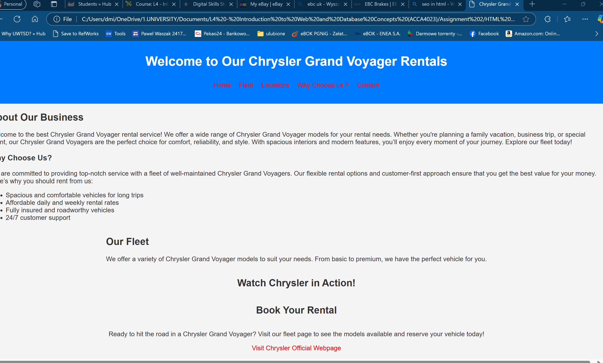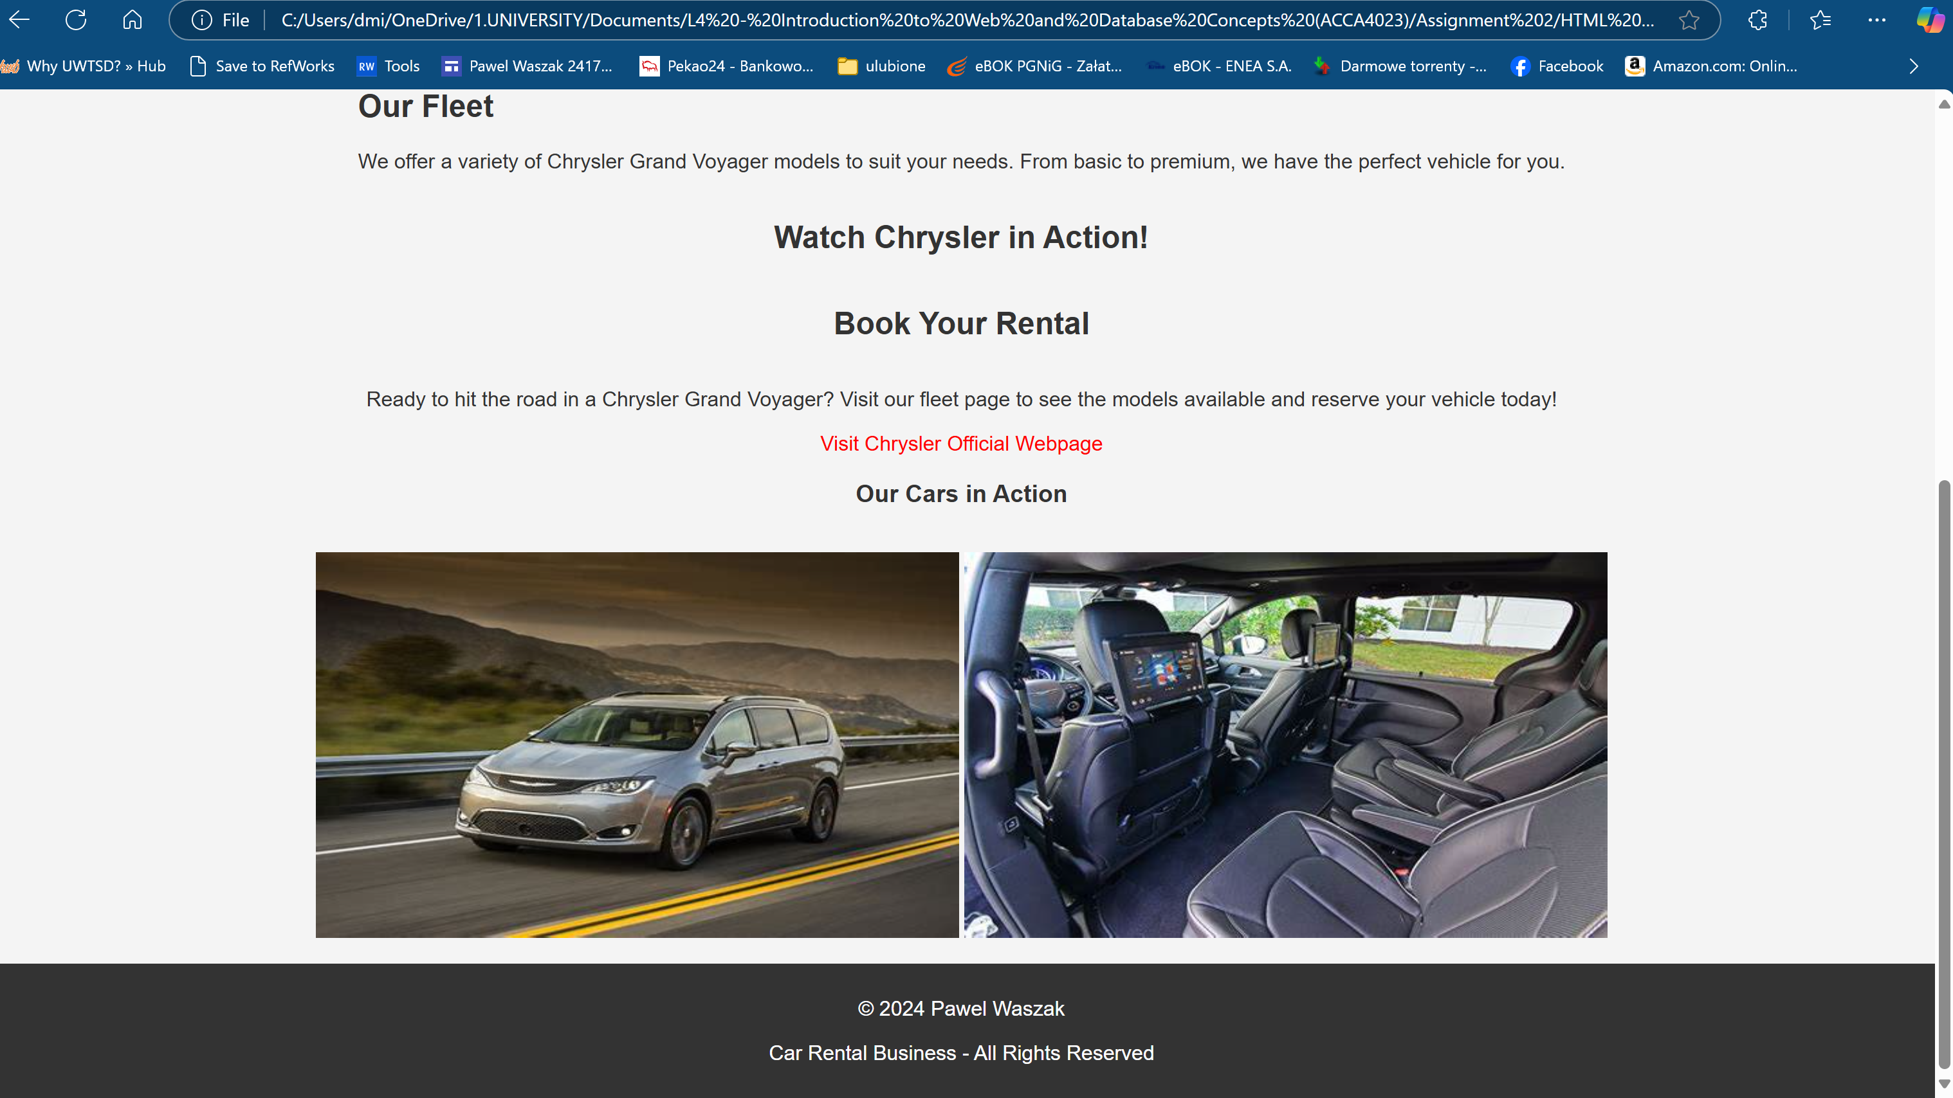

Page 2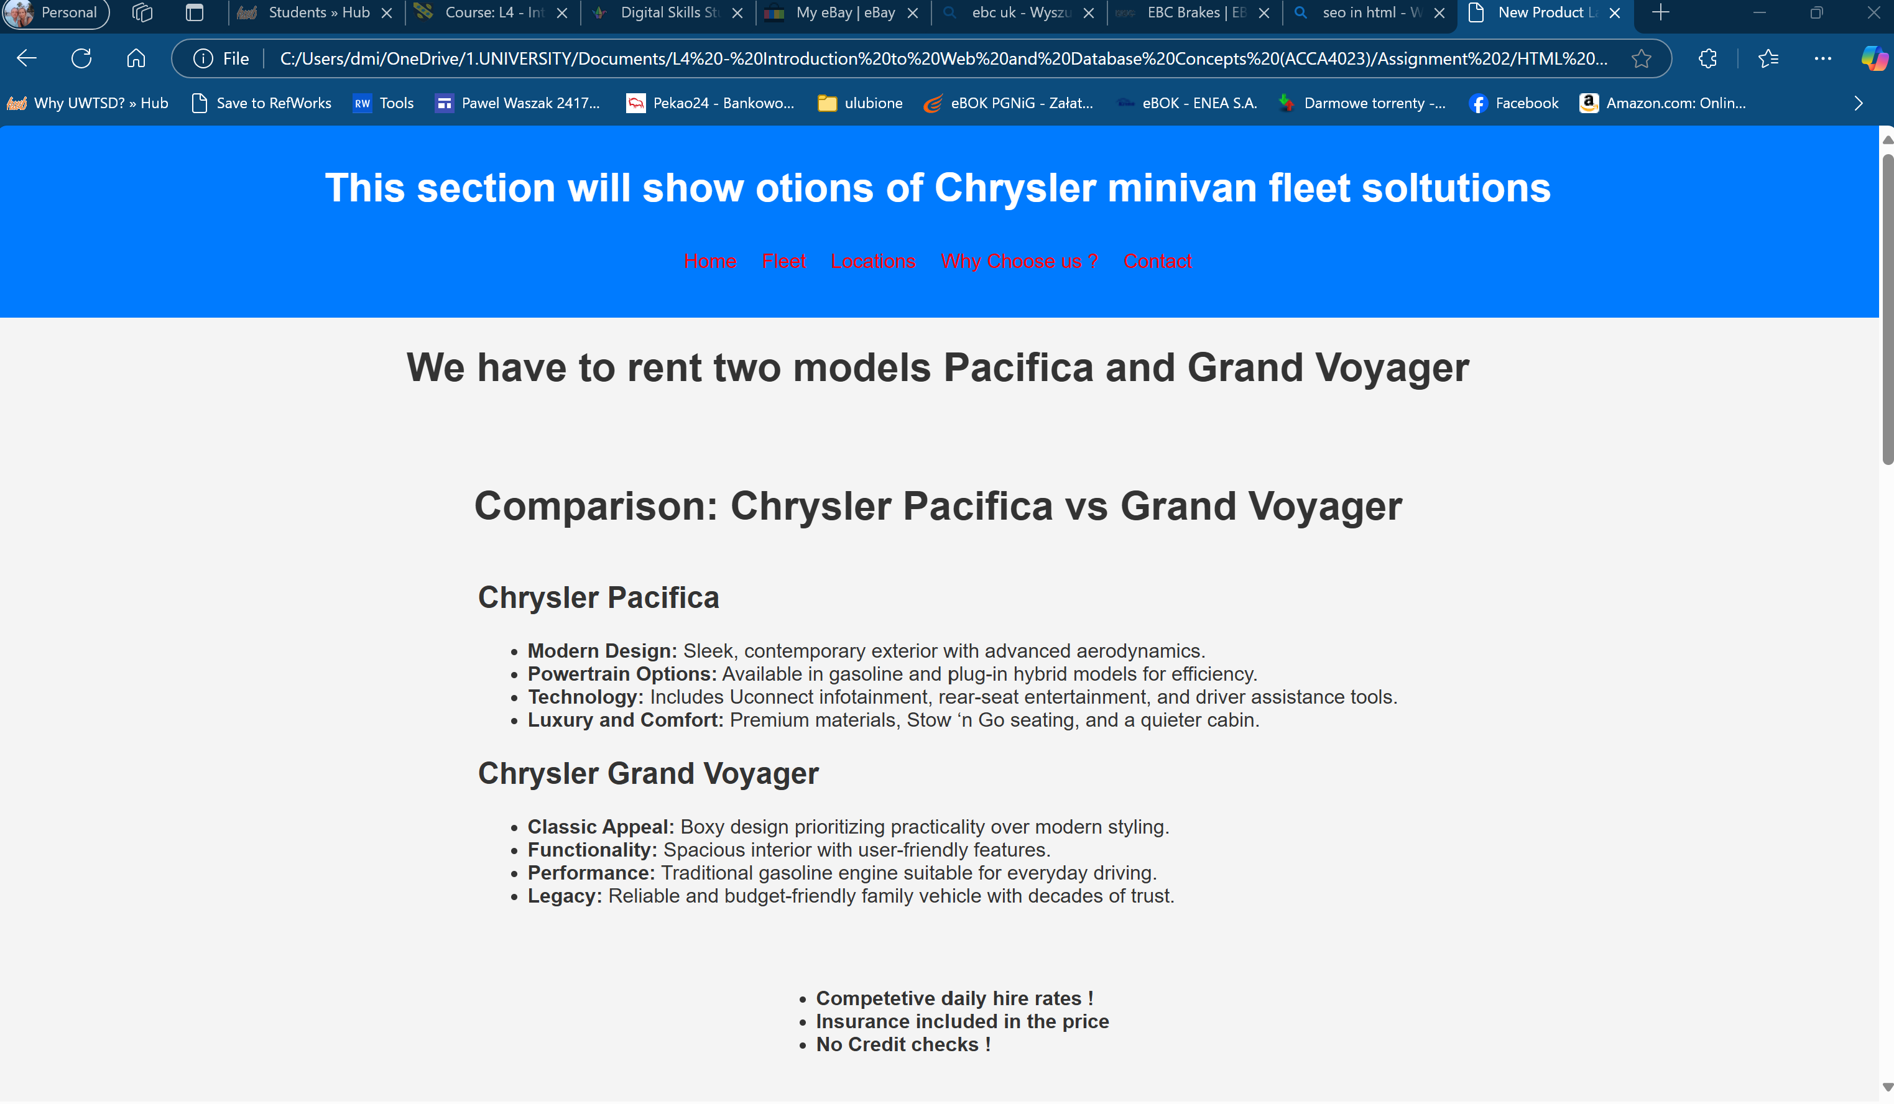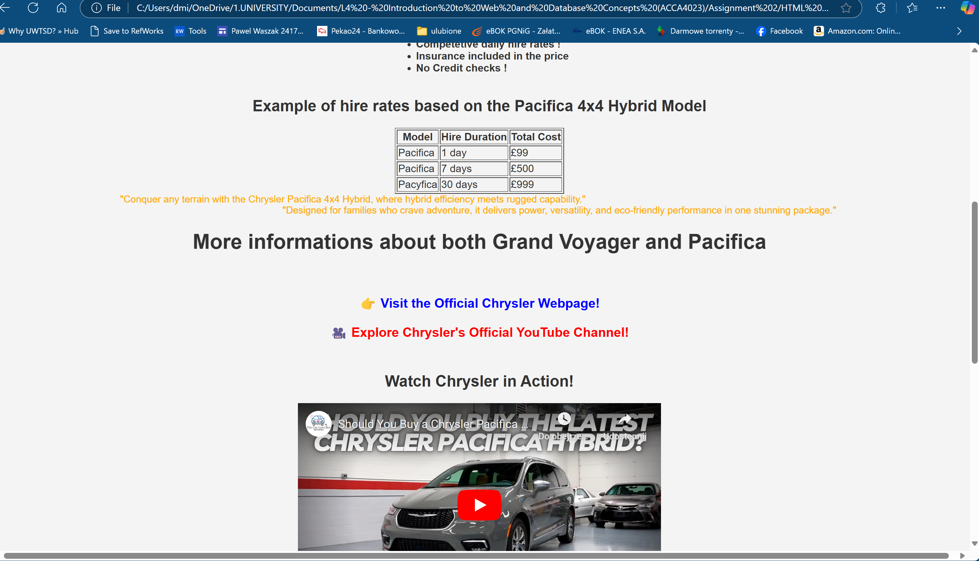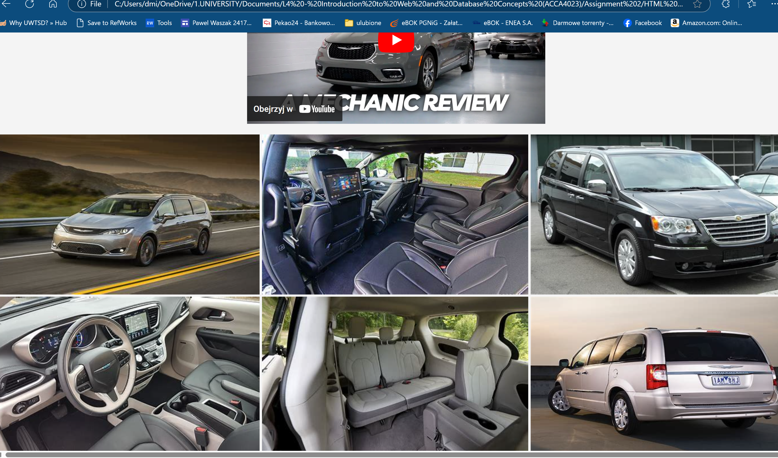

Page 3
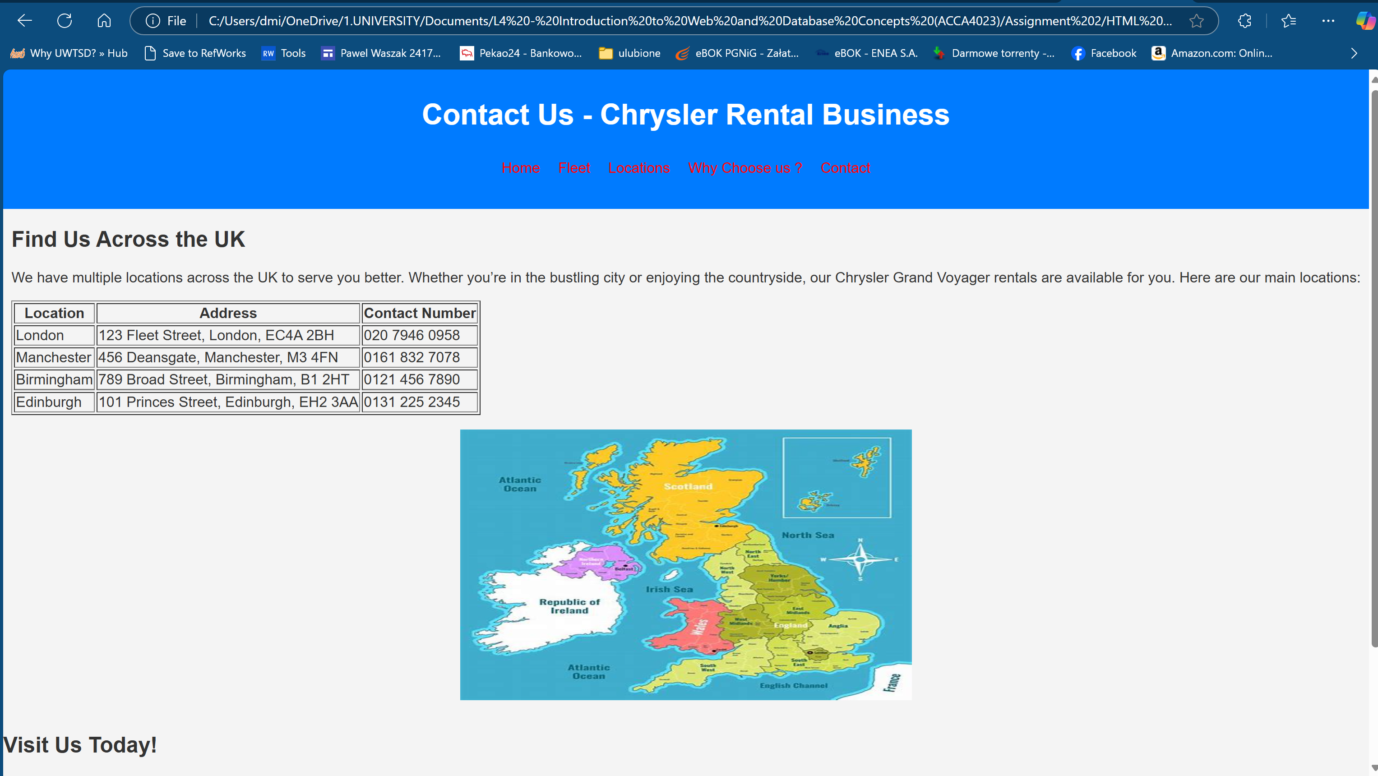
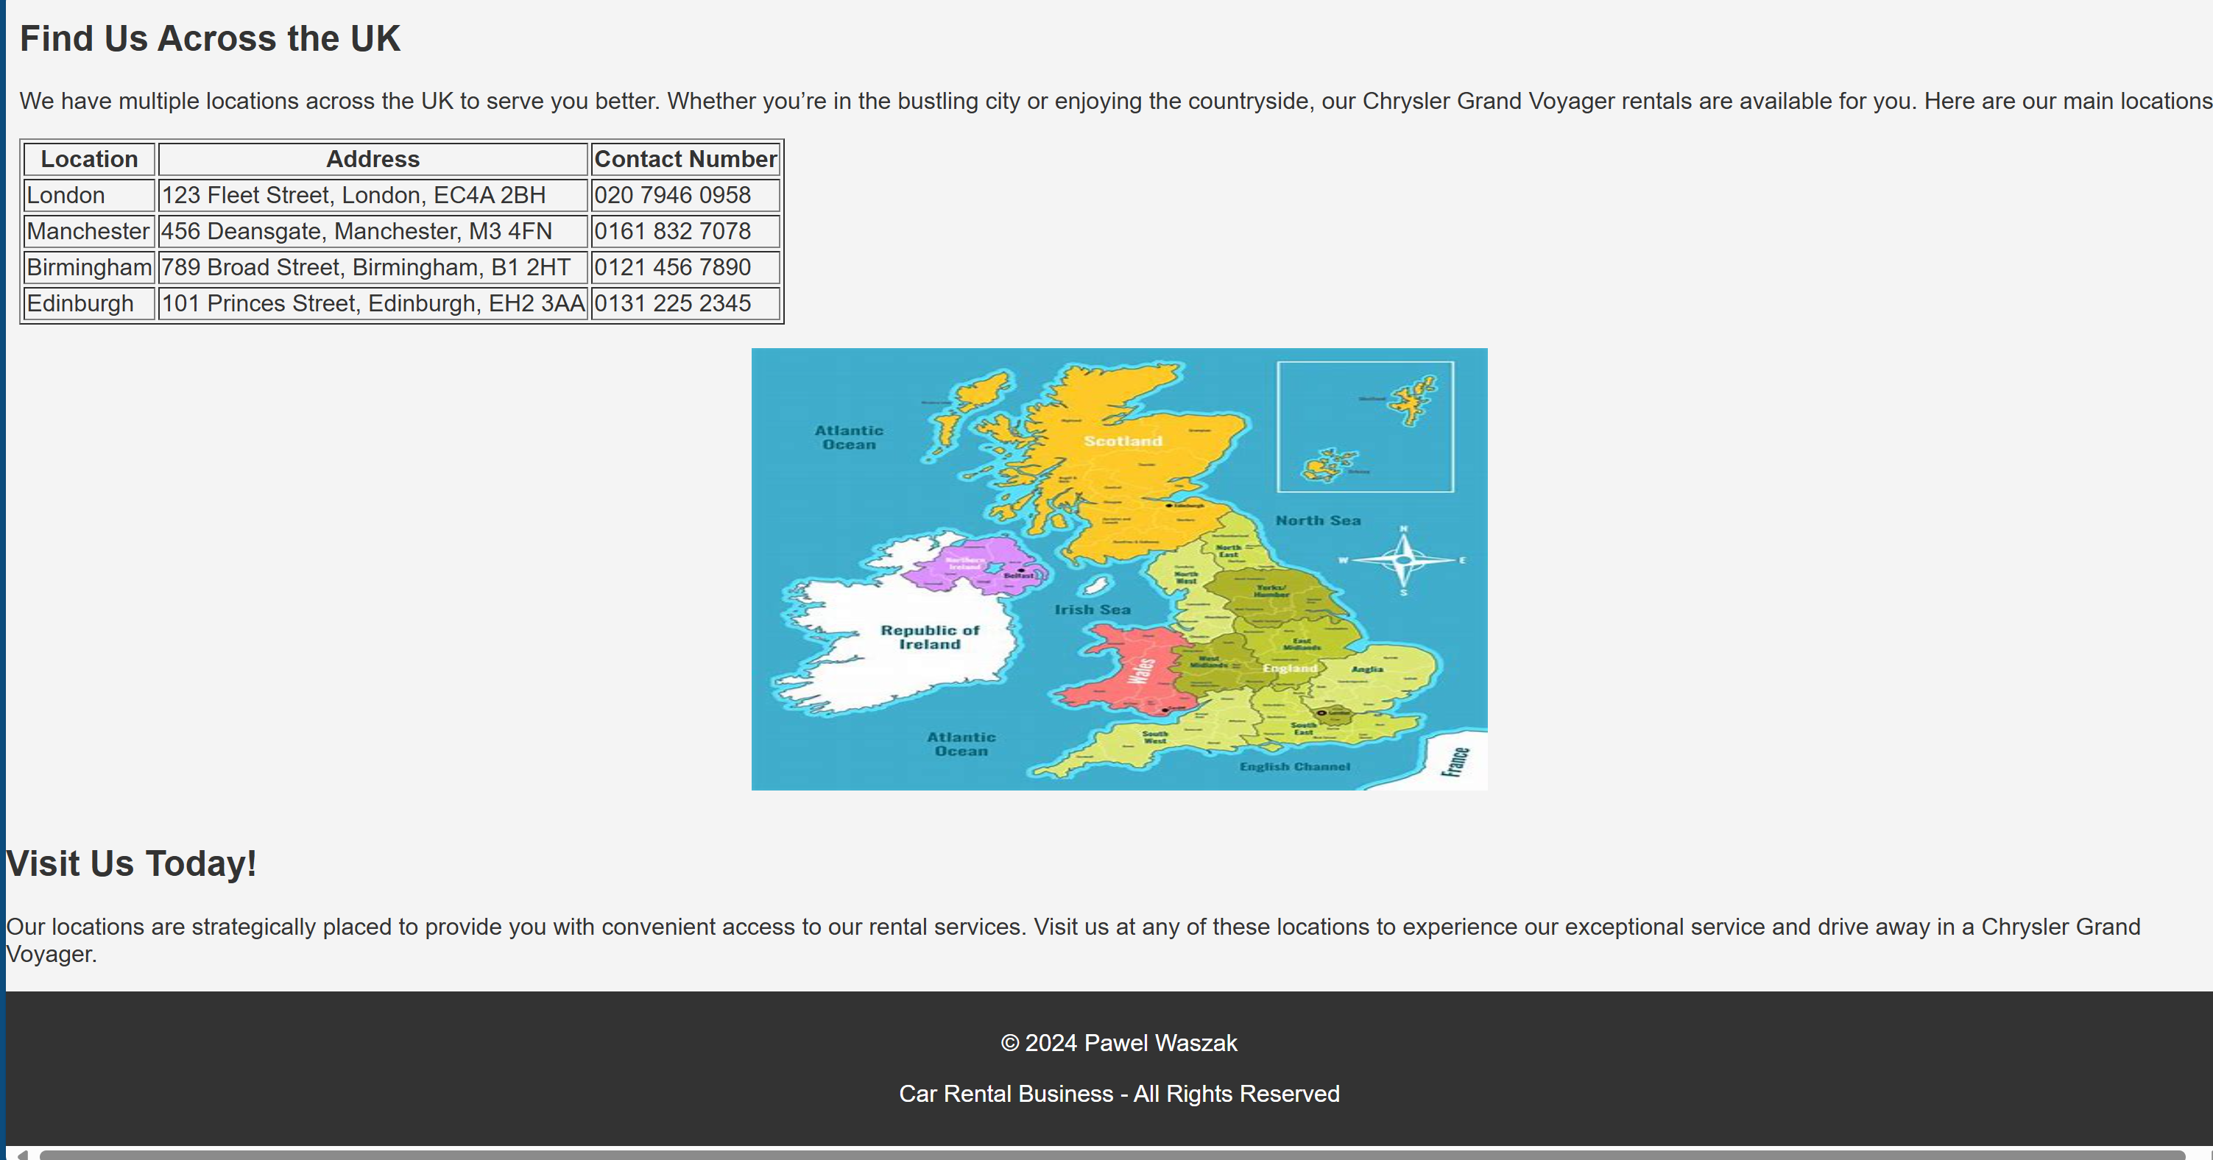

Page 4
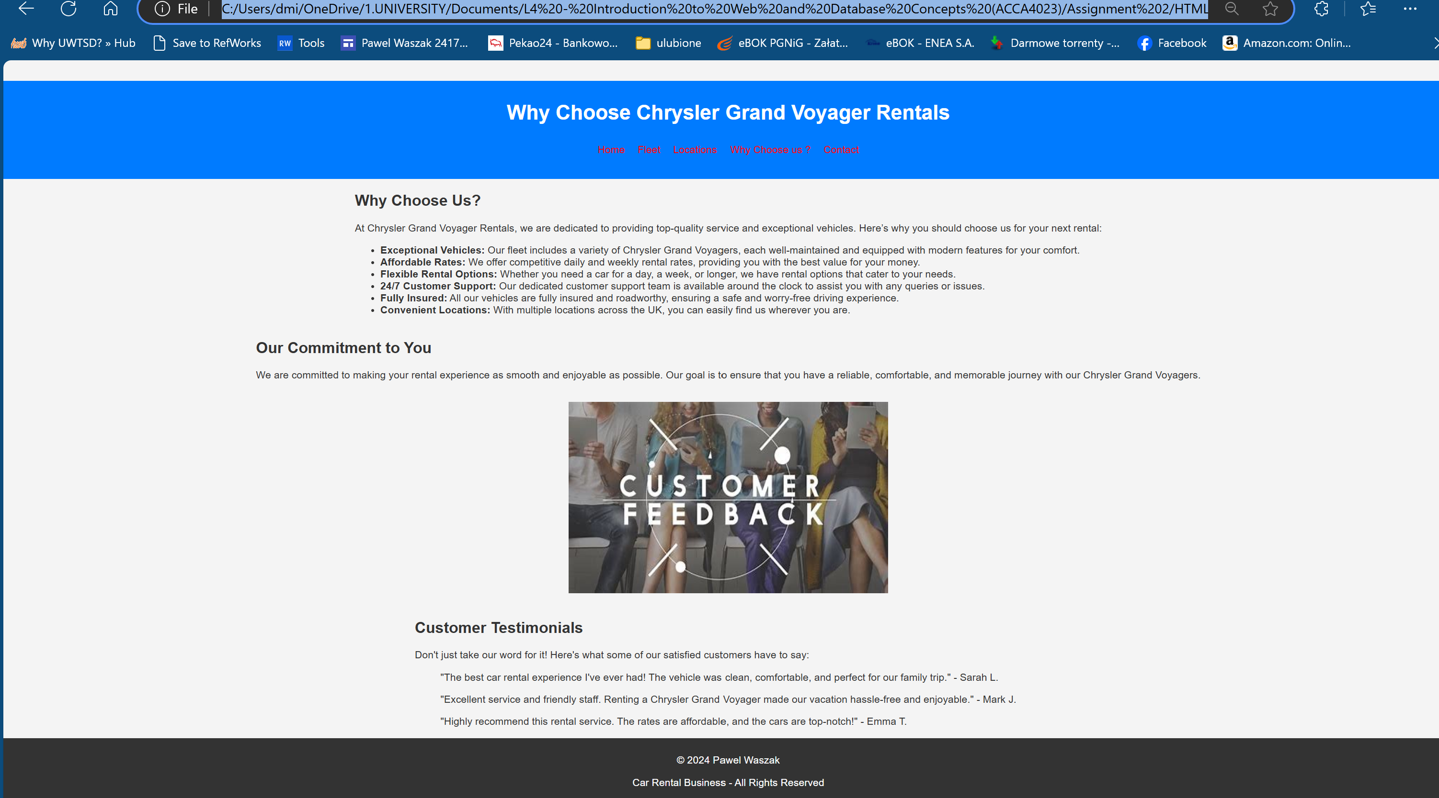

Page 5
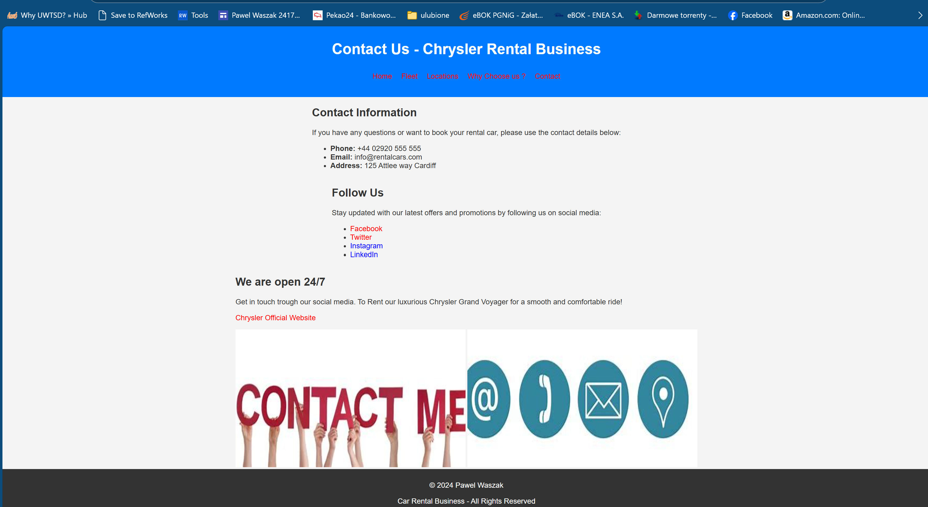

Validation

HTML (http://validator.w3.org/) - you are only required to validate the HTML of your home page

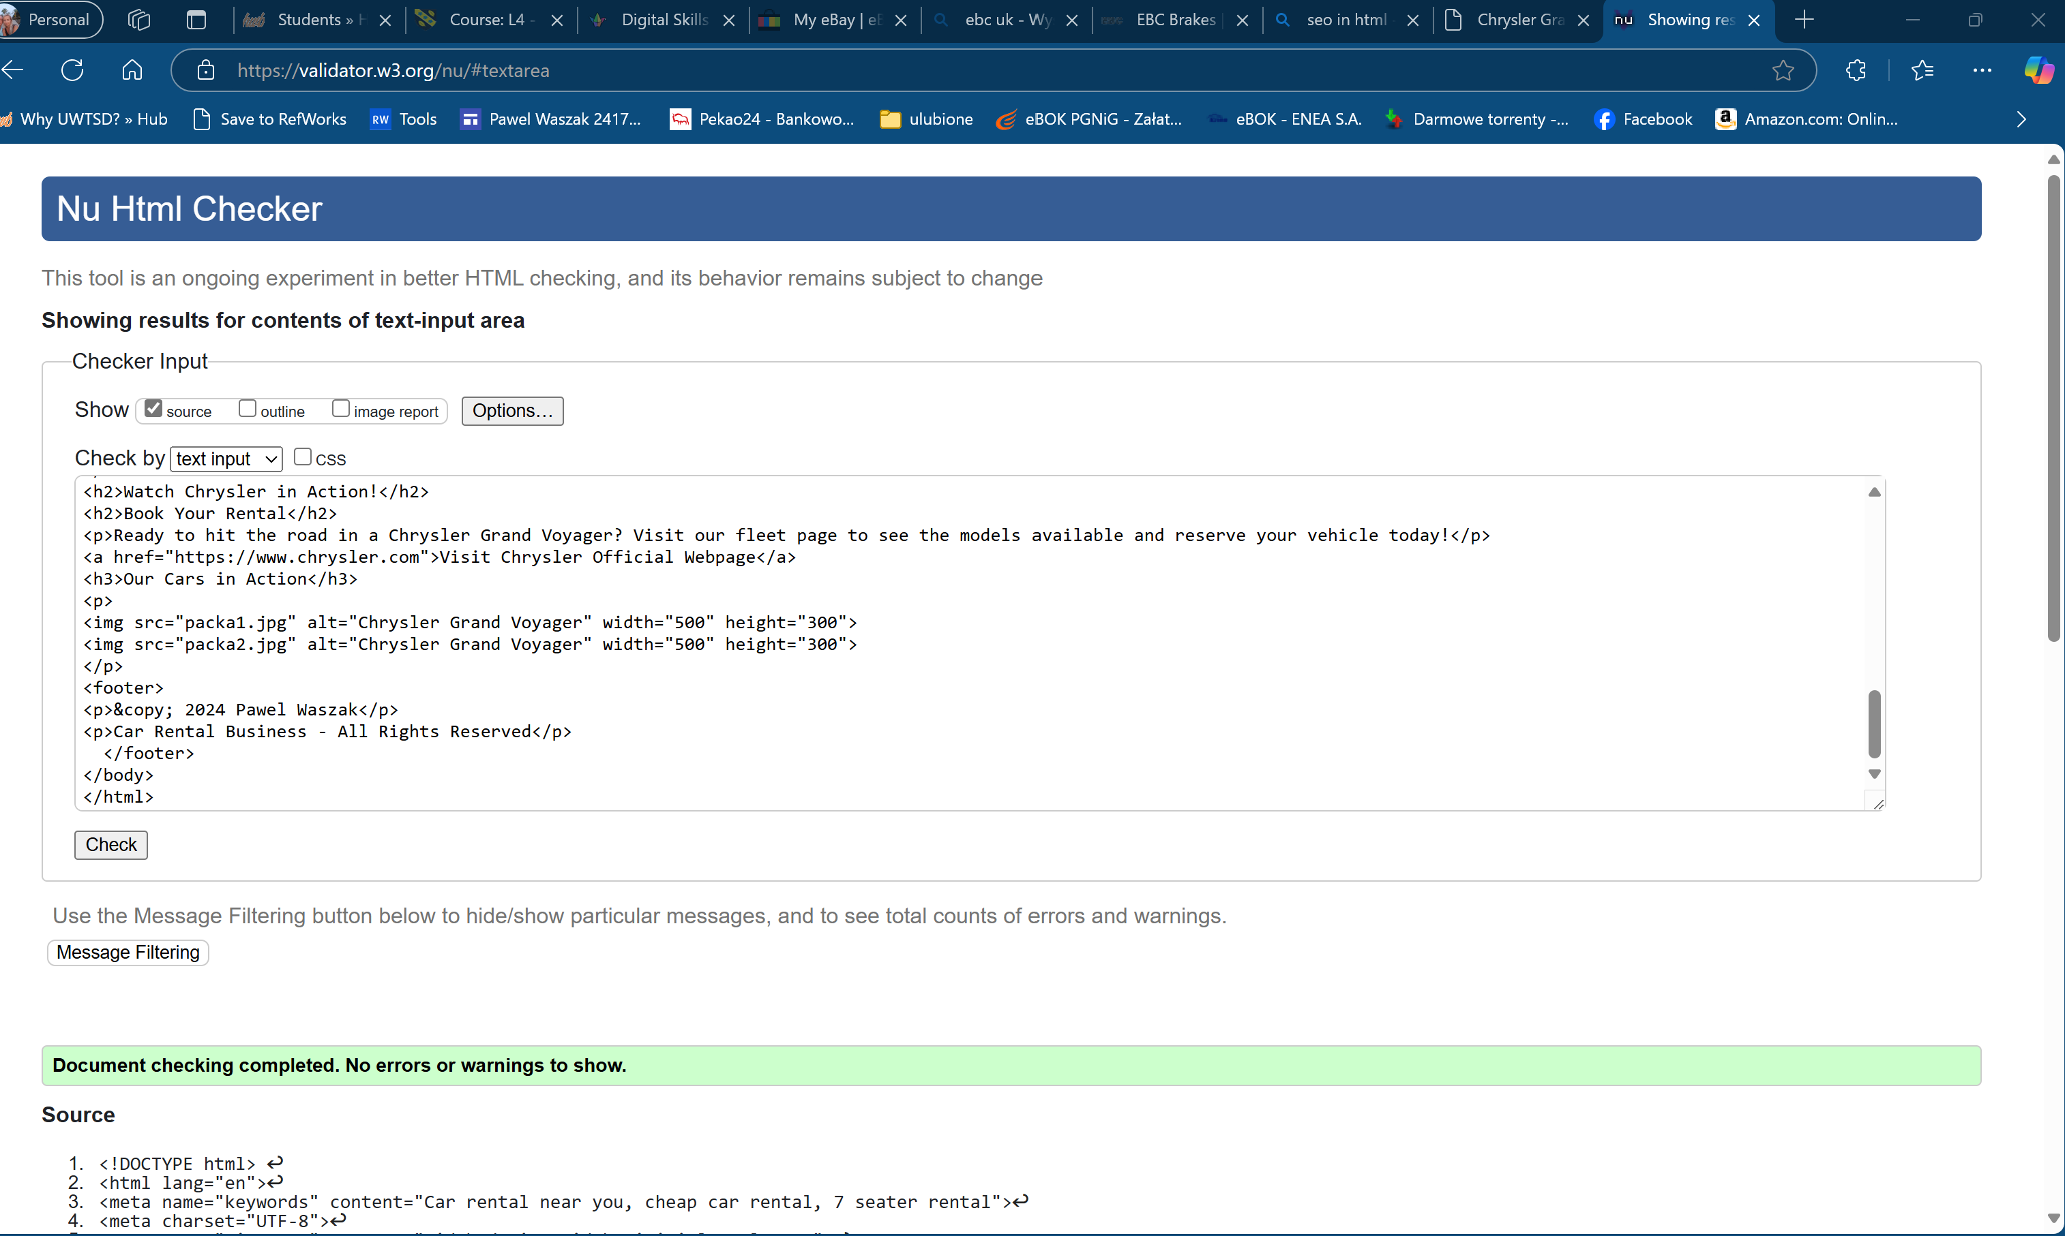

CSS (http://jigsaw.w3.org/css-validator/) – you are only required to validate your website’s main CSS

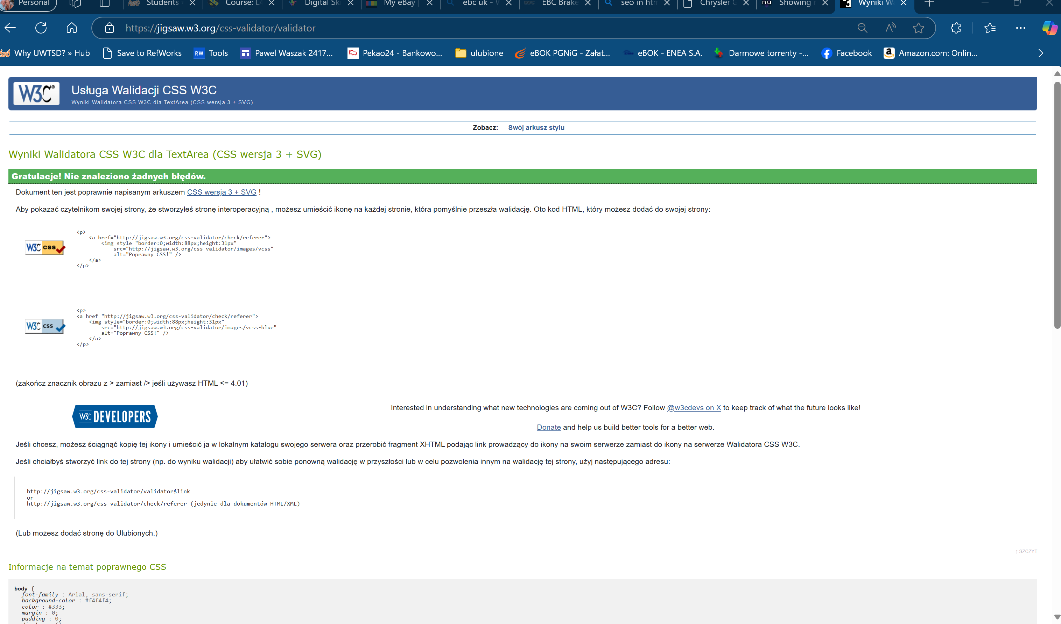

Evaluation
A. Website Usability: Usability refers to how easy it is for users to interact with a website to get a result. It needs to have intuitive navigation, clear design, fast loading times, and relevant content. A well-designed site is useable and attracts visitors to comeback.

Website Accessibility: Accessibility ensures everyone, including people with disabilities can use the site. We can do that by adding alternative text for images, making navigation keyboard-friendly, create appropriate color contrast. There are guidelines that make the web page more user friendly.
Search Engine Optimization (SEO): SEO focuses on optimizing a website to be placed higher in search engine results. Techniques include using relevant keywords, meta tags, mobile-friendly design, implementing good backlinks. SEO will attract more traffic to the webpage.
All terms / tools- usability, accessibility, and SEO create a good website by improving user experience, getting to more web users with bigger web presence in search engines. Creates more traffic to the website.

For research on this terms I have used J. Niederst Robbins, Learning Web design : a beginner's guide to HTML, CSS, Javascript, and web graphics, Beijing, China: O'Reilly, 2018.
Which states:
“User Experience, Interaction, and User Interface design Often, when we think of design, we think about how something looks. On the web, the first matter of business is designing how the site works . Before you pick colors and fonts, it is important to identify the site’s goals, how it will be used, and how visitors move through it. These tasks fall under the disciplines of User Experience (UX) design, Interaction Design (IxD), and User Interface (UI) design. There is a lot of overlap between these responsibilities, and it is not uncommon for one person or team to handle all three.”[1]

B. Provide an evaluation of your completed website as follows: Usefulness (usability and utility): Taking into consideration the design of your website, evaluate its utility (functionality), usability (look and feel and ease of use), and content (information) and provide recommendations for future improvements.
Using the comparison document we have used previously in the class I have adapted the form to Evaluate it in a structured manner. Results are below:

Observation Categories:
1. Website Design and Layout
- Chrysler rental business:
  - How does the website look visually (colors, fonts, images)?
    - The website has good color scheme , clear fonts and good images.
  - Is the layout clean, modern, and easy to understand?
    - Layout is basic clean and easy to understand
  - Are the menus, buttons, and links placed logically?
    - All menus buttons links placed logically and clear

Your Observations:
- Chrysler rental business(Design):
  - Pros: Nice and informative design
  - Cons: Very basic compared to modern webpages

2. Ease of Navigation
- Chrysler rental business:
  - Is it easy to find the car rental booking page?
    - I believe it will be easy to navigate
  - How intuitive is the website? Can you quickly figure out how to perform basic tasks (e.g., selecting car type, dates)?
    - As this is a simple site all is clear and intuitive

Your Observations:
- NationalCar.co.uk (Navigation):
  - Pros: Very easy navigation
  - Cons: Site is simple and options are limited

3. Clarity of Information
- Chrysler rental business:
  - Is the information about car rental options, pricing, and policies clear and easy to understand?
    - Limited options to validate the or choose the options on the website

  - Are key details like insurance, extra fees, or car features presented well?
    - Not much details regarding the added fees etc.

Your Observations:
- Chrysler rental business (Clarity of Information):
  - Pros: Very simple page easy to see all details
  - Cons: Limited amount of further information

4. Overall User Experience
- Chrysler rental business:
  - Did you find the overall experience enjoyable or frustrating? Why?
    - Overall experience is good and no major issues

  - Did the website load quickly, and did the booking process flow smoothly?
    - I believe it will be easy to navigate , booking is not available as a system yet

Your Observations:
- Chrysler rental business (User Experience):
  - Pros: You can easily access what you are looking for
  - Cons: Very basic page a booking system would be nice to have.

Summary Reflection:
- What did you prefer overall, and why?
(Consider ease of use, visual appeal, information clarity, and overall experience.)
    - Overall this is a fair attempt to build a functional website for a business. It is informative and simple to use with all basic details.

- What are some key areas each website could improve?
    - This web page is to simple for modern standards and would require to use more modern programming language to keep up with the rest of the world right now.

C. Search Engine Optimisation (SEO): Document the on-page SEO techniques applied to your website with examples of where and how these have been applied

I have applied few SEO techniques that can been seen below:

Meta Title Tag
The <title> tag is used to define the title of the webpage, which appears in search engine results and browser tabs. It should be clear, concise, and include relevant keywords.
<title>Chrysler Grand Voyager Rentals</title>

Meta Keywords Tag
Although not used by major search engines anymore, the meta keywords tag was used to list important keywords for the page.
<meta name="keywords" content="Car rental near you, cheap car rental, 7 seater rental">
Meta Charset Tag
The charset meta tag specifies the character encoding for the HTML document, ensuring that all characters are displayed correctly.
<meta charset="UTF-8">
Meta Viewport Tag
The meta viewport tag helps ensure that your website looks good on all devices, especially mobile devices.
<meta name="viewport" content="width=device-width, initial-scale=1.0">

D. Accessibility.
“Web Content Accessibility Guidelines (WCAG) 2.1 covers a wide range of recommendations for making Web content more accessible. Following these guidelines will make content more accessible to a wider range of people with disabilities, including accommodations for blindness and low vision, deafness and hearing loss, limited movement, speech disabilities, photosensitivity, and combinations of these, and some accommodation for learning disabilities and cognitive limitations; but will not address every user need for people with these disabilities. These guidelines address accessibility of web content on desktops, laptops, tablets, and mobile devices. Following these guidelines will also often make Web content more usable to users in general.
WCAG 2.1 success criteria are written as testable statements that are not technology-specific. Guidance about satisfying the success criteria in specific technologies, as well as general information about interpreting the success criteria, is provided in separate documents. See Web Content Accessibility Guidelines (WCAG) Overview for an introduction and links to WCAG technical and educational material.
WCAG 2.1 extends Web Content Accessibility Guidelines 2.0 [WCAG20], which was published as a W3C Recommendation December 2008. Content that conforms to WCAG 2.1 also conforms to WCAG 2.0. The WG intends that for policies requiring conformance to WCAG 2.0, WCAG 2.1 can provide an alternate means of conformance. The publication of WCAG 2.1 does not deprecate or supersede WCAG 2.0. While WCAG 2.0 remains a W3C Recommendation, the W3C advises the use of WCAG 2.1 to maximize future applicability of accessibility efforts. The W3C also encourages use of the most current version of WCAG when developing or updating Web accessibility policies.” [2]

Below I have an example of my accessibility test. I have decied to pick one which was :
WebAIM: Contrast Checker
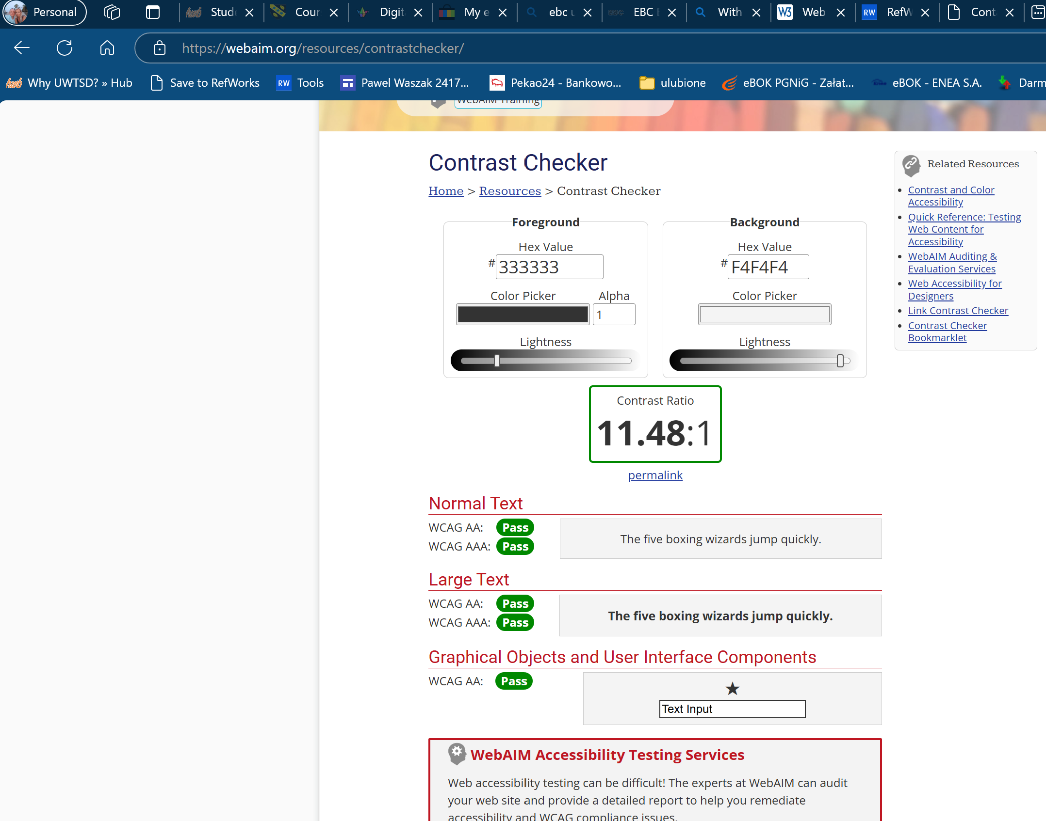

5.References

[1] J. Niederst Robbins, Learning Web design : a beginner's guide to HTML, CSS, Javascript, and web graphics, Beijing, China: O'Reilly, 2018.
[2] "Web Content Accessibility Guidelines (WCAG) 2.1," Accessed: Dec 9, 2024, [Online]. Available: https://www.w3.org/TR/WCAG21/

6. Appendices

Css Styles.
/* General body styling */
body {
font-family: Arial, sans-serif;
background-color: #f4f4f4;
color: #333;
margin: 0;
padding: 0;
display: flex;
flex-direction: column;
align-items: center; /* Centers content horizontally */
justify-content: center; /* Centers content vertically (optional) */
min-height: 100vh;
}

/* Header styling */
header {
background-color: #007BFF;
color: white;
padding: 10px;
text-align: center;
width: 100%; /* Ensure header spans the width of the page */
}

/* Navigation menu */
nav ul {
list-style-type: none;
padding: 0;
display: flex;
justify-content: center;
}

nav ul li {
display: inline;
margin: 10px;
}

nav ul li a {
color: Black;
text-decoration: none;
}

/* Main content styling */
main {
padding: 80px;
text-align: center;
width: 100%;
box-sizing: border-box;
}

/* Styling for tables within the main content */
main table {
margin: 0 auto;
border-collapse: collapse;
}

main table th,
main table td {
border: 1px solid #ddd;
padding: 8px;
text-align: center; /* Centers text in table cells */
}

/* Footer styling */
footer {
background-color: #333;
color: white;
text-align: center;
padding: 10px;
width: 100%;
}
/* Hyperlink styling */
a {
color: blue; /* Default link color */
text-decoration: none; /* Removes underline from links */
}

a:visited {
color: red; /* Color for visited links */
}

a:hover {
color: darkblue; /* Color when hovering over the link */
text-decoration: underline; /* Optional: Adds underline on hover */
}

a:active {
color: orange; /* Color when the link is actively being clicked */
}
Home html
<!DOCTYPE html>
<html lang="en">
<meta name="keywords" content="Car rental near you, cheap car rental, 7 seater rental">
<head>
<meta charset="UTF-8">
<meta name="viewport" content="width=device-width, initial-scale=1.0">
<title>Chrysler Grand Voyager Rentals</title>
<link rel="stylesheet" href="Styles1.css">
<body>
<header>
<h1>Welcome to Our Chrysler Grand Voyager Rentals</h1>
<nav>
<ul>
<li><a href="home.html">Home</a></li>
<li><a href="fleet.html">Fleet</a></li>
<li><a href="locations.html">Locations</a></li>
<li><a href="whyus.html">Why Choose us ?</a></li>
<li><a href="contact.html">Contact</a></li>
</ul>
</nav>
</header>
<section>
<h2>About Our Business</h2>

<p>Welcome to the best Chrysler Grand Voyager rental service! We offer a wide range of Chrysler Grand Voyager models for your rental needs. Whether you're planning a family vacation, business trip, or special event, our Chrysler Grand Voyagers are the perfect choice for comfort, reliability, and style. With spacious interiors and modern features, you’ll enjoy every moment of your journey. Explore our fleet today!</p>
<h3>Why Choose Us?</h3>
<p>We are committed to providing top-notch service with a fleet of well-maintained Chrysler Grand Voyagers. Our flexible rental options and customer-first approach ensure that you get the best value for your money. Here’s why you should rent from us:</p>
<ul>
<li>Spacious and comfortable vehicles for long trips</li>
<li>Affordable daily and weekly rental rates</li>
<li>Fully insured and roadworthy vehicles</li>
<li>24/7 customer support</li>
</ul>
</section>
<section>
<h2>Our Fleet</h2>
<p>We offer a variety of Chrysler Grand Voyager models to suit your needs. From basic to premium, we have the perfect vehicle for you.</p>
</section>
<h2>Watch Chrysler in Action!</h2>
<h2>Book Your Rental</h2>
<p>Ready to hit the road in a Chrysler Grand Voyager? Visit our fleet page to see the models available and reserve your vehicle today!</p>
<a href="https://www.chrysler.com">Visit Chrysler Official Webpage</a>
<h3>Our Cars in Action</h3>
<p>
<img src="packa1.jpg" alt="Chrysler Grand Voyager" width="500" height="300">
<img src="packa2.jpg" alt="Chrysler Grand Voyager" width="500" height="300">
</p>
<footer>
<p>&copy; 2024 Pawel Waszak</p>
<p>Car Rental Business - All Rights Reserved</p>
</footer>
</body>
</html>

Fleet HTML
<!DOCTYPE html>
<html lang="en">
<head>
<meta charset="UTF-8">
<meta name="viewport" content="width=device-width, initial-scale=1.0">
</head>
<header>
<h1>This section will show otions of Chrysler minivan fleet soltutions</h1>
<nav>
<ul>
<li><a href="home.html">Home</a></li>
<li><a href="fleet.html">Fleet</a></li>
<li><a href="locations.html">Locations</a></li>
<li><a href="whyus.html">Why Choose us ?</a></li>
<li><a href="contact.html">Contact</a></li>
</ul>
</nav>
</header>
<title>New Product Launch - Fleet</title>
<head>
<link rel="stylesheet" href="Styles1.css">
<h1>We have to rent two models Pacifica and Grand Voyager </h1>
<p>
<body>
<h1>Comparison: Chrysler Pacifica vs Grand Voyager</h1>
<div class="comparison-container">
<div class="card">
<h2>Chrysler Pacifica</h2>
<ul>
<li><strong>Modern Design:</strong> Sleek, contemporary exterior with advanced aerodynamics.</li>
<li><strong>Powertrain Options:</strong> Available in gasoline and plug-in hybrid models for efficiency.</li>
<li><strong>Technology:</strong> Includes Uconnect infotainment, rear-seat entertainment, and driver assistance tools.</li>
<li><strong>Luxury and Comfort:</strong> Premium materials, Stow ‘n Go seating, and a quieter cabin.</li>
</ul>
</div>
<div class="card">
<h2>Chrysler Grand Voyager</h2>
<ul>
<li><strong>Classic Appeal:</strong> Boxy design prioritizing practicality over modern styling.</li>
<li><strong>Functionality:</strong> Spacious interior with user-friendly features.</li>
<li><strong>Performance:</strong> Traditional gasoline engine suitable for everyday driving.</li>
<li><strong>Legacy:</strong> Reliable and budget-friendly family vehicle with decades of trust.</li>
</ul>
</div>
</div></p>
</head>
<ul>
<li><strong>Competetive daily hire rates !</strong></li>
<li><strong>Insurance included in the price </strong></li>
<li><strong>No Credit checks !</strong></li>
</ul>
<body>
<h2>Example of hire rates based on the Pacifica 4x4 Hybrid Model</h2>
<table border="1">
<!-- Table header-->
<thead>
<tr>
<th>Model</th>
<th>Hire Duration</th>
<th>Total Cost</th>
</tr>
</thead>
<tbody>
<tr>
<td>Pacifica </td>
<td>1 day </td>
<td>£99</td>
</tr>
<tr>
<td>Pacifica</td>
<td>7 days</td>
<td>£500</td>
</tr>
<tr>
<td>Pacyfica </td>
<td>30 days </td>
<td>£999</td>
</tr>
</tbody>
</table>

<marquee behavior="alternate" direction="left" style="color: orange; font-size: 15px;">
"Conquer any terrain with the Chrysler Pacifica 4x4 Hybrid, where hybrid efficiency meets rugged capability."
</marquee>
<marquee behavior="alternate" direction="Right" style="color: orange; font-size: 15px;">
"Designed for families who crave adventure, it delivers power, versatility, and eco-friendly performance in one stunning package."
</marquee>

<h1>More informations about both Grand Voyager and Pacifica </h1>
<div style="text-align: center; margin-top: 40px;">
<a href="https://www.chrysler.com" style="font-size: 20px; font-weight: bold; color: blue; text-decoration: none;">
👉 Visit the Official Chrysler Webpage!
</a>
<br><br>
<a href="https://www.youtube.com/user/chrysler" style="font-size: 20px; font-weight: bold; color: red; text-decoration: none;">
🎥 Explore Chrysler's Official YouTube Channel!
</a>
</div>

<div style="text-align: center; margin-top: 30px;">
<h2>Watch Chrysler in Action!</h2>
<iframe width="560" height="315" src="https://www.youtube.com/embed/EjshCejEJNA?si=gRhkT4CeHbLOXFjt" title="YouTube video player" frameborder="0" allow="accelerometer; autoplay; clipboard-write; encrypted-media; gyroscope; picture-in-picture; web-share" referrerpolicy="strict-origin-when-cross-origin" allowfullscreen></iframe>
</div>

<p>
<img src="packa1.jpg" alt="Chrysler Pacifica" width="500" height="300">
<img src="packa2.jpg" alt="Chrysler inside" width="500" height="300">
<img src="download.jpg" alt="Chrysler Grand Voyager" width="500" height="300">
<img src="packa 3.jpg" alt="Chrysler Pacifica inside 2" width="500" height="300">
<img src="packa 4.jpg" alt="Chrysler Pacifica inside 3" width="500" height="300">
<!-- Image stored at the subfolder-->
<img src="images/gv.jpg" alt="Chrysler GV" width="500" height="300">
</p>

<footer>
<p>&copy; 2024 Pawel Waszak</p>
<p>Car Rental Business - All Rights Reserved</p>
</footer>
</body>
</html>

Contact HTML
<!DOCTYPE html>
<html lang="en">
<head>
<meta charset="UTF-8">
<meta name="viewport" content="width=device-width, initial-scale=1.0">
<title>Contact Us - Chrysler Rental Business</title>
<link rel="stylesheet" href="Styles1.css">
</head>

<body>
<header>
<h1>Contact Us - Chrysler Rental Business</h1>
<nav>
<ul>
<li><a href="home.html">Home</a></li>
<li><a href="fleet.html">Fleet</a></li>
<li><a href="locations.html">Locations</a></li>
<li><a href="whyus.html">Why Choose us ?</a></li>
<li><a href="contact.html">Contact</a></li>
</ul>
</nav>
</header>

<section>
<h2>Contact Information</h2>
<p>If you have any questions or want to book your rental car, please use the contact details below:</p>

<ul>
<li><strong>Phone:</strong> +44 02920 555 555</li>
<li><strong>Email:</strong> info@rentalcars.com</li>
<li><strong>Address:</strong> 125 Attlee way Cardiff</li>
</ul>
</section>

<section>
<h2>Follow Us</h2>
<p>Stay updated with our latest offers and promotions by following us on social media:</p>
<ul>
<li><a href="https://facebook.com/rentalcars">Facebook</a></li>
<li><a href="https://twitter.com/rentalcars">Twitter</a></li>
<li><a href="https://instagram.com/rentalcars">Instagram</a></li>
<li><a href="https://linkedin.com/company/rentalcars">LinkedIn</a></li>
</ul>
</section>

<section>
<h2>We are open 24/7 </h2>
<p>Get in touch trough our social media. To Rent our luxurious Chrysler Grand Voyager for a smooth and comfortable ride!</p>
<p><a href="https://www.chrysler.com">Chrysler Official Website</a></p>

<img src="contact1.jpg" alt="Chrysler Grand Voyager" width="500" height="300">
<img src="contact2.jpg" alt="Chrysler Grand Voyager Interior" width="500" height="300">
</section>
<footer>
<p>&copy; 2024 Pawel Waszak</p>
<p>Car Rental Business - All Rights Reserved</p>
</footer>
</body>
</html>

Locations HTML

<html lang="en">
<head>
<meta charset="UTF-8">
<meta name="viewport" content="width=device-width, initial-scale=1.0">
<title>Contact Us - Chrysler Rental Business</title>
<link rel="stylesheet" href="Styles1.css">
</head>

<body>
<header>
<h1>Contact Us - Chrysler Rental Business</h1>
<nav>
<ul>
<li><a href="home.html">Home</a></li>
<li><a href="fleet.html">Fleet</a></li>
<li><a href="locations.html">Locations</a></li>
<li><a href="whyus.html">Why Choose us ?</a></li>
<li><a href="contact.html">Contact</a></li>
</ul>
</nav>
</header>

<section>
<h2>Find Us Across the UK</h2>
<p>We have multiple locations across the UK to serve you better. Whether you’re in the bustling city or enjoying the countryside, our Chrysler Grand Voyager rentals are available for you. Here are our main locations:</p>

<table border="1">
<!-- Table header -->
<p>
<thead>
<tr>
<th>Location</th>
<th>Address</th>
<th>Contact Number</th>
</tr>
</thead>
<tbody>
<tr>
<td>London</td>
<td>123 Fleet Street, London, EC4A 2BH</td>
<td>020 7946 0958</td>
</tr>
<tr>
<td>Manchester</td>
<td>456 Deansgate, Manchester, M3 4FN</td>
<td>0161 832 7078</td>
</tr>
<tr>
<td>Birmingham</td>
<td>789 Broad Street, Birmingham, B1 2HT</td>
<td>0121 456 7890</td>
</tr>
<tr>
<td>Edinburgh</td>
<td>101 Princes Street, Edinburgh, EH2 3AA</td>
<td>0131 225 2345</td>
</tr>
</tbody>
</table>
</section>

<p>
<img src="map1.jpg" alt="map" width="500" height="300">
</p>
<section>
<h2>Visit Us Today!</h2>
<p>Our locations are strategically placed to provide you with convenient access to our rental services. Visit us at any of these locations to experience our exceptional service and drive away in a Chrysler Grand Voyager.</p>
</section>
<footer>
<p>&copy; 2024 Pawel Waszak</p>
<p>Car Rental Business - All Rights Reserved</p>
</footer>
</body>
</html>

Why Us HTML
<!DOCTYPE html>
<html lang="en">
<head>
<meta charset="UTF-8">
<meta name="viewport" content="width=device-width, initial-scale=1.0">
<title>Why Choose Us - Chrysler Grand Voyager Rentals</title>
<link rel="stylesheet" href="Styles1.css">
</head>

<body>
<header>
<h1>Why Choose Chrysler Grand Voyager Rentals</h1>
<nav>
<ul>
<li><a href="home.html">Home</a></li>
<li><a href="fleet.html">Fleet</a></li>
<li><a href="locations.html">Locations</a></li>
<li><a href="whyus.html">Why Choose us ?</a></li>
<li><a href="contact.html">Contact</a></li>
</ul>
</nav>
</header>

<section>
<h2>Why Choose Us?</h2>
<p>At Chrysler Grand Voyager Rentals, we are dedicated to providing top-quality service and exceptional vehicles. Here’s why you should choose us for your next rental:</p>

<ul>
<li><strong>Exceptional Vehicles:</strong> Our fleet includes a variety of Chrysler Grand Voyagers, each well-maintained and equipped with modern features for your comfort.</li>
<li><strong>Affordable Rates:</strong> We offer competitive daily and weekly rental rates, providing you with the best value for your money.</li>
<li><strong>Flexible Rental Options:</strong> Whether you need a car for a day, a week, or longer, we have rental options that cater to your needs.</li>
<li><strong>24/7 Customer Support:</strong> Our dedicated customer support team is available around the clock to assist you with any queries or issues.</li>
<li><strong>Fully Insured:</strong> All our vehicles are fully insured and roadworthy, ensuring a safe and worry-free driving experience.</li>
<li><strong>Convenient Locations:</strong> With multiple locations across the UK, you can easily find us wherever you are.</li>
</ul>
</section>

<section>
<h2>Our Commitment to You</h2>
<p>We are committed to making your rental experience as smooth and enjoyable as possible. Our goal is to ensure that you have a reliable, comfortable, and memorable journey with our Chrysler Grand Voyagers.</p>
</section>

<p>
<img src="feedback.jpg" alt="feedback" width="500" height="300">
</p>

<section>
<h2>Customer Testimonials</h2>
<p>Don't just take our word for it! Here's what some of our satisfied customers have to say:</p>

<blockquote>
<p>"The best car rental experience I've ever had! The vehicle was clean, comfortable, and perfect for our family trip." - Sarah L.</p>
</blockquote>

<blockquote>
<p>"Excellent service and friendly staff. Renting a Chrysler Grand Voyager made our vacation hassle-free and enjoyable." - Mark J.</p>
</blockquote>

<blockquote>
<p>"Highly recommend this rental service. The rates are affordable, and the cars are top-notch!" - Emma T.</p>
</blockquote>
</section>

<footer>
<p>&copy; 2024 Pawel Waszak</p>
<p>Car Rental Business - All Rights Reserved</p>
</footer>
</body>
</html>

