Workhouses: Pauper Palaces or Bastilles?
A cornerstone of nineteenth-century Poor Law policy was the workhouse, with its attendant principle of less eligibility. The workhouse had to offer a way of life that was less attractive than survival outside And herein lay a terrible paradox. Conditions outside, for the poorest of the workforce, were pretty terrible. The state could not, in a civilised society, institutionalise dirt, disease and starvation. There had to be other ways of deterring the poor from asking for relief.
Workhouse Design: Deterrent and Discipline?
The design and structure of workhouses were intended, in themselves, to act as a deterrent to would-be paupers. They were also meant to instil discipline in the paupers they were designed to house. How were they to do this? Sampson Kempthorne was an architect appointed by the commissioners of the Poor Law to produce acceptable designs.
Kempthorne produced two basic designs:
- A Y-shaped building, two or three storeys high, inside an hexagonal boundary wall.
- A cruciform-shaped building, two storeys high, inside a square boundary wall. Each arm of the cross held dormitories and dining rooms, a chapel and kitchens, schoolrooms and stores – sufficient accommodation for between 200 and 500 paupers.
The designs allowed for the division and segregation of paupers. Before they could be segregated they had to be classified. There were seven different categories into which paupers could be sorted: infirm men; able-bodied men over the age of 15; boys aged 7-15; infirm women; able-bodied women over the age of 15; girls aged 7-15; children under 7. Why were they classified? Segregation allowed workhouse officers to provide appropriately for each class of pauper; it added to the deterrence factor by splitting up families; and prevented the moral ‘contagion’ that would occur if the different categories mixed freely. Paupers were beginning to lose their individuality and were beginning to be treated as impersonal units.
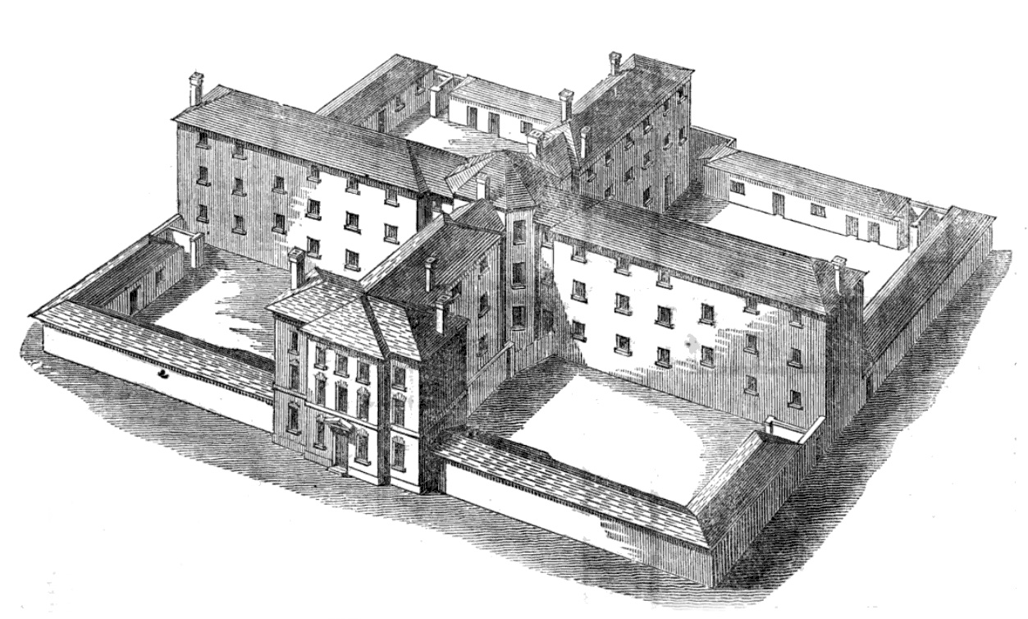

Who were the new Paupers?
Outdoor relief continued to be the main form of support for paupers, despite the best efforts of the commissioners. This means that any analysis of the types of people opting for, or forced into, indoor relief cannot be taken as typical of the pauper population as a whole. But it is interesting to see which people were given indoor relief and to bear this in mind when looking at workhouse provision, regimes and staff and evaluating these for fitness for purpose.
Workhouses provided both short-term and long-term care, and at any one time around one-fifth of all inmates had been inside for five or more years. There were, of course, regional and local differences, but by and large pauper populations within the workhouses were surprisingly similar in structure:
- Young people, for whom the workhouse provided a temporary shelter and a solution to a personal crisis. They moved in and out of the workhouses, maybe several times a year, depending on variables such as the seasonality of employment, the harshness of winter or the severity of a local epidemic;
- Vagrants, who were considered less deserving than any ‘settled’ poor. They were given overnight accommodation in a ‘casual ward’, to which they were not admitted until the evening, when they were fed a meal of bread and water. In the better workhouses, they were stripped, deloused and had their clothes disinfected;
- The elderly, for whom the workhouse provided shelter and sustenance until death. In this group, old men were more prominent than old women. Women, when old, could more frequently be of domestic use to their families and so tended to be kept by their relatives rather than being sent ‘on the parish’;
- Children, who made up about 25 percent and 40 percent of all admissions, were both long-and short- stay inmates. The offspring of transient able-bodied poor went in and out with parents. However most workhouse children were abandoned, orphans or ill. Many were the illegitimate sons and daughters of other inmates and were likely to spend all of their childhood and early adolescence in the workhouse;
- Single women, who could not claim outdoor relief. They made up the significant proportion of any workhouse community and included widows, abandoned wives, single mothers and prostitutes;
- The mentally ill, whose numbers increased as the century progressed.
Workhouse Regime: Designed to Demoralise?
Workhouses had to provide for the most vulnerable and needy members of society, both as transient and as long-term inmates. They had, too, to impose the workhouse test to ensure that the principle of less eligibility was being maintained. Inevitably, these demands and expectations conflicted as boards of guardians struggled to match their own prejudices and preconceptions with the demands of their localities and the requirements of the Poor Law commissioners.
Routine, rules and regulations
Every aspect of workhouse life was governed by a stream of rules and regulations laid down by the commissioners in London. The routine was designed to be unpleasant and was intended to deter people from seeking relief.
- On entry to a workhouse, the pauper family was given a medical inspection and then split up. Husbands were separated from wives and parent from their children, although mothers did usually stay with their children until the age of 7. The assumption was that the pauper had given up all responsibility for his family and was separated from it.
- Children were sent to the workhouse school and, when they were 9 or 10 years old, apprenticed without their parents’ consent.
- Paupers had to wear workhouse uniform that sometimes fitted them and sometimes did not. Guardians were allowed to add variety to the uniform, but few of them did.
- Men were given razors to shave once a week and all paupers had a weekly bath. Workhouse staff watched while this happened. This was to prevent any attempt at self-mutilation or drowning and to add to the sense of loss of personal privacy.
- No personal possessions were allowed and there were no lockers or cupboards in which paupers could put clothes or shoes. This was to prevent any expression of individuality.
- The daily routine was designed to be boring and monotonous:
07.00-08.00 Breakfast
08.00-12.00 Work
12.00-13.00 Dinner
13.00-18.00 Work
18.00-19.00 Supper
20.00 Bedtime
- Each day began and ended with prayers, and an hour earlier in the summer.
Work
It was essential, within the whole scheme of things, that workhouse inmates worked. The primary aim of this work was to rehabilitate the paupers and restore them to the workforce outside. As an aim, this was laudable. But, when translated into practice, huge problems arose, both of an ideological and practical nature. What work would the paupers do that would equip them for a useful working life outside/ the work had to be available in the locality of the workhouse, and it had to be able to be done inside the confines of the workhouse. Nor could it diminish available employment outside the workhouse to the extent that the able-bodied working poor became paupers. The philosophical stance of the commissioners made the situation even more difficult. They held that work done inside the workhouse could not pay more than it cost the workhouse to maintain the pauper. If it did, they argued, there would be no incentive for the pauper to return to the labour market.
What work was done? Some paupers, mainly women and children, worked to help maintain the workhouse. They worked in the laundries, kitchens and sick rooms. They worked as cleaners, attendants, childminders and sloppers-out. If work that was economical and easy to perform could not be found, then dispiriting and monotonous work was given to the paupers. They made sacks and unravelled ropes so that the fibres could be used again; they chopped wood and smashed limestone that was used to make roads; and in some instances they ground animal bones into dust to be used by farmers as fertiliser.
Dietaries
The supply of food to paupers, while it just about kept them alive, served also to degrade and to discipline. The Poor Law commissioners issued six model diets from which boards of guardians could choose the one, or ones, that best suited their pockets and inclinations. Here, again, the principle of less eligibility had to hold sway, as far as possible. But given the poor diets of many outside the workhouse, this was difficult. Therefore the aim of the published dietaries was to sustain and maintain life but to make mealtimes as boring and tedious as possible. Paupers were to get no pleasure from the food they ate.
The way in which meals were taken was designed to instil repressive uniformity. Until 1842 all meals were to be taken in silence. Paupers had the right to have their food weighed in front of them; many workhouses used this regulation to delay the serving of food until it was cold, thus adding further to the pauper’s humiliation. There were other ways to degrade. The meat, oatmeal, cheese and bread that formed the mainstay of pauper meals could be of poor quality. The meals themselves were poorly and carelessly prepared and cooked.e fixed (and often basic and monotonous) diet prescribed for workhouse inmates. The dietary specified the food to be served to each class of maale/female, adult/children etc.) for each meal of the week, often including the et amount to be provided. After 1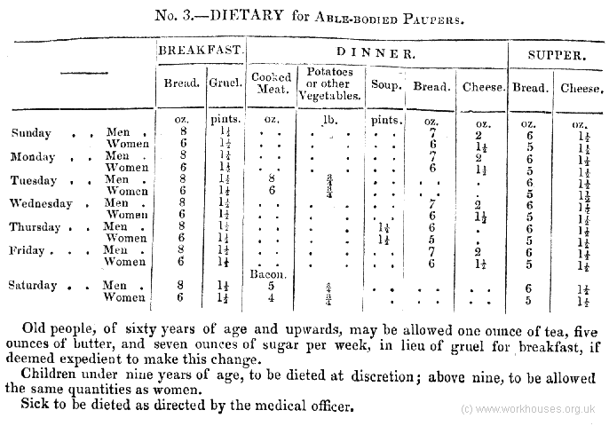834, the Poor Law Commissioners devised a set of six slightly different standard dietaries from which each union could select the one it preferred, based on thal
Discipline
Workhouses could be rowdy places. Staff and paupers often hurled verbal and physical abuse at each other. Disturbances ranged from full-scale riots to foul language. Among paupers there were frequent outbreaks of bullying and blackmail, and there are recoded instances of sexual abuse between staff and paupers and between pauper and pauper.
Workhouse staff used a complicated system of rewards and punishments in order to maintain order. Paupers could be punished for being in the wrong part of the workhouse, making too much noise, working too slowly or cheeking a member of staff. On the other hand paupers could be rewarded with food, ‘clean’ jobs. Often systems of rewards and punishments had no legal backing and had grown up through custom. There were, however, specific punishments laid down by the Poor Law commissioners, and a standard punishment book was kept in which all punishments were formally recorded.
Under the old system there was no control of punishments but at least under the new system, guardians and staff did at least know that there were limits to their powers and that these limits were determined and universally applied by the Poor Law commissioners. Girls and women, for example, could not be beaten; although the reduction of rations was a common punishment, there was a minimum below which they could not be reduced. Most workhouses had punishment cells and for more serious crimes the law was applied..

