Appendices

Appendix A
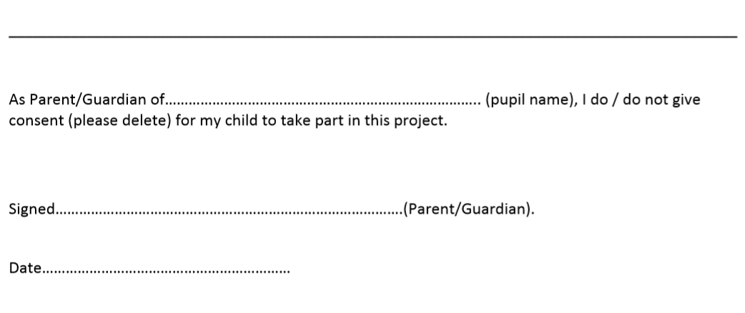

Appendix B



Appendix C
Pupil Information Script
The research is looking at how physical activity, like PE improves/makes better children’s engagement in a maths lesson. What will happen is I will teach a maths lesson in the hall. We will have a special visitor called Miss Simmonds who is Miss Davies’ friend from university come in to watch. Miss Simmonds will be writing notes on how the lesson went, what you enjoyed and about your learning. I am lucky enough to be going to visit her class tomorrow to watch her teacher a lesson too. After the lesson three children will be chosen to answer a few questions I have. I will ask you the questions and Miss Simmonds will sit with us. It doesn’t matter what you say in the interview, it’s your own thoughts on the lesson, you can’t be wrong with an answer. Miss Simmonds may write notes too. The interview will be audio recorded- only your voice, no video. The only people that will hear this interview is Miss Simmonds and myself.
The reason I am doing this research is its part of my University course to become a primary school teacher just like Miss XXX. After I’ve taught you the lesson I will be looking at how you found the lesson, did you learn you anything, what you thought could be improved. Miss Simmonds and I will look at how her class found the lesson too. We will then write an essay on all that we found out about teaching a maths lesson that has physical activity and how it affected children’s engagement. I will use what you and Miss Simmonds thought of the lesson to help me become a better teacher in the future.
Your name won’t be used at any point when either Miss Simmonds or I are writing about you. We will refer/call you ‘Child A’ or ‘Child B’. Our university lecturers will get to read the essay and the headteacher can if they want too but other than that no one else will get to see it.
The most important thing is you don’t have to be part of the research and at any time during the interview you want to leave you can, it really doesn’t matter. We can choose someone else.

Appendix D

Leuven Scale for Engagement
Level | Engagement | Signals | Specific Signs of Engagement
1 | Extremely low | Activity is simple, repetitive and passive. The child seems absent and displays no energy. They may stare into space or look around to see what others are doing. | No movement  Disruptive behaviour  No interaction with adult/peer  No understanding of instructions
2 | Low | Frequently interrupted activity. The child may be engaged in the activity for some time they are observed, but there will be moments of non-activity when they will stare into space or be distracted by what is going on around them. | Off task  Disruptive behaviour  Distracted by environment/distracting others  Minimal interaction  Limited understanding of task – follows peers  Unsure of instructions
3 | Moderate | Mainly continuous activity with intense moments. The child is busy with the activity but at a fairly routine level and there are few signs of real involvement. They make some progress with that they are doing but don’t show much energy and concentration and can be easily distracted. | Adequate level of interaction and engagement  Offers some support to peers  Few signs of real involvement  Lack of energy/concentration/motivation
4 | High | Continuous activity with intense moments. The child’s activity has intense moments and at all times they seem involved. They are not easily distracted. | Good level of interaction and engagement  Follows instructions promptly  Uses knowledge of numbers to find correct puddle  On task  Manages distractions
5 | Extremely high | The child shows continuous and intense activity revealing the greatest involvement. They are concentrated, creative, energetic and persistent throughout nearly all observed period. | Excellent level of interaction and engagement  Oblivious to peer decisions and conversations  Independent  Confident in decision making

Appendix E

Lesson Study 1
Engagement | Child A | Child B | Child C
- Extremely low
- Low
- Moderate
- High
- Extremely high

Lesson Study 2
Engagement | Child A | Child B | Child C
- Extremely low
- Low
- Moderate
- High
- Extremely high
Appendix F

Interview Questions

1. What did you learn?

2. Was it different to other maths lessons? Why?

3. Did you enjoy using your bodies in maths today? Why?

4. Would you like to have more maths lessons like this? Why?

5. What could be improved for the next lesson?

