Commentary on Rochester Castle
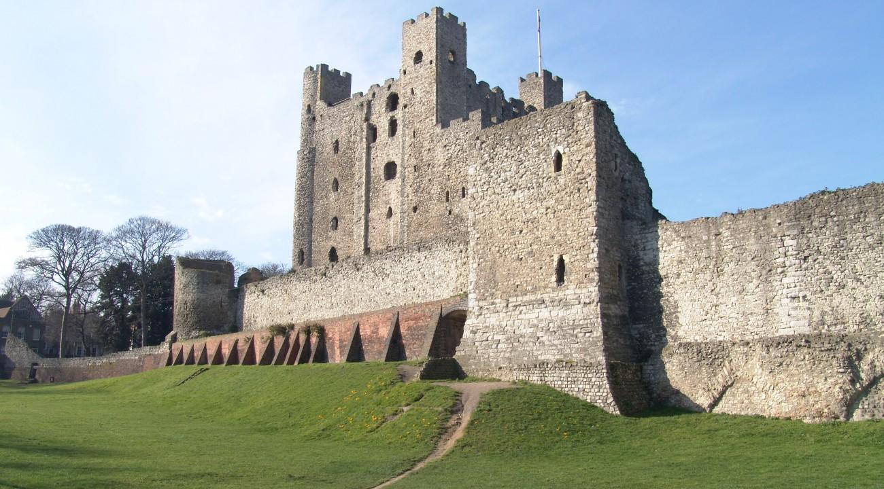
Image of Rochester Castle, England

The conquest of Britain began much earlier than 1066, during the reign of the last Anglo-Saxon king Edward the Confessor. With his marriage childless Edward utilised his lack of an heir by promising the throne to a number of different people, such as the earl of Wessex Harold Goodwinson, later Harold II, as well as William who had very likely been named his successor in 1051. On his deathbed in 1066 Edward named Harold his successor, who was crowned the next day.

However, Harold’s position was delicate as he had supposedly sworn an oath to William to defend his claim to the English throne in 1064. His exiled brother Tostig also raided England’s southern and eastern coasts, later joining his forces to those of Harold III, with Harold II keeping his militia on guard until september when his men were required to return to the fields for the harvest and the supplies ran out, which left England exposed - a vulnerability William quickly took advantage of, though prior to William’s invasion Tostig and Harold III had invaded the north, where both were killed in Harold II’s victory at Stamford Bridge. William, meanwhile, had secured support from both the papacy and the Norman aristocracy, amassing a force of some 4000 to 7000 knights and foot soldiers. Once the winds were favourable he set sail and landed in Pevensey as soon was possible, moving immediately on to Hastings where Harold met him with his own force of over 7000 men, meeting in battle the morning of the next day.

While Harold’s infantry initially held, the Norman assault wore them down until in the afternoon Harold was allegedly killed by an arrow to his eye, with the English remaining scattering by nightfall, allowing William to march to London where at Berkhamstead the major English leaders, such as high ranking nobles and clergy, submitted to him, with William being crowned in Westminster Abbey.

Revolts, however, continued until 1071, the most serious being in Northumbria which William personally suppressed and then devastated the north. In order to maintain a hold over the country a great number of castles were built, such as Rochester Castle on the east bank of the RIver Medway.

Rochester Castle was built on the site of a prior settlement of the Romans, “at the junction of the River Medway and the famous Roman Watling Street”. Prior to the Norman conquest castles were rare in Britain, but quickly proved an essential means in consolidating and controlling captured areas, with the swift construction of fortifications across the country. Construction of Rochester castle itself began in 1080 by the bishop of Rochester, one of William’s greatest architects and also responsible for the tower of London. It faced a number of sieges, the first in 1088 when, after William the Conqueror’s death in 1097, his son Robert was to inherit Normandy and his other son William England; the Bishop of Bayeaux and Earl of Kent Odo, however, conspired to place Robert on the English throne, which resulted in a siege on Rochester Castle and ended with Odo’s exile.

Rochester Castle’s keep has been described as “one of the most impressive surviving medieval castle buildings”, with its height standing at over 38 metres (125 feet). It shows a great deal of sophistication in its detailing, with the arched windows and building corners being made of skillfully shaped Norman stone, with the windows of higher levels being larger and more elaborate, showing chevron carvings.

The castle being built on the bank of the river would have been a location of great tactical importance to the Normans, as it would have allowed them to control traffic travelling along the river Medway, and as it was previously the Roman settlement of Durobrivae which guarded the crossing of a major road between London and Kent it had already proved itself as a good location. Walled from the 3rd century onwards, during the early 5th century it became largely abandoned due to the end of Roman rule, becoming a bishopric during the 7th century until the Norman conquest in 1066, making it ideal to establish a presence where infrastructure such as roads already existed.

Castles were, after all, defensible structures intended to pacify local inhabitants, with Rochester Castle as well as other fortifications across England important to quelling insurrection and rebellion, such as the 36 castles such as Warwick Castle William the Conqueror established to protect against rebellion in the English midlands.

The castle itself might also have proved a significant symbol of Norman strength and their conquest of Britain; described as perching high on the Roman settlement it’s located within, “Rochester Castle dominates the skyline”, with the Normans’ fortifications being able to be seen from nearly everywhere. Such an imposing and ever-present symbol of the Normans’ presence would have stressed both their strength as well as their presence. That the Normans had constructed a castle was also likely not restricted strictly to the fortification of their position and a means of controlling the land around them; it may also have been symbolic of both the Normans’ longevity, in the construction of a building meant to last and dominate, but also of their sophistication, with the keep being considered a masterpiece and the tallest surviving great tower, certainly the tallest at the time of its construction, containing detailing simpler than those of contemporary cathedrals and abbeys but nevertheless still showing great sophistication.

Bibliography
Primary Sources
- Rochester Castle, provided in course reader

Modern Scholarship
- Britannica(2019), Norman Conquest, Encyclopedia Britannica, Accessed: 20/4/21, Available at: https://www.britannica.com/event/Norman-Conquest
- Brain, J (n.d), Rochester Castle, Accessed: 21/4/21, Available at: https://www.historic-uk.com/HistoryMagazine/DestinationsUK/Rochester-Castle/
- Ashbee, J (n.d), History Of Rochester Castle, English Heritage, Accessed: 21/4/21, Available: https://www.english-heritage.org.uk/visit/places/rochester-castle/history/
- English Heritage (n.d a), Significance Of Rochester Castle, Accessed: 21/4/21, Available at: https://www.english-heritage.org.uk/visit/places/rochester-castle/history/significance/
- English Heritage (n.d b), Description Of Rochester Castle, Accessed: 21/4/21, Available at: https://www.english-heritage.org.uk/visit/places/rochester-castle/history/description/
- Friar, S (2003), The Sutton Companion to Castles, Sutton
- Friar, S (2003), Castles in Context: Power, Symbolism and Landscape, 1066 to 1500, Windgather Press

Rochester castle.
Britannica (2019).
Britannica (2019).
Britannica (2019).
Britannica (2019).
Britannica (2019).
Britannica (2019).
Britannica (2019).
Britannica (2019).
Britannica (2019).
Britannica (2019).
Britannica (2019).
Britannica (2019).
Britannica (2019).
Britannica (2019).
Britannica (2019).
Britannica (2019).
Britannica (2019).
Brain, J (n.d).
Brain, J (n.d).
Brain, J (n.d).
Brain, J (n.d).
Brain, J (n.d).
Brain, J (n.d).
Brain, J (n.d).
Ashbee, J (n.d).
Ashbee, J (n.d).
Brain, J (n.d).
English Heritage (n.d a).
English Heritage (n.d a).
Friar, S (2003), P. 47.
Liddiard, R (2005), P. 18.
English Heritage (n.d b).
English Heritage (n.d b).
English Heritage (n.d b).

