Assignment 1: The role and importance of Hospitality & Guest Services within the Hotel Industry
Indigo Hotel

Student name: Adam Maria-Monica
Student ID: 2241338
Module Title: Hospitality and Guest Services BMIH4003
Lecturer’s name: Charlotte Joyner

Contents
1. Slide 1: Title 3
2. Slide 2: Table of Content 3
3. Slide 3: Introduction 3
4. Slide 4: The Customer Base of Indigo Hotel 3
5. Slide 5 – 6: Guest Services at Indigo Hotel 4
6. Slide 7: Role and Function of Guest Services 5
7. Slide 8: Importance of Hospitality and Meet/Exceed Guest Expectations 5
8. Slide 9: Conclusion 6
9. Slide 10: References 7

Introduction
The Indigo Hotel stands out as a classic example of these vital components among the wide variety of facilities in the hospitality sector. It is a popular hotel chain with a distinctive combination of luxurious style and first-rate services that create an amazing stay.
Since its founding in 2004, Indigo Hotel has grown quickly, establishing a presence in some of the most sought-after locations worldwide, from New York to Hong Kong (Pramesti et al., 2022). Despite the booming hotel industry's impressive expansion, many brands there seem uninspired and stale. For more than 15 years, Hotel Indigo has differentiated itself by revolutionizing the hotel guest experience by providing a genuine travel experience deeply based on colorful aesthetics and local culture (Dewi et al., 2023). Their unique approach to design, service, and community involvement breathes new life into the hospitality industry by giving it personality.
Travellers seeking more than simply a place to sleep are drawn to Hotel Indigo's original design philosophy because they want educational experiences that inject colour and culture into every aspect of their journey, from departure to arrival. It has been shown repeatedly that offering memorable stays to customers pays off in the form of return business and passionate word-of-mouth referrals to friends and family.

The Customer Base of Indigo Hotel
Travellers with varying tastes who share a desire for a combination of elegance, comfort, and special experiences make up the customer base that Indigo Hotel serves. Business travellers between the ages of 35 and 44 make up a significant percentage of their customer base (SimilarWeb, 2023). They are drawn to the hotel by its prime urban locations and extensive first-rate services, including well-appointed conference spaces and high-speed internet access.
Leisure travellers, who are lured to the boutique attractiveness of Indigo Hotel, make up a significant portion of their guest base. This group finds it particularly appealing because of its elegant decor and attentive service.
Additionally, visitors drawn to the hotel's creative decor are drawn to its beautiful surroundings, which open up doors to vivid, immersive experiences that engage the senses, challenge the mind, and help visitors feel connected to the spirit of the neighborhood (Dewi et al., 2023).

Guest Services at Indigo Hotel
With dynamic shared spaces teeming with innovation, cultural depth, and a dash of elegance, Indigo Hotels are meticulously designed to function as distinctive destinations in and of themselves (Pramesti et al., 2022). Indigo Hotel believes that maintaining its genuine essence is essential; as a result, it offers enduring hospitality and unforgettable experiences at each of its facilities worldwide.
The Golden Mean, or PHI, is an eternal ideal representing harmony and balance throughout the universe. It serves as the foundation for Indigo Hotel's architectural philosophy. The brand now has 145 operating hotels with 18,916 available rooms in its portfolio, and there are 128 more hotels in the works (Nuraini et al., 2023). To further secure its position as a prominent player in the expanding lifestyle market, the brand has ambitious ambitions to quadruple its portfolio over three to five years. The Indigo Hotel takes great satisfaction in offering a wide range of services that have been painstakingly crafted to leave a lasting impression on its clients. These amenities include attentive housekeeping, a customized concierge service, and in-room dining.
The hotel's restaurants allow guests to indulge in delicious fare, while the spa and well-equipped fitness center offer the chance to relax and revitalize. Modern conference areas and high-speed internet access are available at the Indigo Hotel for business travellers, assuring convenience and efficiency (Dewi et al., 2023). The guest services and amenities of the Indigo Hotel combine modern elegance with a strong emphasis on individualized attention to detail. Every aspect of the experience has been painstakingly designed to generate a feeling of coziness, genuineness, and warmth while also capturing the distinctive culture and personality of the hotel's home city (Agustia et al., 2023). The hotel is committed to giving each client an exceptional and memorable stay, whether through tastefully furnished guest rooms or on-site dining options highlighting regional cuisine. The Indigo Hotel's identity is centered on providing exceptional service, paying close attention to detail, and consistently going above and beyond for guests. These qualities encourage loyalty and encourage favorable word-of-mouth referrals.

Role and Function of Guest Services
By fostering an atmosphere of luxury and exclusivity for its esteemed guests, The Indigo Hotel transforms conventional guest services (Chen et al., 2016). An extensive list of complementary services and an excellent loyalty program demonstrate the hotel's strong dedication to enhancing the guest experience (Nastasoiu et al., 2019). To start a pleasant stay, visitors are warmly welcomed upon arrival with a complimentary beverage, a fruit basket, and the option for in-room breakfast. Additionally, guests get free use of the hotel's cutting-edge fitness center, which encourages wellness during their stay (Băltescu et al., 2016). Additionally, special discounts are generously offered for various stay components, such as lodging, laundry services, and salon services, guaranteeing a pleasurable and affordable vacation (Dewi et al., 2023). The loyalty program of the Indigo Hotel is evidence of its everlasting commitment to its visitors. The Gold Loyalty Card and the Platinum Loyalty Card are the two options available to visitors, each offering special benefits and privileges. Guests who join this program are entitled to exclusive savings on lodging, food, and other purchases (Suresh., et al., 2021). Notably, Gold members may extend their stay with affordability while maintaining elegance and comfort by using a 20% discount, while Platinum members can take advantage of an outstanding 25% discount when booking a Suite Room.

Importance of Hospitality and Meet Guest Expectations
By embracing technology innovations, emphasizing cleanliness and safety, and promoting efficient communication throughout the guest journey, Indigo Hotel continually goes above and beyond to fulfil guest expectations (Pudoval et al., 2022). Above all, the hotel is aware of the shifting expectations of its clients and the rapidly changing digital scene (Nikolskaya et al., 2017). The seamless integration of mobile check-in and digital keys improves the visitor experience and provides efficiency. Traditional check-in processes and actual keycards are no longer necessary because guests may check-in online, obtain room information by email or text message, and enter their rooms using their cell phones (Suresh et al., 2021). The Indigo Hotel does not tolerate any lapses in cleanliness because it is still a high concern. Their continuous dedication to strict hygiene standards and cleaning services guarantees that visitors experience a safe and spotless atmosphere, addressing one of the biggest issues in the business.

Conclusion
In conclusion, the Indigo Hotel stands out in the hotel industry because of its particular fusion of luxury and local culture, which has existed since 2004. It caters to a wide range of customers, including business and leisure travellers, with a dedication to offering immersive, unforgettable experiences. The hotel's first-rate guest services, elegant meeting rooms, and attentive concierge service provide a posh and pleasant ambience. The loyalty program at the Indigo Hotel further boosts customer happiness by offering exclusive perks. With a focus on efficiency, it provides digital keys and mobile check-in. Maintaining strict standards for cleanliness creates a clean, safe atmosphere. With its seamless fusion of luxury, culture, and innovation, Indigo Hotel continues to grow internationally while establishing new benchmarks in the sector.

Power Point Presentation
Slide 1
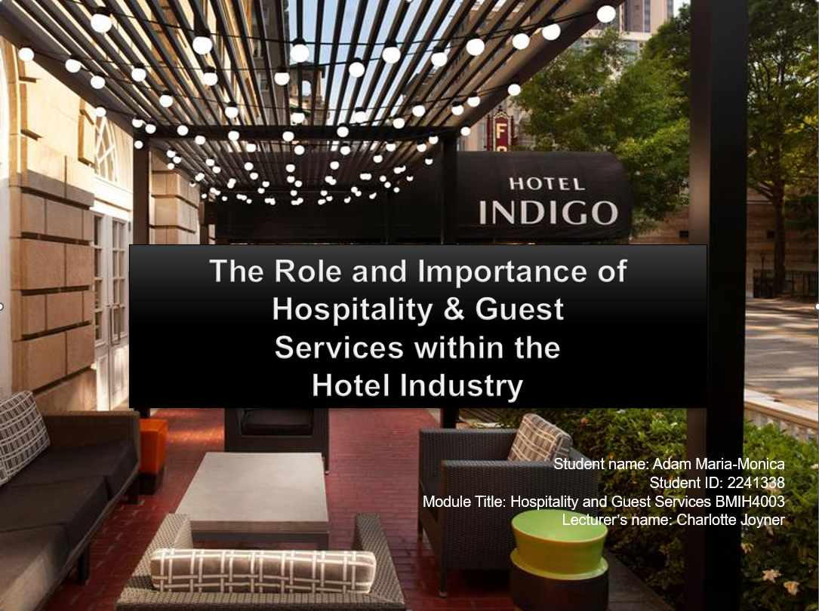

Slide 2
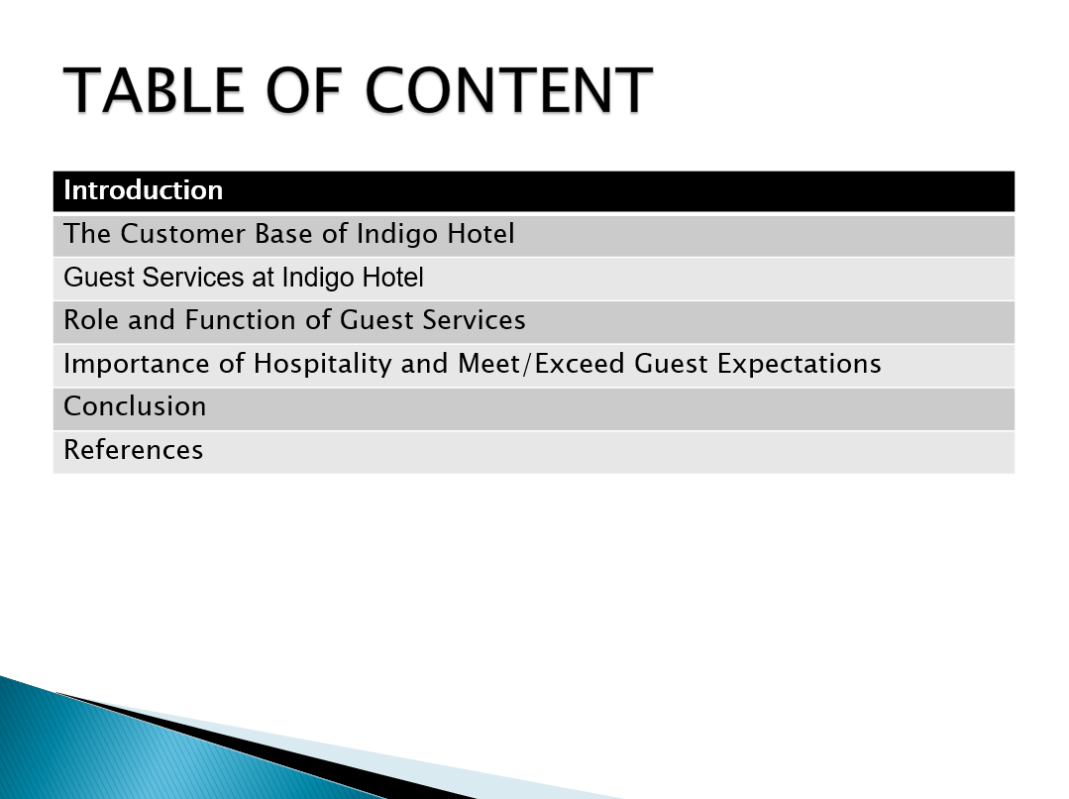

Slide 3
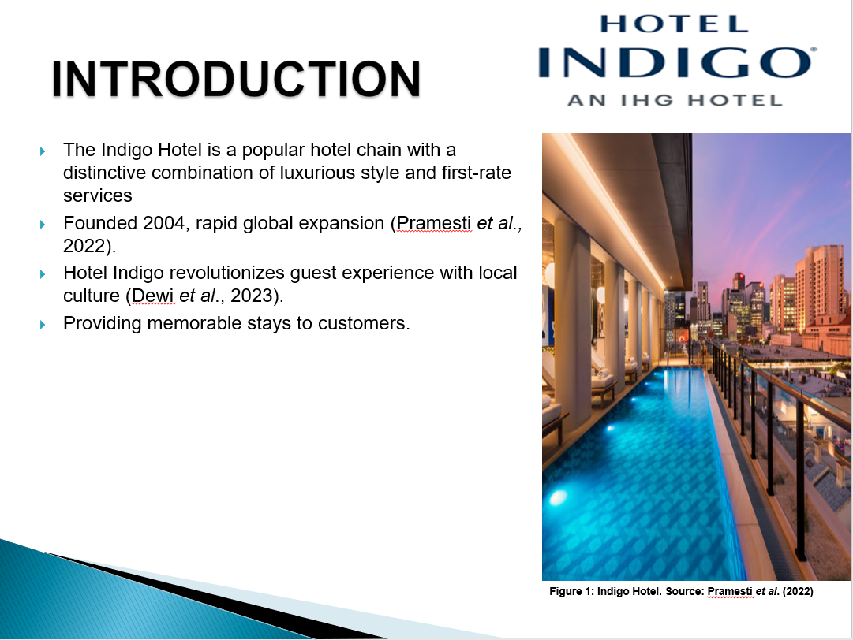

Slide 4
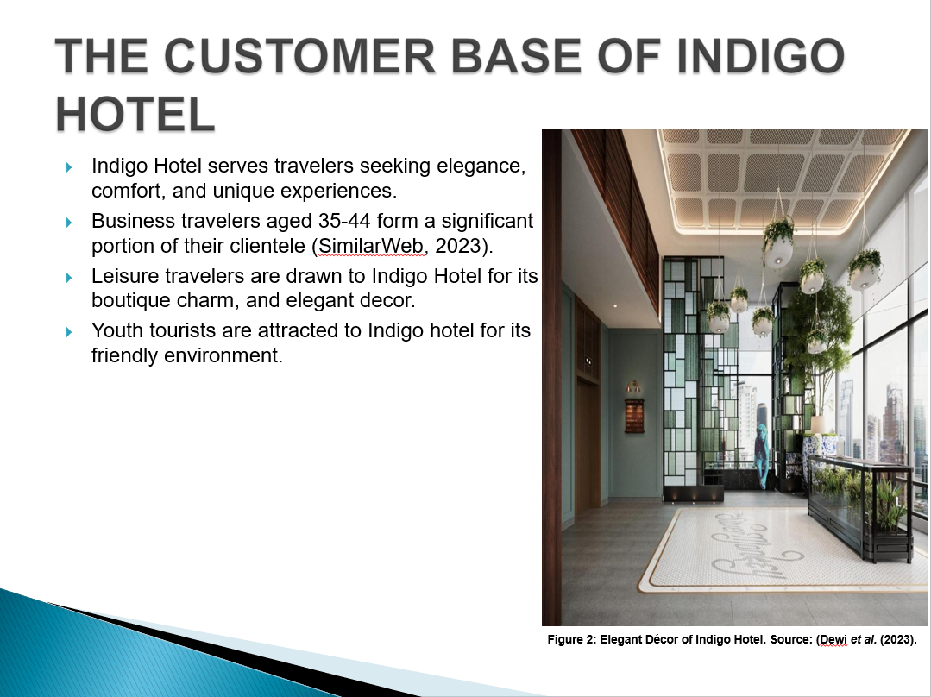

Slide 5
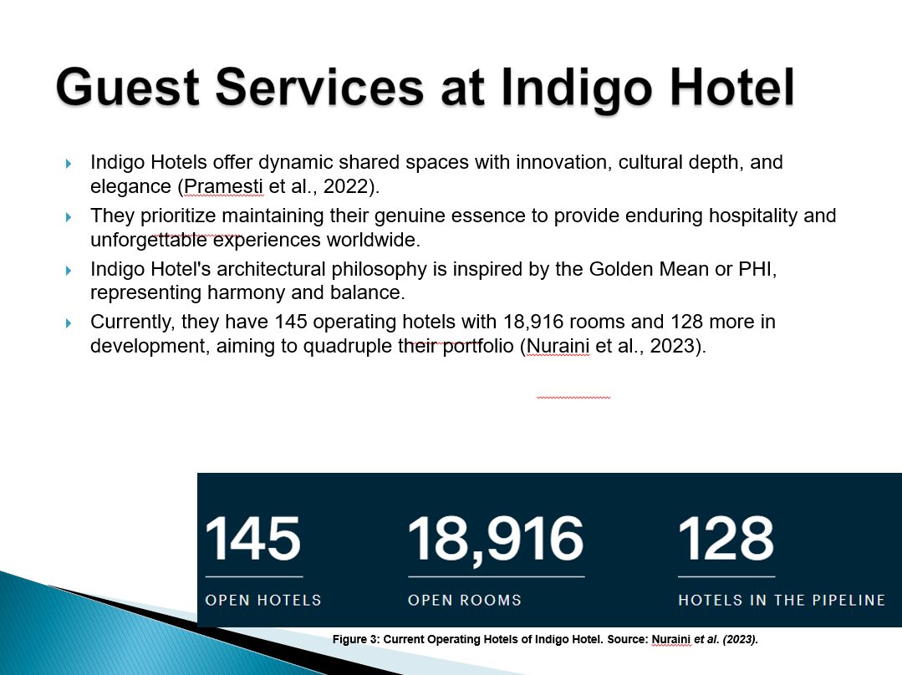

Slide 6
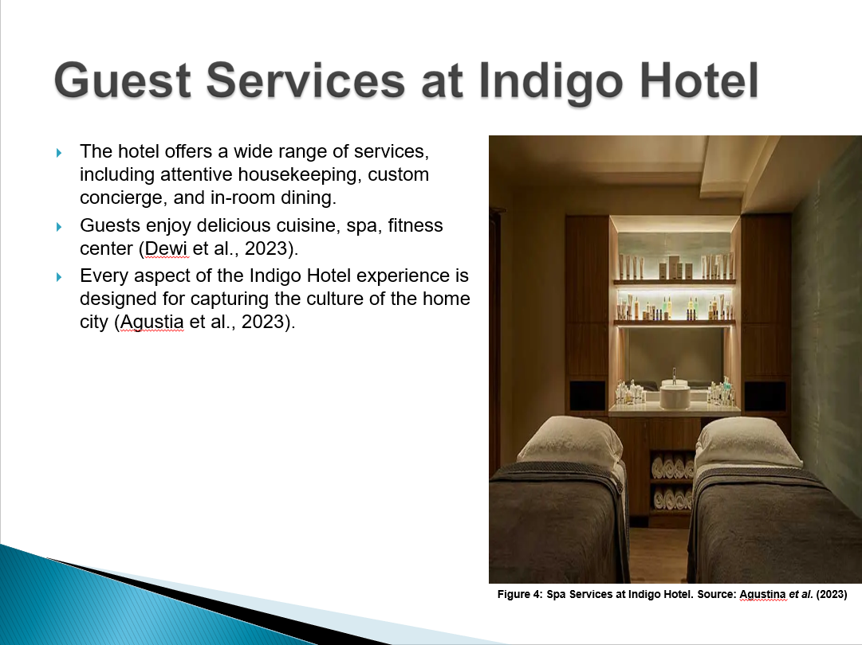

Slide 7
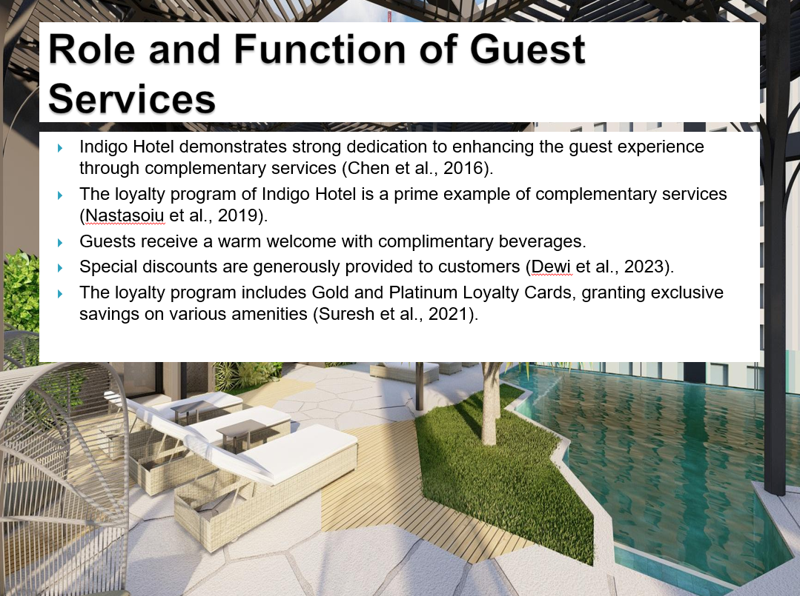

Slide 8
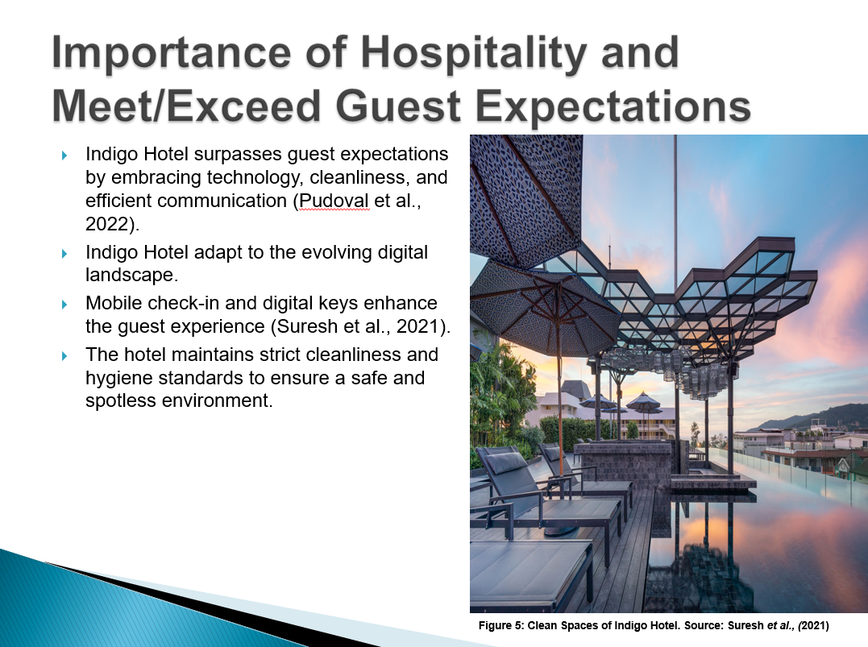

Slide 9
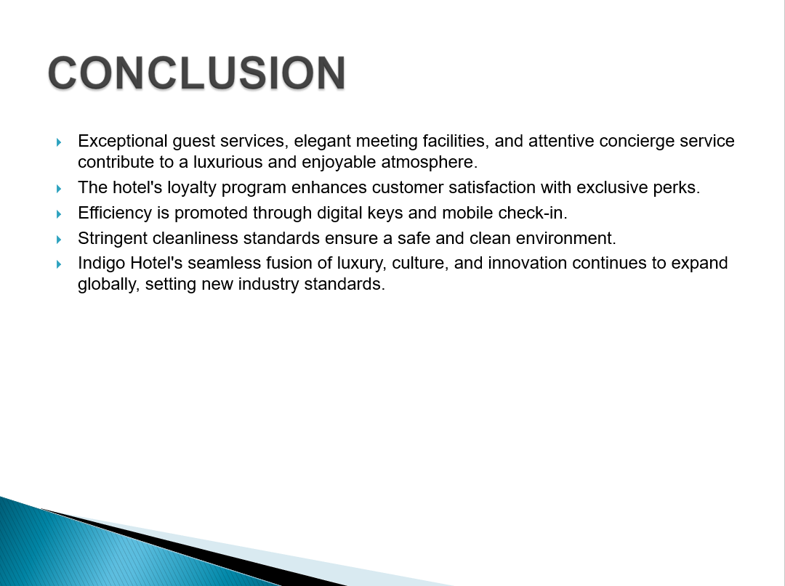

Slide 10


