Data Handling & Business Intelligence

“AS2: Data Analysis & Visualisation”
Name: Galina Rais
ID: 2020307

Table of Contents
Introduction 3
Part 1 4
Superstore sales analysis 4
An assessment of the effectiveness of Excel as a tool for data pre-processing, processing and visualisation 8
Data pre-processing 8
Excel data processing tool 10
Data visualization tools in Excel 12
Part 2 14
2.1: Students like Vanilla flavour 14
2.2 Male and female student numbers 14
2.3: Mean and median of the student who likes chocolate and strawberry flavour 15
2.4: Clustering 17
2.5 Data mining and text mining methods 18
2.6: Advantages and disadvantages 19
Conclusion 21
References 22

Introduction
Business intelligence uses a variety of software tools to analyse data at multiple levels to make insightful decisions. Two statistical programmes that are frequently used for data analysis purposes are Excel and SPSS. The tools will be assessed in this project and used for pre-processing, processing, and data visualisation. Furthermore, this paper will also cover several data mining techniques. The given Superstore data set will be used to conduct part 1 of this task and for part 2 ice-cream data will be used.

Part 1

Superstore sales analysis
The second step in the data processing process, data analysis, gives the gathered data structure and order. Excel's SUM function will be used in data analysis, and graphs will be used for data display (Funmilola, 2017). The primary goal of the superstore data analysis is to identify a decline in profitability and sales. Graphs illustrating changes in sales will be produced using data from the PIVOT table.
Sum of Sales
4500000
4000000
3500000
3000000
2500000
2000000
1500000
1000000
500000
0
2009
2010
2011
2012

The graph above provides a good idea of how the superstore's sales varied from lowest to highest between 2009 and 2012. The superstore's top sales volume is about. The graph displays the company's declining sales. Numeric factors that quantify the superstore's sales fall must be evaluated to comprehend their pattern and other changes that correspond to those changes. The study of the graph shows that the unit price and sales have a large inverse relationship, which is the reason why the superstore is losing customers.

.
Sum of Order Quantity
55000

54000

53000

52000

51000

50000

49000
2009
2010
2011
2012
The graph above displays the year total of orders. The graph shows a shifting pattern, with the highest number of sales occurring in 2009 and the lowest sales occurring in 2011
Sum of Discount
107

106

105

104

103

102

101

100

99
2009
2010
2011
2012
The aforementioned illustrates the shifting trends in discount amounts. The association depicted in the graph indicates no variation in discount over time. Compared to other years that had about the same quantity of sales and discounts, 2010 had the largest discount
.
Sum of Unit Price
250000
200000
150000
100000
50000
0
2009
2010
2011
2012

The graph shows a cost-of-shipping analysis. As the company's revenues increased at that time, the shipping costs decreased with time.
The superstore's sales change with time. The data set spans the years 2009 to 2012, however, because it is so huge, data sorting is necessary. Following sorting, the average formula was used to determine the average sales price for each year. The formula for calculating the average is "=AVERAGE (Range)" (Funmilola, 2017). According to the calculations, the average sales in 2009 were £1955.47, compared to £1616.25 in 2010. As a result, it shows that in 2010 compared to earlier years, average sales decreased. The global depression that began in 2009 and began to have a serious impact on the UK in 2010 was likely to blame for the sales fall.

In the following two years, 2011, and 2012, sales began to rise in comparison to the prior years. However, in 2011 and 2012, respectively, the average sales were £1721.21 and £1822.01. The sales changes over four years are depicted in the bar graph below.

The percentage of average sales over the past four years is depicted in the pie chart below (Sawilowsky, 2017). The graph demonstrates that sales have not varied significantly over time, but rather that the average sales marginally fell in 2010 as compared to 2009. The average sales percentage fell to 22.71 percent in 2009 from 27.48 percent this year. Consequently, the global recession caused a decrease in sales of 5% this year.

However, the sales climbed somewhat once more in 2011 by 2%, reaching 24.19%. On the other hand, as the economy began to recover in those years, the average sales grew by another 1.41 percent, reaching 25.60 percent, in 2012. The data above shows that, despite the sales fluctuations, the superstore was not severely impacted. A modest fall occurred in 2010, but it was followed by a comeback in the following years, even if it did not reach sales in 2012.
According to the study mentioned above, which was gathered from the superstore, Microsoft Excel can be utilised for data analysis, pre-processing, and subsequently data visualisation. This demonstrates that Excel may be used to determine the causes for the superstore's decreasing sales as well as the reasons why they have fallen.

An assessment of the effectiveness of Excel as a tool for data pre-processing, processing and visualisation
Excel is a tool used in business intelligence that helps the organisation and other analysts make data useful for making educated decisions. The benefits of using Excel for data pre-processing, processing, and visualisation are discussed in the sections that follow.

Data pre-processing
Preparing data for processing is referred to as data preparation. The justification for it is that large data sets may include outliers and unneeded inputs that are referred to as "junk" in data analysis (Sawilowsky, 2017). It is crucial to clean up the data and make it useable before processing. Additionally, it makes it easier to keep the standard error within a generally accepted range or to eliminate it from the result.
The most popular data preparation method used in Excel is data sorting. The data can be arranged in the desired order with the help of sorting. Under the Insert tab is a sorting option that can be used to do operations like filtering, custom sorting, and sorting from largest to smallest (Gulay, 2018). When the filtering option is chosen, a filter can be added for two or more menus. On the other hand, user-customized sorting allows for sorting in the manner of choice.
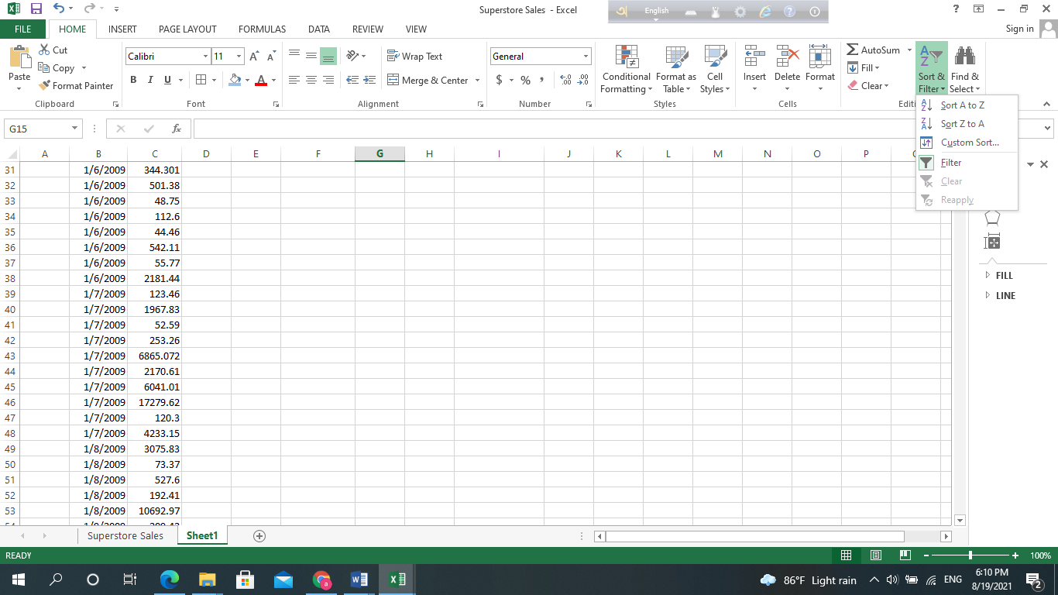
However, choosing the custom sort opens a sort dialogue box where you must provide the range and values for the customised sorting. The sorting procedure is concluded by selecting okay. Using Excel's logical functions, such as IF functions, data can also be preprocessed in addition to being sorted.
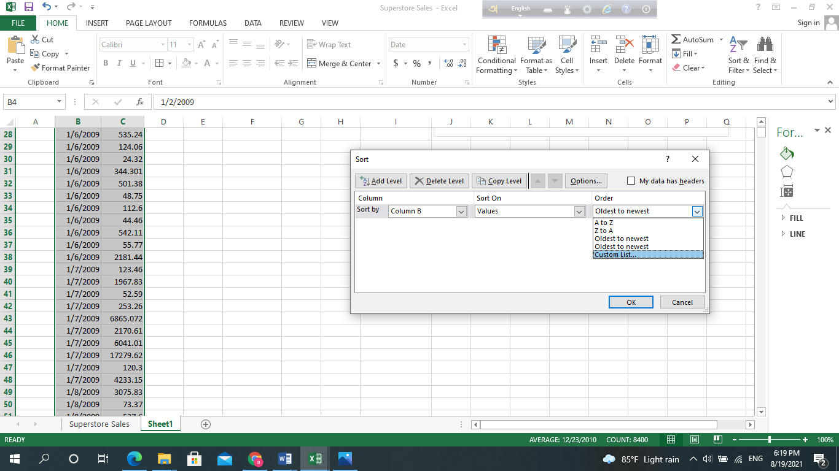
Outliers in the IF function can be discovered using a logical test. For instance, the logical function should be =IF(Cell2500" YES"," NO") if one wants to find all values below 2500 to identify the outlier. The remainder will display "NO," while all values less than 2500 will display "YES."
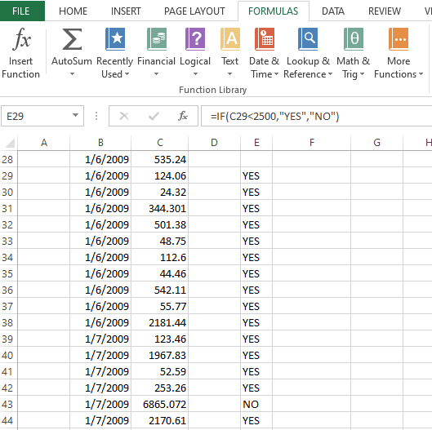
Similar to this, data preparation is supported via the LEFT, RIGHT, MID, etc. functions. As a result, it is possible to extract the absolute data from a big data set.

Excel data processing tool
The built-in features of Excel include a few key data analysis tools that are necessary for processing data for decision-making (Gulay, 2018). Excel's "AVERAGE" function, which quickly calculates the average value of a big data collection, is its most fundamental feature. The following excel screenshot also includes the formula for computing the average from cells C1 through C897: =AVERAGE(C1:C897).
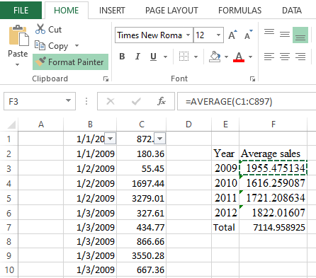
The formula is displayed in the formula bar, and cell F3 has the result value. Excel may be used to analyse data using financial methods such as NPV, IRR, PV, FV, etc. (Funmilola, 2017). The IRR functions, however, can be found on the formula tab of the financial tools menu. The output of the IRR can be obtained by selecting an outcome area, a range, and a value prediction (Internal Rate of Return).
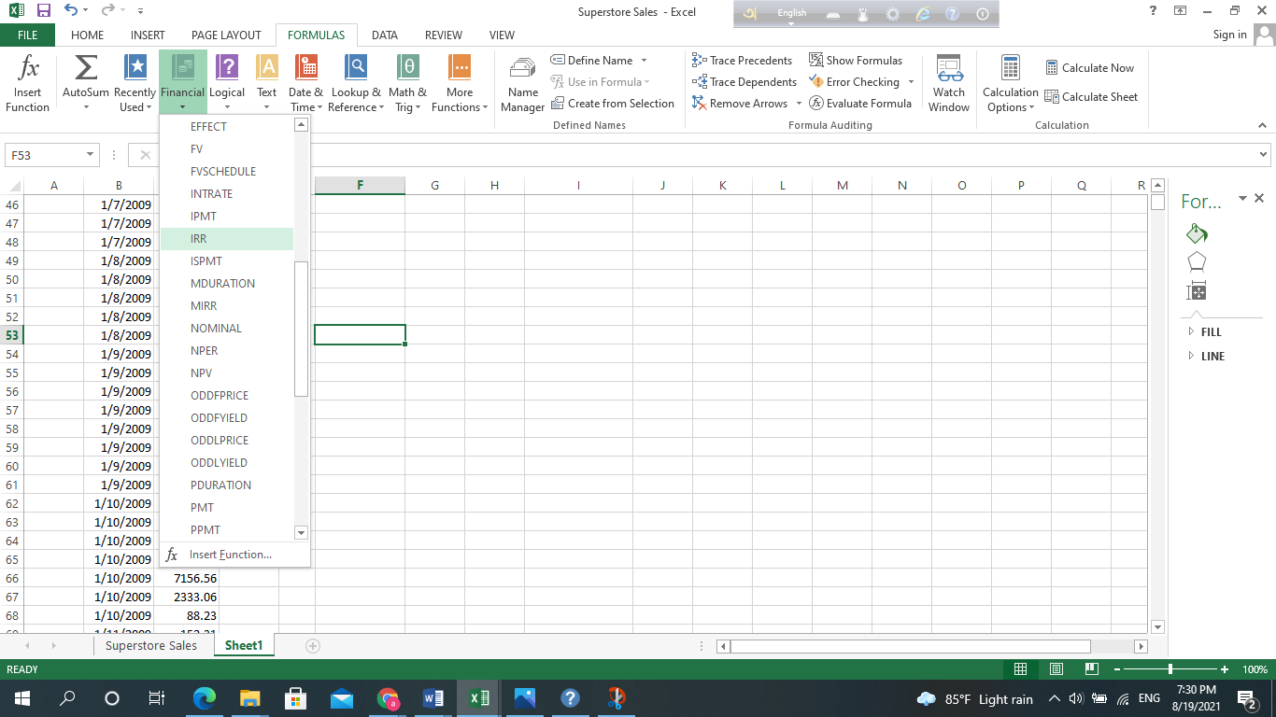
Excel's statistical data analysis features, such as the standard deviation, modes, mean, and median, are used to analyse data for both financial and statistical decision-making. The standard deviation examines variations or deviations from the mean in a value. But it can be done so by selecting the "STDV" function from the Statistical tool menu in the formula bar.
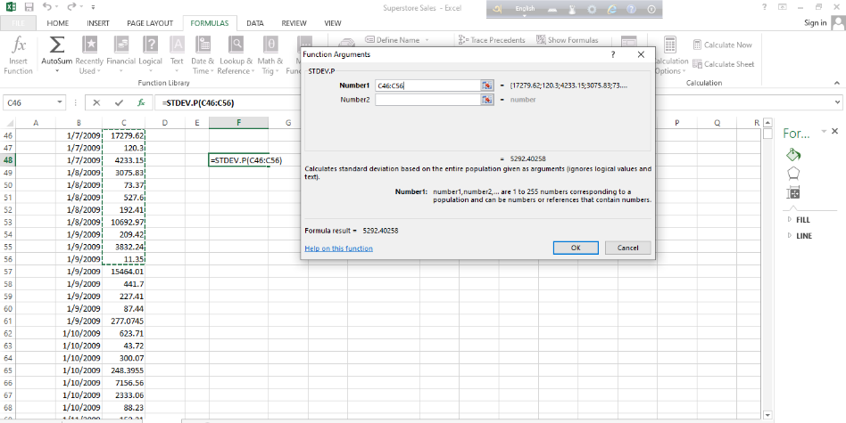
After entering the formula =STDV, a dialogue box where the range of the values must be entered appears to calculate the standard deviation. The chosen cell position will show the intended result. Excel can also be used to analyse financial data, statistical data, math and trig difficulties, engineering problems, etc.

Data visualization tools in Excel
Tools for Excel can be used to visualise data that affects the party being visualised. However, the function is carried out utilising several Excel features for data visualisation, including pie charts, bar graphs, line graphs, dispersed or bubble graphs, etc. (Smith, 2019). They offer sustained comprehension and efficient learning of the obtained data set's real-world situation. For instance, a pie chart illustrating the proportion of sales to total sales was produced in the preceding section's analysis of the sales data.
However, it necessitates utilising an excel formula to convert the average sales into percentage forms. For instance, the Excel formula will be =F5*100/F9 when converting the average sales amount into percentage form in I5. The average sales % will then be calculated by dragging the figure over the following four years. Later, the data area needs to be chosen or highlighted to create a pie chart.
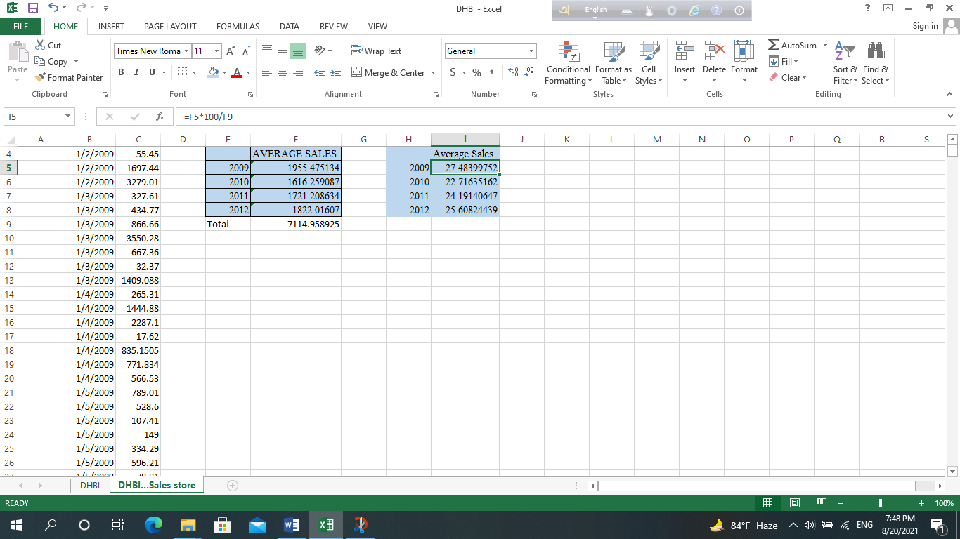
Then, choose a suitable pie chart icon from the chart menu located beneath the insert tab. A 2D, 3D, or Doughnut pie chart is available in the pie chart menu. The pie chart will be produced by choosing the desired icon.
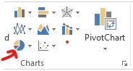

Bar charts and line graphs can also be used to visualise data. The bar charts use a series of lines for the relevant years to depict data fluctuations over time. The line graphs, on the other hand, likewise display the variations in sales over time with a line connecting the first desired years to the last wanted years (Smith, 2019). The audiences and the type of data should be taken into account while choosing a data visualisation tool from the list. It is justified by the idea that if visualisation becomes intricate, it will be unable to achieve the intended result.
Excel is a potent tool for data management and business intelligence from the discussion above of evaluating Excel tools for data pre-processing, data processing, and data visualisation. They support preparing the data for analysis, employing a variety of analytical techniques, and visualising the data for the customers' convenience.

Part 2

2.1: Students like Vanilla flavour
 |  | Frequency | Percent | Valid Percent | Cumulative Percent
 | Vanilla | 95 | 47.5 | 47.5 | 47.5
Valid | Chocolate | 47 | 23.5 | 23.5 | 71.0
 | Strawberry | 58 | 29.0 | 29.0 | 100.0
 | Total | 200 | 100.0 | 100.0

The tabular data display demonstrates that most students preferred the vanilla ice cream flavour (200 in total). A total of 95 kids, or 47.5% of the 475 students, chose the vanilla flavour. 58 students selected strawberry ice cream as their second favourite flavour.

2.2 Male and female student numbers
 |  | Frequency | Percent | Valid Percent | Cumulative Percent
Valid | Male | 91 | 45.5% | 45.5% | 45.5%
 | Female | 109 | 54.5% | 54.5% | 100.0%
 | Total | 200 | 100% | 100%

According to the analysis of the aforementioned bar chart, out of the total 200 students chosen for the survey. In this sample size selection, there were an equal number of male and female students. Based on the information given, it is reasonable to assume that 91 of them were men and 109 were women.

2.3: Mean and median of the student who likes chocolate and strawberry flavour
 |  | Id | Ice cream
N | Valid | 200 | 200
 | Missing | 0 | 0
Men |  | 100.5 | 1.8
Median |  | 100.5 | 2.0

Frequency table
 |  | Frequency | Percent | Valid Percent | Cumulative % Percent
Valid | Vanilla | 95 | 47.5% | 47.5% | 47.5%
 | Chocolate | 47 | 23.5% | 23.5% | 71%
 | Strawberry | 58 | 29.0% | 29.0% | 100%
 | Total | 200 | 100% | 100%

Based on the frequency of the ice cream flavours, the mean and median were calculated using a histogram graph. The estimated data's 1.82 mean suggests that students generally enjoy ice cream. The median, which was established at 2 (Isabell et al., 2022), represents the dataset's midpoint. There are 23.5 and 47.5 students, respectively, who prefer chocolate and vanilla ice cream.
Findings and discussion
The results of the data set showed that most students favoured vanilla ice cream. 200 students were selected as the sample size based on the findings. In the sample size, men and women were approximately equally represented. There were 91 men and 109 women in this group (Altman and Krzywinski, 2017). The majority of the student candidates favoured vanilla ice cream, it was also discovered. Cluster analysis is one of the exploratory analytic methods that focus on discovering data structures. The segmentation analysis is another name for the currently being used analysis.
While considering relevant information, several conversations on common data mining and text mining methods that might be applied in business are held. This category includes techniques like information extraction, grouping, and summarization, among many others. By using these techniques, the project's information extraction is improved, and effective information and data extraction techniques are found (Tuchkova and Kondrasheva, 2019). For the survey, 200 pupils from the school who met the prerequisites were chosen from a pool. This sparked fresh discussions on categorising the variables and giving company managers the relevant data they need.

2.4: Clustering
Intimal cluster centre
 | Cluster
Id | 1 | 200
Female | 1 | 0
Ice Cream |  | 1
Iteration history
Iteration | Change in Cluster Centers
Iteration | 1 | 2
1 | 49.5 | 49.5
2 | 0.0 | 0.0
Cluster centres underwent no or little alteration, leading to convergence. Any centre’s biggest absolute coordinate change is.000. Iteration two is presently under development. 199.005 is the minimum distance between the starting sites.
Final cluster centre
 | Cluster
Id | 51 | 151
Female | 1 | 0
Ice Cream | 2 | 2

Distances
Cluster | 1 | 2
1 |  | 100.0
2 | 100.0
ANOVA
 | Cluster |  | Error |  | F | Sig.
 | Mean Square | df | Mean Square | df | F | Sig.
Id | 500000.0 | 1 | 841.7 | 198 | 594.1 | 0.0
Female | 0.605 | 1 | 0.247 | 198 | 2.5 | 0.1
Ice-cream | 0.605 | 1 | 0.735 | 198 | 0.823 | 0.4
Because the clusters were generated in a way that maximised the differences between instances in various clusters, the F tests should only be used for descriptive purposes. Therefore, the observed significance levels cannot be interpreted as tests of the equal cluster means hypothesis.
Cases number in each cluster
Cluster | 1 | 100.0
 | 2 | 100.0
Valid |  | 200.0
Missing |  | 0.0

One of the most well-liked and efficient data mining methods is the k-means clustering algorithm (Wang, Kung and Byrd, 2018). Data scientists use an unsupervised learning strategy to handle clustering problems. 594.059 is the greatest frequency, while 198 is the estimated df value as a result of mistakes. The initial cluster centres, final cluster distance, and the number of instances in each cluster were generated as three tables to cluster the data. The data were grouped based on these tables, and useful information was extrapolated from them.

2.5 Data mining and text mining methods
Data mining is a technique used in business intelligence to analyse data and make wise judgments (Tuchkova and Kondrasheva, 2019). Making the data set ready and competitive for making informed judgments is the goal of data mining. However, the analysts employ several data mining approaches, which are described in the next section.
Methods | Analysis
Association | In the well-known data mining technique of association, analysts try to find connections between the data in a data collection. Additionally, related data will be used for analysis while other data would be ignored (Gulay, 2018). For instance, while purchasing power is not related to sales, advertising and promotions are.
Forecasting | The analyst can predict future events using a variety of forecasting techniques based on historical data. Other data mining techniques are included, such as trend analysis, clustering, association, connection, etc.
Clustering | The method of locating the variables groups in particular areas is known as the clustering approach (Nasraoui and Ben N'Cir, 2019). The scattered graph helps you visualise how the variables are dispersed throughout the map.
Behavioural patterns | With this approach, the analyst aims to identify previous data patterns and make future predictions using them. The analyst uses historical data spanning several years for this purpose.
Classification | Based on the type of analysis being performed and its goals, the data set is classified into various classifications. For instance, it is necessary to categorise sales with promotions, without promotions, etc. in sales data.

2.6: Advantages and disadvantages
There are various advantages and disadvantages to using SPSS with Excel, which is supported by practical examples and covered in the table (Isbell et. al., 2022). This makes it possible for business managers to carry out fruitful market research and choose realistic plans that might lead to the desired results.
SPSS
Advantages | Disadvantages
• Statistical Package for Social Sciences (SPSS) For students to afford SPSS, it is too expensive.  • The interpretation of the results is straightforward (Krymkowski and Norusis, 2014).  • For a simple table of data, an activity that needs to be finished quickly appears to take a very long time. | • It might not always be possible to extend.  • There are numerous statistical studies accessible, ranging in sophistication.  • To use the newly available feature, you will need extra training.  •  Here, the capability is more advanced and comparable to Excel.
Excel
Advantages | Disadvantages
• Data is kept in the cloud.  • carry out operations in mathematics  • There are analytical methods accessible.  • Simple to comprehend (Sawilowsky, 2017).  • Free downloads of templates are available.  • Coding with computers. | • Lack of security and lack of self-control • Not immune to human error  • Difficult to obtain security  • Agile business practices that are improper for your organisation  • Cannot be completed quickly and discourage collaboration on projects  • Tests are challenging to administer

Conclusion
In conclusion, Excel is a business intelligence tool that aids in making data usable for making educated decisions for the firm as well as other analysts. Excel is used to prepare, process, and visualise data so that insightful decisions can be made. Finding the variables that cluster in particular areas is done using clustering algorithms. The scattered graph helps you visualise how the variables are dispersed throughout the map. Data mining is also used in business intelligence to analyse data and make smart judgments. Making the data set ready and competitive for making informed judgments is the goal of data mining. The SPSS software, on the other hand, is specialised bundled software for data analysis. Excel is a free data analysis programme used with the Windows operating system. But compared to Excel, SPSS has both benefits and drawbacks.

References
Altman, N. and Krzywinski, M., 2017. Clustering. Nature Methods, 14(6), pp.545-546.
Funmilola A, O., 2017. Analysis and Comparison of Open Source Business Intelligence to Commercial Business Intelligence for SME in the UK. Data Research, 1(1), p.44.
Gulay, E., 2018. Comparing Simple Forecasting Methods and Complex Methods: A Frame of Forecasting Competition. Scientific Annals of Economics and Business, 65(2), pp.159-169.
Krymkowski, D. and Norusis, M., 2014. The SPSS Guide to Data Analysis for SPSS x. Teaching Sociology, 16(4), p.472.
Nasraoui, O. and Ben N'Cir, C., 2019. Clustering Methods for Big Data Analytics. Cham: Springer International Publishing.
Sawilowsky, S., 2017. Real data analysis. Charlotte, N.C.: Information Age Pub.
Smith, A., 2019. Data Leak Identification in Social Networks using K Means Clustering & Tabu K Means Clustering. International Journal of Innovative Technology and Exploring Engineering, 9(2), pp.2777-2783.
Tuchkova, A. and Kondrasheva, P., 2019. The term "data mining". Tasks solved by data mining methods. SCIENTIFIC DEVELOPMENT TRENDS AND EDUCATION.

