

Strategic Analysis and Evaluation of Softbank Group's Acquisition of ARM

Student Number: 1806559
Module Title: Strategic Change and Organisations (LCDB7005)
Module Lecturer: Dr. Gladius Kulothungan

Assignment 1

Strategic Analysis and Evaluation of Softbank Group's Acquisition of ARM

Introduction
Softbank spent $31.4 billion to acquire ARM. Softbank explains why it bought ARM: betting on IoT and cloud servers. It believed that "in the era of mobile communications (smart phones, etc.) and the Internet of Things (IoT), where all items such as household appliances, automobiles and infrastructure are equipped with semiconductors, the supply and sales of ARM processors will grow explosively". ARM is a "Unified Processor Architecture, No Chip Production" company. After acquiring the architecture authorization of ARM, these giants authorized chip design companies to develop processors on their own, and then find third-party wafer generation factories to manufacture them. With this business model, ARM builds a strong ecosystem, and its architecture strength lies in efficiency. In the field of smart phones and tablets, low cost, low power consumption and ecosystem advantages make ARM the global leader behind mobile chips. In the field of Internet of Things, the advantages of ARM will continue.
In this article, the second part uses the PESTEL model to analyze the external causes of the acquisition from a macro perspective, and from a micro level to analyze the necessity of Softbank's acquisition of ARM. The third part introduces the difficulties faced by Softbank and ARM after acquisition, and looks at the strategic adjustment made after acquisition from the perspective of Softbank and ARM company respectively.

Reasons

2.1 Macro Motivation——PESTEL Model
The macro environment makes it necessary for Softbank Group to acquire ARM. We use PESTEL model to analyze the influencing factors at that time.
- Political
The Japanese government encourages local companies to invest overseas. Through the international strategic layout, Japanese enterprises can invest in projects with high risk overseas and shield the risk outside Japan. If Softbank succeeds in investing in ARM, it can bring capital, proven technology and business model back to Japan while making huge profits. If the investment fails, it can also summarize experience and lessons in time to avoid the same risks in Japan.
Immigration restrictions. Against the background of population reduction and weak growth of domestic demand, Japanese enterprises actively explore overseas markets to compensate for the shrinking domestic demand. At the same time, shareholders hope that enterprises will improve the efficiency of capital utilization, pay more attention to the rate of return on investment, and accelerate the speed of overseas investment and mergers and acquisitions of Japanese enterprises(Barney, 1991; International Organization for Migration, 2018).
- Economic
The global economic growth rate in 2015 is estimated to be only 2.4%. In many countries, the reduced employment intensity of economic growth, coupled with the stagnation of real wages, poses a great challenge to promoting inclusive and sustainable economic and employment growth. In 2015, the unemployment rates in the United States, Japan and the euro area were 5.3%, 3.4% and 10.9% respectively (UK unemployment rate was 5.5%), (Eurostat, 2016) . After Softbank agreed to acquire ARM, the number of employees in the UK doubled, and the existing management and business model remained. For UK, it is also an acquisition to ease employment pressure.
The exchange rate between Britain and Japan is at an all-time low. Britain's withdrawal from Europe led to a 30% drop in the pound-yen exchange rate, making ARM an attractive acquisition target for Softbank, with a 43% premium not expensive(Sara Sjolin, 2016).
- Social
Population structure and people's way of life have changed. On the one hand, it is expected that by 2050, the global aging population will be the largest single-age population in the world. The smarter the interconnected family is, the safer it is. Using technology, enterprises can create a better living environment for people, so that people can live independently at home, for patients, caregivers, family members, relatives and medical personnel is the best thing.
On the other hand, great changes have taken place in people's way of life. From Table 1, it can be seen that the number of mobile phone users worldwide is increasing year by year, and the growth of the number of users has also brought a lot of application demand. In 2018, 66% of individuals in 52 major countries owned smartphones, up from 63% in 2017 and 58% in 2016(Eurostat, 2016). In addition, the open gene of mobile Internet makes the entrepreneurs invest in the development of mobile applications without hesitation, and the demand of users also makes the rapid development of intelligent devices. All these make people enter the era of intelligent life. Intelligent life is a new way of life. It is based on the Internet platform, relying on cloud computing and cloud services, integrating family scene functions and rich smart home terminal cooperation. Smart home control system, and presents home from many directions and angles. More comfortable, more convenient, safer and healthier specific scenes in the family life, and then jointly create an intelligent community with a common concept of intelligent life. Companies at the forefront of the world should firmly grasp the revolution brought about by changes in people's lifestyles and change their strategies. The acquisition of ARM is a key step in the strategic layout of Softbank.
Table 1: Number of mobile phone users worldwide from 2015 to 2020
(in billions)
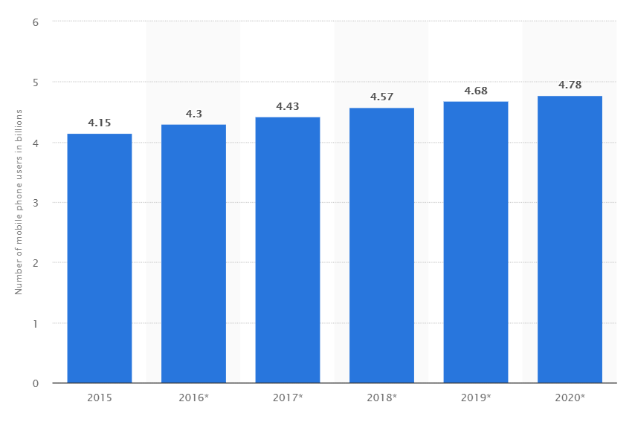
Source:(Statista, 2016)

- Technology
At present, the Internet of Things is the singularity of economic growth. With the popularity of the Internet, people are more and more closely linked. After 2015, this connection basically stopped growing. Now it is the connection between objects and people, so the Internet of Things has expanded its scope. At present, the penetration rate of mobile terminals in most regions of the world is basically saturated. As of the end of October 2017, there are 7.5 billion Networked Mobile terminals, which have entered the stage of slow growth with CAGR of about 3%. On the other hand, the rapid development of the IoT, local connectivity maintained an 18% growth in CAGR, wide-area (including cellular and LPWA) industrial chain mature triggered the outbreak of connectivity, CAGR 26% (Table 2). It is foreseeable that in the next five years, the layout of the Internet of things will be three times that of the collection terminal network, bringing closer connections, applications and data（Table 3）.

Table 2：Development of Connected devices (billions)
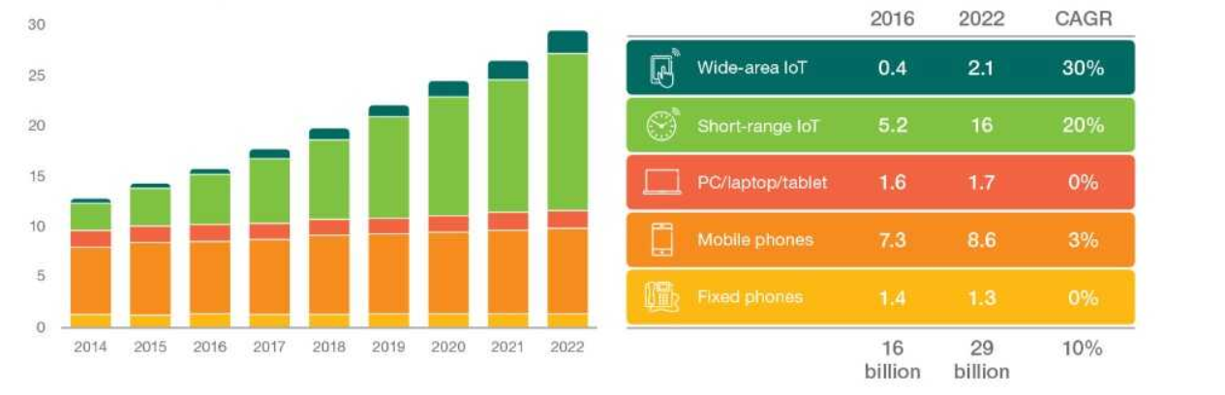
Resource：(Shanhong Liu, 2018)

Table 3: Internet of Things (IoT) connected devices installed base worldwide from 2015 to 2025 (in billions)
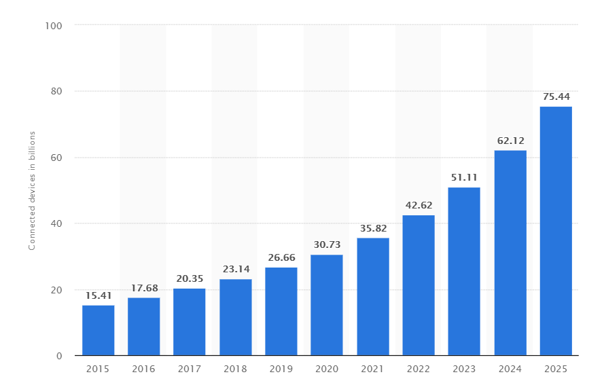
Resource: (Statista Research Department, 2016)
The core of the development of Internet of Things is chips. Chips are everywhere. Specifically, the applications around us, such as voice assistants on mobile phones, fingerprint recognition, face recognition, iris recognition and so on, are the application scenarios of artificial intelligence. The emergence of military and civil UAVs and driverless vehicles is the trend of the future, all of which cannot be separated from artificial intelligence. But AI is not a castle in the air. It has to be attached to something. That's the chip. Traditional CPU and GPU (Graphic Processor Unit) can also calculate AI, but their efficiency is very low.
Another technological revolution is that the world is entering the 5G era. Once 5G is applied and popularized on a large scale, it is of great social significance. At present, information technology is changing from mobile interconnection to universal interconnection. The technological breakthrough of 5G network not only brings consumers a faster and smoother online experience, but also solves the problem of transmission rate and huge data connection set. It has the scenario characteristics of large broadband, low latency and wide connection. Solve the pain point of the Internet of Things. From the era of one-person-card networking with billions of users to the era of interconnection with tens of billions of terminals, the identification and connection of massive networking devices just need to flourish. 5G is the driving force of the ecosystem of the Internet of Things.
Driven by scientific and technological forces, ARM, as the front-end of chip technology, has a large number of market demand, firmly occupies the dominant position, and the acquisition of ARM will give Softbank more voice in the future.
- Environmental
As an Internet company, SoftBank is committed to creating an environment where everyone can safely and happily use the Internet, smartphones and other mobile communications services. SoftBank also promotes CSR activities aimed at educating children to use the Internet safely and reliably to support their healthy development. By understanding the vision of Softbank Group, its goal is to become a growing group in the next 300 years. SoftBank is using cutting-edge technology to protect the environment and adopt new energy sources(SoftBank, 2019).
Softbank's acquisition strategy can further integrate resources and optimize the environment. It is also Softbank Group's practice of corporate social responsibility (CSR) and sustainable development strategy.
- Legal
The level of market share is usually limited (e.g. under U.S. antitrust laws) to prevent organizations from unhealthy market control or acquisition. Softbank's acquisition of ARM has a legal advantage. Because ARM authorization occupies a monopoly position in the mobile terminal market. In fact, early Apple and other companies wanted to buy ARM, but because of the restrictions on mergers and acquisitions, if these companies buy ARM, they will be subject to anti-monopoly investigation. Softbank is legally permitted to acquire because of the nature of its business. The acquisition does not require advance EU anti-monopoly or regulatory approval, and is also beneficial for rapid shareholder approval.

2.2 Micro Motivation

2.2.1 Acquisition of Strategic Assets
The resource-based view (RBV) holds that the main purpose of cross-border M&A is to acquire strategic assets. Strategic assets determine the competitive advantage and performance of enterprises (Amit, Schoemaker, & Schoemaker, 1993). It can be defined as "a series of resources and capabilities that are difficult to trade and imitate, scarce and available for special use, and which can bring competitive advantages to enterprises" (Amit et al., 1993). These assets include reputation, supplier relationships, tacit knowledge, R&D capabilities, brands, knowledge and proprietary technology (Teece J., Gary, & Amy, 1997) .
For Softbank, ARM's chip design market position and its ecosystem are very attractive:
1） On the move terminals market, ARM takes up most of the market share. ARM implements cost leadership and focus strategy in chip design market（Table 4）. The key cost drivers to achieve cost leadership are input cost, economies of scale, experience and product design (Hashem Valipour, Hamid Birjandi, 2012). Because of its early entry, ARM has a lot of experience in the chip design market. 1) the time to enter the market is very important. 2) market share is also important. 3) with the passage of time, there will continue to be new gains(Johnson & Scholes, 2011; Stu Woo, 2016).ARM implements the differentiated focusing strategy in the focusing strategy, which is a good brand of low cost, low power consumption and high efficiency, caters to the development trend of many mobile devices, including smartphones, so as to unify computing devices in the Non-PC field. ARM dominates the world smartphone chip market, although its size is much smaller than that of the leading general chip manufacturer Intel.
Table 4: PC and Move terminals of Chip design
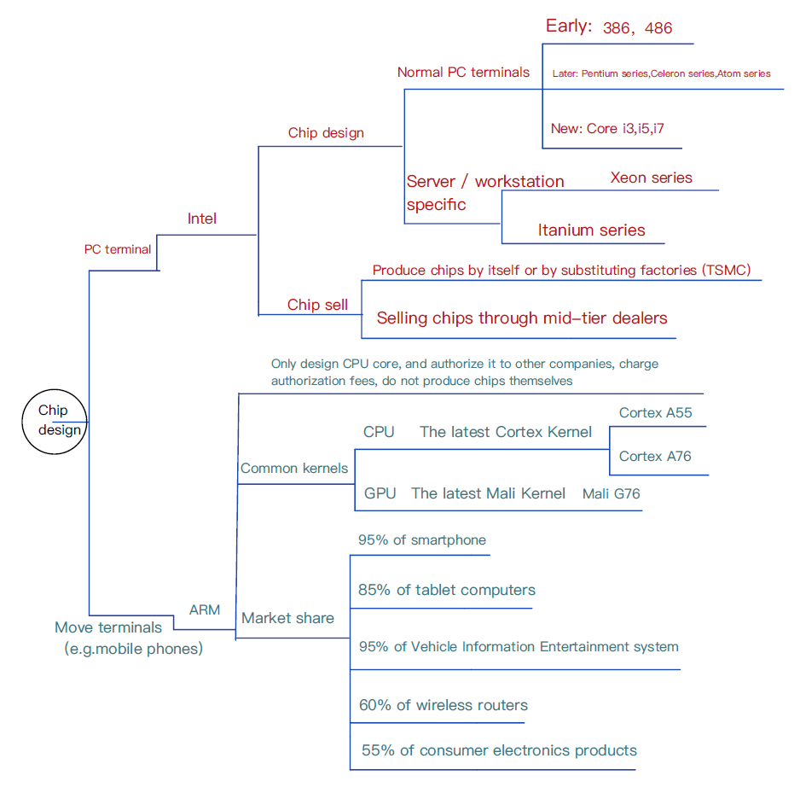
Resource: Author, (Lee, 2017)
Table 5 shows IC designing-IC manufacturing-IC testing-IC application area, ARM is at the top of the chip market, and because it occupies most of the mobile market, and people's living habits change, they tend to use mobile terminal. For Softbank, acquisition of ARM is controlling the main market of chips.
Table 5: The Relations of Different Core Companies in the Industrial Chain
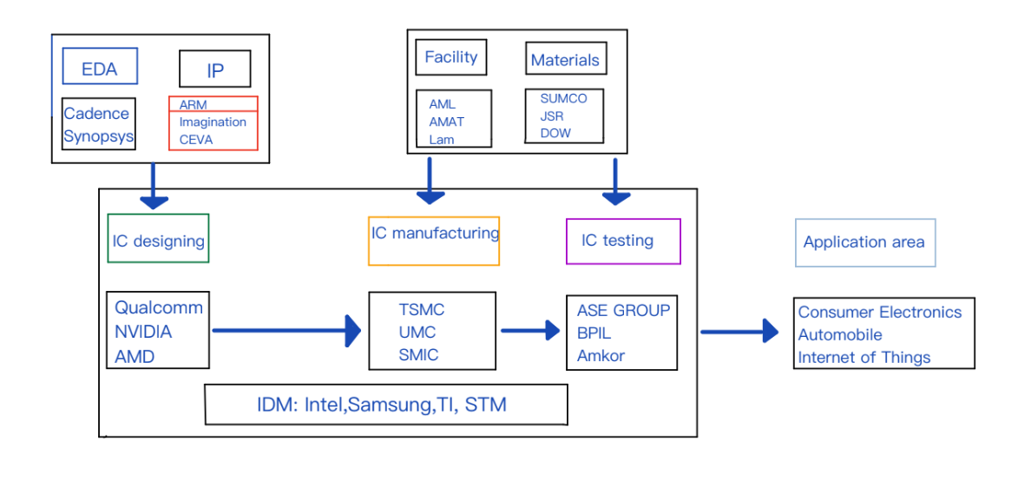
Source: Author
2） The ecosystem of ARM can consummate the ecosystem of Softbank Group.
In addition to its excellent chip design, ARM's business model is also innovative: it provides licensed intellectual property rights and does not manufacture and sell semiconductor chips. ARM authorizes chip design technology (core, system extension, microprocessor and system chip solution) to Intel, Samsung and other companies. After these companies get the ARM core, they design peripheral controllers and integrate the ARM core into a SoC chip. ARM integrates upstream and downstream resources and gradually forms a complete ecosystem, which makes its chips more developed and versatile. Its partners more than 300 companies, and more than 1000 chips using the authorized ARM core(SoftBank, 2018), include semiconductor manufacturers, development tools, application software designers and trainers (Table 6).

Table 6: ARM Ecosystem

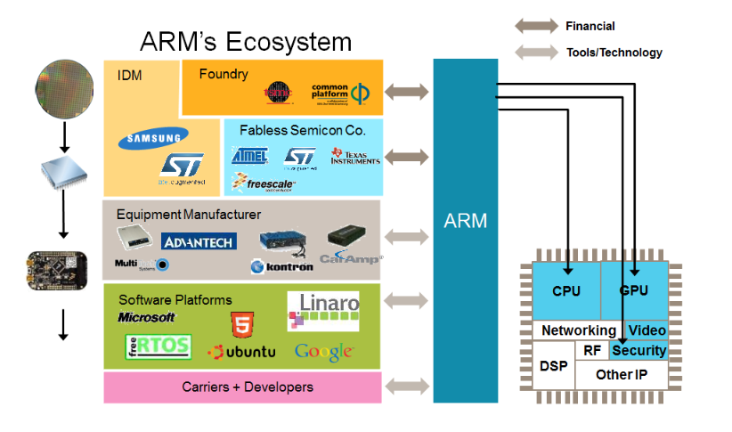
Source:(Karthik Ranjan, 2013)

For SoftBank, ARM ecosystem can help predict the future of technology. From conception the code of machine to delivery, ARM usually takes several years to complete a new design. In order to innovate its design process, ARM must make an accurate judgment on the development direction of the computer industry. Because it can take advantage of the close and continuous relationship with big customers (involving automobiles, medical devices, fitness tracking, UAVs, media, etc.), these industries are constantly being explored. One of ARM's biggest customers is Apple, which has also consulted with credit card companies such as MasterCard and media networks such as Netflix and Disney. All technology companies have been at the forefront of the world, and they are also predicting computing needs for years to come, they need ARM's help to build them. ARM became the information exchange center for future computing applications. After the acquisition of ARM, Softbank can acquire the most promising and worthwhile areas for investment.

2.2.2 Operating Synergy
Through acquisition, the synergy effect of enterprises can be better realized. In order to achieve synergy effect, the key resources of the acquired enterprise can enable the acquired enterprise to implement the strategy and substantially improve its efficiency and effectiveness. There is a direct relationship between key resources and output creation. In addition, the greater the contribution of resources to the value of products, the more important the resources are. The key resources that enhance the competitive position of enterprises through outstanding value creation are usually regarded as the core competitiveness of enterprises. By utilizing a core production technology, a synergistic role can be played in different product lines. Resource sharing leads to cost savings, and the benefits of the whole industry are obvious. Through sharing resources to achieve synergy, thereby generating competitive advantage (Gruca, Nath, & Mehra, 1997).
1）Softbank and ARM have similar vision and mission. Vision and mission are the core of enterprise culture, the soul of enterprise belief system and the starting point of all M&A activities(Montgomery, 2008; Papulova, 2014). Acquisition of ARM conforms to the strategic purpose of Softbank Group.
Softbank Group Vision statement is：The corporate group needed most by people around the world. Mission statement: Endeavoring to benefit society and the economy and maximize enterprise value by fostering the sharing of wisdom and knowledge gained through the IT revolution (Softbank Group, 2015). ARM vision statement is：A trillion securely connected devices, from device to cloud (Josh Walrath, 2018). Statements of shared vision, goals and activities are the common basis for their cooperation and interaction (Holub, 2016).
2）From a competitive point of view, integrated Softbank is expected to break new ground in the Internet of things, or AI, with an overwhelming advantage.
The key to synergies is that the target company controls a particular resource that becomes more valuable when combined with the bidder's resources. Softbank's acquisition of ARM is functional integration, which means that When a company that has an advantage in one functional area acquires another company that has an advantage in different functional areas (SoftBank Group, 2015)，the potential synergies benefit from taking advantage of these areas.
Firstly, first-mover advantage is that the organization gains competitive advantage by taking the lead in introducing new products, processes or services in the market (Johnson et al., 2011). With the dominance of ARM chip design, Softbank occupies the market in the Internet of Things, AI and other fields.
Secondly, after the merger, the pricing power of the enterprise increases, thus higher prices can be charged to downstream enterprises or consumers (Gaughan, 2010). For example, Qualcomm, Apple, Huawei and other large companies or institutions have purchased the ARM instruction set authorization, designed their own micro-structure, or companies such as MediaTek, Exhibition News have obtained the soft-core or hard-core authorization. These companies need to pay the authorization fee and need to renegotiate at some time. In addition, although ARM sells instruction set authorization, it modifies or expands the instruction set, so that ARM firmly holds the right to formulate standards.

Strategic Adjustment after Acquisition

3.1 Problems After the Acquisition
In order to achieve the goal of Softbank's acquisition of ARM, deploy the Internet of Things and develop AI technology, the following issues need to be considered:
- Number of users and security of information. Organizations and private micro vendors providing the Internet of Things need incentives to provide services. However, it is not clear how many customers are willing to pay. Moreover, users are worried about their own information security, which requires suppliers to provide a secure network environment (Bohli, Sorge, & Westhoff, 2009).
- Market penetration costs are high. Rogers described the diffusion of innovation with the S-curve (logistical curve). At first, few people invested in and adopted new technologies. After innovation is tested to be useful, other users will adopt it. When market penetration reaches a high level, the number of additional units sold will decrease (Table 7). Softbank needs a lot of investment to occupy the IoT market. Firstly, early users of the IoT need to be convinced of the practicality of their products. Secondly, the rate of increase in the number of users is also important, otherwise the applicability of innovation will be discounted. The production of useful IoT products depends on multi-party cooperation, so the market cost of penetration is very high (Bohli et al., 2009; Rogers, 2003).
Table 7: Logistical Curve
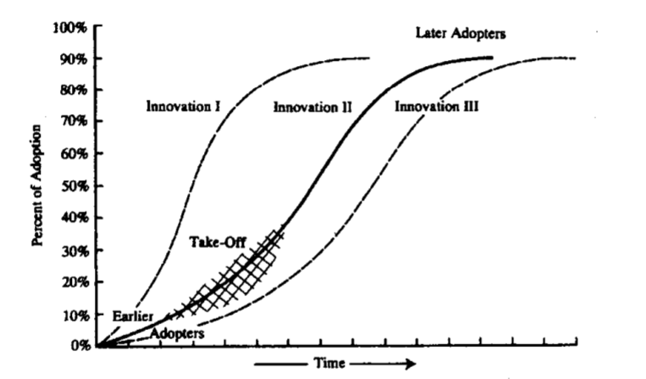
Source：(Rogers, 2003)
- Threats from competitors and policy controls. The first-mover advantage is not necessarily overwhelming, there are two advantages from the competitors. 1) Later competitors can imitate technology or other innovations and save 35% of the cost than innovators. 2) They will learn and observe what innovators do well and what they do badly, they can correct errors in the first time, so the cost of correcting errors is low(Johnson et al., 2011). Moreover, the increase of pricing power often depends on market concentration, which may cause trouble in anti-monopoly supervision (Gaughan, 2010).
In view of the above problems, Softbank and ARM have made some adjustments to their strategy and organizational structure after acquisition.

3.2 SoftBank Group

3.2.1 Group Strategy
As early as several years before the acquisition of ARM, Softbank began to lay out the Internet of Things, artificial intelligence and other technological fields. Including the acquisition of French Aldebaran Robot Company in 2014, and the launch of the well-known emotional robot Pepper. After the acquisition of ARM, Softbank integrated the upstream and downstream industry chain of the Internet of Things.
Softbank Group restructuring, divided into two parts, one for Japan's domestic business, focusing on telecommunications business, focusing on mobile business, is expected to grow slowly in the future, one for overseas investment business, and the direction of investment from the original Internet, telecommunications to robotics, the Internet of Things, artificial intelligence and other fields. It is expected to grow rapidly in the future.
For Softbank, it is necessary to maintain the independence of ARM. In business, "technology and price" are the two trump cards for ARM to occupy the market. In order to defeat the chip giant Intel, they have no distractions in technology development, and reasonable price is the biggest temptation to attract customers. However, if ARM cannot maintain independence after acquisition, due to different concepts, Softbank's involvement will more or less bring about a change, which will affect the business of ARM. This result, whether for Softbank or ARM, will be a little worthwhile. After independence, in order to stabilize the customer's heart and avoid the loss of customers and the sharp shrinkage of business, ARM's patent technology licensing fee/royalty fee will continue to remain within a reasonable price. At the same time, products for ARM customers will continue to maintain a high level, which means that costs continue to invest substantially.

3.2.2 Vision Fund
Just a month after the ARM acquisition, SoftBank Group created the Vision Fund. As a $97 billion fund, Vision Fund is the largest corporate investment fund in history. This fund is an important means to continuously lay out a series of "frontier" technology fields. Softbank has transferred almost a quarter of its ARM shares to the fund. The current portfolio of the Vision Fund finds that it covers many areas, such as chips, shared office space, biomedical, SaaS, agriculture and so on. The news of the expected $10 billion purchase of 20% of Uber shares is more likely to be the largest investment of the Vision Fund. Generally speaking, the vision fund is the Kingmaker strategy.

3.3 ARM

3.3.1 Expanding the IoT and IP Products Group
Softbank divides ARM into two departments, one called IPG, which is responsible for the IP core business of the traditional CPU and GPU. Another new Department is the IoT service department, which mainly deals with IoT solutions, operating systems and cloud services (ARM, 2017). In 2018, ARM acquired Treasure Data, a start-up dedicated to data analytics, and Stream Technologies, a company that develops and improves the connectivity of Internet of things devices. The ARM Technologies acquired from the deal were integrated into its Mbed Internet of things device management platform, which created ARM Pelion IoT platform based on Internet of things hardware.

3.3.2 Paying Attention to the Security of IoT
Risk management is a set of processes and practices used to identify potential risks and limit potential negative consequences. The significant growth of the Internet of Things has greatly increased the number of risk management and security challenges faced by enterprises. Cybercriminals are launching more complex and potentially destructive attacks. With the expansion of the Internet of Things, the number of devices that need to be protected is also increasing (ARM, 2019). Many Internet of Things devices cannot access, manage or monitor as traditional IT devices, and the availability, efficiency and effectiveness of network security and privacy functions are also different. This may require manual tasks for many Internet of Things. Device software needs to address the risk of remote access or control of Internet of Things devices by manufacturers and other third parties(Boeckl, Fagan, Fisher, & Scarfone, 2018).
Aiming at the security problem of the IoT, ARM PSA (Platform Security Architecture) platform security architecture aims to protect the security of trillion networking devices in the future (Table 8). In addition, ARM has also introduced Cortex-M23/M33 processor for Internet of Things security and introduced TrustZone technology based on ARM's latest ARMv8-M architecture. TrustZone ensures the security of data, firmware, and peripherals by creating independent trusted and untrusted states throughout the processor system (“Pelion, 2019).
Table 8: Device-to-Data Platform Built on a Strong Security Framework
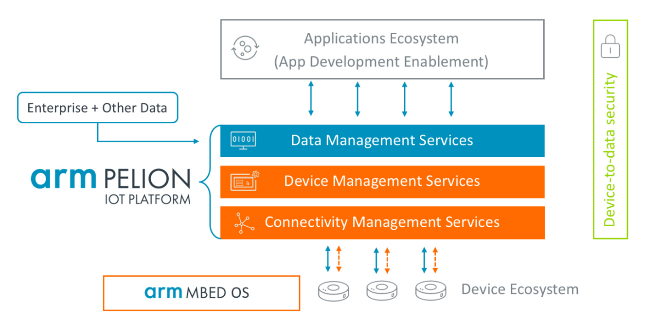
Source：(“Pelion, 2019)

3.3.3 Increasing Market Share in Large Server Chips
After occupying the largest share of the smartphone chip market, ARM's next strategic focus is to increase its market share in large servers, automobiles and the Internet of Things. ARM's weakest place is the data center, a market almost dominated by Intel, which not only involves chips but also manufactures chips. ARM currently has less than 1% market share in the field of large server chips as of 2015, and the company expects to increase its share to 25% by 2020, when the total market in this area will be around $20 billion. ARM will increase the licensing revenue of single chip, increase market share and enrich revenue channels. With the widespread use of ARMv8-A architecture in the future, more copyright revenue will be obtained from each chip. The embedded smart market includes smart devices, microcontrollers, smart cards and embedded connections in automotive, wearable devices, industrial and equipment fields. ARM has signed authorization agreements with 200 companies in this field. Under Softbank's ownership, ARM increased its investment in R&D and was able to invest a lot of cash in corporate acquisitions. Adding stream and treasure data to ARM is a mission to speed up the complexity of its security management from chips to clouds.
But one of the obstacles may be that the design of open source processors becomes a viable alternative to ARM, because any enterprise can use open source processor designs for free. The prospects for this series of designs, called RISC-V, are gradually emerging. Its widespread use will cause trouble for ARM. Moreover, the importance of ARM to computing may induce the company to raise its price, triggering strong opposition from customers.

Conclusion
ARM has been far ahead of its rivals in its own field. Within the framework of Softbank, it is an excellent strategic matching target, which will help Softbank become the next potential market leader (Internet of Things). Softbank's strategy of acquiring ARM brings both opportunities and challenges to its overall layout. For example, ARM has not formed the trend of ecological monopoly like smart phones. On the contrary, because of the fragmented ecological demand, there are still a lot of software and hardware suppliers that have to develop themselves for different industries. They cannot be used as smart phones. There are ready-made software and hardware solutions that can be directly applied. Therefore, in the absence of absolute ecological advantages of ARM architecture, processor cores with different competitive architectures have room for development. Although the IoT industry has a considerable market size, these market sizes also need to take account of terminal premium and service cost calculation, there is no way to fully return the benefits of the chip scheme itself, and ARM's authorization mode is doomed to receive only a very small part of the benefits of the chip scheme. Therefore, Softbank's view of the IoT industry should be cautious in simply estimating the value of ARM itself.

Reference
Amit, R., Schoemaker, P. J. H., & Schoemaker, P. J. H. (1993). Strategic Assets and Organizational Rent. Strategic Management Journal, 14(1).
ARM. (2017). Org Chart ARM - The Official Board. Retrieved July 16, 2019, from https://www.theofficialboard.com/org-chart/ARM
ARM. (2019). Platform Security Architecture (PSA) – ARM.
Barney, J. (1991). Firm Resources and Sustained Competitive Advantage. Journal of Management, 17(1).
Boeckl, K., Fagan, M., Fisher, W., & Scarfone, K. (2018). Considerations for Managing Internet of Things (IoT) Cybersecurity and Privacy Risks. In National Institute of Standards and Technology. https://doi.org/10.6028/NIST.IR.8228
Bohli, J.-M., Sorge, C., & Westhoff, D. (2009). Initial observations on economics, pricing, and penetration of the internet of things market. ACM SIGCOMM Computer Communication Review, 39(2). https://doi.org/10.1145/1517480.1517491
Eurostat. (2016). Statistics illustrated HIDDEN - Eurostat. Retrieved September 3, 2019, from https://ec.europa.eu/eurostat/en/web/lfs/statistics-illustrated
Gaughan, P. A. (2010). Mergers, Acquisitions, and Corporate Restructurings (5th Revise, p. 672). Edition, John Wiley & Sons.
Gruca, T. S., Nath, D., & Mehra, A. (1997). Exploiting Synergy for Competitive Advantage. Long Range Planning, 30(4). https://doi.org/10.1016/s0024-6301(97)00039-3
Holub, M. (2016). Cooperation as base for synergy. Exclusive E-Journal, (August).
International Organization for Migration. (2018). World Migration Report 2018. https://doi.org/10.18356/f45862f3-en
Johnson, G., Whittington, R., & Scholes, K. (2011). Fundamentals of Strategy (Second Edi). Prentice Hall: Financial Times.
Josh Walrath. (2018). ARM Introduces Kigen OS for Cellular IoT - PC Perspective.
Karthik Ranjan. (2013). Diversity of IoT Development Platforms Fueling Innovation at an Unprecedented Scale - IoT blog - Internet of Things - ARM Community.
Lee, A. (2017). ARM Holdings Q3 2017 Roadshow Slides. In Engineer (p. 38).
Montgomery, C. A. (2008). Putting Leadership Back into Strategy. Harvard Business Review.
Papulova, Z. (2014). The Significance of Vision and Mission Development for Enterprises in Slovak Republic. Journal of Economics, Business and Management, 2(1). https://doi.org/10.7763/joebm.2014.v2.90
Pelion: a Flexible, Secure, and Efficient IoT Platform – ARM. (2019).
Rogers, E. M. (2003). Diffusion of Innovations. In The Free Press (Fifth Edit). https://doi.org/10.1007/s10460-007-9072-2
Sara Sjolin. (2016). Pound’s Brexit-driven slump sets U.K. companies up for an M&amp;A wave - MarketWatch. Retrieved September 10, 2019, from https://www.marketwatch.com/story/pounds-brexit-driven-slump-puts-uk-companies-in-the-ma-frame-2016-07-18
Shanhong Liu. (2018). Internet of Things - Statistics &amp; Facts | Statista. Retrieved July 7, 2019, from https://www.statista.com/topics/2637/internet-of-things/
SoftBank. (2018). ARM Limited Q1 2018 Roadshow Slides.
SoftBank. (2019). Environmental and Resource Management Policies | CSR | About Us | SoftBank. Retrieved September 4, 2019, from https://www.softbank.jp/en/corp/csr/global-environment/
Softbank Group. (2015). Annual Report 2015.
SoftBank Group. (2015). Japan Communications Market Data | ANNUAL REPORT 2015 | About Us | SoftBank Group.
Statista. (2016). Number of mobile phone users worldwide 2015-2020 | Statista. Retrieved September 3, 2019, from https://www.statista.com/statistics/274774/forecast-of-mobile-phone-users-worldwide/
Statista Research Department. (2016). • IoT: number of connected devices worldwide 2012-2025 | Statista. Retrieved July 7, 2019, from https://www.statista.com/statistics/471264/iot-number-of-connected-devices-worldwide/
Stu Woo. (2016). ARM: The British Tech Giant That Probably Helped Design the Chip in Your Smartphone - WSJ. Retrieved July 13, 2019, from https://www.wsj.com/articles/ARMs-race-to-the-top-started-with-integration-1468837394
Teece J., D., Gary, P., & Amy, S. (1997). Dynamic Capabilities and Strategic Management. Strategic Management Journal, 18(7).

