2020
PROBLEM SOLVING AND DECISION-MAKING LECTURER: YAJESH KUMAR
BMSW:4004
AISSATU DJALO STUDENT Nr:1908378

Content
1. Introduction
2. Case study (lack of revenue and employee’s dissatisfaction)
3. Analysis
4. Alternatives solutions
5. Cause and Effect
6. Fishbone Diagram
7. Implementation
8. Conclusion
9. Reference

Introduction:

This report is used to analyse the complex problem of a drop in the annual profit in Vegan Corner Restaurant. The goal in creating this report is to investigate the reason behind the drastic drop in profit in Vegan Corner Restaurant. Once the complex problem is found, the appropriate method and solution will be adopted to eliminate these problems. This will be done by creating a process of proposing numerous solutions to bring in positive result. Then a range of decisions making techniques will be used to evaluate the best that fit to the complex problem. After that, a develop a plan of implementation will be communicated to those concerned. Together as a team we will then assess, monitor, and propose tools and techniques to use in implementing the appropriate solution to achieve a successful result.

Case study:

Vegan Corner Restaurant
As owners of Vegan Corner Restaurant, we have noticed a significant drop on the profits in the last 2 years, in comparison to the previous 8 years where we had an excellent review, enough cash flow and we were achieving our monthly target. To understand why we have a drop and are lacking in this last two years we have launched an internal investigation to creating a survey on visitors, customers, and staff. The purpose is to identify the cause of the drop in profit, and to implement a arrange positive change to turn the curve around and bring back Vegan Corner to its perfect course.

Analysis:
With the lack of revenue and productivity within the restaurant we have found, we had to launch an immediate investigation, and as the result of it we found the cause the cause of the drop in our profit as well as its effect in the whole structure of Vegan Corner. We discover that having the wrong employees led to high drop in turnover and did damage our reputation with our current and even future customers. It does not matter how delicious is the food is if the service is bad that will be the only thing that the customers will remember. We fail in realising that customer services or how we treat customers had to be at the forefront of our training methodology. We also realise that some of our employees were unsatisfied. After the investigation we came to conclusion implementing training for the staff and to invest in technology to reduce workload from the staff. According to “Robert Half it is believed that UK employees spends most of their time at work, for example they work 34 hours a week that’s total of 1,791 hours a year.

Alternative solution:
We took into consideration what will be beneficial for Vegan Corner and its employees. Recent studies from University of Warwick shows that 15% of the total employees in the workplace perform best and are happier. Therefore, we have embarked on creating happier working atmosphere to improve and increase productivity. Secondly, we invested in a Touch screen electronic menu to reduce the stress and complications between customer and our service staff, thus reducing mistakes during order placement. With the Touch screen order machines, customers can easily choose what they desire without getting into arguments with our service staff. Thirdly, we also invested into a Vegan Corner app that customers can download into their personal devices. They can through the app place orders before arriving the Restaurant. They can also decide through the app if they are picking up their meal or eating in. According to Aaron Allen.com August 24, 2018,"Many restaurant executive teams are still planning with post-it notes and ballpoint pens while their competitors are harnessing theories, tools, and techniques that sound like science fiction — big data, machine learning, artificial intelligence, behavioural economics, neuromarketing — to create strategy and allocate budgets.

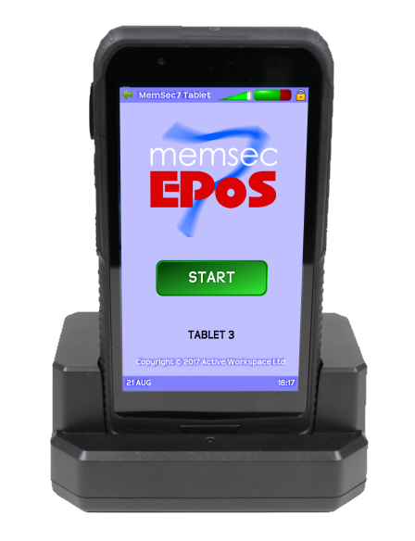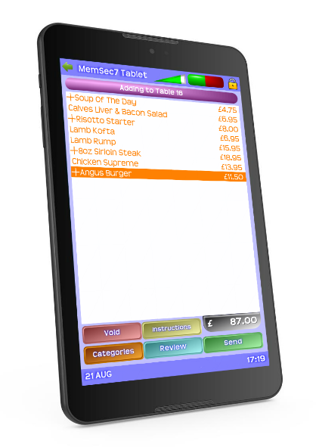

According Memsec Epos, this machine keep pace with and maintain relevancy in our tech-driven world. The restaurant industry is undergoing a massive digital transformation with the implementation of omnichannel platforms geared toward increasing access points and improving customer experiences. The industry has a new demand driven by both customers and competitors to offer a higher standard of ease, convenience, and services through technology. Since technology often becomes outdated within a few months after it is launched, it is important to consider this. This factor could also take into consideration all barriers to entry in certain markets and changes to financial decisions.
Most companies recognize that the old approaches to planning are insufficient and need to catch up with the pace of change in technology and consumer dining behaviour. This new Menu technology can print bills, move items between tabs, add or remove service charges, apply vouchers access gift cards, send menus to the kitchen
Apply vouchers view and activate bookings and notifies when food is ready.
Decision making tools

Cause and effect:

By introducing this new machine into the restaurant is to invest into innovations and technology. With this change we expect to affect a change in our business and operate on a more modern and advance market favourably to compete with other competitors or traditional restaurants. By investing into the technology in search of successful solution to the complex problem of Vegan Corner this assisted in reducing the stress factor that so greatly affected the output of our employees. considering the amount of technological awareness that the market possesses. While working together We had to look at the macro and micro factories and how we tackled all our problems. Once that was implemented there was a positive change within Vegan Corner environment. There was employee freedom and a more perfect organisation within the restaurant.
In difficult moments employees look to the most trusted and reliable leaders. It is important to ensure that the mark is meet through having an open discussion as a team about the present situation. Once those discussion are held, plans to alternative solutions must be communicated and drafted to achieve a successful and positive solution. According to Forbes online “Communicating, even when you don’t have a clear answer but are saying you are evaluating a situation, is better than saying nothing,”. As a business owner making an easy access for everyone within the company stakeholders in the moment of crisis is a positive strategy to create a trusted relationship and a confidential environment. Through the weekly restaurant meeting, staff members are encouraged to ask sincere questions. During critical moments, critical thinking which can also be of great opportunity to help company’s transformation can highlight areas of the business that could use in perfecting as well as revealing new possibilities for growth. Focusing on the organization’s potential, acknowledging, and accepting the negative impact that the lack of employee’s satisfaction can cause loss and affects employee’s excitement. Making them feel comfortable will change the way the work boosts the team morale. In order to have employees freedom and productivity while organisational control, the company had to create a way out of our annual budgets to pay for staffs to external training while investing on new technology to facilitate employees ways of working with more productivity.

Fishbone diagram:
Analysing the restaurant over all in depth of employee’s satisfaction, in search of the gap or area where we have failed, was crucial and important as to all business area such as project management, process improvement and marketing. To find the problem and understand it we took into consideration all those factors and reasons of our restaurant specific problem and elaborate potential solutions for the problems. As we proceeded to what is affecting the business internally and externally with this approach we came to conclusion and agreed that employees are overwhelmed with the workload and were able to process the customers desire at workplace correctly. As a result of lack in technology. With the aim in helping in maintaining team focus. once identify possible ways to progress we can also evaluate areas where changes are not working. In conclusion to the cause and effect and finding solution to the problem we have listed two methods that needs to be implemented which have enhanced on the employees training overall technology training, working less exhausting hours and relying more on the technology to get some tasks done with the help of computers and some others machines. After a period of two years we intend to have a review then make changes and improvement and implement them.
Implementation:
During the process of investigating and finding solutions we faced challenges in getting the insight of individuals interest as well as common interest of the team. Therefore, collecting as team the solution that fit best for our company’s critical and complex problem. We use the framework that was elaborated to amylase and implement the solution that will solve our company complex problem. By clarifying the cause and effect accordingly it was vital to find a structured and successful solution to be implemented. According to Published: (August 2018). "No one can see 10 years into the future. If we go back only five years, most people would not have been able to comprehend how fast the industry has changed. Moreover, most restaurant strategic planning processes have not kept up with the changes. Operations are often state of the art for 2009, not 2018". It is impossible to predict the future but by monitoring changes closely it can increase positive changes by understanding numerous ways the changes can affect it, therefore by implementing short term planning where we can go back and review changes that were made and if it is require to discuss possible solution. With this we have set up 24 months reviewing period where we aim to analyse and evaluate the outcome of solution implemented. We are plan on evaluate and bring in different methods of problem-solving tools, to share all generated possibilities with the team on where changes can be reviewed, and positive solutions brought to the company. By launching our Vegan Corner app consumers can order beforehand whatever they want from the restaurant where they have the options of eating in or take away as well as giving them the freedom and in ordering with a member of the staffs this will give them direct contact with the kitchen. They can use employees as well if they need to, but there are options if they decide not to, as well as we are going to install a machine in the premises where our staffs will have enough time to focus on customer service rather than taking orders that will give them time to do table check interactions with customers offering them extra services that we offer and they were not aware of it. We relate this generic concept of such as commitment, passion, knowledge, and self-efficacy for solving controversial problems. Finally, we introduce the specific concept of “Measures ability in credible growth” to articulate the competence of people to engage in finding solution to problems.

Conclusion:
This study aims at identifying vegan corners complex problem, with this report I got a wider understanding in what sorts of tools and techniques that can be used to solve an complex problem. coming in to completing this report I had a vague idea in understanding professional conflicts but by using the right tools and researching different articles it helped in gaining knowledge and experience. The dimensions of service quality and examining the interrelationships among the service quality dimensions, service quality, perceived value, corporate image, customer satisfaction and behavioural intentions in the quick service restaurant industry. The dimensions of service quality are built on a basis of formative ideas and inspiration. The measures implemented in gathering facts to the related problems were access through the output from the information collected from customers. As well as the proposed solutions were through customers ideas and wishes and the entrepreneurial foresight for improvement.

References:

Aaron Allen, (August 2018). Five tips for purposeful planning. Online. https//www.aaronallen.com. Accessed 30th August 2020.
Forbes (March 2020). Communication is important than ever before. Online. https//www.forbes.com. Accessed 28th August 2020.
Harvard Business Review, (August 2018). Educating the next generation of Business leaders. Online. https//www.hbr.org. Accessed 23rd August 2020.
New Epos, (August 2020). An Epos that does it all. Online. https//www.new.eposnow.com. Accessed 28th August 2020.
Robert Half, (August 2020). Find top talent. Online. https//www.roberthalf.co.uk. Accessed 28th August 2020.
Warwick, (August 2020). New study shows we work harder when we are happy. Online. https//www.warwick.ac.uk. Accessed 23rd August 2020.

