20/07/2026

Database Report Assessment

TRINITY SAINT DAVID UNIVERSITY OF WALES
(LONDON CAMPUS)

• Student Name: PAPY POSO MUKELENGE
• Student ID: 2525113
• MoDULE: Introduction to Web and Database Concepts
• Module code: ACCA4023
• Lecturer: SURESH SHANMUGASUNDARAM
CertHE Computing Skills for Workplace

[Cite your source here.]

Contents
CHAPTER 1: INTRODUCTION 1
Introduction 1
CHAPTER 2: SCENARIO ANALYSIS 2
2.1 Scenario Description 2
2.2 Problem Analysis 2
2.3 System Objectives 2
2.4 Main Entities 2
2.5 Relationships 2
2.6 Chapter Summary 3
CHAPTER 3: ENTITY RELATIONSHIP DIAGRAM (ERD) 3
3.1 Introduction 3
3.2 Description of Entities 3
3.3 Relationships Between Tables 3
3.4 Primary Keys and Foreign Keys 4
3.5 Referential Integrity 4
3.6 Chapter Summary 4
CHAPTER 4: DATABASE IMPLEMENTATION 4
4.1 Introduction 4
4.2 Database Management System 4
4.3 Database Creation 4
4.4 Table Structure 5
Parking : Stores parking facility information. 5
Vehicle : Stores vehicle information. Each vehicle belongs to one customer. 6
4.5 Data Types 7
4.6 Relationships 7
4.7 Validation 8
4.8 Implementation Challenges 8
4.9 Chapter Summary 8
CHAPTER 5: DATABASE NORMALIZATION 8
5.1 Introduction 8
5.2 First Normal Form (1NF) 8
5.3 Second Normal Form (2NF) 8
5.4 Third Normal Form (3NF) 8
5.5 Chapter Summary 8
CHAPTER 6: DATA INSERTION 9
6.1 Introduction 9
6.2 Data Entry 9
6.3 Validation 9
6.4 Chapter Summary 9
CHAPTER 7: DATABASE QUERIES 9
7.1 Introduction 10
7.2 Queries Created 10
7.3 Results 11
7.4 Chapter Summary 11
CHAPTER 8: FORMS 11
8.1 Introduction 11
8.2 Forms Created 12
o Customer Form : The Customer Form allows users to register and update customer information, including the customer's name, telephone number, and address. 12
o Vehicle Form : The Vehicle Form is used to register vehicles and associate each vehicle with its owner. 12
12
o Reservation Form : The Reservation Form allows users to create new reservations by selecting an existing vehicle and an available parking space, together with the entry and exit dates. 12
12
o Payment Form : The Payment Form records customer payments by linking each payment to an existing reservation. 13
13
8.3 Form Validation 13
8.4 Chapter Summary 13
CHAPTER 9: REPORTS 13
9.1 Introduction 13
9.2 Reports Created 13
9.3 Report Validation 14
9.4 Chapter Summary 14
CHAPTER 10: SYSTEM TESTING AND VALIDATION 15
10.1 Introduction 15
10.2 Testing 15
10.3 Evaluation 16
10.4 Chapter Summary 16
CHAPTER 11: GENERAL CONCLUSION 16
REFERENCES 16

CHAPTER 1: INTRODUCTION

Introduction
With the rapid growth of digital technologies, organisations increasingly rely on database systems to manage large volumes of information efficiently. A well-designed database improves data organization, minimizes redundancy, enhances data accuracy, and supports decision-making.
This project focuses on the design and implementation of a relational database for AutoPark Management System, a company responsible for managing several parking facilities located throughout the same city. The purpose of the database is to simplify the management of customers, vehicles, parking areas, parking spaces, reservations, and payments.
Before implementing this solution, most operations were performed manually, making data management slow and prone to errors. Information was difficult to retrieve, duplicate records could occur, and generating management reports required considerable time.
To address these challenges, a centralized relational database was developed using Microsoft Access 2010. The database organizes all information into related tables while maintaining data consistency through primary keys, foreign keys, and referential integrity.
The project followed several stages, including scenario analysis, database modelling, table creation, normalisation, data insertion, query development, form design, report generation, and system testing. Each stage contributed to building a functional database capable of meeting the company's operational requirements. The following chapters describe the analysis, design, implementation, and validation of the proposed database solutions.

CHAPTER 2: SCENARIO ANALYSIS

2.1 Scenario Description
AutoPark Management System operates multiple parking facilities within the same city. The company requires a computerized system capable of managing customers, vehicles, parking locations, parking spaces, reservations, and payments. The previous manual system presented several limitations, including duplicate information, data entry errors, slow searches, and difficulties producing management reports. Consequently, the organisation decided to implement a relational database to centralize all operational data. [1] [2]

2.2 Problem Analysis
The analysis identified several major issues:
- Customer and vehicle information was not centralized.
- Parking space availability was difficult to monitor.
- Payment records were difficult to track accurately.
- Preparing statistical reports required significant manual effort.
A relational database was therefore selected as the most appropriate solution to improve data organization and operational efficiency.

2.3 System Objectives
The proposed database aims to:
- register customers;
- manage customer vehicles;
- manage parking facilities;
- manage parking spaces;
- record reservations;
- record payments;
- produce reports and queries for management purposes.
These objectives support faster information retrieval while reducing manual processing errors.

2.4 Main Entities
The database contains six main entities.
- Customer : Stores customer information, including name, telephone number, and address.
- Vehicle : Stores vehicle details such as registration number, brand, model, color, and owner.
- Parking : Stores information about each parking facility managed by the company.
- Parking Space : Represents individual parking spaces and records their availability status.
- Reservation : Stores parking reservations, including entry date, exit date, vehicle, and parking space.
- Payment : Stores payment information such as payment amount, payment date, and payment method.

2.5 Relationships
The following relationships were identified:
- One customer may own several vehicles.
- One parking contains multiple parking spaces.
- One vehicle may have several reservations.
- One parking space may be reserved multiple times over different periods.
- Each reservation is associated with one payment.
These relationships ensure data consistency and eliminate unnecessary duplication.

2.6 Chapter Summary
The scenario analysis identified the company's requirements and the information that must be managed by the database. It also defined the entities, attributes, and relationships required for the implementation of the system. This analysis provided the foundation for designing the Entity Relationship Diagram presented in the next chapter.

CHAPTER 3: ENTITY RELATIONSHIP DIAGRAM (ERD)

3.1 Introduction
Before implementing the database, an Entity Relationship Diagram (ERD) was developed to represent the logical structure of the system. The ERD illustrates the entities, their attributes, primary keys, foreign keys, and relationships.
This model serves as the blueprint for implementing the relational database in Microsoft Access. [3]

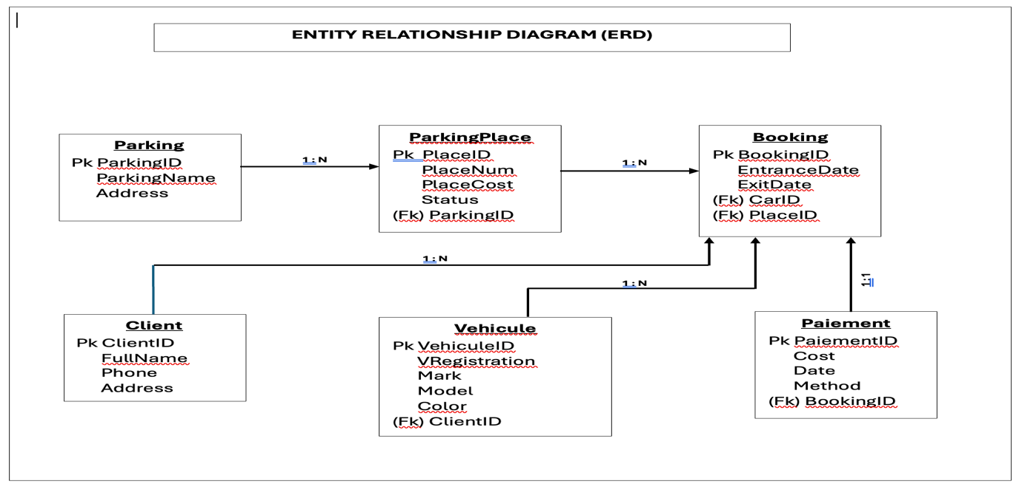

3.2 Description of Entities
The database consists of six related tables:
- Customer stores customer information.
- Vehicle stores vehicle details and references its owner.
- Parking stores parking facility information.
- ParkingSpace stores parking spaces and their availability.
- Reservation records vehicle parking activities.
- Payment records financial transactions associated with reservations.
Each table has a primary key that uniquely identifies every record.

3.3 Relationships Between Tables
The database includes the following relationships:
- Customer (1) → Vehicle (Many)
- Parking (1) → ParkingSpace (Many)
- Vehicle (1) → Reservation (Many)
- ParkingSpace (1) → Reservation (Many)
- Reservation (1) → Payment (1)
These relationships reduce data redundancy and improve database consistency.

3.4 Primary Keys and Foreign Keys
Each table contains one primary key.
Table | Primary Key
Customer | CustomerID
Vehicle | VehicleID
Parking | ParkingID
ParkingSpace | SpaceID
Reservation | ReservationID
Payment | PaymentID
Foreign keys establish the relationships between the tables and ensure that every linked record exists before it can be referenced.

3.5 Referential Integrity
Referential integrity was enabled when creating relationships in Microsoft Access. This feature prevents invalid data from being inserted into the database. For example, a payment cannot be created without an existing reservation, and a vehicle cannot be assigned to a customer who does not exist.
This mechanism increases database reliability and preserves data consistency.

3.6 Chapter Summary
The Entity Relationship Diagram provided a clear representation of the database structure before implementation. It defined the entities, relationships, primary keys, and foreign keys required to build a consistent relational database.
This model served as the foundation for creating the database structure in Microsoft Access and ensured that the system met the requirements identified during the scenario analysis.

CHAPTER 4: DATABASE IMPLEMENTATION

4.1 Introduction
This chapter describes the physical implementation of the database in Microsoft Access 2010. After completing the conceptual design, the database structure was created by defining tables, selecting appropriate data types, establishing relationships, and enforcing referential integrity. The implementation transformed the conceptual model into a functional relational database capable of storing and managing the company's operational data.

4.2 Database Management System
Microsoft Access 2010 was selected because it provides an efficient environment for designing relational databases without requiring advanced programming skills. It supports table creation, relationship management, queries, forms, and reports, making it appropriate for this academic project.

4.3 Database Creation
A new database was created using the .accdb format. Each table was designed in Design View, where field names, data types, and primary keys were defined before creating relationships.
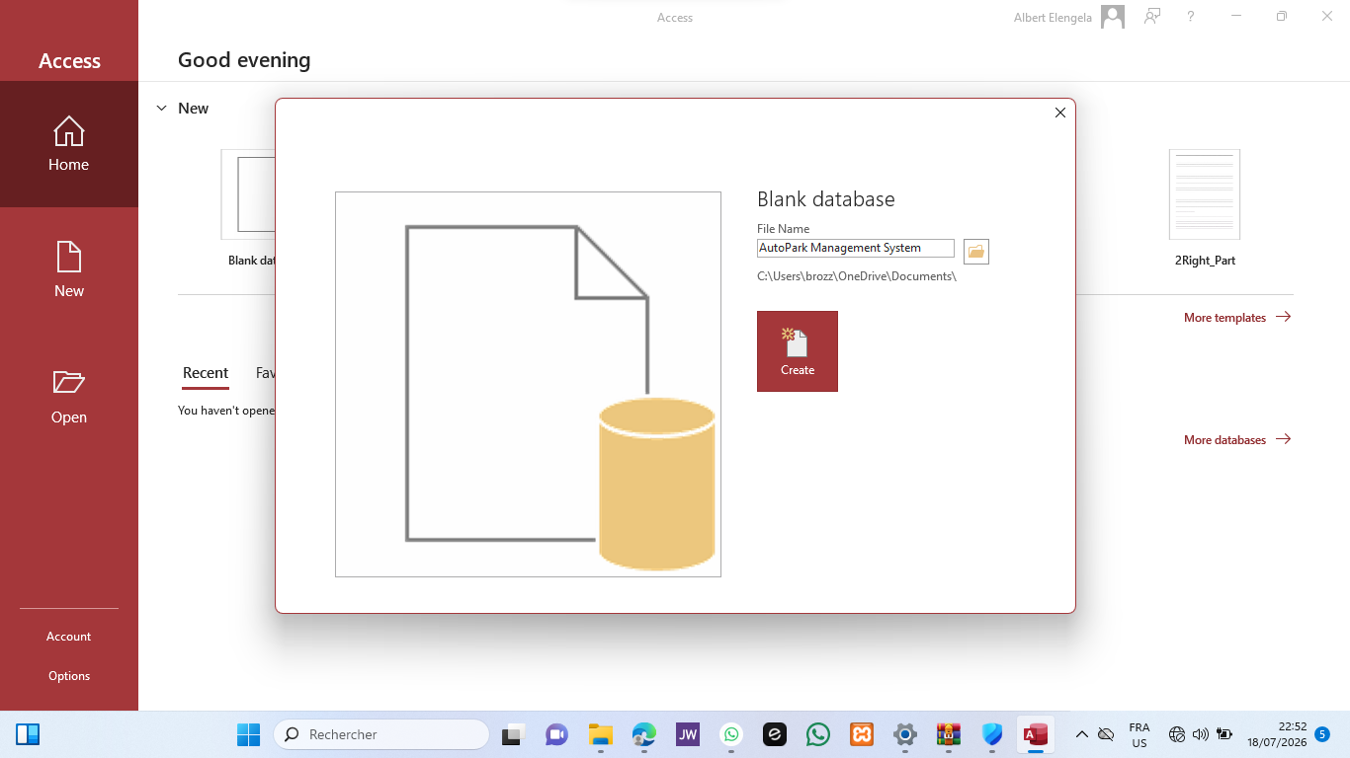

4.4 Table Structure
Six tables were created to support the system.

Parking : Stores parking facility information.
Fields:
- ParkingID
- ParkingName
- Address
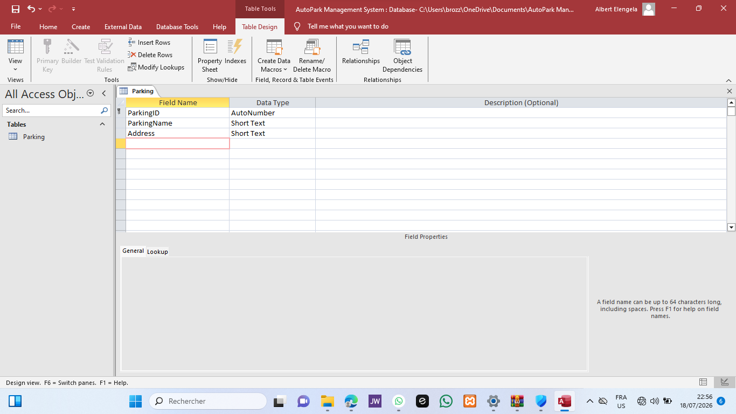

ParkingSpace : Stores parking space information. Each parking space belongs to one parking facility.
Fields:
- SpaceID
- SpaceNumber
- Status
- ParkingID

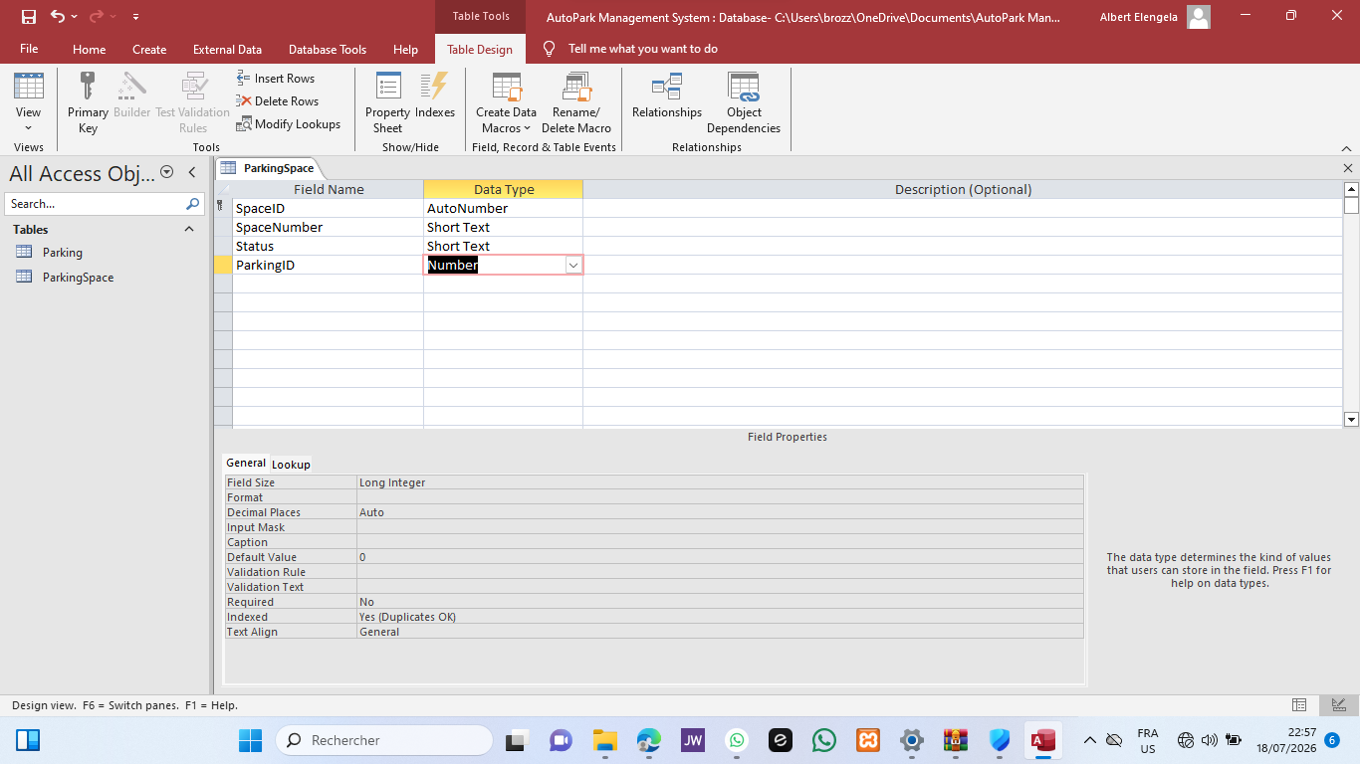

Customer : Stores customer information. Each customer record is stored only once.
Fields:
- CustomerID
- FullName
- Telephone
- Address

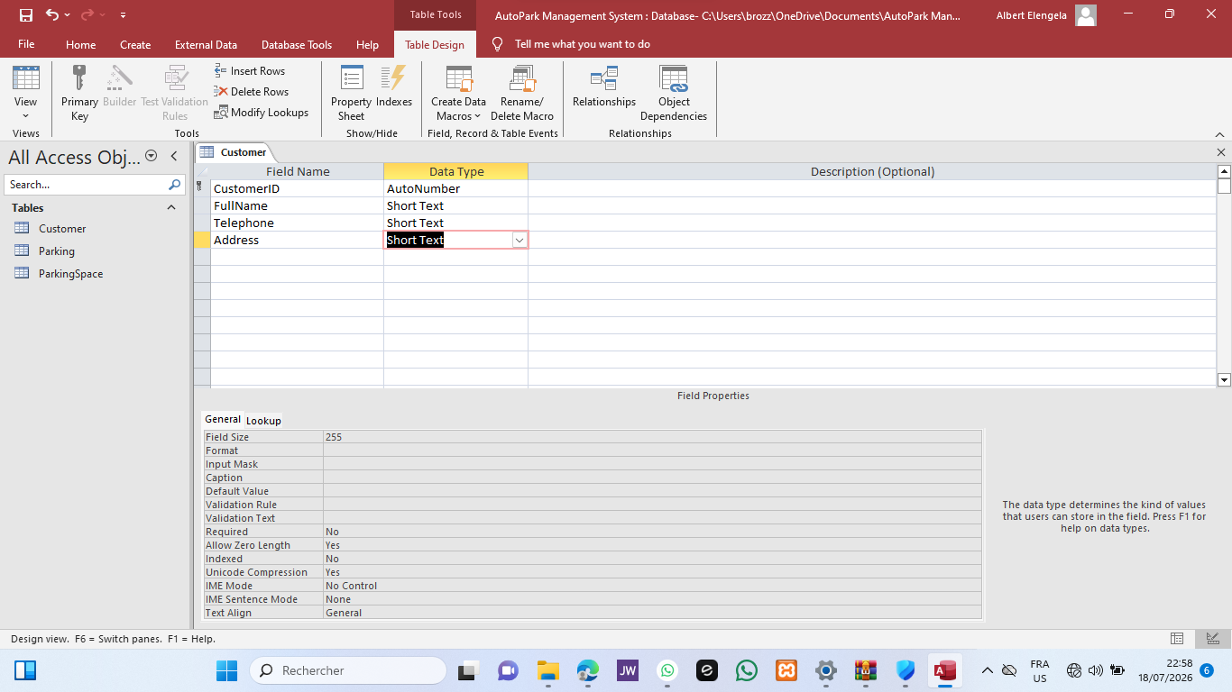

Vehicle : Stores vehicle information. Each vehicle belongs to one customer.
Fields:
- VehicleID
- RegistrationNumber
- Brand
- Model
- Color
- CustomerID

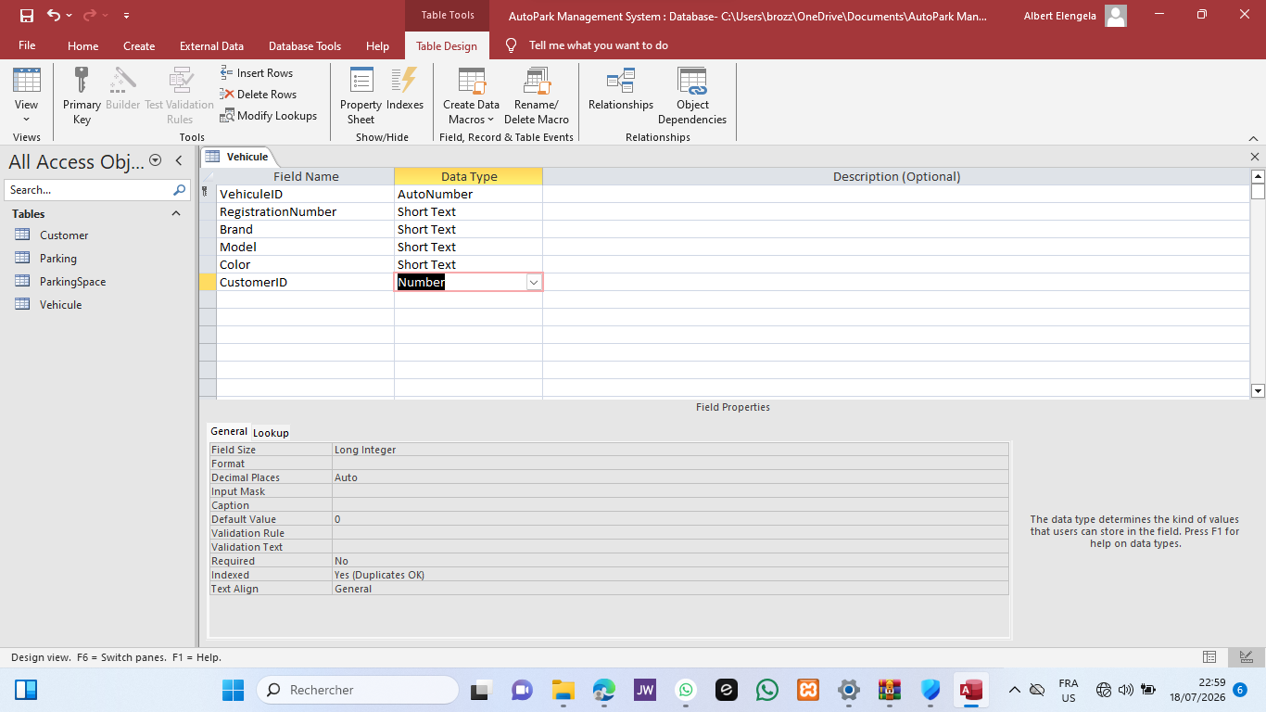

Reservation : Stores parking reservations. This table links vehicles to parking spaces.
Fields:
- ReservationID
- VehicleID
- SpaceID
- EntryDate
- ExitDate

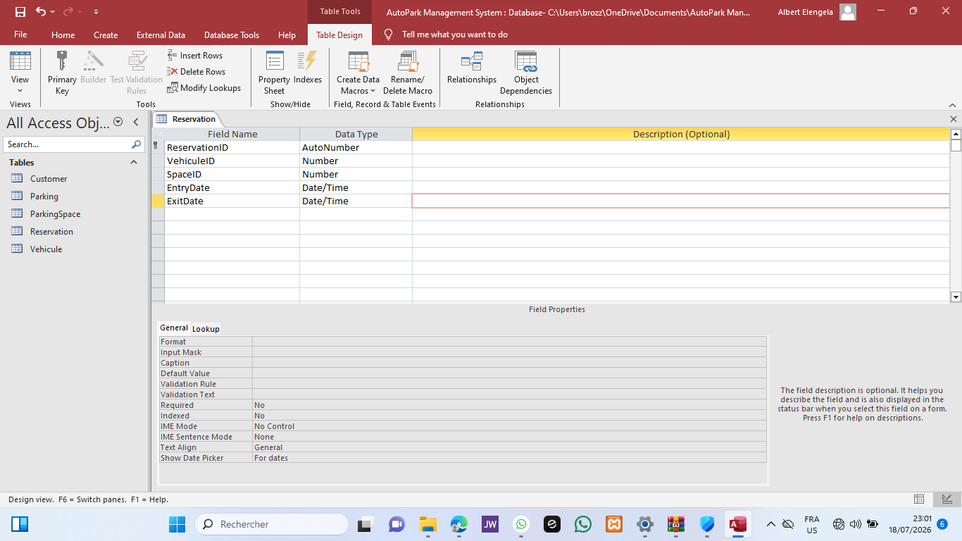

Payment : Stores payment information. Each payment corresponds to one reservation.
Fields:
- PaymentID
- ReservationID
- Amount
- PaymentDate
- PaymentMethod
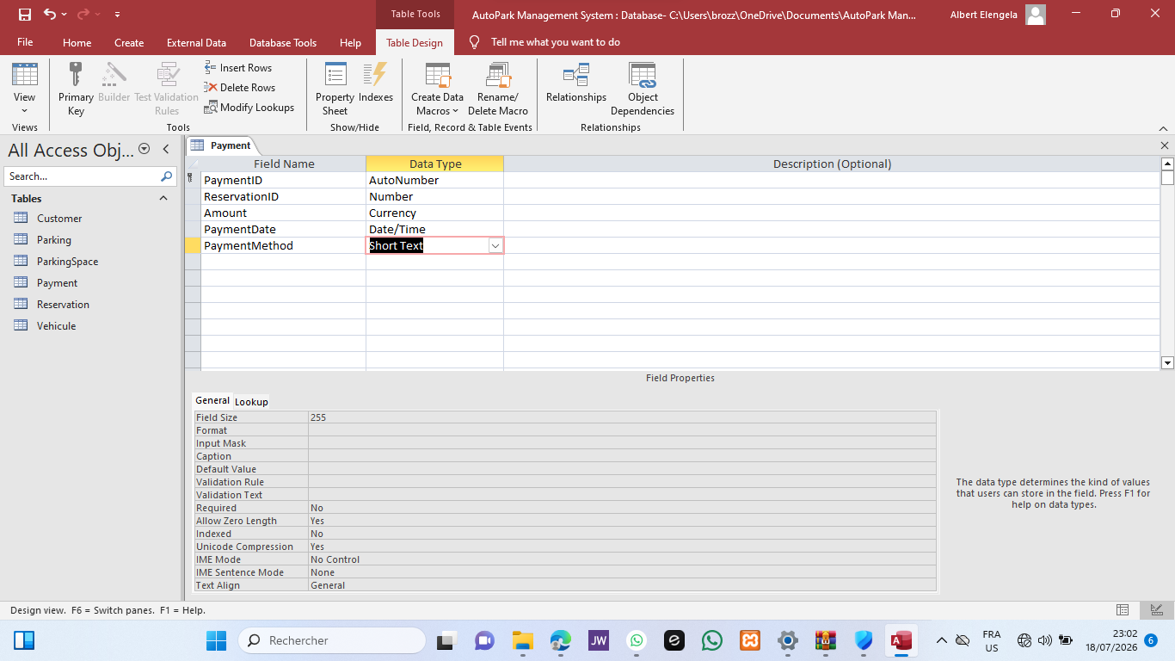

4.5 Data Types
Appropriate data types were assigned to each field.
- AutoNumber was used for primary keys.
- Number (Long Integer) was used for foreign keys.
- Short Text was used for names, addresses, and registration numbers.
- Date/Time was used for reservation and payment dates.
- Currency was used for payment amounts.
Selecting appropriate data types improves storage efficiency and maintains data consistency.

4.6 Relationships
Relationships were created using the Relationships tool in Microsoft Access.
The following relationships were implemented:
- Customer → Vehicle (1:N)
- Parking → ParkingSpace (1:N)
- Vehicle → Reservation (1:N)
- ParkingSpace → Reservation (1:N)
- Reservation → Payment (1:1)
Referential integrity was enabled for every relationship.
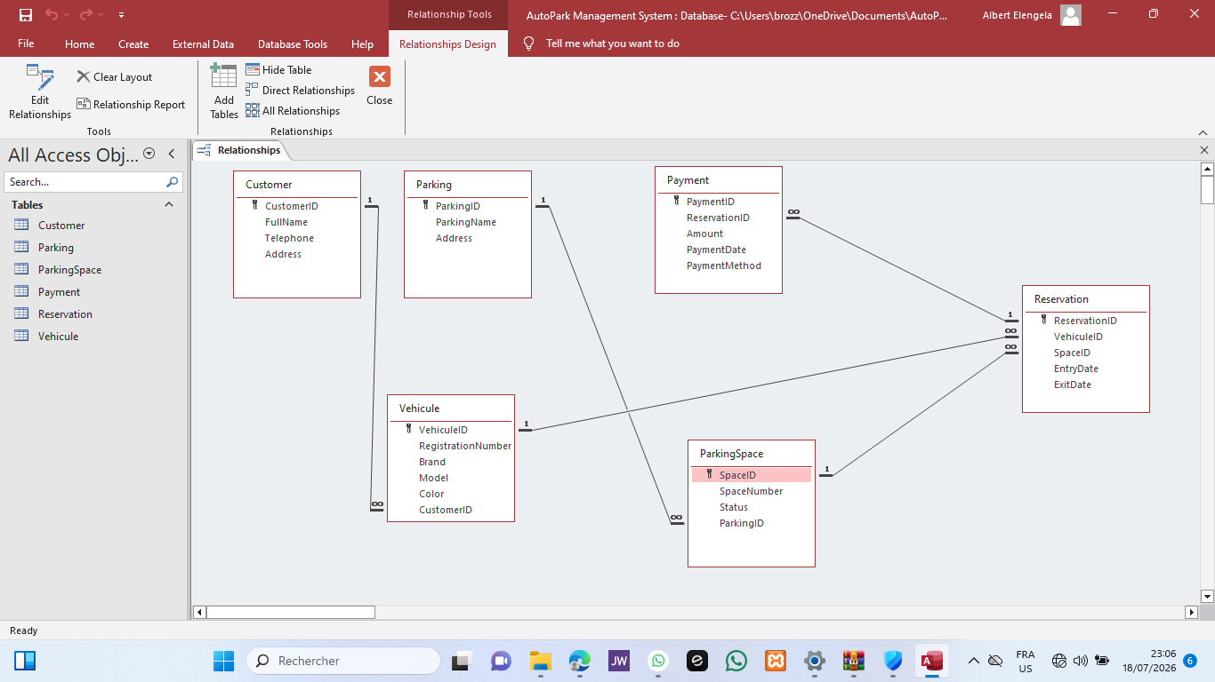

4.7 Validation
After creating the tables and relationships, several test records were inserted to verify that:
- primary keys were unique;
- foreign keys referenced existing records;
- relationships worked correctly;
- referential integrity prevented invalid data.
The tests confirmed that the database structure was functioning as expected.

4.8 Implementation Challenges
During implementation, one issue occurred while creating the relationship involving the Payment table because the table was still open in Microsoft Access. Closing all open tables resolved the problem. Another challenge involved matching AutoNumber primary keys with Number (Long Integer) foreign keys. After correcting the data types, all relationships were successfully created.

4.9 Chapter Summary
The database structure was successfully implemented in Microsoft Access. All tables, data types, and relationships were created according to the conceptual model, providing a reliable foundation for the remaining stages of the project.

CHAPTER 5: DATABASE NORMALISATION

5.1 Introduction
Normalisation is the process of organising data to eliminate redundancy and improve consistency. In this project, the database was normalized up to the Third Normal Form (3NF).

5.2 First Normal Form (1NF)
Each table contains atomic values only. Every field stores a single value, and each record is uniquely identified by a primary key.

5.3 Second Normal Form (2NF)
All non-key attributes depend entirely on their respective primary keys. Partial dependencies were eliminated by separating information into different tables.

5.4 Third Normal Form (3NF)
The database contains no transitive dependencies. Every non-key attribute depends only on the primary key of its table. Normalization reduced redundancy and improved data integrity.

5.5 Chapter Summary
Applying the three normal forms produced a well-structured relational database that is easier to maintain and less prone to inconsistencies.

CHAPTER 6: DATA INSERTION

6.1 Introduction
Sample data were inserted into every table to simulate the daily operations of the company and verify the correctness of the database.

6.2 Data Entry
Records were inserted in the following order:
- Parking
- ParkingSpace
- Customer
- Vehicle
- Reservation
- Payment
This sequence respected referential integrity constraints.

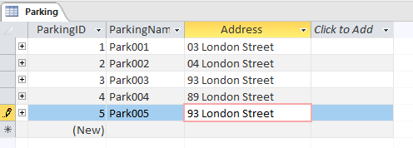

6.3 Validation
After insertion, the records were reviewed to ensure that:
- all foreign keys referenced valid records;
- relationships remained consistent;
- no duplicate records existed.
The database successfully stored all test data.

6.4 Chapter Summary
The insertion of sample data confirmed that the database structure supports normal business operations and that all relationships function correctly.

CHAPTER 7: DATABASE QUERIES

7.1 Introduction
Queries were developed to retrieve useful information from the database and support daily management activities.

7.2 Queries Created
The following queries were implemented:
- Customer List
- Vehicle List
- Reservation List
- Payment List
- Total Revenue
Each query retrieves specific information required by the company.
Customer list Query :
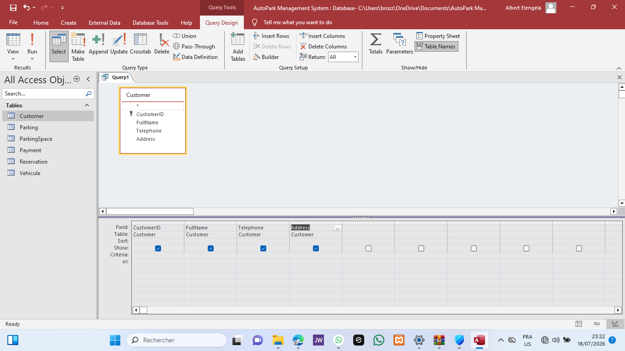

Vehicule list Query :
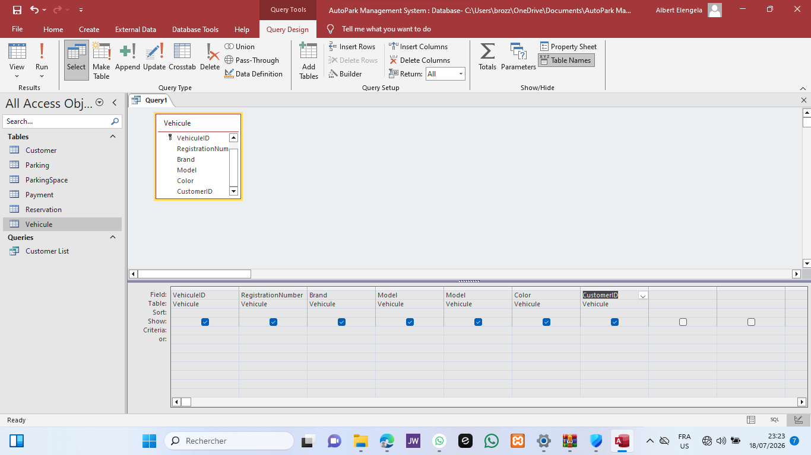

Reservation list Query :
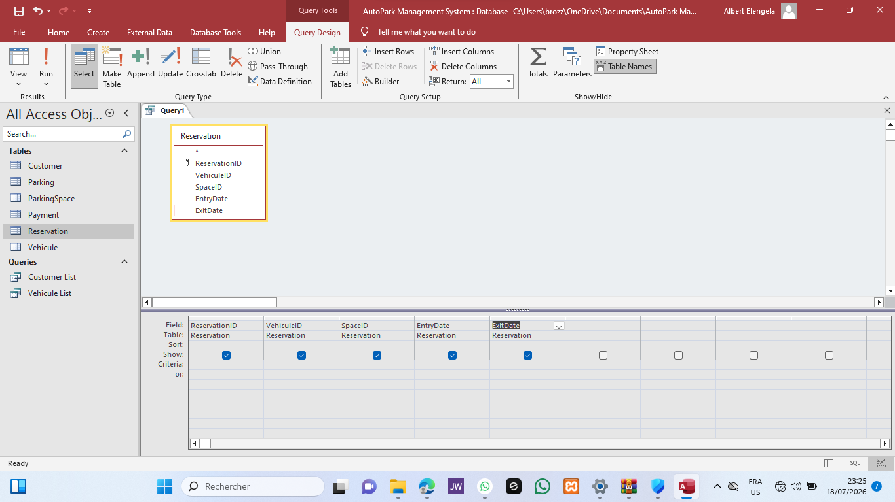

(Insérer Figure 12 : Requête des clients.)

Total revenue :
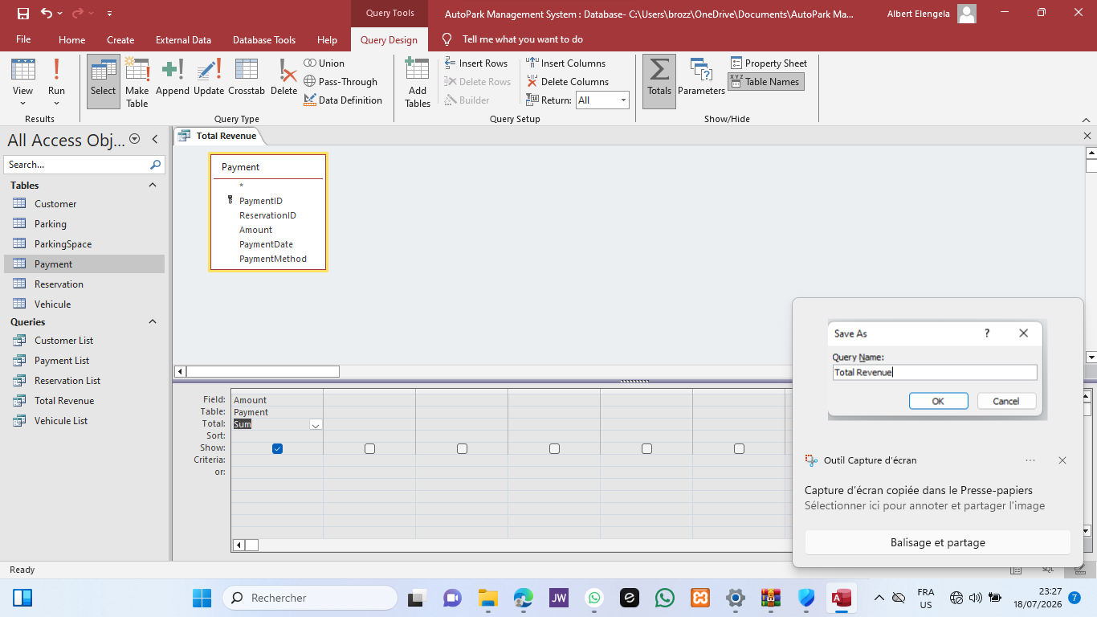

Available space query :
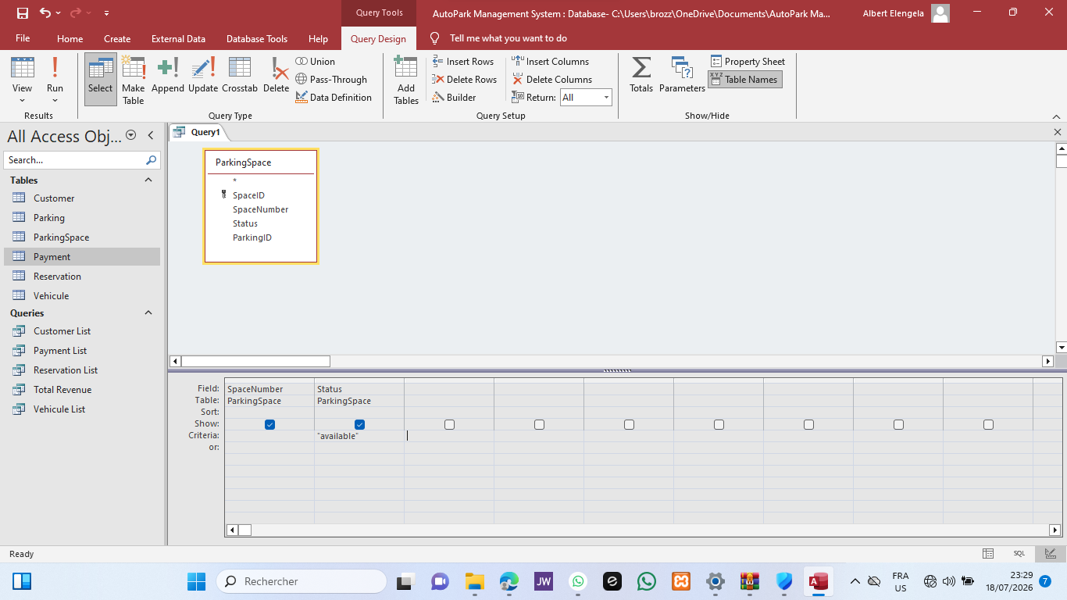

7.3 Results
The queries successfully returned the expected information, allowing users to retrieve customer records, vehicle information, reservations, payment history, and financial summaries quickly.

7.4 Chapter Summary
The queries demonstrated the ability of the database to organize, retrieve, and summarize operational information efficiently. They also provided the foundation for creating forms and reports in the following chapters.

CHAPTER 8: FORMS

8.1 Introduction
Forms provide a user-friendly interface for entering, editing, and viewing information stored in the database. Instead of working directly with tables, users can perform daily operations through organized forms, reducing data entry errors and improving efficiency. In Microsoft Access, forms were created for the main entities of the AutoPark Management System.

8.2 Forms Created
Four forms were developed.
- Customer Form : The Customer Form allows users to register and update customer information, including the customer's name, telephone number, and address.
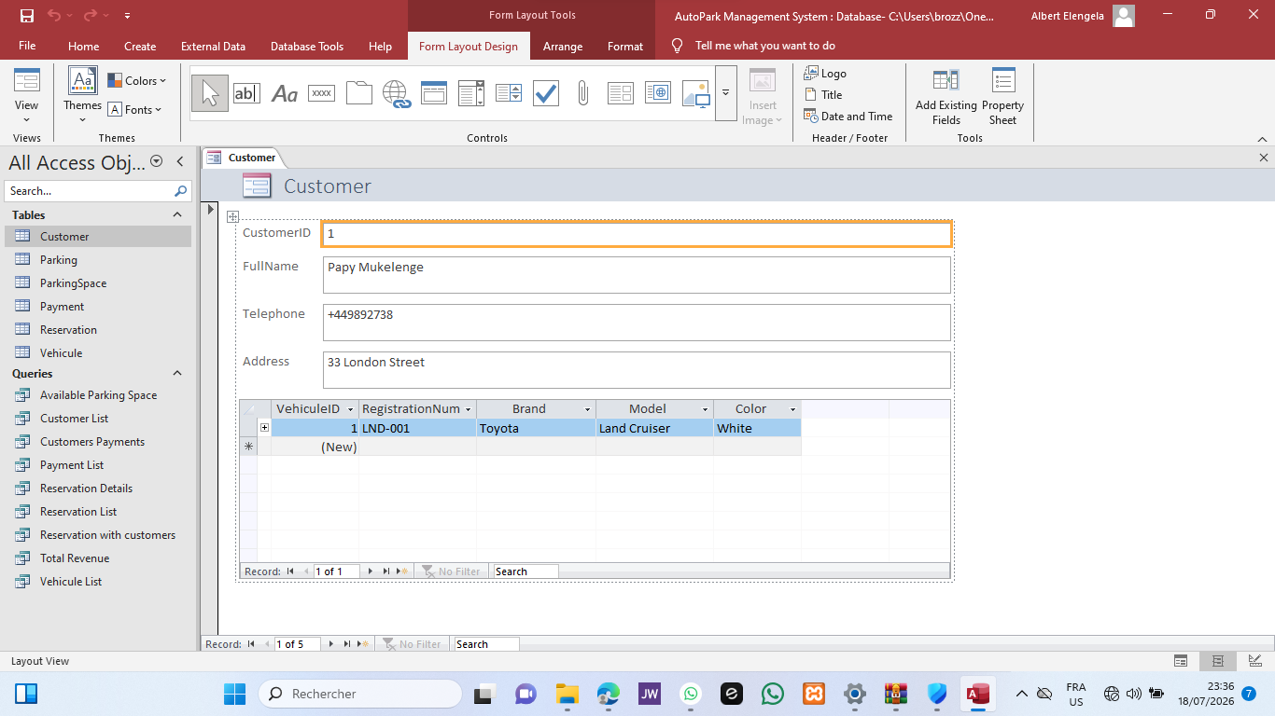

- Vehicle Form : The Vehicle Form is used to register vehicles and associate each vehicle with its owner.
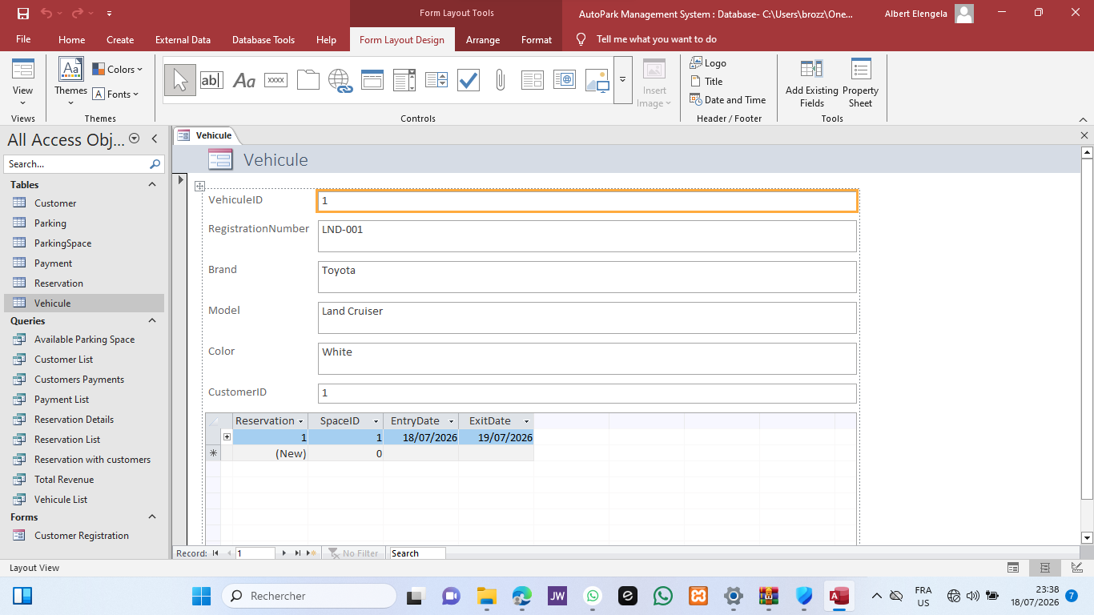

- Reservation Form : The Reservation Form allows users to create new reservations by selecting an existing vehicle and an available parking space, together with the entry and exit dates.
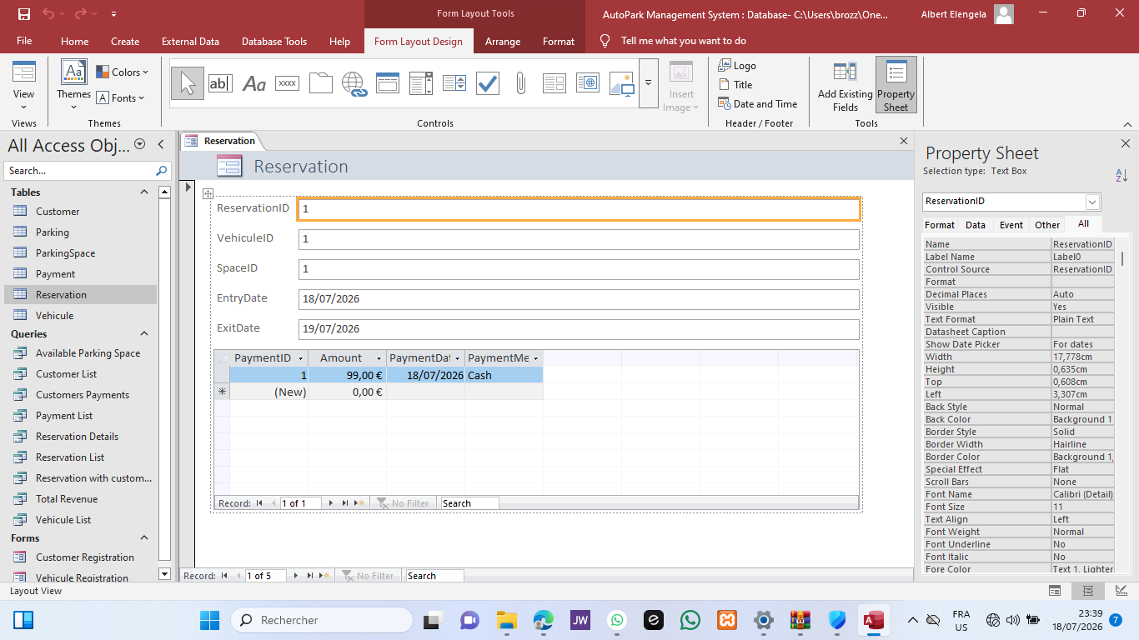

- Payment Form : The Payment Form records customer payments by linking each payment to an existing reservation.
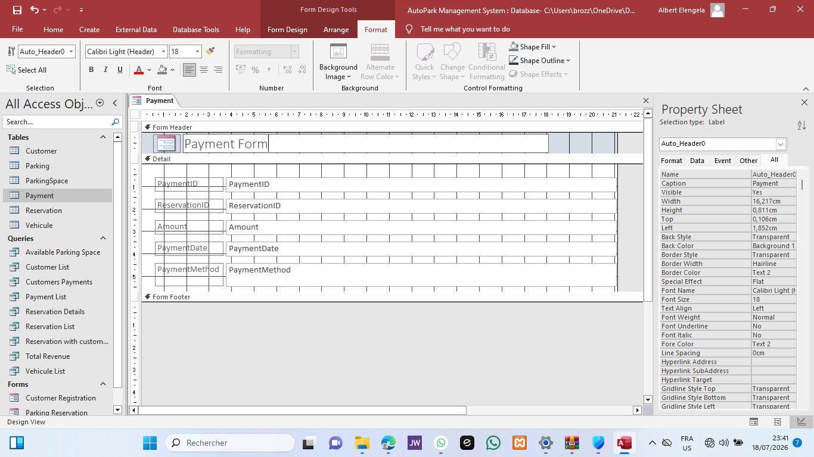

8.3 Form Validation
Each form was tested to verify that records could be created and updated successfully. The forms correctly enforced the relationships defined in the database and simplified data entry.

8.4 Chapter Summary
The forms improved the usability of the database by providing an efficient and organized interface for managing operational data.

CHAPTER 9: REPORTS

9.1 Introduction
Reports present database information in a structured format suitable for analysis and printing. They summarize operational data and support management decisions.

9.2 Reports Created
The following reports were generated:
- Customer Report
- Vehicle Report
- Reservation Report
- Payment Report
- Revenue Report
Each report was created from the corresponding query to ensure that only relevant information was displayed.
Customer report :
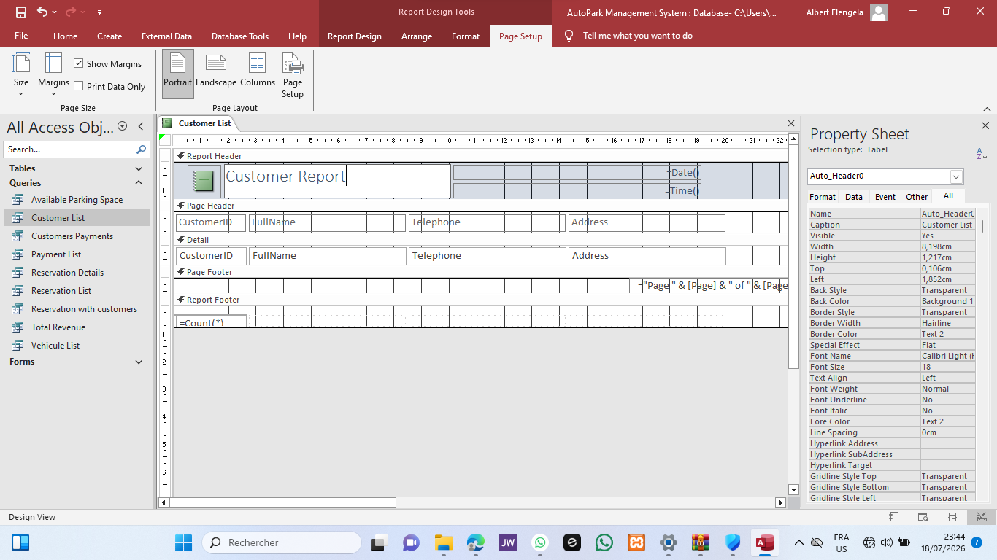

Vehicule report :

Payment report :
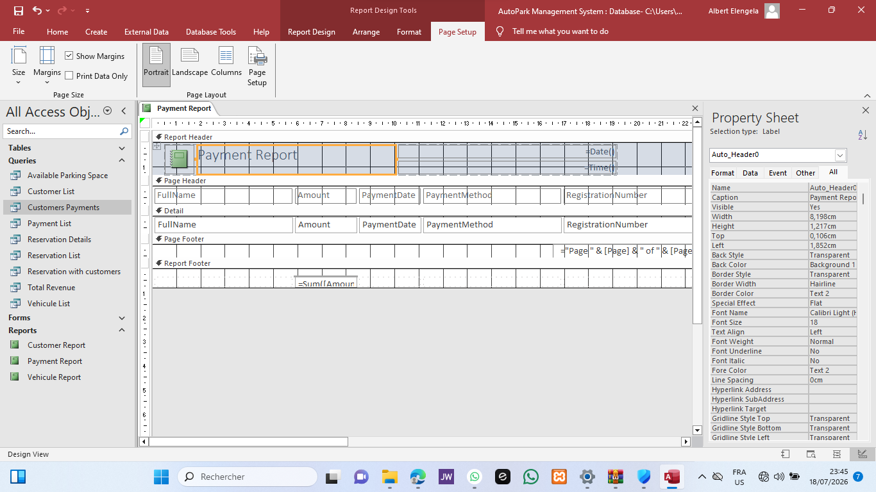

Revenue report :
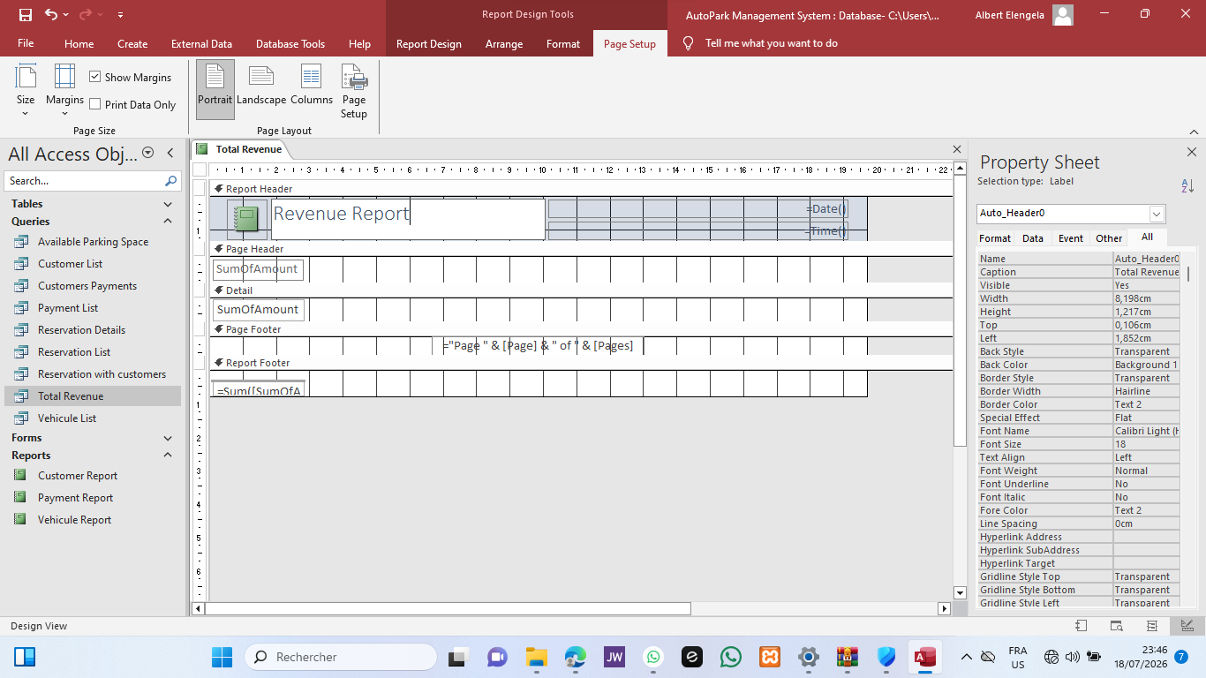

9.3 Report Validation
The reports displayed accurate information and were successfully formatted for printing. They provide managers with a clear overview of customers, reservations, payments, and total revenue.

9.4 Chapter Summary
Reports complete the database by transforming stored data into organized documents that support operational monitoring and decision-making.

CHAPTER 10: SYSTEM TESTING AND VALIDATION

10.1 Introduction
After implementing the database, several tests were conducted to verify that all components operated correctly. These tests evaluated the database structure, relationships, forms, queries, and reports.

10.2 Testing
The following operations were successfully tested:
- adding a new customer;
- registering a new vehicle;
- creating a reservation;
- recording a payment;
- verifying referential integrity.
Microsoft Access successfully prevented invalid records that violated database relationships.
Add customer :
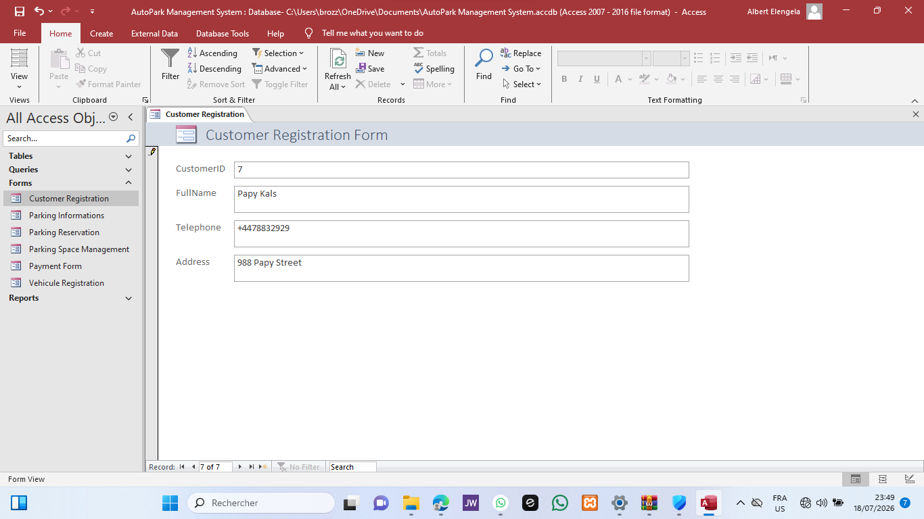

Add vehicule :
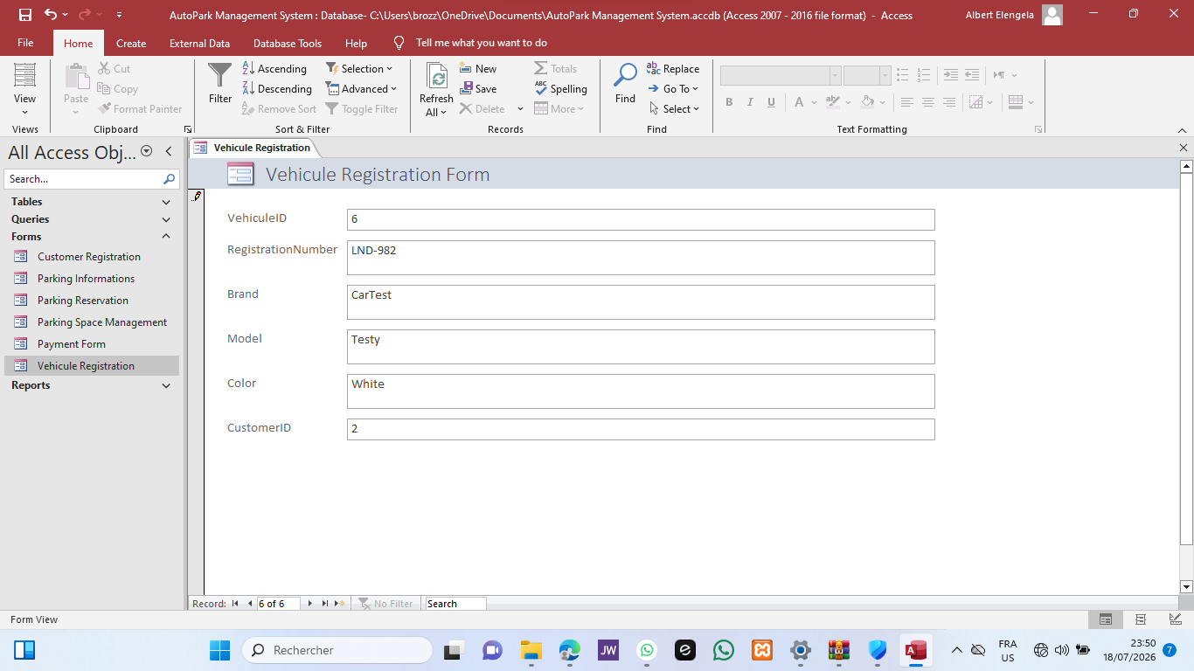

New reservation :
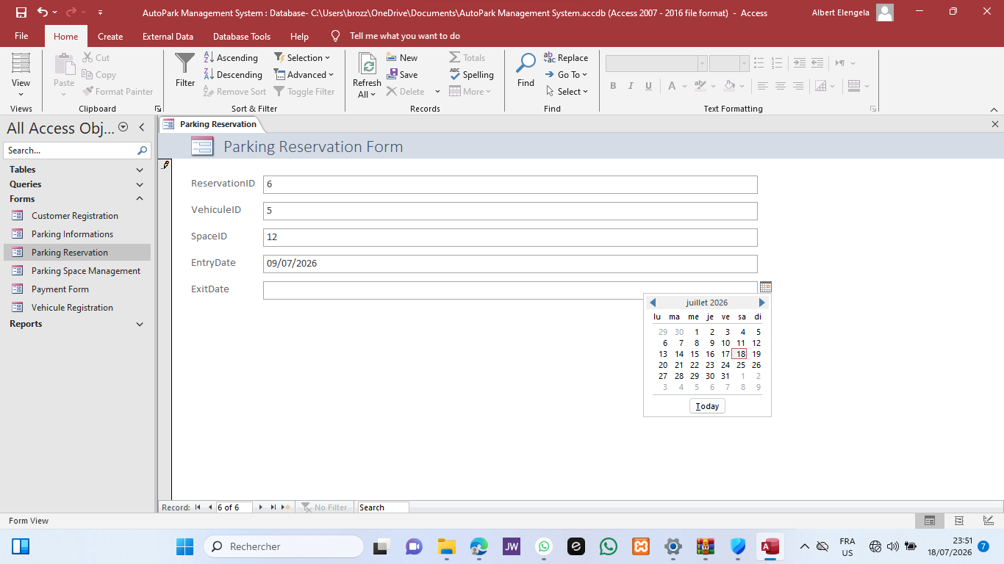

10.3 Evaluation
The tests confirmed that:
- tables were correctly linked;
- data were stored consistently;
- queries returned accurate results;
- forms simplified data entry;
- reports displayed reliable information.
The database successfully met the requirements identified during the analysis phase.

10.4 Chapter Summary
The testing phase confirmed that the AutoPark Management System database is reliable, functional, and capable of supporting parking management activities.

CHAPTER 11: GENERAL CONCLUSION

This project successfully designed and implemented a relational database for AutoPark Management System using Microsoft Access 2010.
The project began with an analysis of the company's requirements, followed by the design of an Entity Relationship Diagram, database implementation, normalization, data insertion, query development, form creation, report generation, and system testing.
The completed database organizes customer, vehicle, parking, reservation, and payment information efficiently while maintaining data integrity through relationships and referential integrity.
Testing demonstrated that all major functions operate correctly and that the database satisfies the objectives established at the beginning of the project.
Although additional features could be implemented in future versions, the current system provides a practical solution for managing parking operations and demonstrates the effective application of relational database concepts.

REFERENCES

[1] | T. Connolly and C. Begg, “Mr,” Database Systems, A Pratical Approach to Design ,Implementation and Management, p. Pearson Education Limited, 2015.
[2] | R. Elmasri and N. B. Shamkant, “Mr,” Fundamentals of Database Systems, p. Pearson, 2016.
[3] | C. Coronel, S. Morris and P. Rob, “Mr,” Database System: Design, Implementation, and Management, p. Gulf.edu.sa, 2010.

