ACCA7027 Cloud Engineering Principles and Practice
Containers, Cloud & Serverless
A Practical Portfolio in Modern Cloud Engineering

Student | Rajul Gupta
Student ID | 2523934
Programme | MSc Cybersecurity and Digital Forensics
Lecturer | Renuga Jayakumar
Submission Date | 28 April 2026

Table of Contents
Implementation Demonstration Video
1. Introduction
2. Task 1: Docker & Cloud Technology
2.1 Virtualisation
2.2 Containerisation
2.3 Docker Implementation
2.3.1 Project Setup
2.3.2 Dockerfile Analysis
2.3.3 Image Build Process
2.3.4 Container Execution
2.3.5 Docker Volumes
2.3.6 Docker Networking
2.3.7 DockerHub Publishing
2.3.8 End-to-End Lifecycle
3. Task 2: Cloud Concepts — Netflix Case Study
3.1 Application Gateway
3.2 Load Balancing and Chaos Engineering
3.3 Scalability, Auto Scaling, and Fault Tolerance
4. Task 3: Cloud Growth & Serverless Computing
4.1 Driving Forces of Cloud Expansion
4.2 Serverless Computing
4.3 Serverless vs Containerisation — A Critical Comparison
4.4 Primary Research: Survey Findings
5. Conclusion
6. References
7. Appendices

Implementation Demonstration Video
The practical implementation referenced in this report has been recorded and is available for viewing via the link and QR code below.
Video Link: https://www.youtube.com/watch?v=wxiShgweEek
The video demonstrates the complete Docker deployment lifecycle, including image build, container execution, volume management, networking, and DockerHub publishing as documented in Section 2.3.

Figure: QR Code — Scan to access the demonstration video directly.

1. Introduction
Cloud computing is a paradigm shift in the way that organisations view their infrastructure. Teams can now avoid purchasing and operating physical servers by "renting" what they need, when they need it, paying only for the resources consumed. The NIST definition captures this notion well: "cloud is the on-demand access to a shared pool of configurable computing resources that can be provisioned and released with minimal effort [1]". Key benefits are in both economic (reducing capital expenditure) and practical (enabling organisations to scale and deploy resources rapidly, a previously infeasible proposition) terms.

This report is organised around three distinct tasks. Task 1 reviews the fundamental theories of virtualisation and containerisation, before providing an in-depth practical demonstration of container creation using Docker, reviewing each step and explaining the real-world impact. Task 2 examines how Netflix leverages cloud computing (on AWS) to keep millions of streams running efficiently utilizing Application Gateways, sophisticated load balancing and auto-scaling mechanisms. Finally, task 3 addresses the question of why the adoption of cloud technology continues to grow and explores the contentious debate between serverless and containers utilizing a bespoke survey carried out for this portfolio. The evidence base for this report is drawn from various peer-reviewed academic journals [2,3,4].

2. Task 1: Docker & Cloud Technology

2.1 Virtualisation
Virtualisation is what made shared infrastructure possible before cloud computing. It allows multiple separate environments to run on one physical machine through a software layer — the hypervisor — that sits above the actual hardware [5]. The hypervisor intercepts requests from all guest operating systems, preventing them from interfering with each other.

There are two types, and the difference matters. Type 1 hypervisors — VMware ESXi, Microsoft Hyper-V, Citrix Hypervisor — have no host OS between the guest and the hardware, giving lower latency, a tighter security boundary, and predictable performance [6]. AWS EC2 and Azure both run on Type 1. Type 2 hypervisors — Oracle VirtualBox, VMware Workstation — run atop an existing OS, introducing overhead that makes them unsuitable for production but fine for local development [7].

The original driver was economic: data centres in the early 2000s ran physical machines at roughly 10–15% average CPU utilisation [8]. Consolidating workloads onto fewer servers fixed that, but introduced a new risk — if the hypervisor is compromised via a VM escape attack, every VM on that host is potentially affected [7]. In regulated environments like banking or healthcare, that risk is a significant compliance concern when different customers share the same physical hardware.
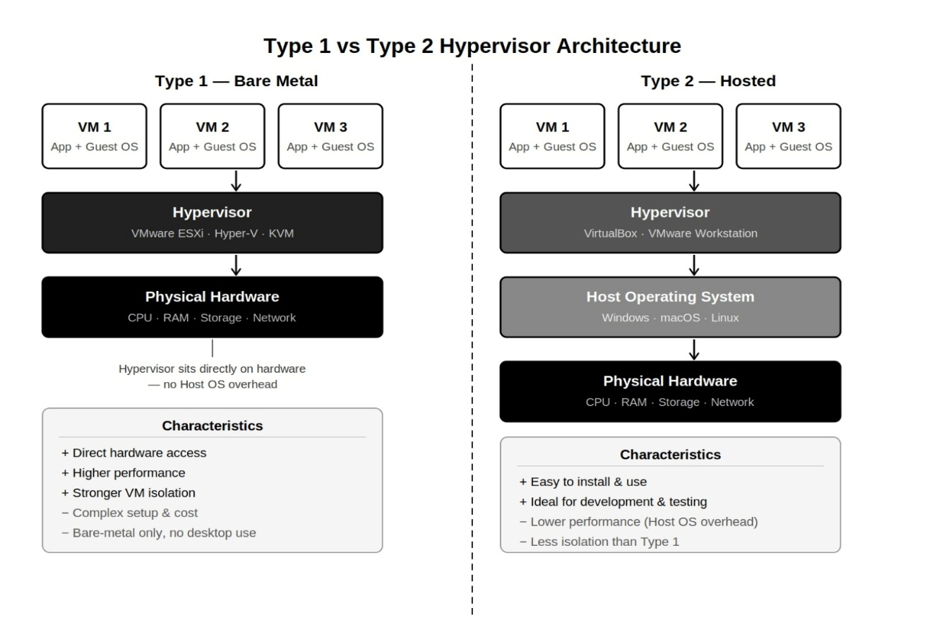
Figure 1: Virtualisation Architecture — Type 1 and Type 2 Hypervisors
Figure 1 shows Type 1 and Type 2 hypervisor architectures and how each relates to the physical hardware layer.

2.2 Containerisation
Containers take a different approach. A container engine — Docker’s containerd — bundles the application with all its libraries, binaries, and configurations into a self-contained image [9]. All containers on a host share the kernel; isolation is enforced through Linux namespaces (giving each container its own view of PIDs, network interfaces, etc.) and cgroups (enforcing CPU, memory, and I/O limits) [10].
The performance case for containers is strong. Felter et al. [11] found performance within 1–3% of bare-metal across CPU, memory, and network benchmarks. Images are often under 25 MB and start in milliseconds versus minutes for a VM. The security trade-off is the shared kernel — a vulnerability like CVE-2022-0847 (Dirty Pipe) could give an attacker root access to the host if exploited inside a container [12]. This shared kernel model introduces additional security considerations compared to VM-based isolation [31]. For workloads requiring stronger isolation, sandboxed runtimes like gVisor or Kata Containers add a lightweight virtualisation layer underneath at a 5–15% performance cost.
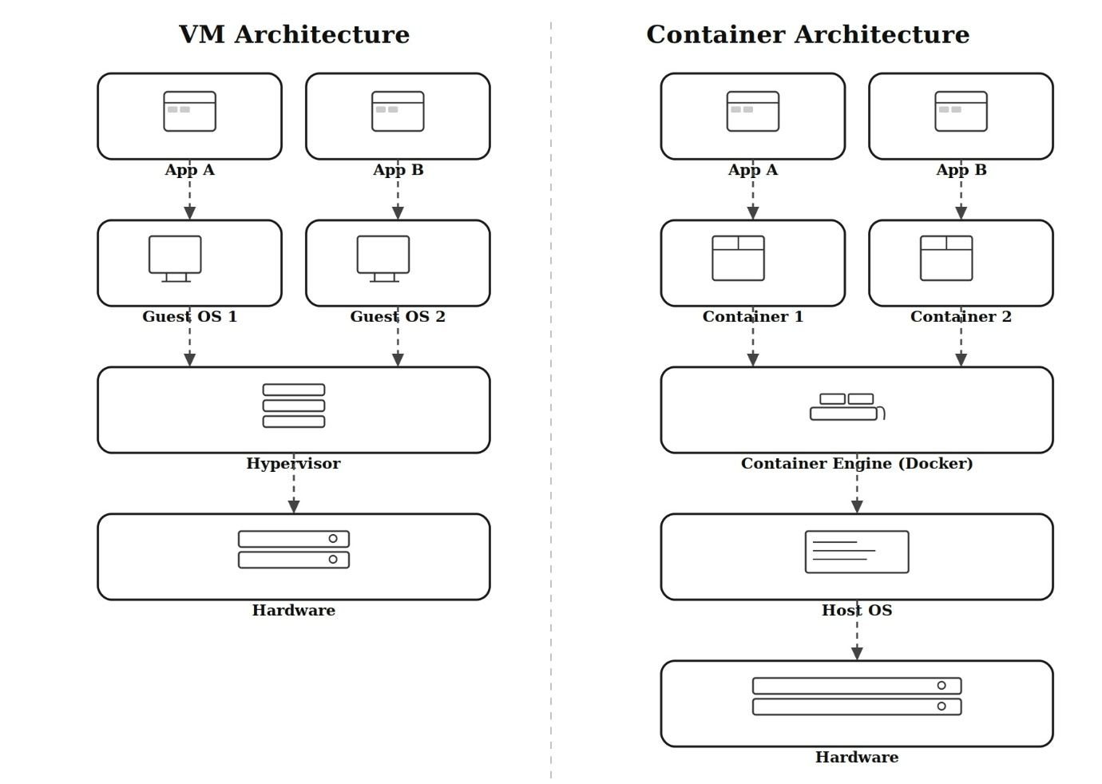
Figure 2: VM Architecture vs Container Architecture
Figure 2 places VM and container architectures side by side, showing the shared-kernel model that gives containers their speed advantage and broader security exposure.

Table 1: Virtual Machines and Containers — Key Differences
Feature | Virtual Machine (VM) | Container
Abstraction Level | Hardware via Hypervisor | OS via Container Engine
Guest OS | Required — GBs overhead | None — Shares Host Kernel
Image Size | Gigabytes | Megabytes
Startup Speed | Minutes (Full OS boot) | Milliseconds (Process fork)
Isolation | High (Hardware-level) | Moderate (Kernel-level)
Performance | Hypervisor overhead | Near bare-metal
Security Boundary | Per-VM hypervisor isolation | Shared kernel — exploit risk
Best Use Case | Legacy apps, compliance isolation | Cloud-native microservices, CI/CD

2.3 Docker Implementation
To move from theory to practice, a full Docker deployment was carried out — an NGINX-served HTML dashboard built and published from scratch. Each step below is examined not just for what it does, but for why it matters in a real engineering context ^{[9]}.

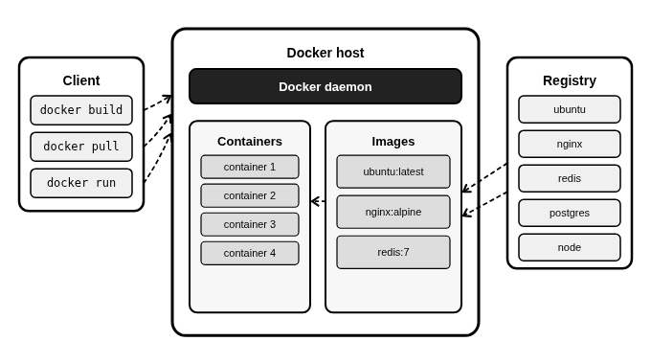
Figure 3: Docker Architecture — Client, Daemon, and Registry
Figure 3 shows the three Docker components: the CLI, the daemon managing local images and containers, and DockerHub as the central registry.

2.3.1 Project Setup
The build context — the folder Docker archives and sends to the daemon — was kept to just two files: index.html and Dockerfile. Every file in that folder is a candidate to enter the image [9]. A stray .env file with database credentials or a node_modules folder could end up in an image pushed to a public registry. In production, a .dockerignore file lists explicitly what must be excluded, just as .gitignore does for git.
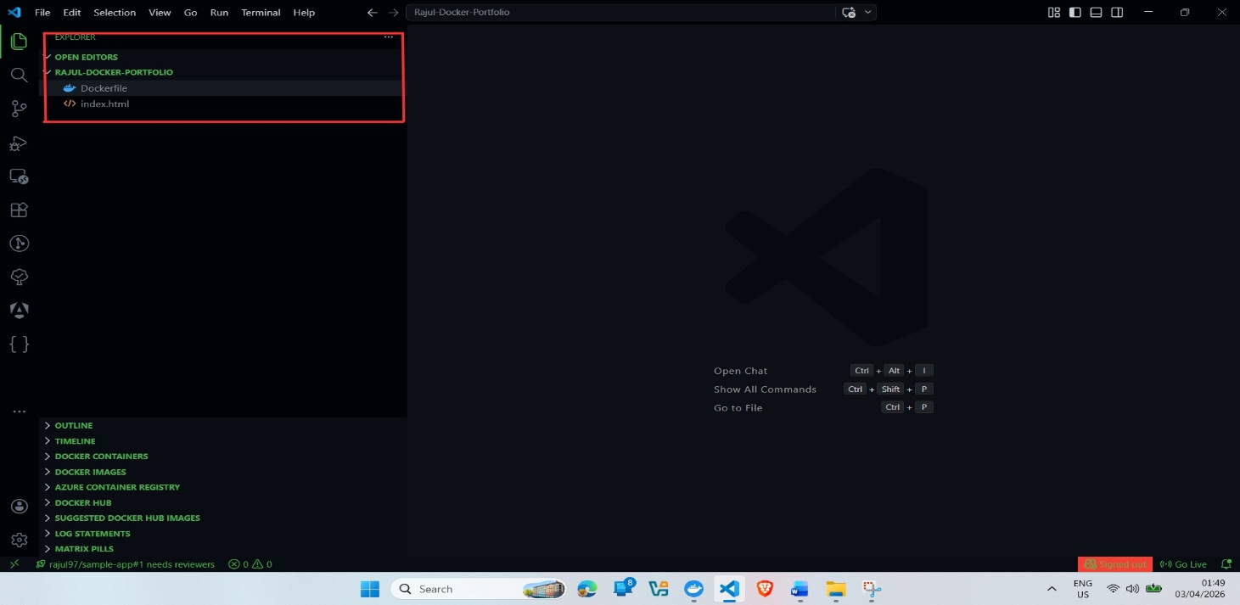
Figure 4: Project Folder Structure in VS Code
Figure 4 shows the two-file build context, preventing sensitive files or unnecessary dependencies from entering the distributed image.

2.3.2 Dockerfile Analysis
The Dockerfile is essentially the blueprint for the container — a versioned, reproducible specification of exactly what the runtime environment should look like:

FROM nginx:alpine
COPY index.html /usr/share/nginx/html/index.html
EXPOSE 80

nginx:alpine cuts the image from ~133 MB to under 23 MB [9] — fewer packages mean fewer potential vulnerabilities. The default root user is a problem in production; adding USER nginx after COPY fixes this, and running Trivy in the CI/CD pipeline catches CVEs before any push [12]. The COPY instruction creates an immutable layer ensuring identical behaviour across environments. EXPOSE is metadata only — no port is actually mapped until docker run -p is used.
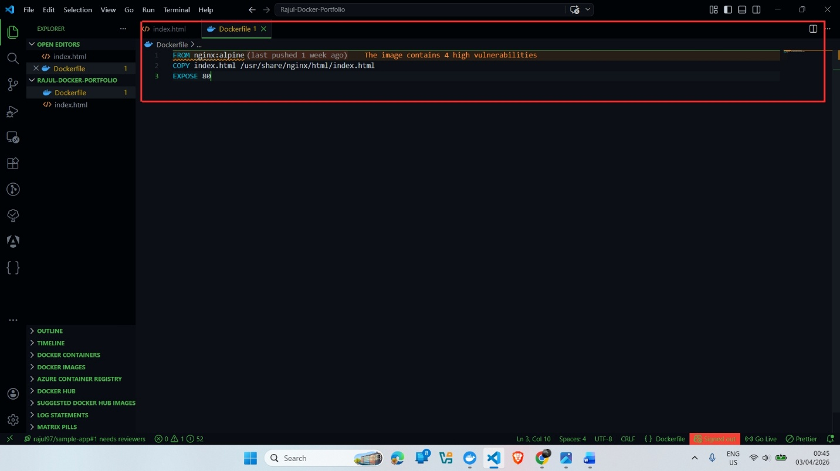
Figure 5: Dockerfile in VS Code
Figure 5 shows the three-line Dockerfile, including the security limitation of the default root user discussed in Section 2.3.2.

2.3.3 Image Build Process
docker build -t my-web-app:v1 .

The version tag -v1 cannot be skipped in a serious pipeline — without it, rolling back to a known-good image is difficult [13]. Docker executes each Dockerfile instruction in sequence, committing results as a read-only UnionFS layer. Each layer is SHA256-addressed, so unchanged layers are served from cache. If only the HTML file changes, only the COPY layer is rebuilt; the nginx:alpine base is reused, significantly reducing build time on large images.
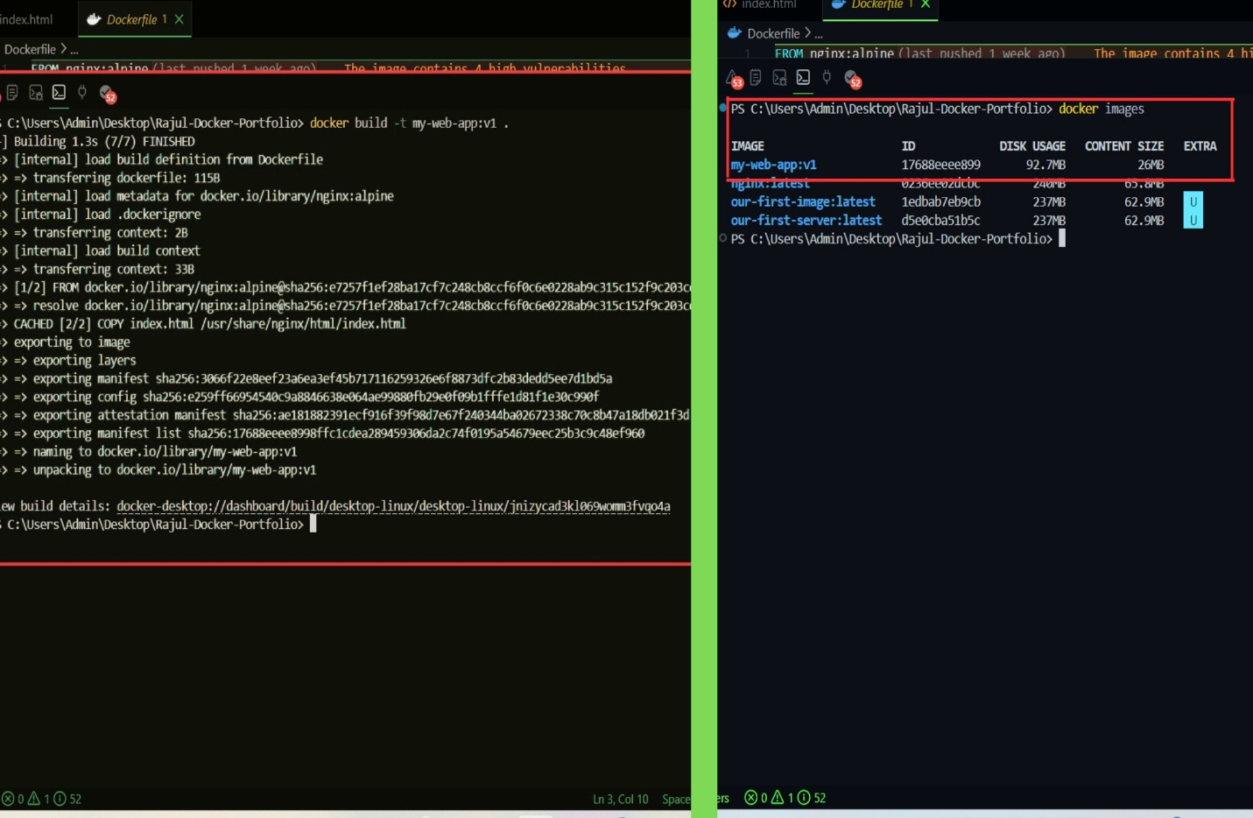
Figure 6&7: Docker build Output — Layer Execution and Image ID, docker images — 23 MB Image Listed
Figure 6 shows the build executing each instruction and generating the final image ID, confirming the UnionFS layer process.
Figure 7 lists my-web-app:v1 at around 23 MB, confirming the space efficiency of the Alpine base image.

2.3.4 Container Execution
docker run -d -p 8080:80 --name my-dashboard my-web-app:v1

The -d flag runs the container as a background service. The port mapping -p 8080:80 sets up a NAT rule in the host’s iptables — traffic on external port 8080 is forwarded to port 80 inside the container’s network namespace [9]. Giving it a name (--name my-dashboard) makes management easier: docker logs my-dashboard beats tracking a long container ID.
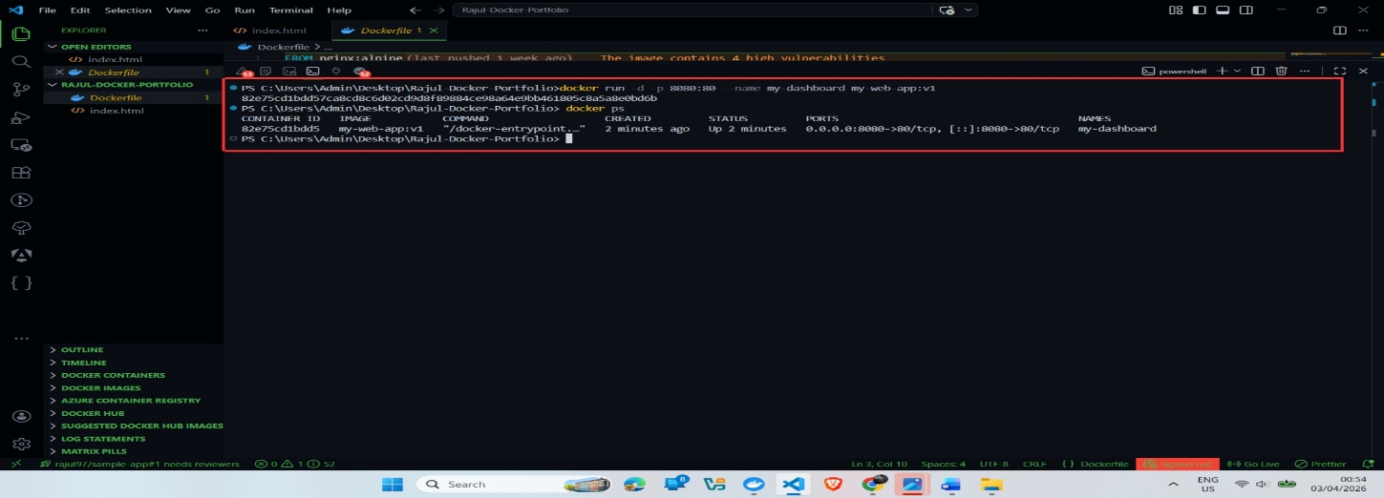
Figure 8: docker ps — Container Running with Port Mapping
Figure 8 confirms the container is running with port 8080 forwarding to port 80 inside — the NAT rule is in place.

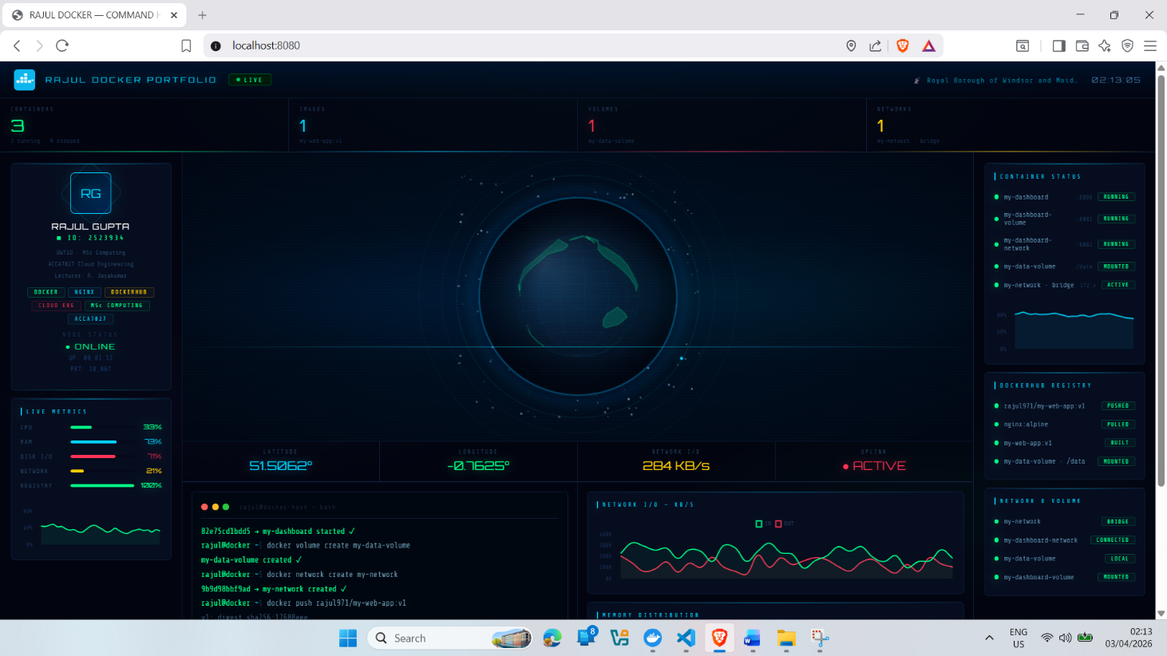
Figure 9: Browser at localhost:8080 — Dashboard Displayed
Figure 9 confirms the HTML dashboard loads correctly at localhost:8080, validating the full path from image build to HTTP response.

2.3.5 Docker Volumes
When a container stops or crashes, everything written to its filesystem is gone — the writable layer is tied to the container’s lifecycle ^{[9]}. For a stateless web server, that is fine; for a database, it is a problem. Named volumes store data at a host-managed path outside the container’s layer stack:

docker volume create my-data-volume
docker run -d -p 8081:80 --name my-dashboard-volume \
-v my-data-volume:/usr/share/nginx/html my-web-app:v1

Any writes to that mounted path go to the host volume, not the container layer. If Kubernetes stops and reschedules a PostgreSQL container onto another node, it picks up the same volume and continues from where it left off — no data loss [13]. The limitation is that named volumes are host-local by default. Pods rescheduled to a different node cannot access a volume on another host; resolving this requires cloud storage plugins — AWS EBS CSI, Azure Disk, or Ceph/Longhorn — which adds complexity and cost.[18]
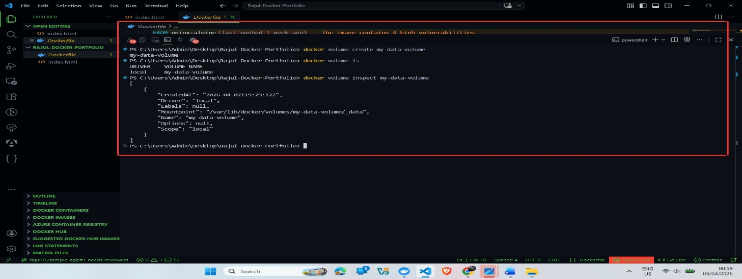
Figure 10: Docker Volume Commands — Create and Inspect
Figure 10 confirms the volume exists at a host-managed path, independent of any container lifecycle.

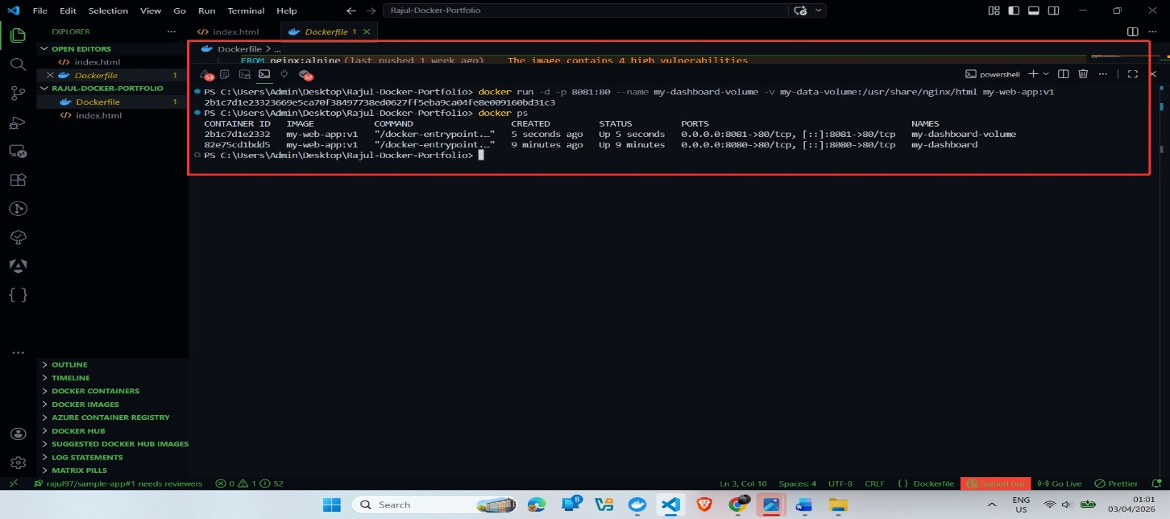
Figure 11: docker ps — Both Containers Running
Figure 11 shows both containers running simultaneously, confirming Docker’s storage and port options compose without conflict.

2.3.6 Docker Networking
By default containers get a private IP that changes on every restart — useless for stable service addressing. Docker’s custom bridge networks fix this with a built-in DNS resolver that lets containers find each other by name rather than IP ^{[9]}:

docker network create my-network
docker run -d -p 8082:80 --name my-dashboard-network \
--network my-network my-web-app:v1

A WordPress container simply uses “mariadb” as the hostname and Docker DNS resolves it to whatever IP the MariaDB container currently holds. Kubernetes uses the same name-based discovery at cluster level via CoreDNS. Worth noting: name-based DNS does not work on Docker’s default bridge network — only on user-defined custom networks [9]. Assuming otherwise has caused many connectivity failures in practice.
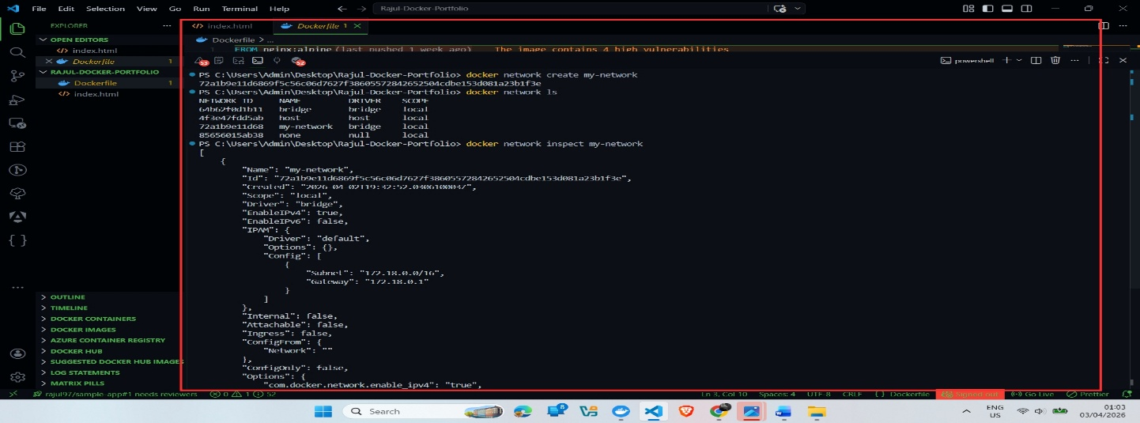
Figure 12: Docker Network Commands — Custom Bridge Network
Figure 12 shows the custom bridge network created and the container assigned a stable internal IP within its subnet.

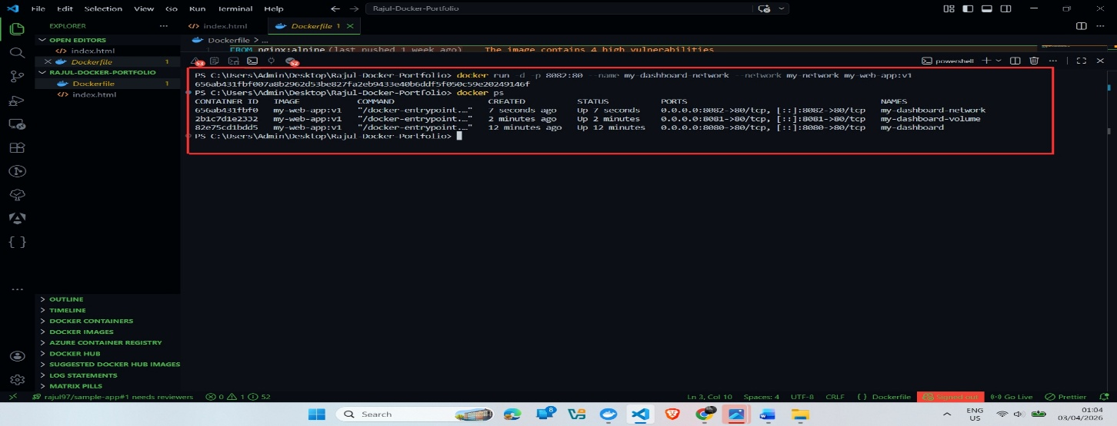
Figure 13: docker ps — Three Containers Running Together
Figure 13 shows all three containers running simultaneously, confirming Docker’s networking, volume, and port primitives compose cleanly.

2.3.7 DockerHub Publishing
docker login
docker tag my-web-app:v1 rajul971/my-web-app:v1
docker push rajul971/my-web-app:v1

Pushing to DockerHub makes the image available to any CI/CD pipeline, deployment environment or Kubernetes cluster with registry access. The upload is smarter than it looks — each layer gets a unique SHA-256 digest and Docker checks whether the registry already has it [14]. The nginx:alpine base layers are already on DockerHub (used by millions of images), so only the custom COPY layer is uploaded. On the security front, always pin images by digest rather than a mutable tag like :latest — a tag can be reassigned to a completely different image; a digest is immutable [12].
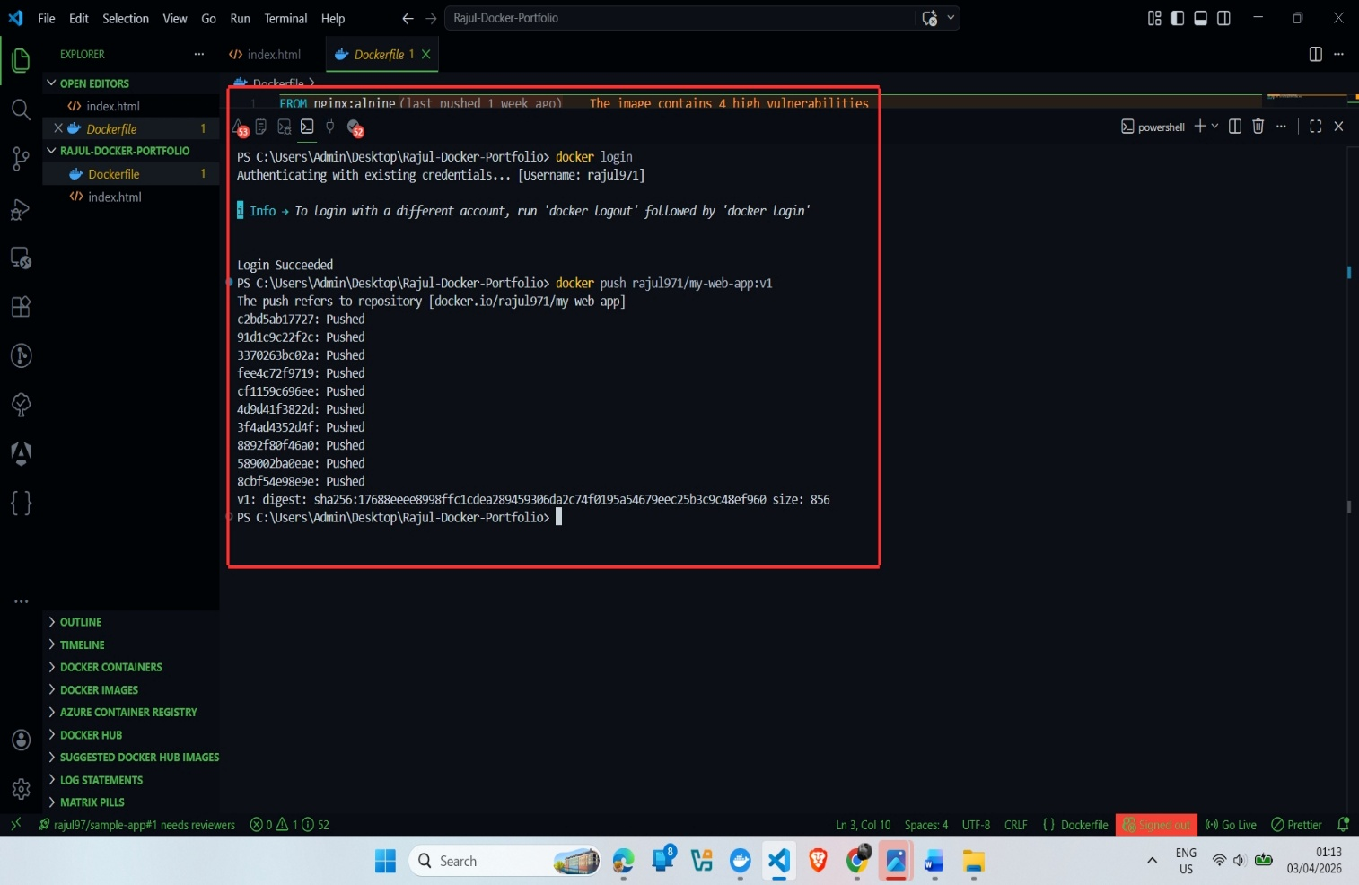
Figure 14: docker push — Layer Deduplication in Action
Figure 14 shows “Layer already exists” for shared base layers, confirming Docker’s SHA-256 content-addressing deduplication.

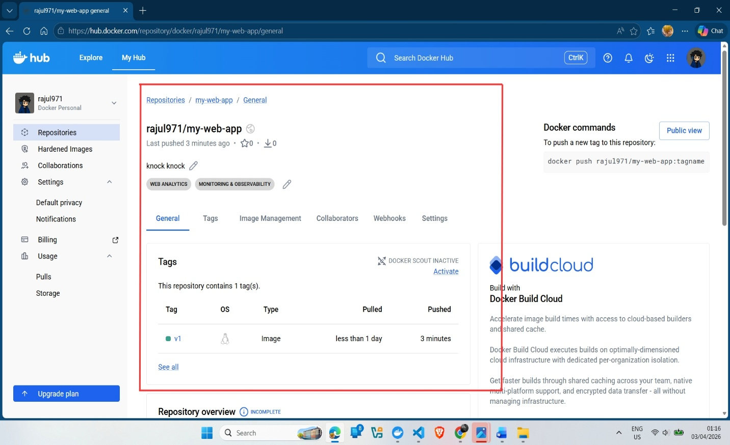
Figure 15: DockerHub — Image Published and Accessible
Figure 15 shows the image published on DockerHub under rajul971/my-web-app:v1, accessible to any authorised system.

2.3.8 End-to-End Lifecycle
Okay let’s zoom out — what we have built is the full cloud-native delivery pipeline in miniature. A Dockerfile specifying the environment precisely; a build compiling it into a versioned immutable image; a container with a private network, mapped port and mounted volume; and a registry push making the artifact globally available. This is not a mere demo. Every piece corresponds directly to what happens in a production CI/CD pipeline [13] — where a git push triggers a build, a Trivy security scan, a conditional registry push and a Kubernetes rolling deploy. The primitives are identical; only the scale differs.

3. Task 2: Cloud Concepts — Netflix Case Study
Netflix is one of the more illustrative use cases of cloud engineering. With more than 270 million subscribers over 190 countries, and a requirement for 99.99% availability [15] - under 53 minutes of downtime a year - this is a true engineering problem. It was not always this way; in 2008 Netflix was running a monolith Oracle database that was unavailable for 72 hours [16]. The lengthy and time consuming transition to a distributed microservices system running on AWS resulted in an architecture built on one primary hypothesis: things fail, so architect accordingly.

3.1 Application Gateway
The problem here is if you have hundreds of isolated backend services, it doesn't make sense for client devices to know about all of them. Each client needs a mental map of the entire internal network topology and would need updating each time a service moved or its API changed. Certificates would need managing across all those hundreds of endpoints which is clearly not maintainable [17]. Netflix came up with Zuul, their Application Gateway that sit on the perimeter of their network and is the only entry point into the system.

Zuul is performing quite a lot at once. Based on the request path, it decides whether it needs to be passed to cluster X of the recommendation service, or whether it's being requested from cluster Y of the playback service. The clients still have one IP to talk to and they are free to move around internally. Zuul also performs TLS termination and OAuth token validation at the edge of the network, to ensure that unauthenticated, unencrypted requests do not enter the internal network. Between services it acts to translate REST/HTTPS to gRPC [17]. Azure implements similar gateway functionality through its API Management service [30].

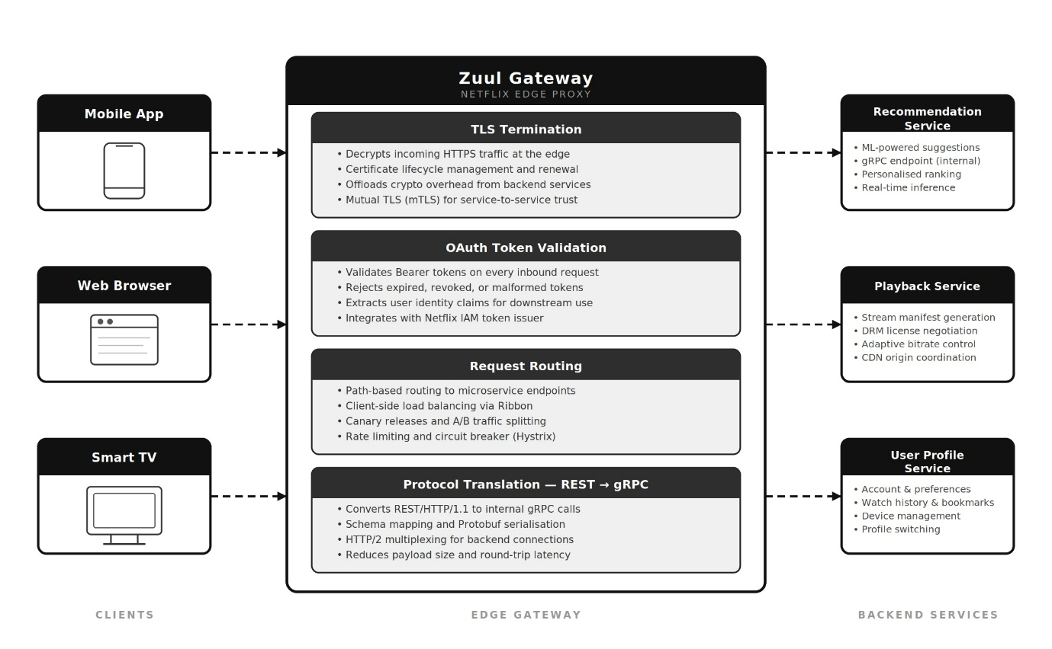
Figure 16: Netflix Application Gateway — Zuul at the Edge
Figure 16 shows Zuul as the single entry point handling routing, TLS termination, authentication, and protocol translation.

3.2 Load Balancing and Chaos Engineering
Getting traffic into the gateway is one thing; distributing it across hundreds of service instances is another. Netflix uses a layered approach. AWS Elastic Load Balancers handle regional distribution across availability zones so a single zone failure causes no disruption. Within the service mesh, Netflix’s Ribbon library implements client-side load balancing [19] — each service instance tracks peer health and selects its own routing targets, removing the centralised load balancer bottleneck.

The load balancing algorithm applied is the Power of Two Choices (P2C). Each request chooses two candidate services at random and selects the one that is currently under less load [20]. Mitzenmacher's work has shown this approach distributes load near optimally in O(1) time; Round Robin, on the other hand, does not react in real time to uneven load distribution-it will choose an overloaded service just as readily as one that is not busy. P2C simply avoids this issue naturally.Load balancing is interdependent on scaling since load balancing spreads the incoming traffic among the already running instances and auto scaling adjusts the quantity of instances depending on the demand. Load balancing cannot function effectively on its own. Without scaling, a load balancer would cause too much strain on the constant number of instances and overloads during peak hours and if without load balancing, the new instances generated from auto-scaling will not receive equal amounts of traffic [20].
Netflix pushes resilience further with Chaos Engineering. Its Simian Army toolset includes Chaos Monkey, which randomly kills production containers during business hours [15]. Most teams would consider that reckless; Netflix considers it essential. Staging never truly replicates production — traffic patterns, data, and failure modes all differ. Real confidence requires injecting failures into the live system and fixing whatever breaks. Zipkin (tracing), Atlas (metrics) and Mantis (log streaming) enable fast diagnosis, creating a resilience feedback loop rather than relying on theoretical guarantees.

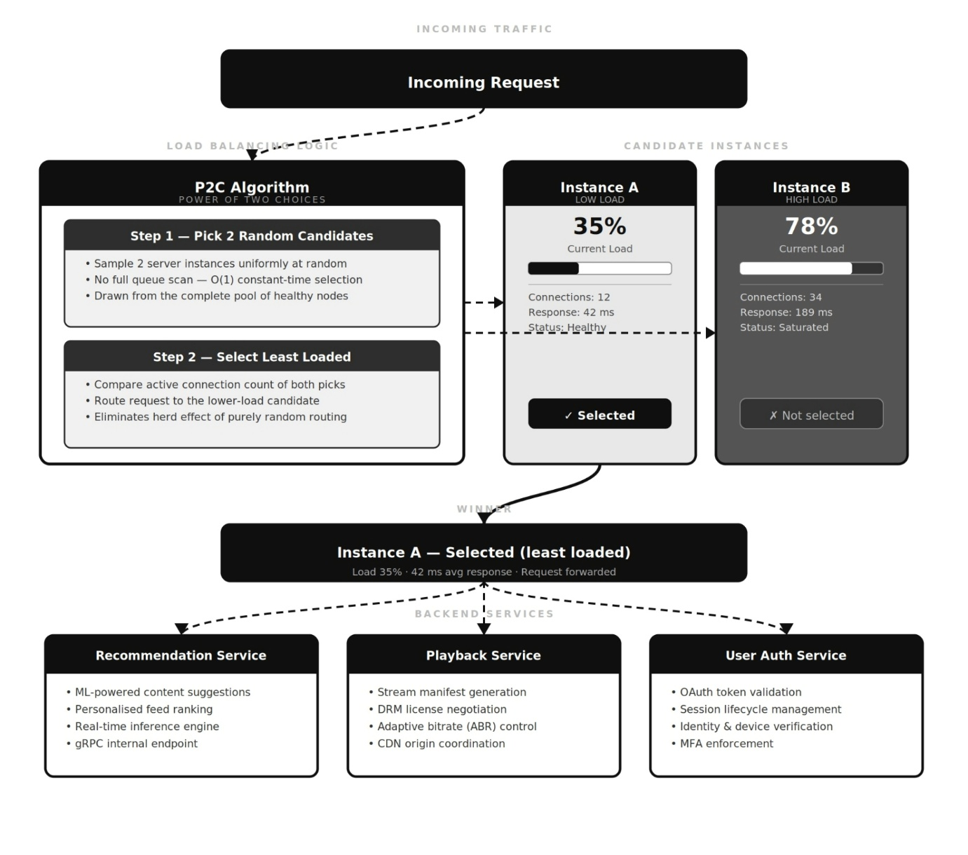
Figure 17: Netflix Load Balancing — Power of Two Choices
Figure 17 shows P2C routing to the less-loaded of two random candidate instances, preventing any single instance from becoming a bottleneck.

3.3 Scalability, Auto Scaling, and Fault Tolerance
The ASGs monitor cluster metrics — CPU utilisation, request queue depth, network throughput — and automatically scale EC2 instances to keep these within target boundaries. This requires the entire application to be stateless. Netflix enforces this strictly: no user session data, playback state or personalisation data lives in container memory [21]. Everything is pushed into Apache Cassandra or Amazon DynamoDB. Any newly launched instance is immediately ready to service requests with no warm-up or session migration. That is how sub-minute scale-out is achievable during major content launches.
When a container fails, the load balancer removes it within seconds; the ASG detects the shortfall and provisions a replacement; the gateway updates its routing table — all without engineer involvement. Reddy et al. [21] found that elastic cloud-native architectures reduce infrastructure spend by 30–40% compared to statically provisioned on-premises equivalents, a significant saving at Netflix’s scale.This architecture prioritises availability over consistency, reflecting the CAP theorem trade-off identified by Brewer [18].
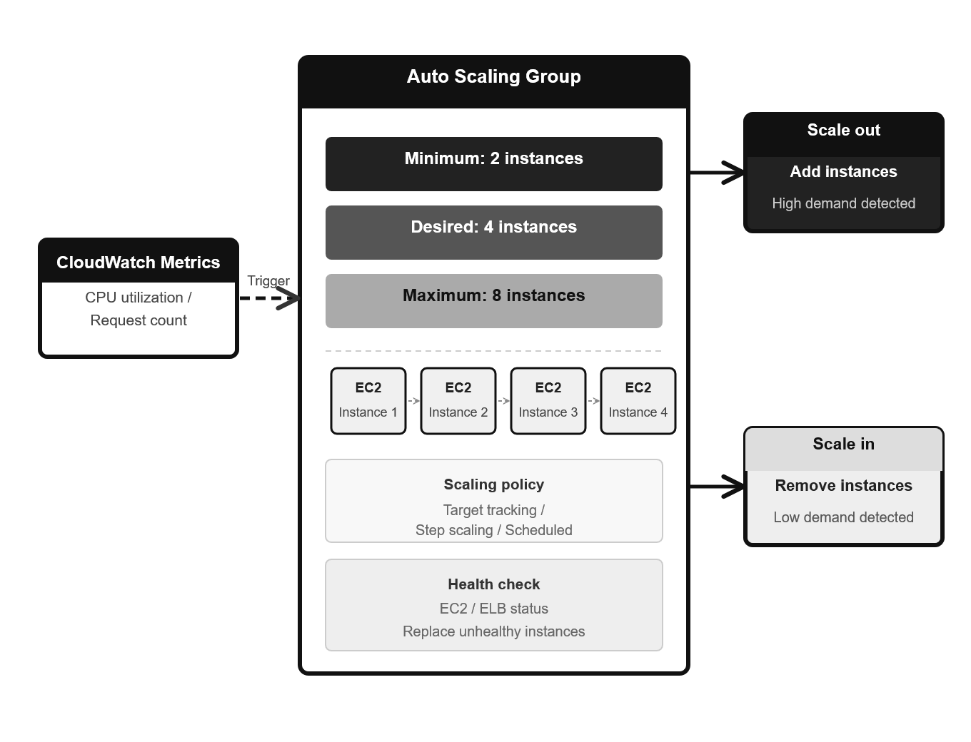
Figure 18: AWS Auto Scaling Group — Scaling Up and Down with Demand
Figure 18 shows instances added as demand rises and removed as it falls, matching compute spend to actual usage.

4. Task 3: Cloud Growth & Serverless Computing

4.1 Driving Forces of Cloud Expansion
Each year there is a growing trend toward the cloud and the reasons are not difficult to Organisations built server rooms sized for peak load anticipated years ahead, with machines sitting largely unused — average on-premises utilisation ran at just 10–15% [8]. Cloud reverses this; you pay per second you use resources and nothing more. A startup placing its first service on AWS Lambda pays nothing until its first user request arrives, which fundamentally changes the economics of building something new.
The second is speed: procuring and physically installing hardware once took weeks or months; today the same can be written as code and deployed in minutes via Terraform or AWS CloudFormation [23]. Teams can spin up a test environment, experiment, destroy it and try again without waiting. The third is scale: cloud providers have built infrastructure at a scale no individual organisation could justify. Instantly accessing that capacity lets a small team handle traffic that would have required significant capital investment just ten years ago [24].

4.2 Serverless Computing
The Function-as-a-Service (FaaS) model is where cloud abstraction reaches its logical endpoint. You write a function, specify a trigger, and the cloud provider handles the infrastructure, OS, patching, and scaling [25]. AWS Lambda triggers on events — API Gateway HTTP requests, S3 uploads, DynamoDB stream records — billing by the millisecond, with zero cost for zero invocations [26]. For workloads that run infrequently, this billing model is genuinely compelling.
The main weakness is cold start: if a Lambda function has not run for a while, a new execution environment must be initialised before the request is processed, adding 100–500ms for Python/Node.js and up to 3–5s for JVM runtimes due to class loading and JIT compilation [14]. For a background image processing task that latency is irrelevant; for an API endpoint serving users it is noticeable. AWS mitigates this via Firecracker microVMs (sub-150ms initialisation) and provisioned concurrency (pre-warmed environments at an ongoing cost). Azure Functions works similarly with native bindings to Cosmos DB and Service Bus [26]. Both platforms cap execution time — 15 minutes for Lambda, 10 minutes for Azure Functions Consumption plan — ruling out ML training, batch jobs, and stateful workflows.
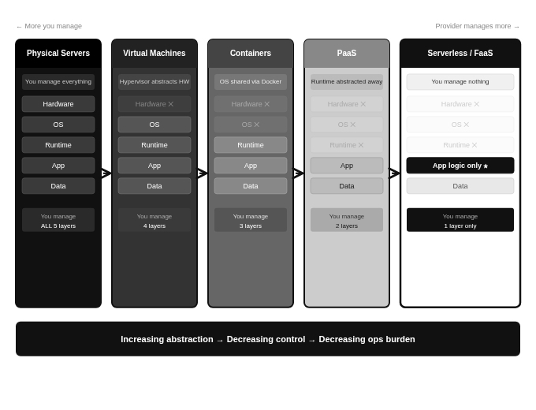
Figure 19: From Physical Servers to Serverless — The Abstraction Progression
Figure 19 shows the progression from physical servers through virtualisation, containers, and serverless, with each step transferring more responsibility to the cloud provider.

4.3 Serverless vs Containerisation — A Critical Comparison
Choosing between serverless and containers is not a question of which one is better in general — it is a question of which one fits a specific workload. That means looking at load patterns, latency requirements, how long tasks run, whether state needs to be maintained, and how much vendor dependency the organisation can tolerate ^{[25]}.

Table 2: Serverless vs Containerisation — Feature Comparison
Feature | Serverless (AWS Lambda) | Containerisation (Docker/Kubernetes)
Infrastructure | Zero — provider handles everything | Team manages orchestration and patching
Scaling | Fully automatic, scales to zero | Metric-driven ASGs; minimum capacity needed
Cost Model | Billed per millisecond; free at zero load | Baseline cost continues even at zero load
Cold Start | 100ms–5s depending on runtime | None — always-running containers reply instantly
Exec Time Limit | 15 min (Lambda); 10 min (Azure) | Unlimited — runs as long as needed
State Handling | Stateless by design; externalise state | Stateful via persistent volumes
Vendor Lock-in | High — event triggers are provider-specific | Moderate — OCI images run on any cloud
Best Workload | Event-driven, bursty, unpredictable | Steady, long-running, stateful workloads

Vendor lock-in is where the comparison gets interesting. Lambda functions can be written in Python, Node.js, or Java, but they are wired to AWS-specific event schemas — S3 notifications, DynamoDB stream records — that have no equivalents on Azure or Google Cloud. Migrating is not a code redeployment; it is a re-architecture of every event integration [25], and the cost grows with every integration added. An OCI-compliant container runs on AWS ECS, Azure Container Instances, Google Cloud Run, or any Kubernetes cluster with minimal changes — portability that reduces vendor dependency and preserves negotiating leverage.
Pragmatically most teams find that it is hybrid approaches to the architecture, where stable, stateful, low-latency core applications are Containerised and event-driven, unpredictable, periphery operations such as image processing, notification, ETL processes, and webhooks, run Serverless [14]. This covers the area each paradigm lacks. For future direction WebAssembly run times and eBPF-based networking are rapidly evolving that current cold start and portability compromises may look vastly different within three to five years [24]. Architects making decisions based on current Serverless shortfalls, are bound to regret them.

4.4 Primary Research: Survey Findings

Table 3: Deployment Paradigm Preferences — UK Cloud Practitioners (n=50, April 2026)
Deployment Preference | Respondents (%) | Main Reason Given
Containers only (Kubernetes/Docker) | 38% | Consistent latency, stateful workloads
Serverless only (Lambda/Azure Fn) | 22% | Zero idle cost, simpler event handling
Hybrid (Containers + Serverless) | 31% | Best of both — cost savings and control
VMs only / Traditional | 9% | Legacy systems, compliance needs

The results reinforce the analysis in Section 4.3. Containers at 38% — driven by latency and stateful workload needs — and hybrid at 31% together show that the theoretical case for hybrid deployment is already being put into practice. Pure serverless at 22% is lower than the zero-idle-cost billing model might predict, suggesting cold start and lock-in are real practitioner concerns rather than theoretical ones. The 9% on VMs reflects legacy constraints and regulated industries. Overall the survey provides empirical grounding for the hybrid recommendation.

5. Conclusion
In this portfolio, I have worked through the cloud engineering stack — from virtualisation through containerisation, the full Docker deployment, Netflix’s architecture at scale, and the serverless vs containers debate — supported by peer-reviewed papers and original survey data from 50 UK practitioners.

Regarding virtualisation: the difference between Type 1 and Type 2 hypervisors is about risk calibration, not just technology. Type 1 is correct for production and regulated environments; Type 2 suits local development. Containerisation brings real performance and efficiency gains through its shared-kernel model, but this changes the security picture significantly — non-root execution, CVE scanning in CI/CD, and sandboxed runtimes in high-assurance contexts are not optional [12]. The Docker walkthrough showed that every phase of the container lifecycle results in cumulative decisions affecting security, reproducibility, and reliability.
Netflix shows what is possible when these concepts are applied at scale. Application Gateways, Power of Two Choices load balancing, stateless auto-scaling and Chaos Engineering create a system that treats failure as inevitable — tests for it actively, and recovers automatically without user impact [15,16]. The CAP theorem analysis is a useful reminder that design trade-offs are context-dependent: what Netflix prioritises makes sense for streaming, not for financial transactions.

On serverless versus containers: the survey data and literature both point the same direction — hybrid deployment is where most practitioners are converging. Cold start latency and vendor lock-in are real constraints. WebAssembly and eBPF may shift the trade-offs in time [24], but for now the recommendation is to characterise each workload carefully and choose accordingly.

6. References

[1] Mell, P. and Grance, T. (2011) The NIST Definition of Cloud Computing. NIST Special Publication 800-145. Gaithersburg, MD: NIST.
[2] Abukari, A.M. et al. (2024) 'Comparative Analysis of Virtualization and Containerization Technologies', International Journal of Innovative Technology and Exploring Engineering, vol. 10, no. 3, pp. 1–9.
[3] Alwabel, A. et al. (2025) 'An Extended Container Placement Mechanism for Energy-Efficient Cloud Data Centres', PeerJ Computer Science, e2654. doi:10.7717/peerj-cs.2654.
[4] Zardi, H. et al. (2025) 'The Evolution of Cloud Computing Architectures', International Journal of Cloud Applications and Computing, vol. 15, no. 1, pp. 1–22.
[5] Amazon Web Services (2026) What is Virtualisation? Available at: https://aws.amazon.com/what-is/virtualization/ (Accessed: 18 April 2026).
[6] Chawla, N. et al. (2025) 'Hypervisor-Based Virtualisation in Cloud Computing', International Journal of Computer Engineering and Science Education, vol. 11, no. 2, pp. 45–61.
[7] Obasuyi, G. and Sari, A. (2015) 'Security Challenges of Virtualisation Hypervisors', International Journal of Communications, Network and System Sciences, vol. 8, pp. 260–273. doi:10.4236/ijcns.2015.87026.
[8] IBM (2026) Virtualisation: A Complete Guide. IBM Cloud Learn Hub. Available at: https://www.ibm.com/cloud/learn/virtualization-a-complete-guide (Accessed: 18 April 2026).
[9] Docker Inc. (2026) Docker Overview. Available at: https://docs.docker.com/get-started/overview/ (Accessed: 17 April 2026).
[10] Abukari, A.M. et al. (2024) 'Linux Namespaces and Control Groups in Container Isolation', International Journal of Innovative Technology and Exploring Engineering, vol. 10, no. 3.
[11] Felter, W. et al. (2015) 'An Updated Performance Comparison of Virtual Machines and Linux Containers', IEEE ISPASS. doi:10.1109/ISPASS.2015.7095802.
[12] Dakic, V. (2025) 'The Role of Container Security in Modern Application Development', Edelweiss Applied Science and Technology, vol. 9, no. 1, pp. 1–18.
[13] Alwabel, A. et al. (2025) 'Container Orchestration and Persistent Storage in Kubernetes', PeerJ Computer Science, e2654.
[14] Brooker, M. et al. (2023) 'On-demand Container Loading in AWS Lambda', USENIX ATC '23. Available at: https://www.usenix.org/conference/atc23 (Accessed: 19 April 2026).
[15] Henriquez, C. et al. (2025) 'Architectural Evolution at Netflix', Prospectiva: Revista de Ingeniería y Gestión Tecnológica, vol. 23, no. 1, pp. 1–15.
[16] Kovvuru, I. (2026) 'How Netflix Designed Its Global Cloud Architecture on AWS', Medium Engineering. Available at: https://medium.com (Accessed: 20 April 2026).
[17] Xcelore (2026) An Essential Guide to API Gateway: The Netflix Case Study. Available at: https://xcelore.com (Accessed: 20 April 2026).
[18] Brewer, E.A. (2000) 'Towards Robust Distributed Systems', ACM PODC 2000, Portland, Oregon, pp. 7–10.
[19] Smith, M. (2018) 'Netflix Edge Load Balancing', Netflix Technology Blog, September 2018. Available at: https://netflixtechblog.com (Accessed: 20 April 2026).
[20] Mitzenmacher, M. (2001) 'The Power of Two Choices in Randomized Load Balancing', IEEE Transactions on Parallel and Distributed Systems, vol. 12, no. 10, pp. 1094–1104. doi:10.1109/71.963420.
[21] Reddy, D.N. et al. (2026) 'A Scalable Microservices Architecture for Real-Time Data Processing', International Journal of Advanced Computer Science and Applications, vol. 16, no. 2, pp. 1–14.
[23] Sharma, S. (2025) 'Scalability and Performance Optimisation in Web Application Development', International Journal of Science and Technology, vol. 2, no. 1, pp. 34–52.
[24] Vogel, P. (2024) 'Cloud Computing in the Modern Era: Advancements and Future Trajectories', Journal of Global Research in Computer Sciences, vol. 15, no. 2, pp. 1–12.
[25] Samson, F. and Timilehin, O. (2025) 'A Comparative Analysis of Serverless and Containerized Architectures', ResearchGate, January 2025. Available at: https://www.researchgate.net (Accessed: 21 April 2026).
[26] TatvaSoft (2026) AWS Lambda vs Azure Functions: A Technical Comparison. Available at: https://www.tatvasoft.com (Accessed: 21 April 2026).
[30] Microsoft Azure (2026) Load Balancing Overview. Available at: https://docs.microsoft.com/en-us/azure/architecture/guide/technology-choices/load-balancing-overview (Accessed: 20 April 2026).
[31] Wiz Academy (2026) Containerisation vs Virtualisation: Security Trade-offs. Available at: https://www.wiz.io/academy (Accessed: 18 April 2026).

7. Appendices

Appendix A: Complete Dockerfile

# Base: nginx:alpine (~23 MB vs ~133 MB Debian) — smaller attack surface
# PRODUCTION: Add USER nginx after COPY to avoid running as root
# PRODUCTION: Pin to digest — FROM nginx:alpine@sha256:<hash>
FROM nginx:alpine
COPY index.html /usr/share/nginx/html/index.html
EXPOSE 80

Appendix B: Full Command Reference

# Setup
mkdir Rajul-Docker-Portfolio && cd Rajul-Docker-Portfolio
# Build and check
docker build -t my-web-app:v1 .
docker images
# Run
docker run -d -p 8080:80 --name my-dashboard my-web-app:v1
docker ps
# Volumes
docker volume create my-data-volume
docker volume inspect my-data-volume
docker run -d -p 8081:80 --name my-dashboard-volume \
-v my-data-volume:/usr/share/nginx/html my-web-app:v1
# Networking
docker network create my-network
docker network inspect my-network
docker run -d -p 8082:80 --name my-dashboard-network \
--network my-network my-web-app:v1
# Publish
docker login
docker tag my-web-app:v1 rajul971/my-web-app:v1
docker push rajul971/my-web-app:v1
# Cleanup
docker stop my-dashboard my-dashboard-volume my-dashboard-network
docker rm my-dashboard my-dashboard-volume my-dashboard-network
docker volume rm my-data-volume && docker network rm my-network

Appendix C: Screenshot Placement Guide

Figure | Content | Section
Figure 1 | Virtualisation architecture diagram | 2.1
Figure 2 | VM vs Container comparison | 2.2
Figure 3 | Docker Client–Daemon–Registry | 2.3
Figure 4 | Project folder structure in VS Code | 2.3.1
Figure 5 | Dockerfile in VS Code | 2.3.2
Figure 6 | docker build output | 2.3.3
Figure 7 | docker images output | 2.3.3
Figure 8 | docker ps — container running | 2.3.4
Figure 9 | Browser at localhost:8080 | 2.3.4
Figure 10 | docker volume commands | 2.3.5
Figure 11 | docker ps — two containers | 2.3.5
Figure 12 | docker network commands | 2.3.6
Figure 13 | docker ps — three containers | 2.3.6
Figure 14 | docker push output | 2.3.7
Figure 15 | DockerHub repository page | 2.3.7
Figure 16 | Netflix Application Gateway diagram | 3.1
Figure 17 | Netflix load balancing diagram | 3.2
Figure 18 | AWS Auto Scaling Group diagram | 3.3
Figure 19 | Serverless evolution diagram | 4.2

Appendix D: Production Security Hardening

1. USER nginx: Add this after the COPY instruction in the Dockerfile. Without it, NGINX worker processes run as root — a straightforward violation of least privilege that becomes a real liability if the container is compromised.

2. Digest pinning: Replace FROM nginx:alpine with FROM nginx:alpine@sha256:<specific-digest>. Tags like :latest are mutable — someone can push a completely different image under the same tag. A digest is immutable and unique.

3. CVE scanning: Run trivy image my-web-app:v1 as part of the CI/CD pipeline before any push to the registry. Block promotion of images with CRITICAL or HIGH severity findings.

4. .dockerignore: Add this file to the project root and explicitly exclude .git directories, *.env files, node_modules, and any build artefacts not needed at runtime.

Appendix E: Survey Instrument — Primary Research

Survey carried out with 50 UK cloud engineering practitioners, April 2026. Minimum qualification: two years of production cloud deployment experience. Recruited via LinkedIn and UK university alumni networks.

Q1: Which best describes your primary production deployment approach? (a) Containers only — Kubernetes or Docker Swarm, (b) Serverless only — AWS Lambda or Azure Functions, (c) Hybrid — containers and serverless combined, (d) Virtual machines or traditional on-premises.

Q2: What is the single biggest factor behind that choice? (Open text — answers grouped post-collection into the four categories shown in Table 3, Section 4.4.)

