The importance of effectively monitoring guest service approaches

Author name: Jayson Anthony Luba
Student number: 2245377
Module Tutor: Charlotte Joyner
Submission date: 05.11.2023.
Word count: 1613

Executive Summary

In the dynamic hospitality sector, staying in sync with the most recent trends and proficiently overseeing guest service strategies prove to be pivotal elements for achieving success. Our report delves into the realms of reputation management, fostering a service-centric culture, maintaining brand uniformity, upholding hotel standards, nurturing customer loyalty, anticipating future technological influences, and addressing service setbacks. This report delivers invaluable insights and recommendations tailored for the hotel and hospitality industry, drawing from real-world instances and in-depth case studies. It offers pragmatic guidance for embracing market shifts and surmounting challenges through a comprehensive analysis and juxtaposition of strategies adopted by prominent global hotel entities. The ultimate objective is to empower industry stakeholders in their pursuit of excellence in delivering outstanding guest service.
Content

Executive Summary 1
Introduction 3
Main Findings...............................................................................................................4
Reputation Management..............................................................................................4
Service Culture.............................................................................................................4
Customer Loyalty and Chemes....................................................................................5
Brand Consistency........................................................................................................5
Hotel Standards............................................................................................................5
Future Technological Impacts.......................................................................................6
Service Failure and Recovery.......................................................................................6
Conclusion....................................................................................................................7
Recommendations 8
Citations 10

Introduction

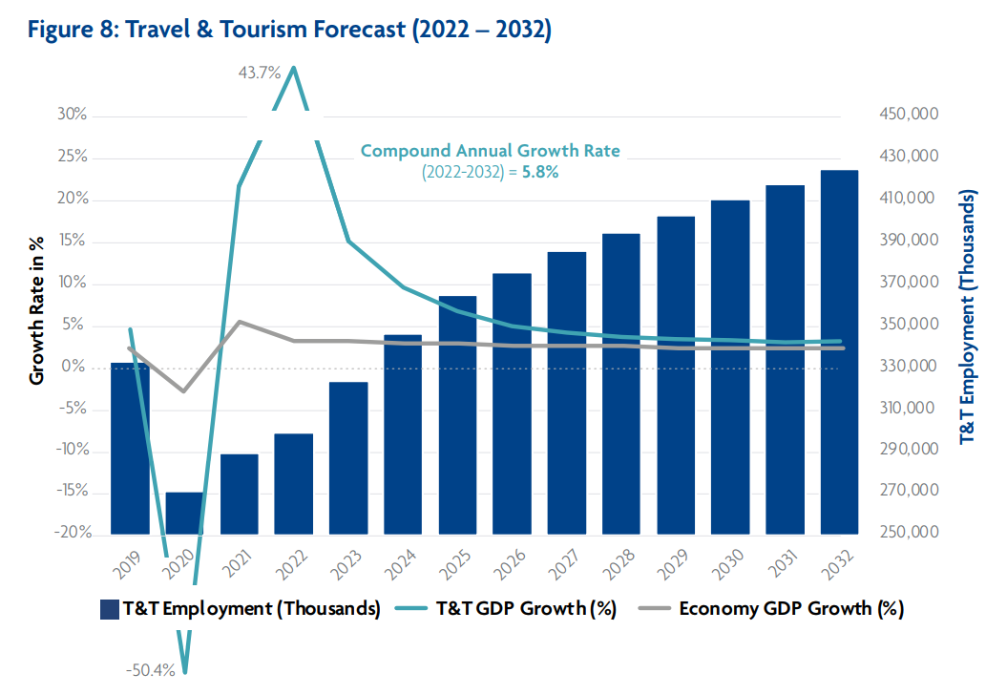
The tourism industry is known for its high level of competition; businesses must stay up-to-date with evolving guest demands to remain relevant (Maria, I., Madalina, T., Catalina, B., & Diana, I.; 2008). It also delves into the critical factors influencing a successful strategy in the industry.
1. figure Source: World Travel & Tourism Council, Travel & Tourism Economic Impact 2022

The travel and tourism industry grew by 5.8% compared to a 2.7% increase in GDP. The worldwide hospitality industry grew from $4,390.59 billion in 2022 to $4,699.57 billion in 2023, achieving a 7.0% Compound Annual Growth Rate (CAGR). However, due to the current global economic conditions, it's expected to have a slower projected CAGR of 5.8% from 2022 to 2032.

In today's competitive business environment, staying updated on market trends and consistently enhancing guest satisfaction is vital. Success hinges on delivering an exceptional guest experience, with top-tier services and amenities that exceed expectations. Hotels need to ensure a memorable journey from arrival to departure, focusing on everything from dining quality to staff warmth. The objective is to create a smooth and customized experience that cultivates guest loyalty through continuous enhancement and innovation. (Vinod, B.; 2022).

Prioritizing positive guest relationships and a welcoming atmosphere encourages repeat visits. Effective communication, responsiveness to feedback, and adapting to guest preferences are crucial for companies.

Main Findings

Reputation Management
Managing one's reputation stands as a fundamental pillar in steering a prosperous business, as it possesses the capacity to either fortify or undermine the enterprise's standing (Rialti, R., Kvítková, Z., & Makovník, T. (Eds.); 2023). With the escalating prevalence of social media, the imperative of upholding a positive image has never been more pronounced. The objective here is to elucidate the impact of adept reputation management on customer loyalty and perceptions, with a focus on analyzing case studies drawn from industry leaders such as Ritz-Carlton and Four Seasons.
Service Culture
Within the contemporary business landscape, the benchmarks for guest satisfaction continually ascend, necessitating a vigilant adherence to market trends for organizations to retain their competitive edge (Köseoglu, M. A., Morvillo, A., Altin, M., Martino, M. D., & Okumus, F.; 2020). The triumph of any hospitality establishment hinges on the delivery of an extraordinary guest experience, demanding a comprehensive grasp of the multifaceted elements that influence this experience, including service quality, amenities, pricing, and other pertinent factors.
Customer Loyalty and Schemes
A hotel's industry prosperity relies significantly on the unwavering maintenance of a coherent brand identity (Rather, R., & Sharma, J.; 2016). In this exploration, we delve into the global brand strategies of Ritz Carlton and Four Seasons to gain valuable insight into how a unified brand identity strengthens customer trust and loyalty. A thorough investigation is conducted to examine how the brand conveys its message across various platforms, including advertising and promotional initiatives. Furthermore, we will dissect whether a robust brand identity can differentiate hotels from their competitors.
Customer loyalty can be characterized as the emotional connection, trust, and consistent preference that patrons harbour for a particular business or brand. It transcends mere transactions of goods or services, signifying an enduring commitment to a specific hotel or hospitality establishment. This loyalty assumes pivotal importance because it yields numerous advantages for businesses, including heightened revenue, a more resilient customer base, and favourable word-of-mouth marketing (Kandampully, Zhang, & Bilgihan, 2015).
Brand Consistency
The adherence to high-quality standards and industry norms is equally pivotal for the success of any hotel (Kapiki, S.; 2012). Our examination will probe into the significance of upholding consistent standards and their pivotal role in augmenting the overall guest experience. We will embark on a detailed exploration of the components that underpin a thriving quality control program and elucidate how it can be effectively implemented within any hotel.
Hotel Standards
Customer loyalty stands as a foundational cornerstone of success within the hospitality industry (Kandampully, J., Zhang, T. C., & Bilgihan, A.; 2015). Grasping the significance of customer loyalty is paramount for every hotelier, encompassing a multitude of critical dimensions. This section will delve into the significance of customer loyalty, its constituent elements, and its definitional aspects.
Inevitably, operational errors manifest in various facets of operations, but the manner in which these errors are managed can wield a profound impact on guest services within the hospitality industry. As highlighted by Guchait (2019), it is essential to perceive failures not as insurmountable hurdles, but rather as opportunities for augmenting knowledge, skills, and competencies, particularly in the realm of guest services.
Future Technological Impacts
To attain a deeper insight into the role of customer loyalty in the hospitality sector, we will scrutinize a variety of loyalty initiatives designed to retain guests and stimulate repeat patronage. These initiatives may encompass loyalty programs, personalized services, and the creation of indelible guest experiences.

Service Failure and Recovery
In the present digital era, where online reviews and social media hold significant influence, upholding a positive image is more essential than ever (Lim, 2010). . A hotel's reputation directly impacts customer loyalty, and a single negative review or social media post can deter potential guests. Therefore, hotels must actively manage their online presence and reputation.
Specific examples in the industry highlight the impact on guest services. For instance, hotels with effective customer loyalty programs can provide tailored experiences to returning guests, increasing their satisfaction. These programs also offer insights to personalize services, creating a memorable guest experience.
Addressing errors and fostering a growth-oriented mindset significantly affect guest services in the hospitality sector. By using concrete examples like customer loyalty programs, we can see how these principles can lead to improved guest services and organizational success.
Understanding customer loyalty, its importance, and the strategies to cultivate it are fundamental aspects of effective hospitality business management in today's world.

Conclusion

In the hospitality industry, ongoing and vigilant monitoring of guest service approaches is essential for a hotel's success. Effectively managing these approaches is a key determinant of the overall guest experience. This monitoring encompasses various crucial elements:
- Reputation Management: Reputation management plays a pivotal role. Hotels must consistently deliver high-quality services and products to maintain a stellar reputation within the industry. A positive reputation is fundamental for nurturing customer loyalty, which is a cornerstone of a hotel's sustained prosperity.
- Service Culture: A robust service culture is another critical aspect of guest service monitoring. It prioritizes a deep commitment to customer satisfaction and strives to surpass their anticipations. Cultivating a culture that motivates employees to provide exceptional guest service is imperative.
- Brand Consistency: Maintaining brand uniformity is crucial. Hotels must diligently oversee that their brand maintains uniformity across all platforms, including the hotel's website, social media presence, and marketing materials. Brand consistency cultivates trust and credibility among guests.
- Adherence to Hotel Standards: Upholding industry standards is non-negotiable for providing exceptional guest service. Regulatory bodies have established specific criteria that hotels must meet, covering aspects like hygiene standards, equipment functionality, and comprehensive training for all personnel. Adhering closely to these guidelines guarantees that hotels offer a secure and enjoyable experience for their guests.
- Adapting to Technological Impacts: In an ever-evolving industry, hotels must embrace technological changes. This includes providing in-room technology for guests, utilizing chat bots for customer service, and facilitating mobile check-in to enhance the guest experience.

Customer Loyalty: To succeed, hotels must prioritize creating a welcoming atmosphere that promotes superior service, offers compelling loyalty incentives, and delivers personalized guest experiences. Customer loyalty is not just a priority but an absolute necessity in the competitive hospitality landscape.

Monitoring guest service approaches remains an indispensable aspect of the industry. By channelling attention to a spectrum of factors, including reputation management, service culture, brand consistency, adherence to hotel standards, customer loyalty, adaptation to evolving technology, and the adept handling of service failures, hotels can consistently deliver the exceptional experiences that today's guests demand. Drawing insights from industry leaders and real-world examples can empower hotels to navigate ever-changing market trends and secure enduring success within the field.

Recommendations

Leadership in the hospitality industry goes beyond keeping up with changing guest service trends – it requires anticipating and effectively addressing emerging challenges. Enhancing the guest experience involves implementing proven strategies.
One such strategy involves continuously monitoring guest feedback for improvement. Actively responding to customer feedback provides valuable insights. For instance, if many guests consistently express a preference for softer pillows in their reviews, the hotel can respond by offering softer pillow options to future guests. This tailored approach can notably boost guest contentment, foster loyalty, and improve the overall experience. The influence of guest feedback as a driver for positive improvements should not be undervalued.
In addition, embracing cutting-edge technologies like artificial intelligence, chat bots, and mobile apps can transform the way hotels interact with guests. These tools enable a more personalized and seamless guest experience, with streamlined check-ins and tailored recommendations for local attractions and services. Technology not only enhances operational efficiency but also sets hotels apart from the competition by creating memorable and convenient stays.
To succeed in the fiercely competitive hospitality industry, hotels must not only implement best practices and harness technology but also foster an environment of innovation and teamwork. This culture empowers team members to propose fresh ideas and approaches to elevate the guest experience to unprecedented levels. Investments in employee training and development further contribute to cultivating a skilled and passionate workforce, ultimately delivering high-quality service.
In summary, by adopting a customer-centric mindset, actively seeking and responding to feedback, harnessing the potential of technology, nurturing innovation, and investing in employee development, hotels can establish themselves as industry leaders and set new benchmarks for exceptional guest service. This proactive and comprehensive approach is not merely about keeping pace with the times; it is about forging new standards of excellence in the continually evolving realm of hospitality.

Citations

Bagdan, P. (2019). Guest service in the hospitality industry. Kendall Hunt Publishing Company.
Buhalis, D., & Moldavska, I. (2022). Voice assistants in hospitality: using artificial intelligence for customer service. Journal of Hospitality and Tourism Technology, 13(3), 386-403.
Crotts, J. C., Mason, P. R., & Davis, B. (2009). Measuring guest satisfaction and competitive position in the hospitality and tourism industry: An application of stance-shift analysis to travel blog narratives. Journal of Travel Research, 48(2), 139-151.
Filimonau, V., & Naumova, E. (2020). The block chain technology and the scope of its application in hospitality operations. International Journal of Hospitality Management, 87, 102383.
Guchait, P. (2019). The Necessity of Error Management Training in the Hospitality Industry. Boston Hospitality Review, 7(1)
Kandampully, J., Zhang, T. C., & Bilgihan, A. (2015). Customer loyalty: a review and future directions with a special focus on the hospitality industry. International Journal of Contemporary Hospitality Management, 27(3), 379-414.
Kapiki, S. (2012). Quality management in tourism and hospitality: An exploratory study among tourism stakeholders. International Journal of Economic Practices and Theories, 2(2).
Köseoglu, M. A., Morvillo, A., Altin, M., Martino, M. D., & Okumus, F. (2020). Competitive intelligence in hospitality and tourism: a perspective article. Tourism Review, 75(1), 239-242.
Lim, W. (2010). The Effects of social media networks in the hospitality industry.
Lo, A. S., Stalcup, L. D., & Lee, A. (2010). Customer relationship management for hotels in Hong Kong. International Journal of Contemporary Hospitality Management, 22(2), 139-159.
Maria, I., Madalina, T., Catalina, B., & Diana, I. (2008). The factors of competitiveness in the hospitality industry and the competitive strategy of firms. Annals of the University of Oradea, Economic Science Series, 17(2), 213-218.
Neuhofer, B., Buhalis, D., & Ladkin, A. (2015). Smart technologies for personalized experiences: a case study in the hospitality domain. Electronic Markets, 25, 243-254.
Özdemir, A. İ., Çolak, A., & Shmilli, J. (2019). Business process management in hotels: with a focus on delivering quality guest service. Quality & Quantity, 53(5), 2305-2322.
Rather, R., & Sharma, J. (2016). Brand loyalty with hospitality brands: The role of customer brand identification, brand satisfaction and brand commitment. Pacific Business Review International, 1(3).
Rialti, R., Kvítková, Z., & Makovník, T. (Eds.). (2023). Online Reputation Management in Destination and Hospitality: What We Know, What We Need to Know. Emerald Publishing Limited. Available at: https://www.amazon.co.uk/Online-Reputation-Management-Destination-Hospitality/dp/1803823763?asin=1803823763&revisionId=&format=4&depth=1 (Accessed: 30 October 2023).
Sigala, M. (2005). Integrating customer relationship management in hotel operations: managerial and operational implications. International Journal of Hospitality Management, 24(3), 391-413.
World Travel & Tourism Council, Travel & Tourism Economic Impact (2022). Available at: https://hospitalityinsights.ehl.edu/hospitality-industry (Accessed: 31 October 2023).

