

BA(Hons) Business Management

Student Name: Liliya Radoslavova Radeve
Student Number: 2418897
Course Name: Entrepreneurship (LCBB5013)
Assignment: Portfolio – Task 1: Business Plan Development
Lecturer Name: Dr Toyin Adisa / Balendran Kandasamy
Session: February 2026 Term

Table of Contents
1
Pawsitive Heaven 3
Business Overview 3
Products and Services 4
Short-Term Objectives (12–24 Months) 5
Long-Term Objectives (3–5 Years) 5
Unique Selling Point 6
Element 2: Business Environment & Competitor Analysis 7
PESTEL Analysis 7
SWOT Analysis 10
Porter's Five Forces Analysis 11
Element 3: 4Ps, Market Segmentation & Marketing Strategies 12
Market Segmentation & Target Customers 12
4Ps of Marketing Mix 13
Online Marketing Strategies 15
Element 4: Legal, Management & Financial Planning 16
Key Legal Structure Definitions (UK Context) 16
Chosen Structure & Justification 17
Organisational Chart 18
Start-Up Funding Requirements & Sources 19
12-Month Cash Flow Forecast 20
Reference list 22

Pawsitive Heaven

Business Overview
Pawsitive Haven is a proposed social enterprise based in East London, established as a
Community Interest Company (CIC). The venture addresses two interconnected social
challenges in the UK: the rising number of abandoned animals and the increasing demand for
accessible community mental health support. By integrating animal welfare services with
Therapeutic provision, the business addresses a clear gap between traditional animal rescue
services and accessible, community-based mental health support.

According to Barringer and Ireland (2019), entrepreneurial opportunity recognition involves
identifying unmet needs within a specific market environment. Pawsitive Haven reflects this
principle by bridging the gap between traditional animal rescue services and structured,
professionally delivered therapeutic support. Existing animal welfare organisations primarily
focus on rehoming, while mental health services often lack innovative, community-based
approaches.

Recent data highlights the urgency of this issue. King (2024) reports a significant increase in
abandoned animals across the UK, emphasising the need for scalable and sustainable rescue
solutions. At the same time, Doherty and Kittipanya-Ngam (2021) argue that hybrid social
enterprise models are particularly effective in creating inclusive social value by combining
commercial activity with social impact. Pawsitive Haven adopts this dual-impact model to
simultaneously address animal welfare and community wellbeing.

The organisation will initially operate a medium-sized facility housing approximately 20–25
rescued cats and dogs, providing rehabilitation and rehoming services alongside supervised
animal-assisted therapy sessions. This integrated approach not only enhances the social impact
of the venture but also supports its operational sustainability.

Pawsitive Haven will operate under a hybrid revenue model, generating income through
animal-assisted therapy sessions, adoption-related services, educational workshops, and
community programmes, alongside grants, donations, and strategic partnerships. This
diversified approach reduces reliance on a single funding source and strengthens the long-
term financial viability of the enterprise.

This model positions Pawsitive Haven as both a socially impactful and commercially viable
enterprise within the growing UK social enterprise sector.

Products and Services
Pawsitive Haven will deliver four integrated service streams designed to combine animal
welfare with community wellbeing while supporting financial sustainability.

Animal Rescue and Rehabilitation forms the core of the organisation’s operations. This
includes veterinary treatment, behavioural assessment, temporary shelter, and rehabilitation
for rescued cats and dogs, followed by responsible rehoming. The focus is on restoring both
physical health and behavioural suitability for adoption.

Ethical Adoption Services ensure that animals are placed in appropriate long-term homes. This
process includes structured adopter screening, matching procedures, and post-adoption follow-
up support, alongside guidance on responsible pet ownership.

Animal-Assisted Therapy (AAT) represents a key value-creating and revenue-generating
activity. Professionally supervised therapy sessions will be delivered to vulnerable groups,
including children in care, individuals experiencing mental health challenges, elderly people
facing loneliness, and individuals with disabilities. Only animals that have successfully passed
behavioural assessments will participate, ensuring safety and welfare for both participants and
animals.

Community Education and Workshops will provide outreach activities such as awareness
events, guided interactions, and educational programmes promoting responsible pet
ownership and animal welfare.

Together, these services create a balanced model in which social impact is aligned with
sustainable income generation, particularly through therapy sessions and workshops, reducing
reliance on external funding sources.

Short-Term Objectives (12–24 Months)
The short-term objectives of Pawsitive Haven are structured using the SMART framework to
ensure clear and measurable progress. Within the first 12 months, the business aims to register
as a Community Interest Company (CIC) and secure suitable premises in East London. During
this period, the organisation plans to rescue and responsibly rehome at least 50 animals while
delivering a minimum of 150 supervised animal-assisted therapy sessions. In addition, Pawsitive
Haven will establish formal referral partnerships with local councils, schools, social services,
and care providers. These objectives are designed to support operational stability and achieve
financial break-even within the first 24 months.

Long-Term Objectives (3–5 Years)
Over a three- to five-year period, Pawsitive Haven aims to expand its operational capacity to
accommodate up to 40 animals while maintaining high welfare standards. The organisation will
strengthen partnerships with healthcare providers, educational institutions, and community
organisations to enhance both adoption and therapy services. It also aims to establish itself as a
recognised model of a sustainable social enterprise within London. Expansion into other UK
regions will be considered once the East London model demonstrates financial stability and
operational efficiency. As noted by Mariotti and Glackin (2016), scalable social ventures require
measurable outcomes; therefore, systematic data collection on therapy impact and adoption
success will support future growth decisions.

Unique Selling Point
The Unique Selling Point of Pawsitive Haven lies in its integrated, rescue-first social enterprise
model, which combines structured animal welfare services with professionally supervised
animal-assisted therapy within a single operational framework. According to Law (2016), a USP
represents the distinctive value that differentiates a business from its competitors, and in the
case of Pawsitive Haven, this differentiation operates across both social and commercial
dimensions.

In contrast to established animal rescue organisations, such as Battersea Dogs Home or Blue
Cross, which primarily focus on rehoming and rely heavily on donations, Pawsitive Haven
adopts a diversified income model while delivering additional therapeutic value to the
community. Furthermore, unlike standalone therapy providers, the organisation operates
within a regulated rescue environment, ensuring that only behaviourally assessed animals are
involved in therapy sessions, with animal welfare remaining the primary priority.

This dual-function approach positions Pawsitive Haven within a relatively underserved niche,
where few organisations integrate animal rescue with structured therapeutic provision. As
noted by Perera (2024), the increasing number of Community Interest Company registrations in
the UK reflects growing institutional support for socially driven business models. Consequently,
Pawsitive Haven is well-positioned to deliver both measurable social impact and long-term
financial sustainability.

Element 2: Business Environment & Competitor Analysis

PESTEL Analysis
Political: The regulatory environment in the UK animal welfare is based on the Animal Welfare Act 2006, which has introduced a legal duty of care and is the basis of the legal support of animal rescue and rehabilitation (Gov.uk, n.d.). The CIC regulatory regime, which is regulated by the Office of the Regulator of CICs, provides Pawsitive Haven with official legal status and credibility of the social mission. This regulatory and policy environment provides Pawsitive Haven with strong institutional support and legitimacy, while also creating opportunities to collaborate with public sector bodies through commissioned social care and community wellbeing programmes.
Economic: The UK cost-of-living crisis has placed a huge financial strain on pet owners, which directly leads to an increase in the rates of abandonment (King, 2024). According to RSPCA (2024), many regions have more than or equal capacity with regard to rescue infrastructure. At the same time, NHS mental health is chronically underfunded and continuously experiencing pressure in demand, which opens a structural opportunity in community-based alternatives. This economic pressure directly increases demand for rescue services while simultaneously constraining household adoption capacity, requiring Pawsitive Haven to implement flexible pricing strategies and diversified revenue streams to remain financially sustainable.
Social: Pet ownership has increased dramatically during the COVID-19 pandemic, but then the number of those abandoned has increased exponentially with the worsening of the economic situation (Murray et al., 2025). Increased social awareness of the issue of mental health, especially concerning the youth, elderly individuals, and disabled citizens, has sanctioned the need to adopt animal-assisted and community-based wellbeing services. The lack of social interaction and loneliness crisis among the older age population in the UK also underlines the need for the Pawsitive Haven therapy and community engagement services. This trend positions Pawsitive Haven to align its services with growing societal demand for accessible, community-based mental health interventions.
Technological: The utilisation of digital platforms can help to improve the efficiency of the operations and the engagement of the community significantly. Rescue operations can be made easy through the adoption management systems, behavioral assessment databases, and microchipping records, which can be carried out online. Social media provides inexpensive ways of telling rescue stories, fundraising, and raising brand awareness. The systematic evidence provided by Pandey et al. (2024) supports that animal-assisted therapy provides quantifiable well-being benefits - the information that Pawsitive Haven can utilise online to gain institutional trust and appeal to referral partners.
Environmental: The procurement of animal feed, bedding, and veterinary consumables will be as sustainable as possible. The waste disposal of veterinary wastes should meet the UK environmental laws. As Mohr et al. (2023) state, ethical standards should be the key to animal care organisations that are beyond the minimum legal conditions. By embedding sustainable practices into its operations, Pawsitive Haven can strengthen its ethical positioning while meeting regulatory expectations and increasing its appeal to environmentally conscious stakeholders and partners.
Legal: Pawsitive Haven is multi-layered in terms of the legal framework. The Animal Welfare Act of 2006 regulates rescue and care operations (Gov.uk, n.d.). The use of therapeutic services where children and vulnerable adults are involved is also covered under the protection of the law, such as the Children Act 1989 and Care Act 2014. Clinical credibility demands registration of the therapist by the British Association for Counselling and Psychotherapy (BACP). Client and adopter data is handled under the GDPR. DBS checks and extensive insurance of the staff should be in place before the commencement of operations. Compliance with this comprehensive legal framework enhances organisational credibility and trust, while ensuring that Pawsitive Haven operates safely, ethically, and in line with safeguarding and data protection standards.

Figure 2: BMA (2024) NHS Mental Health Referrals in England 2016–2024: Adult and CAMHS Services 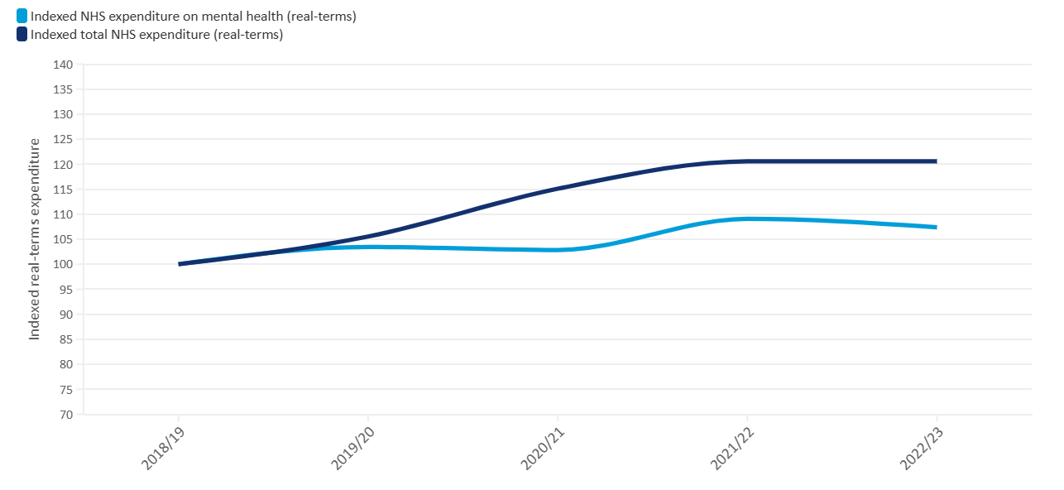
Source: (BMA, 2024)

SWOT Analysis
 | Strengths | Weaknesses
Internal | Rescue-first dual-impact model; Qualified therapist supervision; Diversified revenue; CIC public sector credibility; First-mover advantage in East London integrated AAT market; Evidence-based therapy | High London operating costs; Single therapist dependency risk; Animal behaviour unpredictability; Limited brand recognition at launch
External | Opportunities | Threats
 | Growing NHS social prescribing agenda; Underdeveloped AAT market in East London; Corporate CSR partnerships; Growing CIC registrations (Perera, 2024) | Established competitors (Battersea, Blue Cross); Grant funding volatility; Regulatory tightening; Economic downturn, reducing adoption rates; Mission drift risk; Dependency on public funding cycles
Source: Author (2026)
Critical evaluation: The most significant internal strength is the integrated dual-impact model, which creates both social value and diversified revenue streams. He et al. (2022) reveal that social enterprises have structural hybridity directly linked to long-term sustainability. Nevertheless, reliance of the organisation on one qualified therapist is a major operational risk; its unavailability would at once affect both the revenue stream of therapy and the USP. This should be tackled either by having succession planning or a part-time associate therapist arrangement at the very beginning.
Outwardly, the best strategic opportunity is being aligned with the NHS social prescribing agenda. According to Kannothra et al. (2024), social enterprises need to find a balance between market positioning and mission integrity to ensure that mission drift does not occur - a conflict that Pawsitive Haven needs to actively address to ensure that it does not become the victim of commercial imperatives to the disadvantage of its welfare-first priorities.

Porter's Five Forces Analysis
The Five Forces framework by Porter (Porter, 1980) offers a structural examination of market appeal and competitiveness in the industry that Pawsitive Haven is in.
Force | Assessment | Implication
Threat of New Entrants | MODERATE | There are significant barriers to entry in terms of BACP accreditation, CIC registration, compliance, safeguarding, and premises expenses. Nonetheless, non-formal providers of animal interaction and independent therapists could come in with lesser overheads.
Bargaining Power of Suppliers | LOW–MODERATE | Several veterinary clinics in East London restrict supplier concentration. Nonetheless, BACP-registered therapists are a narrow, specialised labour pool - a supply-side strategic weakness.
Bargaining Power of Buyers | MODERATE | Contractual terms can be utilized by NHS/local authority commissioners. The switching choice is open to adoption and event clients, but ethical differentiation decreases the price sensitivity of values-aligned purchasers.
Threat of Substitutes | MODERATE–HIGH | Therapy is replaced by mainstream counselling, mindfulness apps, and services provided by the NHS. Adoption is substituted by other shelters and commercial breeders. It is necessary to position on integrated and professionally supervised quality.
Competitive Rivalry | MODERATE | Battersea, Blue Cross, and Dogs Trust are larger and better financed but do not provide integrated therapy. Single therapy providers do not provide rescue. Pawsitive Haven has a defendable niche that none of its competitors is currently replicating in East London.
Source: Author (2026)
Overall competitive assessment: There is a medium competition intensity as indicated in the Five Forces analysis. The greatest risk in the structure is the constraint of therapist supply and the risk of substitution of individual service elements. The best opportunity is the untapped niche of integrated rescue-therapy provision - a niche that its competitors cannot easily imitate unless they radically reorganise their modes of operations.

Element 3: 4Ps, Market Segmentation & Marketing Strategies

Market Segmentation & Target Customers
Pawsitive Haven adopts a differentiated targeting strategy. According to Mariotti and Glackin (2016), market segmentation is the division of a larger market into groups that have similar characteristics or needs.

Segment | Profile | Access Route | Key Need
Therapy Clients | Children 5-17 in care; adults 25-55 with anxiety/depression; elderly 65+ | NHS social prescribing, GP/social services referral | Accessible, evidence-based wellbeing support
Adoption Clients | Families and individuals 25-50, East London | Digital search channels, ethical brand alignment | Responsible, welfare-assured adoption
Event Participants | Families with children 3-12 | Direct booking platforms, institutional partnerships, and school partnerships | Purposeful, supervised animal interaction

According to Voorn (2022), alignment of values is one of the major factors of purchasing loyalty in a social enterprise setting. This means that the company has to have a two-channel marketing design: relationship-based institutional marketing on therapy referrals, and value-based digital marketing on adoption and event clients.

4Ps of Marketing Mix
Product: The portfolio has three levels as per Blackwell (2011) and operates in those levels. Major product: animal rescue and welfare. Real product: professional and supervised product and adoption services. Augmented product: After-sales care follow-up, institutional client outcome reporting, and infrastructure of referral partnership. This multi-layered product structure enhances perceived value while reinforcing the organisation’s welfare-first positioning and professional credibility.
Price: Value-based pricing strategy is one in which prices are determined based on the social and therapeutic benefits provided. Therapy sessions: £45–£65. Adoption fees: £80–£150. Packages of events: between £15 and 25 per child. Williams (2022) suggests that social enterprises should have tiered pricing so as to balance generating revenue and accessibility; the sessions that have to be booked through local authority or NHS referrals will be offered at subsidised prices, so that equitable access is achieved without jeopardising the sustainability.
Place: The primary delivery hub is the East London facility, in an area of high target demographic concentration. The outreach therapy will be provided at the partner care homes, schools, and community centres. Williams (2019) claims that the operational efficiency of social enterprises should be balanced with accessibility to the community - the outreach model fulfils both of those. Omnichannel strategy is supported by digital infrastructure such as a professional site with an in-built booking system. The pricing strategy balances financial sustainability with social accessibility, ensuring that cost does not become a barrier to vulnerable groups while maintaining long-term operational viability.
Promotion: The mission-related content of the social media promotion will be organic, consisting of stories of rescue success on Instagram and TikTok. According to Werke and Bogale (2023), digital storytelling is among the most suitable strategies that social enterprises can use when having limited budgets. Google Nonprofits is an initiative that gives free credits to CICs to advertise their offerings through targeted search advertising. The use of formal referral agreements with the primary care networks of the NHS and local authorities will serve as the main institutional promotion channel. This integrated promotional approach strengthens brand trust, enhances community engagement, and supports long-term relationship building with both institutional and individual stakeholders.

Online Marketing Strategies
Strategy | Platform | Benefit | Limitation/Risk
Social Media Storytelling | Instagram, TikTok | Builds emotional engagement; low-cost brand awareness | Risk of exploiting animals for content
SEO Content Marketing | Organisational blog | Long-term organic traffic; sector authority positioning | Slow initial ROI; requires consistent content
Email Retention | Mailchimp | Cost-effective relationship management | GDPR consent management; list-building required
Google for Nonprofits | Google Ads | Free credits targeting adoption/therapy search terms | CIC eligibility verification required
Source: Author (2026)
The combination of low-cost digital tools and targeted content strategies enables Pawsitive Haven to achieve cost-efficient market penetration while maintaining ethical communication standards.
According to Pahari et al. (2024), the key points of successful digital campaigns are authenticity, consistency of the message, and targeting the audience correctly. A policy on internal content about the ethical use of animal and client imagery should be established from the outset to protect reputational integrity and ensure ethical consistency across all communication channels.

Element 4: Legal, Management & Financial Planning

Key Legal Structure Definitions (UK Context)
- Sole Trader: Individual operating independently with full unlimited personal liability (Williams, 2022).
- Partnership: Two or more persons sharing management, profits, and unlimited joint liability, governed by the Partnership Act 1890.
- Limited Company (Ltd): Legally independent entity registered at Companies House; shareholder liability limited to shares held (Law, 2016).
- Franchise: Licensee operates under an established brand and business model, paying fees or royalties.
- Online Enterprise: Any business operating primarily through digital channels, adoptable under any legal structure.
- Social Enterprise: Organisation employing commercial methods to pursue social or environmental objectives, reinvesting surpluses into its mission (Law, 2016).
- Community Interest Company (CIC): A specific UK legal form incorporating an asset lock, ensuring assets remain permanently committed to the social mission.
The comparison of legal structures highlights that a Community Interest Company provides the optimal balance between operational flexibility, stakeholder trust, and long-term mission protection within the UK social enterprise landscape.

Chosen Structure & Justification
Pawsitive Haven will be a Community Interest Company (CIC) limited by guarantee. This gives it legal status as a social enterprise, the asset lock ensures the welfare-first mission is not commercialised, and access to social-enterprise-specific grants and government contracts. As Perera (2024) ascertains, CIC registrations are escalating at a higher rate than any other form of business in the UK. According to Blackwell (2011), mission protection, stakeholder credibility, and access to funds should be the motivators in the structure selection, and the CIC qualifies in all these aspects.
The main weakness of the CIC structure is that it is unable to allocate profits to investors, and this could restrict access to equity investment. Nevertheless, in the case of a mission-driven organisation that depends on grants, government contracts, and community trust, this limitation is tactically correct; it strengthens the social mission message to institutional collaborators.
Therefore, the CIC structure not only supports regulatory compliance but also strategically reinforces credibility with funders, public sector partners, and the wider community.

Figure 3: Social Enterprise UK: CIC Registration Growth in the UK
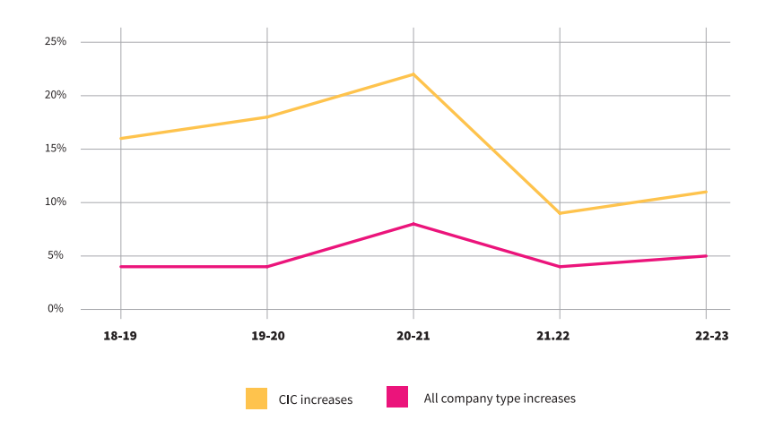
Source: (Social Enterprise Knowledge Centre 2024)

Organisational Chart
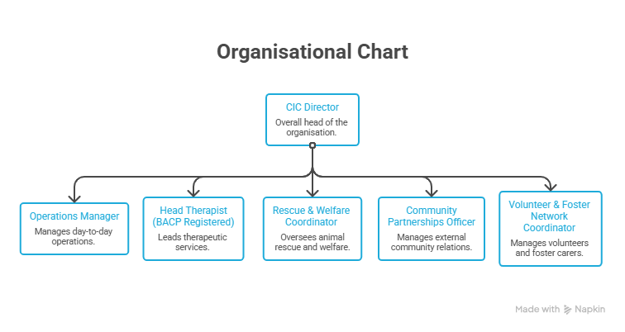Source: Author (2026)
This horizontal hierarchy allows quick decision-making appropriate to a start-up. The second therapist and a special community outreach coordinator will resolve the issue of dependency on the therapist and the requirements of an expanding event programme as the organisation grows.

Start-Up Funding Requirements & Sources
Start-up costs will be estimated at £75,000-100,000 to cover the fit-out of premises in East London, veterinary equipment, initial staffing, insurance, regulatory compliance, and web development. Williams (2019) advises on diversified funding portfolios instead of relying on one source.
Funding Source | Estimated Amount | Purpose | Rationale
National Lottery Community Fund | £25,000-£35,000 | Premises fit-out & animal welfare equipment | Primary grant funder for community-benefit social enterprises
British Business Bank Start Up Loan | £10,000-£15,000 | Operational cash flow (first 6 months) | Government-backed; fixed 6% interest; accessible to CICs
Local Authority Contracts | £15,000-£20,000 (Year 1) | Therapy service delivery income | NHS social prescribing agenda creates commissioning demand
Corporate Sponsorship | £5,000-£10,000 | Community event delivery costs | CSR alignment; non-repayable
Crowdfunding (Crowdfunder.co.uk) | £5,000-£10,000 | Brand awareness + community capital | Mission-aligned community investment
Earned Revenue (Y1) | £20,000-£30,000 | Therapy + adoption + events | Builds financial independence over time
Source: Author (2026)
This diversified funding model reduces financial risk by avoiding over-reliance on a single income source while aligning each funding stream with specific operational needs.

12-Month Cash Flow Forecast
Key assumptions: 3 therapy sessions/week at avg £55; 4 adoptions/month at avg £115; 2 events/month at avg £200 net; grant income distributed across the year; costs based on East London market rates.
Item | Q1 (£) | Q2 (£) | Q3 (£) | Q4 (£) | Year Total (£)
INCOME
Therapy Sessions | 1,980 | 2,640 | 3,300 | 3,960 | 11,880
Adoption Fees | 1,840 | 2,300 | 2,760 | 2,760 | 9,660
Educational Events | 1,200 | 1,600 | 1,800 | 1,600 | 6,200
Grants & Start-Up Loan | 35,000 | – | – | 5,000 | 40,000
Local Authority Contract | – | 5,000 | 5,000 | 5,000 | 15,000
Corporate Sponsorship | – | 3,000 | 2,000 | 2,000 | 7,000
Total Income | 40,020 | 14,540 | 14,860 | 20,320 | 89,740
EXPENDITURE
Premises (rent & utilities) | 4,500 | 4,500 | 4,500 | 4,500 | 18,000
Staffing (Director + Animal Care) | 7,500 | 7,500 | 7,500 | 7,500 | 30,000
Therapist (part-time) | 3,500 | 3,500 | 3,500 | 3,500 | 14,000
Veterinary & Animal Care | 3,000 | 2,500 | 2,500 | 2,000 | 10,000
Insurance & Compliance | 2,000 | 500 | 500 | 500 | 3,500
Marketing & Website | 1,500 | 800 | 600 | 600 | 3,500
Miscellaneous / Contingency | 1,000 | 1,000 | 1,000 | 1,000 | 4,000
Total Expenditure | 23,000 | 20,300 | 20,100 | 19,600 | 83,000
Net Cash Flow | +17,020 | –5,760 | –5,240 | +720 | +6,740
Cumulative Balance | 17,020 | 11,260 | 6,020 | 6,740 | 6,740
Source: Author (2026)
The cash flow forecast demonstrates an initial reliance on grant funding, with negative cash flow in Q2 and Q3 reflecting the typical early-stage funding gap; however, the return to a positive position in Q4 indicates improving operational sustainability as revenue streams stabilise.
Critical limitations: This projection is based on assumptions with a certain degree of uncertainty: grant income timing can be different, there can be reduced volumes of therapy referrals in the first quarter, and the cost of operations in London can be higher than projected. The positive opening balance in the front-loaded grant income in Q1, however, earned revenue streams are modest in Year 1. This supports the strategic value of obtaining grant funding and a local authority contract before the start of operations and developing therapy referral relationships as expeditiously as feasible to increase earned income growth within the first year of operation.

Reference list
Barringer, B.R. & Ireland, R.D. (2019). Entrepreneurship: Successfully Launching New Ventures. 6th Global ed. Harlow: Pearson.
Blackwell, E. (2011) How to Prepare a Business Plan. 5th ed. London: Kogan Page.
BMA (British Medical Association) (2024) Mental Health Pressures Data Analysis. Available at: https://www.bma.org.uk/advice-and-support/nhs-delivery-and-workforce/pressures/mental-health-pressures-data-analysis (Accessed: March 2026).
Doherty, B. & Kittipanya-Ngam, P. (2021) 'The Role of Social Enterprise Hybrid Business Models in Inclusive Value Chain Development', Sustainability, vol. 13, no. 2, pp. 499.
Gov.uk (n.d.) Animal Welfare Act 2006 [online]. Available at: www.legislation.gov.uk (Accessed: March 2026).
He, T., Liu, M.J., Phang, C.W. & Luo, J. (2022) 'Toward social enterprise sustainability: The role of digital hybridity', Technological Forecasting and Social Change, vol. 175, p. 121360.
Kannothra, C.G., Manning, S., Cotterlaz-Rannard, G. & Kundu, S.K. (2024) 'The Interplay of Market Choices and Social Mission: Learning From B2B Social Enterprises in Emerging Economies', Business & Society.
King, G. (2024) 'Increase reported in neglected animals being abandoned – RSPCA', BBC News, 26 November.
Law, J. (2016). A Dictionary of Business and Management. 6th ed. Oxford: Oxford University Press.
Liñares-Zegarra, J.M. & Wilson, J. (2024) 'Access to finance for UK social enterprises', European Journal of Finance, vol. 30, no. 15, pp. 1–28.
Mariotti, S. & Glackin, C. (2016) Entrepreneurship: Starting and Operating a Small Business. 4th Global ed. Boston: Pearson.
Mohr, B.J. et al. (2023) 'Guidelines for the establishment and functioning of Animal Ethics Committees in Africa', Laboratory Animals. London: SAGE Publishing.
Murray, L., Carroll, J. & Tyson, J. (2025) 'People and Pets in the COVID-19 Pandemic and the Cost-of-Living Crisis', Animals, vol. 15, no. 11, pp. 1584–1584.
Pahari, S., Bandyopadhyay, A. & Pingle, S. (2024) 'A bibliometric analysis of digital advertising in social media', Cogent Business & Management, vol. 11, no. 1.
Pandey, R.P. et al. (2024) 'The Role of Animal-Assisted Therapy in Enhancing Patients' Well-Being', JMIRx Med, vol. 5, no. 1.
Perera, S. (2024). Community Interest Company registration is growing more than other business forms [online]. Social Enterprise UK. Available at: Socialenterprise.org.uk (Accessed: March 2026).
Porter, M.E. (1980) Competitive Strategy: Techniques for Analysing Industries and Competitors. New York: Free Press.
RSPCA (2024) Reports and Accounts: 2024 Highlights. Horsham: RSPCA.
Social Enterprise Knowledge Centre (2024). Community Interest Company dissolution rates. University of Worcester
Voorn, R. (2022) 'Brands, values and consumers: the importance of values in consumer behaviour'. Doctor of Philosophy, University of Twente, Enschede.
Werke, S.Z. & Bogale, A.T. (2023) 'Nonprofit Marketing: A Systematic Review', Journal of Nonprofit & Public Sector Marketing, vol. 36, no. 5, pp. 1–38.
Williams, S. (2019). The Financial Times Guide to Business Start Up 2019/20. 31st ed. Harlow: Pearson Education.
Williams, S. (2022). The Financial Times Guide to Business Start Up 2021/23. 32nd ed. Harlow: Pearson.

