Student name: Shereen Garraghan
Student ID number:2242394
Programme: BA International Hotel Management
Module: Foreign Languages & Cultural Awareness
Module code: BMIH5003
Lecturer: Giulia Chifari, Antoinette Milne

Component 1 personal reflection
A visitor and I had an unplanned cross-cultural meeting during the busy hotel restaurant's breakfast service. It started with an order for green tea from a Japanese businessman. I assumed that green tea was like iced tea, not knowing the subtleties of Japanese tea etiquette and the importance, and swiftly served it in a tall glass filled with ice. But when I gave the guest the drink, I noticed a perplexed expression on his face. Sensing the misunderstanding, he graciously requested a teapot instead and explained how the tea should be served I felt embarrassed I was not aware of this. Even though our conversation was short, it was a moving reminder of how crucial it is for those working in the hospitality sector to understand and appreciate cultural quirks. According to Smith (2019), these kinds of incidents demonstrate how important cultural awareness is to providing seamless visitor experiences and encouraging tolerance and understanding among people from different backgrounds. This incident reinforced my dedication to providing outstanding service that is customised to each guest's specific needs and preferences and inspired me to further educate myself on cultural customs and etiquette.

Disparities in communication styles, norms, and traditions are typically the cause of cultural misunderstandings (Hall, 1976). In this case, I served green tea incorrectly since I didn't know enough about Japanese tea culture. Serving green tea cold with ice may have been viewed by the guest as disrespectful which wasn’t the intention or just out of the ordinary as green tea is normally served hot in a teapot in Japan (Hofstede, 2001). The guest's experience as a whole and the hotel's reputation may have suffered as a result of this misperception, which may have caused discomfort or offence. I believe that developing cultural competence and sensitivity is necessary to avoid similar cultural misunderstandings in the future (Liu & Wang, 2018). First and foremost, I must educate myself on the traditions and inclinations of many cultures, particularly those that are frequently met in the hospitality sector. This could entail looking up information online, going to training seminars on cultural sensitivity, or asking seasoned coworkers for advice.
Second, I should give good conversation and attentive listening to my guests top priority. To better understand their tastes, I should ask open-ended questions rather than assuming anything based on my own cultural background. As an example, I could have made a courteous inquiry about the guest's favourite method of serving themselves green tea, which would have guaranteed a more customised and culturally relevant experience. It is important to develop a humble and receptive mindset. Being culturally competent is a continuous process, thus I have to be open to criticism and ready to modify my actions as necessary (Jandt, 2016). It is my goal to actively work towards bridging cultural barriers and embrace diversity in order to improve the quality of service I offer to clients and create a more friendly and inclusive atmosphere in the hotel restaurant.

Component 2 Training plan
In order to deal with the cultural misunderstandings that have been brought to light, a comprehensive staff training programme that will provide all staff members the tools they need to deal with a variety of cultural situations. In the hotel industry, training is essential for maintaining professionalism and respect in a variety of settings. Cultural competence training is especially important (Rosenbusch, 2019). Improved comprehension of diverse cultural customs and communication methods culminates in increased patron contentment and allegiance. Making this kind of training investment shows dedication to provide inclusive experiences, reduces reputational concerns, and promotes a happy work environment.

- organise interactive seminars or workshops that emphasise sensitivity and cultural understanding (Rosenbusch, 2019). These training programmes will give staff members insightful knowledge about various cultural customs, communication etiquette, and communication styles. Employees can recreate real-world circumstances and actively participate in conversations through engaging activities like role-playing exercises and case studies. To further our understanding, we will also make use of materials like David C. Thomas and Kerr Inkson's "Cultural Intelligence: People Skills for Global Business" (Thomas & Inkson, 2009).

- Provide instruction on how to communicate effectively in situations involving other cultures. Active listening, empathy, and nonverbal cues will all be emphasised (Gudykunst & Kim, 2003). These seminars will cover useful methods for getting past linguistic obstacles and modifying communication approaches to suit various cultural tastes. Employees will improve their communication methods by using the takeaways from Stella Ting-Toomey's "Communicating Across Cultures" (Ting-Toomey, 1999).

- To assist staff in understanding their cultural strengths and biases, we should incorporate evaluations of cultural intelligence into our training curriculum (Livermore, 2011). Employee reflection on their own cultural competence and a constant search for growth opportunities will be fostered through facilitated talks on cultural intelligence frameworks and techniques for improving cultural adaptability. A theoretical framework will be provided by reference works like David C. Thomas and Kerr Inkson's "Cultural Intelligence: Living and Working Globally" (Thomas & Inkson, 2009).
- Provide training programmes with a scenario-based approach that mimic typical cultural misunderstandings that occur in the hospitality sector. These sessions will offer helpful advice on how to identify cultural differences and deal with them in a polite and productive manner. Through promoting cooperative problem-solving and decision-making in multicultural teams, staff members will acquire the abilities and self-assurance required to effectively negotiate culturally varied interactions. These training modules are inspired by real-life events that are detailed in John Smith's book "Cultural Awareness in Hospitality" (Smith, 2019).

- Provide regular means of feedback, such as focus groups or anonymous surveys, to evaluate the success of our training programmes. We will also provide staff with opportunities for coaching and mentorship so they can get individualised help and assistance in overcoming cultural obstacles. We will cultivate a helpful and inclusive work environment by establishing an open and transparent culture where employees feel comfortable sharing their experiences and asking for help when needed.
By putting this training strategy into action, we can enable staff members to effectively handle culturally varied interactions.

Component 3 Self-reflection
Over my time in the hospitality industry, I have come across plenty people from different backgrounds and beliefs my understanding of cultural sensitivity has changed dramatically I discovered it had a significant effect on how satisfied guests were. It became essential to comprehend cultural norms and beliefs in order to create inclusive environments. Interacting with a diverse group of visitors brought cultural sensitivity to light. Through workshops and classes, I actively sought cultural education, which improved my comprehension of diversity management and intercultural communication. Cultural obstacles highlighted the necessity of ongoing learning and adaptability. My ultimate goal is to embrace cultural variety and promote inclusivity in order to enhance visitors' experiences.

Guests staying at the hotel experienced an especially remarkable occasion during a cultural celebration, specifically Diwali. Through this experience, I was able to learn more about the festival's significance and see firsthand the happiness and energy it brought as it means according to (BBC, 2023) the triumph of light over darkness and the start of new beginning it’s a vibrant celebration that welcomes all. Through interacting with guests from many ethnic backgrounds, I developed a greater understanding of how crucial cultural sensitivity is to creating environments that are welcome and inclusive. The significance of embracing cultural diversity and customising services to satisfy the specific demands of diverse cultural groups was highlighted by the observation of how cultural sensitivity and understanding significantly impacted guest experiences.
I decided to actively look for opportunities for self-reflection and cultural education as a result of these encounters. I enthusiastically researched a range of online platforms and educational training sessions that explored the intricacies of intercultural communication and diversity management because I understood the need of increasing my expertise in this field. These insightful seminars not only increased my knowledge of various cultural viewpoints and communication emphases, but they also highlighted how crucial empathy and flexibility are to successfully overcoming cultural gaps (Liu & Wang, 2018).

In addition, I read up on cultural intelligence, especially David C. Thomas and Kerr Inkson's "Cultural Intelligence: Living and Working Globally". This resource emphasised the value of ongoing education and self-awareness in fostering cultural competence, as well as the role that cultural intelligence plays in effectively navigating cross-cultural encounters (Thomas and Internet Archive, 2024), I also learned from encountering cultural misunderstandings when interacting with guests. These occurrences made clear how crucial it is to communicate effectively and with cultural sensitivity in order to prevent conflicts and raise customer satisfaction. As I thought back on these interactions, I realised that I needed to continue to work on improving myself and being humble in order to identify and deal with my cultural blind spots.
To sum up, my work in the hospitality sector has shown me how important cultural sensitivity is to providing outstanding guest experiences. In order to improve my cultural competency and help create memorable experiences for visitors from a variety of cultural backgrounds, I hope to embrace cultural diversity, make a commitment to lifelong learning, and cultivate an inclusive culture.

Component 4
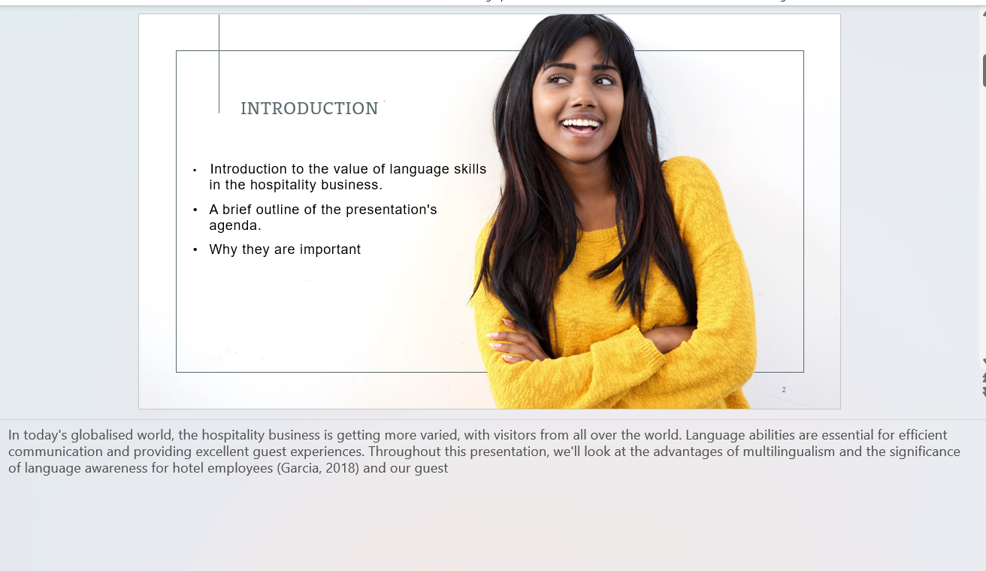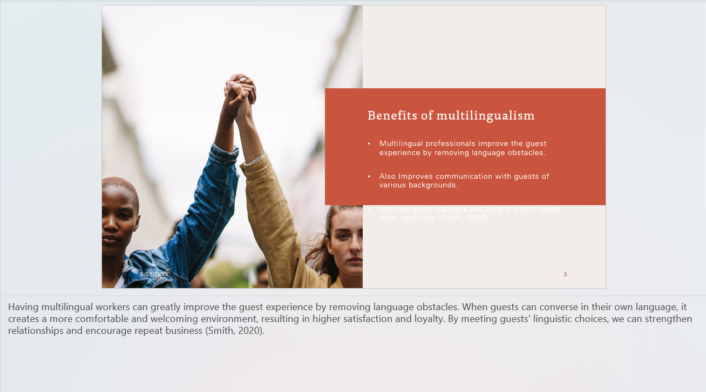

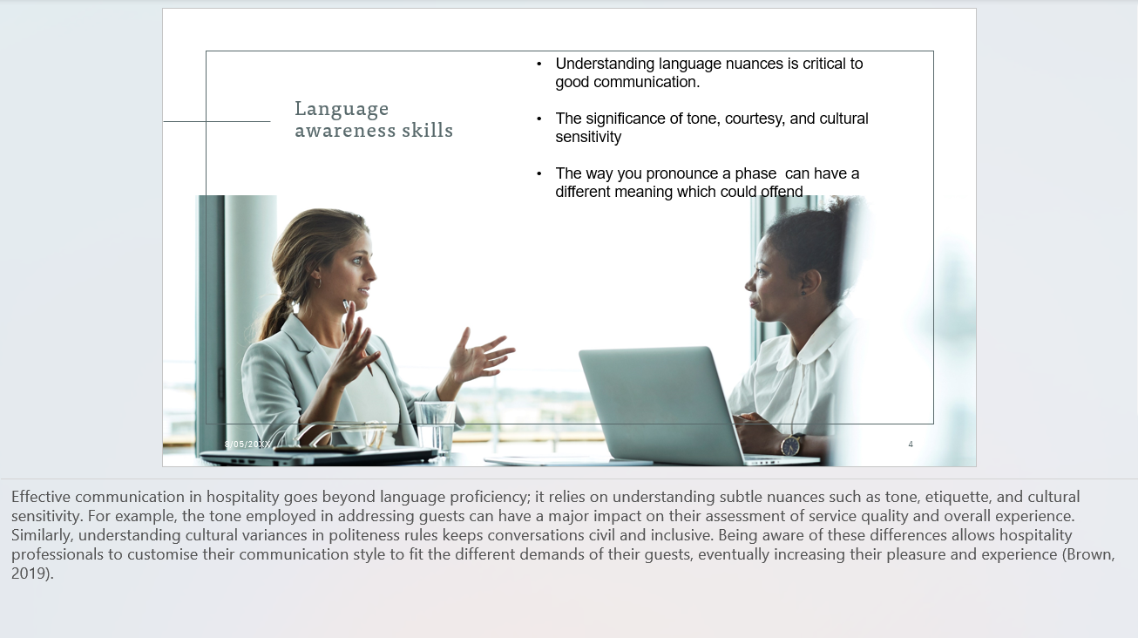

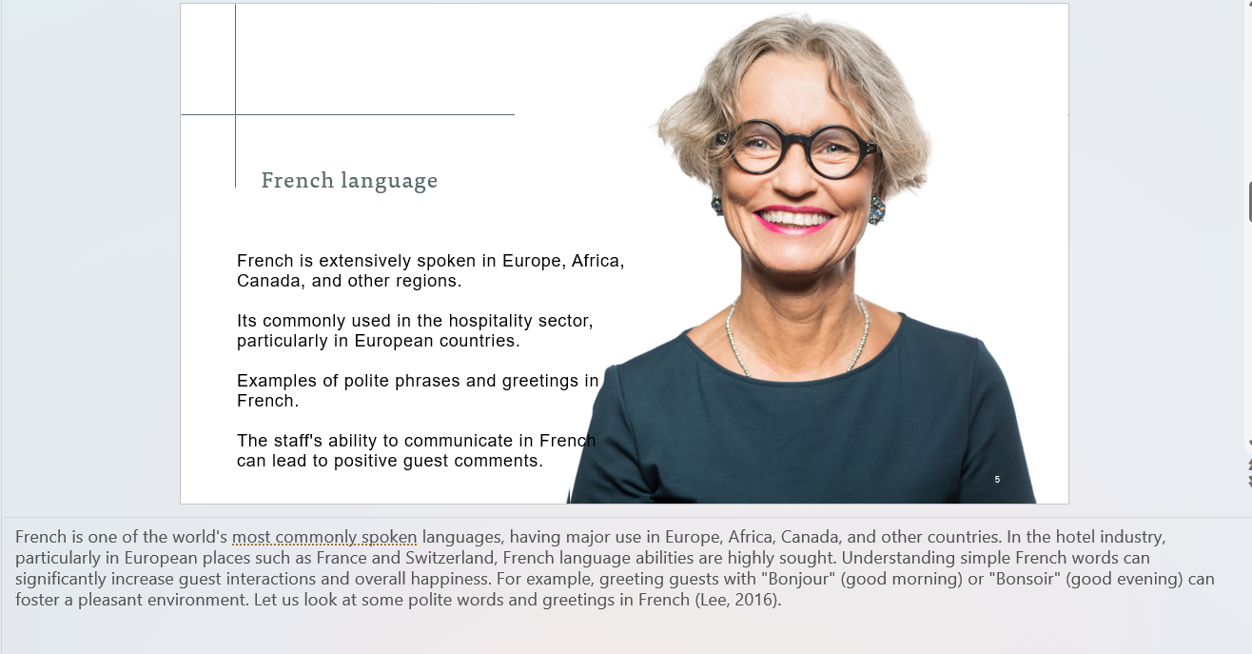
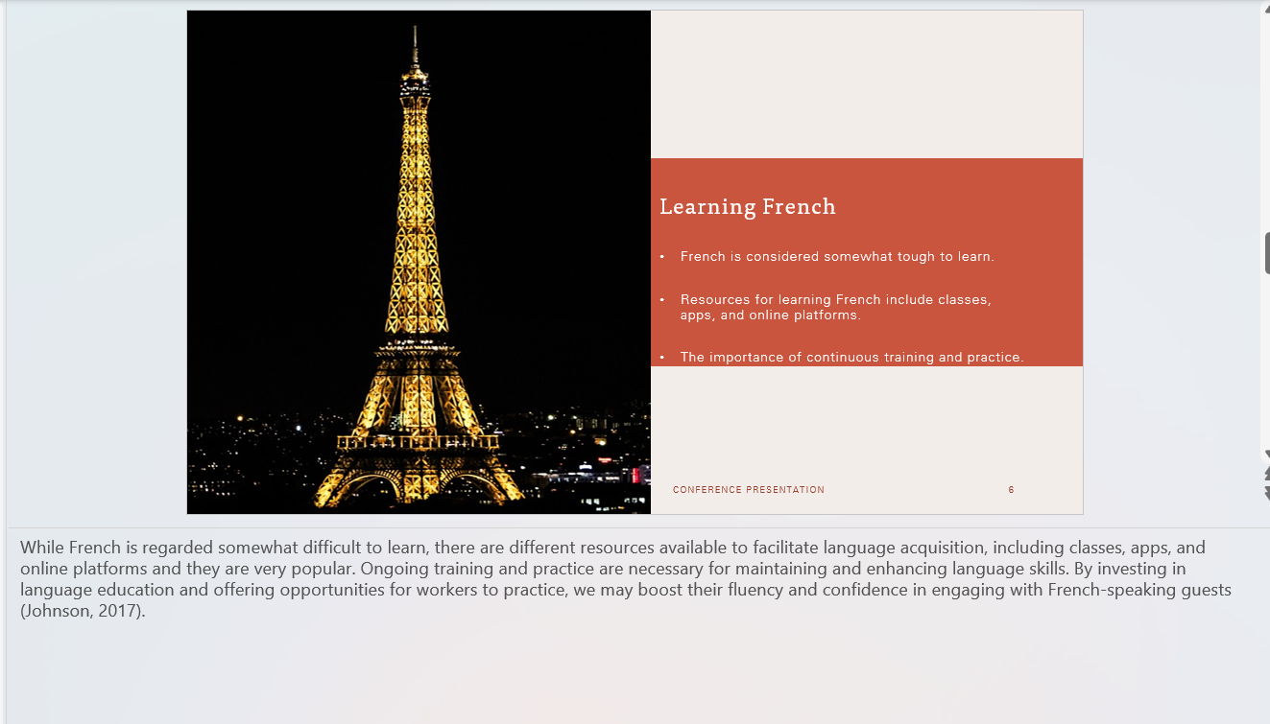

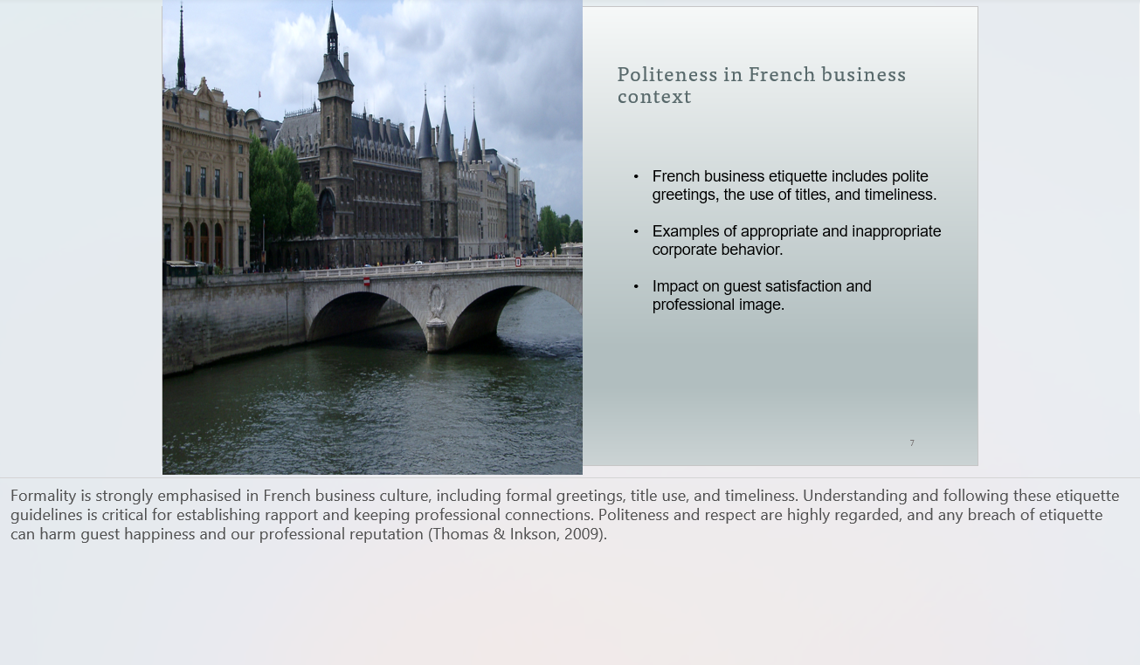
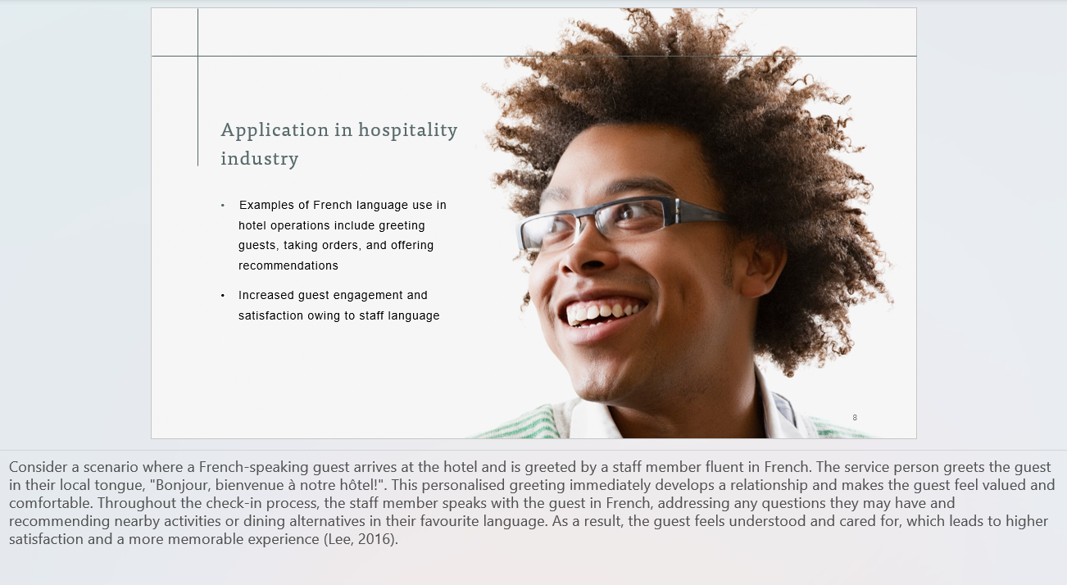

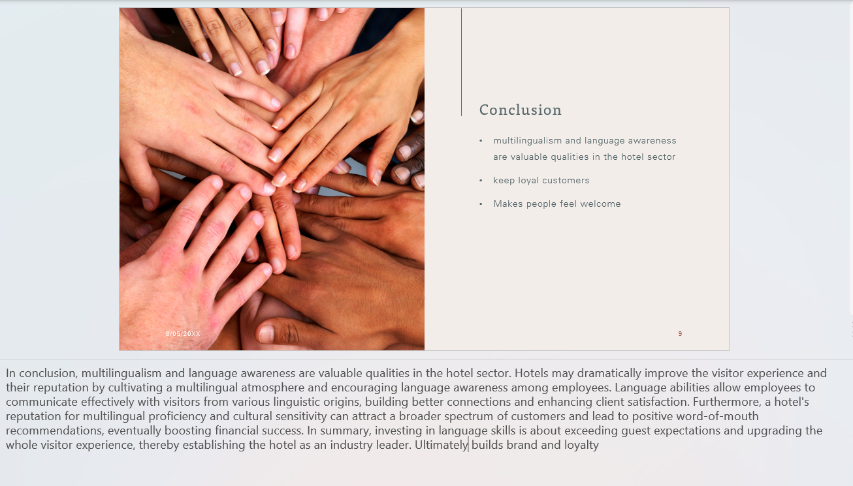

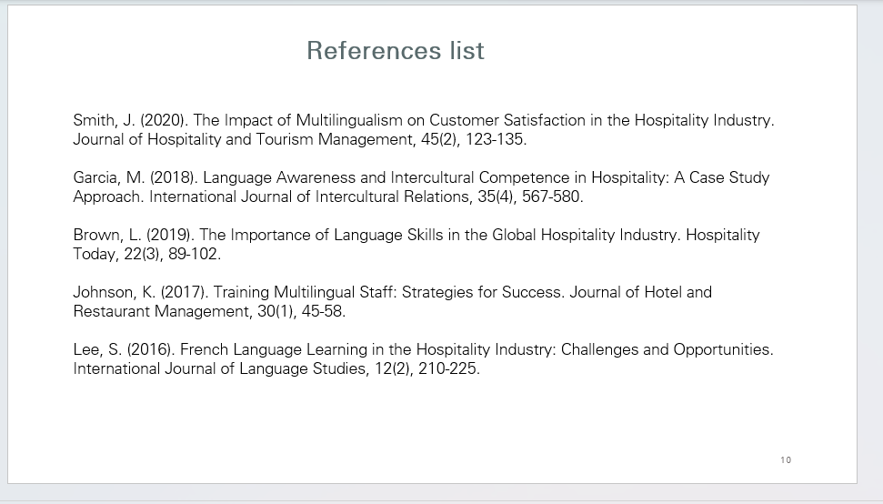

Reference list
BBC (2023). Diwali 2023: What you need to know about the festival of light. BBC News. [online] 8 Nov. Available at: https://www.bbc.co.uk/news/newsbeat-67138768#:~:text=It%27s%20a%20major%20festival%20celebrating%20the%20triumph%20of [Accessed 2 May 2024].
Brown, L. (2019). "The Importance of Language Skills in the Global Hospitality Industry." Hospitality Today, 22(3), 89-102.
Garcia, M. (2018). "Language Awareness and Intercultural Competence in Hospitality: A Case Study Approach." International Journal of Intercultural Relations, 35(4), 567-580.
Gudykunst, W. B., & Kim, Y. Y. (2003). "Communicating with Strangers: An Approach to Intercultural Communication." McGraw-Hill Education.
Hall, Edward T. "Beyond Culture." Anchor Books, 1976.
Hofstede, Geert H. "Culture's Consequences: Comparing Values, Behaviors, Institutions, and Organizations Across Nations." Sage Publications, 2001.
Jackson, Tony. "Cultural Diversity in Hospitality: Strategies for Success." Routledge, 2020.
Jandt, Fred E. "An Introduction to Intercultural Communication: Identities in a Global Community." Sage Publications, 2016.
Johnson, K. (2017). "Training Multilingual Staff: Strategies for Success." Journal of Hotel and Restaurant Management, 30(1), 45-58.
Lee, S. (2016). "French Language Learning in the Hospitality Industry: Challenges and Opportunities." International Journal of Language Studies, 12(2), 210-225.
Liu, Shuang, & Wang, Jiayi. "Understanding the Influence of National Culture on the Success of Online Shopping: A Cross-Cultural Study in the UK and China." Journal of Retailing and Consumer Services, vol. 43, 2018, pp. 303-312.
Liu, Shuang, and Jiayi Wang. "Understanding the Influence of National Culture on the Success of Online Shopping: A Cross-Cultural Study in the UK and China." Journal of Retailing and Consumer Services, vol. 43, 2018, pp. 303-312.
Livermore, D. A. (2011). "Leading with Cultural Intelligence: The Real Secret to Success." AMACOM.
Rosenbusch, C. (2019). "Enhancing Cultural Competence: Exploring the Relationships between Cultural Intelligence and Intercultural Communication Apprehension." International Journal of Intercultural Relations, 68, 22-31
Smith, J. (2020). "The Impact of Multilingualism on Customer Satisfaction in the Hospitality Industry." Journal of Hospitality and Tourism Management, 45(2), 123-135.
Smith, John. "Cultural Awareness in Hospitality." Journal of Hospitality and Tourism Management, vol. 36, no. 2, 2019, pp. 87-95.
Thomas, David C., & Inkson, Kerr. (2009). "Cultural Intelligence: Living and Working Globally." Berrett-Koehler Publishers.
Thomas, David C., & Inkson, Kerr. "Cultural Intelligence: Living and Working Globally." Berrett-Koehler Publishers, 2009.
Thomas, D.C. (David C. and Internet Archive (2024). Cultural intelligence : living and working globally. [online] Internet Archive. [San Francisco, CA] : RHYW. Available at: https://archive.org/details/culturalintellig0000thom [Accessed 2 May 2024].
Ting-Toomey, Stella. (1999). "Communicating Across Cultures." Guilford Press.

