Introduction
Throughout this assignment I shall focus on one child that is within my class. I shall refer to my focus child as Child A. I will explore Student A’s opinions and attitudes towards their own learning as well as providing them with a best fit judgement and next steps to develop their learning. I will use the ‘mosaic approach’ to gather data; as Mayall (2000) writes, historically research has been done on children rather than with them.
The school I was based in for this research was set within a residential area on the outskirts of a large town in South Wales. The school was graded as ‘Excellent’ and prospectus for improvement is also ‘Excellent’ (Estyn, 2017) My focus child has been a member of his current primary school from nursery. He is currently within the reception class which has a self-contained classroom with shared areas indoor and outdoor spaces with the nursery. My focus child comes from a two-parent family, he has a younger sister who is less than a year old. Child A’s father is from the local area and his mother is originally from Poland, he visits Poland regularly and can speak some Polish.

Data Collection
I ensured that I had permission from the school before starting any of my research (see appendix 20), As Cree et al (2002) recommended, co-operation is integral to research and it is important that school staff agree to it before any research is started. Subsequently, after gaining permission from the school I gained assent from the child involved.
I decided to adopt the mosaic approach (Clarke and Moss, 2011) to gather data. The mosaic approach highlights the importance of the child’s voice. The mosaic approach takes a more holistic view of gathering information about the child. It involves the child as they are the most knowledgeable person about their own views and opinions. This encouraged me to listen explicitly to Pupil A’s voice and perspectives on himself as a learner. The mosaic approach is a shift away from more traditional ways of involving children in research such as observations of them and questionnaires. Mason (2004) suggests that in the main, research has been done about children rather than involving them. The child of course is most knowledgeable about their own lives and can convey what affects their learning. Another positive of the mosaic approach is the range of methods that can be used to collect data. As already noted children are the experts of their own lives and Roberts (2008) agrees with this statement and noted that find a way to involve children is important. She also mentions how integral it is that children’s voices are listened to in research.

The mosaic approach ensures children are listened to; the art of listening plays to the strengths of the child involved rather than adults. The approach has been shown to encourage listening with work taking place between the child and adult. Brooker (2002) described the limitations if approaches like this are not used. Brooker noted ‘unless adults are alert to children’s own ways of seeing and understanding and representing then it is unlikely that the child will ever manage to identify with the teacher’s way of seeing’. It shows the importance of children in their own learning.
With the importance of Child A in his own learning we collected work and other forms of data about him to build up a holistic view of him. To begin this process, I gathered the data alongside Child A.
One method of data gathering used was observations. Vygotsky noted that any observation of a child gives a picture of the child’s performance at that time, but it is only a limited picture. Rather than more general observations, I used the Welsh Government publication ‘Observing Children’ as this gave me a focus and clear questions to look at through my observations. There can however be limitations to observations such as my own bias as the observer and as Dunn (2005) has mentioned, children can be aware of researchers observing them. The observations I conduct will be participant observations which involve me ‘watching, listening, reflecting and engaging with the children in conversation’ (Mayall, 2000)
I also held a short interview with my focus child. I was very aware of how young my focus child was, so I ensured that I kept the interview questions understandable. I was very careful to ask open questions to ensure that I didn’t lead Child A’s answers. Cameron (2005) explained the importance of engaging with the interviewee throughout the interview. He highlighted keeping eye contact and small verbal prompts to indicate that the child is being listened to. This in turn ensures that they are relaxed and feel able to share their opinions and ideas with ease.
Another aspect of the mosaic approach are photos taken by the learner. Samuels (2004) takes the view that children should take images themselves as this will show the researcher what is most important to them, so I asked Child A to take photos of what helps him learn within the classroom. Although there are disadvantages in using photography when researching young children. By giving Child A freedom over the camera it means that as research I do not have any control over the pictures taken. This opinion was highlighted by Barker and Weller (2003) whom wrote that children may be tempted to take pictures of things they wanted to take home. Ethically also there may be individuals within the images may not give their consent, to overcome this I shall edit the photos so that their anonymity is kept.
All the research was done within the school setting. It was done in areas of the school that Child A was familiar with. An example of this is the interview with him that was done within the reading area as he wanted to sit on the bean bags. Hill (2006) noted the importance of location as different locations may affect what children talk about. It was integral that the child A felt comfortable around me and so the process of gathering data was not rushed. I ensured that there was a slow process of familiarisation as Punch (2002) suggests that children often need time and space to watch adults within their setting before they feel ready to confide and interact with them. This view is supported further by Denzin (1989) who wrote that our primary focus throughout research must be the children. The opinions and views that we hear are given to us under a promise and we must protect those who have shared them with us.
As Price (1996) has argued that it is better to ‘compromise research rather than compromise participants’. I will ensure that both the identity of Child A and details of the school setting are kept anonymous so that they are not identifiable. This agrees with research guidelines which suggest that identities should not be given within research unless individuals choose to be identified (BERA, 2004).
I was aware of the ethical implications of this research. As I have mentioned I ensured that I gathered permission from the school and gathered assent from the child participating. I made sure that they were comfortable throughout the process and they knew that they could withdraw at any time. I read the United Nations Convention on the Rights of the Child (UNCRC) and made sure that I acted with the best interests of the child always. The UNCRC articles that are of important in correspondence with the research is Article 12 ‘Respect for the views of the child’ and Article 13 ‘Freedom of expression’.
To ensure that the study of Child A is successful I made sure that I was open to change and new ideas when beginning to analyse and provide next steps (Wood and Cajkler 2013).

Analysis of learner
Child A is an active member within the reception cohort. His ability to confidently converse with me using vocabulary far superior to his age is outstanding.
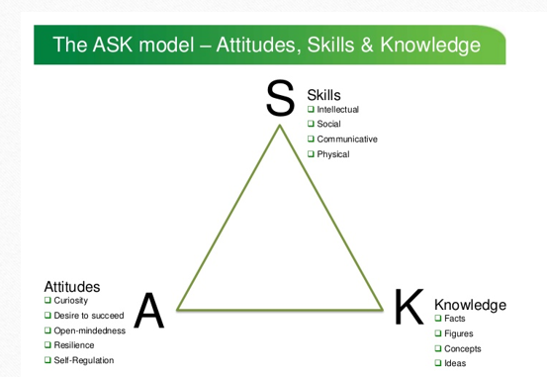
Nottingham (2011)
Nottingham (2011) has studied how children learn and introduced the model above. He highlights the importance of teaching children how to learn. This includes teaching learning strategies, encouraging attitudes towards learning and motivation to learn being strengthened.
The image you can see in Appendix 13 is Child A’s spot on the carpet. Each child has a specific spot that they sit on when on the carpet. This shows the importance that he has given this area. It could suggest his sense of ownership he has of the spot and his belonging within the class. Appendix 14 shows the interactive whiteboard, whilst taking the photo he said that it helps him with his maths which refers to a number line that had recently been used on there.
In Appendix 15 he has taken a photo of the pencil pots. This shows that recognises pencils as things that can help us. I asked him if he thought that they helped him learn and he said, “No they let me write about things that I want to write”,
When I have observed Child A I have noted that he has a natural curiosity for the environment around him. An example of this is after a day that I had been absent from school he came over to me and said “I was wondering where you had been and now your back. Where had you been?”
I have found however that he doesn’t want to make mistakes with his work. Rather than persevering he will regularly look for support whether that be from the teacher working with him or another member of the class. He is willing to accept help from other though. This was seen when another child noticed he was getting confused when he was counting using the bead string, she asked “Do you want me to point for you?”
Another aspect of attitudes for learning is the ability to self-regulate. This is something that Child A currently struggles with. This has been observed in many situations an example is when Dewi the class dragon (who goes home with the children over the weekend) was being given to another child. Child A was inconsolable and remained upset when going out to his mum.
Skills for learning
Alongside the attitudes children need for successful learning we must also think about the skills they will need. Skills for learning encompasses intellectual, social, communicative and physical.
Social skills that I need to focus on with Child A. Although he has quite good intellectual skills and can tell me what is right and wrong and what he should do in certain situations, when it comes to the situation he doesn’t understand what to do. However, Child A is still very young and social skills are something that we develop throughout our childhood.
Child A generally has a positive outlook when observed. He enjoys coming into the classroom, he is aware of the daily routines. He is very inquisitive and will happily chat to fellow children and adults within the classroom.
Knowledge for learning
Child A has a good knowledge of facts and figures to help him within his learn an example of this is when asked during the interview about what he enjoyed learning he said that he liked learning his number bonds to 9 (which had been taught 3 weeks prior to our conversation), He also enjoys learning about time. He could remember the concepts used and different ways to approach the questions. This is shown within the appendix as you can see the different ways he has worked out number bonds.
Language, Literacy and communication
My focus child has a positive attitude to literacy not only within specific lessons but also when transferring these skills into different curriculum areas. He is resilient and will keep going when unsure of spelling. He will use is phonic knowledge to help build words. Appendix 17 and 18 both show the RWI sounds which he said helps him when he’s writing.
Throughout my time with Child A I have seen a variety of Language literacy and communication skills used across the curriculum. He can use prior information learnt to retell a story, He also writes left to right across the page and can tell the difference between upper and lower-case letters bur is still working towards using these in the right places. He uses finger spaces between words well.
When reading he can confidently decode words that he is unsure of. After reading to me he can also re tell the story using images and practical items
Overall, I would say that my focus child is working towards a level 3 which he should be on by the end of the current year. He writes from left to right using the correct formation when forming words. He is also confident at orally composing a sentence describing events and experiences. Child A also remembers finger spaces between words although he is working towards using capital letters in the right places and full stops,
A strength of my focus child is his large vocabulary. According to Snow, Burns and Griffin (1998) when children have larger vocabularies, they become better readers in later childhood. Within school and at home his parents and grandparents talk to him a lot. This links with the research of Pan, Rowe, Singer and Snow (2005) who believe that the more different types of words that adults use with children the larger their vocabularies will develop. It is clear to see from his reading log that he reads regularly at home.
Troy is a confident reader and reads regularly at home with his parents which is well documented throughout his home reading log. It is important to mention at this point that there is close relationship between parental engagement in reading related activities and learners academic performance.
Overall through looking through his school books and evidence within the appendix my best fit judgement for child A’s Language Literacy and Communication would be an outcome 3. I would say that he does meet some of the outcome 4 descriptors, however in my opinion he is a secure level 3.

Numeracy
When asked Child A said that he likes maths especially number bonds and time. As an observer though I have found that although confident with number bonds when this skill was practised within word problems he found this tricky. Whereas in other lessons I have observed him having a go himself before asking for help within the sessions on word problems he was very quick to ask for help. He did not enjoy them at all. He could read the problem to me but couldn’t easily spot the relevant information needed.
Another aspect of maths we have covered is shape both 2D and 3D shape. Child A was able to support others within shape work. He had a concrete understanding of 2D shapes maths a strong area and is proficient in most areas however he finds word problems tricky.
Overall, I would also suggest that in a best fit judgement child A is a secure level 3
Personal and social development
Although Child A appears comfortable and complies with the ‘rules’ of the classroom there are instances where he does not understand the emotions of others. When I asked him if he thought he was important in his own learning he replied, “I don’t think so!” This comment really made me think and assess my own teaching. Children need to understand their own value and role within learning. They of course are the most important person in their own learning.

Next steps
Literacy
Even though I have previously mentioned areas of strength for Child A this doesn’t mean I cannot provide next steps for them. Learning is an ongoing cycle and their can always be more depth to learning. I would continue to encourage reading not just at home because he ‘has to’ but within class and for enjoyment the ongoing progress in reading would then strengthen his written work also. Barrs and Cork (2011) have noted that there are strong links between reading and writing. Especially within the class my focus child enjoys the reading corner. When asked what he thought of reading, he said that it was quite fun and that he liked the Gruffalo. I shall ensure that a range of books and magazines are placed there that are relatable and exciting for the boys; therefore, encouraging a love of books.
Another next steps for literacy would be to ensure Child A’s understanding of capital letters and full stops. Child A has identified through his self-assessment that full stops are something that he needs to work on (see appendix 19). He said that he forgets to put a full stop in. As a next step I would re-cap over basic punctuation and this would be done with the whole class class and then I would ensure that I systematically revisited this within lessons. With verbal reminders throughout the lesson. It is important to point out that I would ensure this was done across the curriculum to ensure that he could transfer this skill to a variety of contexts. I will also introduce visual success criteria for writing as a reminder to children. This will be laminated and placed with children on the table as a visual reminder to add them in.
Although he comes across confidently when speaking one to one with me in class. Through my general observations of him I have noticed that it is on his own terms. I don’t feel that he likes to share his ideas with the class. I would nurture this by using think, pair share to discuss ideas and make the possibility of sharing with the class less daunting. I would also try the lollipop sticks or random name generator on the IWB to choose children to feedback within the plenary and throughout the sessions.

Numeracy
I have highlighted word problems as an area of weakness. A way to approach this would be to explain explicitly how we approach a word problem. Child A has a good reading level and can read the question, so the area we need to focus on is how to pick out the key information; I would build up to full questions using coloured pencils or highlighters to underline the key information within the question. Scaffolding his learning and then once confident allowing him to work with another child to answer one.
Child A was confident making various amounts using 1p coins. His next step would be to make the amounts using different coins (2p, 5p and 10p coins). Although this seems a natural next step I would first scaffold this learning by doing a range of practical activities to deepen his understanding of each coin. Ensuring that he knew how much each coin is worth.
Personal and social development
Whilst observing Child A there were many times where conflict arose. An example of this was when drawing he was upset because another child had laughed at his work. I, Child A and the other child involved spoke about this and how others may feel. After a while I then went back to the table where another child was crying because Child A had laughed at their drawing. This example showed to me that although he knew what he should and shouldn’t do, he couldn’t understand why the child was upset. As Harris (2005) has suggested conversations are the means which children see that other children may have a different perspective other than their own. Developing this idea further I would ensure that we introduce regular circle times within the classroom. Roffey (2009) has suggested that circle games can encourage children to participate in group settings; this would be advantageous to Child A as within group activities he does struggle to join in. Through the games, songs and discussions children can have in circle time this would also improve Child A’s ability to share his own feelings and scaffold his ability to create reciprocal relationships. To be effective this will need to be part of the regular routine of the class rather than an occasional event. Another interesting comment arose in his interview when I asked is there anything that he doesn’t like about school? he said, “I don’t like doing the wrong things like kicking and punching.” Whilst in the school I have not seen him do either of these, so I asked him “Do you do those in school?” and he replied “sometimes”. This presents the idea that although I haven’t seen this side to him Child A may already be starting to notice himself that there are certain situations that he reacts to in this way. The fact that he can reflect after the situation in this way is very good.
Linking to positive relationships within school Child A plays with various children at playtimes and likes to play his own games alone. When asked who his friends were he mentioned Child 2. However, Child 2 has never been seen playing with him. I asked the class teacher whom also had never seen him playing with her.
Although I approach most classroom situations naturally with restorative practice I would ensure that any conflicts within the class are dealt this way. It allows both children to explain how they feel and for the case of Child A it allows him to start to understand how another child is feeling. Pupils usually work in partners for work and discussion, but I would
Alongside the next steps I have already mentioned I would introduce Philosophy for children. As he is a curious child and I believe this can be further supported and developed I do believe this would support his oracy development.
I would also improve my relationship with his parents. There needs to be regular and constructive conversations. Child A’s parents were happy with his progress in parents evening but didn’t see that they had a role to play within his learning. Goodman and Gregg (2010) stated that parental expectations can have a role to play in their child’s attainment.

Conclusion
My experience of the Mosaic approach has been a positive one. I feel that it is what naturally I will do as a teacher. Not just using numerical data from reading scores and tests but also using all the other information that we have access to. I believe that I will use this approach again within my career and it has given me an experience of how to involve children within this process of their own learning. When I use this approach again I would ask the child to help create their own questions to answer as I feel this would give me a deeper understanding of their opinions. Kellett (2005) has noted the use of children in setting their own questions and the wealth of information this provides.
To conclude, this assignment has allowed me to improve my own understanding of progress and also children’s role and own opinions of the process, it has also allowed me to investigate and evaluate my own approaches. In my current teaching practice, I have developed a deeper understanding of my own role and improved my confidence in providing meaningful next steps.
‘It is integral as teachers that we know exactly where our student’s strengths and weaknesses are. It is also important that parents and carers have reference points to determine themselves if their child is making the appropriate progress within their learning’ (Donaldson,2015)
It has shown me the importance that good quality feedback so that children know exactly what their next steps are. It has also shown me that children are experts in their own lives and must know how important they are within the learning environment.

References
Barker, J. and Weller, S. (2003) ‘“Is it Fun?” Developing Children Centred Research Methods’. International Journal of Sociology and Social Policy 23(1/2): 33-58.
Barrs, M and Cork, V (2001) The reader in the writer. London CLPE
British Educational Research Association Revised Guidelines (2004) http://www.bera.ac.uk/guidelines.html (accessed 19.04.18)
Britton, J (1982) cited in Barrs and Cork (2001) The reader in the writer London CLPE
Cameron, H. (2005) ‘Asking the tough questions: a guide to ethical practices in interviewing young children’. Early Child Development and Care 175(6): 597-610.
Cree, V.E., Kay, H. and Tisdall, K. (2002) ‘Research with children: sharing the dilemmas’. Child and Family Social Work 7: 47-56.
Dunn, J. (2005) ‘Naturalistic observations of children and their families’, in S. Greene and D. Hogan (eds) Researching Children’s Experience. Approaches and Methods, pp. 87-101. London: Sage Publications.
12 OECD PISA in Focus 2011/10 (November).
Denzin, N.K. (1989) Interpretive biography London, Sage
Goodman, A. and Gregg, P. (2010) ‘Poorer children’s educational attainment: how important are attitudes and behaviour?’, York: Joseph Rowntree Foundation
Hill, M. (2006) ‘Children’s Voices on Ways of Having a Voice: Children’s and young people’s perspectives on methods used in research and consultation’. Childhood 13(1): 69-89
Hopkins, A. (2008) ‘Classroom conditions to secure enjoyment and achievement: the pupils’ voice. Listening to the voice of Every child matters’, Education 3-13 36:4, 393-401.
Kellett, M. (2005). How to develop children as researchers. London: Sage.
Mayall, B. (2000) ‘Conversations with Children. Working with Generational Issues’, in P. Christensen and A. James (eds) Research with Children. Perspectives and Practices, pp. 120-135. London: RoutledgeFalmer.
Pan, B.A., Rowe, M.L., Singer, J.D., & Snow, C.E. (2005). Maternal correlates of growth in toddler vocabulary production in low-income families. Child Development, 76, 763-782
Price, J (1996) ‘Snakes in the swamp: ethical issues in qualitative research’ in R. Josselson (eds)
Punch, S (2002) Research with Children: The same or different from research with adults? Childhood 9 (3):321
Roffey, S. (2009). Promoting social and emotional learning with games “it’s fun and we learn things”. Simulation & Gaming, 4(5). Retrieved from http://sag.sagepub.com.databases.avondale.edu.au/content/40/5/626.full.pdf+html.
Samuels, J. (2004) ‘Breaking the Ethnographer’s Frames: Reflections on the Use of Photo Elicitation in Understanding Sri Lankan Monastic Culture’. American Behavioral Scientist 47: 1528-1550
Snow, C., Burns, M.S., & Griffin, P. (Eds.) (1998). Preventing reading difficulties in young children. Washington, DC: National Academy Press.

Appendix 1

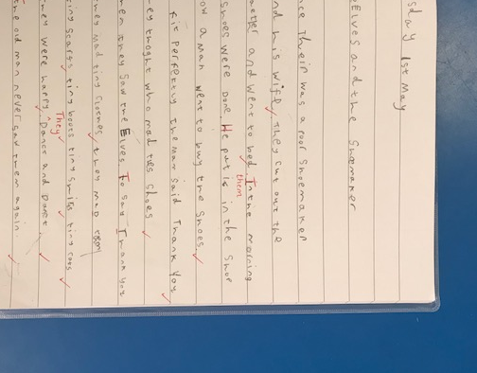

Appendix 2

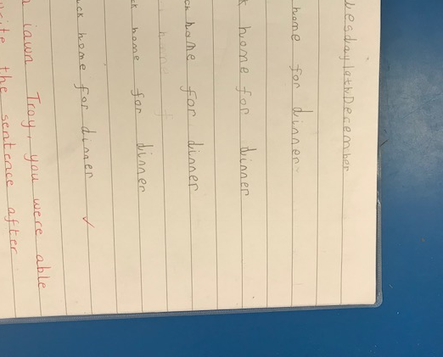

Appendix 3

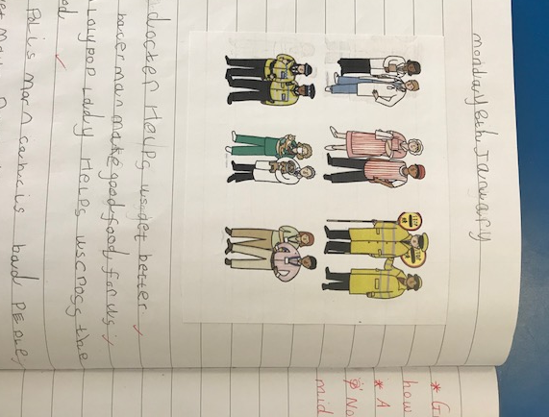

Appendix 4
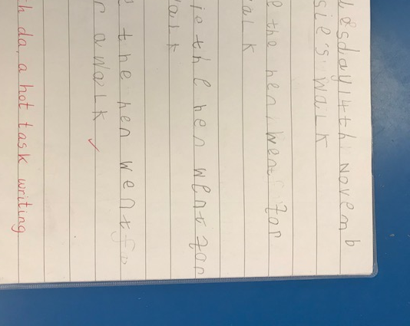

Appendix 5

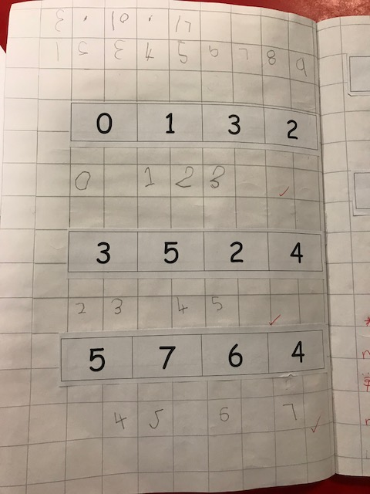
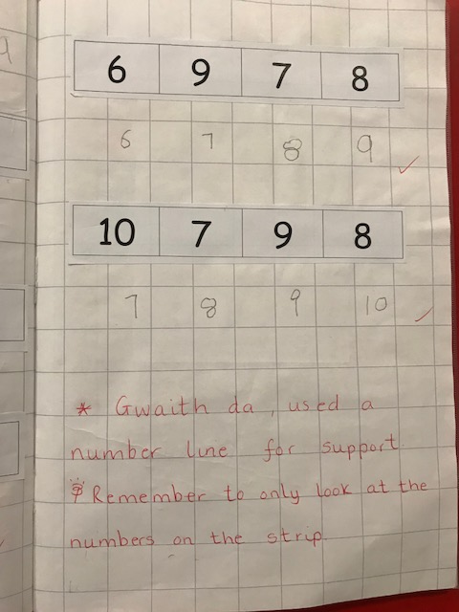

Appendix 6

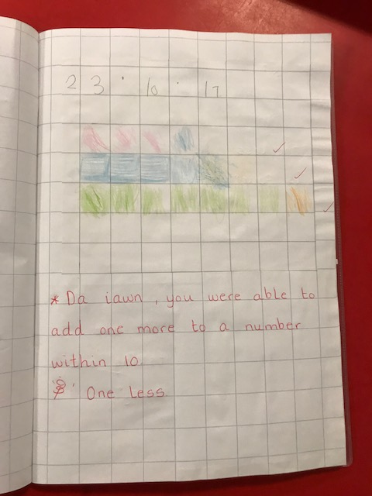

Appendix 7
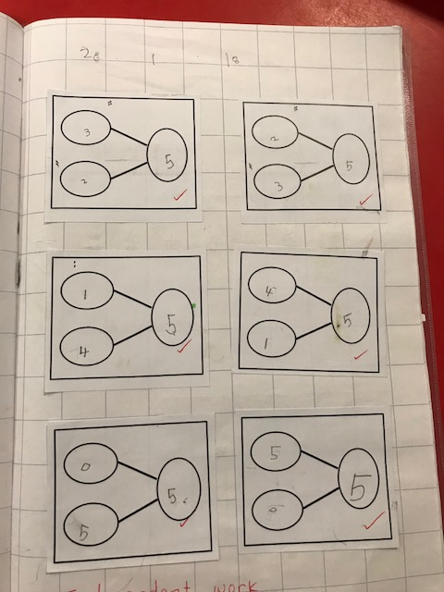

Appendix 8
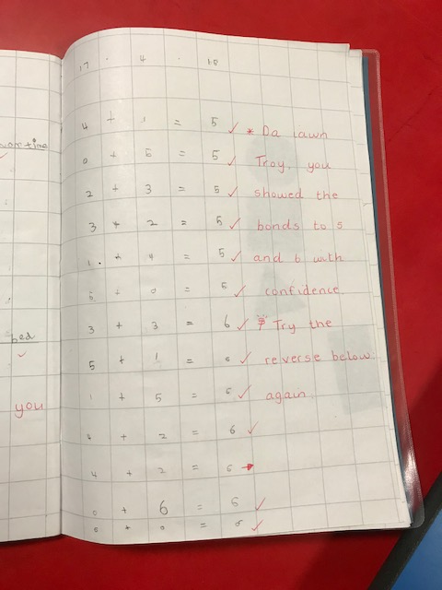

Appendix 9

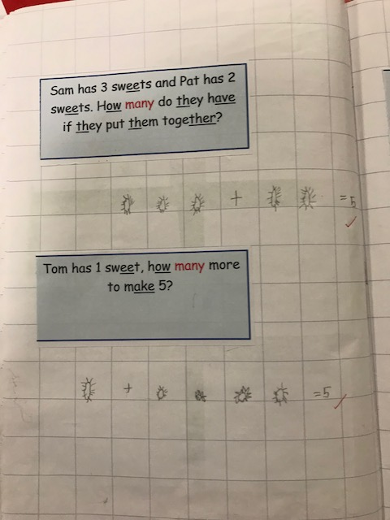

Appendix 10

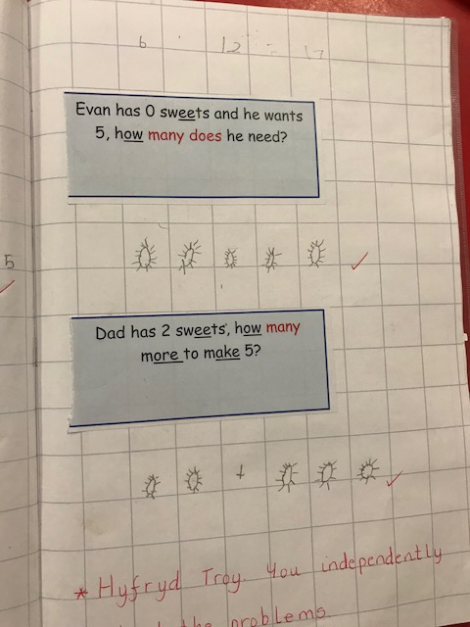

Appendix 11

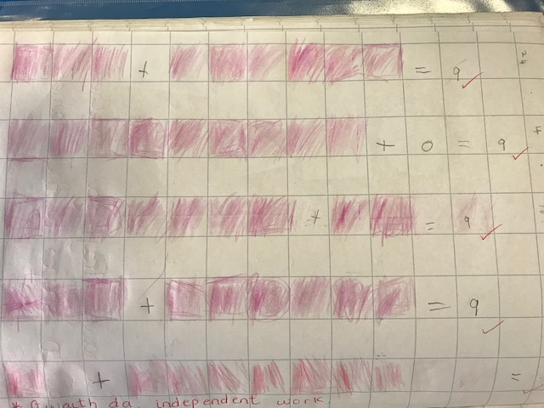

Appendix 12

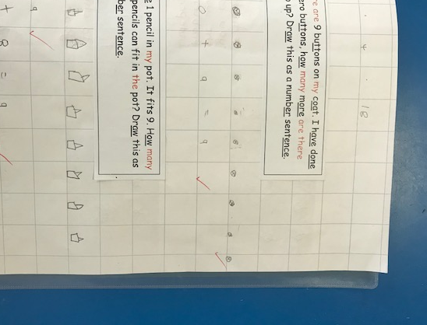

Appendix 13

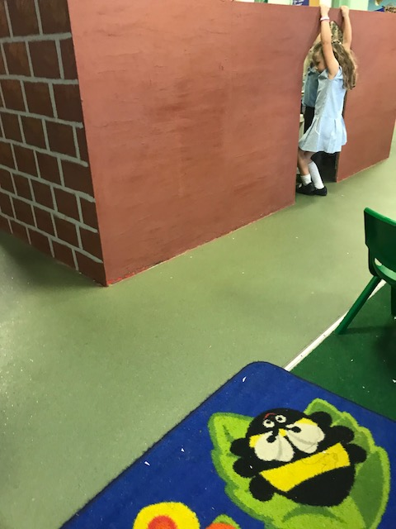

Appendix 14

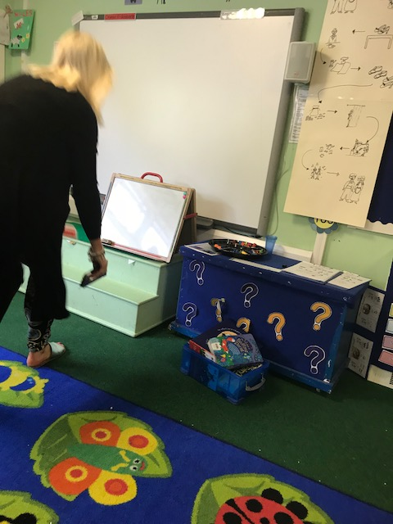

Appendix 15

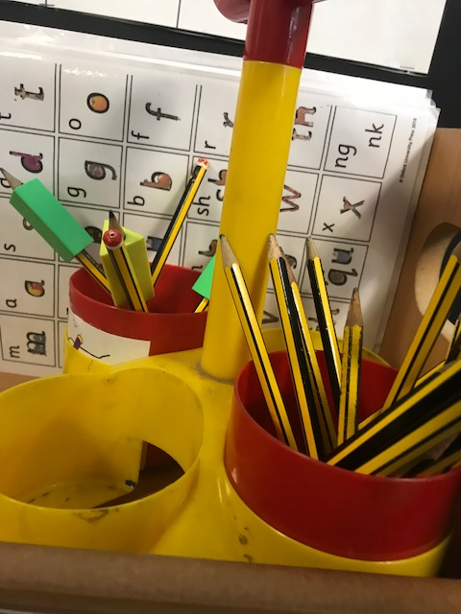
Appendix 16
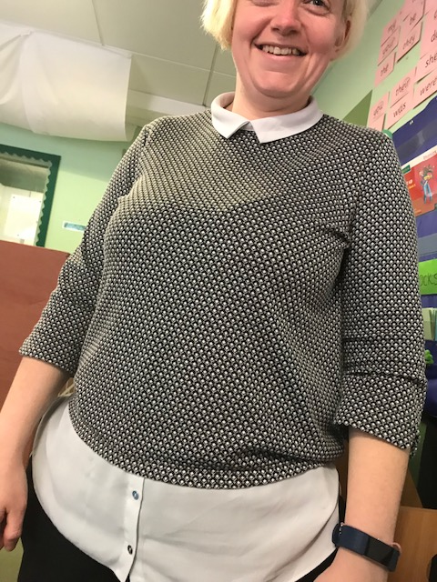

Appendix 17
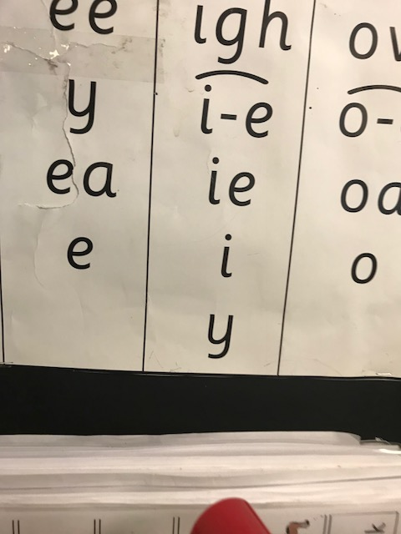

Appendix 18
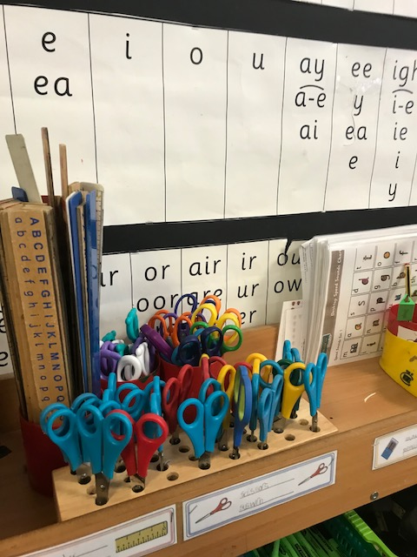

Appendix 19
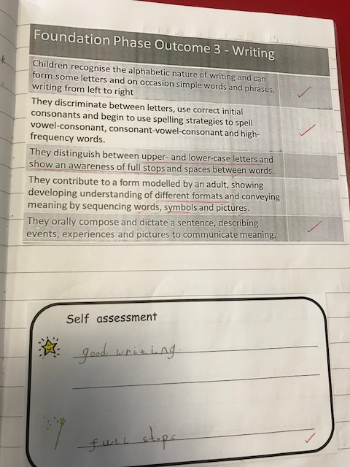

Appendix 20


