 | Targed/Targets | Yr hyn rwyf wedi'i wneud yn yr aseiniad hwn... / What I have done in this assignment...
Targed/Target 1 | Present the ideas of others in your own words. | I have limited the use of direct quotes, and instead I have paraphrased the work of others.
Targed/Target 2 | Use standard English wherever possible instead of abbreviations. | I have limited the use of abbreviations and I have only utilised them in references.

Critically reflect on your pedagogical progress demonstrated through required elements of the Professional Learning Passport, identifying a specific area for professional development and justifying next steps for improvement.
Contents Page
PART ONE
REFLECTION ON SUBJECT KNOWLEDGE DEVELOPMENT (TAB 5)
ASSET ONE, related to Digital Competency ………………………..…………… Pages 2 - 3
ASSET TWO, related to Numeracy…………………………………………….……..Pages 4 – 5
ASSET THREE, related to Literacy……………………………………………………Pages 6 –7

REFLECTION ON PLANNING FOR PROGRESSION (TAB 7)
PROFESSIONAL LEARNING TEMPLATE 1………………………………………Pages 8 - 9
PROFESSIONAL LEARNING TEMPLATE 2………………………………………Pages 10-11

REFLECTION ON PLANNING FOR THE FOUR PURPOSES (TAB 7)
PROFESSIONAL LEARNING TEMPLATE 1………………………………...…Pages 11-12
PROFESSIONAL LEARNING TEMPLATE 2 ……………………………………Pages 13-14

PART TWO
CRITICAL REFLECTION…………………………………………………………….. Pages 14-19
REFERENCES………………………………………………………………………… Pages 20-23
APPENDICES…………………………………………………………………………..Pages 24-28

Part 1: Professional Learning Passport
REFLECTION ON SUBJECT KNOWLEDGE DEVELOPMENT (TAB 5)
ASSET ONE, related to either Lit, Num, DC, or an AoLE

Digital competence
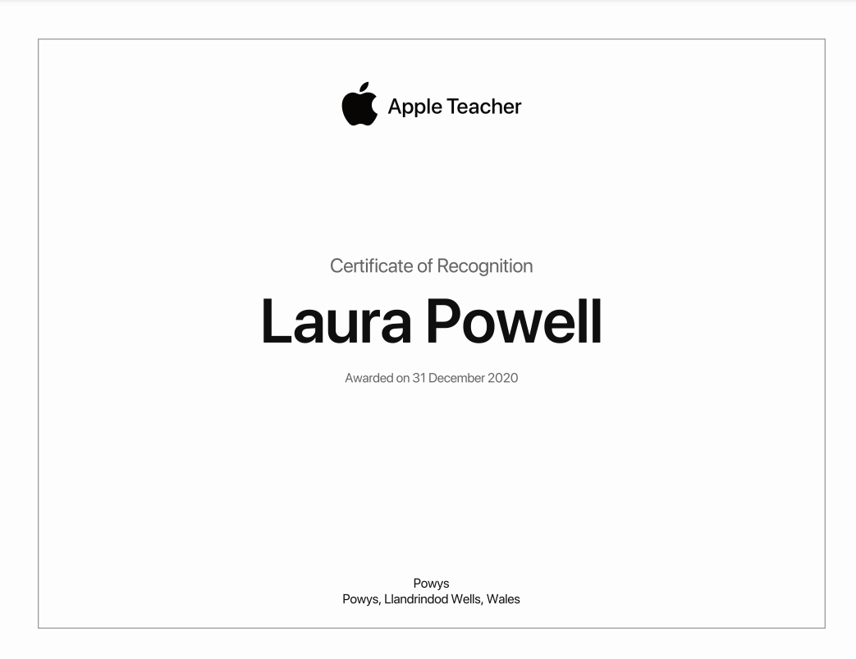
The certificate that I was awarded for the completion of the Apple Teacher course.

During the Christmas 2020 lockdown, I utilised my additional time to complete an Apple Teacher certified course to develop my digital skills and confidence in embracing Apple devices such as iPad and Mac. Within this learning opportunity, I developed my skills in GarageBand, Pages, iMove, Camera, Keynote, Number and Measure. This course proved beneficial during my final Professional Teaching Experience as I planned and devised online learning experiences; I utilised these apps to create more interactive learning experiences. In addition, within the last three weeks of my PTE I used the Measure app in a Forest School session whereby learners were tasked to map out various Australian landmarks and used wooden blocks to firstly estimate and then measure the distance between each landmark, using the Measure app. iPads are a common tool in twenty-first century classroom, and I will continue to explore the various Apple apps to develop my innovation in the classroom. Arguably, to continue to strive for ‘’quality education’’, as dictated in the Sustainable Development Goals (United Nations, 2015), it is perhaps imperative to continue to develop digital competence of teachers, to encourage teaching innovation (Artacho, et al., 2020).
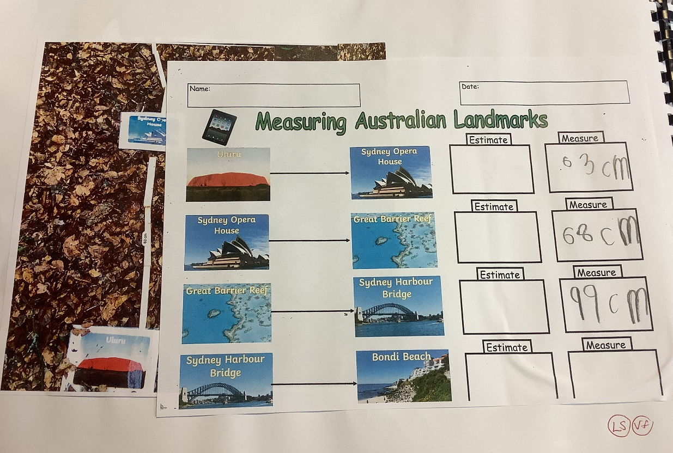
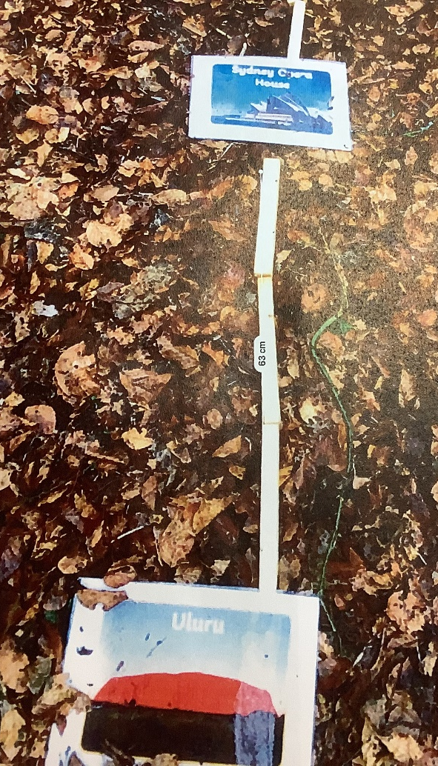
This is an example of a learner’s work completed in Forest School, using the Measure app. Unfortunately, this group of learners were not able to record estimations on sheet due to bad weather conditions.

ASSET TWO, related to either Lit, Num, DC, or an AoLE

Numeracy
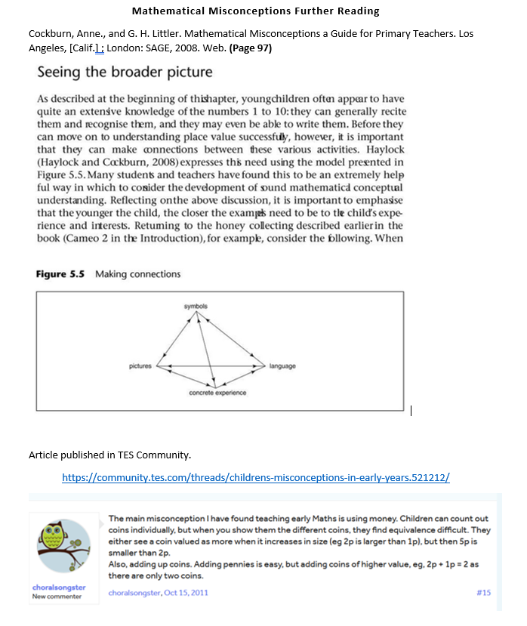

A screenshot that captures an extract taken from ‘’Mathematical Misconceptions: a Guide for Primary Teachers’’.

A screenshot that captures a comment in TES Community, discussing misconceptions in teaching Money in the Foundation Phase.

Prior to planning the sequence of Mathematics lessons based on money, I conducted further reading in ‘’Mathematical Misconceptions: A Guide for Primary Teachers’’, to anticipate any misconceptions that the learners may encounter. This reading proved useful in informing my lesson planning and the resources to support the learning. Furthermore, Cockburn and Littler (2008, p.96) suggest that learners often become confused ‘’when asked to complete exercises involving exchanging ten one-pence pieces for a ten-pence piece’’. I therefore utilised the Numicon pieces to support the teaching of the value of the different coins. Moreover, the ‘’Making Connections’’ model (Haylock and Cockburn, 1989) supported my subject development in Mathematics. This model illustrates the process in learning whereby learners construct understanding of mathematical concepts through the relationship between mathematical symbols, pictures, language and concrete experiences. The model is based on the thinking that the development of understanding involves the process of making cognitive connections between new experiences and our existing knowledge and understanding (Haylock and Manning, 2014). Thus, I activated learners’ previous knowledge in money, Numicon and number concepts in order to form new connections in teaching coin exchange and coin addition.
In addition, an interesting article published in the TES community highlighted that in the Foundation Phase, learners frequently misconceive that the bigger the coin, the higher value the coin holds. Within the stream, educators also discussed that learners can typically count coins individually but find equivalence difficult. I then shared these findings with my class mentor who agreed that addressing the common misconceptions were important teaching and learning points to consider in teaching a difficult concept, such as Money.

ASSET THREE, related to either Lit, Num, DC, or an AoLE

Literacy
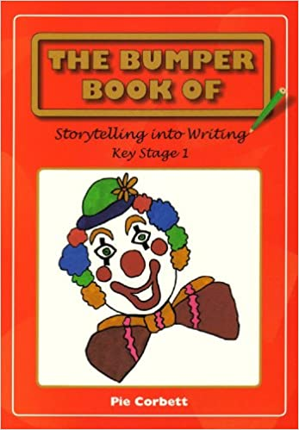

This is the book that I purchased to conduct initial background reading into Pie Corbett’s Talk for Writing approach to learning.
Although I was not developing the learners’ story telling writing skills, this resource gave me an insight into the background of Pie Corbett’s teaching strategy.

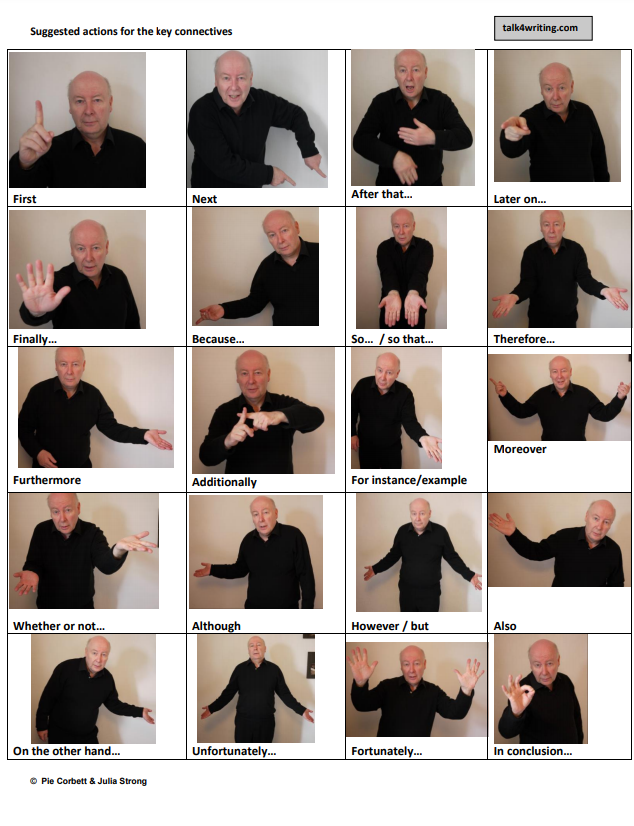

This is a copy of the Pie Corbett Talk for Writing time connectives poster that I used to support my teaching of the various actions. Out of the actions, I taught the learners ‘First’, ‘’Next’’, ‘’Then’’, ‘’After that’’ and ‘’Finally’’.

To introduce the learners into Time Connectives, I utilised Pie Corbett’s Talk for Writing strategy; an approach that enables learners to imitate the language required for a particular topic orally, before writing. This teaching framework is widely used in the classroom across the United Kingdom and according to the Education Endowment Foundation (EEF) (2018), school practitioners indicated that Talk for Writing had a positive impact on learners’ writing skills and confidence levels. Prior to introducing the time connectives to the class, I used the time connective poster to learn and practise the actions for the four chosen connectives. I chose the basic time connectives that learners would require for the recount writing task and in consideration of the linguistic ability of the individuals in the class. Then, I introduced the time connectives with the actions to the learners and practised these actions throughout the day. For example, when giving learners instructions I would model the time connectives and actions and I would also ask the learners to imitate. Learners quickly grasped the time connectives and actions, and it was clear that the actions supported the learners’ understanding and recall. In the classroom, the Talk for Writing proved successful in teaching time connectives as learners were engaged during the imitation stage of learning and then applied the actions as a prompt during the writing task. Another success of the Talk for Writing was the practical element to the learning, which was an important break from writing activities.

REFLECTION ON PLANNING FOR PROGRESSION (TAB 7)
PROFESSIONAL LEARNING TEMPLATE 1, related to different AOLEs
Professional Experience Template 1: Maths Lessons – Exploring Money for the Virtual Trip to Australia (See Appendix 1)

Pedagogy Standard: Advancing: Progression in Learning

What did you do and why?
During the three weeks and three days of face-to-face teaching experience that I had as part of my final Professional Teaching Experience, I focused on Money with my Year 1 and Year 2 class. Initially, I planned a learning experience to ‘’build on learners’ previous experiences’’ (Welsh Government (WG), 2020, p.50). This was a whole class twenty-minute carpet session to identify and assess learners’ ability and understanding of money. This then enabled me to plan the relevant tasks to build on learners’ knowledge and understanding and thus enable progression. A further four learning experiences were planned based on the theme, ‘’Money’’ and were centred around progression and learners’ developing confidence in the concept of money. The carpet session identified that as expected, learners had regressed in mathematical understanding due to the learning loss in the lockdown period. This judgement is supported by the Education Endowment Foundation findings (2021) that suggest that learners’ attainment in maths were negatively impacted by the school closures during the national lockdown. Thus, I started the teaching of Money from the basic, Coin Recognition. I then progressed the learners’ to exploring Coin Exchange and then onto Coin Addition. The learning was concluded with a Problem-Solving task set in ‘’real-life contexts’’ (WG, 2018, p.5) to consolidate learners’ understanding of Money. The tasks I set were differentiated for the four abilities in the class to ‘’meet the needs’’ (WG, 2020, p.21) of all learners and to appropriately challenge the learners. This ensured that the learning was accessible for every learner in the classroom and all learners progressed and advanced understanding in the learning environment.

What have you learned?
From this experience, I have developed an understanding of the importance to map and reflect upon the learning to be able to articulate the next steps. Although I had a clear vision and learning objective as an end goal of what I wanted the learners to achieve, I had to recognise the learners’ individual steps of progression to be able to effectively plan for the wider progression. For example, by the end of the three weeks of exploring Money I wanted the learners to be able to ‘’transfer mathematical skills to classroom activities’’ (WG, 2018, p.5) to promote problem solving skills. As a result of the experience, I have also developed my understanding of ‘’how learning develops incrementally and tangentially’’ (WG, 2017, p.33) and the importance of differentiation at an appropriate level for individuals in the class to access and progress in the learning. As I only taught two out of the four groups, I thus communicated with the Teaching Assistant to plan effectively for those groups and to ensure the activities were set at an appropriate challenge for the learners. During the initial stages of exploring Money, the Teaching Assistant informed me that one group required more experience in Coin Recognition; I thus planned an additional practical activity to consolidate the learners’ knowledge and understanding of the different coins up to the twenty pence piece. I also learnt of the importance of flexibility in the organisation of ability groups, I recognised the individual abilities within the groups and I regularly moved individuals into different groups to support the learner’s different paces of progression.

What next?
As I embark on my Newly Qualified Teacher journey, I will be responsible for the planning and delivering of progression of the learners in my class for the academic year. I will transfer the experience that I have had in planning for progression in Mathematics, into my future classroom. Moreover, I will ensure that I have a clear vision of what I aim for the learners to achieve in the learning sessions and in the long-term over the academic year. In addition, I will continue to effectively differentiate the learning to meet the needs of all learners in the classroom and I shall be flexible in the ability grouping and continuously move learners around the groups to ensure progression and appropriate challenge.

PROFESSIONAL LEARNING TEMPLATE 2, related to different AOLEs
Professional Experience Template 2: Literacy Lessons – The Big Adventure (See Appendix 2)

Pedagogy Standard: Advancing: Progression in Learning

What did you do and why?
During my final Professional Teaching Experience, I set myself the challenge to engage the learners in an extended writing task. To motivate and engage the learners into writing, I introduced the ‘’Big Adventure’’; an expedition around the school to show Miss Powell the various areas in the outdoor environment. This developed a sense of excitement for the learning, and more importantly the learners understood the purpose for the task. The learning objectives for the extended writing task was for learners to write a recount of the ‘’Big Adventure’’, using time connectives, past tense verbs, and basic sentence rules. Initially, I introduced the concept of a ‘’verb’’, through ‘’Veronica Verb’’ a familiar character in the classroom. Learners thoroughly enjoyed recapping verbs, particularly in playing ‘’Simon Says’’ and demonstrated an excellent understanding of verbs, as doing words. Then, I progressed the learners onto an innovative ‘’Transformer’’ activity to transform the verbs into the past tense. Again, learners thrived from the use of the ‘’Transformer’’ character to change the verbs into the past tense. Learners orally explored both regular verbs that use the ‘’ed’’ ending and irregular verbs. After that, learners progressed into exploring Time Connectives, through Pie Corbett’s Talk for Writing. Next, we went on the Big Adventure, and explored the various language tools, such as verbs and time connectives. Finally, learners sequenced pictures of the different areas that we visited and wrote the corresponding time connective along with the verbs to describe what they did. Learners then utilised the plans to support the extended writing task, to write a recount of the Big Adventure. This whole process took three weeks, and it was important that I gradually progressed learners to develop their confidence levels to write. This was the first extended writing task since learners returned to school, and for several learners it would have been the first writing task for several weeks.

What have you learned?
One of the most significant lessons that I have been enlightened to is the duration required to develop learners’ confidence and skills to complete an extended writing task. Learning is not linear and to effectively prepare and support learners, I had to carefully plan learning opportunities that were progressive and built upon learners’ previous experiences. Each individual step was successfully planned and delivered, and learners enjoyed the learning experiences. Learners were particularly engaged in exploring Pie Corbett’s Time Connectives and effectively recalled the various time connective, utilising the actions to support recall. The use of practical, hands-on actions developed learners’ writing skills and extended their vocabulary. This is perhaps supported by an evaluation of ‘’Talk for Writing’’ whereby school practitioners reported that the project had a positive impact on learners’ writing skills and that it developed both learners and teachers’ confidence in writing (Dockrel, et al., 2015). Despite the wide spectrum of linguistic abilities within the class, every individual learner progressed in the learning and it proved the importance of differentiated tasks.

What next?
I will continue to devise purposeful and exciting contexts to motivate writing experiences. When planning for extended writing tasks, I will furthermore ensure that I plan step-by-step learning experiences to support progression and thus develop learners’ confidence to write. An area of development that I would like to focus on is exploring writing stamina. I would like to have the opportunity to observe various strategies that teachers employ to develop writing stamina.

REFLECTION ON PLANNING FOR THE FOUR PURPOSES (TAB 7)
PROFESSIONAL LEARNING TEMPLATE 1, related to a different Four Purpose
Professional Experience Template 1: Wellbeing Week – Healthy, confident individuals (See Appendix 3)

Pedagogy Standard: Advancing: Four purposes
What did you do and why?
Upon return to face-to-face learning, I planned and delivered a three day ‘’Well-Being Week’’ for learners in the Year 1 and Year 2 class, to introduce the learners back into the school routine. I anticipated that several learners would feel anxious and would require opportunities to support social interaction. The theme of the Well-Being Week was focused on the story of ‘’The Colour Monster’’, which provided an engaging ‘’hook’’ to stimulate the learning. The aims of the session were to develop ‘’healthy, confident individuals’’ (WG, 2020, p.11) and to prepare and equip the learners for the transition back into school. The activities were centred around wellbeing and included independent, paired and group work. On the first day of school for learners, we had circle time on the carpet, as a whole class. Literature on circle time suggests several benefits such as improved self-esteem, improvements in social skills and learners’ well-being (Glazzard, 2016). In the circle time session, learners shared ‘’News in Barcud Coch’’ and any concerns or worries about returning to school. We then wrote these worries down, and the Colour Monster ate them up. The Wellbeing Week not only develop learners’ wellbeing, but also developed learners’ awareness of wellbeing and taught them strategies to manage their emotions. On the first day back to school, I did not plan focus groups that required a teacher support, all the activities were independent to ensure that I could distribute myself around the classroom to talk to individuals. The purpose, ‘’healthy, confident’’ (WG, 2020, p.11) individuals was the central driver for learners’ experiences during the well-being week to ensure that learners were happy and ready to learn.

What have you learned?
An important consideration during the Wellbeing Week was for learners to develop positive relationships with peers and myself, as the temporary class teacher. Arguably, positive in-school relationships are fundamental to the well-being of both learners and teachers and underpin an effective learning environment (Roffey, 2012). During this experience, I was enlightened to the impact that learners’ wellbeing on learning outcomes. Tyng et al. (2017) suggests that emotions can influence cognitive processes such as attention span and engagement in learning. This is perhaps echoed by Pound (2014, p.11) who argues that emotions are the ‘’ignition switch’’ in learning. As a result of the online experience, I also learned of the impact of the home background on learners’ experiences and the challenge to defy these circumstances to ensure that every individual receives the same opportunities. The home-school partnerships is another significant factor to develop ‘’healthy, confident individuals’’ (WG, 2020, p.11); Epstein’s (2001) ‘’overlapping spheres of influence’’ positions the learner at the centre and suggests that the school, community, and family share a responsibility for the learning and development of a child. Furthermore, I was enlightened to the importance of providing learners with opportunities for social interaction amongst peers to promote ‘’healthy, confident individuals’’ (WG, 2020, p.11). As learners had spent over two months at home, learners had to adjust back into a class of thirty learners and thus familiarise themselves with fundamental social skills such as turn-taking, sharing of resources and listening.

What next?
I aim to conduct further reading and research into how schools can work in partnership with parents and the wider community to support the development of a child. I will observe effective practice on how schools have worked with parents over the lockdown period to support the online learning experience. Many schools across Wales would have had the statutory responsibility to deliver weekly wellbeing ‘’Check In’’ sessions with learners to ensure the safety and wellbeing at home. In my future classroom, a priority will be to develop positive relationships with the parents of the learners in my class. This will be a fundamental element to developing ‘’healthy, confident’’ (WG, 2020, p.11) individuals that are ready to learn.
PROFESSIONAL LEARNING TEMPLATE 2, related to a different Four Purpose
Professional Experience Template 2: The Big Adventure – Ambitious, capable learners (See Appendix 4)

Pedagogy Standard: Advancing: Four purposes
What did you do and why?
Learners completed an extended writing task three weeks into the return to school after the extensive lockdown period. Learners went on a ‘’Big Adventure’’ and then wrote a Recount, based on the events in the Big Adventure using the new language and vocabulary that had been introduced. This was challenge for learners, who may have not picked up a pencil since before Christmas. However, it was also an opportunity to develop ‘’ambitious, capable learners’’ (WG, 2020, p.11) who thrived from the challenge of completing the Recount. I devised a Success Criteria in the form of a checklist of the features that I expected to observe in learners’ writing. These checklists were differentiated as I had different expectations for the different ability groups within the class. In the writing, learners then ‘’set themselves high standards’’ (WG, 2020, p.24) and independently discussed what they wanted to describe in their writing. The teachers supported the learners’ spelling and reminded the learners to use the planning sheet to support the writing. Learners demonstrated the ability to communicate effectively in a different form, through writing in the past tense and organising the work with time connectives. Once completed, learners then completed a self-assessment slip to reflect on how they felt about their writing; I was pleased that all learners in the class indicated a green, happy face. This suggests that all learners enjoyed the challenge of an extended writing task.

What have you learned?
An extended writing task is an excellent opportunity to support learners to become ambitious, capable learners. This task was the pinnacle in a series of learning experiences that equipped learners with different language skills and new vocabulary to then utilise in the extended writing. The use of the ‘’Planning the Big Write’’ paper was an effective tool to encourage learners to be independent in writing. It also prompted the learners’ memory of the Big Adventure and provided them with tricky word spellings and the time connectives to structure the sentences. This is perhaps supported in the Education Endowment Foundation (2020), ‘’Improving Literacy in Key Stage 1’’ report that suggested that learners’ writing can be improved by teaching them to plan their writing.
Although the sentence quality did vary amongst individuals, the purpose of the task was for learners to apply the language and body of new knowledge into the extended writing task. My focus when marking was the use of time connectives, past tense verbs and full stops and capital letters. This experience will then support learners to ‘’be ready to learn throughout their lives’’ (WG, 2020, p.11). Writing is not a skill that learners require to merely complete schooling, this is a skill that learners will use and need throughout life as a vital form of communication in future jobs and careers. In developing ‘’ambitious, capable’’ (WG, 2020, p.11) learners, I learned that my role is to facilitate opportunities to challenge learners, which is sometimes initially out of learners’ comfort zone. However, with well-planned series of learning experiences that build on previous experiences to equip and develop confidence, learners can complete tasks that do challenge them.

What next?
I will continue to set high expectations and levels of challenge to motivate learners and to develop ‘’ambitious, capable’’ (WG, 2020, p.11) individuals. The four purposes will be the drivers for learners’ experiences and my own planning. Moreover, I aim to use the vocabulary named in the four core purposes in the classroom to ensure that learners are aware of the purpose of the learning and eventually are then able to make links with the learning and the four purposes.

PART TWO

Part 2: Critical Reflection
Words: 2133
Introduction
Critical reflection enables practitioners to research and identify teaching and learning strategies leading to professional development (Shandomo, 2010; Hargreaves and Page, 2013). Upon my own critical reflection, an area that I would like to explore and develop further is building learners’ writing stamina. Throughout my previous professional teaching experiences, I have observed learners’ lack of motivation and focus on writing for extended periods, and I am thus interested in developing strategies to create an engaged community of writers. Franks (2020) highlighted that writing stamina is a challenge for practitioners. Although the responses in Franks’ (2020) report were collected from Year 5 practitioners and perhaps lacks a wider representation of learners at a primary school age, the report highlights the challenge in developing writing skills. During my final professional teaching experience, I set the learners the task to write a recount, based on ‘’The Big Adventure’’; learners had various opportunities and experiences to consolidate their understanding of the vocabulary and past tense patterns required to complete the task. However, I observed that several learners, regardless of ability, lacked motivation and stamina to write at length.
Therefore, I will conduct research into writing stamina to develop my knowledge and understanding, discover new teaching strategies and in turn develop my professional development and practice, which is perhaps fundamental for Newly Qualified Teachers (Harju and Niemi, 2016) and critical reflection of practice (Singh, Rowan & Allen, 2019). This links to targets from the professional teaching standards including pedagogy, leadership and professional learning (Welsh Government (WG), 2017).
Whilst Woolley (2014) suggests that learners develop simultaneously as readers, writers, listeners and speakers, the assessment data on Welsh learners’ attainment in oracy, reading and writing indicates that the percentage of learners achieving the expected Level 4 is consistently lower in writing (WG, 2020). For example, in 2019 the percentage of learners who achieved the expected Level 4 in writing was 85.2 per cent, whilst 89.6 per cent of learners achieved the expected outcome in reading and 90.2 per cent in oracy (WG, 2019). Although the assessment data is perhaps an important aspect of accountability (Brill, et., 2018), Davidson, Kempton and Thoung, (2015) may argue that progression may be a better reflection of the learning process. Furthermore, the use of the term ‘’expected levels’’ may contradict the progression steps in the Curriculum for Wales (WG, 2020). In Donaldson’s (2015) recommendations, it was suggested that progression should not be hindered by expected outcomes related to the age-according to levels. Moreover, the ‘’expected levels’’ are perhaps no longer pertinent in the current climate, following the extensive period of partial school closures during the national lockdown (Moss, et al., 2020).
Critical Discussion
The term ‘’writing stamina’’ refers to the ability to write for sustained periods of time (Lemov, 2014) and it is perhaps imperative in developing ‘’ambitious, capable learners’’ (WG, 2020, p.11) that are well-equipped to meet the demands of society (Graham, 2019). Writing is a fundamental skill (Woolley, 2014; Medwell, 2011) and whilst Tolchinsky (2016) suggests that learners begin to explore how to write at home, a basic aim of schooling is to develop competent writers (Graham, 2019).
It may be argued that Dweck’s (2012) mindset theory is influential in developing learners’ writing stamina in the classroom. In the context of writing competency, learners who can recognise that writing is a malleable skill, which can develop through effort and support, possess a growth mindset (Hoeve, 2018). This is perhaps supported by educational research which highlights that writing efficacy has a significant impact on motivation and on the achievement in the writing task (Gillespie, Olinghouse & Graham, 2013). Furthermore, Maslow’s (1943) hierarchy of needs illustrates that learners’ lower-level deficit needs, such as self-efficacy, must be met to ensure learners are at their full potential to write. However, Maslow (1978) later indicated that the satisfaction of needs is not a complete phenomenon; the levels do not have to be entirely satisfied to progress.
Arguably, an important consideration in developing writing stamina is to acknowledge that it is a process, not merely a one-off event (Graham, 2016; Chamberlain, 2018); learners should have frequent opportunities to experience and explore writing to develop stamina (Minns, et al., 2017, Rietdijk, et al., 2018). Similarly, Bourque (2017) suggests that learners require opportunities to write little and often to build stamina. Whereas Woolley (2014) argues that writing is dependent on oral language and to support the development of writing stamina, learners should have the ability to articulate what they want to write. This is perhaps supported by an Estyn (2019, p.1) effective practice report which highlighted that oracy was an area of development to ‘’equip and prepare pupils for writing at length’’. Similarly, the ‘’Big Write’’ teaching approach is based on the premise that ‘’If a child can say it, a child can write it’’ (Andrell education, p.1). Practitioners have reported that the Big Writing approach is an effective strategy to develop writing stamina and prepare learners for extended writing sessions (Harland, et al., 2014). However, the comparisons of learners’ writing performance prior and following the implementation of Big Write in the baseline assessment showed no statistical improvements (Harland, et al., 2014).
There are several strategies and teaching approaches targeted to develop writing stamina (Minns, et al., 2017; Woolley, 2014; Bourque, 2017). One strategy that practitioners may use to support learners’ writing stamina is to scaffold the writing process (Padmadewi, 2019). Wood, Bruner, and Ross (1976, p.90) defined scaffolding as the process "that enables a child or novice to solve a task or achieve a goal that would be beyond his unassisted efforts". Graham et al (2016) indicates that writing development is shaped through mentoring and may recognise the significance of scaffolding in the development of writing stamina. The ‘’think-aloud’’ method of modelling writing, referred to by Woolley (2014, p.45), is an example of a scaffold in writing development; the process involves a shared writing activity to encourage a discussion into the text and language type. However, the scaffold may develop more dependence than independence for learners and it is perhaps important to consider that a scaffold is intended to be a temporary structure (Minns, et al., 2017). According to Fitri and Al-Hazfizh (2013), shared writing enables learners to develop confidence and competence in their writing skills as the practitioner demonstrates the internal thinking process.
Collaborative writing is perhaps another strategy that can be utilised to develop learners’ writing stamina (Minns, et al., 2017; Grief et al. 2007). This approach differs to shared writing as learners produce the written text, whereas in shared writing, the practitioner transcribes the entire text while learners discuss the process (Gibson, 2012). The Vygotskian social constructivist theory may be closely aligned with the collaborative writing approach due to the emphasis of social interaction in the learning process. Vygotsky’s (1986) theory may suggest that collaborative writing will offer learners the opportunity to learn and develop from peers. Furthermore, collaborative writing may support learners’ writing stamina due to the division of labour (Wigglesworth& Storch, 2012). However, Grief (2007) suggests that to facilitate effective collaborative learning, practitioners will need to ensure equal distribution amongst learners in the group. In contrast to the collaborative writing approach, Piaget (1950) may argue that learners should independently acquire writing skills and referred to the learner, as the ‘‘lone scientist’’.
Moreover, it is important to develop purposeful and authentic contexts for writing (Woolley, 2014; Graham, 2019). Frater (2004, p.58) suggests that too often in the education system, learners ‘’learn to write for the circular purpose of learning to write’’. However, the Curriculum for Wales (WG, 2020) may defy this circular purpose as it is a purpose driven curriculum and sets out the responsibility to deliver an education that provides a range of rich and authentic contexts for learning. Cremin (2011) emphasises that learners should recognise the purpose and value of writing in meaningful and relatable contexts. These contexts for learning should provide opportunities to develop writing stamina as learners should have the knowledge and understanding to write at length (Andrews, 2008). This is perhaps supported by Bourque (2017) who suggests that learners are empowered by understanding, and that understanding will empower learners to write.
Practitioners have shared strategies to develop learners’ writing stamina in various educational blogs (Davies, 2021; Valdez, 2018; Olenczuk, 2017). Davies (2021) draws a connection between the development of reading stamina and writing stamina; learners are encouraged to read as part of a daily routine, and this should be applied for writing. Valdez (2018) discusses the Power Writing approach to develop writing stamina; Power Writing occurs as part of learners’ daily routine for up to five minutes. The aim is for learners to write as much as they can in the allocated time. Once the timer signals, learners then count the number of words written down and input the data into a graph, which will display the learners’ growth (Valdez, 2018). Similarly, Davies (2021) and Olenczuk (2017) suggest daily opportunities for short burst writing in the classroom to develop writing stamina. Arguably, a major criticism of this approach is that it emphasises quantity over quality in teaching writing (Anderson, et al, 2015). However, Davies (2021) compares the development of writing stamina to athletic training; as athletes train to build endurance, writers must, too. Wilburne and Dause (2017) furthermore discuss the impact of goal setting on learners’ motivation and perseverance.
Conclusion
To conclude, writing development is perhaps variable and there are no specific strategies to develop writing skills (Bazerman et al., 2017). It is an individualised process that should recognise the different learners in the classroom (Graham, et al., 2016). It may be argued that those who do not learn to effectively write are at a disadvantage to academic, occupational, and personal progression (Graham, et al., 2016). Similarly, Hernansson and Lindgren (2019) indicate that writing development is a crucial focus in education to enable participation in a text-based society, as the development of technology over the past few decades has ‘’increased the amount of writing in most people’s lives’’ (Brandt, 2015, p.4).
Furthermore, Hernansson and Lindgren (2019) argue that if the education system is to equip learners with adequate skills to achieve success in examinations, then the development of extended writing, should perhaps be a priority. Whilst this source is not out-dated, it is perhaps aligned with the previous performativity driven education system, rather than the Curriculum for Wales which advocates the development of the whole child, rather than merely cognitive development (WG, 2020).
This paper has discussed some of the strategies to develop learners’ writing stamina to support learner progression in extended writing. Based upon the findings of the literature, one aspect that I will engage with during my future teaching will be considering learners’ mindset. As previously discussed, writing development is a process, rather than a one-off event (Chamberlain, 2018); therefore, an understanding of growth mindset should support learners’ perseverance in extended writing (Jankay, 2020). Hoeve (2018) indicates that fixed mindsets in writing are commonplace in the classroom, and it is important for the teacher to model growth mindset learning behaviours. Therefore, to develop learners’ writing stamina, I will model perseverance and a growth mindset to encourage the development of ‘’ambitious, capable learners’’ (WG, 2020, p.11). This is perhaps supported by Ings (2009, p.21) who suggests that the process of writing requires stamina, motivation and ‘’a lot more courage’’. The introduction of growth mindset into the classroom will target the Qualified Teaching Standard, ‘’Developing new techniques’’ (2017, p.94), to enhance and shape practice. Furthermore, learner mindset is arguably one of the paramount consideration of practitioners in the current climate (Pokhrel& Chhetri, 2021), as highlighted by Sibieta (2021), there are clear indications of reduced mental health amongst young people, as a consequence of the pandemic.
It may be argued that in addressing learners’ writing stamina, it will contribute towards narrowing the gap that exists between oracy and writing attainment (WG, 2019). However, this may impose a greater challenge for practitioners in the current climate (Kuhfeld, et al., 2020); Sibieti (2021) indicates that it is estimated that by the end of the pandemic, most learners in the United Kingdom will have been absent from the classroom for over half a year, which equates to more than five percentage of learners’ entire time in school. However, the term ‘’learning loss’’ is not a new phenomenon, it is often connected to the summer holiday period (Kuhfeld, 2019; Shinwell and Defeyter, 2017). This is perhaps supported by Davies (2021) who suggests that at the start of the academic year, the entire class will lack writing stamina. As a practitioner, it is important that learners can communicate their ideas effectively (Woolley, 2014), and therefore for learners who struggle to write, building writing stamina is a fundamental element of the writing process as it builds the foundations for communicating the ideas and progression in learning (Graham, et al., 2016).

Reference List
Anderson, P, Anson, C, Gonyea, R & Paine, C (2015). The Contributions of Writing to Learning and Development: Results from a Large-Scale Multi-institutional Study. Research in the Teaching of English. 50. 199-235.
Andrell Education (ND) What is Big Writing? Oxford University Press. Available at: https://www.andrelleducation.com/big-writing/ (Accessed 01 March 2021)
Andrews, R (2008) Shifting Writing Practice: focusing on the productive skills to improve quality and standards in Getting Going: generating, shaping and developing ideas in writing, London: Department for Children, Schools and Families, 4–21.
Artacho, G. A, et al., (2020) Teacher Training in Lifelong Learning—The Importance of Digital Competence in the Encouragement of Teaching Innovation

Bazerman, C, Applebee, A.N. & Berninger, V.W. & Brandt, D, Graham, S & Matsuda, P.K, Murphy, S. & Rowe, D.W. & Schleppegrell, M (2017). Taking the long view on writing development. Research in the Teaching of English. 51. 351-360. Bourque, P (2017) Building Stamina for Struggling Readers and Writers. Literacy in Every Classroom. Educational Leadership Journal. Volume 74 | Number 5

Brill, F, Grayson, H and Kuhn, L. (2018) What Impact Does Accountability Have on Curriculum, Standards and Engagement In Education? A Literature Review. Slough: NFER.
Chamberlain, L. (2018) Inspiring Writing in Primary Schools. United Kingdom: SAGE Publications.
Cockburn, A. D. and Littler, G. eds (2008) Mathematical Misconceptions: A Guide for Primary Teachers. London: SAGE Publications Ltd. Available at: <http://www.doi.org/10.4135/9781446269121> [Accessed 1 March 2021].
Cremin, T (2011) Motivating children to write with purpose and passion. The Literate Classroom: Third Edition. 10.4324/9780203834732.

Davies, R (2021) ‘’Building Writing Stamina with Daily Writing Activities’’, Differentiated Teaching (blog) Available at: https://www.differentiatedteaching.com/building-writing-stamina/ (Access 01 April 2021)
Dockrell, J & Marshall, C & Wyse, D (2015) Evaluation of 'Talk for Writing'. 10.13140/RG.2.1.2332.0160.
Dweck, C. S. (2012). Mindset: The New Psychology of Success

Estyn (2019) Effective Practice: Improving writing skills. Available at: https://www.estyn.gov.wales/effective-practice/improving-writing-skills (Accessed 01 March 2021)
Educational Endowment Foundation (2020) Improving Literacy in Key Stage 1. Available at: https://educationendowmentfoundation.org.uk/public/files/Publications/Literacy/Literacy_KS1_Guidance_Report_2020.pdf (Accessed 01 March 2021)
Educational Endowment Foundation (2018) Talk for Writing. Available at: https://educationendowmentfoundation.org.uk/projects-and-evaluation/projects/talk-for-writing// (Accessed 01 March 2021)
Educational Endowment Foundation (2021) Best evidence on impact of Covid-19 on pupil attainment. Available at: https://educationendowmentfoundation.org.uk/news/eef-publishes-new-research-on-the-impact-of-covid-19-partial-school-closures/ (Accessed 01 March 2021)
Epstein, J L, (2001) School, family and community partnerships, Preparing educators and improving schools, Boulder, CO, Westview Press
Franks, J (2020) The writing or the writer: What is the priority for a teacher of writing in English primary schools? Doctoral thesis (Ph.D), UCL (University College London).
Frater, G. (2004) Improving Dean’s writing: what shall we tell the children.
Literacy, 38, 2 10.1111/j.0034-0472.2004.03802003.x.

Fitri, V M, Hafizh, M (2013) Using a shared writing strategy in teaching a recount text to junior high school students. Journal of English Language Teaching, Volume 1, No. 2. Available at: http://ejournal.unp.ac.id/index.php/jelt/article/viewFile/1959/1674 (Accessed 01 March 2021)
Gibson, S A (2012) A strategy guide of shared writing. San Diego. Available at: http://www.readwritethink.org/professional-development/ (Accessed 01 March 2021)
Gillespie, A, Olinghouse, N. G, & Graham, S (2013) Fifth-grade students' knowledge about writing process and writing genres. The Elementary School Journal, 113(4), 565-588.
Glazzard, J (2016) The value of circle time as an intervention strategy. Journal of Educational and Developmental Psychology. Psychology. 6. 207-215. 10.5539/jedp.v6n2p207.
Graham, S., et al., (2016). Credibly assessing the writing achievement of young struggling writers: Application of generalizability theory. Learning Disability Quarterly, 39, 72–82.
Graham, S (2019) Changing How Writing Is Taught. Review of Research in Education, 43(1), pp. 277–303. doi: 10.3102/0091732X18821125.
Grief, S, Meyer, B. and Burgess, A (2007) Effective teaching and learning: Writing. London: NRDC.
Hargreaves, J & Page, L (2013) Reflective Practice. Wiley Publisher.
Harju, V & Niemi, H (2016) Newly Qualified Teachers’ Needs of Support for Professional Competences in Four European Countries: Finland, the United Kingdom, Portugal, and Belgium. Center for Educational Policy Studies Journal. 6
Harland, J, Lynn, L. and Sainsbury, M. (2014) Initial Evaluation of the Impact of Big Writing. Slough: NFER.
Haylock, D & Cockburn, A (1989) Understanding Early Years Mathematics, pp 2-4
Haylock, D & Manning, R (2014) Mathematics Explained for Primary Teacher. SAGE Publications

Hermansson, C. & Lindgren, E. (2019) Developing young writers in ELT. Part of the Cambridge Papers in ELT series. Cambridge: Cambridge University Press
Hoeve, S (2018) Using Mindset Pedagogy to Promote Growth and Increase Efficacy in Student Writers. Dissertations. 3321. https://scholarworks.wmich.edu/dissertations/3321
Ings, R (2009) Writing is Primary: Action Research on the Teaching of Writing in Primary Schools. Esmée Fairbairn Foundation
Jankay, A. (2020) The Impact of Growth Mindset on Perseverance in Writing, Journal of Teacher Action Research, 7(1), pp. 60–79. Available at: https://search-ebscohost-com.ezproxy.uwtsd.ac.uk/login.aspx?direct=true&db=eue&AN=146799414&site=ehost-live (Accessed: 6 April 2021).
Kuhfeld, M, et al.,(2020) Projecting the potential impacts of COVID-19 school closures on academic achievement. (EdWorkingPaper: 20-226). Available at: https://doi.org/10.26300/cdrv-yw05 (Accessed 01 March 2021)
Kuhfeld, M. (2019) Surprising new evidence on summer learning loss. Phi Delta Kappan, 101(1), pp. 25–29. doi: 10.1177/0031721719871560.
Lemov, D (2014) ‘’TLAC 2.0 EXCERPT: ON BUILDING STAMINA’’, Teach like a Champion (blog) Available at: https://teachlikeachampion.com/blog/tlac-2-0-excerpt-building-stamina/ (Accessed 01 March 2021)
Maslow, A. H. (1943). A Theory of Human Motivation. Psychological Review, 50(4) , 370-96
Maslow, A. H. (1987). Motivation and personality (3rd ed.). Harper & Row Publishers.
Medwell, J (2011) Primary English: teaching theory and practice 5th ed., Exeter: Learning Matters.
Moss, G., et al., (2020). Primary teachers’ experience of the COVID-19 lockdown – Eight key messages for policymakers going forward. UCL Institute of Education: London, UK.
Minns, H, et al., (2017) Primary English: Teaching Theory and Practice. United Kingdom: SAGE Publications.
Olenczuk, K (2017) Writing Time Is Not Over! How to increase writing stamina during writer’s workshop. Third Grade Doodlers (blog). Available at: http://www.thirdgradedoodles.com/2017/12/WRITING-TIME-IS-NOT-OVER-HOW-TO.HTML (Accessed 01 April 2021)
Padmadewi, N & Artini, L (2019) Using Scaffolding Strategies in Teaching Writing For Improving Student Literacy in Primary School. 10.2991/icoie-18.2019.36.
Pokhrel, S. & Chhetri, R (2021) A Literature Review on Impact of COVID-19 Pandemic on Teaching and Learning. Higher Education for the Future, 8(1), 133–141. https://doi.org/10.1177/2347631120983481
Pound, L (2014) How children learn. London: Practical Pre-School Books.
Piaget, J (1950) The Psychology of Intelligence. London: Routledge

Roffey, Sue. (2012) Developing Positive Relationships in Schools. 10.1007/978-94-007-2147-0_9.
Shandomo, H.M. (2010). The Role of Critical Reflection in Teacher Education.
Shinwell, J & Defeyter, M (2017) Investigation of Summer Learning Loss in the UK Frontiers in Public Health, 5 (270). ISSN 2296-2565

Sibieta, L (2021) The crisis in lost learning calls for a massive national policy response. The IFS. Nuffield Foundation. Available at: https://www.ifs.org.uk/publications/15291 (Accessed 01 March 2021)

Singh, P, Rowan, L & Allen, J (2019) Reflection, research and teacher education, Asia-Pacific Journal of Teacher Education, 47:5, 455-459, DOI: 10.1080/1359866X.2019.1665300
Tyng, C. M., Amin, H. U., Saad, M., & Malik, A. S. (2017). The Influences of Emotion on Learning and Memory. Frontiers in psychology, 8, 1454. https://doi.org/10.3389/fpsyg.2017.01454

United Nations (2015) Transforming Our World: The 2030 Agenda for Sustainable Development. New York: UN Publishing
Valdez, K (2018) ‘’Building Writing Stamina with Power Writing’’ Primary Cornerstones (blog). Available at: https://primarycornerstone.com/2018/03/14/building-writing-stamina-power-writing.html (Accessed 01 April 2021)
Welsh Government (2018) National Literacy and Numeracy Framework. Crown Copyright. Available at: https://hwb.gov.wales/api/storage/2b2b4da6-a24a-4925-b519-d2b1130371a2/170601-numeracy.pdf
Welsh Government (WG) (2017) Professional Standards for Teaching and Leadership. Cardiff: WG. Available at: https://learning.gov.wales/docs/learningwales/publications/170901-professional-standards-for-teaching-and-leadership-en.pdf (Accessed 12 March 2020)
Wilburne, J & Dause, E. (2017)Teaching self-regulated learning strategies to low-achieving fourthgrade students to enhance their perseverance in language. Investigations in Language Learning, 9(1), 38-52
Welsh Government (2019) National teacher assessment data collection. Welsh Government. National Statistics. Available at: https://statswales.gov.wales/Catalogue/Education-and-Skills/Schools-and-Teachers/Examinations-and-Assessments/Key-Stage-2/nationallevelresults-by-subject-year (Accessed 01 March 2021)
Welsh Government (WG) (2020) Curriculum for Wales guidance. Crown copyright. Available at: https://hwb.gov.wales/storage/afca43eb-5c50-4846-9c2d-0d56fbffba09/curriculum-for-wales-guidance-120320.pdf (Accessed 12 March 2021)
Woolley, G. (2014) Developing literacy in the primary classroom. London: Sage.
Wood, D. J., Bruner, J. S., & Ross, G. (1976). The role of tutoring in problem solving. Journal of Child Psychology and Psychiatry, 17(2), 89–100.
Wigglesworth, G & Stoch, N (2012) What role for collaboration in writing and writing feedback. Journal of Language Writing. Volume 21, Issue 4. Available at: https://www.sciencedirect.com/science/article/abs/pii/S106037431200077X#:~:text=When%20writing%20and%20processing%20feedback,offer%20each%20other%20immediate%20feedback. (Accessed 01 March 2021)
Tolchinsky, L. (2016). From text to language and back again: The emergence of written language. In C. A. MacArthur, S. Graham, & J. Fitzgerald (Eds.), Handbook of writing research (2nd ed., pp. 144–159). New York, NY: Guilford Press

Appendix

Appendix 1 – Professional Experience Template 1: Maths Lessons – Exploring Money for the Virtual Trip to Australia

Appendix 2 - Professional Experience Template 2: Literacy Lessons – The Big Adventure

Appendix 3 - Professional Experience Template 1: Wellbeing Week – Healthy, confident individuals

Appendix 4 - Professional Experience Template 2: The Big Adventure – Ambitious, capable learners

Appendix 1
Link to PLP - https://v3.pebblepad.co.uk/spa/#/public/kwhG4ZptyxHfj8fhgfMHdbr7cy

Appendix 2
Link to PLP –
https://v3.pebblepad.co.uk/spa/#/public/kwhG4ZptyxHfjhd9RcWf6Hdd9W

Appendix 3
Link to PLP –
https://v3.pebblepad.co.uk/spa/#/public/kwhG4ZptyxHfjzWk7c9j63H4fw

Appendix 4
Link to PLP –
https://v3.pebblepad.co.uk/spa/#/public/kwhG4ZptyxHfjrb4nmfyhM5zyM

