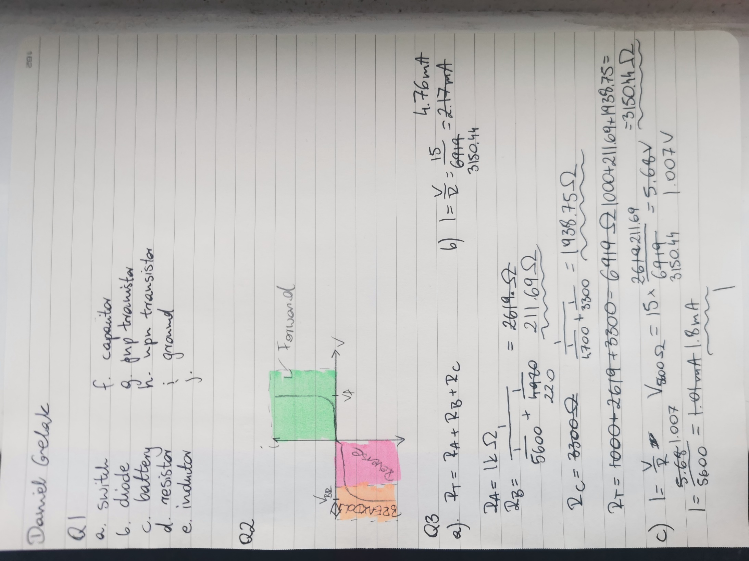
Sdsadda dsa dadafdsdfs fdsfdsfsd fsdfsdfsdf fsdfdswfsdfsd fdsfdsfsaddfas fdsafsdafsd fjhsdkjfh jfhdskjhfkjsddhfjk foidhwsuioefhwiufh feoihfoiushfiuhsaio foijoiewrjhawouihfwapuio lefhjeoiuahwiuohfail flkjeswhfeiluahefiwaulh e;akljelkjfhaklwjehf Daniel Grelak Daniel Grelak Daniel Grelak



