Programme: MSc Public Health and Social Care in Practice
Module: Health Care System Organisation and Leadership
Module Code: LCHS7002

Assignment Title: Case Study Analysis Report
“A Systems Thinking Analysis of the Wrong-Patient Surgery Incident at Kota Medical College Hospital: Leadership, Clinical Governance and Patient Safety Improvement”
Lecturer: Dr Pascal Navelle

STUDENT NAME: SIKANDARBHAI RAMANI
STUDENT ID: 2541566
WORD COUNT: 5372

Table of Contents
1. Introduction 4
2. Main Body 5
2.1 Understanding the Incident through Systems Thinking 5
2.1.1 Overview of the Kota Medical College Hospital Incident 5
2.1.2 Systems Thinking Perspective on the Incident 6
2.1.3 Root Cause Analysis of the Adverse Event 8
2.2 Clinical Governance, Accountability and Patient Safety 11
2.2.1 Patient Journey and Safety Verification Failures 11
2.2.2 Clinical Governance and Organisational Accountability 12
2.2.3 Responsibility and Accountability within the Surgical System 15
2.3 Leadership for Patient Safety and Organisational Improvement 16
2.3.1 The Role of Leadership in Patient Safety 16
2.3.2 Leadership Theories Applied to the Kota Medical College Hospital Incident 16
2.3.3 Leadership Implications for Organisational Improvement 19
2.4 Organisational Learning, Patient Safety Culture and Continuous Quality Improvement 20
2.4.1 Organisational Learning Following Patient Safety Incidents 20
2.4.2 Developing a Positive Patient Safety Culture 20
2.4.3 Continuous Quality Improvement in Surgical Practice 21
2.4.4 Organisational Learning as the Foundation for Sustainable Improvement 23
3. Recommendations 24
4. Conclusion 28
References 29

List of Figures
Figure 1: Rich Picture of Kota Medical College Hospital incident 6
Figure 2: Systems Thinking Analysis of Kota Medical College Incident 7
Figure 3: Root Cause analysis of wrong patient incident 9
Figure 4: Surgical patient Journey and Safety verification pathway 12
Figure 5: Clinical Governance Framework for safe surgical care 14
Figure 6: Corrective and Preventive Action Framework 18
Figure 7: Monitoring and Evaluation Framework 22

List of Tables
Table 1: Root Cause Analysis Matrix 9
Table 2: Centralisation vs Decentralisation 14
Table 3: Responsibility and Accountability Matrix 15
Table 4: Leadership Theory Evaluation Matrix 18
Table 5: Recommendation Implementation Strategy 24

1. Introduction
According to WHO (2021), patient safety is a key concern in healthcare since clinical errors which can be prevented, may have severe repercussions on the results of the treatment, the trust of the population and organisational performance. Wrong-patient surgery is one of the most serious preventable adverse events. Such events reflect failures at the levels of identification, communication, leadership and governance systems can result in unnecessary patient harm as recommended by WHO (2009a). A report by NHS England (2019) provides evidence that to enhance patient safety, organisations need to comprehend the interrelationship between systems, rather than solely addressing each error.
In Kota Medical College Hospital, Rajasthan, an elderly man was incorrectly admitted to surgery because he raised his hand during the call-out of another person to be operated. The man was waiting when his son was under surgery and this led to an unwarranted surgical incision based on SCMP (2025). As per the reports of Singh (2025), the immediate error was procedural, but the incident was indicative of larger organisational vulnerabilities that pertained to communication, patient identification, verification practices, leadership oversight and clinical governance. Thus, the incident offers a feasible chance to critically review the interactions between organisational systems and clinical processes to affect patient safety outcomes in a complex healthcare setting as postulated by McNab, et al., (2020).
According to Ahmed, et al., (2024), Leadership and governance are equally significant since they determine the organisational environment that shapes the behaviour of the staff, their accountability, communication and ongoing quality improvement. Equally, clinical governance offers orderly supervision in the form of policies, surveillance, incident learning and quality assurance helping healthcare organisations to spot the threats before patients suffer any harm (NHS England, 2024). Thus, the report critically evaluates the incident in the Kota Medical College Hospital through the prism of systems thinking, clinical governance, leadership and patient safety and provides evidence-based recommendations to promote sustainable organisational learning and safer surgical practice.

2. Main Body

2.1 Understanding the Incident through Systems Thinking

2.1.1 Overview of the Kota Medical College Hospital Incident
The Kota Medical College Hospital, Rajasthan incident took place on 12 April 2025 after an elderly man waiting outside the operating theatre was mistakenly identified as a different patient who was to undergo a dialysis fistula procedure (SCMP, 2025). The man was then ushered into the operating theatre where healthcare professionals performed the anaesthesia and started the surgery without verifying his identity using the established verification processes as per Singh (2025). Further, according to the reports of SCMP (2025), this mistake was not noticed until the time the surgery of the targeted patient was completed. The family members then noticed that the elderly man was no longer present in the waiting area which is why they immediately started investigating the matter.
However, even though the event was caused by a wrong patient going through the surgical route, holding a single medical practitioner accountable would offer a partial explanation of how the unfavourable occurrence took place. In line with WHO (2009a), the organisational safety events unfolded in such a manner that multiple organisational safeguards simultaneously failed. This allowed communication errors, poor patient identification, poor verification practices and ineffective procedural adherence to occur without being interrupted. Therefore, to comprehend the incident, it is important to expand the scope of organisational interactions and find effective approaches that could help to avoid such negative experiences of clinical practice in the future (McNab et al., 2020).
Figure 1 shows that the incident was not confined to one clinical error but indicates the connections between patients, health care professionals, organisational systems, communication channels, leadership and governance. As proposed by McNab, et al., (2020), instead of showing single failures, the rich picture shows how two or more interrelated factors contributed to the negative incident. This further promotes a systems thinking viewpoint that reflects the examination of interplay across the healthcare system rather than specific performance.
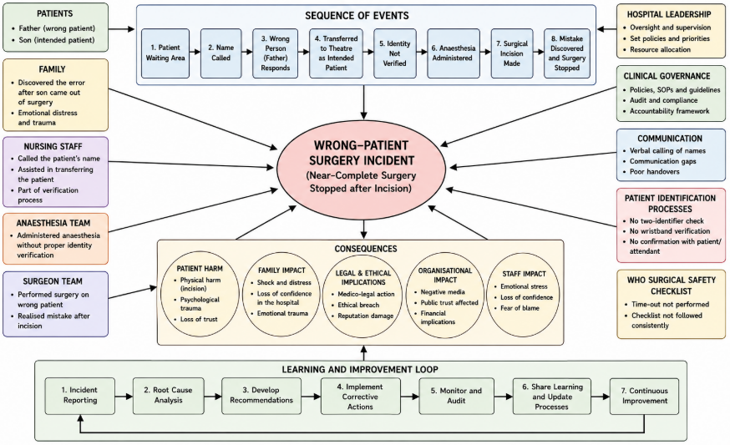
Figure 1: Rich Picture of Kota Medical College Hospital incident
(Source: By Author)

2.1.2 Systems Thinking Perspective on the Incident
McNab, et al., (2020) suggested that systems thinking views healthcare organisations as interrelated systems where leadership, governance, communication, workforce practices and clinical procedures have an interconnected impact on each other. Instead of defining patient safety outcomes by only looking at individual behaviours, this view admits that the results of patient safety are formed through organisational, professional and operational interactions.
Therefore, based on AHPSR (2009), adverse events need to be explored by looking at the interaction of the weaknesses of multiple organisational elements to form a situation where patients may suffer injuries. Diab, et al., (2025) also discovered that robust systems among healthcare professionals enhance identification of organisational risks before the occurrence of patient safety incidents.
Using this lens in analysing the Kota Medical College Hospital incident would show that the unnecessary surgery was caused by a combination of organisational failures rather than a single error. According to NHS England (2019), leadership alone cannot strengthen the practice of regular compliance with the procedures of patient safety. Therefore, the governance processes could not reveal the flaws in the practices of patient identification and verification prior to the onset of surgery.
Similarly, Riplinger, et al., (2020) highlighted that the healthcare professional communication did not interrupt the false patient route to enable assumptions to substitute for formal identity verification at various points of care. The interaction of these failures made the already existing safety barriers less effective and allowed the adverse event to go through the surgical system unnoticed in time, as WHO (2021) explains.
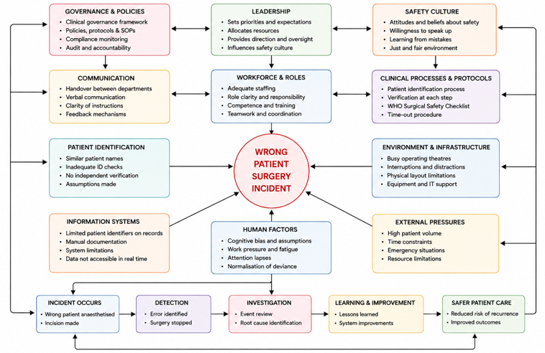
Figure 2: Systems Thinking Analysis of Kota Medical College Incident
(Source: By Author)
As shown in Figure 2, leadership, governance, communication, clinical procedures and organisational learning are interrelated elements, but not separate organisational functions. The interplay of these factors justifies how various vulnerabilities were compounded over the course of patient experience. In support of this McNab, et al., (2020) stated the fact that sustained patient safety gains cannot be obtained by single procedures that correct various processes independently of the others.

2.1.3 Root Cause Analysis of the Adverse Event
Root cause analysis offers a methodological, systematic way of establishing the underlying organisational environment that leads to patient safety events rather than focusing on the immediate clinical mistake as per WHO (2009a). In the Kota Medical College Hospital case, the wrong patient was taken into the operating theatre since several contributory factors did not occur independently but occurred in combination. The lack of strong patient identification practices provided the possibility to rely on verbal response rather than formal identity checking and poor communication minimised the possibility of healthcare professionals questioning assumptions during patient transfer (Harris, et al., 2020).
Other organisational weaknesses also enhanced the chances of the negative event. Pre-anaesthetic elements of the WHO Surgical Safety Checklist and other standard verification procedures were either not performed or ineffectively performed before anaesthesia and surgery started (Brown, et al., 2021). The lack of leadership control was also manifested since the standards of compliance with the procedure and patient safety were not always reinforced throughout the surgical pathway (Ahmed, et al., 2024). Moreover, organisational safety culture did not promote proactive identification and detection of unsafe processes early enough and did not allow procedural deviations to persist without any form of effective challenge (Finn, et al., 2024). Together, these interplaying forces indicate that the occurrence was indicative of a larger systems problem that needed organisational and not individual solutions.
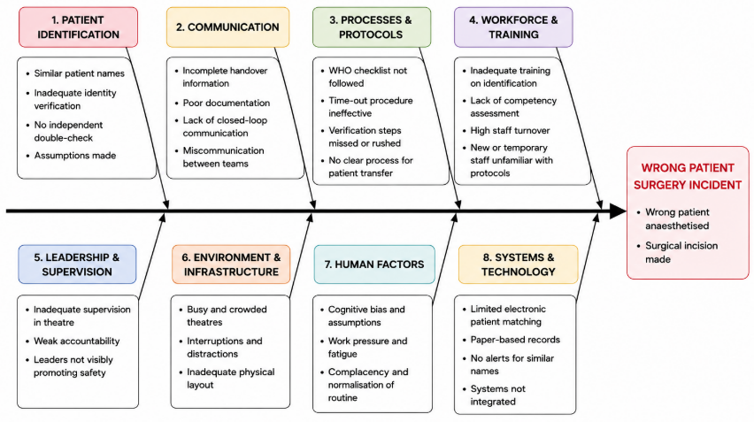
Figure 3: Root Cause analysis of wrong patient incident
(Source: By Author)
Figure 3 classifies the main contributory factors under the interrelated organisational categories as opposed to standalone errors. This visualisation supports the idea that patient identification, communication, leadership, governance, human factors and clinical processes are all interconnected and affected the adverse event (WHO, 2021).
Table 1: Root Cause Analysis Matrix
Root Cause Category | Evidence from the Kota Case | Organisational Impact | Systems Thinking Interpretation
Patient identification failure | Patient entered theatre after responding to a similar name without identity verification | Wrong patient selected for surgery | Failure of multiple verification barriers rather than an isolated error
Communication breakdown | Staff transferred the patient without confirming identity between departments | Loss of shared situational awareness | Poor information flow across interconnected clinical processes
Failure to follow verification procedures | WHO Surgical Safety Checklist and Time-Out process not completed effectively | Wrong patient underwent anaesthesia and incision | Standardised safety processes were bypassed
Human factors | Assumptions based on similar patient names and routine workflow | Increased likelihood of cognitive error | Human performance is shaped by system conditions
Leadership oversight | Insufficient supervision of patient transfer and theatre preparation | Weak safety accountability | Leadership failed to reinforce compliance with safety standards
Clinical governance failure | Lack of monitoring and enforcement of patient safety procedures | Breakdown of organisational controls | Governance systems failed to detect procedural non-compliance
Organisational safety culture | Routine practices appeared to override formal safety protocols | Unsafe practices became normalised | Safety culture influences behaviour across the whole system
Table 1 expands upon the Fishbone Diagram, critically incorporating each contributory factor with its organisational implications and systems thinking explanation. The matrix illustrates that the harm to the patient was caused by the interplay of the weaknesses in leadership, governance, communication, patient identification and adherence to procedures rather than a single clinical failure. This systematic review underpins the necessity of organisation-wide enhancement that would reinforce several safety barriers at once, resulting in a more robust healthcare system that could avoid similar negative events as McNab et al. (2020) describe.

2.2 Clinical Governance, Accountability and Patient Safety

2.2.1 Patient Journey and Safety Verification Failures
Patient identification and verification are core patient safety steps since all steps of the surgical pathway are expected to verify that the right patient is receiving the appropriate procedure (WHO, 2009a). According to Riplinger, et al., (2020), the types of verification activities are aimed at reducing the number of avoidable harms by making sure that patient identity is consistently verified prior to transfer, anaesthesia, and surgery. The surgical pathway therefore serves as a chain of related safety measures where every verification step ought to spot possible errors before they lead to patient harm (WHO, 2021).
In the case of the Kota Medical College Hospital, these verification measures failed in several instances due to the elderly man entering the surgery pathway after giving a response to a patient's name, just like that of his son (SCMP, 2025). Rather than confirming patient identity using the established procedures independently, healthcare professionals were left to make assumptions, which were not challenged during the entire process of patient transfer and preparation of the theatre (Singh, 2025).
Lack of verification prior to anaesthesia and surgical incision indicates that procedural safeguards were not consistently applied even though they are recognised as having a role in safe surgical practice (Brown, et al., 2021). It was reported that evidence of preventable operating room ‘never events’ typically accumulate when multiple verification failures coincide, supporting the idea that multiple independent patient safety checks should be performed prior to surgery (Arad, et al., 2023). Thus, the adverse event portrays a malfunction throughout the entire patient experience as opposed to failure at a single stage of clinical care (Harris, et al., 2020).
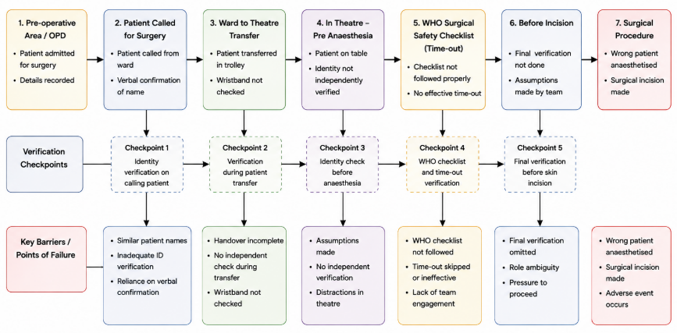
Figure 4: Surgical patient Journey and Safety verification pathway
(Source: By Author)
As Figure 4 illustrates, there were multiple verification opportunities prior to the start of surgery, but none of them stopped the wrong patient pathway. Instead of reflecting individual procedural oversights, the figure shows the manner in which the vulnerabilities have built up during patient transfer, identity confirmation, anaesthetic preparation and surgical verification. This affirms the need to have good safety barriers at all levels of the surgical journey (WHO, 2009a).

2.2.2 Clinical Governance and Organisational Accountability
Clinical governance offers the organisational structure by which healthcare organisations sustain quality, enhance patient safety, and stimulate continuous learning by creating explicit systems of responsibility (NHS England, 2019). Proper governance involves more than policy development since it should be monitored regularly, with leadership support, incident reporting and staff involved to make sure that the safety procedures are still ingrained in the daily clinical practice (Drew and Pandit, 2020). Therefore, governance is expected to design an environment in which patient identification, communication and verification procedures are regularly checked prior to the emergence of flaws into serious adverse events (WHO, 2021). Challinor, et al., (2025) also stated that systems thinking describes patient safety events better because it acknowledges healthcare organisations as complex adaptive systems.
The Kota Medical College Hospital case shows that the governance mechanisms failed to stop the deviation of the procedures in spite of the numerous opportunities to exercise organisational control (NHS England, 2024). The processes of verification were not always supported, and the supervision of the leadership and regular monitoring of compliance did not seem adequate to highlight the unsafe practices prior to the start of the surgery (Ahmed, et al., 2024) noted. Gqaleni and Mkhize (2024) noted that such weaknesses imply governance should be considered an active organisational function supporting frontline practice rather than merely a collection of written policies.
Figure 5 illustrates that successful clinical governance requires ongoing interactions between leadership, patient safety, risk management, incident reporting and quality improvement. All these organisational elements enhance the overall strength of the clinical practice by aiding in proactive, not reactive, investigation of patient harm after it has happened. This framework thus emphasises governance as a continuous organisational effort rather than a single administrative practice (NHS England, 2024).
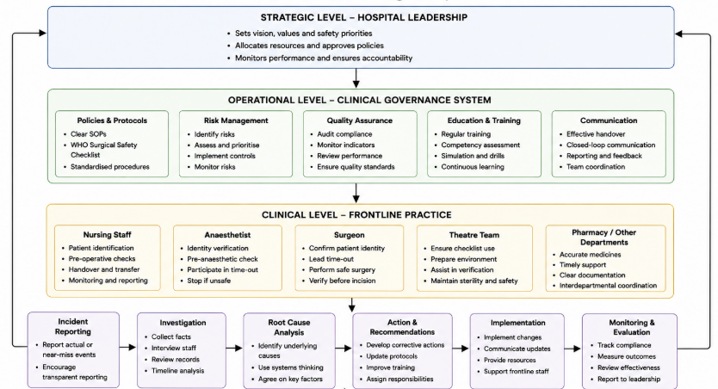
Figure 5: Clinical Governance Framework for safe surgical care
(Source: By Author)
Table 2: Centralisation vs Decentralisation
Dimension | Centralised | Decentralised | Preferred Approach
Decision-making | Standardised | Flexible | Balanced
Accountability | Organisational | Shared | Shared accountability
Communication | Structured | Collaborative | Integrated
Risk Management | Organisation-wide | Local | Combined
Patient Safety | Consistent standards | Staff ownership | Hybrid model
Table 2 indicates that neither fully centralised nor fully decentralised governance is in itself the best in terms of patient safety. Rather, integrating organisational control with local clinical accountability promotes similar safety standards and gives healthcare professionals enough flexibility in their responses to complex surgical settings (Carstensen, et al., 2023).

2.2.3 Responsibility and Accountability within the Surgical System
Patient safety as a responsibility should be shared throughout all professionals involved in the surgical pathway since each role can help to ensure the effective verification and communication processes are in place (WHO, 2021). Nurses, surgeons, anaesthetists, theatre coordinators and organisational leaders are supposed to play specific roles independently and promote multidisciplinary efforts to avert preventable harm to patients (Palweni, et al., 2023). As the Kota incident shows, accountability became divided due to multiple professional obligations not being challenged or interrupted effectively, which allowed the wrong patient to go through several steps of surgical care (Martins, et al., 2024).
Table 3: Responsibility and Accountability Matrix
Stakeholder | Key Responsibility | Improvement Required
Ward Nurse | Verify patient identity | Two-person verification
Operation Theatre Nurse | Confirm identity before theatre | Independent verification
Anaesthetist | Verify identity before induction | Mandatory confirmation
Surgeon | Lead WHO Time-Out | Checklist compliance
Theatre Coordinator | Coordinate patient transfer | Standardised transfer protocol
Governance Team | Monitor compliance | Routine safety audits
Hospital Leadership | Promote safety culture | Leadership development
Table 3 shows that the role of patient safety is not confined to a single professional group, but shared by a number of professional groups. The matrix repeats the need to have proper accountability, which must be coordinated, independently verified and communication maintained throughout the surgical pathway. Enhancement of these shared responsibilities would minimise chances of such negative occurrences and introduce a more robust organisational safety culture (Finn, et al., 2024). Vikan, et al., (2024) discovered that well-identified multidisciplinary roles and communication reinforce safe surgical teamwork and minimise chances of avoidable patient injury.

2.3 Leadership for Patient Safety and Organisational Improvement

2.3.1 The Role of Leadership in Patient Safety
The issue of effective leadership is a key organisational need since leaders determine the behaviour of communication, accountability, teamwork, and safety that directly impact patient care (Ahmed, et al., 2024). As Drew and Pandit (2020) stated, leadership goes beyond operational management to provide organisational settings in which healthcare professionals are always concerned with patient safety and quality improvement. Therefore, the leadership must develop clear expectations, uphold clinical standards, and motivate employees to report safety issues prior to avoidable harm (NHS England, 2019).
The situation in Kota Medical College Hospital shows that leadership affects organisational performance because a lack of supervision and reinforcement of verification procedures minimised the chances of preventing the adverse event (SCMP, 2025). Instead of looking at the incident as a single procedural error, the leadership must be appreciated as an organisational force influencing staff decision-making, procedural compliance, and multidisciplinary communication along the surgical pathway (Althobaiti, 2026). Consequently, better leadership would have encouraged more accountability and enhanced a consistent practice of patient identification before surgery (WHO, 2021). Kristensen, et al., (2016) showed that visible leadership enhances patient safety culture by fortifying organisational expectations and assisting in ongoing staff engagement.

2.3.2 Leadership Theories Applied to the Kota Medical College Hospital Incident
Transformational leadership helps healthcare workers come together to develop a collective obligation to patient safety through organisational learning, staff motivation, and continuous improvement (Ree, 2020). According to the evidence provided by Pfaff and Braithwaite (2020), transformational leaders can promote the safety culture through fostering collaboration, trust, and collective responsibility rather than solely based on procedural compliance. Use of such a leadership style in the Kota incident implies that more organisational commitment to patient safety might have supported the verification practices before patient transfer and surgery (Althobaiti, 2026).
The distributed leadership issue is another way to see patient safety responsibility since it should not be limited to the senior management within multidisciplinary healthcare teams but instead spread among all healthcare workers (Carstensen, et al., 2023). Independently, nurses, surgeons, anaesthetists, and theatre coordinators are supposed to make contributions towards patient verification and shared accountability for safe surgical practice (Palweni, et al., 2023). The Kota incident shows that disjointed efforts and poor collaboration minimised the chances of healthcare professionals detecting and questioning the wrong patient route to surgery (Martins, et al., 2024).
Behavioural leadership is an addition to these styles since leaders enhance patient safety by acting as role models, overseeing normal practice, and enforcing organisational norms (Lyons, et al., 2020). Instead of expecting that the procedures will be observed, behavioural leaders constantly observe the practice and give constructive feedback that reinforces adherence to patient safety requirements (Ahmed, et al., 2024). These leadership behaviours would have strengthened compliance with patient identification processes prior to the patient going to the operating theatre (Brown, et al., 2021).
Situational leadership and democratic leadership are also a path to safer healthcare due to the complexity of the clinical setting that demands open communication, involvement of the staff, and adaptability of the decision-making process (Singh, et al., 2024). Democratic leadership promotes doubt in uncertain conditions among healthcare professionals, whereas situational leadership helps leaders offer different supervision to clinical conditions as they vary (Carstensen, et al., 2023). Using these complementary interventions in the Kota incident implies that more robust communication and adaptive leadership could have broken the chain of failures in verification before the surgery could begin (Lyons, et al., 2020).
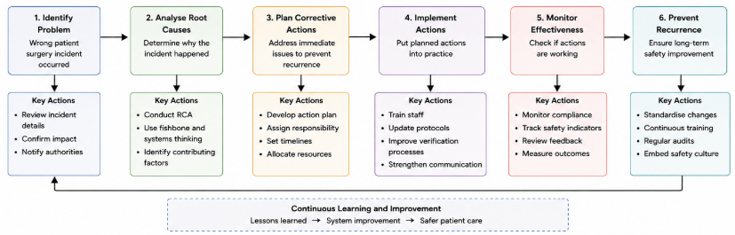
Figure 6: Corrective and Preventive Action Framework
(Source: By Author)
Figure 6 proves that successful leadership in patient safety requires the ability to incorporate the complementary leadership strategies rather than stick to a single theoretical viewpoint. The framework demonstrates that transformational, distributed, behavioural, democratic and situational leadership help to reinforce communication, accountability, teamwork and organisational learning. This combined strategy supports safer clinical practice through which various leadership behaviours challenge various organisational challenges across the patient safety system (Ahmed, et al., 2024).
Table 4: Leadership Theory Evaluation Matrix
Leadership Theory | Application to the Case | Overall Relevance
Transformational | Develops proactive safety culture | High
Distributed | Shared responsibility across teams | High
Democratic | Encourages speaking up | Moderate–High
Behavioural | Reinforces safe practices | High
Situational | Adapts leadership to clinical context | Moderate–High
Table 4 will provide a comparison of various theories of leadership applied to the Kota Medical College Hospital incident, comparing their applicability to real-life situations to avoid such negative outcomes. Despite the benefits of all leadership approaches to organisations, transformational and distributed leadership have more potential as they can reinforce organisational culture, shared accountability, and multidisciplinary collaboration at the same time (Carstensen, et al., 2023). Therefore, according to the claims of Spanos, et al., (2024) healthcare leaders must acquire adaptive leadership skills that can adequately react to intricate organisational problems and threats to patient safety.

2.3.3 Leadership Implications for Organisational Improvement
As the analysis of leadership shows, the prevention of wrong-patient surgery should be organised at the highest level of organisational leadership, which is not limited to overseeing the daily clinical processes (WHO, 2021). According to NHS England (2024), effective leaders must constantly reinforce the patient safety culture, track compliance with the procedures, promote multidisciplinary communication, and facilitate organisational learning following adverse events.
The NHS (2023) Leadership Evidence Brief also recognises leadership capability as a vital organisational aspect in fostering sustainable quality improvement and safer patient care. Thus, leadership must be used together with governance and systems thinking to establish resilient healthcare organisations that can detect risks in the early stages, avoid procedural failures, and maintain perpetual quality improvement (Ahmed, et al., 2024).

2.4 Organisational Learning, Patient Safety Culture and Continuous Quality Improvement

2.4.1 Organisational Learning Following Patient Safety Incidents
According to WHO (2021), organisational learning helps healthcare organisations to consolidate patient safety by methodically investigating adverse events, finding contributory factors and establishing long-term improvements. Instead of perceiving incidents as clinical failures, learning organisations explore systems in organisations, relationships among staff and procedural flaws to avoid the occurrence of similar events in future (McNab, et al., 2020). Therefore, patient safety incidents can be turned into a chance to enhance governance, leadership, communication and clinical practice through effective organisational learning based on AHPSR (2009).
The Kota Medical College Hospital incident is a good example of why learning should not be limited to the attribution of individual responsibility since multiple organisational failures interacted before patient injury (SCMP, 2025). It would not be enough to focus on frontline staff only, since weaknesses related to the process of patient identification, leadership, governance, communication and verification which all led to the occurrence of the adverse event, would be overlooked (WHO, 2009a). Thus, organisational learning would analyse short-term failure in procedures and long-term system conditions and then formulate long-term improvement plans taking in consideration the Patient Safety Incident Response Framework (PSIRF) (NHS England, 2024). Dresti (2025) stressed that organisational learning should be a priority in the process of effective investigations within the framework of the PSIRF instead of individual blame.

2.4.2 Developing a Positive Patient Safety Culture
The culture of patient safety affects the communication methods used by healthcare professionals, the ways of reporting concerns and adhering to the organisation's procedures due to the shared values influencing the everyday clinical behaviour (Finn, et al., 2024). Sexton, et al., (2017) emphasised that positive safety cultures empower the staff to question unsafe environments, talk about mistakes and engage in organisational learning without fear of being blamed. Ahmed, et al., (2024) highlighted that these behaviours make organisations more resilient as possible risks are identified sooner and corrective action is taken before patient harm sets in. Curry, et al., (2017) showed that the positive effects of enhancing organisational culture by leadership and staff engagement are long-term benefits in clinical performance and patient safety. Nwosu, et al., (2022) in support discovered that positive operating room safety culture supports efficient collaboration, communication, and compliance to patient safety measures in surgical care.
Using these principles, in the Kota incident implies that an enhanced patient safety culture would have influenced healthcare professionals to challenge patient identity prior to surgery being commenced (Singh, 2025). Aaberg, et al., (2021) illustrated that more and better opportunities to stop the wrong patient pathway can be offered to the staff in the form of open communication, psychological safety and multidisciplinary collaboration, before anaesthesia and surgical intervention. This means that the enhancement of the patient safety culture is an organisational imperative and not the duty of an individual professional (WHO, 2021). An additional finding by Hesgrove, et al., (2024) was that stronger workplace safety cultures positively correlate with patient safety culture in a hospital environment.

2.4.3 Continuous Quality Improvement in Surgical Practice
According to Drew and Pandit (2020), constant quality improvement enhances performance in healthcare by establishing systematic procedures that observe clinical practice, assess patient safety outcomes and instigate evidence-based organisational changes. In contrast to single corrective measures, continuous improvement involves frequent auditing, involvement of staff, leadership dedication and continued assessment. Gillespie, et al., (2018), suggested that changes implemented continue to be functional during clinical practice. These values prompt healthcare organisations to work towards enhancing patient safety by constantly monitoring it instead of responding to severe events when they have taken place (Brown, et al., 2021).
In the Kota Medical College Hospital case, continuous quality improvement would facilitate frequent patient identification procedure audits, multidisciplinary communication and following the WHO Surgical Safety Checklist (Harris, et al., 2020). Regular surveillance of these safety procedures would allow organisational leaders to detect procedural flaws at a younger age.
Lalani, et al., (2023) proposed that organisational strategies integrated enhance patient safety by enhancing coordination, communication, as well as shared accountability within healthcare services. Dhamanti, et al., (2025) highlighted that such practices ensure and strengthen regular compliance with evidence-based surgical practice. Quality improvement, thus, must be a continual organisational endeavour that promotes safer patient outcomes based on the constant assessment and adjustment (WHO, 2021).
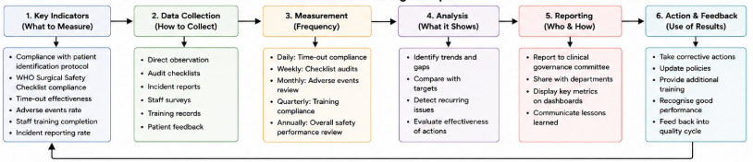
Figure 7: Monitoring and Evaluation Framework
(Source: By Author)
Figure 7 demonstrates that the improvement of patient safety is based on an ongoing organisational cycle and not on a single investigation after an adverse event. The functions of incident reporting, root cause analysis, implementation, monitoring, organisational learning and quality improvement are all interrelated processes that can be strengthened collectively to improve healthcare systems. This cyclical methodology makes sure that lessons learned from one incident are carried across into long-term organisational changes that can avert future patient safety failures (NHS England, 2024).

2.4.4 Organisational Learning as the Foundation for Sustainable Improvement
According to the evidence presented by Gqaleni and Mkhize (2024), to achieve sustainable patient safety improvements, healthcare organisations need to prioritise learning outcomes in governance, leadership, education and regular clinical monitoring. Likewise, ongoing organisational reflection enhances resilience in healthcare since the lessons of negative events are inculcated into the policies, staffing and daily clinical care (WHO, 2021). Hence, the incident at the Kota Medical College Hospital can be regarded as a chance to enhance organisational systems by persistently learning, bettering patient safety culture and quality improvements.

3. Recommendations
The evaluation proved that the incident in the Kota Medical College Hospital was caused by the interplay of organisational weaknesses and not a single clinical error. As suggested by the frameworks of WHO (2021), it should be improved at the levels of leadership, governance, communication, patient identification and organisational learning. As a result, the recommendations below are aimed at enhancing organisational frameworks that promote safer surgery and minimise the chances of similar patient safety events as recommended by the (NHS England, 2024).
Table 5: Recommendation Implementation Strategy
Recommendation | Responsible Stakeholder | Key Implementation Actions | Resources Required | Success Indicator (KPI) | Expected Outcome
Strengthen patient identification | Clinical Governance Team | Introduce mandatory two-person verification at all transfer stages | Staff training and revised SOPs | 100% identity verification compliance | Elimination of wrong-patient identification events
Improve WHO Surgical Safety Checklist compliance | Theatre Manager | Mandatory Time-Out before anaesthesia and incision with regular audits | Checklist training and audit tools | >95% checklist compliance | Reduced surgical safety incidents
Implement digital patient verification | Hospital Management and IT Department | Introduce barcode or electronic wristband verification | IT infrastructure and equipment | Reduction in patient identification errors | Improved patient traceability
Leadership development programme | Hospital Executive Team | Leadership training focused on patient safety and safety culture | Leadership workshops | Improvement in staff safety culture scores | Stronger organisational safety leadership
Multidisciplinary simulation training | Department Heads | Regular TeamSTEPPS-based simulation exercises | Facilitators and protected training time | Improved teamwork and communication measures | Enhanced interprofessional collaboration
Governance audit and organisational learning | Clinical Governance Committee | Quarterly safety audits, incident reviews and feedback cycles | Audit team and reporting systems | Audit compliance >90% and implementation of action plans | Continuous organisational learning and sustained patient safety improvement
Table 5 shows that improvement of patient safety in the long term is sustainable only with the involvement of organisational leadership, front-line healthcare professionals and clinical governance teams and not with single changes in procedures. All the recommendations endorse specific organisational functions and all of them reinforce patient identification, communication, governance, leadership and continuous organisational learning. McNab, et al., (2020) highlighted that an integrated implementation approach indicates a systems thinking viewpoint that is cultivated throughout the report.
Riplinger, et al., (2020) in their study pointed out that the priority at the organisational level should be to strengthen the process of patient identification, as the negative event started when the wrong patient completed several stages without the successful verification of his/her identity. The implementation of two-person identity checks in advance of patient transfer, anaesthesia and surgery would enhance the current safety measures and minimise the use of verbal confirmation and personal opinion based on individual assessment (Rajurkar, et al., 2024). Sohn, et al., (2020) also revealed that biometric patient identification technologies offer an extra layer of verification, which can help to minimise wrong-patient procedures in high-risk clinical settings.
Regular use of the WHO Surgical Safety Checklist must also be strengthened since standardised verification will decrease wrong-patient surgery by enhancing multidisciplinary communication and adherence to the procedure (WHO, 2009a). The WHO (2009b) guidance also suggests structured implementation resources that would help to ensure a consistent application of the Surgical Safety Checklist in healthcare organisations.
Checklist implementation must be backed by routine audits, direct observation and constructive feedback so that verification activities become meaningful patient safety practices and not administrative exercises as (Brown, et al., 2021). Krstulović, et al., (2025) emphasised that the implementation requires not only the availability of checklists but also the need to address organisational obstacles, the involvement of the staff, and regular monitoring.
According to Lyons, et al., (2020), healthcare leaders need to invest in structured leadership development programmes that enhance patient safety culture, multidisciplinary collaboration and organisational accountability. Transformational and distributed leadership should be a special focus of leadership education since these styles promote shared accountability, free communication and ongoing organisational learning across complicated surgical settings (Carstensen, et al., 2023).
According to Aaberg, et al., (2021), multidisciplinary simulation training to improve communication, teamwork and clinical decision-making should be performed regularly and enable healthcare professionals to rehearse patient identification, surgical verification and emergency responses in realistic clinical settings. Simulation learning assists organisations to detect flaws in procedures in advance and enhance the confidence of staff ahead of the onset of patient safety risks in daily clinical practice (Dhamanti, et al., 2025).
Lastly, healthcare organisations ought to develop ongoing governance audits to track patient identification, adherence to procedures, reporting of incidents and taking of corrective measures (Gqaleni and Mkhize, 2024). Ongoing observation will make sure that organisational learning is integrated into daily clinical practice and it promotes long-term gains that have the potential to stop similar negative events in the entire healthcare system.

4. Conclusion
As the analysis shows, the Kota Medical College Hospital incident was caused by intertwined organisational failures and not a single clinical error. The use of systems thinking revealed that leadership, communication, governance, patient identification, and procedural compliance weaknesses were all involved in the adverse event. This viewpoint emphasised the significance of studying the interrelationship among the organisational systems rather than assigning blame to the individual healthcare professionals.
The assessment also showed that effective clinical governance, leadership, positive patient safety culture, and organisational learning are key organisational capabilities to prevent the occurrence of similar incidents. Enhancing these aspects that are interrelated would enhance accountability, strengthen evidence-based surgical practices, and promote multidisciplinary cooperation along the patient journey. Moreover, the given recommendations offer viable organisational strategies that assist in improving quality in a sustainable manner and reinforce patient safety in complicated healthcare settings. On the whole, it can be concluded that to avoid wrong-patient surgery, the work of organisations should be organised to improve as a whole instead of changing only certain procedures since resilient healthcare systems rely on continuous learning where the leaders carefully follow the best practices in patient safety.

References
Aaberg, O.R., Hall-Lord, M.L., Husebø, S.I.E. and Ballangrud, R. (2021) A human factors intervention in a hospital - evaluating the outcome of a TeamSTEPPS program in a surgical ward. BMC Health Services Research, 21(1).
Ahmed, Z., Ellahham, S., Soomro, M., Shams, S. and Latif, K. (2024) Exploring the impact of compassion and leadership on patient safety and quality in healthcare systems: A narrative review. BMJ Open Quality, 13(2), pp.1–7.
AHPSR (2009) Systems thinking for health systems strengthening. [Online] ahpsr.who.int. Available at: https://ahpsr.who.int/publications/i/item/2009-11-13-systems-thinking-for-health-systems-strengthening [Accessed on: 4th August 2026].
Althobaiti, F.M. (2026) The effects of leadership on patient safety culture in health care: A systematic review. BMC nursing, 25(125).
Arad, D., Rosenfeld, A. and Magnezi, R. (2023) Factors contributing to preventing operating room “never events”: A machine learning analysis. Patient Safety in Surgery, 17(1).
Brown, B., Bermingham, S., Vermeulen, M., Jennings, B., Adamek, K., Markou, M., Bassham, J.E. and Hibbert, P. (2021) Surgical safety checklist audits may be misleading! Improving the implementation and adherence of the surgical safety checklist: A quality improvement project. BMJ Open Quality, 10(4), p.e001593.
Carstensen, K., Kjeldsen, A.M. and Nielsen, C. (2023) Distributed leadership in health quality improvement collaboratives. Health Care Management Review, 49(1), pp.46–58.
Challinor, A., Bifarin, O., Khedmati Morasae, E., Saini, P., Berzins, K. and Nathan, R. (2025) Systems thinking in mental health patient safety: A narrative review of complex adaptive systems. Journal of Evaluation in Clinical Practice, 31(4).
Curry, L.A., Brault, M.A., Linnander, E.L., McNatt, Z., Brewster, A.L., Cherlin, E., Flieger, S.P., Ting, H.H. and Bradley, E.H. (2017) Influencing organisational culture to improve hospital performance in care of patients with acute myocardial infarction: A mixed-methods intervention study. BMJ Quality & Safety, 27(3), pp.207–217.
Dhamanti, I., Pratiwi, I.N., Miftahussurur, M., Sholikhah, V.H. and Yakub, F. (2025) Surgical team perceptions of the surgical safety checklist implementation in Indonesian hospitals: A descriptive qualitative study. BMJ Open, 15(6), p.e089013.
Diab, A., Ragab, R. and Abdelwahab, A. (2025) Exploring the hidden synergy between system thinking and patient safety competencies among critical care nurses: A cross-sectional study. BMC Nursing, 24(1).
Dresti, S. (2025) Investigating under the patient safety incident response framework (PSIRF): Sharing HSSIB learning for future development. [Online] HSSIB. Available at: https://www.hssib.org.uk/patient-safety-investigations/investigating-under-the-patient-safety-incident-response-framework-psirf-sharing-hssib-learning-for-future-development/investigation-report/ [Accessed on: 4th August 2026].
Drew, J.R. and Pandit, M. (2020) Why healthcare leadership should embrace quality improvement. BMJ, 368(368).
Finn, M., Walsh, A., Rafter, N., Mellon, L., Chong, H.Y., Naji, A., O’Brien, N., Williams, D.J. and McCarthy, S.E. (2024) Effect of interventions to improve safety culture on healthcare workers in hospital settings: A systematic review of the international literature. BMJ Open Quality, 13(2), p.e002506.
Gillespie, B.M., Harbeck, E.L., Lavin, J., Hamilton, K., Gardiner, T., Withers, T.K. and Marshall, A.P. (2018) Evaluation of a patient safety programme on surgical safety checklist compliance: A prospective longitudinal study. BMJ Open Quality, 7(3), p.e000362.
Gqaleni, T.M.H. and Mkhize, S.W. (2024) Barriers to implementing patient safety incident reporting and learning guidelines in specialised care units, KwaZulu-Natal: A qualitative study. PLOS ONE, 19(3), p.e0289857.
Harris, K., Søfteland, E., Moi, A.L., Harthug, S., Storesund, A., Jesuthasan, S., Sevdalis, N. and Haugen, A.S. (2020) Patients’ and healthcare workers’ recommendations for a surgical patient safety checklist – A qualitative study. BMC Health Services Research, 20(1).
Hesgrove, B., Zebrak, K., Yount, N., Sorra, J. and Ginsberg, C. (2024) Associations between patient safety culture and workplace safety culture in hospital settings. BMC Health Services Research, 24(1).
Kristensen, S., Christensen, K.B., Jaquet, A., Møller Beck, C., Sabroe, S., Bartels, P. and Mainz, J. (2016) Strengthening leadership as a catalyst for enhanced patient safety culture: A repeated cross-sectional experimental study. BMJ Open, 6(5), p.e010180.
Krstulović, J., Ursić, L., Hrgović, Z., Šuljić, N., Roje, R., Znaor, L. and Marusic, A. (2025) Barriers and facilitators for implementing who’s surgical safety checklist in a publicly funded hospital: A qualitative study from a tertiary-level public hospital in Croatia. BMJ Open, 15(6), pp.e095155-e095155.
Lalani, M., Wytrykowski, S. and Hogan, H. (2023) Approaches to improving patient safety in integrated care: A scoping review. BMJ Open, 13(4).
Lyons, O., George, R., Galante, J.R., Mafi, A., Fordwoh, T., Frich, J. and Geerts, J.M. (2020) Evidence-based medical leadership development: A systematic review. BMJ Leader, 5(3), pp.leader-2020–000360.
Martins, N.R.S., Martinez, E.Z., Simões, C.M., Barach, P.R. and Carmona, M.J.C. (2024) Analyzing and mitigating the risks of patient harm during operating room to intensive care unit patient handoffs. International Journal for Quality in Health Care, 37(1).
McNab, D., McKay, J., Shorrock, S., Luty, S. and Bowie, P. (2020) Development and application of ‘systems thinking’ principles for quality improvement. BMJ Open Quality, 9(1), p.e000714.
NHS (2023) Evidence brief: Leadership contents. [Online] https://www.england.nhs.uk/. . Available at: https://www.ewin.nhs.uk/sites/default/files/Leadership%20Evidence%20Brief.pdf [Accessed on: 4th August 2026].
NHS England (2019) The NHS patient safety strategy. [Online] NHS England. NHS England. Available at: https://www.england.nhs.uk/patient-safety/the-nhs-patient-safety-strategy/ [Accessed on: 4th August 2026].
NHS England (2024) Patient safety incident response framework. [Online] www.england.nhs.uk. Available at: https://www.england.nhs.uk/long-read/patient-safety-incident-response-framework/ [Accessed on: 4th August 2026].
Nwosu, A.D.G., Ossai, E., Ahaotu, F., Onwuasoigwe, O., Amucheazi, A. and Akhideno, I. (2022) Patient safety culture in the operating room: A cross-sectional study using the hospital survey on patient safety culture (HSOPSC) instrument. BMC Health Services Research, 22(1).
Palweni, V.S., Malasela, J.M. and Randa, M.B. (2023) Nurse managers’ leadership styles as an impetus to patient safety in an academic hospital. Health Sa Gesondheid, 28(28).
Pfaff, H. and Braithwaite, J. (2020) A parsonian approach to patient safety: Transformational leadership and social capital as preconditions for clinical risk management—The GI factor. International Journal of Environmental Research and Public Health, 17(11), p.3989.
Rajurkar, S., Verma, T., Mishra, S.P. and Bhatt, M. (2024) Novel artificial intelligence tool for real-time patient identification to prevent misidentification in health care. Journal of Medical Physics, 49(1), pp.41–48.
Ree, E. (2020) What is the role of transformational leadership, work environment and patient safety culture for person‐centred care? A cross‐sectional study in Norwegian nursing homes and home care services. Nursing Open, 7(6), pp.1988–1996.
Riplinger, L., Jiménez, J.P. and Dooling, J.P. (2020) Patient identification techniques – approaches, implications, and findings. Yearbook of Medical Informatics, 29(1), pp.81–86.
SCMP (2025) Indian hospital probed after man mistakenly operated on while waiting on son’s surgery. [Online] South China Morning Post. Available at: https://www.scmp.com/week-asia/health-environment/article/3307457/indian-hospital-probed-after-man-mistakenly-operated-while-waiting-sons-surgery [Accessed on: 4th August 2026].
Sexton, J.B., Adair, K.C., Leonard, M.W., Frankel, T.C., Proulx, J., Watson, S.R., Magnus, B., Bogan, B., Jamal, M., Schwendimann, R. and Frankel, A.S. (2017) Providing feedback following leadership WalkRounds is associated with better patient safety culture, higher employee engagement and lower burnout. BMJ Quality & Safety, 27(4), pp.261–270.
Singh, H.K. (2025) Tale of 2 “jagdishes”: Hospital mix-up could have led to unwanted surgery. [Online] www.ndtv.com. Available at: https://www.ndtv.com/india-news/kota-medical-college-tale-of-2-jagdishes-hospital-mix-up-could-have-led-to-unwanted-surgery-8187530 [Accessed on: 4th August 2026].
Singh, P., Singh, S., Kumari, V. and Tiwari, M. (2024) Navigating healthcare leadership: Theories, challenges, and practical insights for the future. Journal of Postgraduate Medicine, 70(4), pp.232–241.
Sohn, J.W., Kim, H., Park, S.B., Lee, S., Monroe, J.I., Malone, T.B., Kinsella, T., Yao, M., Kunos, C., Lo, S.S., Shenk, R. and Machtay, M. (2020) Clinical study of using biometrics to identify patient and procedure. Frontiers in Oncology, 10(586232), p.586232.
Spanos, S., Leask, E., Patel, R., Datyner, M., Loh, E. and Braithwaite, J. (2024) Healthcare leaders navigating complexity: A scoping review of key trends in future roles and competencies. BMC Medical Education, 24(1).
Vikan, M., Deilkås, E.CT., Valeberg, B.T., Bjørnnes, A.K., Husby, V.S., Haugen, A.S. and Danielsen, S.O. (2024) The anatomy of safe surgical teams: An interview-based qualitative study among members of surgical teams at tertiary referral hospitals in Norway. Patient Safety in Surgery, 18(1).
WHO (2009a) Implementation manual WHO surgical safety checklist 2009. [Online] www.who.int. Available at: https://www.who.int/publications/i/item/9789241598590 [Accessed on: 4th August 2026].
WHO (2009b) Tool and Resources: WHO Surgical Safety Checklist. [Online] Who.int. Available at: https://www.who.int/teams/integrated-health-services/quality-of-care-and-patient-safety/patient-safety-guidance-and-tools/safe-surgery/tool-and-resources [Accessed on: 4th August 2026].
WHO (2021) Global patient safety action plan 2021-2030. [Online] www.who.int. Available at: https://www.who.int/publications/i/item/9789240032705 [Accessed on: 4th August 2026].

