  Component One: Student Journal (learning log) 750 words +/- 10%  Contribution to Overall Module Assessment: 25% | Student No: | GEORGE ANDREI CODRIANU
 | Module Title: | HOTEL ADMINISTRATION. FRONT DESK OPERATIONS
 | Module Code: | BMIH4004
 | Lecturer: | Daniel Payne
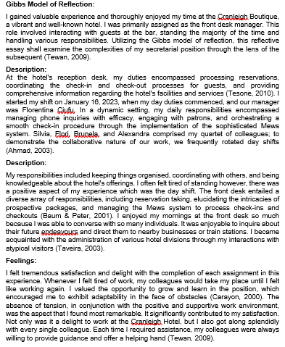

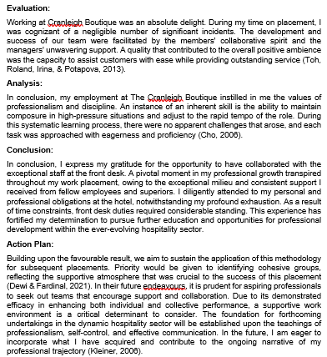

Component Two
Contribution to Overall Module Assessment: 25%
Trip Advisor Review Response 150 words +/-10%

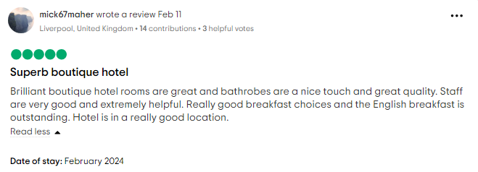
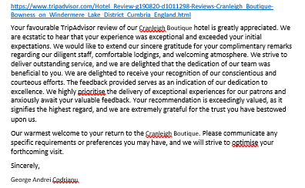

Screen shot of referenced Trip Advisor review used:
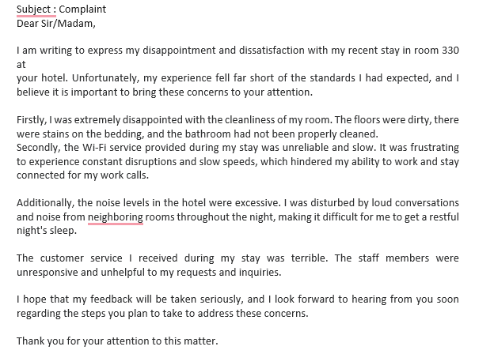
Letter of complaint response 500 words +/- 1-%
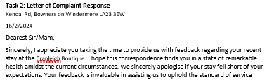
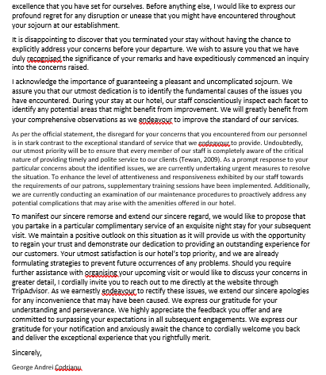

Component Three:
Contribution to Overall Module Assessment: 50% (1000 words +/- 10%)
Writing in essay format
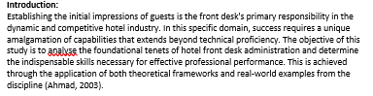
Key Skill 1 – Customer Service Skills | Key Skill 2 – Communication Skills
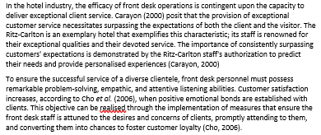 | 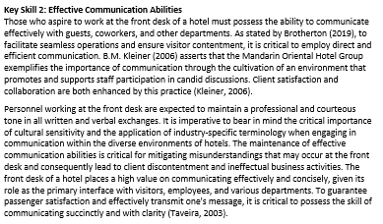
Key Skill 3 – Organisational Skills | Key Skill 4 – Problem Solving Skills
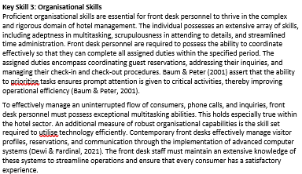 | 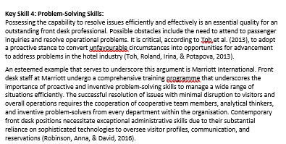

In conclusion, to be successful in hotel front desk administration, one must possess a wide range of abilities that go beyond mere technological proficiency. The importance of surpassing the expectations of every individual client is demonstrated through the possession of outstanding customer service skills, comparable to those demonstrated by the Ritz-Carlton (Setyarini & Maria, 2018). The Mandarin Oriental Property Group has exemplified the significance of outstanding communication abilities in fostering efficient cooperation across the entire establishment, not limited to front desk interactions (Taveira, 2003). Strong organisational aptitude is a prerequisite for efficiently managing the myriad of duties associated with front desk operations, as demonstrated by the Four Seasons Hotels & Resorts. As demonstrated by Marriott International, the capacity to address challenges productively is a critical requirement for proactively resolving problems and providing an outstanding customer experience. Front desk personnel are required to consistently enhance and adapt their fundamental proficiencies in light of the perpetually changing landscape of the hospitality industry (Setyarini & Maria, 2018)


