Introduction of physiology

BMHP-5003

Individual Academic

POSTER
Task 1

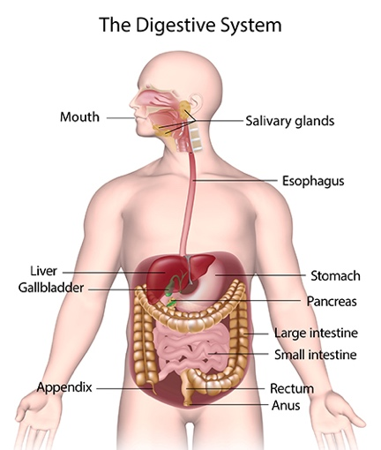

Lecturer: Mumtaz Goolam
Verifier: Dr Mark Gallagher

Presented by Gulnaz Begum 1907551
The mouth is the starting point for the digestive system, and digestion begins here before you even take the first bite of a meal. Swallowing occurs in the pharynx, partly as a reflex and partly under voluntary control. Food is pushed into the pharynx by the tongue and soft palate (the soft part of the roof of the mouth), which closes off the trachea. The food is then swallowed and enters the oesophagus (Wilson, Waugh and Ross, 1996).

DIGESTIVE SYSTEM

Salivary glands Their secretions are released into ducts that lead to the mouth. The three main pairs are the parotid glands, submandibular glands, and sublingual glands (Wilson, Waugh and Ross, 1996).

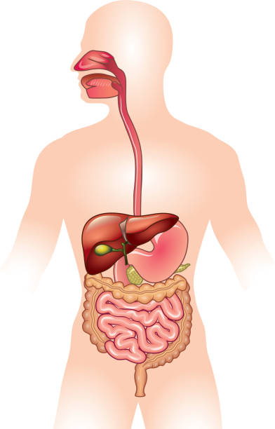
The liver is in charge of regulating the majority of chemical levels in the blood as well as excreting bile. This helps to remove waste from the liver. The liver filters all blood that exits the stomach and intestines. The liver is crucial in maintaining plasma glucose levels. The liver is the body's largest gland, weighing between 1 and 2.3 kg. (Waugh, Grant and Ross, 2010).

Pharynx and esophagus is the part of the digestive tract that receives food from the mouth. The pharynx is connected to the oesophagus, which transports food to the stomach, and the trachea, which transports air to the lungs. (Seger and Depoortere, 2021).

Digestion is the complex process of breaking down food into nutrients that the body can use for energy, growth, and cell repair. The digestion process generates waste, which must be removed.

Seger and Depoortere (2021) states The gastrointestinal tract also called GI tract consists of a series of hollow organs linked by a long, twisting tube that runs from the mouth to the anus. The gastrointestinal tract is made up of hollow organs such as the mouth, oesophagus, stomach, small intestine, large intestine, and anus. The digestive system's solid organs are the liver, pancreas, and gallbladder.

Large intestine The colon is a muscular tube that connects the small intestine to the rectum and is five to seven feet long. It is made up of the cecum, ascending (right) colon, transverse (across) colon, descending (left) colon, and sigmoid colon, which connects to the rectum. The purpose of the large intestine is to absorb water and salts from the material that has not been digested as food, and get rid of any waste products left over (Wilson, Waugh and Ross, 1996).

The rectum is an 8-inch-long straight chamber that connects the colon to the anus. The rectum's job is to receive stool from the colon, notify you that stool needs to be evacuated, and hold the stool until evacuation occurs (Peate, 2021).

The pancreas is the primary producer of digestive enzymes, which are secreted into the duodenum, the small intestine's first segment. These enzymes are responsible for the breakdown of protein, fats, and carbohydrates (Waugh, Grant and Ross, 2010).

Stomach The stomach resembles a bag with strong muscular walls In addition to holding food, it functions as a food mixer and grinder. The stomach produces acid as well as powerful enzymes, which continue to break down the meal and turn it into a liquid or paste consistency. The food is then transported to the small intestine (Wilson, Waugh and Ross, 1996).
Small intestine uses enzymes produced by the pancreas and bile from the liver to break down food. The small intestine is the 'work horse' of digestion because it absorbs the majority of nutrients. Peristalsis is also active in this organ, moving food through and mixing it with pancreatic and liver digestive secretions, including bile. The duodenum is primarily in charge of the ongoing breakdown process, whereas the jejunum and ileum are in charge of nutrient absorption into the bloodstream (Waugh, Grant and Ross, 2010).

The gall bladder is a pear shaped sac attached to the posterior surface of the liver by connective tissue. The gallbladder is a small pouch-like organ located in the upper right corner of your stomach. It stores bile, which is a fluid produced by the liver that aids in the digestion of fatty foods. (The Digestive System, 2021).

Teeth are used to break down food into smaller pieces in the mouth by chewing. This is known as mechanical digestion. The teeth cut and crush food, which is then mixed with saliva to form a ball of food known as a bolus. Peate, (2021)

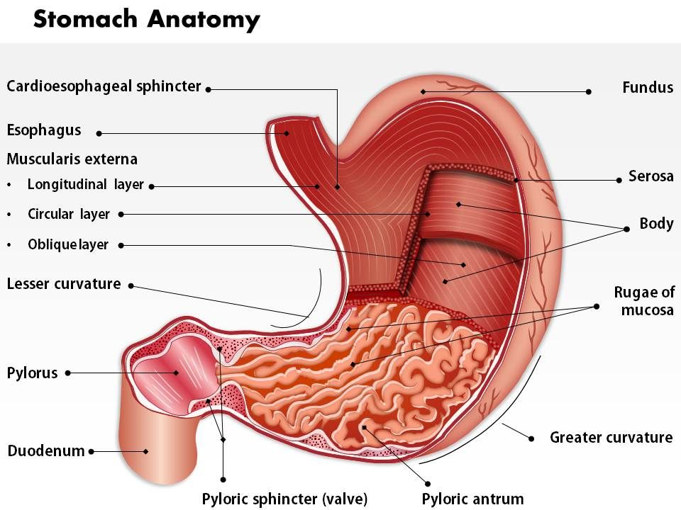
Stomach Cancer

Jones, Mohr and Popp, (2013) mentioned that symptoms of Abdominal discomfort, pain, nausea, vomiting, weight loss, difficulty swallowing, vomiting blood or blood in the stool, and feeling full or bloated after a small meal are all symptoms of stomach cancer.

Stomach cancer is a form of cancer that begins in the stomach as an abnormal growth of cells. The stomach is a strong sac in the upper central of your stomach, just below your ribs. Your stomach receives and holds food before breaking it down and digesting it. Gastritis weakens the stomach lining and frequently causes changes in the cells, which can lead to stomach cancer. Inadequate vitamin absorption in your stomach can also lead to defects that prevent your body from creating red blood cells or affect nerve role (Waugh, Grant and Tibbitts, 2009).

Peate, (2021) cited that stomach cancer indicates the spread through the stomach's inner, supportive, muscle, or outer layers. It is possible that it has spread to nearby lymph nodes. But later it will spread to other organs if left untreated.

(Redirect Notice, 2021)

These are the 5 layers which stomach acid and digestive enzymes are made. Most cancers start from here.

The layers are important to determine the stage of cancer, which can affect treatment options and prognosis. As a cancer progresses from the mucosa to deeper layers, the stage advances and treatment may become more extensive.
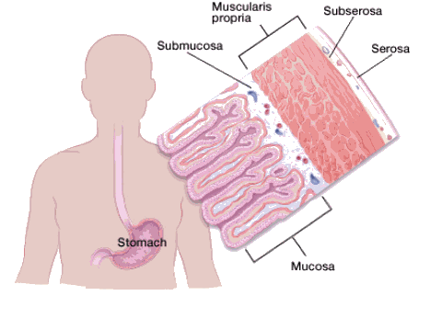

Facts & Figures 2021 | American Cancer Society, 2021)
Mahadevan, (2020) insists of Peristalsis is a series of wave-like muscle contractions that aid in the movement of food through the digestive tract. It starts in the oesophagus, where smooth muscle waves transport swallowed food balls to the stomach. The peristaltic movement, also known as Peristalsis, is the contraction and relaxation of food in the oesophagus and food pipe, causing food to be forced down the track to the stomach.

Recommendations

I would recommend a patient with stomach cancer to maintain a healthy weight and eat early to avoid excessive bloating. Food cannot be digested properly as cancer in the stomach stops blood flow which can cause blockages. It may be difficult for a person to eat as a result of this so small portions are recommended. Consuming plenty of fresh fruits and vegetables, as well as whole grain foods such as whole grain breads, cereals, pasta, and rice in small portions as you will have digestion problems and vomiting, diarrhoea or even constipation. Limit your alcohol consumption as this can damage the stomach lining and can cause several symptoms from abdominal pain to vomiting. Tobacco products can also increase you cancer from spreading as it increases the risks of heart and lung diseases . Avoid smoked and pickled foods, as well as salted meats and fish.

REFERENCES
- Cancer.org. 2021. Cancer Facts & Figures 2021 | American Cancer Society. [online] Available at: <https://www.cancer.org/research/cancer-facts-statistics/all-cancer-facts-figures/cancer-facts-figures-2021.html> [Accessed 9 July 2021].
- Choice Reviews Online, 2011. The encyclopedia of the digestive system and digestive disorders. 48(10), pp.48-5435-48-5435.
- Google.com. 2021. Redirect Notice. [online] Available at: <https://www.google.com/url?sa=i&url=https%3A%2F%2Fwww.slideteam.net%2F0514-stomach-anatomy-medical-images-for-powerpoint.html&psig=AOvVaw2MtsgCpxI1yzv73F8Ce4n2&ust=1625788516838000&source=images&cd=vfe&ved=2ahUKEwjsob2plNLxAhVQiRoKHQ_rA-EQr4kDegUIARD1AQ> [Accessed 7 July 2021].
- Jones, T., Mohr, U. and Popp, J., 2013. Digestive System. Berlin, Heidelberg: Springer Berlin / Heidelberg.
- Kono, S. and Hirohata, T., 1996. Nutrition and stomach cancer. Cancer Causes and Control, 7(1), pp.41-55.
- Mahadevan, V., 2020. Anatomy of the stomach. Surgery (Oxford), 38(11), pp.683-686.
- Peate, I., 2021. The gastrointestinal system. British Journal of Healthcare Assistants, 15(3), pp.132-137.
- Peate. I, and Nair, M. (2011) Fundamentals of Anatomy and Physiology for Student Nurses. Chichester: Wiley Blackwell.
- Ross, J. and Waugh, A., n.d. MCQs for Ross and Wilson Anatomy and physiology in health and illness.
- Seger, a. and Depoortere, I., 2021. Circadian clocks in the digestive system. [online] pp.239–251. Available at: <https://doi.org/10.1038/s41575-020-00401-5> [Accessed 4 June 2021].
- Tucker, L. (2011) An Introductory Guide to Anatomy and Physiology. (5th Edition). London: Ems Publishing.
- Waugh, A., Grant, A. and Ross, J., 2010. Ross and Wilson anatomy and physiology in health and illness. Edinburgh: Churchill Livingstone.
- Waugh, A., Grant, A. and Tibbitts, R., 2009. Ross & Wilson anatomy and physiology in health and illness.
- WebMD. 2021. The Digestive System. [online] Available at: <https://www.webmd.com/digestive-disorders/digestive-system> [Accessed 27 May 2021].
- Wilson, K., Waugh, A. and Ross, J., 1996. Ross and Wilson anatomy and physiology in health and illness ISE. Edinburgh: Churchill Livingstone.
- Waugh, A. & Grant, A. (2014) Ross and Wilson Anatomy and Physiology in Health and Illness: (12th Edition) London: Churchill Livingstone.

