
[Document title]


Ros viorel
STUDENT ID: 1817983

Contents
Introduction 2
An understanding of the communication skills 2
Analysis of the communication in my own workplace 5
Using my findings from published literature (i.e. refer to theory), some ways how communication could be improved. 6
Conclusion 8
References 9

Introduction
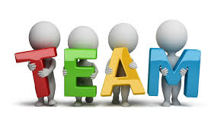
Teamwork can be defined as the collaborative effort in order to accomplish any task or reach any goal or objective. On the other hand, communication is the way of exchanging information and data. When any innovation or any information related to something new or old needs to be transferred to others then it is called communication (Smallbusiness.chron.com, 2019). Now, comes the terms effective teamwork and communication, these denote that the teamwork and communication which are done in line with some standards, rules and regulations in order to reach any goal or objective. However, this portfolio of evidence is going to illustrate different communication skills, analyze the communication in my workplace, and lastly how communication or communication skills can be improved in the context of assistant marketing manager (my position or post) of my organization Lloyds Bank. Lloyds Bank is a multinational bank of the UK which operates its banking activities in the UK, Scotland, and Wales and its headquarter is in London.

An understanding of the communication skills
Communication skills are the skills which are required to improve the communication of an entity in any sphere and activity. Now, there have several skills of communication which will be demonstrated in this segment. There are many skills of communication around in organization or in personal or academic life but some most significant ones are in the following-

Listening
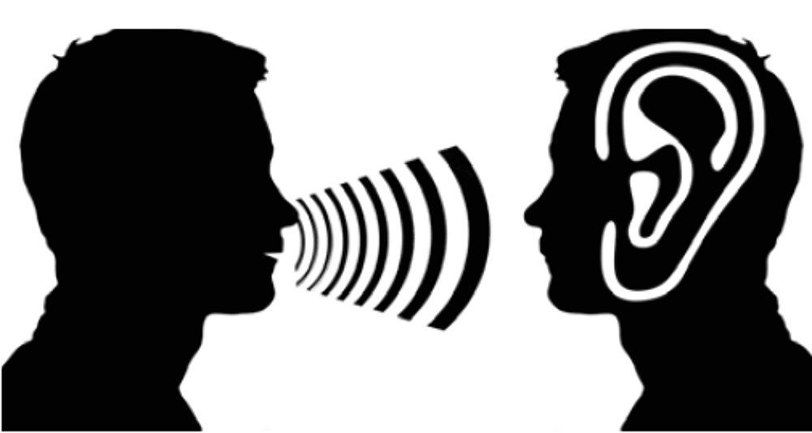
Listening is the first one communication skill which helps communication significantly to be smooth. Without listening the main aim of communication becomes failed (White, 2010).Apart from that, listening must be effective which can help in achieving the goals and objectives of communication. When the tone or word is delivered then effective attention which is a part of listening should be paid in order to understand every particular theme of communication which results in the effective communication.
Openness & Friendliness
In case of openness and friendliness everything can be achieved easily. When one becomes open to different things then they can freely express them and many information can be achieved with less efforts .Openness paves the way for friendliness .This is the era of information that means who have information more he or she is the powerful person ever. When you will show enmity then no one here to provide information which you want but in case of being amiable everybody shares information even the information which should not be shared to anybody .As, it is the era of free flow of information therefore, the openness should be free to everything otherwise the free flow of information is not possible.
Confidence & Honesty
These two terms make the trust issue in the communication. Nobody will believe you and share his or her valuable information if you cannot be trustworthy while for being trustworthy you must be honest and confident in case of communication. Therefore, these two terms or factors are very significant in ensuring effective communication.

Brevity & Clarity
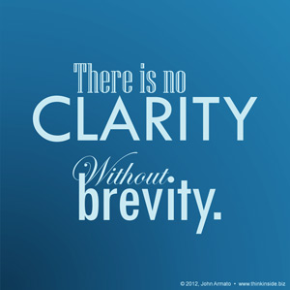
When people talk too much then other lose interest in listening. It happens when the communication or talking is unclear. Apart from these, communication should be brief and clear in terms of talking and expressing (Moustafa, 2016). In this era of technological advancement everybody is busy and they don’t have time to listen the foul and ambiguous talks wasting their valuable time. Apart from that, brevity and clarity are the two indicators of communication which make communication easier and lovely to others.
Ability to accept and provide feedbacks
There are different proverbs on criticism as well as criticizers that listening criticism is the best way to rectify oneself. Aside from that, the persons in communication must be the ones who have the capability of accepting and proving feedbacks. Everything in feedbacks should be accepted and delivered positively otherwise the free flow of information cannot be possible or the effective communication is not possible.
Respect & Empathy
There is proverb that give respect and take respect. Further, everybody has emotion as well as sorrows and sufferings which should be cared mindfully .When people feel that they are taken care of and listened then they share information and the process of communication becomes easier. Apart from that, who are in communication they must show respects and empathy to each other.
Choosing the right format
When the planning is right then it is true for a task that it will go in right direction. There are various formats in communication which are very significant for effective communication. Therefore, persons in communication should choose proper communication format which will lead the proper communication at the last.
Body Language Skills
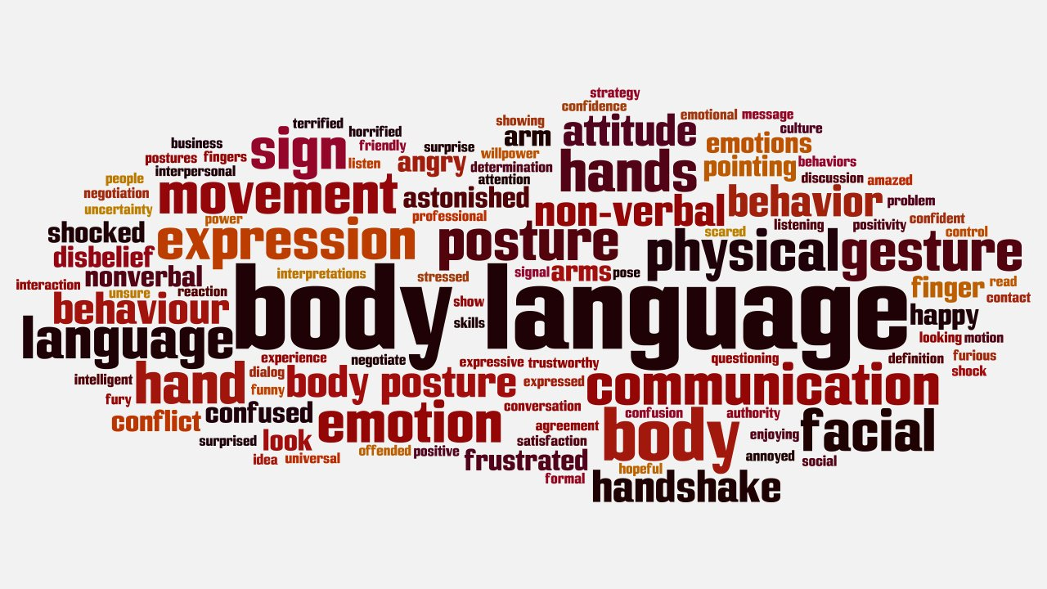
In case of communicating in different languages body languages play significant role. When the language cannot be understood then the body language can do a lot. Along with the language, when the body language then it makes the communication process more effective (Wainwright and Thompson, 2010) .Apart from that, the persons who will be in communication should provide gesture alongside of language properly.

Analysis of the communication in my own workplace
In every organization there have formats of communication as well as types of communication. Apart from these, my organization Lloyds Bank is not out of it. In our organization there have two sorts of communication or two formats of communication which are very visible-Verbal communication and Written communication. These two formats are used vigorously for any sorts of communication. Now, let’s see these two formats in detail -
Verbal communication
Verbal or oral communication is used for almost all purposes in which the written communication is not needed. Verbal communication refers to using the tools which are needed to communicate with words by speaking. In my organization the verbal communication is used from the top level of management to the bottom for any purposes. Due to the easiness of this format everybody likes it as well as wishes to use this method in communication (Saussure and Rocci, 2016). In meeting, training sessions, board meetings ranging from the high-ups to the lower levels use this communication method.
Written communication
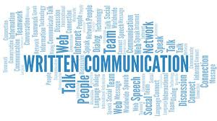
Written communication refers to using paper and pencils in communication for exchanging the information that means in one word using the writing or paper works. Written communication is significant for every organization for various purposes like getting the summary on different meetings, providing directions on various activities and so on (Written Communication Special Issue Call for Papers Writing and Medicine, 2009). These activities now-a-days can be accomplished via online sites or tools but all the activities are not possible via online. Now-a-days, a common and most used trend of the staffs our organization is that they are more in online different sites which the organization found the best way to communicate for various purposes .hence, most of the written and verbal activities are accomplished via these sites which are easy to reach everybody, cost and time consuming reducer.

Using my findings from published literature (i.e. refer to theory), some ways how communication could be improved.
There might be lack in communication as well as lack in skills of communication which might foil different purposes regarding to the communication even in many cases the basic purpose of an organization might be ruined or disturbed due to the poor communication or for having lacking in communication . Therefore, the communication must be improved or from the lacking an organization should get out of .In this segment some ways are proposed for improving communication or skills of communication which are suggested from the findings of some literatures and a theory like “How to Talk to anyone” by LEIL LOWNDES and “How to win friends and influence people” by Dale Carnegie while the theory is “effective communication theory”. Now the ways are in following-

Listening well without interruption
First rule of improving communication is listening properly without any interruption. When the listening will be perfect then the other aspects of any communication process will be easier (Oureverydaylife.com, 2019) .By listening properly the persons who are in communications can valuate others and even get value or respect of others .Therefore, effective listening is very significant in improving communication.
Becoming watchful
There is a proverb goes like the cautious people caught by less difficulties. Apart from that, when in any aspect or area of life the caution can be maintained then it becomes easy to get of many problems at the same time to be good and disciplined with every problem. In communication the persons in communication should be watchful in the aspects like how others are desiring from, how others are expressing them, and so on for improving communication.
Maintaining quality voice and tone
Quality tells everything and it is a catalyst in every cases of life or anything which can make things easier. In communication for improving it quality should be maintained when quality will be ensured then the communication process becomes easier and smooth for others in terms of understanding, expressing and others.
Using exact words in communicating
In communication the theme or the exact words should be used and ambiguous words should be avoided which make communication sweet and interesting to others. Saying exactly what should be spoken helps to understand and improve a communication better than any other ways or tools.
Practicing clarity and brevity
Communication should be brief and clear in terms of talking and expressing. In this era of technological advancement everybody is busy and they don’t have time to listen the foul and ambiguous talks wasting their valuable time. Apart from that, brevity and clarity are the two indicators of communication which make communication easier and lovely to others. If the clarity and brevity can be maintained or practiced then communication is a must to be improved.
Practicing appropriate gestures
Body language or gesture can be used as alternative to the language. Appropriate gestures should be demonstrated while speaking or communicating which makes the communication process or communication more understandable to others. Communication becomes appropriate with appropriate gestures. Apart from these, for improving communication appropriate gestures should be developed.
Asking questions
Lastly, asking questions can extract any information which is occult or which is not in remembrance of the speaker (Hackley, 2017). Asking question is the generator of knowledge. While questions are asked then the speaker gets interested in sharing information more than before .Therefore, in improving communication questions should be asked.

Conclusion
Communication is the way in the age of 4th industrial revolution which is based on information technology and advancement of modern technologies to get the information of others easily (Graham, 2009) .If properly communicated then the innovative and many significant information can be gathered easily which might be worthy than millions of money . Apart from that, in communication proper methods should be used and most significantly communication should be effective along with teamwork for a modern organization to prosper or go forward .In that perspective ,this portfolio of evidence illustrated different communication skills , analyzed the communication in my workplace , and lastly described how communication or communication skills can be improved in the context of assistant marketing manager(my position or post) of my organization Lloyds Bank. Lloyds Bank is a multinational bank of the UK which operates its banking activities in the UK, Scotland, and Wales and its headquarter is in London.

References
- Graham, I. (2009). Communication. Mankato, Minn.: QEB Pub.
- Hackley, S. (2017). Asking the Right Questions. Negotiation Journal, 33(4), pp.375-378.
- Moustafa, K. (2016). First clarity, then brevity. Australasian Physical & Engineering Sciences in Medicine, 39(2), pp.361-362.
- Oureverydaylife.com. (2019). [online] Available at: https://oureverydaylife.com/five-benefits-of-attentive-listening-12596329.html [Accessed 23 Aug. 2019].
- Saussure, L. and Rocci, A. (2016). Verbal Communication. Berlin: de Gruyter Mouton.
- Smallbusiness.chron.com. (2019). Effective Communication & Team Work. [online] Available at: https://smallbusiness.chron.com/effective-communication-team-work-3167.html [Accessed 23 Aug. 2019].
- Wainwright, G. and Thompson, R. (2010). Understand body language. London: Teach Yourself.
- White, G. (2010). Listening. Oxford: Oxford University Press.
- Written Communication Special Issue Call for Papers Writing and Medicine. (2009). Written Communication, 26(2), pp.210-211.

