

Student name: Roman Pacek
Student ID:2415805

Module name: Introduction to Physiology
Module code: BMHP5023
Lecturer name: Dr Soban Sadiq

Assessment: Written Assignment (Diabetes)

1. Introduction
Diabetes mellitus is a chronic metabolic condition that affects the body’s ability to regulate blood glucose levels effectively. It develops when the body either does not produce enough insulin or is unable to use insulin properly, leading to increased levels of glucose in the bloodstream (World Health Organization, 2023). There are two main types of diabetes. Type 1 diabetes is an autoimmune condition where the pancreas produces little or no insulin, whereas Type 2 diabetes is more common and is mainly linked to insulin resistance, where the body’s cells do not respond effectively to insulin (Diabetes UK, 2023). Globally, Type 2 diabetes accounts for around 90–95% of all diabetes cases, making it a significant public health concern (International Diabetes Federation, 2021).
In the UK, over 4.3 million people are currently living with diabetes, and this number is continuing to rise (Diabetes UK, 2023). This highlights the growing importance of understanding and managing the condition, particularly within primary care settings.
Risk factors for Type 2 diabetes include both modifiable and non-modifiable factors. Modifiable risk factors include poor diet, physical inactivity, obesity and smoking, while non-modifiable factors include age, ethnicity and genetics (NHS, 2023). Individuals who are overweight are significantly more likely to develop the condition due to increased insulin resistance.
The endocrine system plays a key role in regulating blood glucose levels. The pancreas, a major organ within this system, contains the islets of Langerhans, which include beta cells that produce insulin and alpha cells that produce glucagon (Marieb and Hoehn, 2019). These hormones work together to maintain a glucose balance within the body.

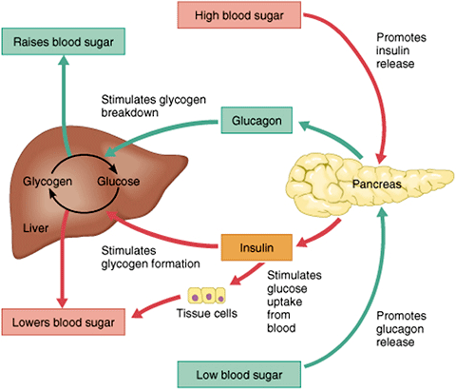
Structure of the pancreas and endocrine function (OpenStax, 2020)

This report will explore how blood glucose levels are regulated, how energy is produced within cells, the importance of monitoring blood glucose levels, and how lifestyle changes can improve the management of Type 2 diabetes.

2. Blood Sugar Regulation

Blood glucose levels are tightly regulated by the endocrine system to ensure that the body maintains a constant and adequate supply of energy for cellular function. This process, known as glucose homeostasis, is primarily controlled by the hormone’s insulin and glucagon, both of which are secreted by the pancreas (Guyton and Hall, 2021).
The pancreas contains specialized clusters of endocrine cells known as the islets of Langerhans. Within these islets, beta cells are responsible for producing insulin, while alpha cells produce glucagon. These hormones act in opposition to maintain blood glucose levels within a normal physiological range, typically between 4–7 mmol/L in fasting conditions (Marie and Hoehn, 2019).
After eating, carbohydrates are broken down into glucose and absorbed into the bloodstream, causing blood glucose levels to increase. This rise is detected by the beta cells in the pancreas, which respond by releasing insulin. Insulin enables glucose to enter body cells by increasing the presence of glucose transporter proteins, particularly GLUT4, on the cell membrane in muscle and fat tissue (Silverthorn, 2020). Once inside the cells, glucose can be used to produce energy through cellular respiration or stored as glycogen in the liver and skeletal muscles in a process known as glycogenesis.
In addition to promoting glucose uptake, insulin also inhibits hepatic glucose production by suppressing processes such as gluconeogenesis and glycogenolysis. This combined effect ensures that blood glucose levels are reduced after eating and maintained within a safe range.
When blood glucose levels decrease, such as during periods of fasting or between meals, the alpha cells of the pancreas release glucagon. This hormone mainly targets the liver, where it stimulates glycogenolysis, the breakdown of stored glycogen into glucose, as well as gluconeogenesis, the production of new glucose from non-carbohydrate sources such as amino acids (Guyton and Hall, 2021). As a result, glucose is released back into the bloodstream, helping to restore blood sugar levels. This process is particularly important for maintaining a constant energy supply to vital organs, especially the brain, which depends heavily on glucose for normal functioning.
This regulatory system demonstrates a clear relationship between anatomical structures and physiological processes. The structure of the pancreas and its specialized cells directly influence the body’s ability to regulate glucose levels. When these structures function normally, homeostasis is maintained. However, in individuals with Type 2 diabetes, this system becomes disrupted.
In Type 2 diabetes, insulin resistance reduces the ability of cells to respond to insulin effectively, meaning that glucose uptake is impaired. As a result, glucose remains in the bloodstream, leading to hyperglycemia (DeFronzo, 2015). Over time, the beta cells of the pancreas may become dysfunctional, further reducing insulin production and worsening glycemic control.
This disruption highlights how failure at the cellular and hormonal level can lead to significant physiological consequences. Chronic hyperglycemia is associated with damage to blood vessels and tissues, increasing the risk of complications such as cardiovascular disease, neuropathy and kidney disease (NICE, 2023). Therefore, maintaining effective blood glucose regulation is essential for overall health and preventing long-term complications.

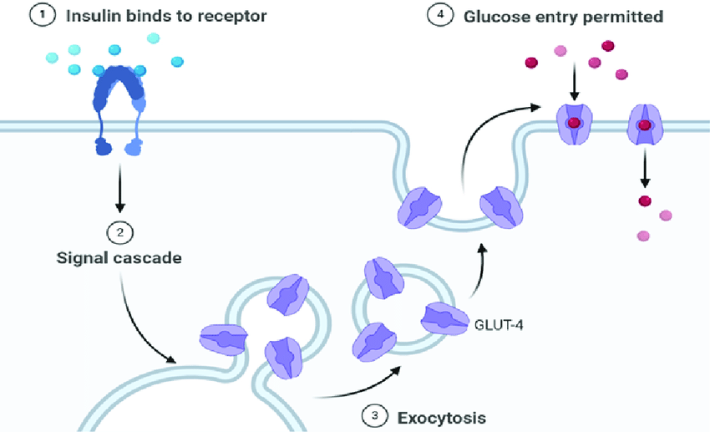
Blood glucose regulation by insulin and glucagon (OpenStax, 2020)

In individuals with Type 2 diabetes, this process becomes disrupted. Insulin resistance means that cells do not respond effectively to insulin, preventing glucose from entering cells. As a result, glucose builds up in the bloodstream, leading to hyperglycemia (DeFronzo, 2015).
This demonstrates the relationship between anatomy and physiology. Damage to the pancreatic beta cells (structure) affects insulin production (function), which disrupts glucose regulation (physiology). If left unmanaged, this can lead to serious complications such as cardiovascular disease, which is responsible for approximately 50% of deaths in people with diabetes (World Health Organization, 2023).

3. Cellular Metabolism
Glucose is the body’s primary source of energy and is used in a process known as cellular respiration to produce ATP (OpenStax, 2020). This process requires oxygen and takes place in the mitochondria of cells.
Cellular respiration occurs in three stages:
- Glycolysis (cytoplasm)
- Krebs cycle (mitochondria)
- Electron transport chain (mitochondria)

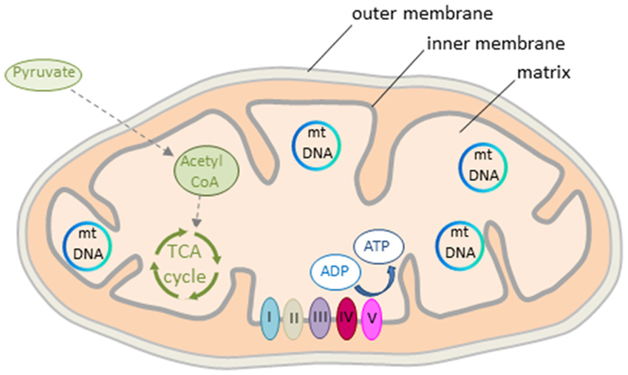
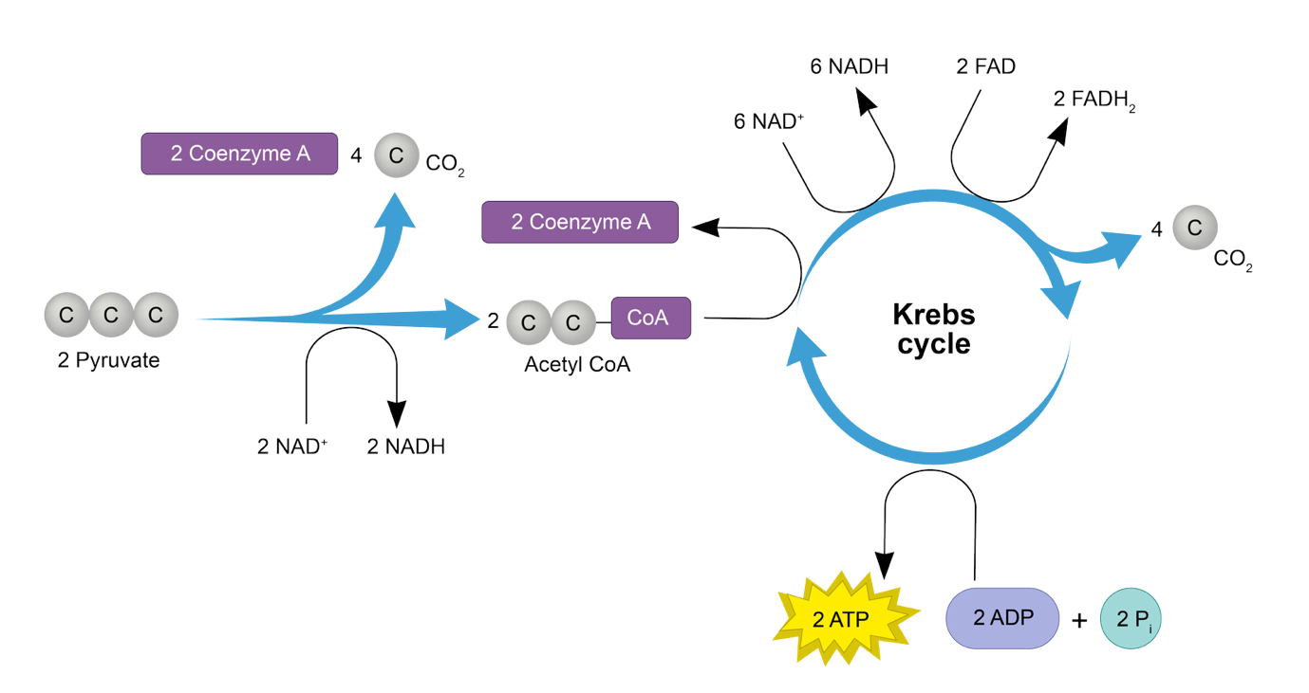
Cellular respiration and ATP production (OpenStax, 2020)
Oxygen is essential in the final stage, as it allows the production of large amounts of ATP, which is used for cellular activities such as muscle contraction and nerve function (Silverthorn, 2020).
In Type 2 diabetes, insulin resistance prevents glucose from entering cells efficiently. This means that despite high levels of glucose in the blood, cells may not receive enough energy. This can lead to symptoms such as fatigue. Additionally, prolonged high blood glucose levels can damage mitochondria, reducing the efficiency of energy production (Rolo and Palmeira, 2006).
This highlights the strong link between anatomical structures (mitochondria) and physiological processes (energy production), demonstrating how disruptions at a cellular level can affect overall body function.

4. Recording and tracking blood sugar levels for type 2 diabetes
Monitoring blood glucose levels is an essential part of managing Type 2 diabetes. It allows individuals to understand how their condition changes over time and how different factors affect their blood sugar levels (NICE, 2022).
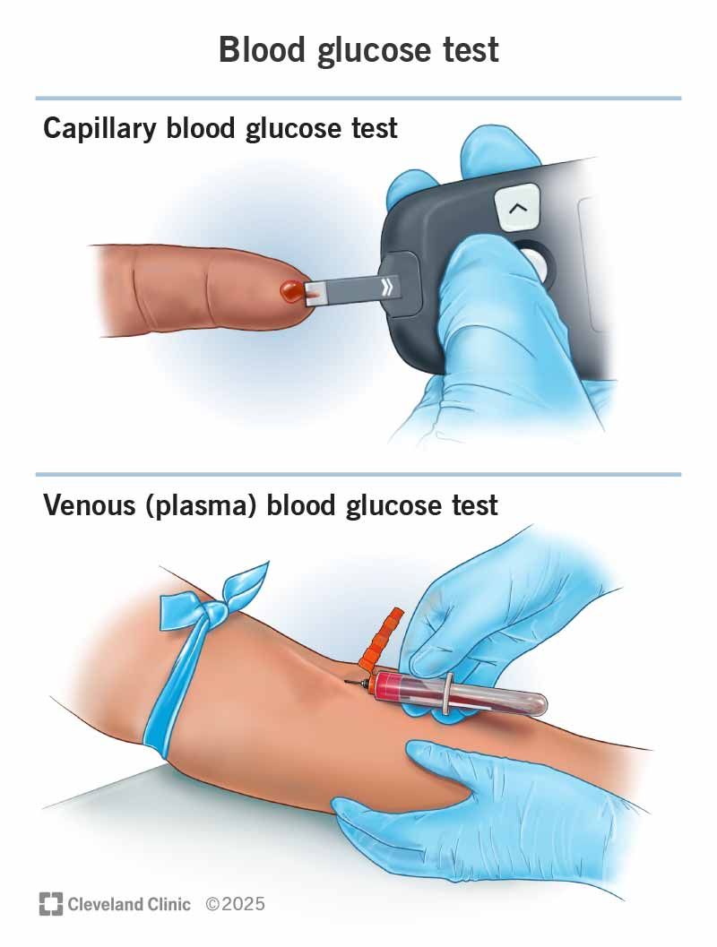
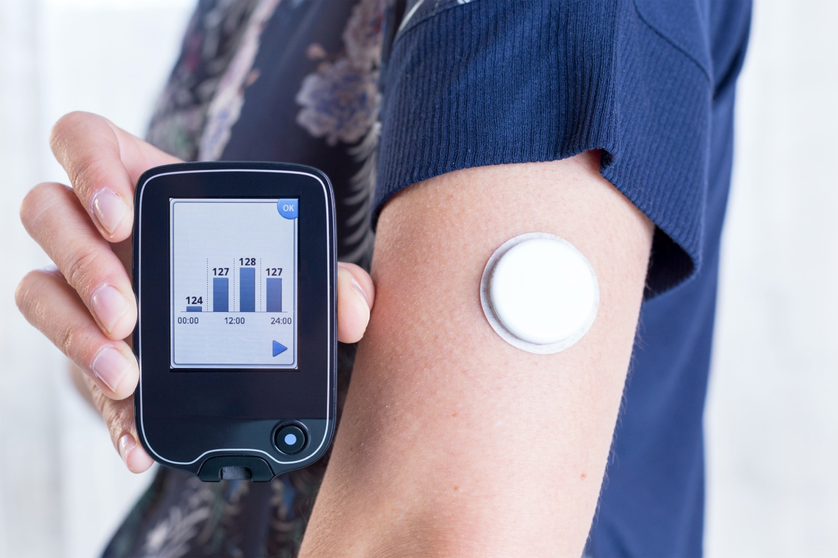
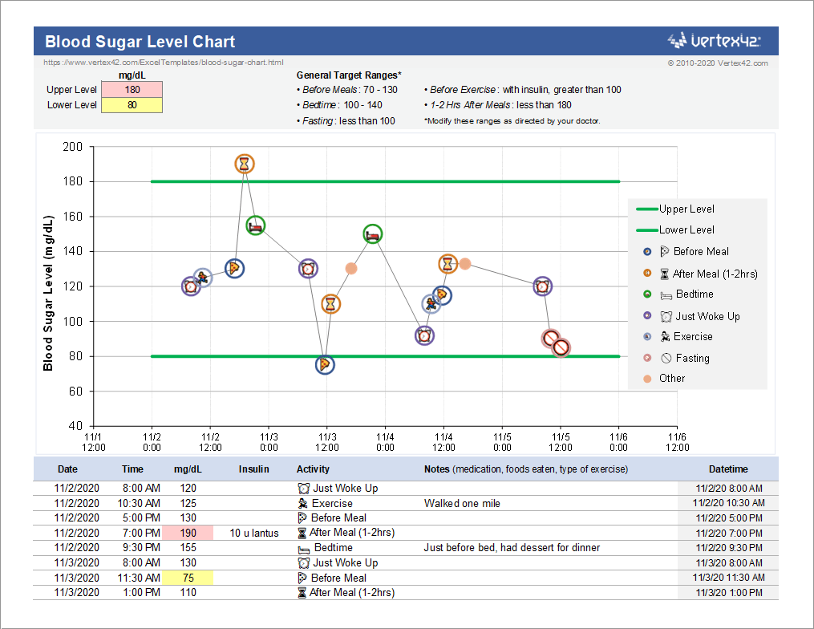
Blood glucose monitoring methods (NHS, 2023)
Tracking blood glucose levels helps individuals to:
- Identify patterns in blood sugar levels
- Understand the effects of diet and exercise
- Prevent complications by detecting high or low levels early
Research shows that regular monitoring can reduce HbA1c levels, improving overall diabetes control (Farmer, 2012).
If blood glucose levels are not monitored, individuals may be unaware of dangerous fluctuations. This can lead to uncontrolled hyperglycemia, increasing the risk of complications such as kidney damage, nerve damage and cardiovascular disease (NICE, 2023).
However, monitoring is only effective if patients understand how to interpret their results. This highlights the importance of education and support from healthcare professionals, particularly practice nurses.

5. Recommendations
Effective management of Type 2 diabetes requires a combination of lifestyle modifications and healthcare interventions that aim to improve glycaemic control and reduce the risk of long-term complications. These strategies should be evidence-based and tailored to the individual to ensure they are realistic and sustainable (NICE, 2023).

Diet
A balanced diet plays a crucial role in regulating blood glucose levels. Patients should reduce their intake of foods high in refined sugars and processed carbohydrates, as these can cause rapid increases in blood glucose levels. Instead, they should increase consumption of fiber-rich foods such as whole grains, vegetables and legumes, which promote slower glucose absorption and help maintain stable blood sugar levels (Diabetes UK, 2023).
In addition, adopting a low glycemic index (GI) diet can further support glycemic control by reducing post-meal glucose spikes (Jenkins, 2002). This highlights the importance of dietary education in enabling patients to make informed food choices.

Physical Activity
Regular physical activity is essential in improving insulin sensitivity, allowing glucose to be taken up more effectively by body cells (Colberg, 2016). Exercise also increases glucose uptake by skeletal muscle independently of insulin, which is particularly beneficial for individuals with insulin resistance.
Patients should aim for at least 150 minutes of moderate-intensity physical activity per week, such as brisk walking or cycling (NHS, 2023). Even small increases in daily activity can have a positive impact on blood glucose control and overall cardiovascular health.

Weight Management
Weight management is a key factor in improving insulin sensitivity and reducing the progression of Type 2 diabetes. Excess adipose tissue is associated with increased insulin resistance due to the release of inflammatory mediators (Taylor, 2019).
Evidence suggests that even a modest weight loss of 5–10% of total body weight can lead to significant improvements in glycemic control and, in some cases, remission of the condition. This demonstrates the strong relationship between lifestyle factors and metabolic health.

Smoking Cessation
Smoking is a significant risk factor that contributes to insulin resistance and increases the likelihood of cardiovascular complications in individuals with diabetes. It also promotes inflammation and vascular damage, which can worsen long-term outcomes (Pan, 2015).
Therefore, smoking cessation should be strongly encouraged as part of a comprehensive diabetes management plan. Healthcare professionals can support patients through interventions such as counselling and nicotine replacement therapies.

Health Promotion
Health promotion strategies, such as structured education programmed (e.g. DESMOND), can help patients develop the knowledge and skills needed to manage their condition (Davies, 2008).
Although these interventions are effective, they can be difficult to maintain. Therefore, a patient-centered approach is essential, where care is tailored to individual needs. Practice nurses play a key role in supporting behavior change and encouraging long-term adherence.

6. Conclusion
In conclusion, Type 2 diabetes is a complex condition that involves both anatomical and physiological processes. The pancreas, insulin, and cellular metabolism all play important roles in regulating blood glucose levels.
Understanding how these systems work can help individuals manage their condition more effectively. Monitoring blood glucose levels and making lifestyle changes are essential for improving outcomes and reducing the risk of complications.
Healthcare professionals, particularly practice nurses, play a vital role in supporting patients through education and personalized care. By promoting self-management and healthy lifestyle choices, they can help improve the quality of life for individuals living with Type 2 diabetes. ￼

References
Colberg, S.R., (2016) ‘Physical activity/exercise and diabetes: A position statement of the American Diabetes Association’, Diabetes Care, 39(11), pp. 2065–2079.
Davies, M.J., Heller, S., Skinner, T.C., Campbell, M.J., Carey, M.E., Cradock, S., Dolosse, H.M., Daly, H., Doherty, Y., Eaton, S. and Fox, C. (2008) ‘Effectiveness of the diabetes education and self-management for ongoing and newly diagnosed (DESMOND) programmer’, BMJ, 336(7642), pp. 491–495.
DeFronzo, R.A., Ferran Nini, E., Groop, L., Henry, R.R., Herman, W.H., Holst, J.J., Hu, F.B., Kahn, C.R., Raz, I. and Shulman, G.I. (2015) ‘Type 2 diabetes mellitus’, Nature Reviews Disease Primers, 1, pp. 1–22.
Diabetes UK (2023) Type 2 diabetes. Available at: https://www.diabetes.org.uk (Accessed: 8 April 2026).
Farmer, A.J., Perera, R., Ward, A., Heneghan, C., Oke, J., Barnett, A.H. and Davidson, M.B. (2012) ‘Meta-analysis of individual patient data in randomised trials of self-monitoring of blood glucose in people with non-insulin treated type 2 diabetes’, BMJ, 344, e486.
Guyton, A.C. and Hall, J.E. (2021) Textbook of Medical Physiology. 14th edn. Philadelphia: Elsevier.
International Diabetes Federation (2021) IDF Diabetes Atlas. 10th edn. Brussels: IDF.
Jenkins, D.J.A., Kendall, C.W.C., Augustin, L.S.A., Franceschi, S., Hamidi, M., Marchie, A., Jenkins, A.L. and Axelsen, M. (2002) ‘Glycemic index: Overview of implications in health and disease’, The American Journal of Clinical Nutrition, 76(1), pp. 266S–273S.
Marieb, E.N. and Hoehn, K. (2019) Human Anatomy & Physiology. 11th edn. Harlow: Pearson.
NHS (2023) Type 2 diabetes. Available at: https://www.nhs.uk (Accessed: 8 April 2026).
NICE (2022) Type 2 diabetes in adults: management of blood glucose monitoring. Available at: https://www.nice.org.uk (Accessed: 8 April 2026).
NICE (2023) Type 2 diabetes in adults: management. Available at: https://www.nice.org.uk (Accessed: 8 April 2026).
OpenStax (2020) Biology 2e. Houston: OpenStax. Available at: https://openstax.org (Accessed: 8 April 2026).
Pan, A., Wang, Y., Talaei, M., Hu, F.B. and Wu, T. (2015) ‘Relation of smoking with total mortality and cardiovascular events among patients with diabetes mellitus: A meta-analysis and systematic review’, JAMA, 314(1), pp. 54–63.
Rolo, A.P. and Palmeira, C.M. (2006) ‘Diabetes and mitochondrial function: Role of hyperglycemia and oxidative stress’, Toxicology and Applied Pharmacology, 212(2), pp. 167–178.
Taylor, R. (2019) ‘Calorie restriction and reversal of type 2 diabetes’, Cell Metabolism, 29(3), pp. 548–556.
World Health Organization (2023) Diabetes. Available at: https://www.who.int (Accessed: 8 April 2026).

