A report focussing on:

The Health and Safety Benefits for Horbury on me joining a Professional Body

Prepared for:

P. Lloyd – Managing Director

Created by:
K. Bowen

Date completed:
January 14th 2022

Executive Summary
In this essay, I am going to be explaining the major factors and importance as to why I think it is extremely important for me to join a professional body, I will also be explaining the large benefits on the health and safety aspect for the company I work for (Horbury) through me joining a professional body. This essay will also include a personal development plan in order to help me highlight and identify the training and skills needed in order to join a recognised professional body.
Main Body
A professional body is an organisation that holds individual members who are personnel associated with a specific profession, interest, or occupation. “Professional bodies will possess specific knowledge, skills and experience of academic principles related to its members’ professions or occupations which, in turn, can help support the professional development and advancement of its members”. (What is Professional Membership of Professional Bodies/Institutions? – Meaning and Definition, 2022). As you can see through joining a professional body this will allow me to gain useful specific knowledge, skills and help develop myself which will therefore in turn allow me to be an even greater asset to the company. There are numerous different benefits for Horbury through me joining a professional body within the built environment sector such as allowing me to evolve and grow as a person which will therefore in turn allow me to have a successful career development, as “career development helps to attract top staff and retain valued employees”. Nadarajah, S., Kadiresan, V., Kumar, R., Kamil, N. N. A., & Yusoff, Y. M. (2012). This will therefore allow me in Horbury help enabling me in maximising my growth and therefore help allow me to be as capable as possible within my job as a Quantity Surveyor and allow me to be able to grow in to becoming a Senior Quantity Surveyor/Commercial manager within the business. It is very important for me to join the RICS professional body, the Royal Institution of Chartered Surveyors is a professional body which helps to promote and enforce the highest professional qualifications and standards in the development of management of construction and infrastructure. (2022). The importance for me in joining this professional body is due to it allowing me to undertake excellent training provided by the RICS with a range of training through seminars, courses and workshops which allow me to keep learning, also through this body I will be able to gain and share knowledge within the sector through multiple sources of relevant industry and technical information provided by the RICS.
One of the largest benefits to Horbury through me joining a professional body will be the vast improvements on the health and safety records of the company, this will be one of the biggest financial benefits and also ethical benefits for the company. The Health and Safety at Work Act regulations were introduced in 1974 in order to help safeguard employees and also set out the general duty’s employers have towards employees and also employees have to each other, the legislation was introduced necessary to ensure the health and safety of all workers within work. (Health and Safety at Work etc. Act 1974, 2021). These regulations were further developed on due to the ever-changing working environment which further led to the Health and Safety at Work Regulations being introduced in 1999 which helped to reinforce the Act of 1974 with it also introducing new legislations due to some of the old legislations being outdated. (The Management of Health and Safety at Work Regulations 1999, 2021). This Act reinforced Regulations in which needed to be abided by in order to ensure the health and safety of every person within an organisation. The health and safety of workers has been a huge issue and problem all over the world, with the UK suffering badly with keeping and ensuring safety of its employees. As you can see from Figure 1 below the scary statistics of fatalities, death and mental health issues caused through work within the United Kingdom. These statistics from 2020 show the gradual increasing number of injuries, deaths and mental health issues caused from work continuously increasing over the years, which is a critical concern for all employers. This is therefore the reason as to why I think that for me joining a professional body will allow me to gain sufficient knowledge and skills within this area which will allow me to have a great oversight within Horbury as to what can be done to help prevent these numbers from increasing and also to help ensure the well being and health and safety of everyone within the business. As you can also see-through Figure 2 The fatalities at work for construction within 2019/20 was 4 million which had increased from 3 million 6 months previous. This helps show how the importance of health and safety within work needs to be taken and also the lack of severity companies is taking it due to the deaths and fatalities occurring each year. The affects of me joining a professional body will have on the health and safety records of the company will be significant due to me being able to gain professional experience and advise within this sector, as I will be gaining an extremely specific construction knowledge on health and safety matters within this sector. Through joining a professional body, I will be able to gain sufficient training which will in turn allow me to learn successful strategies within health and safety which I will be able to help implement within Horbury such as looking through all the live projects and drawing a detailed breakdown of the health and safety risks and being able to draw together a plan which can help minimize any risks. Through joining a professional body this will allow me to gain the necessary experience within the body to have a much wider understanding of the construction industry which will allow me then to have a much better view of the health and safety risks that have arisen within the company and allow me to be able to tackle them with better solutions due the skills and training gained from joining a professional body. The resources I will be able to gain and help to utilise will be very significant within helping improve the health and safety records of Horbury due to being able to network with experienced intellectual people within the same field who will help to offer me guidance and advice within the health and safety issues in construction and also will be able to offer me solutions and guidance within how I can help operate and change the way Horbury operate its health and safety strategies. Another factor as to why me joining a professional body will help to improve the health and safety records of Horbury is
Personal Development Plan
As you can see from the table below, I’ve designed a personal development plan in which I’ve created it solely based on what I feel I need to develop on and achieve in order for me to be able to join a professional body. In order to help track and monitor my progress, I am going to be reviewing the personal development plan every year as this will help me to keep focusing on these targets and also allow me to review whether I need to add to the PDP in order to achieve my end goal.

Name: Kieran Bowen
Job role and responsibilities: Quantity Surveyor – Price/forecast construction jobs
Review of learning needs |  |  | Development plan
Reference | In what area do I need to improve my performance? | What do I need to learn to achieve this? | What will I do to achieve this? | What are the likely resources and support that I will need? | How will I evaluate a successful outcome?
 | Gaining Degree in Quantity Surveying | - All aspects of construction and surveying  - Understand project cycle from tendering to claiming retention of a job | - Training  - Attend all lectures and do extra work | - Support from lecturers and work colleagues  - Financial support from work | - On completion of my degree
 | Improve on my time management and organisational skills | - To manage my time more effectively  - To understand the duration tasks, take to complete | - Set more time aside  - Allow myself to keep track of a daily diary in order to keep organised and on top of this | - Communication with work colleagues to ensure working well and on track with tasks  - Efficient time allocated for tasks | - Keeping on top off all tasks  - Little extra work needed due to good time management  - Continuation of daily diary to keep organised still continues
 | Gaining experience within my job. | - Be open minded  - Be patient  - Willing to listen and learn always | - Work hard within work to continue to learn new skills and techniques  - Listen and continue to grow overtime | - To be able to learn and spend vast amount of time with line manager | - Overtime gaining more responsibility in work  - Being more involved in the details of projects in work  - Gain feedback off manager to evaluate the experience and growth of me
 | Emotional intelligence | - In time with experience be able to read people better  - Need to learn how to be more self-aware | - Gain experience  - Be more aware when negotiating jobs  - Be more savvy and in touch with my emotions | - Support from work colleagues  - To be trusted to act on the right emotions and intentions within work when making big decisions | - Evaluate if I have acted on the right emotions over time after making big decisions  - If I have emotionally matured over time

References

Gov. 2022. Health and safety at work - 2020 statistics for Great Britain. [online] Available at: <https://www.myzoneglobal.com/news/health-and-safety-at-work-2020-statistics-for-great-britain> [Accessed 03 January 2022].

Hse.gov.uk. 2021. Statistics - Work-related fatal injuries in Great Britain. [online] Available at: <https://www.hse.gov.uk/statistics/fatals.htm> [Accessed 20 December 2021].

Legislation.gov.uk. 2021. Health and Safety at Work etc. Act 1974. [online] Available at: <https://www.legislation.gov.uk/ukpga/1974/37/contents> [Accessed 13 December 2021].

Legislation.gov.uk. 2021. The Management of Health and Safety at Work Regulations 1999. [online] Available at: <https://www.legislation.gov.uk/uksi/1999/3242/contents/made> [Accessed 13 December 2021].

Nadarajah, S., Kadiresan, V., Kumar, R., Kamil, N. N. A., & Yusoff, Y. M. (2012). The relationship of HR practices and job performance of academicians towards career development in Malaysian private higher institutions. Procedia-Social and Behavioral Sciences, 57, 102-118.

Rics.org. 2022. [online] Available at: <https://www.rics.org/de/about-rics/> [Accessed 2 January 2022].

Theweldinginstitute.com. 2022. What is Professional Membership of Professional Bodies/Institutions? – Meaning and Definition. [online] Available at: <https://www.theweldinginstitute.com/What-is-Professional-Membership-of-Professional-Bodies/Institutions-FAQ> [Accessed 15 December 2021].

Appendix
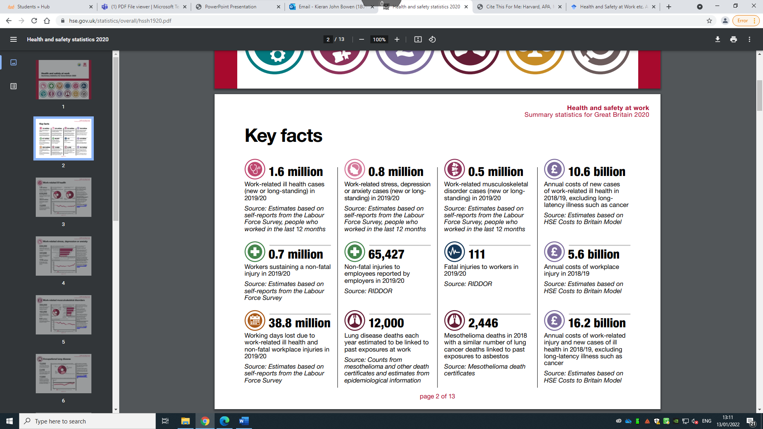
Figure 1
(Health and safety at work - 2020 statistics for Great Britain, 2022)

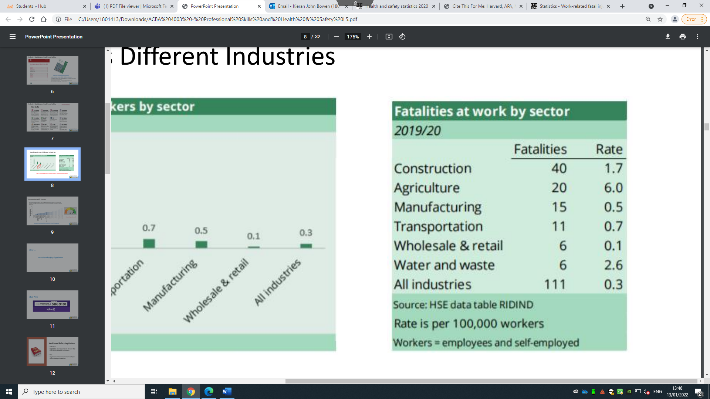
Figure 2
(Statistics - Work-related fatal injuries in Great Britain, 2021)

