
Skills for the Workplace
Module Assignment Submission
Student Name: | Carol Turnell
Student Number: | 1900187
Module No: | BMSK4006
Module Title: | Managing Enterprise in the 21st Century Reflection

Statement of Confirmation of Authenticity
By the act of making this submission, the student declares that this is the work of the student named above. The work has not, in whole or in part, been knowingly presented elsewhere for assessment, or where assessment has been built on a previous assessment, this has been identified. Where materials have been used from other sources it has been properly acknowledged. If this statement is untrue, the student acknowledges that an assessment offence has been committed.
Attention is drawn to the plagiarism and unfair practice policies of UWTSD.

Table of Contents
Refelction Submission Part 2 Managing Entrprise in the 21st Century BMSK 4006 3
Part 2 Introduction 3
2.1 The group 3
2.2 Meetings 3
2.3 Section allocation 4
2.4 Preparing the plan 4
2.5 Contrubution Skillset and Knowledge ……………………………5
2.6 Business and Entrepreneurial Skills………………………………………………………………………………………………….
References Gibbs Reflective Cycle 6
Appendix 1 Entreperneurial Characteristics Checklist 7
Appendix 2 Strenghts and Weakness Audit 8

Reflective Submission

Part 2. Introduction

For this part of the assignment I will reflect upon the process we followed to develop the business plan, how we worked together as a team to prepare the plan and what skills I have learned whiles doing this project, whiles using the Gibbs Reflective Cycle.

2.1 The Group
For this assignment we had to develop a business plan as part of a group, the groups were put together by the tutor, some were groups of 3 and others of 4.
My initial feeling on this was a little worried, as I had not worked that closely with all of the individuals in the group, so I was unsure how it would work out, also why the groups were put together by the tutor, as we were previously told we could select our own groups, as we had already had conversations about who we would group up with, then this would be changed.
I was in a group of 4 with Dorell, Claire and Debra, I was very happy with my group members, as I had communicated well with them over the last 11 months, so I was looking forward to getting started on the business plan with them all.
Once we were allocated the group, we created a WhatsApp group so that we could discuss the assignment, I thought this was a good idea as we could all keep in contact and use it to transfer information on the plan.
We discussed in the group that there was a residential weekend organised by the university to deliver the business plan module, unfortunately I was unable to attend, so I was a little worried Id of missed a large chunk of the material, but the feedback from the weekend was that not much was actually delivered, so we didn’t have anything to go by only little bits of information.

2.2 Meetings
We organised a meeting to get started on the plan, this meeting was at Claire’s home, where Dorell, Claire and I attended, Debra was on holiday, so she was unable to attend.
At the meeting we discussed what business we should come up with for the plan, Debra had agreed for us to decide as she was away and was happy for us to make the call, we discussed a Gay wedding idea, and a cake business, but our final decision was for a Beauty and Aesthetics business, as I already have a business in this field, it seemed the obvious choice, as I felt I had quite a lot of knowledge to help support the plan, everyone was happy and we decided to go with this idea for the business plan.
We then started going through the assignment business plan checklist, we had decided that Claire was going to take down the information and I was going through the check list, and Dorell was responsible for taking notes of all of the references, we found we used our own personal skillsets to do the parts of the assignment that we felt we were strong in, in those areas.
We had a system which we were all happy with, for us to start gathering the information.
We started with the introduction, where I was explaining the background and the idea of the business as I was very knowledgeable in this area, I explained the legal status of the business, along with the products and services we could offer and the price for all of the treatments we were planning to offer.
We covered lots of sections of the checklist making notes, and we all had a list of points we had to work on in our own time.
This meeting went very well, as we started to have the foundations of the plan, we ended the meeting after around 3 hours and agreed to catch up with each other in the WhatsApp group to pass on our information as and when we had it to add to the plan, Claire would then transfer this information onto the master copy.
Debra was due to return from holiday, so we were organising another meeting to go through what information we had gathered to date, we arranged to meet in costa but on this occasion Dorell wasn’t available, we agreed in this meeting who would be doing what sections of the plan check list.

2.3 Section Allocation

We decided that Dorell would start with the introduction as she was appointed as team leader by the tutor, and to do section 7, as in the previous meeting, Dorell had started to compile the references lists.
I had offered to deliver the introduction section and section 6 the costing section, as we all agreed due to the fact I already run my business that this information would be best for me to work on, I was more than happy to take these sections on as I was confident It was a strong skill set of mine.
Debra was happy to take section 4 which was the sales and marketing area, along with the operations section.
At the end of the second meeting we all had allocated sections and could then carry on with our parts of the business plan.

2.4 Preparing of the plan

I felt by this point we were all working together very well as a team, we were all focused on what we had to do, and we communicated well in the WhatsApp group, asking each other for information and helping each other with any questions we may have struggled with.
When each of us had completed certain sections of the plan we would then forward to Claire for her to add this to the master copy and for the layout of the plan to take shape.
I had sent copies of the insurance quote and price lists and adverts from the social media accounts for the appendix and we would all send the references over for Dorell as and when.
We all then send over our final work for the plan to be completed and final draft made, this was then emailed out to us all for us to view, before the final submission by Dorell.

2.5 Contribution, Skillset and Knowledge

I feel I contributed a valuable amount of information towards the plan, from my experience in the industry I was able to offer a great deal of information whilst we were going thought the business check list on our first meeting, It was information that I was familiar with from running my own business for the last 8 years.
I was able to contribute towards the marketing and sales sections by utilising the Facebook and Instagram pages from actual customer feedback, and in the competitor’s area, where I had experience in finding out this information for myself whilst trading.
I was also able to provide the team with the legal aspects from the clinical waste requirements and the HIW requirements for trading with Lasers, and with my experience in keeping in contact with the environmental health department to ensure correct code of practices were being followed, to ensure customer safety was always a priority, I feel my skills and knowledge were an advantage for me and the team in this assignment.

2.6 Business and Entrepreneurial Skills.

From a young age I have always been very work driven, at the age of 26 I opened my first business, then opening another 2 sister companies within 2 years.
I have always been very money driven, and feel I am good at spotting an opportunity to make money, I was able to see the potential in the beauty industry and the impressive profit margins with very little set up costs, this was also a passion of mine which I also wanted to fulfil, so this was a perfect opportunity to use this idea for the business plan.
From the initial idea of starting a beauty business It was very easy to identify that the avenue to follow in a 2 year period would be to progress toward the training route, where I would complete my teachers training and open a training academy, with a view to start locally, then to add additional areas, such as west wales as there is a gap in the market for this in this area.

See Appendix 1
Entrepreneurial Characteristics Checklist
Score of 449
See Appendix 2
Starting your own Enterprise Strength and Weakness Audit

References
GIBBS, G. (1988) Learning by Doing: A Guide to Teaching and Learning Methods. Oxford: Further Educational Unit, Oxford Polytechnic.
Kind regards

Appendix 1

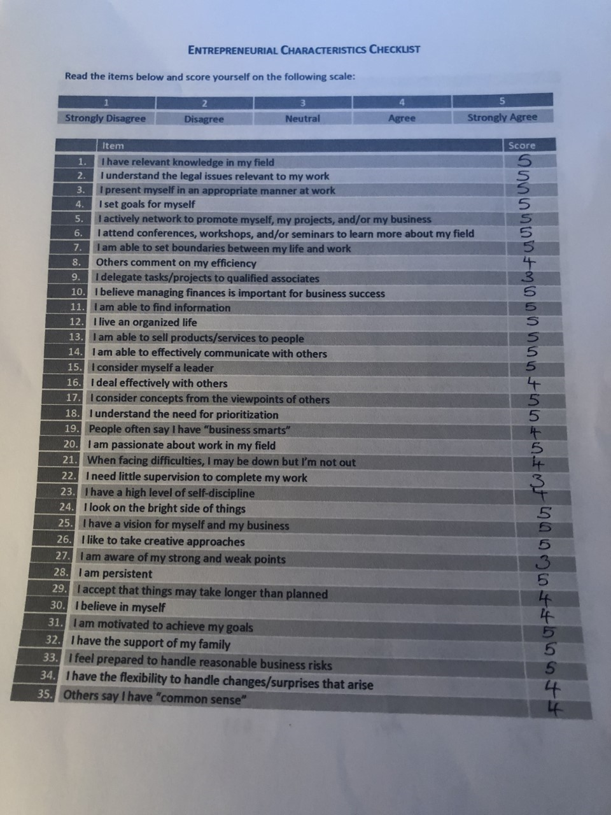

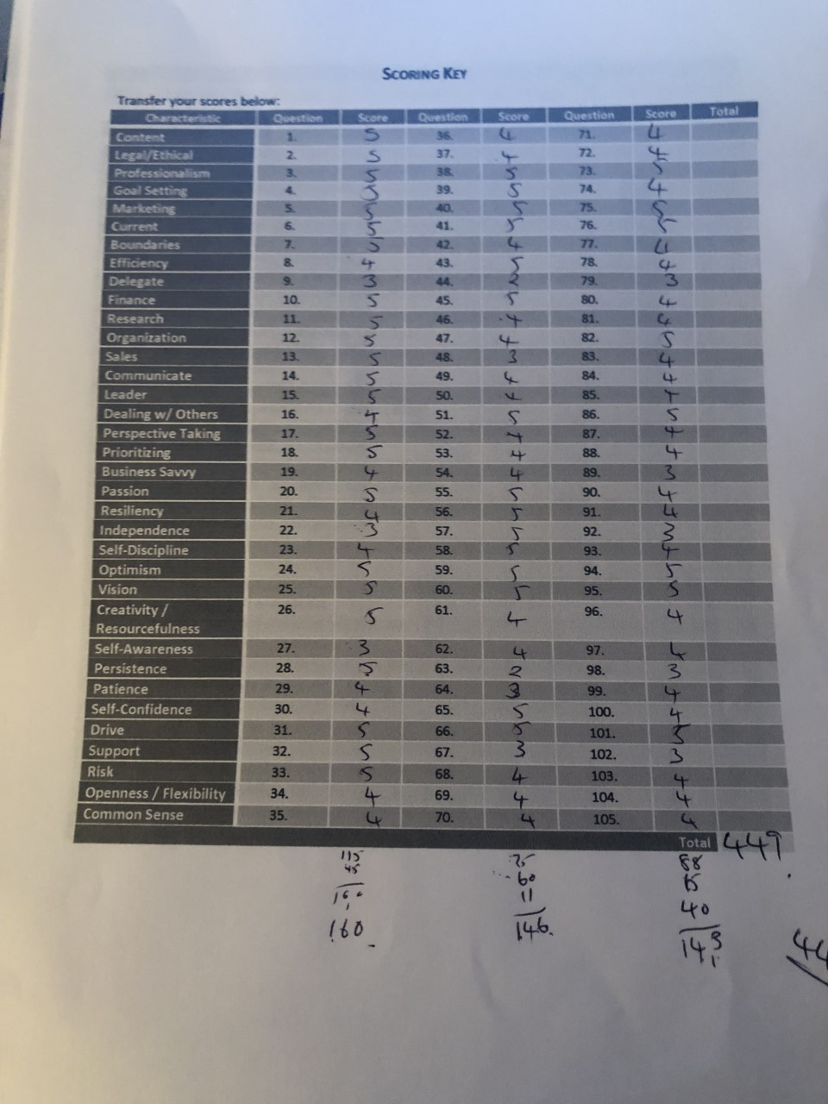

Appendix 2
Starting your own enterprise Strength and Weakness Audit
The table of general business skills below will help you to identify your strengths and weaknesses to give you a better idea of whether you are ready to start your own business.
Examine each of the skills areas listed in the table.
Ask yourself whether you possess some or all of the skills listed.
Then rate your skills in each area by ticking the appropriate number, using a scale of 1-5, with 1 as low, 2 as between low and medium, 3 as medium, 4 as between medium and high, and 5 as high.

 | Rating  Low to High |  |  |  |  | Average Rating
Skills | 1 | 2 | 3 | 4 | 5
Selling & Marketing |  |  |  | 4
Market research |  |  |  | 4
Knowing your competitors |  |  |  | 4
Market planning |  |  |  | 4
Negotiating |  |  |  | 4
Tracking competitors |  |  |  | 4
Customer service |  |  |  |  | 5
Pricing |  |  |  |  | 5
Financial Planning & Accounting |  |  |  | 4
Cash flow planning |  |  |  | 4
Monthly financial monitoring |  |  |  | 4
Bank relationships |  |  |  | 4
Monthly profit and loss statements/balance sheets |  |  |  | 4
Bookkeeping |  |  | 3
Administrative |  |  |  | 4
Work Scheduling |  |  | 3
Payroll handling |  |  |  | 4
Benefits administration |  |  | 3
Personnel management |  |  | 3
Hiring employees |  |  |  | 4
Firing employees |  |  |  | 4
Motivating employees |  |  |  | 4
Staff training |  |  |  |  | 5
General management skills |  |  |  | 4
Personal business skills |  |  |  | 4
Oral presentation skills |  |  | 3
Written communication skills |  |  | 3
Computer skills |  |  | 3
Word processing skills |  |  | 3
Fax, e-mail experience |  |  |  | 4
Organisational skills |  |  |  | 4
Intangibles |  |  | 3
Ability to work long and hard |  |  |  |  | 5
Ability to manage risk and stress |  |  |  |  | 5
Family support |  |  | 3
Ability to deal with failure |  |  |  | 4
Ability to work alone |  |  |  |  | 5
Ability to work with and manage others |  |  |  | 4
Total |  |  |  |  |  | 148

Conclusion
After you have rated yourself in each area, total up the numbers. Take the average score on the rightmost section of the table and total them to get the Grand Total. Then apply the following rating scale:
If your total is less than 20 points, you should reconsider whether owning a business is the right step for you
If your total is between 20 and 25, you are on the verge of being ready, but you may be wise to spend some time strengthening some of your weaker areas
If your total is above 25, you’re ready to start a new business now

