18th October 2013, last updated at 15:58.

Paul McCartney plays impromptu concert in covent garden

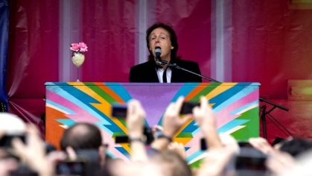
The 71-year-old performed songs from his latest album.
Sir Paul McCartney has given an impromptu gig in Covent Garden during the lunchtime rush.
Good afternoon, he told that assembled crowd of more than 2,000 fans. Welcome to Covent Garden.
"Were just going to do some songs from our new album so get your phones out... As if they werent already" he added.
The 71-year-old sang four songs from his latest album, new, from a truck parked on the piazza It follows a similar stunt in new york last week.
The London gig began at 13:30 bst, about an hour after Sir Paul announced it on Twitter.
"I'm getting ready to pop up in Covent Garden" the former Beatle tweeted. "Oh baby"
"Alright! Busking" he joked after taking to the stage watched by his daughter, Stella.
"This is a change from the '60s because we would just have been coming in from the clubs right now."
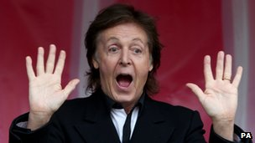
The singer opened with his current single, also called New, and closed with the same song approximately 20 minutes later, telling the audience: Thank you very much. OK now, back to work!
"It was very exciting," Sir Paul told the bbc afterwards "It felt little bit like I was in a dream - sort of a little bit spacey."
The gig was an unexpected bonus for many tourists.
"We were actually just looking around Covent Garden and we had this big surprise," said flavia, a visitor from paraguay. "Im so happy, I cant believe!"
She wasnt concerned by the abbreviated set, saying: "even five minutes would be OK Any time seeing him would be OK".
Covent Garden employee Harel, 37, said he was "disappointed, but not surprised," Sir Paul only played five songs.
While Craig Williams, who "legged it" to the show from work said, "even for that quick 10, 15 minutes, its all worth it".
"I honestly believe the Beatles music saved my life" he added.
"There were some dark times and hes just got a 'live life to the full' mentality, and I really clicked with that."
Hit-and-run
The gig came exactly a week after sir Paul was mobbed by fans, following a pop-up show in times square.
He said the shows had been suggested by Stella. "She said, what you should do is just pop up somewhere and do a gig, and everyone will just get their phones out and they'll tweet it," the star told the BBC.
"And I said, well that's not a bad idea - however, I've now got to go and do it!"
The hit-and-run concerts echo The Beatles final live performance, a mile down the road from Covent Garden, on the roof of their record label, apple.
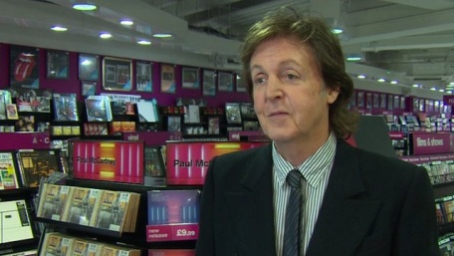
Paul McCartney: Covent Garden gig "was Stella's suggestion".
That show, in January 1969, brought traffic on savile row to a standstill and was eventually shut down by police who ordered the bands touring manager, Mal Evans, to turn off their amplifiers.
"It started to filter up from Mal that the police were complaining," Sir Paul later recalled in the beatles anthology.
"We said, We're not stopping. He said, 'The police are going to arrest you'."
The star remembered replying: "Good end to the film. Let them do it. Great That's an end: Beatles Busted on Rooftop Gig!"
McCartneys latest solo album was released on monday. Early sales data suggests the record, which was produced by Mark Ronson (Amy Winehouse) and Paul Epworth (Adele), amongst others, is likely to chart at number three this weekend
He is also due to appear on BBC ones Graham Norton show on Friday night.

