Name of University: University of Wales Trinity Saint Davids
Report Title: Organisational Change – Case Study: Jaguar Land Rover Automotive Plc

Module Name: Change Management and Stability
Module Code: BMMB 7000D (L7)
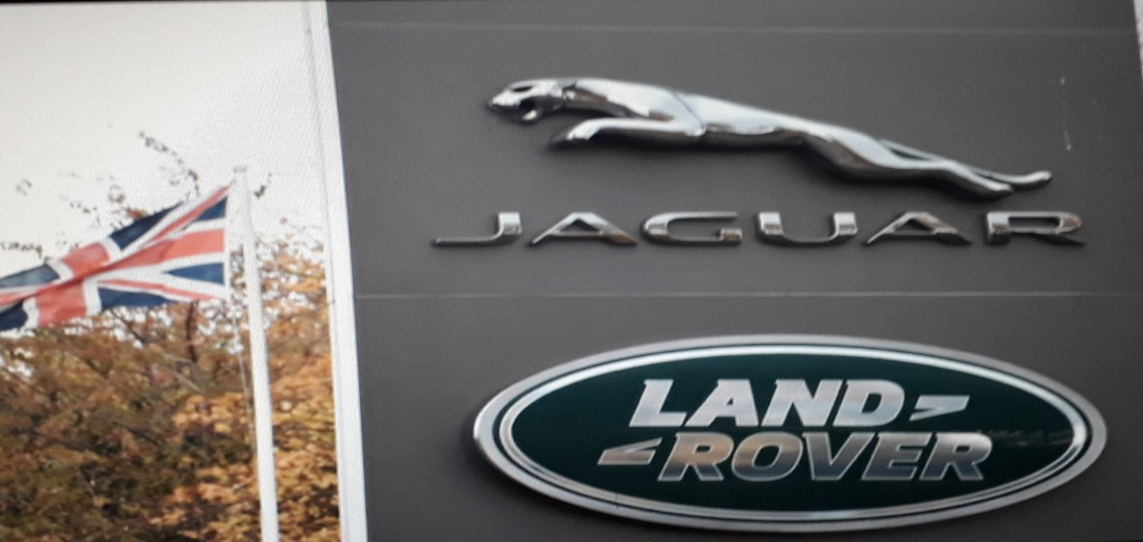
Course Leader: Prof. Roisin Mullins
Department: Business and Health Management

Student Number: George Sunday Uzonwa
Student Number: 2013467
Submission Date: 8 July 2022
Table of Contents
1.0 Executive Summary………………………………………………………….………………2
2.0 Introduction………………………………………………………………….…………….…3
2.1 Historical Overview of Jagua Land Rover………..…...…………….………………...5
2.2 Reason for Change …………………………………………………….……………...7
3.0 Critical Appraisal of the key change management models ………….……......…………..8
4.0 The Change Management Model Analysis and Utilization .............…………………….10
4.1 Kurt Lewin’s Stage Change Model …………………...………..….……………..…10
4.2 Kurt Lewin’s Model Utilization by JLR…………………………..…………………12
4.2 Kurt Lewin’s Effectiveness at JLR ………………………………………………… 12
4.3 Merits and Demerits of Kurt Lewin’s for JLR ……… ……………………………13
5.0 Further Analysis of Change Management and Utilisation ….…………………………..15
6.0 Dealing with Resistance to Change …….…………………………………………………16
3.2 McKinsey 7’S Model …………………………………………………………………7
3.2(a) McKinsey Model – Hard Factors ……………………………………..…………...8
3.2 (b) McKinsey Model – Soft Factors ………………………………….…..…………..8
4.0 Change Management Models ……………………………………………….……..……….9
4.1 Utilisation for Small Scale Change Programme………..…..........................................9
4.2 Utilisation for Large Scale Change Programme………………..……………………..9
5.0 Identifying and Dealing with Resistance to Change ……………………….…………….10
5.1 Resistance Identification Factors …………………………………..………………..11
5.1 Dealing with Resistance to Change ……………………………………..…………..11
6.0 How to Identify if the change has been completed ………………….……………….…..12
6.1 When and evidence of the Change Completeness…………………………..….……13
6.2 How to Assess the Effectiveness of the change………………...………...…………13
6.3 Possible Merits and Demerits………………………….…………………… ………14
7.0 Conclusion ………………………………………………………………………………….14
8.0 Recommendation ……………………………………………………………...…………...14
9.0 References ………………………………….…………….……………………...………….15
Executive Summary
Despite the challenges and consequences of economic meltdown to the global economy caused by the Covid-19 pandemic, Brexit, Climate Change, Wars, and subsequent economic showdown orchestrated by Credit Crunch and world leaders not acting fast enough to save our world. With the commitment to zero-emission and the gradual shift from the conventional diesel combustion diesel vehicles to hybrid, all-electric and hydrogen vehicles have become attractive and promising new norms and future for Jaguar Land Rover(JLR). Ralf Speth, Thierry Bolloré, JLR’s CEO revealed in a press conference Jaguar will become an all-electric brand going forward and the company is working towards a zero-carbon future. The paradigm shift in the face of rapid innovation supports and backed several bilateral, unilateral and multilateral regional government agreements and strong investment policies to curb the critical factors such as climate change, GDP, inflation, interest, and exchange rates affecting the automobile and transport sector along with some qualitative factors like recession that affect consumer demands. Tata Motors which acquired Jaguar Land Rover (JLR) in 2008, did so to fulfill its strategy of diversification, merger, and acquisition as a means of survival and growth.
This report covers the Strategic adoption of JLR into the premium class segment by Tata motors. Although the study has been a motivational advisory and change management agent that instigated the executive car conglomerate, JLR to rise to the challenges of new technology to support product brands that can satisfy customer demand, commit to zero-emission, and support the new way of work to enable it to stay in business in the current climate.
This submission has helped the JLR see the need to change its renewable policy, and make a new commitment to its current change management program with zero carbon investment commitment having leveraged the benefit of change before now with its small-scale hybrid and hydrogen brand program that transformed executive car market. This report focused on achieving the following outcome:
- To critically analyze theoretical perspectives and approaches to change management and demonstrate their practical application in a variety of organizational environments;
- To critically evaluate whether change is beneficial or a hindrance to organizations today by examining key internal and external drivers such as culture, leadership, power, digitalization, economic and political pressures, and the forces of competition.

Introduction
This report aims to critically analyze the theoretical perspectives and approaches to change management and demonstrate their practical application in an automotive manufacturing operations environment. The second object of this report is tied to critically evaluate the benefit compared to the hindrances of change management to the JLR from the key internal and external factors perspectives such as SWOT, PESTEL, Forces 5 Framework, and other theoretical frameworks and change models that have a direct impact on the Leadership, power, culture, and digitalization. The inquiry is aligned with both Donaldson’s structural contingency theory (2001) and Syed’s (2015) reflections regarding psychological alignment.

SWOT Analysis
SWOT analysis includes both internal and external factors that have a direct impact on JLR and its business environment. For example:
- JLR Strength is in its popularity as a British luxury automotive manufacturing brand that managed to stand above scandals with an excellent brand image.
- JLR has managed to employ and retain a skilled workforce to deliver quality and exceptional executive and performance products.
- The market entry barrier was over showed because JLR created niche product categories with executive qualities that carved their way into the rich and premium customer despite passing through many turbulent uncertain times including the Covid-19 pandemic, Brexit, etc.
- JLR is owned by TATA company which came with years of legacy and pride, acquiring JLR was a bonus of entrustment with an added sales increase and acquisition of increased market share.
- JLR has maintained one of the highest brand values in the global automobile sector and ranked 55th amongst 100 of 2016 auto ranking against 57th in 2015 which is an indication of supremacy in the segment.
- R&D Spending by JLR has been enormous to substantiate the auto conglomerate’s readiness for a sustainable future with recent spending on hi-tech.

PESTEL Analysis
PESTEL analysis includes those macro factors that impact the overall business environment of JLR such as Political, Economic, Social, Technological, Environmental, and Legal. Harvard Business School Review case study on JLR Finance and strategic management stated that there are critical needs for managers at JLR to examine three inter-relation environments such as the industry environment in which the company operates and thrives, the geographical market or country, and the wider socio-economic environment. The importance of PESTEL analysis in strategic planning of change management process requires:
- JLR organization must choose its vision, mission, and reasons for existence.
- The management of the organization must analyze its competitive environment to identify opportunities, and threats as an unexpected change in the macro-environment, and whether the threat of opportunity may impact Porter's 5 framework effectiveness which will significantly impact JLR's ability to build sustainable competitive advantage. (Harvard Business School).
- Analyze the strength and weaknesses of JLR
- Trigger developmental strategies in the face of opportunities and exert full the organization’s full strengths toward mitigating weaknesses and impact threats of the macro environment.
- Execute strategy for the building feedback loop that can help to fine-tune processes and strategies for progression.
Maintaining effectiveness and objectivity are the relenting factors of incongruities between JLR culture and the ecosystem within which the organizational change management teams operate. It is also contentious that this study savors further the key operating models that support teams at JLR to thrive and relish the complexity of the uncertain environment they operate in, and hence improve their satisfaction and wellbeing whilst delivering increased value for both the business and the consumers (Davis, 2016a). This study also looked at the rationale, approach, and operating models that liberate the capabilities of the ‘project and technical’ community (Drucker, 1999), as opposed to the apparent Scientific Management (Taylor, 1914) bureaucratic efficiency model has no relevance today.

Historical Overview of Jaguar Land Rover
The UK's position in global politics and business history, and FDA international investment uptrend placed it as one of the most prominent and accessible destinations for foreign investments. The huge Indian growing consumer goods supply-chain, and flourishing East Asian economy with incredible growing middle-class with proven indelible potential envisaged and largely perceived UK’s shared history with India as the key driver for the UK-Indian investment and hence TATA acquisition of JLR from the US-owned Ford Motor Company. JLR is guided by the following three main corporate strategic pillars:
- Integrity to do business in a fair, honest, and transparent manner.
- Develop an understanding of customer care, respect, compassion, and humanity.
- Embrace excellence and recognize that enough is not enough for all stakeholders

TATA Motors' acquisition of JLR
Tata Motors (established in 1945) is Indian largest multi-holding automobile manufacturing conglomerate, the fourth largest truck producer in the world, and the second-largest bus producer with US$8.8billion dating back to the 2008 financial year when it acquired the British Luxury Car manufacturer Jaguar and Land Rover known today as Jaguar Land Rover (JLR). Tata Motor has previously been involved in joint ventures with Daimler Benz, Cimmis Engine Company Inc., and Fiat before the acquisition of JLR in the June 2008 financial crisis for US$2.3billion, a loan that has a tight credit condition.
The global ambitions of Tata, one of the Indian largest automobile business empires have capitalized on these opportunities to resume UK operations, and acquire Jaguar and Land Rover (Annual Report Archive, 2018). Tata Motors Group currently operates three independent auto business units such as Jaguar Land Rover, Commercial Vehicles, and Passenger Vehicles that offer significant differential values propositions to satisfy customers across its segments while enjoying the privilege of a corporate and synergy approach (Economic times, 2022).
Jaguar Land Rover Limited is regarded as a British iconic luxury car despite its takeover by Ford Premier Automotive Group (FORD PAG). For this case study, this report is limited to JLT as a subsidiary of Tata Motors Limited with its head office in Coventry, UK. The core business activity of the JLR conglomerate involves designing, manufacturing, and selling the marque, the company’s luxury brands. As a further advancement, Jaguar cars and the van cover had been merged in 2002 in the group of Ford Motor Company (Mukherjee, 2022). Both marques Jaguar and Land Rover have a long history dating back to the 1930s and 1940s. They first merged in 1968 as part of the British Layland, later again separated to become independent of each other, and then as subsidiaries of BMW (in the case of Land Rover), and Ford Motor Company (Jaguar). In 2000, Rover Group was broken up from BMW and Land Rover was sold on to Ford Motor Company, becoming part of its Premier Automotive Group.
Jaguar Land Rover became an independent subsidiary of Tata Motors haven bee acquired from Ford in 2008 (Annual Report, 2010/2011). On January 1, 2013, the operations of Jaguar Cars Limited, and Land Rover were merged and renamed Jaguar Land Rover Automotive PLC.
Reasons for Change
Irresistible Restructural Need
The inherent electrification, hybridization, and hydrogenation of vehicles in travel and environmental ecosystem have become attractive with low running costs, prominent in reduction of carbon footprint and greenhouse gases to the atmosphere with an ever-improving range of models backed by zero policy and investment commitments by national and regional governments, businesses, and community organizations around the world increasingly were some the reasons on this report that made change inevitable for JLR despite the negative consequences, low growth experiences and enduring financial crisis to the global market and economy by the Covid-19 pandemic, and sequences of the economic calamities the pandemic, Brexit and extended credit crunch.
JLR has capitalized on renewable and sustainable investment policy and environmental ecosystem, plus the UK’s statutory capacity rating on infrastructure, business dynamism, innovation capacity, and institutionalism to restructure, and embrace change across its product and service brands including the switch to full electric vehicle production by 2030. The reasons for this include the following:
- Commitment to zero carbon footprint by reducing emissions, and greenhouse gases in the atmosphere by producing carbon-free electric cars and sustainable energy products.
- Support the campaign for environmental protection by giving up on combustion engine diesel and heavy oil vehicles and replacing them with hybrid, hydrogen, and fully electric vehicles that started with the organization's structural change along with its business size (Halaj, 2021).
- Commitment to change management by Adopting and adapting to a change management system that will transform the company and the entire management systems, employees, stakeholders, and partners to adapt to the new way of work caused by the pandemic, Brexit, and other economic uncertainties that trigger restructuring and make the transition from the conventional engine to fully electric vehicle.
Critical Appraisal of Key change Models
As JLR is reimagining the modern luxury car future through its two distinct British brands with new fully electric car models, mild-hybrid models, plug-in hybrid as well as the new smart patrol and diesel engines jaguars and land rovers sold 432,588 vehicles around the world in the fiscal year 2020-2022. This is a clear indication that Land Rover continues to be the global leader in luxury SUVs such as Range Rover, Discovery, and Defender models serving families around the world. Furthermore, JLR becomes the first automobile brand to unleash a fully electric performance luxury SUV, the Jaguar I-Pace and Jaguar F-Type with fully Sports exhausts.
Change is inevitable in today’s competitive and changing business environment and steep competition which is why organizational change management focuses on the significance of the big change. Change management models have been applied successfully and objectively applied using models such as Kurt Lewin Model.
Change management helps organizations to seek a collaborative new way of doing things to acquire improvement and better results across the conglomerate’s production line through effective and efficient performance aimed at meeting standards and customer expectations which applies to Kurt Lewin's change model. The employees make sharing of knowledge about task assignments, customer service, performance outcomes and decisions making, information flow from multilevel, making business plans, competitive conditions, new technological equipment, work methods, ideas for organizational improvement, share skills and expertise, share development programs, contribute to solving problems and business operation (Cummings & Worley, 2003). The study of Wenger, McDermott and Snyder (2002) states, that knowledge sharing is crucial among individuals of an organization. Knowledge sharing in organizational resources is critical for competition, sustainability, and a dynamic economy (Hakanson, 1993; Foss & Pedersen, 2002).
Furthermore, any change management process requires acceptability across the board for it to succeed. There are a plethora of models shown below regarding the key change management in an organization such as Jaguar Land Rover (JLR) that plays an important role in facilitating the businesses to adopt changes management models such as Kurt Lewin's model, Kotter’s 8 stages, and McKinsey 7’S models.
The Change Management Models analysis and Utilisation
Change Management Model and Analysis
The change management model is the process used by an organization to manage and overcome certain internal and external business challenges as listed above. JLR summary change Portfolio is shown in figure 1 below:
Below is the analysis of change management models used by JLR:
- Kurt Lewin’s Change Management Model
Kurt Lewin's model as the name entailed has been developed by Kurt Lewin in the late 1950s and it is used in three steps namely Unfreeze, Moving, and Refreeze to improve standards. “Quasi-stationary processes are not perfectly constant but show fluctuations around an average level” ( Lewin 1947). This model has certainly been utilized by JLRto identify and evaluate both the actors and factors which impact different aspects of work situations and how to change interventions could be initiated and implemented over time or span. For example, retraining employees could be the only micro factor or combination of driving forces that can put pressure on the JLR management team to raise output levels to meet consumer demands or reduce it when demand is low or several factors could be responsible. The three stages of this model have been analyzed below:
Unfreeze
This is the preparation stage when strategic planning about what business operations need to change and reasons for change has been substantiated, and the officers responsible for change are tasked with retraining forces to increase the output level in year one. Here the change leadership can analyze restraining and design an action plan to decrease restraining forces by increasing the driving forces instead. For example, here the JLR needs to deal with the issue of change rebels and involve staff and all stakeholders in the change plan explaining why the change is needed and expected long-term outcome narratives (Clegg et al., 2020).
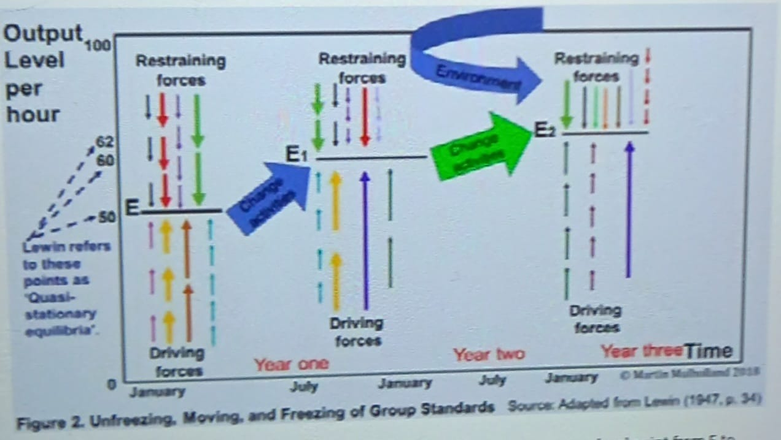
Fig 1: Kurt Lewin’s Change Management Analysis Diagram

Change (Move)

Having decided what to change, then the change will move a step further towards execution and implementation of the plan along JLR's existing structure or restructure.
Fig. 2
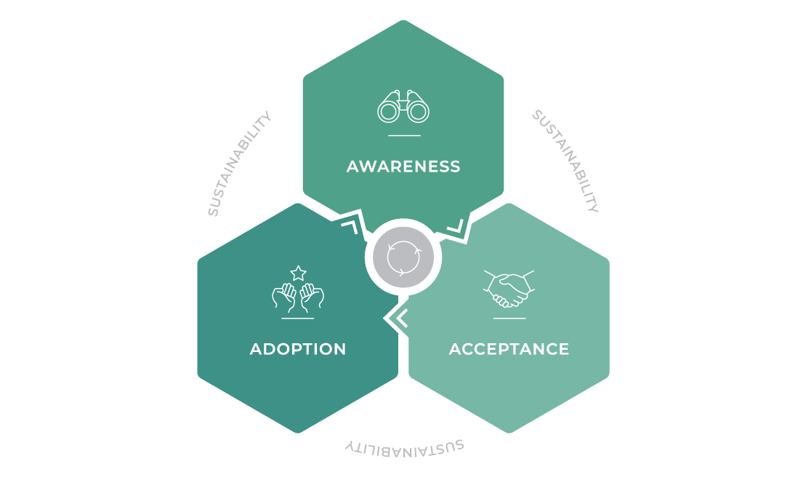
Summary of JLR change Management Portfolio – from changeportfolio.com

This portfolio fulfilled the five key change success matrices such as awareness; acceptance, adoption implementation, and sustainability.
Refreeze
This stage is the stage of review, assessment, and monitoring ensuring that the JLR change business plan has been duly followed and relevant policy and regulations have been complied with or ditched whether all things are following the purpose of implementing the change or not. The typical review of how to work in a new structure to accomplish the desired goals in the future (Halaj, 2021). At this stage learning and development, innovation, and employee training are necessary to prepare staff for continuity, stability, and sustainability in the future.
Kurt Lewin’s Model Utilisation by JLR
- To identify and appoint individuals and groups of individuals that can influence the change and make the process as smooth as possible
- Knowledgeable of the environment of the influential individuals or groups
- Assess the forces influencing individual or group resistance and design a change program that deals with them and drives standards. Knowledge and understanding about developing the motivations of influencing individuals and groups.
- Implementation of the program of change that unfreezes, changes (move), and refreeze those standards by reviewing them.
Kurt Lewin’s Change Model Effectiveness
Lewin’s change model is effective for the JLR business model for the following reasons:
- The huge financial investment policy and regulatory support within the JLR business environment.
- Excellent change agent for JLR capable change management.
- Excellent SMART objectives
- Robust change programs that promote, and support a cleaner, healthier and safer environment and deliver future values critical in stopping climate change.
- Excellent duration for delivery of JLR change program.
- Excellent business culture
- The change management agent has enough power to deliver the change task
- Support for individuals and groups exerting restraining and driving forces
Merits and Demerits of Kurt Lewin’s Model

Merits of Kurt Lewin’s Model
- Having three elements: unfreeze, change (move) and refreeze made the model easier to understand and apply.
- Provides a clear, visual, and practicable change overview.
- The model is suitable for most businesses.
- Lewin’s model can easily be applied in analyzing change business environment to determine where change is required.
- The leadership infers in this change model is democratic as teams including both restraining and driving forces are consulted.
- The change agent finds the model supportive in developing the communication plan and change program that connects and support groups collaboration across the organization.
- The highlights of the model include the need to underpin new behaviors and operations at the refreezing level.

Demerits of Kurt Lewin’s Model
- There is no specificity for the skills that must be possessed by a change agent
- The model shows no particular way to identify potential restraining and driving forces.
- The issues of conflicting goals that the change agent may have including concerns that surround restraining and driving forces remained unaddressed by this model.
- Also, there is a lack of realistic change project duration within which implementation is expected.
- Lewin’s model does not address the effect of autocratic leadership on the change program if adopted by the change agent.
Criticisms of Kurt Lewin’s Change Model
- The model is too mechanistic and simplistic
- The model takes no note of the influence of politics and power in the organizations.
- Can only be applied in incremental change.
- Promotes only management driven-approach

Further Analysis of Change Management Models
Although Kurt Lewin’s change model was JLR’s first choice, with Kotter’s 8 stages in the frame, there has not been a proper utilization of the models discussed above and hence the change management strategies of the British Automotive Giant had suffered set back to some extent. Furthermore, the auto conglomerate also adopted structural as well as an operational change plan from combustion heavy oil engine vehicles to full renewable electric vehicles by 2039 (David. and Petrovičová, 2022).
It is another worth considering for the fact that the company had made a vision with regards to the adoption of the change in its structure along with the size of its business. It had to be merged numerous times after careful planning and thus the plan became easy to execute. Even though the company has also faced several hassles in the form of resistance from all working staff but eventually it managed to survive these days. Initially, it had to merge several times but after the size of the business has grown significantly then the many times it had to separate due to some reasons. It had to face the criticism of several investors and other major investors. The company has practically implemented the model Mickensy model of key change management. According to this model, a change program needs to break down into several components that could be flexible and easy to do. In this case, the JLR initially had breakdown all its goals into small goals that were easy to achieve and the strategies used to get the desired outcome were not complicated. The company had decided to increase its revenue after it had been introduced as a holding company when it was acquired by Tata Group. There has been some increase in its revenue as it started dealing with other new models of Ford Motors that had been acquired by millions of businessmen at that time (RAMKUMAR, 2022).
On top of that, the company also emphasized its team building in the form of hiring competent staff, and several On Job training sessions had been conducted during those days when it seemed to be very challenging for the company.
Dealing with Resistance to the change
Resistance to change is inevitable according to research studies due to certain factors that individuals or groups of employees are not satisfied with. For example, the internal union representatives may be forced by influential individual or group of employees not to agree with certain change plans which make adoption of those plans difficult in the change process. However, there were several pros to adopting these changes in the form of revenue maximization and the prosperity of the business enterprise (Molina et al., 2022). On top of that, the company was looking forwards to building a brand image in the mind of almost all the people. The main reason for the resistance from the people was that the staff was not willing to take on more responsibilities as the new structure of the business had increased their Job Descriptions to a large extent. Even though they had been provided several training sessions on the floor but it had added to their workload which was not acceptable. Moreover, there was a threat to the jobs of numerous people who were not willing to take on more responsibilities as the company started hiring those people who could be hard workers, responsible, and can facilitate the business to move forward.

Identification of Factors
These factors had been identified when the people did not support the idea of bringing change in its structure as well as the size of the business. Not only this but also the company had brought a significant change when it had to converted from fueled vehicle to electric vehicle as it affected the revenues of multiples people i.e suppliers and the demand of the petrol had been dropped to some extent. Since the use of petrol is necessary for these fueled cars having no substitute and thus the monopoly of the petrol had been affected to a large extent. The usage of electric cars had given rise to a perfectly competitive market which was a good sign. Last but not the least, an overwhelming number of people had to lose their jobs as a result of the decline in the operational activities of the company (David. and petrovičová, 2022)

Dealing with Resistance Factors
Jaguar Land Rover managed to face these challenges by using several effective measures. These changes had not been accepted by a few employees and other stakeholders as it could influence their dividend income as there would be a significant change in the size of the business. However, the company had practically implemented the models to a large extent in the form of making a detailed plan and splitting down this major plan into small achievable components. It had followed the Lewins change management model to a great extent as it had made plans regarding what to do and how to do it. It decided to change its structure and the size of the business and then seek out all those possibilities that could be a strength for the business in doing that (Kashan et al., 2022). It identified all the opportunities which could be beneficial for the company while executing its plan. The environmental campaign all over the globe was one of the biggest opportunities that facilitated JLR to adopt electric motor cars (Kaberi and Kung’u, 2022). Furthermore, the rising oil price all over the world had been another opportunity for the company in adopting the new idea concerning the resistance by employees, and other stakeholders, the company announced its new dividend policy as per the revenue of the business. Moreover, a new team of employees had been hired who were willing to take on more responsibilities and give their dedication to the work (David. and petrovičová, 2022).
Methods for Clarifying that the Change Program has been Completed
The following good metrics for measuring change activities will help JLR and other organizations involved with change management programs to measure or determine when the change programs have been completed:
- Speed of execution
- Performance improvement
- The program key performance indicators (KPIs) set before the implementation
- Adherence to the timeline or duration
- Benefits realization and return on investment (ROI)
Although, these may vary, depending on the tracking methods used, including successful implementation, and accomplishment of targeted objectives. For example, the JLR change program may involve a new brand executive electric car model implementation or a different technology plan such as a sustainable Battery technology program. The success of these programs will be determined when relevant stakeholders are benefiting from the use of the new systems or processes or maybe productivity or sales have increased. In that case, if your employees cannot reap the benefit of the new product or technology, it will be difficult to measure the success of the change program internally. It is then not advisable to start external distribution because the organization’s bottom line needs attention.
Methods for Assessing the Effectiveness of a Successful Change program.
Take a look at this blog post from Jeff K M, whose church was building a new Sanctuary building for which the congregation will be paying. The church created a steering committee, manned and controlled by members of the congregation. Inviting members of the congregation to participate in the real project, evaluation, and feedback process during every stage of the process made them feel a valuable part of the process making them embrace the change management process by making an input.

Fig.3 Church Sanctuary Project - Jeff's blog post

This business change management lesson from this is that getting members committed to the process was an integral way to ensure that everyone is on the same page of the change management process, which in itself will be a major success. Therefore, change management is not limited to large corporations and known brands only.

The employees, shareholders, and stakeholders including external partners involved with the change program might want to poll to see how the change program has affected their experiences in the following ways:
- How friendly the new system is or user friendly
- Ability to meet or increase customer or consumer experience
- Whether the systems maximize efficiency or allow autonomy or simple manual decision or are more likely to increase profit and create an opportunity for gaining market shares.
- Whether the polls clarify the successes of those potentials and operational changes along the entire change process.
For example, the business values of the change process of the JLR company could be determined by the following measures:
- User login volume,
- Quality of successful operations carried out
- Successful volumes of the transaction,
- Audit and compliance findings, and
- Culture of honesty and transparency.
Again, being good is never good enough because culture requires constant and continuous monitoring, and improvement for the long-term employee and customer journey. Along that line, change actors might decide on the metrics for enough success when they become comfortable to transition out of the implementation stage.
In that case, the following cultural values must be tracked:
- Employees' confidence and trust in their leadership,
- Employees feeling valued,
- Freedom to make mistakes and learn from them,
- Room for training and personal development,
- Sense of job security, and
- Others (e.g leaders walk the walk).

Conclusion
In today’s business porous and inflationary business environment, businesses including automotive industries such as JLR find themselves in an unpredictable pandemic economic, turbulent markets, self-eclipsing technology, and dramatic demographic trends that make change imperative. Many theories have been given by different researchers, like the action research model (French, 1969); the positive model by Cameron, Dutton, and Quinn (2003), and Lewin’s change model (Lewin, 1947). Adopting a change company is challenging for the JLR company but inevitable. The change management team collaborated with other influential change agents to deal with the individual and group of employees, and other stakeholders’ resistance while dealing with micro and macro factors that impact its business environment. JLR has made significant success in the short-term implementation of Kurt Lewin’s model to transform and accomplish part of its sustainable objectives given it a competitive market advantage. Having effectively and successfully adopted the Kurt Lewin model, JLR also planned to apply a combination of theoretical models to achieve its long-term strategic sustainable goal of zero-emission. JLR product brand has been strengthened with extensive structural adjustment and market sustainability strategy supported by strong restructuring, and change policy which the business currently leverages.
The company uses a gradual change approach that allows the benefits of continuing production across its product brands. For example, the company recognizes that conventional combustible diesel and petrol vehicles are still popular in East Asia and Africa, while hybrid electric; hydrogen, and fully electric vehicle models remain popular in the western world and Eastern blocks. JLR strategy is committed to satisfying these segments of its market brands while committed to its fully zero-emission by 2050 to get rid of combustible Engine diesel and petrol brands by 2039.
Recommendation

By Reinventing and Repositioning the organization one can deal with all the opposition
to change (Jaguar Landrover CEO). Don’t delay the change activity as time and tide wait for no
body. If the market and environment are monitored, the market and the environmental, change
will be anticipated and forecasted early and easily, Harvard Business School (2007).
Change today and not Tomorrow as there may be no tomorrow if the problem escalates.
Do not let bureaucracy hinder change. Change is for the good and is possible through proper
communication. Change is simple but needs to be adapted well for anticipated results
accomplishment. It is important to engage influencers’ amongst the employees to become agents
of change in other to quell resistance or reduce it to a minimum. All concerned parties should
be aware of the anticipated change plan and the short and long-term benefits.

References
Berrett K., Bäckstrand, J., and Halldórsson, Á., (2022). Enhancing theorizing in purchasing and supply management through middle-range theories. In Handbook of Theories for Purchasing, Supply Chain and Management Research (pp. 80-93). Edward Elgar Publishing.
Cameron, K., Dutton, J., & Quinn, R., (2003). Positive organizational scholarship: Foundations of a new discipline. New York:
Clegg, B., Chandler, S., Binder, M., and Edwards, J., 2020. Governing inter-organizational R&D supplier collaborations: a study at Jaguar Land Rover. Production Planning & Control, 24(8-9), pp.818-836.
Cummings, T. G., & Worley, C. G., (2003). Organization development and change (8th ed., pp. 1–694). California: Melissa S. Acuna.
DAVID, S., and PETROVIČOVÁ, K., (2022). Floristický a vegetačný prieskum vodných nádrží v areáli jaguar Land Rover slovakia v nitre floristic and vegetation survey of water reservoirs in the area of jaguar Land Rover slovakia in nitra.
DAVIS, M. 2016a. Deciphering the current Vehicle Attribute Delivery context. WMG: University of Warwick. Unpublished work.
de Boer, M., Gaylard, A.P. and Parmar, B., 2022. The Aerodynamic Development of the New Range Rover Evoque (No. 2022-01-0890). SAE Technical Paper.
DONALDSON, L., 2001. The contingency theory of organizations, London, SAGE.
French, W. (1969). Organization development: Objectives, assumptions, and strategies. California Management Review, 12, 23–34.
Hakanson, H., In P. Beije, In, P., Groeneppen, J., & Nuys, O., (1993). Networks as a mechanism to develop resources in networking in Dutch Industries. Leven Apeldorn: Granat. (Eds.)
Halaj, M., Vančová, M.H. and Močarníkova, K., 2021. The Decision-Making Process in Jaguar Land River Nitra.
https://changefolio.com/wp-content/uploads/2020/08/ChangeFolio_Triple-A-Model.png
https://www.coventrytelegraph.net/news/coventry-news/jaguar-land-rover-new-boss-19841523
https://economictimes.indiatimes.com/industry/auto/auto-news/tata-motors-group-businesses-are-self-sustaining-to-attain-net-zero-automotive-debt-by-fy-24-says-n-chandrasekaran/articleshow/92254835.cms?utm_source=contentofinterest&utm_medium=text&utm_campaign=cppst
https://www.expressandstar.com/news/business/2022/05/12/jlr-reports-annual-loss-for-2021-2022/
https://www.limelights.com/insights/our-top-3-frameworks-to-drive-organizational change?utm_term=change%20management%20process&ut
http://www.siamindia.com
Juniyanti, D.P. and Agustin,2022 A., Change Management: A Strategy for Developing BUMDES.
Kaberi, L. and Kung’u, P., 2022. Strategic Change Management Practices on Performance of Savings and Credit Cooperative Societies in Kiambu County, Kenya. International Journal of Business Management, Entrepreneurship, and Innovation, 4(1), pp.20-35.
Kasana, D., Dodd, J., Smithwick, J., Shalwani, A. and Lines, B., A Quantitative Assessment of Change Adoption Success within the Facility Management Industry. In Construction Research Congress 2022 (pp. 993-1001).
Kashan, A.J., Lay, J., Wiewiora, A., and Bradley, L., 2022. The innovation process in mining: Integrating insights from innovation and change management. Resources Policy, 76, p.102575.
Lewin, K.,1947. Field theory in social science. New York: Harper & Row.
Lewin’s change management model. (1947). Understanding the three stages of change. Available at: http://www.mindtools. com/pages/article/newPPM 94.htm. (Accessed on 07 July 2022).
Molina, R.I.R., Sukier, H.B., Castro, L.C.M. and Raby, N.D.L., 2022. People Management model from a sustainable approach: theories and reflections. Procedia Computer Science, 198, pp.596-601.
Mukherjee, D., 2022. A case for Tata Motors' acquisition of Jaguar Land Rover: strategic implications of the takeover. International Journal of Strategic Business Alliances, 7(1), pp.69-80.
PESTLE Analysis. 2018. What is PESTLE Analysis? A tool for business analysis [accessed 7 April 2018]. Available at: http://pestleanalysis.com/what-is-pestle-analysis/
Philip, Siddharth Vikram (15 February 2021). "Jaguar's Electric Shift May Leave U.K. Plant With No Car to Make
Ramukar, S., 2022. Role of Inter-Firm Networks and Relationships in the Adoption and Diffusion of Eco-Innovations to Accelerate the Circular Economy Transition.
TAYLOR, F. W., 1914. The Principles of Scientific Management, Harper.
SYED, M., 2015. Black box thinking: the surprising truth about success (and why some people never learn from their mistakes), John Murray. Woolgar, A., 2021. Land Rover fails to defend 3D shape mark oppositions. Journal of Intellectual Property Law & Practice.
Wenger, E., McDermott, R., & Snyder, W., (2002). Cultivating communities of practice: A guide to managing knowledge. Boston, MA: Harvard Business School Press.

Appendix
Brief Pictorial representation of Jaguar Land Rover Executive Brand History 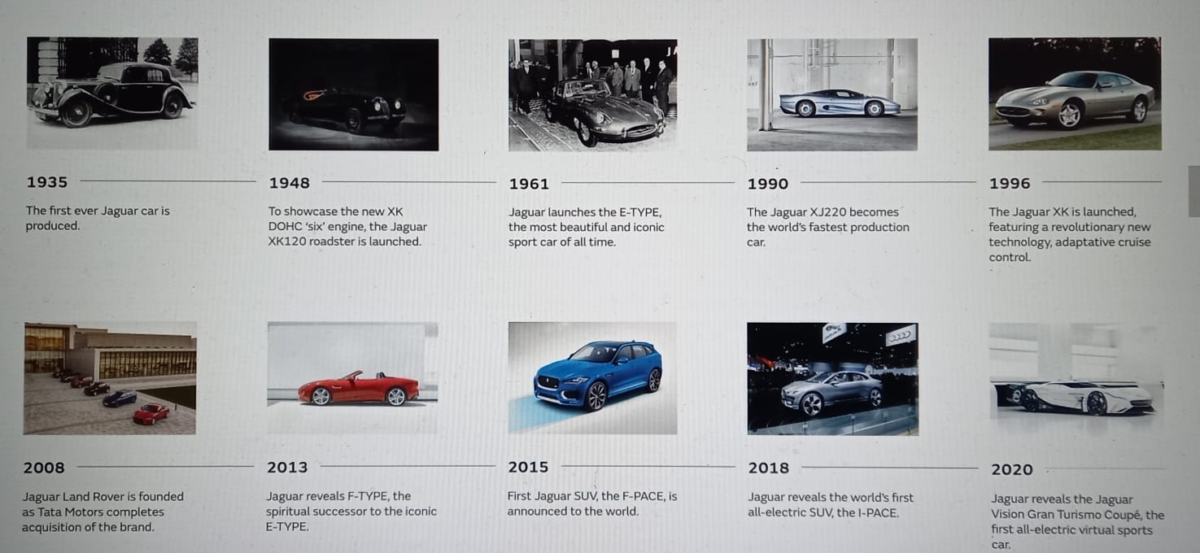
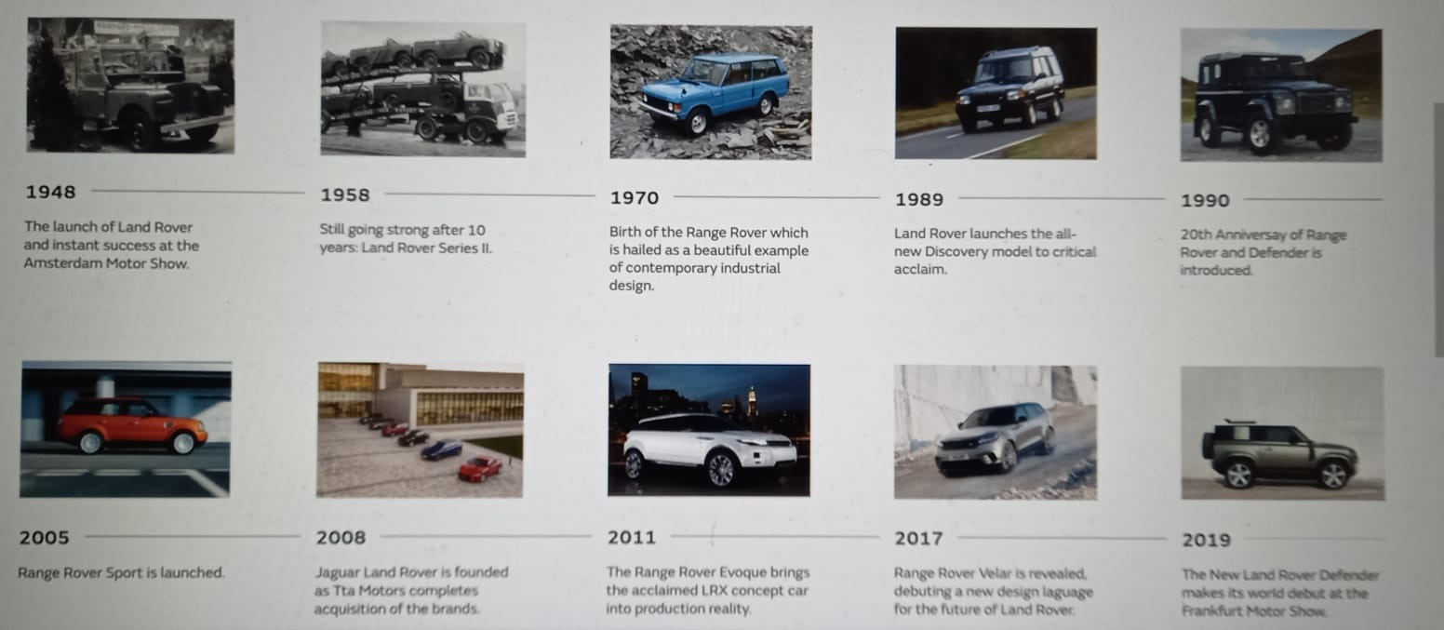Pictorial overview of Jaguar Land Rover Executive Product Brands and Year of Release.

Change Program in the Jaguar Land Rover
Assessment of Program’s effectiveness
The decision of this significant change in the structure of the organization was complicated and the execution of the plan was another tough step that had been taken by the company. However, denial of the fact that the program will eventually prove its future authenticity and significance is impossible. Even though several people had lost their jobs but the program encouraged creativity and instigated the people to work hard so that the program could be executed properly. The use of electric cars had c created jobs for several skilled people who might be jobless otherwise. A significant number of electric engineers had been given chance to demonstrate their skills and thus work for the company. According to research, there had been an increase in the employment rate of those skilled people by around 45% (Kasana et al., 2022) which played an important role to grow the size of the economy. The most important thing is the initiative of the company for the protection of the environment and to keep the earth healthy and secure from a plethora of diseases.
Practical examples – Jaguar Land Rover
The company had facilitated all its consumers to meet their needs in the form of introducing electric cars and hence promoted the idea so that the campaigns regarding environmental protection could be supported. On top of that, the change in the leadership from autocratic to democracy and hence shaped a new vertical functional structure of the organization. According to the research articles of Cecrece and chase 2012, the company started merging with other automobile companies to promote the supply chain in such a manner that the revenue could not be decreased and hence protecting the rights of the shareholders (Cecrece and chase 2012).

Furthermore, the acquisition of Tata motors had been beneficial for the employees as it created several job opportunities for the people. However the change in the structure of the organization had added some burden on the employees but the company managed to motivate them in the form of perks and other incentives (Molina et al., 2022). The company has boosted its sales up to 54.5% and there could be an increase by the end of this decade. Moreover, the company is going to create job opportunities for more than 2000 people all over the globe in its different regions and branches (Philip, 2021).
Last but not least The company has determined to fully convert its operational activities and all the vehicles into electric by the end of 2025 and several engineers and technical workers have been assigned this task for which the company is spending an enormous amount of funds (Legget, 2015).
Other Change Management Models on Jaguar Land Rover’s Utilisation Plan

Kotter Change Management Model
This theory has been presented by a professor at Harvard University which emphasize on all people are the party to the change process (Harvard Business School Website). This theoretical model has 8 segments such as create; build; form; enlist; enable; generate; sustain; and institute (Kotter, 1995). The first segment signifies the importance of change and highlights in urgency the actions that may be required outright. The second deals with building capable correlation (team) that can develop and coordinate the change plan and motivate the people in a team. The third stage involves developing realistic vision and mission strategies for achieving the change program. The fourth segment is about persuading employees and stakeholders to recognize the need for the change, support, and buy into it. The fifth stage involves eliminating the change barriers including rules and regulations, ineffective systems, etc. The sixth involves creating a short-term win by keeping concerned people motivated to enable quality delivery. The seventh stage involves increasing the tempo throughout the process till the vision is accomplished. For example, the final segment suggests maintaining the change even if the desired goal has been accomplished and the desired outcomes have been achieved (Woolgar, 2021). This is why JLR has considered this model to alternate with Lewin’s model currently in use in the company.
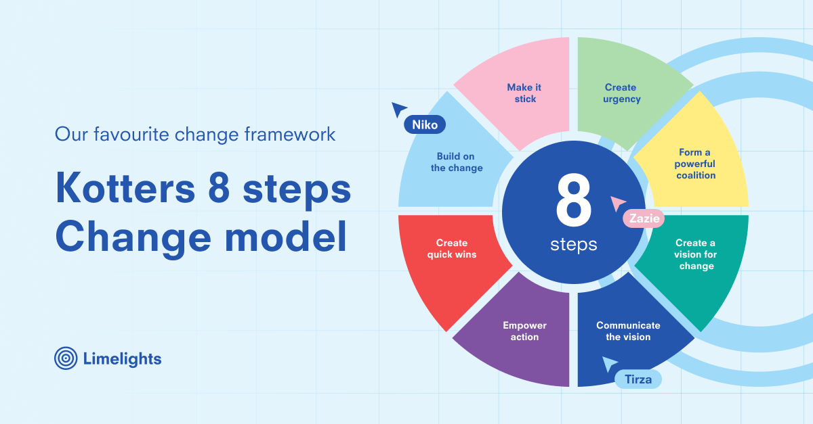
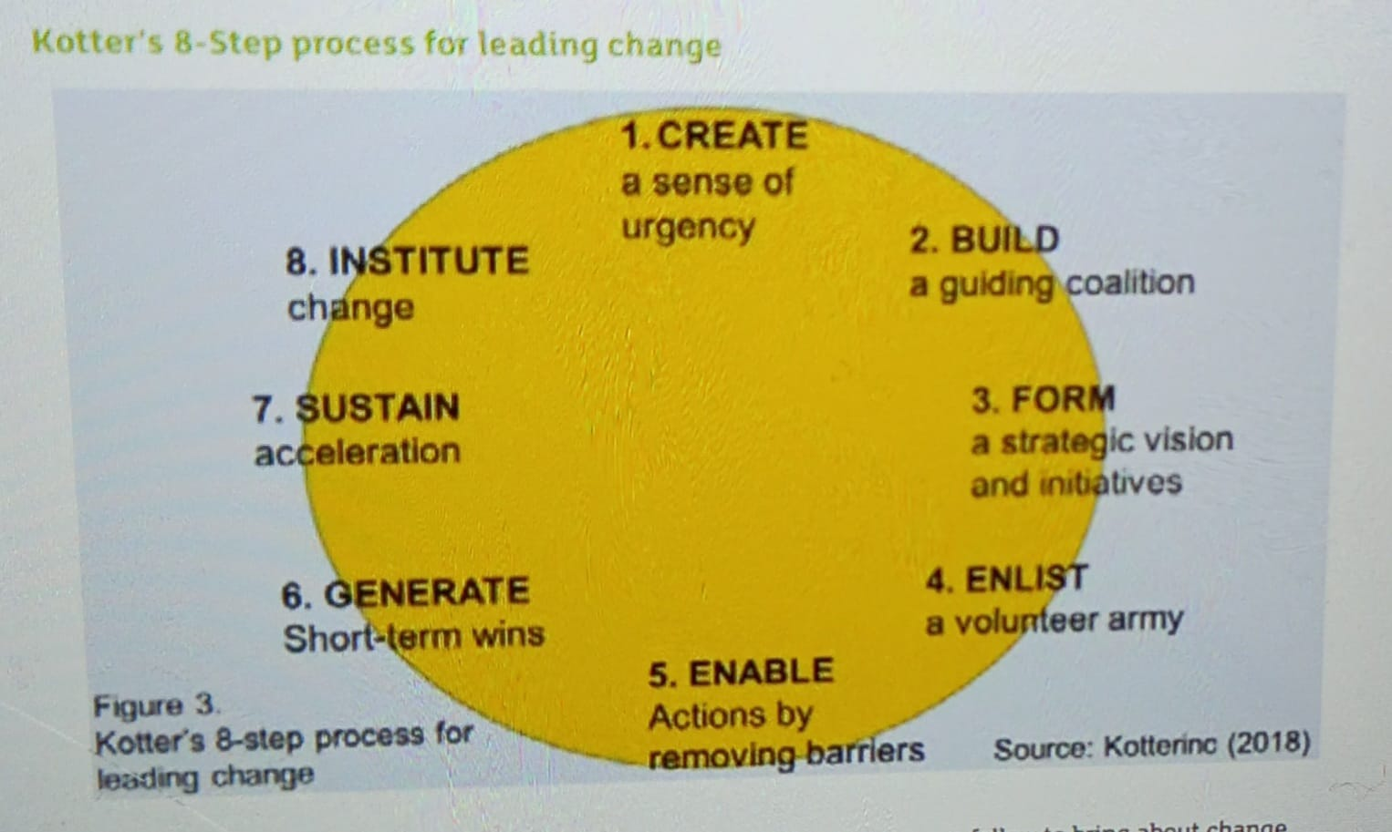
Fig 2: Kotter’s 8 stages of change management analysis
How JLR uses Kotter’s Change Model
- The model can be used for the identification of steps of the change process at JLR.
- Help to understand the change requirements at every stage
- Exhibit the importance of communicating the vision and values of change can be inspiring and motivating factors for employees to embrace change plans.
- Change programs must be designed for both short-term and long-term success.
- Kotter’s model provides the tool for JLR to implement change to achieve its vision.
- It also supports required working behavior and ethics at the end of the change process.
Merits of Kotter’s Model
- Consists of 8 stages that are easy to understand
- Provides an easy and visual overview of the proposed change programs
- Easy to apply in most change business environments
- Facilitate analysis of the business environment
- The model supports the development of a change program by the change agent inclusive of information dissemination within teams.
- Infer empowerment to the stakeholders and leadership style.
- The model highlights change activities along the stages.
Demerits of Kotter’s Model
- The model did not deal with the specificity of skills and capabilities the change agent must possess.
- The duration of the change program implementation remains uncertain.
- The time of change at each stage is uncertain.
- The duration for change pressure execution and time of accomplishment is unaddressed.
- There is uncertainty around the provision of details about how to execute each stage.
- Does not cover actions that may be needed to get rid of the likely barriers
- Kotter’s model did not address specific behavioral aspects.

Criticisms of Kotter’s Model
The model is based on a rigid approach; irrelevant in certain contexts aspects; based on limited research; difficulties in change management; and difficulties in dealing with the proposed change management. In the case of JLR, the employees have not been mentally prepared for Kotter’s change and hence the company had to face resistance from them the resistance has put the organization into hassles which ultimately affect the revenue and other operational activities to a large extent (de Boer et al., 2022).

McKinsey 7’S Model Analysis
According to this model, a change program needs to break down into several components that could be flexible and easy to do. Moreover, the organization can be facilitated to emphasize its vision and main target. On top of that, the model instigates a company to focus on its structure along with its working staff and their training so that they could be capable of accepting the new change in the organization. McKinsey 7’S Model of Jaguar Land Rover is discussed as below:

Figure 3 McKinsey 7S Models (Author’s own)

McKinsey 7’S Model Stages
Strategy
- Well-defined strategy – communicated to all stakeholders and employees JLR
- A clear set of roles and responsibilities
- Consideration of competitive position and available resources
Structure
- Flatter organizational hierarchy structure
- Secured employees with developed senses of recognition and empowerment.
- Hybrid level structure.
Systems
- Well-defined controls and systems.
- Informal discussions and observations.

Soft Factors of McKinsey 7’S Model
Shared Values
- Well-defined strategy – communicated to all stakeholders and employees of Jaguar Land Rover
- A clear set of roles and responsibilities
- Consideration of competitive position and available resources
Skills
- Skills-based training for employee development and improvement
- Focus on employee skills for non-substitutable competency.
Style
- Participative leadership style in Jaguar Land Rover.
- Interaction of employees and stakeholder groups.
Staff
- Competent employees for the management of global operations
- Identification of employees’ needs and lacking areas.

