Internet protocols

IP Addressing
Report

By
Zlatka Ciorica
Student ID: 1905836
BCs Cloud Computing Level 4
University of Wales
Trinity Saint David London Campus

Date:29/12/2019

Content:
I.Internet Addressin Version 6……………………………………………..page 4
1.IPv4 and IPv6…………………………………………………………..page 4
2. Different Types of IPv6……………………………………………….page 4
2.1. Anycast address…………………………………………………page 5
2.2. Multicast Address……………………………………………….page 5
2.3. Unicast address………………………………………………….page 5
2.3.1. Global unicast address…………………………………….page 5
2.3.2. Link-local addresses………………………………………..page 5
2.3.3. Site-local-use unicast……………………………………….page 5
2.3.4. IPv4-compatible IPv6 unicast……………………………page 6
2.3.5. IPv4-mapped IPv6 unicast………………………………page 6
3. Representation of IPv6……………………………………………….page 6
II. IPv4 and IPv6 addressing scheme for a school of Management and Engineering
…………………………………………………………………………………page 8
1.School of Applied Computing: ……………………..……………..page 8
2.School of Automotive Engineering ………………………………page 8
3.School of Engineering: ……………………………………………page 9
4.IPv6 addressing of 6 servers and MP and ISP……………………page 9
References…………………………………………………………………….page 10

List of Figures:

Figure 1 (Figure 1 IPv6 types of Addresses)………………………………….page 5
Figure 2(representation of IPv6)………………………………………………page 7
Table 1(School of Applied Computing-ipv4 addressing)…………………….page 8
Table 2(School of Automotive Engineering-ipv4 addressing)……………….page 8
Table 3(School of Engineering-ipv4 addressing)……………………………..page 9
Table 4(ipv6 addressing)………………………………………………………..page 9

- Internet Addressing Version 6

- IPv4 and IPv6
IPv4 is widely used in present days. They have been some newer components and functions, updates and renovations but looks like that the combinations will exceed the limit. Here comes the newer IP addressing version IPv6 which some say is inevitable and others still believe its no need for the upgrade. It is believed that IPv6 will replace the present version 4 when the the Internet would no longer be able to service the needs of the users. Looks like the address system is not able to keep up with the Internet itself. The effort now is using of all left unallocated addresses. Ipv4 was designed for simpler days without take into account the growth. The problems are limited address hierarchy, small address size, numerous functional limitations. Ipv6 is developed to avoid all the problems with the Ipv4. Once the Ipv6 is accepted won’t be just loading a new software. The process can be described like technical migration for elements to be moved. It will take maybe years for completion. (M. Sportack, 2003)[1]
IPv4 limit of addresses is 4.29 billion 32-bit which was enough in 1980. Now the number of addresses needed are a lot more than the actual population of Earth. The answer is not the person, it is how many devices per person are connected to the Internet. We can take in account the obvious: computers, laptop, tablets, mobile phones. There are devices which people don’t realise that have IP addresses like satellite boxes and cars. Here comes the role or if I can say the need from IPv6. The new version gives more addresses and the chance for improvement in IP and protocols. Afterall IPv6 is finally enabled by default on every major operating system (Linux, Mac OS, Windows), all mobile operating systems and gaming stations (Microsoft Xbox One and Sony’s PlayStation). It is expected by 2020 another 35 billion devices and half of the world’s population is yet to get Internet access. When we are nearly out of IPv4 addresses IPv6 is finally adopted. (Rick Graziani, 2017)[1]
- Different types of IPv6
There are three different functional categories IPv6 addressing: anycast, unicast and multicast. Version 6 doesn’t use broadcast addresses, but multicast address type. Unicast is for single interface and could be several types like global, reserved and link local. Multicast type is one-to-group and enables more efficient use of the network and has large address range. The anycast IPv6 version is one-to-nearest and many devices can share the same address. (www.learningcisco.net, 2020)

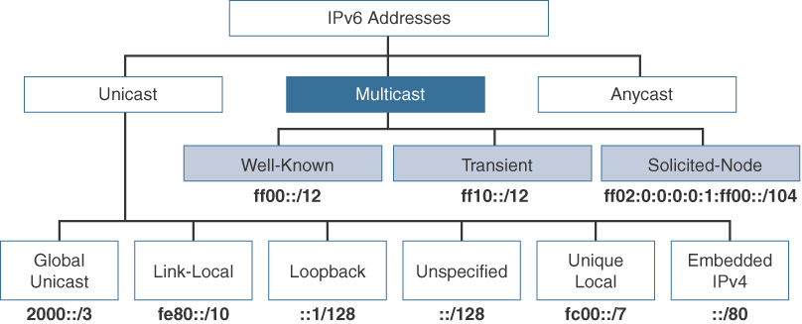

Figure 1 IPv6 types of Addresses
(sourse: IPv6 Fundamentals: A Straightforward Approach to Understanding IPv6,2017)
2.1.The Anycast address is made very simple to assign the same unicast address to more than 2 hosts, which are functionally equivalent. Anycast can be created of any unicast address. These type of IPv6 address routes ‘packets’ to the ‘closest’ host. This leads to solving the problem with geographically dispersed but functionally equivalent hosts. For example, the distributed Web sites can be served successfully without causing congestion in the Internet. (M. Sportack, 2003)[2]
2.2 Multicast addresses- the technique used here is a device sends a single packet to many destinations or one-to-many. Looks like multicast is better option than broadcast. Representation of IPV6 Multicast Address is ff00:0000:0000:0000:0000:0000:0000:0000/8 or ff00:0:0:0:0:0:0:0:0/8 and the compressed version is ff00::/8. (Rick Graziani, 2017). The structure is starts with an 8-bit 11111111, 4-bit lifetime indicator for permanent multicast group , 4-bit score indicator that limits the reach of multicast group within a network, 112-bit identifier. (M. Sportack, 2003)[3]
2.3.Unicast addresses are specialised which makes them controllable. They were developed five types of architecture: aggregatable global unicast address, Link-local-use unicast, Site-local-use unicast, IPv4-compatible IPv6 unicast, IPv4-mapped IPv6 unicast. (M. Sportack, 2003)[4]

2.3.1. Global unicast address (GUAs) are globally routable and they are equivalent to IPv4.the structure of GUA is global routing prefix, subnet ID and interface ID. The range of GUA is from 2000 to 3fff which in binary is 0010 0000 0000 0000 to 0011 1111 1111 1111. (M. Sportack, 2003)[5]
2.3.2. Link-local addresses LLA are confined to a single network segment or subnet and not routable off the link. The range is fe80::/10(fe80-febf) which in Binary is 1111 1110 1000 0000 – 1111 1110 1011 1111. (M. Sportack, 2003)[6]
2.3.3. Site-local-use unicast- specially designed for organisation and enterprise with IP address but doesn’t need access to the Internet. The structure is 10-bit local-use flag
(1111111011), 32-bit reserved with binary value 0, 16-bit for subnet, 64-bit for interface. (M. Sportack, 2003)[7]
2.3.4. IPv4-compatible IPv6 unicast-specially to facilitate migration from IPv4 to IPv6. The way of work is quite simple which can be seen in the structure. 80-bity reserved with binary value 0, 16-bit also reserved and valued 0 and the last 32-bits contains the old IPv4 address. . (M. Sportack, 2003)[8]
2.3.5. IPv4-mapped IPv6 unicast- it is designed to make easier the migration of IPv4 address to IPv6. This type enables automatic tunnelling of IPv4 packets through IPv6 network. The structure is 80-bits reserved and set to 0, 16 bits with high value of ffff or 1111111111111111, 32 bits contains the old IPv4 address. . (M. Sportack, 2003)[9]

3.Representation of IPv6
IPv6 addresses are with length of 128 bits and represented with hexadecimal digits in a string for a total of 32 hexadecimal values. (www.learningcisco.net, 2020). The preferred form is x:x:x:x:x:x:x:x and each x is 16 bit long=total 128 bits. Every section is called hextet.
Here are the Decimal, Hexadecimal and Binary compared
Decimal: 0 1 2 3 4 5 6 7 8 9 10 11 12 13 14 15
Hexadecimal: 0 1 2 3 4 5 6 7 8 9 A B C D E F
Binary: 0 1 10 11 100 101 110 111 1000 1001 1010 1011 1100 1101 1110 1111 10000 10001
128-bit address extend the addressing up to 340,282,366,920,938,463,463,374,607,431,768,211,456 possible new addresses. The address space is so large that difficult to assimilate. (M. Sportack, 2003)[10]

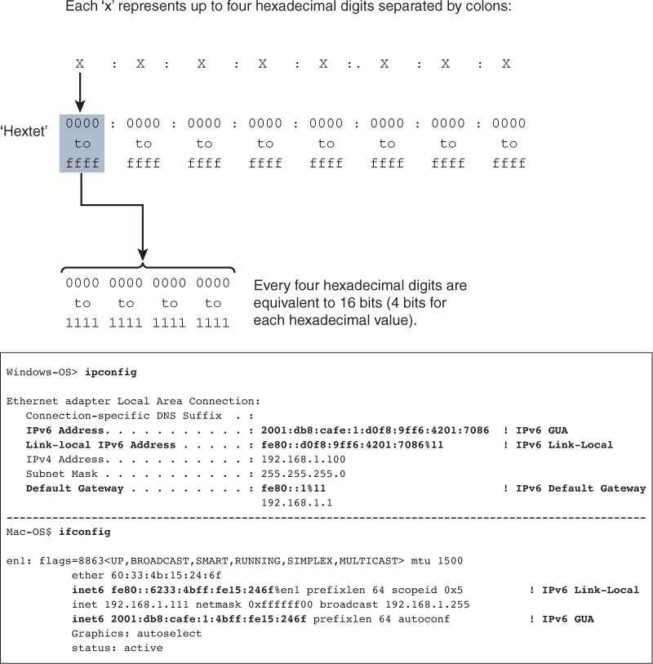

Figure 2
(sourse: IPv6 Fundamentals: A Straightforward Approach to Understanding IPv6,2017)

II. IP addressing scheme for School of Management and Engineering
- School of Applied Computing:
Network address 128.16.0.0/22, mask:255.255.252.0-711 hosts,
broadcast: 128.16.3.255
 | Subnet mask | Network address | First IP Address | Last IP Address | Broadcast
Open access laboratory with 245pcs and 5 printers | 255.255.255.0 | 128.16.0.0/24 | 128.16.0.1 | 128.16.0.254 | 128.16.0.255
Laboratory 308-140 pcs | 255.255.255.0 | 128.16.1.0/24 | 128.16.1.1 | 128.16.2.254 | 128.16.1.255
Laboratory 301-60 pcs | 255.255.255.192 | 128.16.2.0/26 | 128.16.2.1 | 128.16.2.62 | 128.16.2.63
Laboratory 309-50 pcs | 255.255.255.192 | 128.16.2.64/26 | 128.16.2.65 | 128.16.2.126 | 128.16.2.127
Laboratory 304-45 pcs | 255.255.255.192 | 128.16.2.128/26 | 128.16.2.129 | 128.16.2.190 | 128.16.2.191
Laboratory 306-40 pcs | 255.255.255.192 | 128.16.2.192/26 | 128.16.2.193 | 128.16.2.254 | 128.16.2.255
Laboratory 303-36pcs | 255.255.255.192 | 128.16.3.0/26 | 128.16.3.1 | 128.16.3.62 | 128.16.3.63
Laboratory 302- 30pcs | 255.255.255.192 | 128.16.3.64/26 | 128.16.3.65 | 128.16.3.94 | 128.16.3.95
Test centre 20 pcs, 1 IP Phone, 1 printer | 255.255.255.224 | 128.16.3.96/27 | 128.16.3.97 | 128.16.3.126 | 128.16.3.127
Staff room 20 | 255.255.255.224 | 128.16.3.128/27 | 128.16.3.129 | 128.16.3.158 | 128.16.3.159
Laboratory 310- 18pcs | 255.255.255.224 | 128.16.3.160/27 | 128.16.3.161 | 128.16.3.190 | 128.16.3.191

Table 1

- School of Automotive Engineering
network address 128.16.7.0/23, mask 255.255.254.0-283 hosts,
broadcast 128.16.8.255

 | Subnet mask | Network address |  | First IP Address |  | Last IP Address | Broadcast
Laboratory 301-50 pcs | 255.255.255.192 |  | 128.16.7.0/26 |  | 128.16.7.1 | 128.16.7.62 | 128.16.7.63
Laboratory 206-48pcs | 255.255.255.192 |  | 128.16.7.64/26 |  | 128.16.7.65 | 128.16.7.126 | 128.16.7.127
Laboratory 205-40pcs | 255.255.255.192 |  | 128.16.7.128/26 |  | 128.16.7.129 | 128.16.7.190 | 128.16.7.191
Laboratory 101-40pcs | 255.255.255.192 |  | 128.16.7.192/26 |  | 128.16.7.193 | 128.16.7.254 | 128.16.7.255
Laboratory 103-35pcs | 255.255.255.192 |  | 128.16.8.0/26 |  | 128.16.8.1 | 128.16.8.62 | 128.16.8.63
Staff room -25pcs | 255.255.255.224 |  | 128.16.8.64/27 |  | 128.16.8.65 | 128.16.8.94 | 128.16.8.95
Laboratory 102-25pcs | 255.255.255.224 |  | 128.16.8.96/27 |  | 128.16.8.97 | 128.16.8.126 | 128.16.8.127
CAD Laboratory-20 pcs | 255.255.255.224 |  | 128.16.8.128/27 |  | 128.16.8.129 | 128.16.8.190 | 128.16.8.191
Table 2

- School of Engineering:
network address:128.16.4.0/23, mask: 255.255.254.0-406 hosts
broadcast: 128.16.6.255

 | Subnet mask | Network address | First IP Address | Last IP Address | Broadcast
Laboratory 202-80pcs | 255.255.255.128 | 128.16.4.0/25 | 128.16.4.1 | 128.16.4.126 | 128.16.4.127
Laboratory 409- 80pcs | 255.255.255.128 | 128.16.4.128/25 | 128.16.4.129 | 128.16.4.254 | 128.16.4.255
Laboratory 203-65pcs | 255.255.255.128 | 128.16.5.0/25 | 128.16.5.1 | 128.16.5.126 | 128.16.5.127
Laboratory 410-45pcs | 255.255.255.192 | 128.16.5.128/26 | 128.16.5.129 | 128.16.5.190 | 128.16.5.191
Laboratory 404-45pcs | 255.255.255.192 | 128.16.5.192/26 | 128.16.5.193 | 128.16.5.254 | 128.16.5.255
Laboratory 408-28pcs | 255.255.255.224 | 128.16.6.0/27 | 128.16.6.1 | 128.16.6.30 | 128.16.6.31
Laboratory 205-25pcs | 255.255.255.224 | 128.16.6.32/27 | 128.16.6.33 | 128.16.6.62 | 128.16.6.63
Laboratory 201-20pcs | 255.255.255.224 | 128.16.6.64/27 | 128.16.6.65 | 128.16.6.94 | 128.16.6.95
Staff room-18pcs | 255.255.255.224 | 128.16.6.96/27 | 128.16.6.97 | 128.16.6.126 | 128.16.6.127

Table 3
- IPv6 Addressing-The servers are DNS, Email, Finance, Registry, File server and a Print server and IPv6 address for the link between MP and ISP.
Server IPv6 Address
DNS | 0:0:0:0:0:ffff:8010:0900
Email | 0:0:0:0:0:ffff:8010:0901
Finance | 0:0:0:0:0:ffff:8010:0902
Registry | 0:0:0:0:0:ffff:8010:0903
File server | 0:0:0:0:0:ffff:8010:0904
Print server | 0:0:0:0:0:ffff:8010:0905
MP/ISP | 0:0:0:0:0:ffff:8011:0

Table 4

References:
M. Sportack, (2003) IP Addressing fundamentals, Cisco Press

Rick Graziani, (2017), IPv6 Fundamentals: A Straightforward Approach to Understanding IPv6, 2nd Edition , Published by Cisco Press

Learning Cisco, 2020 [online] Available at https://www.learncisco.net/courses/icnd-1/introducing-ipv6/ipv6-address-types.html ( Accessed on: 3 January 2020)

