University of Wales Trinity Saint David
Management Accounting
Assessment 1

STUDENT NAME: Aygyul Shakirova, ID 1818045

Dr. Rexon Tayong Nting

2020

CONTENT

Introduction..............................................................................................................3
Discussion................................................................................................................3
- What is budgeting?......................................................................................3
- Types and style of budgeting………………………………………………………………….4
- How does it help managers in decision making?.........................................7
- Explaining which budget flexible or fixed is the most suitable for changing environments. Real – world examples of companies that have to adapt to changing environments through using a suitable budget style…………………9
- Types of budgeting system…………………………………………………………………….10
- What is Participative budgeting................................................................ 11
- How does it support decision making in changing environments.............12

Conclusion..............................................................................................................13
References..............................................................................................................14

Introduction

In today's world of evolving technologies and rapid changes in the environment every business organization has to be able to operate in a competitive environment. A business organization needs to adapt well in this competitive environment to thrive. For this purpose, every manager needs to have knowledge and be aware of the following:

- .What is budgeting?
- Types and style of budgeting.
- How does it help managers in decision making?
- Explaining which budget flexible or fixed is the most suitable for changing environments. Real – world examples of companies that have to adapt to changing environments through using a suitable budget style.
- Types of budgeting system
- What is Participative budgeting?
- How does it support decision making in changing environments?

Discussion

- What is budgeting?

Schmitd (2020) shares information about budget in a business encyclopedia: “A budget is a primary tool in business for planning, tracking, and controlling spending. In business, a budget is a plan for an organization's outgoing expenses and incoming revenues for a specific period.”
The business dictionary (2020) provides a definition of the budget process, (budgeting): “The procedure by which an organization or individual creates and manages a financial plan. Within a larger business, the budget process is typically performed by managers who often obtain projected spending requirements and suggestions from their staff”.

- Types and styles of budgeting

The chart bellow shows that the different types of budgets are classified on the basis of time, capacity, receipts and expenditure and scope.

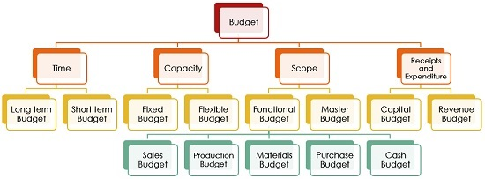
(business jargons, 2019)

Style of budgeting
Fixed budget - the fixed budget is static and unchanged, regardless of the level of activity actually achieved (Rao, 2014).
Tab.1
Fixed budget
Merits | Demerits
No need to plan a budget every month as this budget will not change month by month it is easier to comply with spending limits according to the planned budget. (Miriam, 2020). | Lack of mobility, which makes it difficult to properly direct capital according to the current needs of the business in a changed environment. ( Saxena, 2020)
Can be planned in advance. (Miriam, 2020). | Fixed budget as it cannot predict very precisely the current situation of the business environment has limited application and is ineffective method for cost control. (toppersbulletin,2020).
The fixed budget will take into account all possible costs when planning a long-term goal. (Miriam, 2020).

The fixed budget is easier to keep and check. (Miriam, 2020).

A fixed budget is a useful tool for people with a fixed income.
(Miriam ,2020)

Flexible budget - the flexible budget is created to change at different levels of activity actually achieved (Rao, 2014).

Flexible budget
Merits | Demerits
The flexible budget can more accurately represent the inflow of cash flow and gives a more accurate forecast of sales profit into business. (Hawk, 2020). | Difficulties in forming and administering to the flexible budget as most costs are fixed. (Bragg, S. 2019).
The flexible budget tries to adapt to the levels of constantly changing resources in stocks and to the level of corresponding consumption and thus offers better control over business processes. (Hawk, 2020). | Cannot be preloaded in the accounting software for comparison with the financial statements, which is the reason for issuing the financial statements with a delay. (Bragg, S. 2019).
The flexible budget is better at adapting to constantly changing external factors that can affect business productivity. (Hawk, 2020).
The flexible budget provides management with real-time data by offering much greater control over the costs of business operations which makes the business competitive. (Hawk, 2020).
Tab.2

- How does it help managers in decision making?

The graph below shows the benefits of the budgeting process for managers.
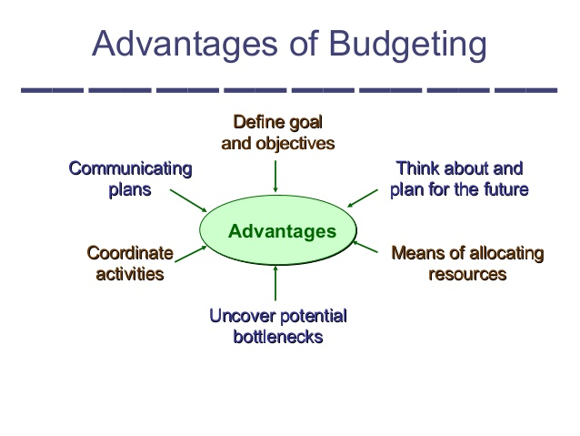
(Economy & Finance, 2016)
Budgeting process encourages the manager to think ahead and this enables the manager for the identification of short-term problems. This helps the manager to have enough time to calmly and reasonably consider the identified potential problem of the business (Atrill and Mclaney, 2009).
Budgets provide help for better co -ordinations between different departments in an organization (Atrill and Mclaney, 2009).
Budgets are business tools for motivate managers by assigning a specific task or goal, (which are related to the objectives of the business) to them and by monitoring the level of their achievement (Atrill and Mclaney, 2009).
Budget is a tool through which a mechanism can be organized that allows managers to spend up to a certain limit (Atrill and Mclaney 2009).

The key to achieving the long-term goals of the business, which are set in its strategic plan, is the budget. Because to achieve its goals the company needs a budget who will finance the process. At the same time, the budget is the tool through which managers can implement a short-term business plan and make short-term decisions, due to unforeseen changes in the business environment, so that the company can realize the opportunities and ensure the desired long-term goals (Corporate finance institute, 2020).

This is very clearly demonstrated in the figure below.

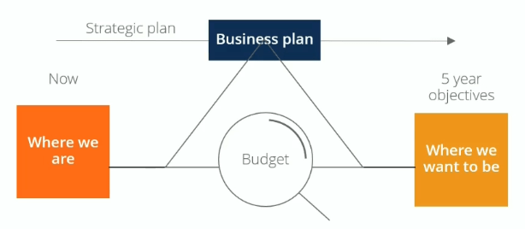
(Corporate finance institute, 2020)

- Explaining which budget flexible or fixed is the most suitable for changing environments. Real – world examples of company that have to adapt to changing environments through using a suitable budget style.

The fixed budget assumes a static situation and therefore cannot anticipate unexpected changes in the business environment, and this budget does not provide the ability to respond to the current situation. (Demerits – fixed budget, tab.1)

The flexible budget meets the needs of the current real situation. Provides real-time data that allows more accurate forecasts of current costs, profits and the corresponding current consumption, i.e. a flexible budget is an important tool for better control over business, for realizing current opportunities and for creating competitiveness. (Merits – flexible budget, tab.2)

The merits of the flexible budget, which are described above, clearly show that flexible budget is more suitable for a rapidly changing and highly competitive business environment. (Merits – flexible budget, tab.2)

Vodafone is a good example for this type situation.

Vodafone is an international telecommunications company that provides mobile and broadband services, based in England (CBR online, 2020).

Due to quarantine caused by the Covid-19 Pandemic, Vodafone is monitoring the following changes "with a 30% increase in internet traffic, more than 25% increase in landline calls, and 42% increase in mobile voice traffic". So that they can meet these new challenges, “they have changed the way they manage their voice and data traffic and added more capacity to their broadband connection" (Vodafone, 2020).

The company Vodafone responds to the increased demand by investing more funds to expand its capacity by using the method of flexible budgeting.

Types of budgeting system

This graphic shows that there are two types of budgeting system -Top-down budgeting and Bottom-up budgeting (participative budgeting)

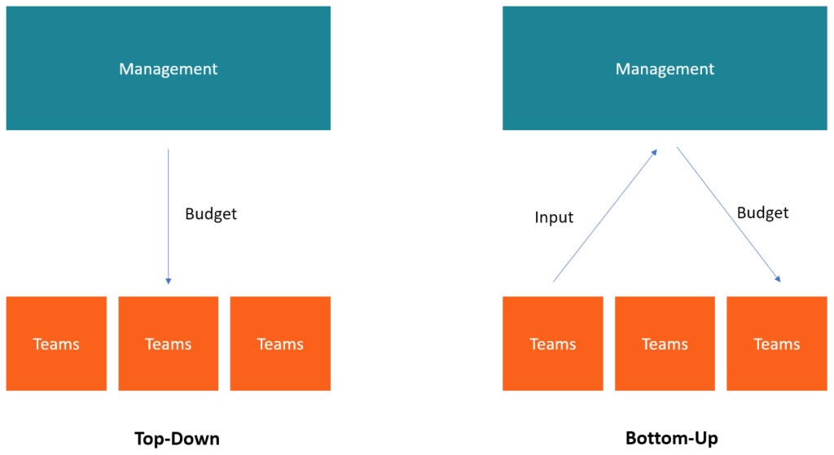

(Corporate finance institute, 2020)

The top-down approach is the process in which the senior management team at a high level draws up a budget for the whole organization and then allocates the funds to departments ( Braun, 2017).

Bottom-up budgeting is the process by which managers draw up a budget and then send it to a higher level for approval, then if no further revisions are needed, this budget is approved and a master budget is created (Braun, 2017).

- What is Participative budgeting?

Participative budgeting
Merits | Demerits
improves and increases the motivation of managers | there is a risk that senior managers will lose control
contains more up-to-date and better information, especially in a rapidly changing environment | inexperienced managers can make bad decisions
has a positive effect on the commitment and understanding of managers | there is a risk that composite budgets are inconsistent with the business strategy
improves communication at different levels | the preparation of the budget process is slower and there is a risk of disputes
Senior managers can better focus on strategy | junior managers can set easy goals (budget gap)
(Lidia, 2013)

- How does it support decision making in changing environments?

Vodafone (2020) shares this information: “Vodafone is focused on two scaled and differentiated regional platforms in Europe and Africa. Vodafone operates mobile and fixed networks in 22 countries and partner with mobile networks in 48 more” (Vodafone, 2020).
As the use of the services of the mobile operator Vodafone increased significantly during the Covid-19, Vodafone needs additional information for the level of the percentage increase in the demand in order to be able to adequately meet the increased demand of its customers.
And the general managers of Vodafone, in order to be able to receive this up-to-date information from all countries, in which Vodafone operates, they collect information from the local managers of Vodafone, i.e. the general managers use participative budgeting.

Conclusion

Today's business environment is associated with fast technologies, often changing conditions and high competition. Businesses could successfully adapt to this environment using key factors such as flexible budgeting and participative budgeting.

References

- Atrill, P. and Mclaney, E. (2009) Management Accounting for decision makers. 6th edn. England:Education Pearson.
- Braun, G. (2017) Top down or bottom up corporate budgeting – Which One is Best?. [Online]. Available at: https://www.truesky.com/top-down-or-bottom-up-corporate-budgeting-which-one-is-best/
- Bragg, S. ( 2019) “Flexible budget”. [Online]. Available at: https://www.accountingtools.com/articles/2017/5/17/flexible-budget
- Business dictionary (2020) “What is the budget process”. [Online]. Available at: http://www.businessdictionary.com/definition/budget-process.html
- Business jargons (2019) “Budget”. [Online]. Available at: https://businessjargons.com/budget.html
- CBR online (2020) “ What is Vodafone?”. [Online]. Available at: https://www.cbronline.com/what-is/what-is-vodafone/
- Corporate finance institute (2020) “Budgeting”. [Online]. Available at: https://corporatefinanceinstitute.com/resources/knowledge/finance/budgeting/
- Corporate finance institute (2020) “ What is top-down and bottom-up budgeting?”. [Online]. Available at: https://corporatefinanceinstitute.com/resources/knowledge/finance/top-down-budgeting/
- Economy & Finance (2016) “Profit planning & Master Budget”. [Online]. Available at: https://www.slideshare.net/Managerit/budget-1-profit-planning-master-budget
- Hawk, R. (2020) “What are the pros and cons of a fixed budget?” [Online]. Available at: https://www.wisegeek.com/what-are-the-pros-and-cons-of-a-flexible-budget.htm

- Lidia, G. (2013) “An overall analysis of participatory budgeting”. [Online]. Available at: https://www.semanticscholar.org/paper/An-Overall-Analysis-of-Participatory-Budgeting-and-Lidia/349d2aa55146bcfa1d1d80d6307163d58994208a
- Miriam, C. (2020) “The Advantages of Using a Fixed Budget”. [Online]. Available at: https://www.sapling.com/7747158/advantages-using-fixed-budget
- Rao, R. (2014) “Budgeting”. [Online]. Available at: https://www.slideshare.net/ramusakha/budgeting-39223635
- Saxena, V. (2020) “What are the pros and cons of a fixed budget?”. [Online]. Available at: https://www.wisegeek.com/what-are-the-pros-and-cons-of-a-fixed-budget.htm
- Schimtd, M. (2020) “How to Plan, Manage, and Analyze Business Budgets and Cash Budgets”. Business-encyclopedia. [Online]. Available at: https://www.business-case-analysis.com/budget.html#budget-defined

- Toppersbulletin (2020) Difference between fixed budget and flexible budget. [Online]. Available at: https://www.toppersbulletin.com/difference-between-fixed-budget-and-flexible-budget/

Vodafone (2020) “Keeping our network reliable”. [Online]. Available at: https://www.vodafone.co.uk/network

