BA Fine Art: Studio, Site and Context

Ways of Thinking (ADDA 4022)

Essay: De-construct the meaning of an artwork in relation to the politics of representation from the perspective of gender studies, the postcolonial condition or the visualisation of violence.

Word count XX plus bibliography

In 1941 the British Army established the Army Film and Photographic Unit (AFPU), a corps of soldiers of whom many had been press photographers or film cameramen in civilian life (Imperial War Museum, no date). The AFPU was present for the liberation of the Nazi concentration camp at Bergen-Belsen on 17th April 1945 and spent 2 weeks recording conditions at the camp in still photography and moving images. The image I have chosen to analyse is that of an unnamed woman by an unnamed photographer of the unit, taken on the second day of the British occupation of the camp.
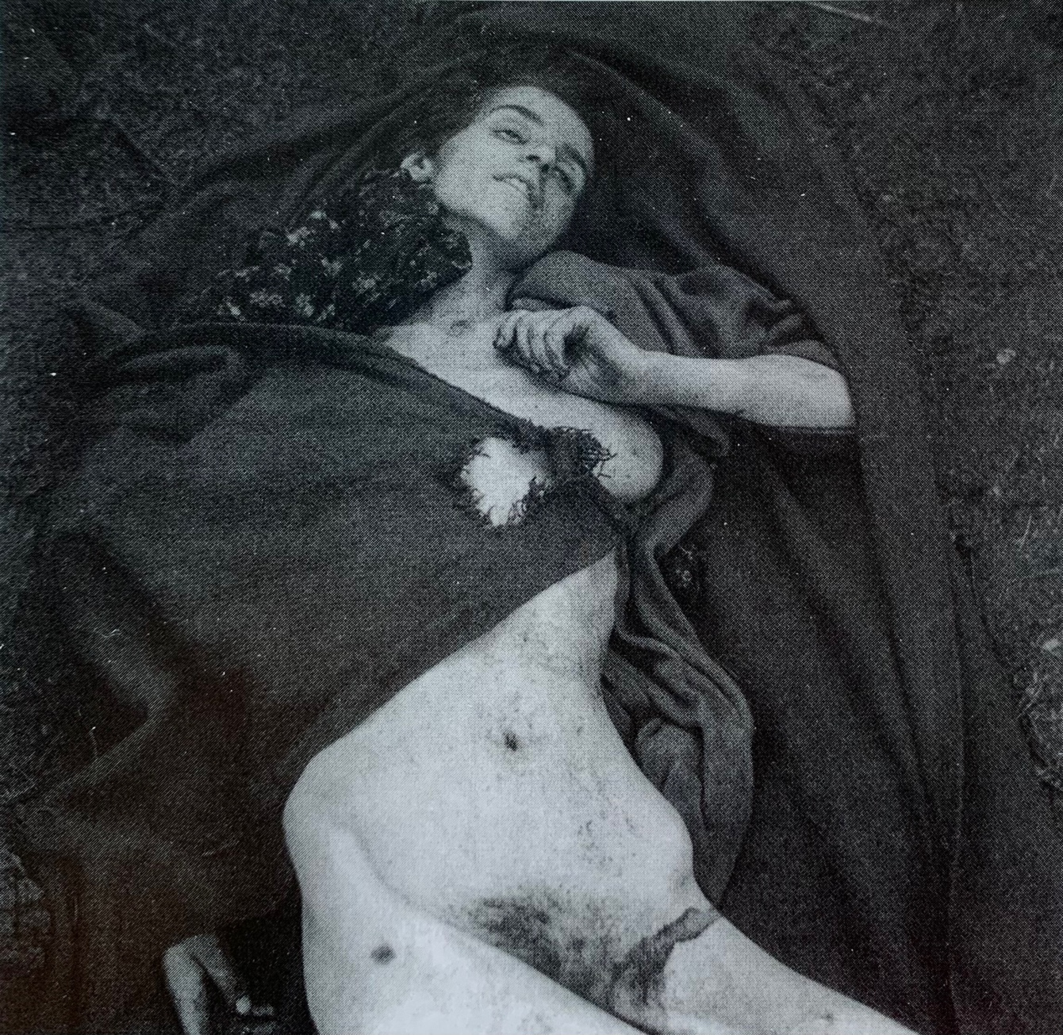

In Regarding the Pain of Others Susan Sontag notes that war photographers and the images that they construct shape our understanding of war p17 (Sontag, 2004). So what can be understood from this image? It is apparently the corpse of a young woman, supine, naked, emaciated, eyes and mouth slightly open after being killed in a Nazi death camp. It was produced by an extension of the British government and its provenance is considered sufficiently reliable that it is held in the archive of the internationally renowned Imperial War Museum. The image, not publicly available on the Museum’s website, is catalogued as IWM negative BU 4027, was originally captioned ‘A mother and two children among the dead’ (Imperial War Museums, no date) and I include a photograph as reproduced in print in Archive Fever – Uses of the Document in Contemporary Art (Enwezor, 2008, p. 32). (Note to self: find out how many images of Bergen-Belsen were taken). This blunt description of an appalling image prompts a number of questions; what is its purpose? can it be trusted as ‘objective truth’? should it be viewed and in what context?
Sontag observes (2004, p. 9) that there are multiple uses for photographic depictions of other people’s suffering – as a supporting argument for pacificism, to stoke desire for revenge, propaganda, public information, a need to document – but all images can be interpreted variously according to the viewer’s pre-existing beliefs. In the images of Bergen-Belsen, Buchenwald and Dachau, however, Sontag argues for ‘the power of photographs to define, not merely record, the most abominable realities trump[ed] all the complex narratives’ (Sontag, 2004, p. 19). Walter Benjamin contends that ‘photographs can become exhibits in the trial that is history’ p14 (1936, p. 14) and these particular images have endured in their value as documents of Nazi atrocity (Enwezor, 2008, p. 32).
(Note to self: find out if these images were used as evidence in trials and if their veracity has been questioned by holocaust deniers.)
Regardless of intention, all photographs are constructed artefacts and the ‘truth’ of any subject depicted is mediated and framed through the point of view of a photographer. Nevertheless, despite a history of falsification and manipulation tracing back to the Crimean War in the mid 19th century, photographs are historically perceived as objective records of fact and more so when they are ‘without the taint of artistry’ (Sontag, 2004, p. 21). Some contemporary critics attached more value to the workmanlike images produced by army photographers than to those by well-known artists such as Lee Miller, who documented the liberation of concentration camps with more considered compositions. (Note to self: find source)
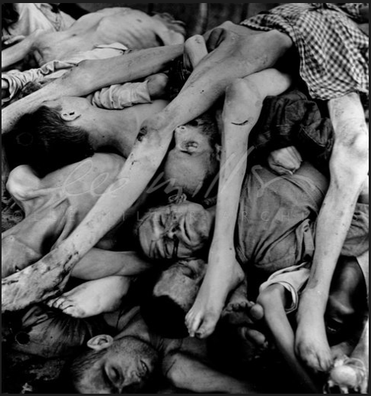
(Lee Miller Archives, 1945)

(Go on to address:
Taboo of showing faces of the dead in war photography and in what circumstances this is typically broken.
Distasteful if unintentional intersection of the composition of this image with female nude paintings (recalls Egon Schiele) reference Berger – discuss this point only if word count allows
Discuss appropriation by Robert Morris as basis for work in his Firestorm series.
Context of viewing image (reference Berger, Benjamin, oral history on IWM site and article in The Guardian)

Bibliography

Works Cited
(n.d.).
Benjamin, W. (1936). The Work of Art in the Age of Mechanical Reproduction (2008 ed.). London, United Kingdom: Penguin Books.
Enwezor, O. (2008). Archive Fever: Uses of the Document in Contemporary Art. New York: International Center of Photography.
Imperial War Museum. (no date, November 6). The Photographers and Filmmakers Who Captured the Second World War. Retrieved November 6, 2023, from Imperial War Museums: https://www.iwm.org.uk/history/the-photographers-and-filmmakers-who-captured-the-second-world-war
Imperial War Museums. (no date). Imperial War Museums. Retrieved November 6, 2023, from https://www.iwm.org.uk/collections/item/object/205399125
Lee Miller Archives. (1945, June). Horrors of a Concentration Camp. Retrieved from leemiller.co.uk: https://www.leemiller.co.uk/media/Every-disease-imaginable-was-rife-in-the-camp-and-weakened-by-starvation-and-abuse-the-prisoners-died-in-thousands-/FPWye0kY45UyHWHwFYXuLA..a
Sontag, S. (2004). Regarding the Pain of Others (2019 ed.). London: Penguin Books.

