RESTAURANT BUSINESS PLAN
GGG BULGARIAN TRADITIONAL FOOD TRUCK
Birmingham, United Kingdom
(2022)
Students:
Gurpreet Kaur Cheema (2026299)
Gabriela Mancheva( 2026312)
Georgi Grozdanov (2026314)
BMSW4006_BIRM
University of Wales Trinity Saint David

Table of Contents
Executive summary 3
Competitor’s Analysis 4
SWOT ANALYSIS 4
PESTEL ANALYSIS 7
Political 7
SOCIAL FACTORS 8
Technological Factors 9
Environmental factors 9
Legal 9
TARGET MARKET 10
Marketing and Sales Plan 10
Management team 10
Management team 11
CASH FLOW FORECAST 12
Profit and Loss Forecast 13
Referencing list: 14

Executive summary
GGG BULGARIAN TRADITIONAL FOOD TRUCK will be a mobile kitchen offering traditional Bulgarian food. Meshana Skara, Shopska Salata,Tarator,King of the grill: kebapche, lyutenitsa,turshia,French fries with sirene,p arlenka are all in the menu. We will provide small portions for kids, similar to the children's menu. Also available are combination portions for 2,3 individuals or family meals.
Gabriela, Georgi, and Gurpreet, all business partners, will establish the business. Type of business organization: Partnership Limited Company, where all is shared equally. The advantages of this type of business organization are that different partners can bring different skills to the business. Gabriela, Georgi, and Gurpreet have different experiences in several aspects of the business, which will be quite beneficial in putting it together.
The food truck would be located at Birmingham city centre. Located in a commercial district with a large number of people and potential customers. Traditional Bulgarian furniture and accessories will be used in the décor.
The staff will be trained to provide sufficient details to interested customers about the cuisine, culture, and traditions of Bulgaria.
Meal Price range from £6- £15
Average lunch price: £8.00
Average dinner price: £11.00

Competitor’s Analysis
Any business that offers meals to the same target market as a restaurant is considered a competitor. Our direct competitors (which are very similar to us) are ‘’ MEALZ ON WHEELS’’, ‘’ The Chicken Truck’’ and ‘’ Sandwich Van’’. All of them are in food industry. The food van " MEALZ ON WHEELS" has a very good interior, which is a bonus, however the restaurant is closed on Sundays and does not deliver to homes. "The Chicken Truck" poses a real risk of competition, Because they offer home deliveries and have a great reputation online with many positive reviews for the quality of their meals.
"Sandwich Van" : There's not a lot of competition for this organization because they don't have a lot of products and the items are not at all unique, and they don't do home deliveries. One of the most significant advantages is because they provide fast service.
SWOT ANALYSIS
SWOT analysis means strengths, weaknesses, opportunities, and threats which is a framework of a company's competitive position and developing strategic plans. It analyses Internal and external elements, as well as existing and future possibilities.
The strengths of GGG Bulgarian traditional food truck:
- Small BUSINESS
- SPECIAL MENU
- HIGLY- ENTUSIASTIC TEAM
- LOCATION IN BUSINESS DISTRICT
The biggest benefit of small business is the independence and flexibility. Employees and managers are communicating more effectively and quickly.
Another advantage of our company is that we have a unique menu. Our menu is based on traditional Bulgarian cuisine. There is no other Bulgarian restaurant in Birmingham, which identifies it.
HIGLY- ENTUSIASTIC TEAM: Everything improves in a company when there is an enthusiastic crew. The benefits of being enthusiastic include being more productive, more confident, and having people see you in a more comfortable way. The fact that our team will be working for themselves and for a common goal is the key cause for their enthusiasm.
LOCATION IN BUSINESS DISTRICT: Location plays a huge role in attracting new potential customers. A company's long-term success can be considerably by good site selections. It may cost a lot of money in lost personnel, productivity, and capital if you fail in to choose the good one.
The weaknesses of GGG Bulgarian traditional food truck:
- SMALL WORKING AREA
- MECHANCAL BREAK DOWNS
- INSURANCE COSTS
The first disadvantage is the small work area, which might sabotage staff efficiency and productivity.
INSURANCE COSTS: Because vans have larger engines and storage space, there's a higher likelihood they'll be hauling costly stuff, van insurance is normally more expensive than vehicle insurance.
Opportunities for the company:
- LOW-COST VAN RENTAL
- LEARNING NEW SKILLS AND TECHNIQUE
We can discover a low-cost van rental although we can avoid buying one when we first start our company and instead hire one. Our rental price is 2000 pounds, which includes the vehicle and the ground. For short-term needs, renting a van is typically the most convenient alternative.
Another advantage of renting a van is that there is no need to worry about depreciation or trade-in problems.
LEARNING NEW SKILLS AND TECHNIQUES is a great method for new businesses to grow. Learning new abilities is an important element of every employee's or management team's career. Nowadays, there are numerous options for learning. There are online courses available (some of them are even completely free.). Learning may be therapeutic for a troubled mind since it is both exciting and satisfying. Learning offers enjoyment and happiness to everyone, regardless of age or professional qualifications, whether it's for a hobby or a profession.

PESTEL ANALYSIS
A PESTLE analysis is a tool used to collect and analyse information outside the business enviornment. Pestle stands for Political, economic, social, technological, legal and environmental.

Political
There are political factors to consider when starting a firm. Some of them are:
- tax policy – The corporation tax is 19% on all businesses’ income profits and capital earnings. For enterprises with income of more than £50,000, the rate will be hiked to 24 percent in April
2023. The standard VAT rate is 20%.
- political stability: Governments are capable of increasing or decreasing company tax, affecting their earnings. They can also have an impact by raising the value-added tax on goods or boosting business rates. They can enact new legislation, such as the National Minimum Wage, which has an influence on profits and labour rights.
Trade restrictions:
- Organic food labelling - For the purpose of organics commerce, the United Kingdom (England, Scotland, and Wales) has recognised the EU as equal until December 31, 2021.
The importation and exportation of items between the United Kingdom and the European Union, must follow these rules:
- Apply for a GB Economic Operator Registration and Identification (EORI) number.
- Determine if you wish to engage the importation–exportation agent or make your own declarations.
- The declaration for the goods must be done by the organisation that moves them or the person itself.
ECONOMIC FACTORS
The economy encompasses all activities in a country that include the production, distribution, and consumption of commodities and services.
Consumer spending has an impact on pricing, investment decisions, and the number of people employed by enterprises.
Businesses are affected by the economy in three ways.
Unemployment indicates that an economy is not making full use of available labour. The economy will not expand as swiftly as it might, and it may even begin to slow. This drop-in economic activity will have a direct impact on enterprises.
Interest rate fluctuations. The interest rate is the cost of borrowing money or the amount of interest a saver gets.
In this business case all these things are not a problem because the taxes will be paid regularly, also the salaries other expenses as well. The loan from the bank will be requested to have a good start and make the business run at the beginning.

SOCIAL FACTORS
Several societal elements might have a bad or good impact on the restaurant. People nowadays are increasingly health-conscious. As a result, they will prefer organic food over junk food. To boost their consumer base, restaurants usually cater to both types of customers, i.e., spicy or junk food lovers and organic food lovers.
As we know vegetarian and vegan people are increasing now days so there is an option them as well.
also the united kingdom is a country where are people from around the world and they are open to all kind of culture and food
Technological Factors
Technology is transforming the way restaurants operate and react to new problems, leaving an indelible impression on the business. To be successful in today's environment, a restaurant must be adaptable and responsive to changes in processes and norms. Using a phone app, an internet portal, or a QR code to make a payment has become routine. Restaurant operators may use digital software to guarantee that orders are correct, service is nice, and all personnel are given the tools they need to thrive.

Environmental factors
Because sustainability is the key to success, there are some unique rules that our restaurant must adhere to. In the restaurant sector, hygiene is the most important factor. Food disposal is one of these operations, according to the Environmental Protection Agency (EPA), which ends up in landfills and incinerators, impacting local air and water quality. Temperature, food, pollution, population density, noises, light, and parasites are all environmental influences.

Legal
- Anti-trust law in Travel & Leisure industry and overall in the country.
- There will be no discrimination within the employee and the employers
- Copyright, patents / Intellectual property law
- Consumer protection and e-commerce will be respected
- Employment law will be followed
- The food respects all the health and safety laws in the United Kingdom.
- All the customers data will be protected

TARGET MARKET

- Kids and adults
- Family and people who eat out
- Male and female
- Customers who love Bulgarian food
- People who want to explore different traditional food
Marketing and Sales Plan
We'll keep up with industry developments a website, Facebook page, and Twitter account. Our menu, map, and opening times will all be easily accessible. We may consider fax or email orders in the future, as well as phone orders. Our meals will be photographed by a professional photographer and uploaded on our social media sites and website.
GGG Bulgarian traditional food truck will offer special promotions and discounts to reach new and loyal customers showing our appreciation.
Management team
Organizational Structure:
The owners, Georgi Gabriela, and Gurpreet, will try to work alone at beginning, hiring only one part-time employee to help them manage their days off. The candidate will be scored and evaluated against a set of pre-determined criteria for each post. For this post, background checks will be conducted. Referrals will always be at the forefront of recruiting efforts.

Management team
Georgi Grozdanov, one of the owners, will be the general manager.
Georgi started working in restaurants at the age of 19 years old. Georgi is a good problem-solver. He understands how to encourage and lead his team. For managing company administration and personnel concerns, he also has great written and spoken communication abilities.
Gabriela Mancheva, the second owner, will be the restaurant's assistant manager. She will meet and welcome clients because she has previous expertise communicating with consumers and selling them various products. Gabriela will assist customers by solving any issues they may have with the service or meal quality. She is a natural born leader with excellent organizational, customer service, and decision-making skills.
Gurpreet Cheema, the third owner, will also operate as the restaurant's assistant manager. She has deep knowledge in the food industry, as well as some leadership skills that will be extremely beneficial to the company. She will be in charge of coordinating daily restaurant operations and training workers on how to follow restaurant procedures.

CASH FLOW FORECAST
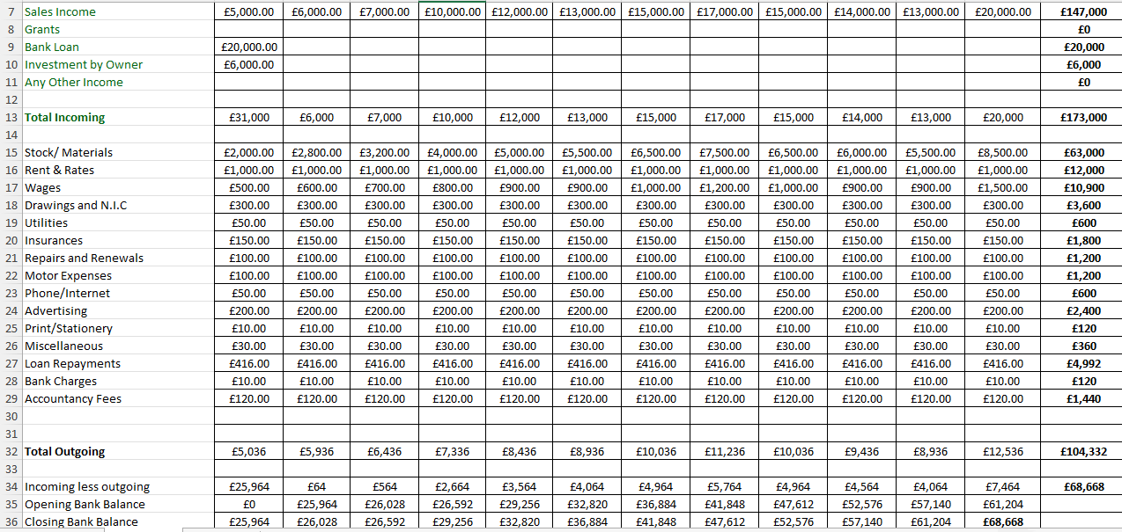

Profit and Loss Forecast
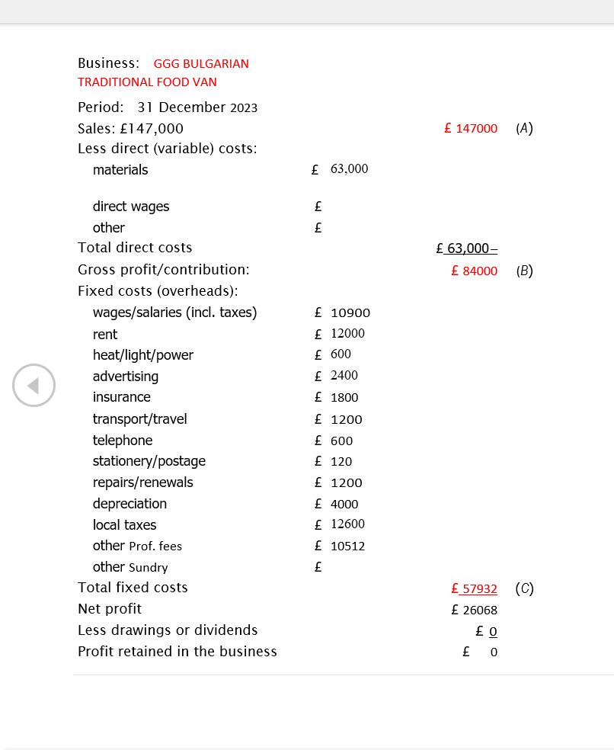

Referencing list:
BBC Bitesize. (n.d.). The economic factors that affect business activity - Economic influence on business activity - Eduqas - GCSE Business Revision - Eduqas. [online] Available at: https://www.bbc.co.uk/bitesize/guides/zjjnnrd/revision/1#:~:text=The%20economy%20includes%20all%20activities
Farooq, U. (2019). StackPath. [online] Marketingtutor.net. Available at: https://www.marketingtutor.net/pestle-analysis-of-a-restaurant/
Gibson, B. (n.d.). How Technology is Changing the Restaurant Industry. [online] www.jolt.com. Available at: https://www.jolt.com/blog/how-technology-is-changin-the-restuarant-industry.
Sciencedirect.com. (2015). Environmental Factors - an overview | ScienceDirect Topics. [online] Available at: https://www.sciencedirect.com/topics/social-sciences/environmental-factors.
Edrawsoft. (n.d.). Detailed PESTEL Analysis of Restaurant Industry | EdrawMax Online. [online] Available at: https://www.edrawmax.com/article/restaurant-industry-pestel-analysis.html.
RESTAURANT BUSINESS PLAN (COMPANY NAME) (COMPANY NAME) (STREET ADDRESS) (CITY, STATE ZIP CODE) (CREATION DATE). (n.d.). [online] Available at: https://images.template.net/wp-content/uploads/2016/01/23141702/Restaurant-Business-Plan-Sample-PDF-Free-Download.pdf [Accessed 23 Mar. 2022]
LimeTray’s Restaurant Management & Marketing Blog. (2019). 12 Unique Restaurant Promotion Ideas to Win More Customers. [online] Available at: https://limetray.com/blog/restaurant-promotion-ideas/#:~:text=Discounts%20%E2%80%93%20Time%2Dbased%2C%20Percentage [Accessed 23 Mar. 2022]

