

ADAA7000 Coexistent Perspectives Module

Name: Libby Pearson

Student number: 2507601

Word Count: 4232

- Please keep all drafts of your essay. You may be asked to produce these as evidence of your writing process.

- Please ensure you follow the AI guidance on the assessment brief and note when and how you are able to use AI.

- Please also note the guidance regarding plagerism on your assessment brief also refers to referencing the source of your material and that includes the use of AI.

For this assessment,
I confirm that I have not used Generative AI to support me in structuring my submission, including creating a draft argument structure, identifying parts and headings.
I confirm that I have not used Generative AI to create text for my submission.
I confirm that I have not used Generative AI for creative materials, such as images.

Student Signature: Libby Pearson

Question 1. The Contemporary Condition:
How do contemporary artists respond to the ‘ethico-aesthetic’ challenges of ecological precarity in late modernity? Drawing on Guattari’s “The Three Ecologies,” critically analyse the ecological strategies of Edward Burtynsky and Otobong Nkanga.
Essay Title: Exposing Damage, Imagining Repair: Dual Ecological Strategies in the Works of Edward Burtynsky and Otobong Nkanga

Abstract
“It is now 85 seconds to midnight”
From the edge of our fragile planet, two artists respond to a wounded world through three interconnected ecologies.
Edward Burtynsky and Otobong Nkanga, confront the planet’s unravelling, through strikingly different visions. Through the lens of Félix Guattari’s Ecosophy, their works respond to ecological precarity, revealing the deep entanglement of Guattari’s environmental, social, and mental registers.
Burtynsky's large scale aerial photographs expose the environmental damage caused by industrial extraction. The "industrial sublime" confronts viewers with both the aesthetic allure and ethical horror of the Anthropocene. His work offers macroscale visualisation of planetary degradation and the global capitalist infrastructures that sustain it. Burtynsky shifts viewers subjectivity, encouraging us to recognise our own complicity within extractive systems.
Nkanga works through installation, performance and materials research to foreground the intimate, embodied and historically situated effects of extraction. Her practice highlights the entanglement of resources, bodies, and colonial histories. Nkanga frames care, attentiveness, and repair as forms of resistance to the psychic flattening forced upon us, by global capitalism.
Together their works illuminate key pathways through which contemporary artists, navigate and respond to ecological crisis in late modernity. One exposes damage at industrial scale, and the other imagines repair through relationships with land, bodies, and nonhuman life.
Through artistic practice, the damage can be diagnosed, the ecological crisis exposed, and alternative modes of repair and care proposed. This is not just art, this is an ecosophical reckoning, and together, we can it slow down and turn back the hands of the doomsday clock.

Exposing Damage, Imagining Repair: Dual Ecological Strategies in the Works of Edward Burtynsky and Otobong Nkanga
Introduction: ecological precarity and contemporary art
“It is now 85 seconds to midnight”, announced the Doomsday Clock (Bulletin of Atomic Scientists, 2026) on 1st January 2026 thus marking the closest humanity has ever come to global catastrophe. This significant point in our lifetime can be attributed to the hegemonic actions of global and post-industrial capitalism that perpetuate growing inequality and ecological precarity. Against this fragile backdrop of planetary insecurity, cultural platforms have emerged as a medium to expose and reshape our understanding of ecological crisis that once was a peripheral concern but is now firmly centre stage.
There has been an increasing trend in the contemporary art world to consider “life on earth”, not only as a stimulus of creativity, but also a realm to influence directly (Tate, 2024). This essay will examine how contemporary artists, Edward Burtynsky (Burtynsky, 2019) and Otobong Nkanga (Nkanga, 2019), respond to ‘ethico-aesthetic’ (Guattari, 1989, p.24, 47) challenges of ecological precarity in late modernity. The essay will review how these artists foreground existential risks to evoke an emotional response in the viewer. And while their approaches are markedly different, their strategies of responding to the ecological crisis humanity finds itself in, are, complementary.
Felix Guattari’s The Three Ecologies / Ecosophy (Guattari, 1989), will be employed as the theoretical framework to underpin the essay, acting as an entry point into the metaphysical reasonings behind Burtynsky’s and Nkanga’s work in this sphere. Ecosophy will facilitate the extension of ecology, as a definition to encompass Guattari’s three ecological registers: environmental, social, and mental (Guattari, 1989, p.18). Through the lens of Ecosophy, this essay will analyse how each artist visualises engagement with the natural world as a response to ecological entanglement, and how their strategies respond to Guattari’s three registers and the wider Anthropocentric machinations of Integrated World Capitalism (IWC) (Guattari, 1989, p.20, 31).
The rationale for selecting The Three Ecologies (Guattari, 1989) as the underpinning framework, is the agency of Guattari’s Ecosophy and how the concept of ethico-aesthetics, reframes environmental catastrophe as inseparable from social and mental degradation. By applying Ecosophy, the essay aims to articulate how artists offer an alternative, ethically engaged aesthetic through creative, “resingularised” and transversal practices (Guattari, 1989, p.22, 28, 36). The varied aesthetics, materials and ethical strategies of both Burtynsky and Nkanga’s work, confronts these destructive capitalist systems and provides a platform to imagine alternative modes of care, accountability, and coexistence. The essay will examine how they both expose the scale of environmental damage and navigate possibilities for repair through their parallel approaches.
A study of Burtynsky’s large-scale aerial photographs (Burtynsky, 2019) will demonstrate how he exposes the “industrial Anthropocene”. By contrast, a review of Nkanga’s (Nkanga, 2019) approach to ecological crisis, will be analysed through her embodied, material and historically situated forms. Ecosophy, will demonstrate how contemporary art can expose damage and diagnose ecological precarity, while simultaneously imagining repair.
Gerhard Richter once said: “Art is the highest form of hope” (Phaidon Press, 2016). And as the hand of the atomical clock edges closer to midnight and global catastrophe, the essay will argue that the work of Burtynsky and Nkanga are exemplars of aesthetic strategies through the collective reimagining of relations between humans, environments, and social systems. And, how their practice aligns with Guattari’s ecosophical registers through contemplation of mediations of ecological precarity.

Theoretical Framework: The Three Ecologies and Ethico-Aesthetics
Although it was published in 1989, Guattari’s The Three Ecologies (Guattari, 1989) continues to offer both currency and relevance for reframing how ecology extends beyond standard environmental concerns, enabling “more-than-human” narratives of the Anthropocene era. Rather than limiting ecology to nature, climate, or biodiversity, Guattari introduces the concept of Ecosophy. He argues that the ecological crisis is better understood as a condition of three domains: environmental, social, and mental. In this vein, Guattari notes that ecological catastrophe cannot be tackled solely by technical or policy measures. He suggests it demands a transformation of subjectivity, social organisation, and perception. Ecology, he posits, concerns the assemblages of how humans live, relate, and imagine their place in the world. Ecosophy, emanates from an ethically grounded and politically regenerative way of thinking that embraces difference, fosters creativity, and collective transformation. It is, therefore, a valuable framework in which to review contemporary artistic practices and responses to ecological precarity in late modernity.
Guattari was influenced by “Steps to an Ecology of Mind” by anthropologist Gregory Bateson (Bateson, 1972) who advocates for “embodiment, contextuality, and pattern to human mental abilities”. Guattari quotes Bateson at the beginning of his Three Ecologies (Guattari, 1989 p.17, 36):
“There is an ecology of bad ideas, just as there is an ecology of weeds,”
Bateson suggests that just as weeds can destabilise a garden, bad ideas can similarly disrupt societal and ecological systems. Both deem the need for humans to decentre themselves and take responsibility for the entire health of our planetary ecosystem and place it firmly in the lap of social and mental ecology. Guattari extrapolates this and articulates three interconnected ecologies, environmental (nature), social (human relations), and mental (subjectivity) as central to Ecosophy. Guattari writes that Ecosophy involves “a reconstruction of social and individual practices” under the “ethico-aesthetic aegis” of these three complementary ecologies (Guattari, 1989, p.27).
While environmental ecology tends to concern nature, Guattari argues that the ecosystems that exist in the Anthropocene are mostly shaped by human intervention as a direct result of the “repressive, capitalist social order” (Guattari, 1989, p.32). Systems of extraction and consumption, which will be reviewed in the work of Burtynsky and Nkanga, he argues are a function and product of “Integrated World Capitalism,” and nature, therefore, is inseparable from political and economic forces. In the Three Ecologies he expands Ecosophy beyond the social and political, and incorporates mental ecology, highlighting the machinic potential of the unconscious (Guattari, 1989, p.45). Expanding on this, Guattari advocates that the health of societies depends, not just on material conditions, but also on the quality of human interactions, creativity, and the capacity for collective action. Mental ecology, therefore, involves both individual and collective subjectivity, in relation to how people perceive, think, feel, and imagine their place in the world.
Turning to Integrated World Capitalism (IWC), Guattari writes:
“IWC tend increasingly to decentre its sites of power, moving away from structure producing goods and services towards structures producing signs and syntax and – in particular, through the control which it exercises over the media, advertising, opinion polls, etc” (Guattari, 1989, p.47)
He asserts that the “monstrous system” (Guattari, 1989, p.20) of IWC not only shapes economies, but also mental landscapes that encourage conformity, passivity, and disengagement from ecological realities. Ecological crises, therefore, are inseparable from the crisis of subjectivity because when people cannot imagine alternatives, they cannot mobilise action. So, how contemporary artists engage with this is important, especially when subjectivity increasingly becomes standardised because of IWC’s increasing control over desire, imagination, and emotional life.
Extending this further, it is apparent that Guattari’s ecosophical theory is an ideal framework for artists as aesthetic practice and renewed “aesthetic paradigms.” Through artistic practices and strategies “universes of reference and existential territories” can be created and extended into everyday life (Guattari, 1989, p.26, 46). Viewing art, not merely as aesthetic production, but as a therapeutic and almost political counterbalance to the grip of IWC, can promote art as a “molecular revolution” to disrupt control. Through the lens of Ecosophy, contemporary artists have a vade mecum at hand, to generate new sensations and promote lived experiences, fostering alternative ways of living, by offering the viewer potential for different experiences.
Despite his critical observations, Guattari was not a pessimist. He was driven by a profound sense of hope, rooted in the possibility of “resingularisation” and transversality. As a core concept of Ecosophy, Guattari notes that resingularisation signifies the processes through which singularity, creativity and difference can be reactivated within individual groups and institutions. Contrary to the “molecular fractures” caused by capitalism, resingularisation resists the standardisation of subjectivity and exposes normative forms of life to enable unique, creative, and locally embedded notions of being. It essentially breaks the dominant subjectivities of IWC. Guattari argues that exposing these “molecular fractures” in dominant systems can reveal new sensibilities, desires and intelligences that resist exploitation by IWC (Guattari, 1989, p21.)
Guattari uses the term ‘transversality’ (Guattari, 1989, p28, 39.) to connect his domains of ecology and describe assemblages that cut across hierarchies and closed systems. He posits that transversality allows the flow of ideas and practices across the three registers, enabling hybrid forms of political, aesthetic, environmental, as well as therapeutic practices, to intersect and resist IWC forces. Transversality, therefore, acts as a connector and antidote to stagnation, supporting the cooperation and assembling otherwise disparate groups.
As the essay moves onto explore the work of Burtynsky and Nkanga, Guattaris Ecosophy will present an “optimistic” perspective that encourages a response to IWCs destruction of the planet.
The next sections of the essay will illustrate how both Burtynsky and Nkanga navigate and engage Guattari's Ecosophy in their individual strategies and practices.

Burtynsky: Exposure, Scale and Ecological Diagnosis
Photographer Edward Burtynsky (Burtynsky, 2019) accomplishes his advocacy for environmental conservationism through revealing the damage caused by collective capitalist/human impact on the planet. By gaining “impossible to achieve” access to sites of industrial significance, that most people will never see or know exist, he has been able to expose the vast scale of global industrial growth and supply chains. Achieving this access has required long careful negotiation with the companies that own and operate these sites, in some cases taking years to secure. As a result, Burtynsky's images are some of the most powerful representations of the Anthropocene and the destructive impact of Integrated World Capitalism on the planet.
His large format photographs often resemble abstract paintings, but are in fact precise, factual records of humanity’s footprint on the Earth’s surface. As a visual representation of Guattari’s IWC’s destructive power, Burtynsky invites viewers to examine the damage left behind. His images capture scenes of oil extraction, tailing ponds, mines, and shipwrecking yards to reveal the infrastructural logics that drive environmental devastation. They engulf us with existential dread inducing visions of the ‘toxic sublime,’ or in his own words, the ‘industrial’ sublime. He leads viewers to confront the discomfiting duality of breathtaking beauty and catastrophic degradation by capturing unseen landscapes scarred by extractive capitalism.
Among his many works, three bodies stand out, Oil (Burtynsky, 2009), The Great Acceleration (Burtynsky, Campany, 2025) and Extraction/Abstraction (Burtynsky, 2024), selected for their compelling photographic documentation of environmental transformation. Simon Schama poignantly says of Burtynsky’s work “Those of us who have long been moved by his panoramas of poison – the wastescapes of industrial detritus – must hope, this…. will be…a summons to go beyond admiration to action” (Burtynsky, 2024, p.5).
By intervening in the viewers sense of detachment, Burtynsky prompts a recognition of complicity with destructive global systems and IWC’s “dominant modes of valorising human activities,” (Guattari, 1989 p.43, 44) while holding visual appeal. This can be seen in images B1-B4. With reference to Kant ((Kant, Frierson, and Guyer, 2011) and Peeples (Peeples, 2011), aesthetically and emotionally, Burtynsky’s images give rise to feelings of awe, grandeur, and terror that envelope the viewer. His images often obfuscate viewers in relation to the risks and damage involved in extraction and the contaminated sites left behind. To demonstrate this, ImageB1 initially appears to depict a snowscape with verdant living branches stretching out across the landscape, but it is in fact industrial waste seeping over a desert where a river once ran. It signifies a landscape in distress as a direct result of IWC.
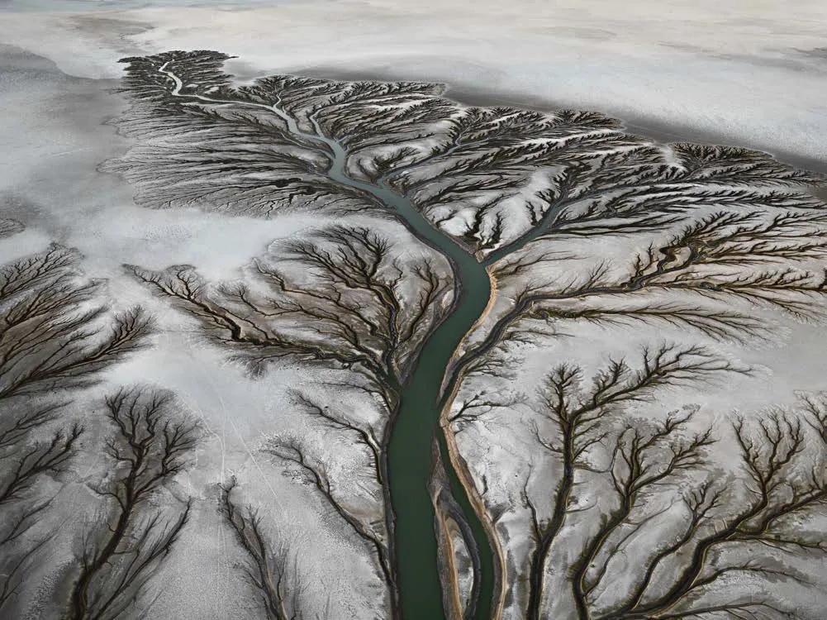
Image#1: Colorado River Delta#2, Near San Felipe, Baja, Mexico (Burtynsky, 2010)
Image#2 “Nickel Tailings” records byproducts of nickel mining/extraction from ore (Burtynsky, 2024). The image has an almost post-apocalyptic quality to it, with its brilliant orange flowing river that looks like molten lava. Its aesthetic appeal compels the viewer to contemplate the contradictions of consumption and industrial “progress” as it becomes apparent it is oxidised waterborne waste. Burtynsky depicts environments so severely reshaped by industry that it barely resembles the earth at all. He skews perspective, giving the illusion of grand scale when the stream is only a meter wide. Exposing the damage caused by IWC’s actions he confronts complacency - depicting an increasingly devastated biosphere depicted as awe inspiring pictures. To quote David Campany (Campany, 2025 pg. 9) “finding ways to create individual photographs and bodies of work …. capable of holding attention long enough to allow the difficulties of the world to reveal themselves in new and unexpected ways.” While Burtynsky’s images may act as a distraction, they engage effective communication about IWC and ecological precarity.

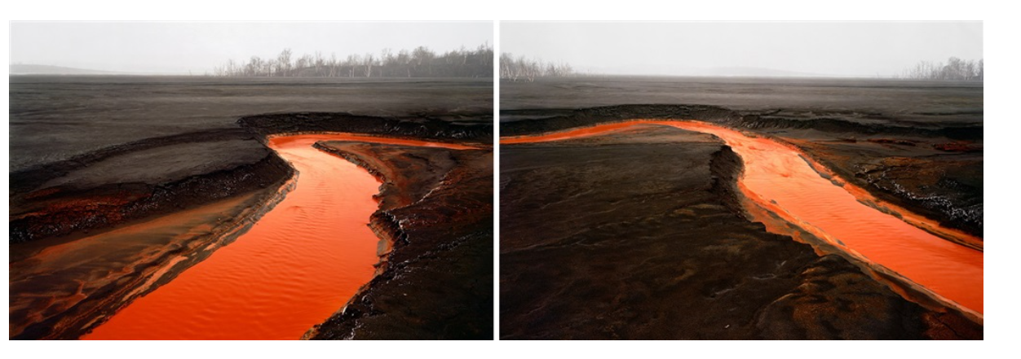
Image#2 Nickel Tailings Number 34 and 35, Sudbury Ontario Canada, 1996 (Burtynsky, 2024, p.214-216)

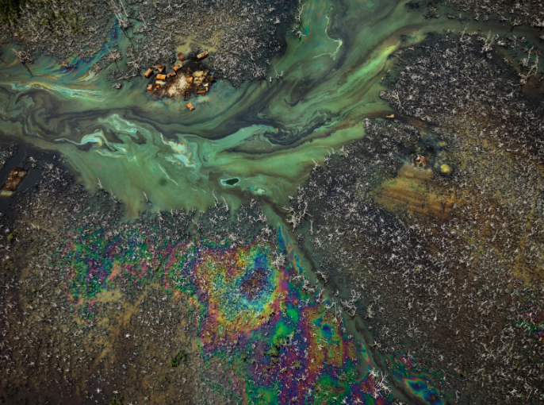
Image#3 Oil Bunkering #9, Niger Delta, Nigeria, 2016 ((Burtynsky, 2024, p.148-149)

Images#3/4/5, trace the journey of oil from extraction>refinement>consumption>waste. Burtynsky describes oil as “the foundational force behind nearly all human altered landscapes” ((Burtynsky, 2009) with a hidden infrastructure that sustains life as we know it, while IWC accelerates the degradation of the planet. Beneath the visual order lies a record of irreversible ecological disruption. Image#3 is an almost ethereal and astral space-scape of stars and planets with its iridescent, luminous colours but is in fact oil waste from the Niger delta showing destruction and ecological harm.
Image#4/5 of oil post consumption, depict the shipbreaking yards of Bangladesh where decommissioned oil tankers are dismantled and stripped by human hand, for re-use or landfill. In these photographs, Burtynsky captures the ghost-like remains of gigantic tankers, which lie motionless on a toxic bed. Closer inspection reveals small specks of humans with no personal protective equipment, carrying out hazardous work. The images make visible how environmental degradation, labour precarity and psychic disengagement converge in the Anthropocene. While the images play out in sepia, they emanate a visual language that puts the global dilemma right in front of us, without diverting our eyes or attention.

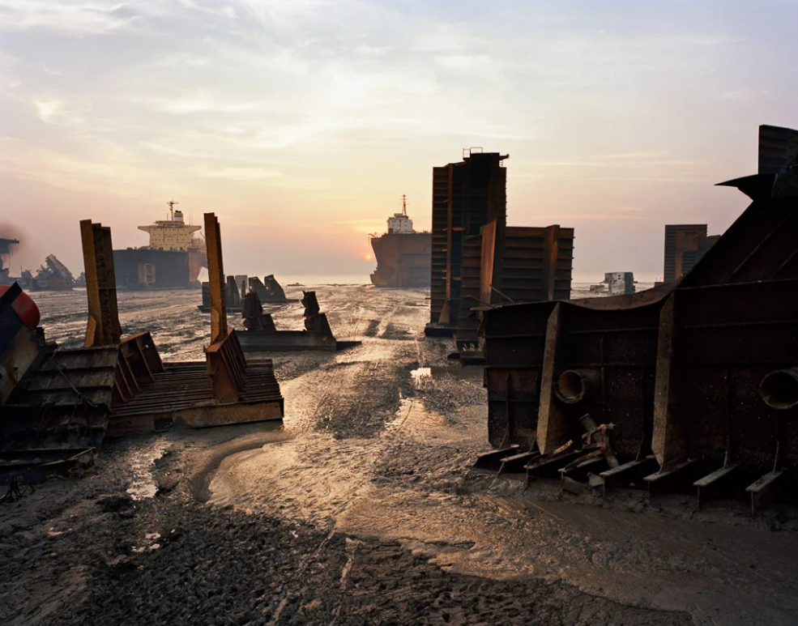Image#4 Shipbreaking #13, Chittagong, Bangladesh (Burtynsky, 2024, p.212-213)

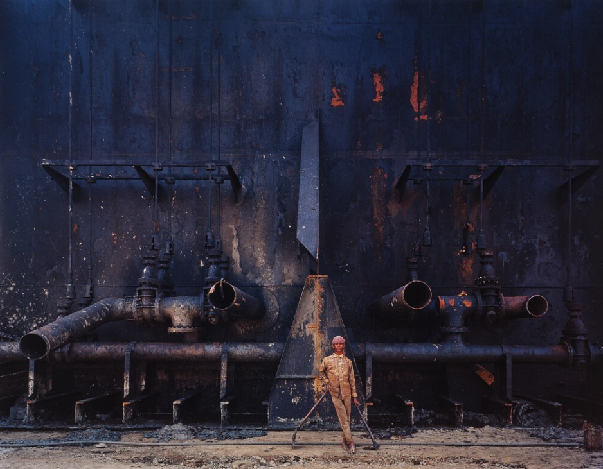
Image#5 Shipbreaking #23, Chittagong, Bangladesh (Burtynsky, 2009, p.157)
Through an aesthetic of the industrial sublime, Burtynsky challenges consumer culture and capitalist expansion, by foregrounding ecologically unequal exchange with the absence of humans. By doing so he prompts reflection across the three ecological registers. Through his images, Burtynsky enables resingularisation position photography as an ethico aesthetic catalyst, disrupting consumption of environmental information and provokes new forms of conscious subjectivity regarding our place in the Anthropocene.
Supported by Ecosophy, Burtynsky’s work encompasses the three registers as visualisations of ecological crisis that is material (environmental), relational (social) and subjective (mental). The absence of people underscores the degradation of social ecology under IWC and situates the work firmly within critical discussions of the Anthropocene and environment. In respect to mental ecology, Burtynsky’s images confront the normalisation of destruction that accompanies late modernity. The reconfiguration of ethical political and aesthetic relations across all three ecologies supports Guattaris resingularisation and connecting the domains of ecology, transversality.
In summary, Burtynsky’s work suspends opinion and invites us to figure it out for ourselves. In the act of seeing, there is not a fixed reference point, and we experience overlapping responses on both cognitive and emotional vectors. If we look and act together, we might feel accountable to each other and the planet through as shared vision

Otobong: Repair, Entanglement and Ethical Imagination
Otobong Nkanga is a visual artist whose practice “examines the social and topographical relationship with our everyday environment” (Nkanga, 2019). Her work connects ethical and imaginative engagement with the earth, which provokes narratives connected to land. She begins from the understanding that flora are living beings “like our body.” In her view water, air, trees, stones, and plants are not passive materials but entities with which humans exist in constant relation. This belief forms the basis of her artwork and exploration into ecology, extraction, memory, and repair. Her work is multi-disciplinary and consists of installations, performances, drawings, tapestries, and sculptural work, which interrogate how bodies, human and non-human, are entangled with territory and resources, as a consequence of global capitalism.
Nkanga’s work exposes how the exploitative relationships, directed by IWC towards land, mirrors some of the unequal relationships that permeate within our global and local societies. By exploring issues surrounding the mining and extraction of mineral resources, she places them alongside these social, political, and material consequences. By further mapping connections between minerals, land, and global trade, alongside communities displaced and impacted by extraction, she highlights the complexity of systems that bind people to place.
Drawing on histories of colonisation, native knowledge systems, and ecological crisis, Nkanga creates “constellations” that work to reveal the reparative potential of natural and social structures (Composuremagazine.com, 2018). There is, therefore, a compelling argument to link Nkanga’s practice with Guattari’s Ecosophy and the three ecological registers.
Evident through Nkanga’s analysis of destructive impacts on environment, is subjectivity and social relations. Her work imagines land as both a memory and body, where environmental and psychological trauma accumulate. In treating the earth as more than just a resource to be exploited, she reframes it as a living archive of histories, injuries, with possibilities for renewal. This resonates strongly with Guattari’s stance that environmental destruction is not only an ecological issue but also a crisis of perception and social justice (mental and social ecology). Interconnecting the three ecosophical registers can be supported by Nkanga in conversation about her work From Where I Stand, she says “…materials have to be embedded in each other to become what they are. So, at different levels, you stay thinking about connectedness and understanding the world through that way of looking.” (Barlow et al., 2019)
Nkanga’s work is extensive. For discussion in this essay the following works have been selected: From Where I stand (Barlow et al., 2019), In pursuit of Bling (Nkanga, 2025) and Carved to Flow (Hansen and Reini, 2021).
From Where I stand (Barlow et al., 2019), investigates the relationship between people and land through consumption of natural resources. Nkanga makes evident the complex economic and political systems that shape these through installations and performances which highlight how minerals and plants are extracted and transformed, as shown in images #6 and #7. The large installation contains images of magnified mica flakes created into a tapestry. The viewer is drawn to the mineral’s aesthetic properties, its shine, which is presented as a scale larger than the body, depicting the minerals intricate crystalline structure. This scale reveals a brittle, faceted, and fractured composition, which extends to irony for its use in creating the perfect skin/cosmetics, after processing through the wider supply chains of IWC.
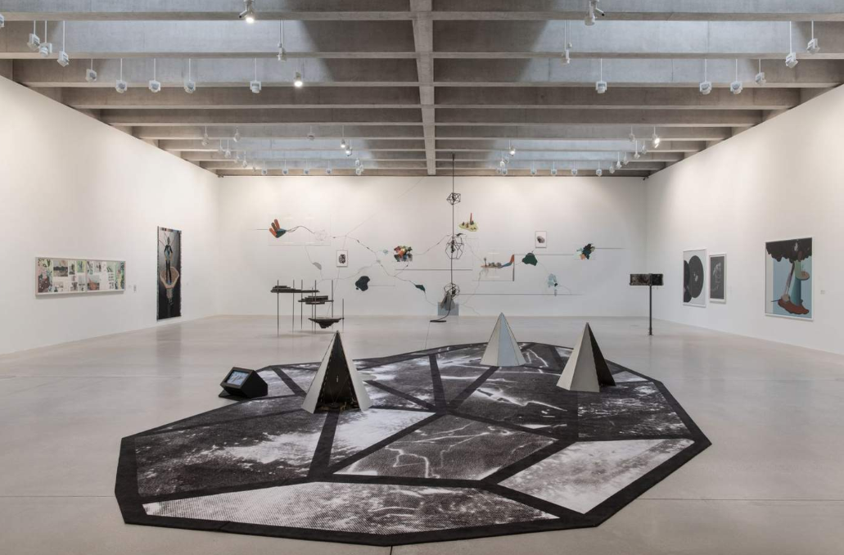
Image#6: From Where I Stand, 2015-2019, Installation Views, Tate St Ives (Barlow et al., 2019, p48-49
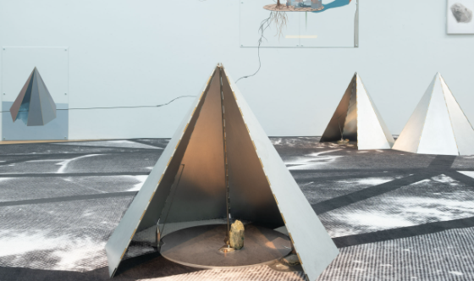
Image#7: From Where I Stand, 2015-2019, Installation Views, Tate St Ives (Barlow et al., 2019, p50)

Image#8 demonstrates Nkanga in performance mode, interacting with the audience on both social and mental registers.
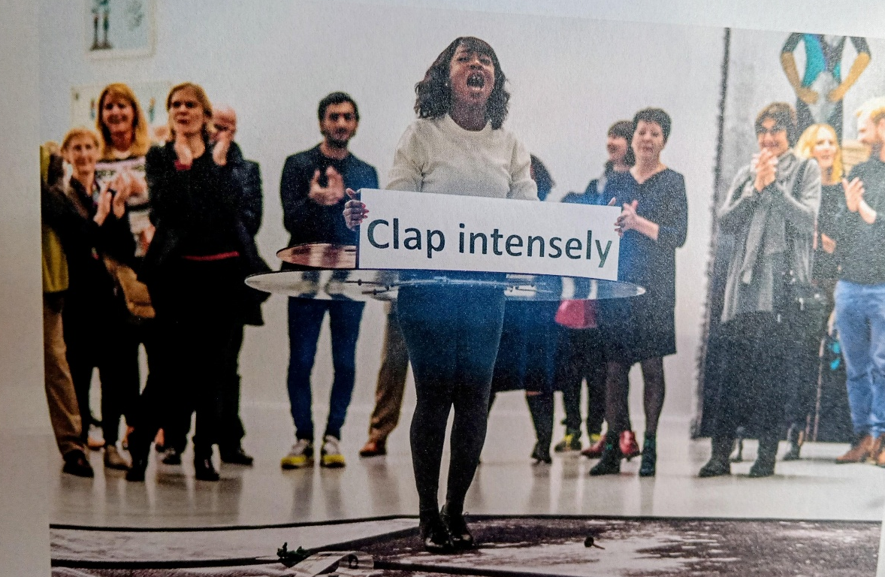
Image#8: From Where I Stand, 2015-2019, Installation Views, Tate St Ives (Barlow et al., 2019, p.47)

The Pursuit of Bling (Nkanga, 2025) (see images #9-#11) reveals the destructive assemblage of IWC/capitalism through narratives that explore how the earth and body are entwined through post-colonial extractivism. This work highlights exploitation and environmental degradation which lead to social inequality.
The set-up imitates the structure of a mineral atom and assembles thirty tables around two tapestries. The tapestries are central and surrounded by extractive artefacts and a video of Nkanga holding a piece of glimmering mica to her mouth. The composition emphasizes the interconnectedness between body, mineral and land while Nkanga’s intervention exposes the interdependence of these forces. Viewers are encouraged to recognise their participation and complicity with these types of global circuits.
It can be argued that the work references the three ecological registers. By exposing the damage caused by IWC, Nkanga is inviting us to review the remains of the past and in a moment of glimmer a future for hope and repair.
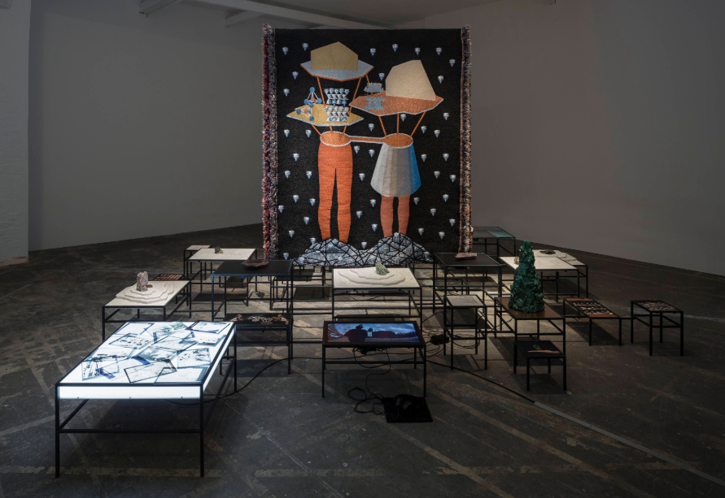
Image#9: In Pursuit of Bling, 2014 (Nkanga, 2025 p.115)

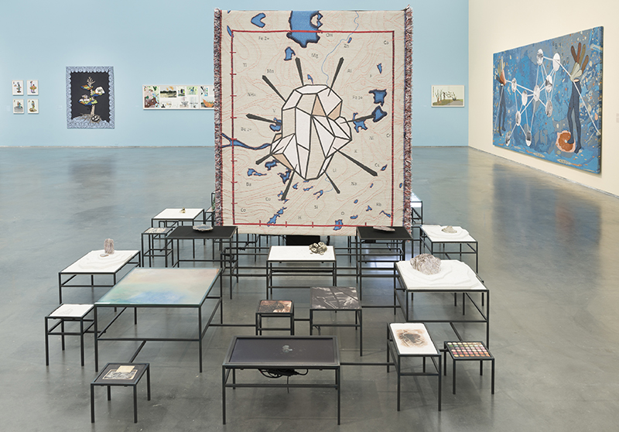
Image#10: In Pursuit of Bling, 2014 (Nkanga, 2025 p.114)
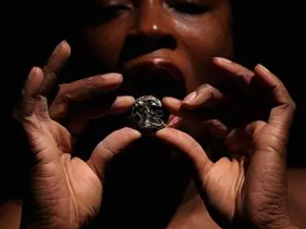
Image#11: In Pursuit of Bling, 2014 (Nkanga, 2025 p.113)

Carved to Flow (Nkanga, 2024) is a collaborative project that explores themes of land, identity, and the circular economy. To close the loop, Nkanga established a soap making laboratory which creates a zero-waste product that is “carved to flow.” For this work, Nkanga created poems, which provide a narrative and voice to the art and revolve around the circular economy as a series of soap sculptures resembling towers. The collaboration has sold over 15,000 bars of soap and funded two non-profit initiatives including an organic farm in Nigeria.
With reference to all three ecological registers through the non-profits, Nkanga’s artwork contributes to broader conversations about ecological responsibility, environmental justice and the role of culture in shaping planetary repair and futures, see Images #12-14. The work forms an aesthetically powerful, immersive encounter with the present and future condition of the planet.

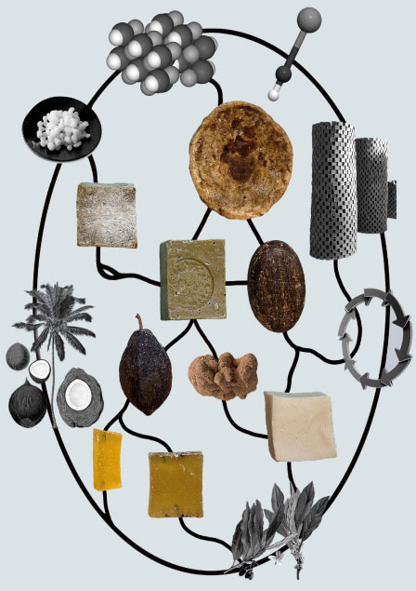
Image #12: Carved to Flow, (Nkanga, 2017)
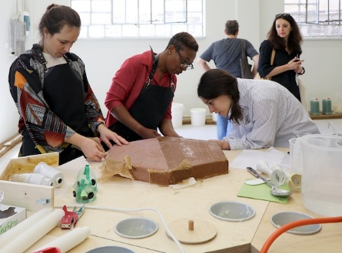
Image #13: Carved to Flow: Laboratory, soapmaking session with Otobong Nkanga, Greece, 2017, (Hansen and Reini, 2021, p.142)
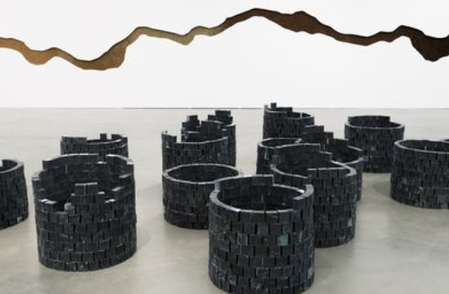
Image #14: Carved to Flow: Germination, To dig a hole that collapses again, 2018 (Hansen and Reini, 2021, p.145)
Nkanga’s work opens up the question - what actions are people willing or unwilling to take in response to ecological and social crisis? It enhances Guattaris notion of resingularisation through its ethical imagination and presentation of Ecosophical values. Viewers are invited to confront ecological realities, in much the same way Burtynsky does with his large-scale photographs, but Nkanga does this by bringing these into the lived experience while envisaging more hopeful alternatives.
Nkanga’s connecting domains of ecology are apparent through traversal practices that offer thoughtful reflection on repair, entanglement, and ethical imagination. Her work reveals the deep ties between land, memory and identity and emphasizes that degradation is inseparable from social inequality and psychological fragmentation. Her work is a persuasive example of how to deploy a message and use strategies to illuminate the environmental crisis, challenge IWC systems and nurture new forms of care, resilience, and interconnectedness.

Conclusion: From Exposure to Repair
By understanding resingularisation and transversality as tools in a framework for artistic practice, both the artist and the viewer can be grounded in an environment where individuals and communities are empowered to craft new ways of being and imagining, in a more sustainable and life affirming way. Guattari’s “ecosophical praxis” elaborates this as a mode of thought and action, capable of reconnecting human subjectivity with environmental responsibility and collective care (Guattari, 1989, p.36).
Guattari’s Ecosophy has been shown to provide the foundation for understanding crisis as multi-dimensional, rather than exclusively environmental. His three registers have offered a model for grasping the mutually reinforcing dynamics, that shape ecological precarity in late modernity. Environmental interventions alone remain limited without integrating the social and mental registers.
Although their strategies differ in scale, medium and affect, both Burtynsky and Nkanga, engage their audiences in exposure of environmental devastation and the consequences of industrial capitalism of Guattari’s notion of IWC. They both enact transversality by transversing Guattaris environmental, social, and mental registers and demonstrate how deeply the registers are interconnected.
While Burtynsky acts more as an observer, exposing the systemic IWC operations of extraction at a planetary level, Nkanga redraws the relationships between humans, materials, and more-than-human worlds. Each artist, however, moves beyond static representation, with Burtynsky offering more analytical images and Nkanga performing reparative gestures that present ecological interdependence. Together their practices demonstrate how contemporary art can diagnose ecological precarity in late modernity, while simultaneously imagining forms of social, ecological, and existential reward.
The differences in their approach and focus are shown in how they approach material and landscape from fundamentally distinct positions. Burtynsky’s remote aerial perspectives present industrial landscapes as monumental and sublime, encouraging shock and awe as a reaction on the scale of human impact. Nkanga’s work by contrast operates through proximity and intimacy, foregrounding bodily engagement, materiality, and sensory experience. The medium and narrative differ, with Burtynsky using photography to capture a frozen definitive still of a landscape, and Nkanga a multidisciplinary approach of installation, material, and performance – both are designed to expose processes and movement over time. Together their practice demonstrates how artistic perspective, whether detached or embodied, shapes our understanding of material, place, and human agency.
Burtynsky’s work is notably devoid of humans, emphasising the absence of care in these vast empty landscapes. Whereas Nkanga’s work places the human body at the centre, often using her own for performances and installations to express social consequences and the “pain” of the land. One shifts subjectivity and encourages audiences to recognise their complicity within extractive systems - the other frames care, attentiveness, and repair as forms of resistance to the psychological flattening provided by global capitalism.
In conclusion, the essay has offered a critique of how capitalist actions and outcomes affect planetary crisis, using Ecosophy as a framework for contemporary artists to adopt, and respond, to ecological precarity in late modernity. Viewed through the lens of Guattari’s Three ecologies, Burtynsky’s and Nkanga’s practices remind us that while the doomsday clock moves closer to midnight, signalling escalating danger, it carries the implicit possibility of reversal. The collective reimagining of relationships between humans, environment and systems, leads to the resingularisation of transversal pathways through which that trajectory could still be turned back.

References
Aesthetica Magazine. (2025). Aesthetica Magazine - Edward Burtynsky: Beauty and Fragility. [online] Available at: https://aestheticamagazine.com/edward-burtynsky-beauty-and-fragility/ [Accessed 20 Apr. 2026].
Barlow, A., Jackson, G., Tate (St Ives and Art (2019). Otobong Nkanga from where I stand. London Tate Publishing.
Bateson, G. (1972). Steps to an ecology of mind. University of Chicago Press.
Bulletin of the Atomic Scientists (2025). Doomsday Clock - Bulletin of the Atomic Scientists. [online] Bulletin of the Atomic Scientists. Available at: https://thebulletin.org/doomsday-clock/ [Accessed 1 Jan. 2026].
Burtynksy, E. (2024). Musée Magazine. [online] Musée Magazine. Available at: https://museemagazine.com/features/2024/4/23/edward-burtynksy-the-scale-of-human-impact.
Burtynsky, E. (2009). Burtynsky Oil. Göttingen: Steidl.
Burtynsky, E. (2010). Photographs: Water. [online] Edward Burtynsky. Available at: https://www.edwardburtynsky.com/projects/photographs/water [Accessed 1 Mar. 2026].
Burtynsky, E. (2019). Edward Burtynsky. [online] Edward Burtynsky. Available at: https://www.edwardburtynsky.com/ [Accessed 1 Feb. 2026].
Burtynsky, E. (2024). Edward Burtynsky: Extraction / Abstraction. Steidl.
Campany, D. (2025). Edward Burtynsky: The Great Acceleration. Steidl.
Composuremagazine.com. (2018). The Scars of Colonialism: Artist Otobong Nkanga – Composure Magazine. [online] Available at: https://composuremagazine.com/otobong-nkanga/ [Accessed 20 Apr. 2026].
Eliasson, O. (2016). Why art has the power to change the world. [online] World Economic Forum. Available at: https://www.weforum.org/stories/2016/01/why-art-has-the-power-to-change-the-world/.
Félix Guattari (1989). The three ecologies. London: Bloomsbury Academic Revelations (2000).
Félix Guattari (1995). Chaosmosis: an ethico-aesthetic paradigm. Sydney: Power.
Hansen, T. and Reini, K.M. (2021). Otobong Nkanga. Uncertain where the Next Wind Blows. Henie Ovstad.
Judge, V. (2019). Art and sustainable ecology and economics | Vaughan Judge | TEDxBozeman. YouTube. Available at: https://www.youtube.com/watch?v=hsX60N8AyZQ [Accessed 1 Apr. 2026].
Kant, I., Frierson, P.R. and Guyer, P. (2011). Immanuel Kant: observations on the feeling of the beautiful and sublime and other writings. Cambridge; New York: Cambridge University Press.
NKanga, O. (2017). CARVED TO FLOW. [online] Carvedtoflow.com. Available at: https://www.carvedtoflow.com/ [Accessed 25 Jan. 2026].
NKanga, O. (2025). I Dreamt of You in Colours. First ed. Musee d’Art Moderne De Paris.
Nkanga, O. (2019). Otobong Nkanga | Visual Artist. [online] Otobong Nkanga. Available at: https://www.otobong-nkanga.com/ [Accessed 5 Dec. 2025].
Peeples, J. (2011). Toxic Sublime: Imaging Contaminated Landscapes. Environmental Communication, 5(4), pp.373–392. doi: https://doi.org/10.1080/17524032.2011.616516.
Press, P. (2016). Gerhard Richter says art is the highest form of hope. [online] Phaidon. Available at: https://www.phaidon.com/en-gb/blogs/phaidon-archive/gerhard-richter-says-art-is-the-highest-form-of-hope?srsltid=AfmBOopOrqzI5E-SGdpZVd17k1bMBhG7hhfhV2I0ROKwtCDbMIg0GnH1 [Accessed 5 Feb. 2026].
Tate (2024). Can art save the world from environmental catastrophe? | Tate. [online] www.youtube.com. Available at: https://www.youtube.com/watch?v=lQwrCxkMnPM [Accessed 28 Mar. 2026].
Tate (n.d.). Otobong Nkanga: From Where I Stand. [online] Tate. Available at: https://www.tate.org.uk/whats-on/tate-st-ives/otobong-nkanga/otobong-nkanga-where-i-stand.

