
-

Institute of Inner-City Learning Birmingham Campus

BSc Hons) Health and Social Care
Name: Shamaila Sakhawat
Student Number: 2309140
Lecturer: Chloe Harries
Module: Independent Project
Module Code: BMHP6020
Assignment Title: Chapter 3

Disclaimer
This document was correct at the time of publication. The Module Coordinator reserves the right to modify any statement, if necessary, make variations to the content or methods of delivery of programmes of study, to discontinue programmes, or merge or combine programmes if such actions are necessary by UWTSD. Every effort will be made to keep disruption to a minimum, and to give as much notice as possible. An electronic copy of this handbook can be found on the Moodle page for the module.

DECLARATION
This work has not previously been accepted in substance for any degree and is not being concurrently submitted in candidature for any degree.
Signed: Shamaila Sakhawat
Date…24/7/2026
STATEMENT 1
This dissertation is being submitted in partial fulfilment of the requirements for the degree of BSc.
Signed……Shamaila Sakhawat
Date………24/7/2026
STATEMENT 2
This dissertation is the result of my own independent work/investigation, except where otherwise stated. Other sources are acknowledged by footnotes giving explicit references. A bibliography is appended.
Signed………Shamaila Sakhawat
Date……24/7/2026
STATEMENT 3
I hereby give consent for my dissertation, if accepted, to be available for photocopying and for interlibrary loan, and for the title and summary to be made available to outside organisations.
Signed………Shamaila Sakhawat
Date……24/7/2026
STATEMENT 4
I hereby give consent for my dissertation, if accepted, to be available on the university’s IT system to those who have consent to use the system.
Signed……………Shamaila Sakhawat
Date……24/7/2026

My project title: An Exploration of the Physiological Mechanisms and Long-Term Health Impacts of Type 2 2Diabetes Mellitus in Older Adults Living in Birmingham

ACKNOWLEDGEMENTS
I would like to express my sincere gratitude to my dissertation supervisor for their guidance, encouragement, and constructive feedback throughout the completion of this research project. Their ability and support were invaluable in helping me develop my understanding of the subject and strengthen the quality of this dissertation.
I would also like to thank the academic staff within the Health and Social Care programme at the University of Wales Trinity Saint David for providing the knowledge, resources, and academic support that contributed to this study. Special thanks are extended to the university library staff for their assistance in accessing relevant academic literature and research materials.
I am grateful to my fellow students and colleagues for their encouragement, discussions, and support throughout the research process. Their motivation and shared experiences helped maintain my focus and commitment during the completion of this dissertation.
Finally, I would like to express my heartfelt appreciation to my family and friends for their patience, understanding, and unwavering support throughout my studies. Their encouragement has been a constant source of motivation and has played a significant role in enabling me to achieve this milestone.
Thank you to everyone who contributed, directly or indirectly, to the successful completion of this dissertation.

Table of Contents

Section | Page
Declaration | 2
Title Page | 4
Acknowledgements | 5
Table of Contents | 6
List of Figures (if applicable) | 7
List of Tables (if applicable) | 8
Chapter 1 – Introduction | 9
1.1 Introduction | 9
1.2 Aim of the Dissertation | 10
1.3 Rationale and Purpose of the Research | 12
1.4 Dissertation Objectives | 13
1.5 Chapter Conclusion | 14
Chapter 2 – Literature Review | 15
2.1 Introduction and Purpose of the Chapter | 15
2.2 Historical Background of Type 2 Diabetes Mellitus | 16
2.3 Theoretical Background, Key Theories and Concepts: Insulin Resistance Paradigm | 21
2.4 International Context of Type 2 Diabetes Mellitus | 25
2.5 National and Local UK Context | 26
2.6 Chapter Summary and Key Points | 30
Chapter 3 – Methodology | 32
3.1 Introduction | 32
3.2 Research Strategy and Development of Keywords | 33
3.3 Searching for Information: Databases and Platforms | 34
3.4 Research Validation and Screening Techniques | 35
3.5 Inclusion and Exclusion Criteria | 36
3.6 Data Analysis: Thematic Coding Approach | 37
3.7 Ethical Considerations | 38
3.8 Chapter Summary | 39
Chapter 4 – Findings and Discussion | 40
4.1 Introduction | 40
4.2 Thematic Analysis | 40
4.3 Theme 1 – Physiological Mechanisms of Type 2 Diabetes Mellitus | 41
4.4 Theme 2 – Long-Term Health Impacts of Type 2 Diabetes Mellitus | 47
4.5 Theme 3 – Management and Support Strategies for Older Adults with Type 2 Diabetes Mellitus | 52
4.6 Chapter Conclusion | 56
Chapter 5 – Conclusion and Recommendations | 58
5.1 Conclusion | 58
5.2 Recommendations | 59
5.2.1 Recommendation 1 – Improve Early Screening and Diagnosis Programmes | 60
5.2.2 Recommendation 2 – Increase Personalised Diabetes Education and Lifestyle Support | 61
5.2.3 Recommendation 3 – Strengthen Integrated Health and Social Care Services | 63
Chapter 6 – References and Appendices | 64
6.1 References | 69
6.2 Appendix A – Source Tracking Table | 70
Appendix B – Results Summary Table | 72
Appendix C – Literature Search Log | 74
Appendix D – Inclusion and Exclusion Criteria | 75
Appendix E – Thematic Coding Framework | 76
Appendix F – CRAAP Test Evaluation | 78

CHAPTER 1

1.1 Introduction
Type 2 Diabetes Mellitus (T2DM) is a chronic and progressive metabolic disorder characterised by persistent hyperglycaemia resulting from insulin resistance and the gradual dysfunction of pancreatic B-cells responsible for insulin secretion (Saini, 2010; Achilli, Deng, and Liu, 2025). The condition accounts for 90–95% of all diabetes cases globally and is widely recognised as one of the most significant public health challenges facing modern healthcare systems (Bellary et al., 2021). In the United Kingdom, the prevalence of diabetes has increased over the past two decades. According to NHS Digital (2022) data indicate that more than 4.9 million people are currently living with diabetes, with the majority diagnosed with T2DM and prevalence rising significantly among adults aged 60 years and older.

Population ageing has intensified the burden of T2DM, particularly in large urban centres such as Birmingham. Birmingham is the second largest city in the UK, with a population exceeding 1.1 million people and characterised by substantial ethnic diversity and socioeconomic variation. Epidemiological research suggests that areas with higher deprivation and diverse populations, such as Birmingham and the West Midlands, demonstrate higher diabetes prevalence with the national average (Congdon, 2006; Au-Yeung et al., 2024). Local health data indicate that 8–10% of adults registered with comprehensive practices in Birmingham have diagnosed diabetes, with prevalence increasing significantly with age and among South Asian and Black ethnic groups.

Ageing contributes to metabolic dysregulation through mechanisms, including increased visceral adiposity, mitochondrial dysfunction, oxidative stress, and chronic low-grade inflammation (Halim and Halim, 2019; Shou, Chen, and Xiao, 2020). These processes impair insulin signalling and glucose metabolism, increasing susceptibility to T2DM. Older adults with T2DM are therefore at increased risk of complications including cardiovascular disease, neuropathy, nephropathy, retinopathy, and cognitive decline (Arnold and Arvanitakis, 2018).

1.2 Aim of the Dissertation:
The primary aim of this dissertation is to explore the physiological mechanisms underlying Type 2 Diabetes Mellitus and examine its long-term health impacts among older adults living in Birmingham. By integrating current understanding of metabolic pathophysiology with local demographic and public health context, this study aims to provide insight into how ageing and environmental factors influence disease progression. The research seeks to contribute to improved health and social care strategies, supporting more effective prevention, management, and long-term care for older adults living with T2DM in Birmingham.

Definitions and Terminology Key Definitions:

This dissertation examines the physiological mechanisms and overall health consequences of Type 2 Diabetes Mellitus (T2DM) among adults living in Birmingham. To ensure clarity and consistency throughout the study, key terms, and concepts relevant to the research are defined below.

Type 2 Diabetes Mellitus (T2DM) is a chronic metabolic disorder characterised by persistent hyperglycaemia resulting from insulin resistance and pancreatic B-cell dysfunction, leading to impaired insulin secretion (American Diabetes Association, 2023). T2DM is the most prevalent form of diabetes globally and is associated with ageing, obesity, physical inactivity, and genetic predisposition.

Insulin resistance refers to a pathological state in which peripheral tissues such as a skeletal muscle, liver, and adipose tissue exhibit reduced responsiveness to insulin. liver, and fat show reduced responsiveness to insulin, resulting in impaired glucose uptake and increased hepatic glucose production (DeFronzo, 2009).
B-cell dysfunction describes the progressive decline in pancreatic beta-cell function and insulin secretory capacity, During the early stage of T2DM, B-Cells compensate for insulin resistance through hyperinsulinemia, leading to reduced insulin production and poor glycaemic control.

Hyperglycaemia is defined as elevated blood glucose concentrations, commonly assessed using fasting plasma glucose or glycated haemoglobin (HbA1c), which reflects blood glucose levels over two to three months.

T2DM is associated with microvascular complications, including cardiovascular disease and stroke, and microvascular complications such as nephropathy, retinopathy, and neuropathy (UKPDS Group, 1998). Frailty is a geriatric syndrome characterised by reduced physiological reserve and vulnerability to stressors and is more common in individuals with T2DM, particularly in older adults.

Acronyms and Abbreviations:
T2DM – Type 2 Diabetes Mellitus
HbA1c – Glycated Haemoglobin
BMI – Body Mass Index
CVD – cardiovascular disease
NHS – National Health Service
UKPDS – UK Prospective Diabetes Study

1.3 Rationale for Research

Purpose of the Research:

The increasing prevalence of Type 2 Diabetes Mellitus (T2DM) among older adults represents a growing challenge for health and social care systems in the United Kingdom. As the population ages, the number of individuals living with chronic metabolic conditions such as T2DM continues to rise, increasing pressure on healthcare services, long-term disease management, and community support. Birmingham, the second largest city in the UK, has been identified as an area with high diabetes prevalence, particularly among ethnically diverse populations and communities experiencing socioeconomic deprivation (Public Health England, 2019). Research shows that South Asian and Afro-Caribbean populations are disproportionately affected by T2DM, often developing the condition at younger ages and lower body mass index thresholds compared with White European populations (Foroughi and Wareham, 2014).

Although extensive research has examined the biological mechanisms underlying T2DM, these mechanisms are often discussed at a general level. DeFronzo (2009) described the pathophysiology of T2DM through the “ominous octet”, highlighting the role of multiple organs in disease development. However, limited research integrates these physiological mechanisms with local population contexts within UK cities such as Birmingham.

Several research gaps justify this study. There is limited research integrating physiological mechanisms with long-term outcomes in older adults within specific urban contexts such as Birmingham. In addition, many studies do not link physiological mechanisms with geriatric conditions such as frailty, multi morbidity, and cognitive decline. Socioeconomic inequalities and ethnic disparities are also underrepresented in mechanistic diabetes research. This dissertation aims to address these gaps by linking mechanisms with outcomes in a population.

Aim and Objectives
To explore the physiological mechanisms underlying Type 2 Diabetes Mellitus and evaluate its long-term health impacts among older adults living in Birmingham.

Research Objectives:
List the specific objectives that will help achieve the research aim. You will copy and paste this information from your proposal.

Objective 1: To examine how age-related physiological changes affect glucose regulation and insulin sensitivity in older adults and analyse how these changes increase care needs within health and social care settings (Reimann, 2023).

Objective 2: To analyse the key physiological characteristics of Type 2 Diabetes Mellitus in older adults, including insulin resistance and chronic hyperglycaemia (Sinclair et al., 2020).

Objective 3: To evaluate the long-term physiological complications of T2DM in older people, such as cardiovascular disease, neuropathy, and renal impairment, and their impact on functional independence (WHO, 2022; Stratton et al., 2000).

Objective 4: To provide evidence-based recommendations for improving the management and support of older adults with Type 2 Diabetes within Birmingham’s health and social care services (Diabetes UK, 2023; NHS Digital, 2022).

1.5 Conclusion

Summary of Chapter
This chapter has introduced the research topic by outlining the epidemiological and physiological significance of Type 2 Diabetes Mellitus among older adults, with particular emphasis on Birmingham’s urban and demographic context. Key terminology has been defined to establish conceptual clarity. The rationale for the research has highlighted existing gaps in integrating physiological mechanisms with long-term health outcomes within local populations.

Signposting to Chapter 2:

Briefly introduce the next chapter and explain its role in the dissertation.
The next chapter will present a comprehensive literature review examining current evidence on the pathophysiology of T2DM, its chronic complications, and the influence of demographic and socioeconomic determinants. This chapter will critically evaluate existing studies, identify limitations in current knowledge, and provide the theoretical and empirical foundation for the present research study. It will also highlight key debates, methodological approaches, and relevant public health perspectives that inform the research aims and objectives. Together, these discussions will justify the study’s focus and research questions and outline the conceptual framework used throughout.

CHAPTER 2 – Background Information and Analysis

2.1 Introduction Purpose of the Chapter:
This chapter provides the conceptual and contextual foundation for understanding Type 2 Diabetes Mellitus (T2DM), with particular emphasis on its physiological mechanisms and long-term health impacts in older adults. The purpose of this chapter is to critically examine the historical development, theoretical frameworks, and policy contexts that have shaped contemporary knowledge of T2DM. Rather than presenting a purely descriptive overview, it considers how diabetes has been conceptualised within biomedical, epidemiological, and public health perspectives.

The chapter outlines the historical evolution of diabetes research, tracing the transition from early descriptions of symptoms to contemporary molecular explanations of metabolic dysfunction. It then examines key theoretical frameworks explaining T2DM, including insulin resistance, beta-cell dysfunction, and the concept of inflammaging associated with ageing populations. In addition, broader social perspectives are considered through the social determinants of health framework, which highlights how socioeconomic conditions influence disease risk.

Finally, the chapter situates T2DM within international, national, and local UK policy contexts, with particular focus on Birmingham’s demographic and socioeconomic characteristics. This chapter is directly relevant to the aims of this study because it explores how physiological mechanisms such as insulin resistance, beta-cell dysfunction, and chronic inflammation contribute to long-term health outcomes among older adults with T2DM. In addition, examining social and policy influences provides a broader understanding of how biological and environmental factors interact to shape disease progression and healthcare experiences in Birmingham.

Monitoring Blood Glucose
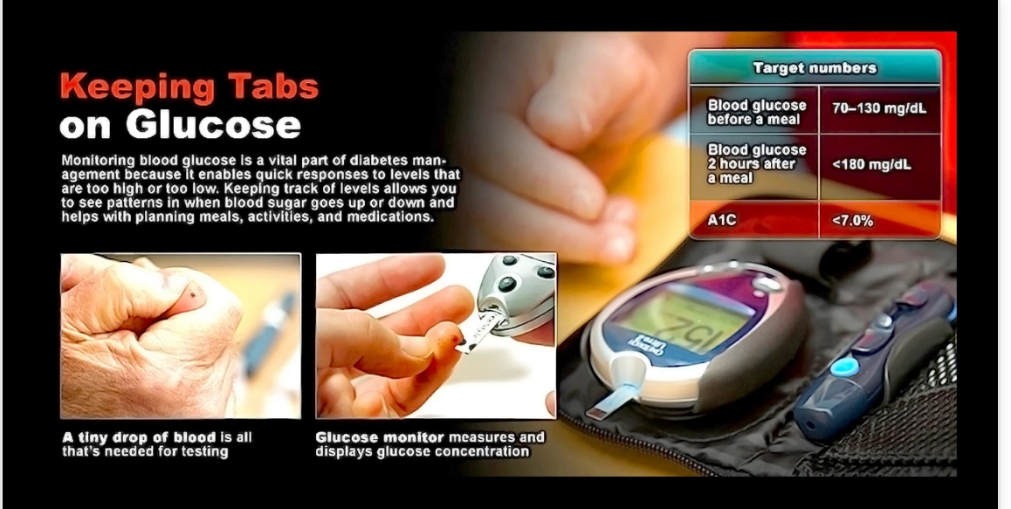

Figure 1: Monitoring blood glucose is an important part of managing Type 2 Diabetes Mellitus and reducing long-term complications.

Source: National Institute of Diabetes and Digestive and Kidney Diseases (NIDDK).

2.2 Historical Background

Development of the Topic

Historical Timeline of Insulin Research and Genetic Discoveries
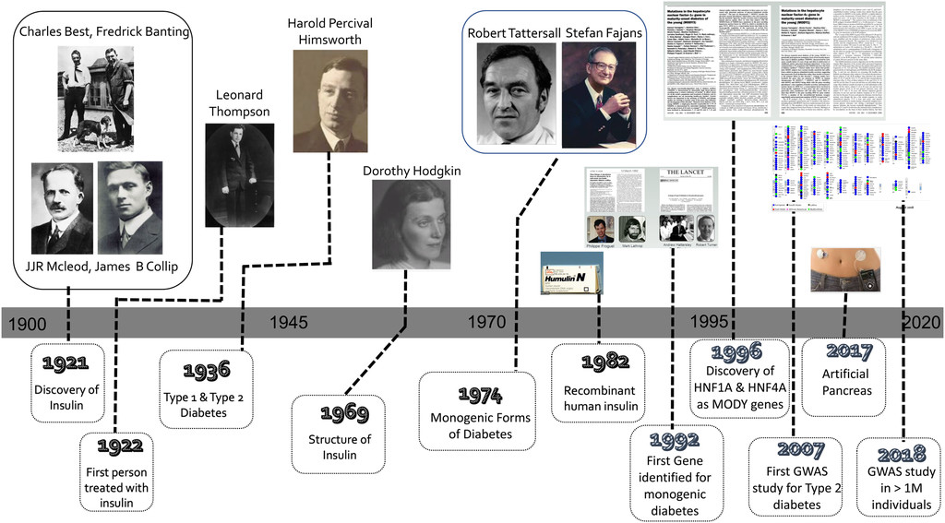

Figure 2: Timeline indicating key genetic discoveries in the context of understanding the hormone insulin and its therapeutic use in diabetes management.

Citation/Source: Journal of Endocrinology, 250(3). Available at: https://doi.org/10.1530/JOE-21-0067

The understanding of diabetes has evolved significantly over centuries, reflecting broader changes in medical knowledge and scientific methodology. Early references to diabetes appear in ancient Egyptian and Indian medical texts, which described symptoms such as excessive urination, persistent thirst, and unexplained weight loss (Polonsky, 2012). However, these early accounts lacked a clear explanation of the physiological mechanisms responsible for the condition and were based primarily on observable symptoms rather than scientific evidence.
A breakthrough occurred in the nineteenth century when Paul Langerhans identified clusters of cells in the pancreas, later known as the islets of Langerhans, which were eventually recognised as central to insulin secretion and glucose regulation. The discovery of insulin in 1921 by Frederick Banting and Charles Best transformed diabetes from a fatal disease into a manageable chronic condition and marked a turning point in endocrinology and metabolic research (Polonsky, 2012). The introduction of insulin therapy significantly improved survival rates and changed the clinical management of diabetes worldwide, allowing patients to live longer and healthier lives.

Despite these advances, the classification of Type 2 diabetes remained unclear for much of the twentieth century and was commonly referred to as adult-onset diabetes. This terminology reflected age of diagnosis rather than underlying biological mechanisms and overlooked the heterogeneity of the disease and its complex causes (Reed, Bain, and Kanamarlapudi, 2021). Over time, researchers recognised that Type 2 diabetes is a multifactorial metabolic disorder influenced by genetic, environmental, behavioural, and socioeconomic factors rather than age alone.

By the late twentieth century, epidemiological evidence demonstrated a rapid increase in the prevalence of T2DM, particularly in industrialised countries. This rise was strongly associated with lifestyle changes including reduced physical activity, increased consumption of energy-dense foods, obesity, and urbanisation (Forouhi and Wareham, 2014). Urbanisation, technological development, and changes in occupational structures contributed to increasingly sedentary lifestyles, further increasing the risk of metabolic disease. These societal changes played a significant role in the global expansion of T2DM, particularly in urban populations.

One of the most influential clinical investigations was the UK Prospective Diabetes Study (UKPDS), conducted between 1977 and 1997, which demonstrated that improved glycaemic control reduced the risk of microvascular complications such as retinopathy and nephropathy (UKPDS Group, 1998). The findings significantly influenced clinical practice and diabetes management guidelines. Consequently, HbA1c became widely adopted as a key indicator for monitoring long-term glucose control and guiding treatment strategies. The UKPDS also highlighted the importance of blood pressure control and cardiovascular risk management among individuals with diabetes.

Subsequent research introduced additional complexities to diabetes management. Large clinical trials, including the ACCORD study, suggested that intensive glycaemic control may increase mortality risk in older adults due to hypoglycaemia and cardiovascular complications (Sinclair et al., 2012). These findings emphasised the need for more individualised treatment approaches, particularly for ageing populations experiencing frailty, co-morbidities, and polypharmacy. Consequently, diabetes management shifted from strict glycaemic targets towards more personalised and patient-centred care.

Another significant development was DeFronzo’s (2009) “ominous octet” model, which expanded understanding of T2DM by identifying eight interacting physiological mechanisms contributing to hyperglycaemia. These include impaired insulin secretion, increased hepatic glucose production, adipose tissue dysfunction, altered incretin activity, increased glucagon secretion, increased renal glucose reabsorption, neurotransmitter dysfunction, and reduced glucose uptake in skeletal muscle tissue. This model provided a more comprehensive explanation of disease progression and highlighted the complexity of Type 2 diabetes pathophysiology.

However, although DeFronzo’s model significantly improved biomedical understanding of T2DM, it has been criticised for focusing primarily on physiological dysfunction while giving limited attention to wider environmental and socioeconomic influences. This limitation may reduce the effectiveness of interventions if broader determinants such as poverty, food insecurity, and unequal access to healthcare are not simultaneously addressed.

In recent decades, diabetes has increasingly been recognised as a global public health challenge shaped by biological, behavioural, environmental, and social factors (International Diabetes Federation, 2021). Collectively, these developments demonstrate that understanding of T2DM has progressed from early symptom-based descriptions to complex multidisciplinary models integrating biomedical and public health perspectives.

Overall, the historical development of diabetes research demonstrates that T2DM is influenced by both biological mechanisms and wider social factors. While advances in endocrinology and metabolic science improved understanding of disease processes, public health research highlighted the importance of lifestyle, deprivation, and health inequalities. This combined perspective is particularly important when examining older adults, whose health outcomes are shaped by both physiological ageing and long-term social circumstances.

Significant Historical Figures and Contributions

Several key researchers and institutions have significantly influenced the development of diabetes knowledge and treatment. Frederick Banting and Charles Best played a fundamental role through their discovery of insulin, which provided the first effective treatment for diabetes and dramatically improved patient survival rates (Polonsky, 2012). Their work remains one of the most important medical discoveries of the twentieth century.
Later, Ralph DeFronzo contributed to a deeper understanding of the complex pathophysiology of T2DM through his “ominous octet” framework, demonstrating that hyperglycaemia results from dysfunction across multiple organs rather than a single physiological defect (DeFronzo, 2009). This model influenced modern pharmacological treatment approaches, which now target multiple physiological pathways.
The investigators of the UK Prospective Diabetes Study also made substantial contributions by establishing the importance of glycaemic control in preventing long-term complications, influencing clinical guidelines and evidence-based diabetes management strategies (UKPDS Group, 1998).
More recently, Sinclair et al. (2012) emphasised the importance of personalised care approaches for older adults with diabetes, highlighting the risks of over treatment and the need to prioritise patient safety, quality of life, and functional independence rather than focusing solely on glycaemic targets.
Collectively, these developments illustrate how understanding of T2DM has evolved from early symptom-based descriptions to complex models integrating physiological, behavioural, environmental, and public health perspectives. This progression demonstrates that Type 2 diabetes is not only a metabolic disorder but also a condition influenced by multiple interacting biological and social factors, reinforcing the need for multidisciplinary approaches to prevention, treatment, and long-term management.

2.3 Theoretical Background, Key Theories and Concepts

Insulin Resistance Paradigm

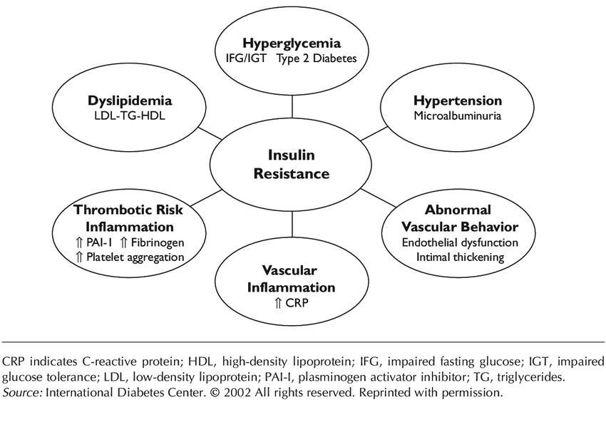
Theoretical Relationship of Insulin Resistance to Other Features of the Insulin Resistance Syndrome
Figure 3. Theoretical Relationship of Insulin Resistance to Other Features of the Insulin Resistance Syndrome

One of the most widely accepted explanations for the development of T2DM is the insulin resistance paradigm. This theory proposes that peripheral tissues, particularly skeletal muscle, and adipose tissue, become less responsive to insulin, resulting in reduced glucose uptake and elevated blood glucose levels (DeFronzo, 2009). In response, pancreatic beta cells initially increase insulin production to maintain glucose homeostasis; however, this compensatory mechanism eventually fails, leading to persistent hyperglycaemia.

Insulin resistance is strongly associated with obesity, particularly visceral adiposity, which contributes to metabolic dysfunction through inflammatory pathways (Galicia-Garcia et al., 2020). While the insulin resistance model explains many aspects of metabolic dysfunction, it may not fully account for environmental and socioeconomic influences on disease progression. This limitation may reduce the effectiveness of interventions if broader social factors are not addressed.

This theory is directly relevant to the present study because insulin resistance contributes to many long-term complications experienced by older adults, including cardiovascular disease, frailty, and reduced physical functioning.

Beta-Cell Dysfunction and Glucolipotoxicity

Another important theoretical framework focuses on beta-cell dysfunction. Prolonged exposure to elevated glucose and circulating free fatty acids can lead to cellular stress and progressive beta-cell damage, commonly referred to as glucolipotoxicity. This process reduces insulin secretion and worsens glycaemic control over time (Reed, Bain, and Anomalepidid, 2021).

However, emerging evidence suggests that beta-cell dysfunction may not always be irreversible. Research involving bariatric surgery and substantial weight reduction has demonstrated that remission of T2DM can occur in some individuals, indicating that pancreatic function may partially recover under favourable metabolic conditions.

These findings are important for this research because they demonstrate that physiological decline in T2DM may not always be permanent and that management strategies targeting metabolic improvement may positively influence health outcomes in older adults.

Inflammaging and Metabolic Senescence
The concept of inflammaging has become increasingly relevant in explaining T2DM among older adults. Inflammaging refers to chronic low-grade inflammation associated with ageing that contributes to the development of age-related diseases (Frasca et al., 2021). Inflammatory cytokines such as interleukin-6 and tumour necrosis factor-alpha impair insulin signalling and promote metabolic dysfunction, accelerating disease progression and increasing the risk of complications including cardiovascular disease and cognitive decline (Talley et al., 2016).

Recent evidence also suggests that inflammaging contributes to frailty, immune dysfunction, and reduced physiological resilience among older adults (Dugan, Conway, and Duggal, 2023). This is particularly relevant to ageing populations because it helps explain why older adults with T2DM often experience multiple co-morbidities simultaneously.

Social Determinants of Health Framework

While biomedical theories provide insight into physiological mechanisms, they do not fully explain variations in diabetes prevalence across populations. The social determinants of health framework highlights how socioeconomic factors such as income, education, employment, and housing influence health outcomes (Marmot, 2010).

Individuals living in disadvantaged communities often experience limited access to healthy foods, safe recreational environments, and healthcare services, increasing vulnerability to chronic diseases including T2DM. Research in Birmingham has demonstrated that socioeconomic deprivation and ethnicity significantly increase diabetes risk, particularly among South Asian populations (Au-Yeung et al., 2024).

Application of Theories
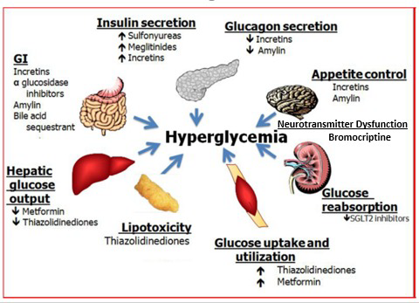

Figure 4: Sites of Action of Pharmacological Therapies for the Treatment of Type 2 Diabetes.

Source: Adapted from DeFronzo (2009).

These theoretical perspectives have influenced both diabetes research and clinical practice. The insulin resistance model underpins the mechanism of action of metformin, which reduces hepatic glucose production and improves insulin sensitivity (Bellary et al., 2021). The concept of inflammaging has informed research exploring relationships between diabetes, frailty, and cognitive impairment in older adults, while the social determinants framework has guided public health strategies and targeted diabetes prevention programmes.

Critical Evaluation of Theories
Although these theoretical frameworks provide valuable insight into T2DM, each has important limitations. The insulin resistance paradigm has been criticised for emphasising obesity and individual lifestyle behaviours while insufficiently considering environmental and socioeconomic influences. This may limit intervention effectiveness in deprived communities where opportunities for healthy living are restricted.

Similarly, the beta-cell dysfunction model traditionally assumes irreversible pancreatic decline, yet evidence from weight-loss interventions and bariatric surgery suggests that metabolic recovery may be possible in some individuals. The inflammaging framework remains supported by observational evidence, making causal relationships difficult to establish. In addition, while the social determinants framework explains population-level inequalities, it may not fully integrate underlying biological mechanisms.

Recent research also highlights the heterogeneity of T2DM. Ahlqvist et al. (2018) identified distinct subtypes of adult-onset diabetes based on genetic and metabolic characteristics, challenging traditional classifications and supporting more personalised treatment approaches.

Overall, these theories demonstrate that T2DM is a multifactorial condition shaped by interactions between biological dysfunction, ageing processes, behavioural factors, and wider social inequalities. Understanding these interacting influences is essential for developing effective prevention and management strategies for older adults living with diabetes.

2.4 International Context
Type 2 Diabetes Mellitus is recognised globally as one of the most significant chronic non-communicable diseases. According to the International Diabetes Federation (2021), approximately 537 million adults worldwide are living with diabetes, with prevalence expected to increase over coming decades due to ageing populations, urbanisation, physical inactivity, and rising obesity levels.

The burden of T2DM differs across countries and regions. Low- and middle-income countries have experienced particularly rapid increases in prevalence, often linked to nutritional transition, reduced physical activity, and expanding urban environments. In many countries, healthcare systems face growing pressure from diabetes-related complications, including cardiovascular disease, kidney failure, and visual impairment.

International research also demonstrates significant inequalities in diabetes prevalence and outcomes across ethnic and socioeconomic groups. South Asian, African, and Hispanic populations often experience higher rates of T2DM, and earlier disease onset compared with White European populations (International Diabetes Federation, 2021). These disparities highlight the importance of considering both biological susceptibility and wider social determinants of health.

While biomedical advances have improved diabetes treatment globally, major challenges remain regarding prevention, early diagnosis, and equitable access to healthcare. Consequently, international public health organisations increasingly emphasise integrated approaches combining clinical management with population-level interventions targeting obesity, diet, physical activity, and health inequalities.

2.5 National and Local UK Context UK Perspective
In the United Kingdom, T2DM is recognised as a major public health concern due to its increasing prevalence and long-term health consequences. Approximately 4.9 million people in the UK are living with diabetes, the majority of whom have T2DM (NHS Digital, 2022). The condition places substantial pressure on healthcare resources and accounts for a considerable proportion of NHS expenditure.

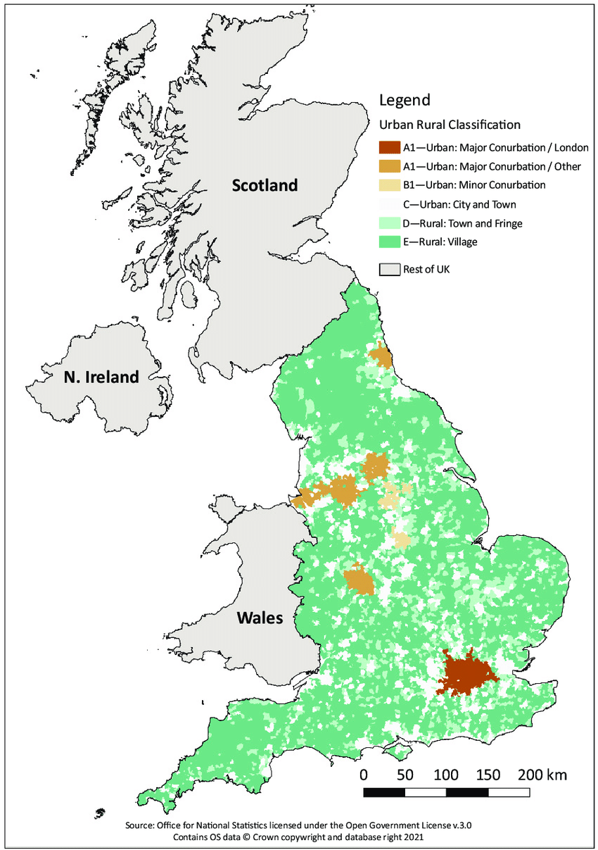
The burden of T2DM is particularly high among older adults, as ageing is associated with physiological changes that impair glucose metabolism and increase insulin resistance (Bellary et al., 2021). Prevalence is also higher among individuals living in socioeconomically deprived communities, highlighting the importance of wider social determinants of health.

National Diabetes Management
National diabetes management strategies are coordinated primarily through primary care services. The NHS Long Term Plan (2019) emphasises prevention, early diagnosis, and integrated care pathways to reduce the burden of chronic disease. A key initiative is the NHS Diabetes Prevention Programme, which targets individuals at considerable risk of developing T2DM and promotes lifestyle interventions including improved diet, increased physical activity, and weight management.

Although evaluations suggest these interventions can reduce diabetes risk, participation and outcomes vary across regions and population groups. This may indicate that behavioural interventions alone are insufficient without addressing wider structural inequalities influencing health behaviours.

Ethnic Inequalities in Diabetes Prevalence
Ethnic inequalities represent a prominent issue within UK diabetes management. South Asian populations are more likely to develop T2DM at younger ages and lower body mass index levels than White European populations (Barnett et al., 2006). These disparities are influenced by a combination of genetic susceptibility, cultural dietary patterns, socioeconomic inequalities, and differential access to healthcare services.

Policy and Regulation
Clinical management of diabetes in the UK is guided by recommendations from the National Institute for Health and Care Excellence (NICE), which promotes personalised treatment approaches based on age, co-morbidities, and hypoglycaemia risk (NICE, 2022). The Quality and Outcomes Framework incentivise general practitioners to meet targets such as HbA1c monitoring, blood pressure control, and complication screening.

However, critics argue that performance targets may prioritise measurable biomedical outcomes over holistic patient-centred care. Integrated Care Systems were introduced to improve coordination between healthcare services, although workforce shortages and financial pressures continue to challenge effective service delivery.

Local Context: Birmingham
At the local level, Birmingham provides an important context for examining T2DM due to its diverse population and high diabetes prevalence. Public Health England reports that diabetes rates in Birmingham exceed the national average, reflecting demographic and socioeconomic influences. The city has a large South Asian population and areas of significant socioeconomic deprivation, both associated with increased risk of T2DM (Au-Yeung et al., 2024).


Figure 5. Birmingham: Local Context

Figure 5: Sites of Action of Pharmacological Therapies for the Treatment of Type 2 Diabetes.

Source: Birmingham City Council (2024) and Public Health England.
Local health authorities have introduced community screening programmes and culturally tailored health education initiatives. However, structural inequalities, deprivation, and limited access to healthy environments continue to influence health outcomes and may reduce the effectiveness of public health interventions.

This local context is directly relevant to the present study because it highlights how physiological mechanisms of diabetes interact with wider environmental and social influences affecting older adults in Birmingham.

Chapter Summary
Overall, this chapter has demonstrated that T2DM is a complex condition influenced by interacting physiological, behavioural, social, and environmental factors. Historical developments in diabetes research have improved understanding of metabolic dysfunction, while public health perspectives have highlighted the importance of inequality, deprivation, and ageing.

The chapter also examined international, national, and local healthcare contexts, showing how policy, ethnicity, and socioeconomic conditions influence diabetes prevalence and management within Birmingham. These findings reinforce the importance of adopting an integrated approach when investigating long-term health outcomes among older adults with T2DM.

2.6 Conclusion Summary of Key Points

This chapter has critically examined the historical development, theoretical frameworks, and policy contexts shaping contemporary understanding of Type 2 Diabetes Mellitus. The discussion demonstrated how conceptualisation of diabetes has evolved from early symptom-based descriptions to complex biomedical models encompassing insulin resistance, beta-cell dysfunction, and chronic inflammation.

While these physiological frameworks provide valuable insight into disease mechanisms, they do not fully account for social and environmental factors influencing disease distribution and outcomes. The social determinants of health perspective emphasise how socioeconomic conditions, cultural contexts, and health inequalities contribute to variations in prevalence and long-term complications.

Analysis of the international and UK policy landscape shows that diabetes management is supported through structured governance, including NICE guidelines and national prevention programmes. Nevertheless, persistent inequalities in urban areas such as Birmingham highlight the limitations of biomedical approaches alone.

Signpost to Next Chapter

These insights underscore the need for research integrating both biological and contextual perspectives. Chapter 3 therefore outlines the methodological framework used to investigate the physiological mechanisms and long-term health impacts of T2DM among older adults in Birmingham.

CHAPTER 3 – Methods and Search Strategy

1 – Introduction Purpose of the Chapter:
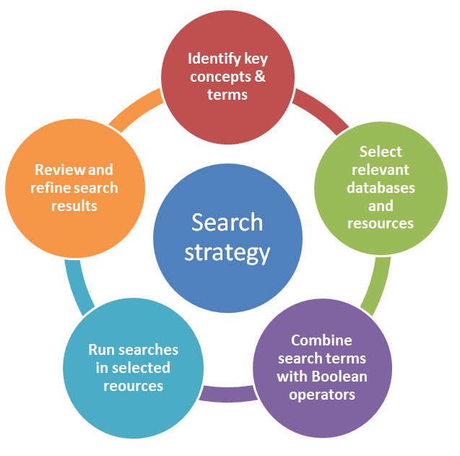

Figure 6: Aveyard (2019) explains that an effective literature search involves identifying key concepts and terms, selecting appropriate databases, developing a search strategy, using Boolean operators, and critically reviewing search results to identify relevant evidence.

The purpose of this chapter is to provide a clear and systematic explanation of how this research was conducted using a structured desk-based, literature-based methodology (Aveyard, 2019). As this project explores the physiological mechanisms and long-term health impacts of Type 2 Diabetes Mellitus (T2DM) in older adults living in Birmingham, the use of secondary research enables the synthesis of existing biomedical, clinical, and epidemiological evidence in a rigorous and academically appropriate manner (Snyder, 2019). The Academic Methodology Poster presented a visual summary of this process; however, this chapter expands on each component in detail, including the search strategy, validation procedures, inclusion and exclusion criteria, and thematic analysis approach.

Connection to the Dissertation:
The methods outlined in this chapter are fundamental to the dissertation, as they determine the quality, relevance, and credibility of the literature selected. The systematic identification and analysis of sources directly inform the thematic findings presented in Chapter 4, ensuring that conclusions are grounded in robust academic evidence.

3.2 – Search Strategy Developing Keywords:
The search strategy was derived directly from the research question. Primary keywords included: Type 2 Diabetes Mellitus, physiological mechanisms, pathophysiology, long-term complications, older adults, elderly, ageing, and Birmingham. To enhance sensitivity, medical terminology and synonyms were incorporated, such as T2DM, insulin resistance, beta-cell dysfunction, microvascular complications, microvascular complications, and geriatric population (DeFronzo et al., 2015; Zheng et al., 2018).

Boolean Operators:
Boolean operators were systematically applied to refine results. For example:
- “Type 2 Diabetes Mellitus” AND “older adults”
- “T2DM” AND “pathophysiology”
- “Insulin resistance” AND “ageing”
- “Type 2 Diabetes” AND (“Birmingham” OR “United Kingdom.
The operator OR broadened searches by capturing alternative terminology, while AND narrowed results to ensure conceptual relevance. NOT was occasionally used to exclude studies focused exclusively on Type 1 Diabetes.

Structured Search Plan:

A structured search log was maintained to record databases used, search strings, filters applied, and number of results retrieved. This systematic documentation enhances transparency and replicability, consistent with best practice in literature-based research (Page et al., 2021).

– Searching for Information Databases and Platforms:

Academic literature was sourced primarily from PubMed, CINAHL, ScienceDirect, Google Scholar, and the UWTSD Online Library. These databases were selected because they collectively provided comprehensive coverage of biomedical, nursing, public health, and multidisciplinary research, making them the most appropriate sources for addressing the research question on the physiological mechanisms and long-term health impacts of Type 2 Diabetes Mellitus (T2DM) in older adults living in Birmingham. PubMed was prioritised due to its strong indexing of peer-reviewed biomedical and endocrinology research, making it particularly relevant for understanding T2DM pathophysiology (Chatterjee, Khunti and Davies, 2017). CINAHL supported exploration of nursing and public health perspectives, while ScienceDirect provided access to full-text clinical and epidemiological studies. Google Scholar and the UWTSD Online Library were used to identify additional relevant literature and ensure comprehensive coverage of available evidence.

Using Filters
Filters were applied to ensure the quality, relevance, and reliability of the evidence included. Publications were limited to 2014–2024 to support currency, as diabetes management and understanding of disease mechanisms have evolved significantly over the past decade (Zheng et al., 2018). Only peer-reviewed journal articles written in English were included to ensure methodological quality and accessibility for critical appraisal. Where possible, UK-based studies were prioritised to maintain contextual relevance to Birmingham and ensure the findings reflected healthcare practice and epidemiological trends within the UK, particularly data from the NHS and regional populations (Diabetes UK, 2023).

Search Process
Initial searches yielded a high volume of pharmacological intervention studies. To better align with the research aim of exploring physiological mechanisms and long-term health impacts rather than treatment effectiveness, additional search terms such as “chronic complications,” “cardiovascular disease,” “neuropathy,” and “age-related metabolic decline” were incorporated. When Birmingham-specific data were limited, broader UK studies were included to provide contextually relevant evidence while maintaining applicability to the target population.

A source-tracking spreadsheet was developed to record the author, year, method, sample characteristics, key findings, and thematic relevance. This systematic approach enhanced transparency and consistency throughout the review process. The spreadsheet is presented in Appendix A.

– Research Validation Skimming Techniques:
Articles were initially screened by reviewing titles and abstracts to assess alignment with the research focus. Full-text screening followed where preliminary relevance was showed. This staged approach reduced selection bias and ensured efficient filtering of large result sets (Page et al., 2021).

CRAAP Test Application:
The CRAAP test (Currency, Relevance, Authority, Accuracy, Purpose) was applied to evaluate source credibility. Currency was ensured through date restrictions. Relevance was determined by direct connection to T2DM mechanisms or long-term outcomes in ageing populations. Authority was assessed by examining author credentials and publication in high-impact, peer-reviewed journals such as The Lancet Diabetes & Endocrinology and Diabetes Care. Accuracy was evaluated through methodological robustness, including sample size, study design, and statistical transparency. Purpose was considered to ensure neutrality and absence of commercial bias.

Decision Making:
For example, a longitudinal cohort study published in a reputable medical journal examining cardiovascular risk in older adults with T2DM (Rawshani et al., 2018) met ambitious standards across Currency, Authority, and Accuracy, and was therefore included.

3.5 Inclusion and Exclusion Criteria

Inclusion Criteria:
Inclusion criteria comprised peer-reviewed journal articles published between 2014–2024, studies focused on T2DM pathophysiology or chronic complications, research involving adults aged 60 years and above, and UK-based or comparable Western population studies. Systematic reviews, meta-analyses, and longitudinal cohort studies were prioritised due to their high evidential strength (Snyder, 2019). When applied alongside the Boolean search strategy and database filters, these criteria helped refine the search process, ensuring that only the most relevant and high-quality evidence was selected to address the research question.

Exclusion Criteria:
Exclusion criteria included non-peer-reviewed sources (e.g., blogs), studies focused solely on Type 1 Diabetes, research on paediatric populations, non-English publications, and outdated studies unless considered seminal (e.g., foundational pathophysiology research such as DeFronzo et al., 2015). Applying these exclusion criteria alongside the inclusion criteria reduced irrelevant results and strengthened the consistency and reliability of the evidence synthesis.

Justification:
These criteria ensured methodological consistency, academic rigour, and focused alignment with the research aim, while supporting a transparent and systematic selection process that enhanced the relevance and credibility of the final studies included.

3.6 Analysing Research

Thematic Coding Approach:
A thematic coding approach was adopted to systematically analyse the literature selected for this study (Braun and Clarke, 2006). Each article was read in detail, with key ideas, issues, and terminology highlighted and recorded. Initial codes were generated based on recurring concepts, such as insulin resistance, beta-cell dysfunction, chronic inflammation, vascular damage, neuropathy, and cardiovascular risk. These codes reflected both physiological mechanisms and long-term complications of Type 2 Diabetes Mellitus (T2DM) in older adults. This approach enabled findings from studies with different methodologies to be analysed consistently and compared systematically, strengthening the overall synthesis of evidence.

Developing Themes:
- Physiological Mechanisms of T2DM, encompassing insulin resistance, beta-cell dysfunction, and inflammatory pathways.
- Long-Term Complications, including cardiovascular disease, nephropathy, neuropathy, and reduced life expectancy (Zheng et al., 2018; Rawshani et al., 2018).
A spreadsheet was used to categorise studies according to themes, with colour coding to identify conceptual overlap. Combining thematic coding with this structured organisation facilitated the identification of recurring patterns across the literature and ensured that the analysis remained focused on answering the research question. This structured process enhanced analytical clarity and directly informed the thematic structure presented in Chapter 4.

Organisation:
To organise and manage the analysis, a spreadsheet-based system was used, with colour-coded codes and themes, enabling clear tracking of patterns and overlaps. Used alongside the inclusion and exclusion criteria and thematic coding process, this approach improved transparency, consistency, and traceability throughout the literature review. This structured approach ensured transparency and directly informed the thematic discussion presented in Chapter 4.

3.7 Ethical Considerations

Secondary Research Ethics:
This study relied exclusively on secondary research, analysing existing peer-reviewed literature; no new data collection from participants occurred, eliminating direct ethical risks (Snyder, 2019).

Academic Integrity:
Academic integrity was maintained by accurately citing all sources using the Harvard referencing system, ensuring that authors’ work was properly acknowledged and avoiding misrepresentation of findings.

Transparency and Credibility:

Transparency was prioritised through systematic documentation of the search strategy, inclusion and exclusion criteria, and analytical methods. Literature was selected and presented objectively, reflecting diverse evidence without bias, thereby upholding the credibility and trustworthiness of the research, and ensuring that the study met recognised ethical standards for desk-based academic research.

3.8-Chapter Conclusion

Summary:
This chapter has outlined a systematic and transparent methodology for identifying, evaluating, and synthesising literature related to T2DM in older adults. By implementing a structured Boolean search strategy, applying clearly defined inclusion and exclusion criteria, using the CRAAP test to validate sources, and employing thematic coding to organise findings, high-quality and contextually relevant evidence was selected.

Link to Next Chapter:
The rigorous methodological framework established in this chapter underpins the credibility of the study and provides a strong evidential base for Chapter 4, where physiological mechanisms and long-term health impacts will be critically analysed in relation to older adults living in Birmingham.

CHAPTER 4 – Findings and Discussion

4.1 – Introduction
This chapter presents and discusses findings from a thematic analysis of secondary literature on Type 2 Diabetes Mellitus (T2DM) in older adults living in Birmingham. Two key themes appeared from the analysis (Braun and Clarke, 2006). The first examines the physiological mechanisms of T2DM, including insulin resistance, beta-cell dysfunction, and chronic inflammation, which contribute to disease progression (DeFronzo et al., 2015; Sinclair et al., 2020). The second explores long-term health impacts such as cardiovascular disease, neuropathy, reduced mobility, and poorer quality of life (Rawshani et al., 2018; Zheng et al., 2018). The chapter also considers healthcare policies and prevention strategies that support diabetes management in older adults.

4.2 – Thematic Analysis

Definition of Thematic Analysis:
This chapter presents the findings and discussion derived from the thematic analysis of secondary literature relating to Type 2 Diabetes Mellitus (T2DM) in older adults living in Birmingham. The chapter explores the key physiological mechanisms associated with T2DM and evaluates the long-term health impacts experienced by older adults. A thematic approach was used to identify recurring patterns across the selected studies, allowing the findings to be organised into two central themes (Braun and Clarke, 2006). Theme One focuses on the physiological mechanisms of T2DM, including insulin resistance, beta-cell dysfunction, and chronic inflammation, which are recognised as major contributors to metabolic dysfunction and disease progression in older adults (Sinclair et al., 2020; DeFronzo et al., 2015). Theme Two explores the long-term health impacts of T2DM, including cardiovascular complications, neuropathy, nephropathy, reduced mobility, and decreased quality of life, all of which can significantly affect independence and increase healthcare demands among ageing populations (Zheng et al., 2018; Rawshani et al., 2018). The discussion critically evaluates current literature, compares findings across studies, and links the evidence to the research objectives and wider health and social care implications within Birmingham. Furthermore, this chapter considers the role of healthcare policies and preventative strategies in improving diabetes management and reducing long-term complications in older adults (NICE, 2022; NHS England, 2019).

Link to Coding/Results Table:
In this study, thematic analysis was applied to the selected literature concerning Type 2 Diabetes Mellitus in older adults. A thematic coding approach was adopted to systematically examine recurring issues within the literature. Articles were reviewed in detail, and initial codes such as insulin resistance, beta-cell dysfunction, chronic hyperglycaemia, cardiovascular disease, neuropathy, and renal impairment were identified. These codes were grouped into broader themes using a coding spreadsheet and colour-coded categorisation process to improve analytical clarity.
Two major themes emerged from the analysis. The first theme focused on the physiological mechanisms underlying T2DM in older adults, while the second theme explored the long-term health impacts associated with the condition. These themes form the basis of the discussion presented in the following sections.

4.3 – Theme 1 (Physiological Mechanisms of Type 2 Diabetes mellitus)

Definition
Type 2 Diabetes Mellitus (T2DM) is a long-term metabolic disorder characterised by insulin resistance, impaired insulin secretion, and chronic hyperglycaemia (Sinclair et al., 2020). Insulin is a hormone produced by pancreatic beta cells which helps regulate blood glucose levels. In individuals with T2DM, the body becomes resistant to insulin, meaning glucose cannot effectively enter cells to produce energy. As a result, glucose accumulates in the bloodstream, leading to persistent hyperglycaemia and long-term physiological damage (DeFronzo et al., 2015).
The physiological mechanisms of T2DM refer to the biological and metabolic processes that contribute to the development and progression of the condition. These mechanisms include insulin resistance, beta-cell dysfunction, chronic inflammation, obesity-related metabolic changes, and impaired glucose regulation. In older adults, these mechanisms are often worsened by age-related physiological decline, increasing the risk of complications and long-term health problems (Reimann, 2023).

Understanding the physiological mechanisms of T2DM is important because they form the foundation of disease progression and directly influence treatment strategies, patient outcomes, and health and social care needs. This theme therefore plays a significant role in addressing the research aim, which is to explore the physiological mechanisms and long-term health impacts of T2DM in older adults living in Birmingham.

Historical/Contextual Background:
Historically, Type 2 Diabetes Mellitus (T2DM) was associated with insulin deficiency and ageing. However, advances in medical research have demonstrated that T2DM is a complex condition influenced by insulin resistance, chronic inflammation, obesity, sedentary lifestyles, and genetic factors (Cerf, 2013; Hotamisligil, 2017).
The prevalence of T2DM has increased significantly in recent decades. Diabetes UK (2023) reports that approximately 4.3 million people in the UK are living with diabetes, with T2DM accounting for around 90% of cases. Older adults are particularly vulnerable due to age-related metabolic changes, reduced physical activity, and increased obesity rates.
Within Birmingham, health inequalities and socioeconomic deprivation may further increase diabetes prevalence and negatively affect disease management. Additionally, ageing contributes to reduced muscle mass and increased visceral fat, both of which impair insulin sensitivity and glucose metabolism (Reimann, 2023).

Impact on Research Question
This theme is linked to the dissertation title and research goals because it explores the underlying physiological mechanisms responsible for the development and progression of T2DM in older adults. Understanding these mechanisms is essential for finding why older adults are more susceptible to diabetes-related complications and increased care needs.

Objective One aimed to examine how age-related physiological changes affect glucose regulation and insulin sensitivity in older adults. The literature strongly demonstrates that ageing contributes to reduced insulin sensitivity, increased adiposity, and impaired metabolic function (Reimann, 2023). These physiological changes increase the likelihood of chronic hyperglycaemia and disease progression.

Objective Two focused on analysing the key physiological characteristics of T2DM, including insulin resistance and chronic hyperglycaemia. The evidence reviewed within this theme clearly supports this objective by demonstrating how insulin resistance and beta-cell dysfunction interact to impair glucose regulation (Sinclair et al., 2020).
This theme is also important because understanding physiological dysfunction can help healthcare professionals develop more effective interventions and preventative strategies. Early identification of insulin resistance and metabolic dysfunction may reduce long-term complications and improve quality of life for older adults.

Data and Statistics:

Statistical evidence highlights the growing burden of T2DM. The International Diabetes Federation (2021) estimated that 537 million adults worldwide are living with diabetes. In the UK, prevalence is particularly high among individuals aged over 65 years (Diabetes UK, 2023).
Obesity is still one of the strongest risk factors for T2DM, with overweight individuals being significantly more likely to develop the condition. Furthermore, NHS England (2019) estimates that more than one million people in the UK may have undiagnosed diabetes, increasing the risk of complications due to delayed treatment.
While lifestyle factors play a key role, researchers increasingly recognise the influence of ageing, chronic inflammation, and biological factors on disease development (Hotamisligil, 2017).

Theories, Policies, and Legislation
The biomedical model is one of the main theoretical frameworks used to explain T2DM. This model focuses on biological dysfunction, disease pathology, and physiological abnormalities (Engel, 1977). From this perspective, T2DM develops due to impaired insulin function, pancreatic beta-cell damage, and metabolic imbalance.

Although the biomedical model helps explain the physiological basis of T2DM, critics argue that it overlooks social and environmental influences on health. Engel (1977) proposed the biopsychosocial model, which considers the interaction between biological, psychological, and social factors. This approach may be more appropriate when examining diabetes among older adults living in Birmingham because social deprivation, ethnicity, healthcare access, and lifestyle behaviours also influence disease outcomes.

Policy and Legislation:
Several healthcare policies and guidelines support the management of T2DM in the UK. The NHS Long Term Plan (NHS England, 2019) prioritises diabetes prevention, early diagnosis, and personalised care pathways. Similarly, NICE guidelines recommend regular blood glucose monitoring, lifestyle interventions, and individualised treatment plans for older adults with T2DM (NICE, 2022).
These policies aim to reduce hospital admissions, improve patient outcomes, and decrease the financial burden of diabetes-related complications on healthcare systems. However, despite these policies, inequalities in healthcare access still exist, particularly within deprived communities. Therefore, healthcare providers in Birmingham must ensure that diabetes services are inclusive, accessible, and culturally appropriate.

Positive and Negative Implications:
The physiological mechanisms associated with T2DM have significant implications for both individuals and healthcare systems. One major implication is the increased risk of long-term complications resulting from persistent hyperglycaemia. Poor glucose regulation can damage blood vessels, nerves, kidneys, and the cardiovascular system, leading to severe health problems and reduced life expectancy (Zheng et al., 2018).

Another implication is the increasing demand placed on health and social care services. Older adults with T2DM often require ongoing monitoring, medication management, dietary support, and assistance with mobility or daily activities. This creates additional financial and workforce pressures for local healthcare services within Birmingham.

There are also positive implications associated with increased understanding of physiological mechanisms. Advancements in medical research have improved diabetes treatments, early screening programmes, and preventative healthcare initiatives. Better understanding of insulin resistance and inflammation has contributed to the development of medications that target multiple physiological pathways rather than focusing solely on blood glucose reduction.

However, some negative implications remain. Many older adults struggle to support lifestyle changes due to mobility limitations, cognitive decline, or financial barriers. Additionally, delayed diagnosis and health inequalities may worsen disease outcomes among vulnerable populations.

Examples from Your Articles

Several studies strongly support this theme. Reimann (2023) found that age-related reductions in muscle mass and increases in body fat significantly impair insulin sensitivity, increasing the risk of T2DM among older adults.
Similarly, Sinclair et al. (2020) identified insulin resistance and chronic hyperglycaemia as key physiological characteristics of T2DM and highlighted the challenges of diagnosing diabetes in older populations.
DeFronzo et al. (2015) concluded that insulin resistance and beta-cell dysfunction are interconnected processes that gradually worsen over time. The authors emphasised the importance of early intervention to delay disease progression.
Together, these studies demonstrate that ageing, metabolic dysfunction, and impaired insulin action are central mechanisms underlying T2DM.

Connections to Other Themes
This theme links directly to Theme Two, which explores the long-term health impacts of T2DM. Insulin resistance, beta-cell dysfunction, and chronic hyperglycaemia contribute to cardiovascular disease, neuropathy, nephropathy, and reduced functional independence. Therefore, understanding these physiological mechanisms is essential for preventing complications and improving outcomes for older adults living in Birmingham.

4.4 – Theme 2 (Long-Term Health Impact of Type 2 Diabetes Mellitus)

Definition of theme
The long-term health impacts of Type 2 Diabetes Mellitus (T2DM) refer to the chronic physical, psychological, and social complications that develop due to prolonged hyperglycaemia and metabolic dysfunction. T2DM is associated with progressive damage to major organs and body systems, including the cardiovascular system, kidneys, nerves, and eyes (Zheng et al., 2018). These complications can significantly reduce quality of life, increase dependency, and contribute to premature mortality among older adults.

Long-term complications are commonly divided into microvascular and microvascular complications. Microvascular complications include neuropathy, nephropathy, and retinopathy, while microvascular complications include cardiovascular disease, stroke, and peripheral vascular disease (Stratton et al., 2000). Older adults are particularly vulnerable to these complications because ageing itself is associated with reduced organ function, weakened immunity, and increased frailty.

This theme is important because it explores how the long-term consequences of T2DM affect older adults living in Birmingham, particularly in relation to independence, healthcare needs, and quality of life. Understanding these complications is essential for improving prevention strategies, healthcare interventions, and long-term patient outcomes.

Historical/Contextual Background:
Historically, diabetes management focused on controlling blood glucose levels. However, research has since shown that poorly managed T2DM can lead to serious long-term complications affecting multiple organs and body systems (Rawshani et al., 2018). Consequently, healthcare services now place greater emphasis on prevention, early intervention, and complication management.
According to the World Health Organization (2022), diabetes is a leading cause of cardiovascular disease, kidney failure, blindness, and lower limb amputations worldwide. In the UK, diabetes-related complications continue to place significant pressure on NHS services, particularly among older adults (NHS Digital, 2022).
Older adults are at increased risk because ageing naturally reduces organ function and resilience. Furthermore, factors such as obesity, physical inactivity, poor diet, and delayed diagnosis can accelerate disease progression and increase the likelihood of complications (Diabetes UK, 2023). Although advances in treatment and monitoring have improved outcomes, diabetes complications are still a major public health concern.

Relevance to Title/Research Question:
This theme directly addresses the dissertation aim by evaluating the long-term health impacts of T2DM among older adults living in Birmingham. It particularly supports Objective Three, which focused on assessing complications such as cardiovascular disease, neuropathy, and renal impairment and their effects on functional independence.
The literature demonstrates that these complications can reduce mobility, increase dependence on health and social care services, and negatively affect quality of life. The findings also support Objective Four by highlighting the need for early intervention, personalised care, and improved support services to reduce complications and improve outcomes.

Data and Statistics:
Statistical evidence demonstrates the significant burden of T2DM complications. Diabetes UK (2023) reports that people with diabetes are approximately twice as likely to develop cardiovascular disease compared with those without diabetes.
Rawshani et al. (2018) found that poor glycaemic control was associated with increased mortality and reduced life expectancy. In addition, diabetic neuropathy affects around half of people with diabetes and is a major cause of lower limb amputations (Pop-Busui et al., 2017).
Diabetes is also a leading cause of chronic kidney disease and renal failure worldwide (Thomas et al., 2015). While strict glucose control may reduce complications, some evidence suggests that intensive treatment may increase the risk of hypoglycaemia in frail older adults, highlighting the importance of personalised care (Sinclair et al., 2020).

Theoretical Framework:

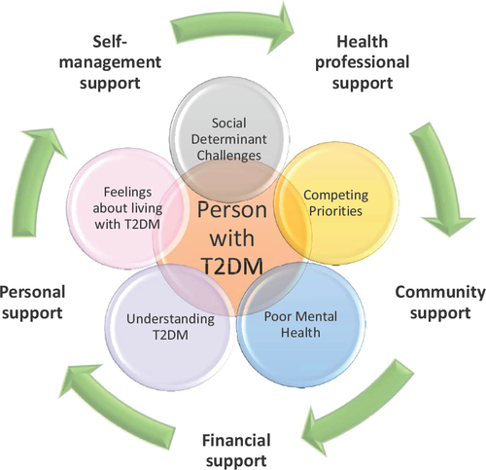

Figure 7: Social and contextual challenges influencing self-management in people with Type 2 Diabetes Mellitus (T2DM)

The self-management theory emphasises the role of individuals in managing chronic conditions through healthy lifestyles, medication adherence, and blood glucose monitoring (Barlow et al., 2002). Effective self-management can reduce complications and improve quality of life.
The biopsychosocial model (Engel, 1977) is also relevant because it recognises that health outcomes are influenced by biological, psychological, and social factors. This is particularly important in Birmingham, where health inequalities and social circumstances may affect diabetes management.
The chronic care model further supports coordinated and patient-centred care for individuals living with long-term conditions (Wagner et al., 2001).

Policy and Legislation:
The NHS Long Term Plan (NHS England, 2019) focuses on early intervention, prevention, and personalised care for chronic conditions such as T2DM. This policy aims to reduce hospital admissions and improve long-term outcomes for older adults.
NICE guidelines (2022) recommend regular monitoring for complications including cardiovascular disease, neuropathy, kidney disease, and retinopathy. These guidelines help healthcare professionals identify complications early and improve patient care.
The Equality Act 2010 is also relevant because it protects individuals with chronic conditions from discrimination and promotes equal access to healthcare services.
Although these policies have improved diabetes care, health inequalities still exist within Birmingham. Some older adults may face barriers such as poor access to healthcare, financial difficulties, or limited health education, which can negatively affect diabetes management and long-term outcomes.

Positive and Negative Implications:
The long-term impacts of T2DM have significant implications for older adults and healthcare services. Complications such as cardiovascular disease, neuropathy, and kidney impairment can reduce independence, increase frailty, and lower quality of life (Zheng et al., 2018). These complications also increase healthcare costs and place additional demands on NHS services (NHS Digital, 2022).
However, improvements in medication, screening, and integrated care have enhanced diabetes management and reduced complication rates for many individuals (Diabetes UK, 2023). These developments highlight the importance of preventative healthcare and personalised treatment approaches.

Examples from Your Articles
Several studies support the long-term health impacts of T2DM among older adults. Rawshani et al. (2018) found that poor glycaemic control was associated with increased cardiovascular disease risk and higher mortality rates, highlighting the importance of effective diabetes management.
Zheng et al. (2018) demonstrated that prolonged hyperglycaemia contributes to microvascular complications, including neuropathy, nephropathy, and retinopathy, as well as microvascular complications such as cardiovascular disease.
Furthermore, Biessels and Despa (2018) identified an association between T2DM and cognitive decline, showing that diabetes can affect both physical health and independence in older adults.
Overall, these studies highlight that T2DM complications are multi-system conditions requiring early intervention, personalised care, and ongoing monitoring.

Connections to Other Themes
This theme strongly connects with Theme One concerning the physiological mechanisms of T2DM. The long-term complications discussed within this section develop as a direct result of insulin resistance, chronic inflammation, and prolonged hyperglycaemia. Persistent metabolic dysfunction damages blood vessels, nerves, kidneys, and cardiovascular tissues over time.
Therefore, understanding the physiological basis of T2DM is essential for preventing complications and improving long-term outcomes. Both themes highlight the importance of early intervention, preventative healthcare, and personalised treatment strategies for older adults living with diabetes in Birmingham.

4.5 – Theme 3 (Management and Support Strategies for Older Adults with Type 2 Diabetes Mellitus)

Definition of the Theme
Management and support strategies for Type 2 Diabetes Mellitus (T2DM) refer to the medical, lifestyle, and social care interventions used to control blood glucose levels, reduce complications, and improve quality of life among individuals living with diabetes. These strategies include medication management, dietary support, physical activity, blood glucose monitoring, patient education, and integrated healthcare services (NICE, 2022).

In older adults, diabetes management often requires a personalised approach because ageing is associated with frailty, multiple health conditions, and reduced functional ability. Effective support strategies are essential for preventing complications, maintaining independence, and improving long-term wellbeing.

Historical/Contextual Background:

Historically, diabetes management focused on controlling blood glucose levels through medication. However, healthcare approaches have gradually become more holistic, recognising the importance of lifestyle modification, prevention, and patient-centred care (Diabetes UK, 2023).

In the UK, the number of older adults living with T2DM has increased significantly due to population ageing, obesity, and sedentary lifestyles. As a result, healthcare providers now place greater emphasis on early intervention, self-management, and integrated care services.

In Birmingham, diabetes management is particularly important because the city has important levels of deprivation and health inequalities. Some older adults may face barriers such as poor access to healthcare, language differences, financial difficulties, and limited health education. These factors may negatively affect diabetes management and increase complication risks.

Data and Statistics:
According to Diabetes UK (2023), more than 4.3 million people in the UK are currently living with diabetes, with older adults representing one of the highest-risk groups. Research suggests that structured diabetes education programmes can significantly improve blood glucose control and reduce complications.

NHS England (2019) reported that early intervention and lifestyle management programmes have reduced diabetes-related hospital admissions in some areas. However, complications remain common among older adults with poor glycaemic control.

Statistics also show that individuals who maintain healthy body weight, balanced diets, and regular physical activity are less likely to experience severe complications (WHO, 2022). Despite this, many older adults face challenges maintaining lifestyle changes due to reduced mobility, chronic illness, or social isolation.

Theoretical Framework:
The self-management theory is highly relevant to this theme because it focuses on patient involvement in managing chronic conditions (Barlow et al., 2002). Effective self-management includes medication adherence, healthy eating, physical activity, and regular monitoring of blood glucose levels.

The biopsychosocial model is also important because diabetes management is influenced by biological, psychological, and social factors (Engel, 1977). Older adults may require emotional support, social care assistance, and culturally appropriate healthcare services in addition to medical treatment.

Policy and Legislation:
Several policies support diabetes management in the UK. NICE guidelines (2022) recommend personalised care plans, annual health checks, and structured education for individuals with T2DM. The NHS Long Term Plan (NHS England, 2019) also promotes prevention, integrated healthcare services, and community support programmes for chronic illnesses.

The Equality Act 2010 supports equal access to healthcare services and protects individuals with chronic conditions from discrimination. These policies aim to improve healthcare outcomes and reduce inequalities among vulnerable populations.

Positive and Negative Implications:
There are several positive implications associated with effective management of Type 2 Diabetes Mellitus (T2DM) among older adults. Early intervention, regular blood glucose monitoring, healthy lifestyle changes, and personalised care plans can reduce the risk of complications such as cardiovascular disease, neuropathy, and kidney damage (NICE, 2022). Effective diabetes management may also improve quality of life, maintain independence, and reduce hospital admissions. In addition, patient education and community support programmes can help older adults better understand their condition and improve self-management skills.

However, there are also negative implications. Many older adults experience difficulties managing diabetes due to frailty, cognitive decline, poor mobility, or multiple long-term health conditions (Sinclair et al., 2020). Some individuals may struggle with medication adherence, maintaining healthy diets, or participating in regular physical activity. Financial difficulties and health inequalities within Birmingham may also limit access to healthcare services, diabetes education, and support programmes. Furthermore, poor diabetes management can increase pressure on NHS and social care services through rising hospital admissions and long-term care needs.

Overall, these positive and negative implications demonstrate the importance of accessible, personalised, and integrated diabetes care for older adults living in Birmingham.

Example from your Articles
Several studies included in the literature review provide strong evidence supporting the importance of effective diabetes management among older adults.
Sinclair et al. (2020) found that personalised diabetes care plans improved glycaemic control and reduced the risk of complications. The authors argued that treatment goals should be adapted according to the individual’s age, health status, and level of independence. This finding supports the need for patient-centred care within Birmingham’s ageing population.
Similarly, Diabetes UK (2023) highlighted the benefits of lifestyle interventions, including healthy eating, weight management, and regular physical activity. The report suggested that individuals who actively engage in self-management are more likely to achieve improved blood glucose control and experience fewer diabetes-related complications.
NHS England (2019) also emphasised the value of integrated healthcare services. The NHS Long Term Plan promotes collaboration between healthcare professionals, social care providers, and community organisations to support people living with long-term conditions. The report concluded that coordinated care could reduce hospital admissions and improve patient experiences.
Although these sources generally agree on the importance of early intervention and self-management, some differences exist regarding implementation. While lifestyle modification is widely recognised as effective, some researchers acknowledge that older adults may face barriers such as mobility limitations, cognitive decline, and social isolation. Therefore, management strategies must be flexible and adapted to individual circumstances.
Together, these studies demonstrate that successful diabetes management needs both medical intervention and wider social support. These findings help answer the research question by showing how appropriate management strategies can reduce the long-term health impacts of T2DM among older adults.

Connections to Other Themes
This theme has strong links with both previous themes identified within the study. Theme One demonstrated how physiological mechanisms such as insulin resistance, beta-cell dysfunction, and chronic inflammation contribute to the development of T2DM. Understanding these biological processes allows healthcare professionals to select proper treatment and management strategies.
Theme Two explored the long-term complications associated with T2DM, including cardiovascular disease, neuropathy, nephropathy, and reduced functional independence. The management approaches discussed within this theme are designed to prevent or delay the development of these complications.
Therefore, all three themes are interconnected. The physiological mechanisms lead to disease progression, long-term complications result from poor metabolic control, and effective management strategies help reduce these negative outcomes. Collectively, the findings highlight the importance of early diagnosis, personalised care, patient education, and integrated health and social care services in improving the health and wellbeing of older adults living with T2DM in Birmingham.

4.6 – Chapter Conclusion

This chapter has critically discussed the findings obtained from the thematic analysis of literature relating to Type 2 Diabetes Mellitus (T2DM) in older adults living in Birmingham. Three main themes were found and explored throughout the chapter. The first theme examined the physiological mechanisms of T2DM, including insulin resistance, beta-cell dysfunction, and chronic inflammation. The second theme evaluated the long-term health impacts of T2DM, such as cardiovascular disease, neuropathy, nephropathy, and reduced functional independence. The final theme explored management and support strategies, highlighting the importance of personalised care, early intervention, patient education, and integrated healthcare services.

The findings demonstrated that T2DM is a complex chronic condition influenced by biological, social, and environmental factors. The evidence also showed that older adults are particularly vulnerable to complications due to age-related physiological decline and existing health inequalities. Furthermore, the chapter identified the importance of effective diabetes management in reducing complications, improving quality of life, and supporting independence among older adults.

Overall, this chapter addressed the research objectives by linking current literature to the physiological mechanisms and long-term impacts of T2DM. The following chapter will present the conclusion and recommendations of the study, including suggestions for improving diabetes care and support services for older adults living in Birmingham.

CHAPTER 5 – Conclusion and Recommendations

5.1 Conclusion
This dissertation explored the physiological mechanisms and long-term health impacts of Type 2 Diabetes Mellitus (T2DM) among older adults living in Birmingham. Through a systematic review and thematic analysis of contemporary literature, the study examined the biological processes underlying disease development, evaluated the consequences of long-term metabolic dysfunction, and considered strategies to improve management and support within health and social care settings.
The findings demonstrated that T2DM is a multifactorial and progressive condition driven by interconnected physiological mechanisms, including insulin resistance, beta-cell dysfunction, chronic inflammation, and age-related metabolic decline. These processes contribute to persistent hyperglycaemia and increase susceptibility to a range of serious complications. The evidence further highlighted that ageing worsens metabolic dysfunction through reductions in muscle mass, increased visceral adiposity, oxidative stress, and impaired physiological resilience.
The study also demonstrated that long-term complications of T2DM extend beyond glucose dysregulation and significantly affect overall health and wellbeing. Cardiovascular disease, neuropathy, nephropathy, retinopathy, frailty, cognitive decline, and reduced functional independence were consistently identified as major consequences of prolonged hyperglycaemia. These complications can negatively impact quality of life, increase dependency on health and social care services, and place substantial pressure on healthcare resources.
Importantly, the research highlighted that biological factors alone do not explain the burden of T2DM. Socioeconomic deprivation, ethnic inequalities, lifestyle factors, and healthcare accessibility all influence disease prevalence, progression, and outcomes. This is particularly relevant within Birmingham, where demographic diversity and health inequalities contribute to increased diabetes risk among older adults.
The findings suggest that effective diabetes management needs a comprehensive approach integrating medical treatment, patient education, preventative healthcare, and coordinated health and social care services. Early intervention, personalised care planning, and culturally support programmes were identified as essential components of effective diabetes management.
Although the study was limited by its reliance on secondary literature and the availability of Birmingham-specific evidence, it provides a comprehensive understanding of the complex relationship between physiological mechanisms, ageing, and long-term health outcomes. Overall, the research concludes that improving prevention, early diagnosis, and integrated care pathways is essential for reducing complications and enhancing the health, independence, and quality of life of older adults living with Type 2 Diabetes Mellitus in Birmingham.


5.2 – Recommendations5.2.1 – Recommendation 1 – Improve Early Screening and Diagnosis Programmes

Figure 8: shows a patient receiving routine health screening from a healthcare professional, illustrating how early detection through regular screening supports preventive healthcare and improves treatment outcomes.

One important recommendation is to improve early screening and diagnosis programmes for older adults at risk of Type 2 Diabetes Mellitus within Birmingham. Early detection through screening can improve treatment outcomes (NHS, 2024). insulin resistance and abnormal glucose regulation before severe complications develop. Healthcare providers should increase routine diabetes screening within GP practices, community health centres, pharmacies, and care homes, particularly for adults aged over 65 years and individuals from high-risk communities (NHS England, 2019).

Early intervention may reduce the risk of cardiovascular disease, neuropathy, and kidney damage through earlier treatment and lifestyle support (Rawshani et al., 2018). Increased screening can also improve patient education and encourage healthier lifestyle choices before complications become severe.

However, barriers to this recommendation include limited NHS resources, staff shortages, and reduced patient engagement. Some older adults may also avoid screening due to fear, lack of awareness, or cultural barriers. To overcome these challenges, healthcare providers should introduce culturally sensitive awareness campaigns, mobile screening services, and community outreach programmes (Diabetes UK, 2023). Greater collaboration between local councils, GP surgeries, and community organisations may also improve accessibility and participation.

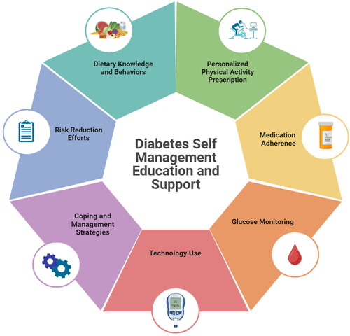
5.2.2 – Recommendation Increase Personalised Diabetes Education and Lifestyle Support

Figure 9: Components of Diabetes Self-Management Education and Support (DSMES). Source: Author’s adaptation based on the reviewed literature, including Chatterjee, Khunti and Davies (2017), Zheng et al. (2018), and Diabetes UK (2023).

Another recommendation is to improve access to personalised diabetes education and lifestyle support programmes for older adults living with T2DM. Education programmes should focus on healthy eating, physical activity, medication management, blood glucose monitoring, and complication prevention (Barlow et al., 2002). Providing personalised education can improve self-management skills and encourage older adults to take greater control of their condition.

Lifestyle support services should also consider the specific needs of older adults, including mobility difficulties, sensory impairment, and mental health challenges. Healthcare professionals should work closely with patients and carers to develop realistic and achievable management plans.

The positive impact of this recommendation includes improved glycaemic control, reduced hospital admissions, and better quality of life (Sinclair et al., 2020). Effective education may also reduce long-term healthcare costs by preventing complications and promoting independence.

Despite these benefits, barriers such as financial limitations, low health literacy, language differences, and poor digital skills may reduce participation in education programmes. Some older adults may also struggle to maintain long-term lifestyle changes due to physical limitations or social isolation. These barriers could be addressed by offering free community-based programmes, translated educational materials, home visits, and additional support from multidisciplinary healthcare teams.

5.2.3 – Recommendation 3 – Strengthen Integrated Health and Social Care Services

The final recommendation is to strengthen integrated health and social care services for older adults living with T2DM in Birmingham. Diabetes management often requires support from multiple healthcare professionals, including GPs, nurses, dieticians, podiatrists, social workers, and mental health specialists. Improved communication and coordination between services may help provide more effective and patient-centred care (NICE, 2022).

Integrated care services could improve monitoring of complications, reduce hospital admissions, and support older adults in maintaining independence within their own homes (NHS England, 2019). Community-based healthcare programmes may also provide emotional support and reduce social isolation among individuals living with chronic illness.

One positive implication of integrated care is improved continuity of treatment and earlier identification of complications. Older adults may receive more holistic support that addresses both medical and social care needs. This approach may also reduce pressure on hospitals and emergency healthcare services.

However, barriers include funding limitations, workforce shortages, and communication difficulties between healthcare departments. Some organisations may also use different record systems, making information sharing more difficult. To overcome these issues, healthcare providers should invest in shared digital systems, staff training, and multidisciplinary teamwork. Increased government funding and policy support may also improve the effectiveness of integrated diabetes care services (NHS Digital, 2022).

CHAPTER 6 – References and Appendices

6.1 – References

Accili, D., Deng, Z., and Liu, Q. (2025) ‘Insulin resistance in type 2 diabetes mellitus’, Nature Reviews Endocrinology.
Ahlqvist, E., Storm, P., Käräjämäki, A., Martinell, M., Dorkhan, M., Carlsson, A., Vikman, P., Prasad, R.B., Aly, D.M. and Almgren, P. (2018) ‘Novel subgroups of adult-onset diabetes and their association with outcomes’, The Lancet Diabetes & Endocrinology, 6(5), pp. 361–369.
American Diabetes Association (2023) ‘Classification and diagnosis of diabetes’, Diabetes Care, 46(Supplement 1), pp. S19–S40.
Arnold, S.E. and Arvanitakis, Z. (2018) ‘Brain insulin resistance in type 2 diabetes and Alzheimer disease: concepts and conundrums’, Nature Reviews Neurology, 14(3), pp. 168–181.
Aveyard, H. (2019) Doing a Literature Review in Health and Social Care: A Practical Guide. 4th edn. London: Open University Press.
Au-Yeung, C.H., Ellis, D., Dallaway, A. and Riley, J. (2024) ‘Socioeconomic and ethnic inequalities increase the risk of type 2 diabetes: analysis of NHS Health Check attendees in Birmingham’, Frontiers in Public Health, 12.
Bailey, C.J. (2019) ‘Metformin: historical overview’, Diabetologia, 62(9), pp. 1566–1576.
Barlow, J., Wright, C., Sheasby, J., Turner, A. and Hainsworth, J. (2002) ‘Self-management approaches for people with chronic conditions: a review’, Patient Education and Counseling, 48(2), pp. 177–187.
Barnett, A.H., Dixon, A.N., Bellary, S., Hanif, M.W., O’Hare, J.P., Raymond, N.T. and Kumar, S. (2006) ‘Type 2 diabetes and cardiovascular risk in the UK South Asian community’, Diabetologia, 49(10), pp. 2231–2240.
Bellary, S., Kyrou, I., Brown, J.E. and Bailey, C.J. (2021) ‘Type 2 diabetes mellitus in older adults: clinical considerations and management’, Nature Reviews Endocrinology, 17(9), pp. 534–548.
Biessels, G.J. and Despa, F. (2018) ‘Cognitive decline and dementia in diabetes mellitus’, The Lancet Neurology, 17(1), pp. 64–74.
Birmingham City Council (2024) Birmingham demographics and public health overview. Available at: https://www.birmingham.gov.uk (Accessed: 24 June 2026).
Braun, V. and Clarke, V. (2006) ‘Using thematic analysis in psychology’, Qualitative Research in Psychology, 3(2), pp. 77–101.
Cerf, M.E. (2013) ‘Beta cell dysfunction and insulin resistance’, Frontiers in Endocrinology, 4, pp. 1–12.
Chatterjee, S., Khunti, K. and Davies, M.J. (2017) ‘Type 2 diabetes’, The Lancet, 389(10085), pp. 2239–2251.
Cho, N.H., Shaw, J.E., Karuranga, S., Huang, Y., Fernandes, J.D.R., Ohlrogge, A.W. and Malanda, B. (2018) ‘IDF Diabetes Atlas: global estimates of diabetes prevalence and incidence’, Diabetes Research and Clinical Practice, 138, pp. 271–281.
Congdon, P. (2006) ‘Estimating diabetes prevalence by small area in England’, Journal of Public Health, 28(1), pp. 71–81.
Davies, M.J., D’Alessio, D.A., Fradkin, J., Kernan, W.N., Mathieu, C., Mingrone, G., Rossing, P., Tsapas, A., Wexler, D.J. and Buse, J.B. (2018) ‘Management of hyperglycaemia in type 2 diabetes, 2018: a consensus report by the American Diabetes Association and the European Association for the Study of Diabetes’, Diabetologia, 61, pp. 2461–2498.
DeFronzo, R.A. (2009) ‘From the triumvirate to the ominous octet: a new paradigm for the treatment of type 2 diabetes mellitus’, Diabetes, 58(4), pp. 773–795.
DeFronzo, R.A., Ferrannini, E., Groop, L., Henry, R.R., Herman, W.H., Holst, J.J., Hu, F.B., Kahn, C.R., Raz, I. and Shulman, G.I. (2015) ‘Type 2 diabetes mellitus’, Nature Reviews Disease Primers, 1, Article 15019.
Diabetes UK (2023) Diabetes statistics. Available at: https://www.diabetes.org.uk (Accessed: 24 June 2026).
Emerging Risk Factors Collaboration (2010) ‘Diabetes mellitus, fasting blood glucose concentration, and risk of vascular disease: a collaborative meta-analysis of 102 prospective studies’, The Lancet, 375(9733), pp. 2215–2222.
Engel, G.L. (1977) ‘The need for a new medical model: a challenge for biomedicine’, Science, 196(4286), pp. 129–136.
Forouhi, N.G. and Wareham, N.J. (2014) ‘Epidemiology of diabetes’, Medicine, 42(12), pp. 698–702.
Frasca, D., Blomberg, B.B., Paganelli, R. and Weksler, M.E. (2021) ‘Inflammaging and metabolic disease’, Frontiers in Aging, 2.
Funnell, M.M. and Anderson, R.M. (2004) ‘Empowerment and self-management of diabetes’, Clinical Diabetes, 22(3), pp. 123–127.
Galicia-Garcia, U., Benito-Vicente, A., Jebari, S., Larrea-Sebal, A., Siddiqi, H., Uribe, K.B., Ostolaza, H. and Martín, C. (2020) ‘Pathophysiology of type 2 diabetes mellitus’, International Journal of Molecular Sciences, 21(17), Article 6275.
Gregg, E.W., Cheng, Y.J., Srinivasan, M., Lin, J., Geiss, L.S., Albright, A.L. and Imperatore, G. (2012) ‘Trends in death rates among adults with and without diabetes’, Diabetes Care, 35(6), pp. 1252–1257.
Halim, M., and Halim, A. (2019) ‘The effects of inflammation, ageing and oxidative stress on the pathogenesis of type 2 diabetes mellitus’, Diabetes & Metabolic Syndrome: Clinical Research & Reviews, 13(2), pp. 1165–1172.
Holman, R.R., Paul, S.K., Bethel, M.A., Matthews, D.R. and Neil, H.A.W. (2008) ‘10-year follow-up of intensive glucose control in type 2 diabetes’, New England Journal of Medicine, 359(15), pp. 1577–1589.
International Diabetes Federation (2021) IDF Diabetes Atlas. 10th edn. Brussels: International Diabetes Federation. Available at: https://diabetesatlas.org (Accessed: 24 June 2026).
Kalyani, R.R., Golden, S.H. and Cefalu, W.T. (2017) ‘Diabetes and ageing: unique considerations and goals of care’, Diabetes Care, 40(4), pp. 440–443.
Marmot, M. (2010) Fair Society, Healthy Lives: The Marmot Review. London: Institute of Health Equity.
National Institute for Health and Care Excellence (NICE) (2022) Type 2 diabetes in adults: management (NG28). Available at: https://www.nice.org.uk/guidance/ng28 (Accessed: 24 June 2026).

Forouhi, N.G. and Wareham, N.J. (2014) ‘Epidemiology of diabetes’, Medicine, 42(12), pp. 698–702.
Frasca, D., Blomberg, B.B., Paganelli, R. and Weksler, M.E. (2021) ‘Inflammaging and metabolic disease’, Frontiers in Aging, 2.
Funnell, M.M. and Anderson, R.M. (2004) ‘Empowerment and self-management of diabetes’, Clinical Diabetes, 22(3), pp. 123–127.
Galicia-Garcia, U., Benito-Vicente, A., Jebari, S., Larrea-Sebal, A., Siddiqi, H., Uribe, K.B., Ostolaza, H. and Martín, C. (2020) ‘Pathophysiology of type 2 diabetes mellitus’, International Journal of Molecular Sciences, 21(17), Article 6275.
Gregg, E.W., Cheng, Y.J., Srinivasan, M., Lin, J., Geiss, L.S., Albright, A.L. and Imperatore, G. (2012) ‘Trends in death rates among adults with and without diabetes, 1997–2006’, Diabetes Care, 35(6), pp. 1252–1257.
Halim, M. and Halim, A. (2019) ‘The effects of inflammation, ageing and oxidative stress on the pathogenesis of type 2 diabetes mellitus’, Diabetes and Metabolic Syndrome: Clinical Research and Reviews, 13(2), pp. 1165–1172.
Holman, R.R., Paul, S.K., Bethel, M.A., Matthews, D.R. and Neil, H.A.W. (2008) ‘10-year follow-up of intensive glucose control in type 2 diabetes’, New England Journal of Medicine, 359(15), pp. 1577–1589.
International Diabetes Federation (2021) IDF Diabetes Atlas. 10th edn. Brussels: International Diabetes Federation. Available at: https://diabetesatlas.org (Accessed: 24 June 2026).
Kalyani, R.R., Golden, S.H. and Cefalu, W.T. (2017) ‘Diabetes and ageing: unique considerations and goals of care’, Diabetes Care, 40(4), pp. 440–443.
Marmot, M. (2010) Fair Society, Healthy Lives: The Marmot Review. London: Institute of Health Equity.
National Institute for Health and Care Excellence (NICE) (2022) Type 2 diabetes in adults: management (NG28). Available at: https://www.nice.org.uk/guidance/ng28 (Accessed: 24 June 2026).
NHS Digital (2022) National Diabetes Audit. London: NHS Digital. Available at: https://digital.nhs.uk (Accessed: 24 June 2026).
NHS England (2019) The NHS Long Term Plan. Available at: https://www.longtermplan.nhs.uk (Accessed: 24 June 2026).

Page, M.J., McKenzie, J.E., Bossuyt, P.M., Boutron, I., Hoffmann, T.C., Mulrow, C.D., Shamseer, L., Tetzlaff, J.M. and Moher, D. (2021) ‘The PRISMA 2020 statement: an updated guideline for reporting systematic reviews’, BMJ, 372, Article n71.
Polonsky, K.S. (2012) ‘The past 200 years in diabetes’, New England Journal of Medicine, 367(14), pp. 1332–1340.
Pop-Busui, R., Boulton, A.J.M., Feldman, E.L., Bril, V., Freeman, R., Malik, R.A., Sosenko, J.M. and Ziegler, D. (2017) ‘Diabetic neuropathy: a position statement by the American Diabetes Association’, Diabetes Care, 40(1), pp. 136–154.
Public Health England (2023) Diabetes prevalence and deprivation indicators. Available at: https://fingertips.phe.org.uk (Accessed: 24 June 2026).
Rawshani, A., Franzén, S., Eliasson, B., Svensson, A.M., Miftaraj, M., McGuire, D.K., Sattar, N. and Gudbjörnsdottir, S. (2018) ‘Risk factors, mortality and cardiovascular outcomes in patients with type 2 diabetes’, New England Journal of Medicine, 379(7), pp. 633–644.
Reed, J., Bain, S. and Kanamarlapudi, V. (2021) ‘Current trends in type 2 diabetes epidemiology and pathogenesis’, Diabetes, Metabolic Syndrome and Obesity: Targets and Therapy, 14, pp. 3003–3025.
Saeedi, P., Petersohn, I., Salpea, P., Malanda, B., Karuranga, S. and Unwin, N. (2019) ‘Global and regional diabetes prevalence estimates for 2019 and projections for 2030 and 2045’, Diabetes Research and Clinical Practice, 157, Article 107843.
Saini, V. (2010) ‘Molecular mechanisms of insulin resistance in type 2 diabetes mellitus’, World Journal of Diabetes, 1(3), pp. 68–75.
Sinclair, A.J., Dunning, T. and Rodriguez-Mañas, L. (2012) ‘Diabetes mellitus in older people’, The Lancet, 379(9823), pp. 1537–1545.
Sinclair, A., Saeedi, P., Kaundal, A. and Karuranga, S. (2020) ‘Diabetes and global ageing among 65–99-year-old adults’, Diabetes Research and Clinical Practice, 162, Article 108078.
Skyler, J.S., Bakris, G.L., Bonifacio, E., Darsow, T., Eckel, R.H. and Groop, L. (2017) ‘Differentiation of diabetes by pathophysiology, natural history, and prognosis’, Diabetes, 66(2), pp. 241–255.
Snyder, H. (2019) ‘Literature review as a research methodology: an overview and guidelines’, Journal of Business Research, 104, pp. 333–339.
UK Prospective Diabetes Study (UKPDS) Group (1998) ‘Intensive blood-glucose control with sulphonylureas or insulin compared with conventional treatment and risk of complications in patients with type 2 diabetes’, The Lancet, 352(9131), pp. 837–853.
World Health Organization (2021) Global report on diabetes: ageing, prevention, and management of diabetes. Available at: https://www.who.int (Accessed: 24 June 2026).
World Health Organisation (2024) Diabetes fact sheet. Available at: https://www.who.int (Accessed: 24 June 2026).
World Health Organisation (2024) Social determinants of health. Available at: https://www.who.int/health-topics/social-determinants-of-health (Accessed: 24 June 2026).
Zheng, Y., Ley, S.H. and Hu, F.B. (2018) ‘Global aetiology and epidemiology of type 2 diabetes mellitus and its complications’, Nature Reviews Endocrinology, 14(2), pp. 88–98.

6.2 Appendix A-Source Tracking Table

Author & Year | Article Title | Keywords/Codes | CRAAP Score | Justification
DeFronzo (2009) | From the Triumvirate to the Ominous Octet | Insulin resistance, beta-cell dysfunction | 5/5 | Seminal paper explaining the physiological mechanisms of T2DM.
DeFronzo et al. (2015) | Type 2 Diabetes Mellitus | Pathophysiology, hyperglycaemia | 5/5 | Comprehensive and highly cited review of disease mechanisms.
Galicia-Garcia et al. (2020) | Pathophysiology of Type 2 Diabetes Mellitus | Obesity, inflammation | 5/5 | Recent evidence explaining molecular mechanisms of T2DM.
Bellary et al. (2021) | Type 2 Diabetes Mellitus in Older Adults | Older adults, management | 5/5 | Focuses specifically on ageing and diabetes management.
Sinclair et al. (2020) | Diabetes and Global Ageing Among Adults Aged 65–99 Years | Frailty, personalised care | 5/5 | International evidence on diabetes in older adults.
Rawshani et al. (2018) | Risk Factors, Mortality and Cardiovascular Outcomes in Patients with Type 2 Diabetes | Cardiovascular disease | 5/5 | Large cohort study examining mortality and complications.
Zheng et al. (2018) | Global Aetiology and Epidemiology of Type 2 Diabetes Mellitus and its Complications | Long-term complications | 5/5 | Excellent review of diabetes complications.
Biessels & Despa (2018) | Cognitive Decline and Dementia in Diabetes Mellitus | Dementia, cognition | 4.5/5 | Strong evidence linking diabetes with cognitive decline.
Frasca et al. (2021) | Inflammaging and Metabolic Disease | Chronic inflammation | 4.5/5 | Explains inflammation associated with ageing and T2DM.
Au-Yeung et al. (2024) | Socioeconomic and Ethnic Inequalities Increase the Risk of Type 2 Diabetes | Birmingham, deprivation | 5/5 | Local Birmingham evidence showing deprivation and ethnicity increase diabetes risk.

Studies selected for detailed analysis (strongest five):
- DeFronzo et al. (2015)
- Bellary et al. (2021)
- Sinclair et al. (2020)
- Rawshani et al. (2018)
- Zheng et al. (2018)

Appendix B – Results Summary Table (Detailed Analysis of the Five Strongest Studies)

Author & Year | Type of Study | Research Method | Strengths & Limitations | Main Findings | Theme
DeFronzo et al. (2015) | Review | Comprehensive literature review | Strong scientific evidence; not primary research | Insulin resistance and beta-cell dysfunction are key mechanisms of T2DM. | Theme 1
Bellary et al. (2021) | Narrative Review | Review of studies on older adults | Excellent focus on ageing; no original data | Older adults require individualised diabetes management. | Theme 1 & 3
Sinclair et al. (2020) | International Review | Global evidence synthesis | Highly relevant to older adults | Frailty and hypoglycaemia require personalised care. | Theme 2 & 3
Rawshani et al. (2018) | Cohort Study | National cohort (approximately 270,000 participants) | Large sample; observational design | Poor glycaemic control increases cardiovascular disease and mortality. | Theme 2
Zheng et al. (2018) | Review | Systematic evidence reviews | Strong overview; not UK-specific | T2DM causes neuropathy, nephropathy, retinopathy, and cardiovascular disease. | Theme 2

Appendix C- Literature Search Log

Stage | Number
Records identified through database searching | 3,182
Records after removal of duplicates | 2,964
Records screened by title and abstract | 69
Full-text articles assessed | 42
Articles tracked using the Source Tracking Table | 10
Articles selected for detailed thematic analysis | 5

Search process:
A broad literature search identified 3,182 records. After screening and eligibility assessment, 42 articles were reviewed in full. Ten key studies were tracked using the Source Tracking Table. Following CRAAP evaluation, the five highest-quality and most relevant studies were selected for detailed thematic analysis and used within the “Examples from the Articles” sections of Chapter 4

Appendix F – CRAAP Test Evaluation
Article Assessed:
Rawshani, A. et al. (2018) ‘Risk factors, mortality and cardiovascular outcomes in patients with type 2 diabetes’, New England Journal of Medicine, 379(7), pp. 633–644.

CRAAP Element | Assessment
Currency | Published in 2018 and remains relevant to current research on long-term outcomes, mortality and cardiovascular risks associated with Type 2 Diabetes Mellitus.
Relevance | Directly examines cardiovascular outcomes, mortality, and risk factors in people with Type 2 Diabetes, supporting the dissertation objective on long-term health impacts.
Authority | Published in the New England Journal of Medicine, a highly respected peer-reviewed medical journal. The authors are recognised researchers in diabetes and cardiovascular medicine.
Accuracy | Based on a large national cohort study involving approximately 270,000 participants. The study uses robust statistical methods and provides reliable evidence.
Purpose | The purpose was to improve understanding of diabetes-related risks and inform clinical practice and patient management.

CRAAP Score: 25/25

Decision:
Included in the final literature review because it demonstrates high academic quality, strong methodology and direct relevance to the research aim and objectives.

