Student Name | Jose M. Lopete
Student Number
Lecturer Name | Anita Nam
Module Title | Academic and Employability Skill
Module Code | BMSK4001

Table of Contents
1.0 INTRODUCTION 3
2.0 ANALYSE THE MAIN EMPLOYABILITY SKILLS 3
2.1 Team working 3
2.2 Communication 4
2.3 Time management 6
2.4 Problem solving skill 7
3. PERSONAL SWOT ANALYSIS 7
4.PERSONAL DEVELOPMENT PLAN 9
5. CONCLUSION 10
References: 11

INTRODUCTION
According to an article published on the Gardian by Bacchus (2010), due to the prompt improvement of the world that we live, the rivalries among the organisations are also accumulating. Therefore, the organisations are continuously seek for employees who not only have good academic qualification but also poses sound employability skills to gain competitive advantages over their opponents in the severe competitive market. Organisations now a day look for the employees who are equipped with a wide range of skills in order to improve their organisational environment and hire employees who have various skills to fill up their various job roles (Foster, 1998, p.4). Therefore, as a graduate it is important to gain the skills that the employers are looking for to join their workforce.
In order to fit in the competitive job market, it is important for graduates to identify the skills that the employers frequently look for and also need to identify the skills that the graduates currently have or need to develop for future employment opportunity. This can be done by conducting a personal SWOT analysis (Manktelow et al, 2018) and carrying out a personal development plan. The objectives of this report is to
- Analyse the main employability skills that the employers look for.
- Personal SWOT analysis
- Personal Development Plan

2.0 ANALYSE THE MAIN EMPLOYABILITY SKILLS
In present literature scholars have defined employability skills in various way. According to Miller, Biggart and Newton (2013) “employability skills are the basic skills necessary for getting, keeping and doing well in a job, and which cut horizontally across all industries and vertically across all jobs. It is also defined as skills required not only to gain employment, but also to progress within an enterprise so as to achieve one’s potential and contribute successfully to enterprise strategic directions.”
The research conduct by Wickramasinghe and Perera (2010) identified five common employability skills that employers often seek for and these are described below.

2.1 Team working
According to Morgan, P. (2017) teamwork can be defined when few people working together and challenging a particular task that all individual promise to achieve. The author further articulate in team a people work to accomplish shared objectives and common goals and share their wide-ranging skills to perform assigned roles and responsibilities.
Importance of teamwork skill in organismal context
Clearly a company with a good culture of team working are likely to success. Having the ability of effective team working will help you to improve several employability skills areas, like, communications, project management skill, conflict management, problem solving, and other. To work efficiency and productive, is very important to have the ability to work in group environment, as this will help reduce your level of stress, improved problem solving, bring huge benefit in terms of office environment, and others. (Fay et al., 2014)
How teamwork skill can be improved
Teamwork can be achieved by efficient communication, organising tasks, equilibrium of job roles, mutual understanding and support, determination.
There are few theory and rule about how to improve your team working skills in order to ensure that any task is completed successfully, likewise they are some number of reasons why team fail and why team success.
Also as team member you must bear in mind the way the team is put together is key to perform any project. The DISC model defined Peter (1917) mentioned Marston (1928) is an important tool for team building and also gives an important insight how the team members work in a group. The DISC model, D-dominance, I-influence, S-steadiness, and C- conformity is the way to identify the different role that any team members play in any particular task. In the other hand the Belbin`s Team roles was develop by Belbi and others (1928) describe some few factors that are important when we form a team for any task. Like knowledge that any team member has and their skill and ability.

2.2 Communication
According to Maund, Schriek and Tinkler (2011. p.47), communications skill is the ability to communicate with others. However, according to when we describe the word effective communication we must bear in mind that communication is all about hearing, listening, understanding massage, body language and speaking. The authors point out that communication is the exchange of thoughts, information, or idea that result in mutual understanding between one or more sender and one or more receiver. Thus, process requires a massage that will be transmitted within a communication channel. Whereas depending the way we delivered the communication, message can be either verbal or nonverbal in term of the channel or transmission medium communication are face-to-face, email and footage.
Importance of communication skill in organismal context
An effective and efficient communication is an important skill to achieve efficiency, productivity and improve strong workplace relationship within an entire company. Organisations that invest time and are determine to improve communication within their organisation will swiftly create faith and trust among employees, which will lead them to a increased proactivity and achieve good organisational culture. Consequently, good communication among managers, employees, suppliers and customers is a valuable asset to a company. A good commutation skill will provide the graduate with a better edge than their counterparts when applying for a job role.
How communication skill can be improved
This section analyse the processes to improve communication skill that have been identified by the scholars.
- Clearly delivery of message – during delivery of it is important to articulate the message obviously. During the deliver of message it is viable to believe in the idea or massage that will be delivered, show respect and appreciation to listeners.
- Choose your medium carefully – Once the message is ready it is important the medium of delivering the message carefully. The medium can be verbal, non verbal and written. It is important to select which way will be suitable to communicate with the employees.
- Keep everyone involved – It is important to ensure the communication channels are always open. As stated Maund, Schriek and Tinkler (2011) and Brownell (1996, p.96 ) it is important to use HUNTER model to keep every involved. The model consists of six elements: Hearing, Understanding, Remembering, Interpreting, Evaluating, and Responding. Clearly the sender of the massage sometimes they want to know that they are been hear, so adopting good posture that make the speaker field you are interested in his massage. Do not interrupt the listeners. Asking question and paraphrasing is another way to keep the audience engaged and interested in the conversation.
- Listen and show empathy – According to Page (2018), “Communication is a two-way process and no company or individual will survive long if it doesn’t listen and encourage dialogue with the other party. Listening shows respect and allows you to learn about any outstanding issues you may need to address as an employer”.

2.3 Time management
Time management, is sample as, planning or control the amount of time spending in a specific activity to increase your efficiency and your productivity knowing that your times are limited. Clearly effective time management is not only learning how to control your time is also learning how to manage your self in relate to the time.
Importance of time management skill
Time management refer to business, project development or work activity but can also include any specific task in your personal life. Furthermore, if you know how to control your time your degree of time management and Project Management is higher. Went we mention Time Management is the same as mention project management as both take in to account the factor Time (Aminshayan, 2010). Controlling your time will give you some benefit like: reduce stress, be a good productive team member with your colleagues, deliverer good quality task and helps to discipline ourselves. If you have lack of time management skill you will always been busy but not productive.
How time management skill can be improved
According to Houserebate (2019), how to prioritise you task, how to coup with the dead line or due date, in order to make time more productive as the mater of that be good at the workplace. To answer to this question and the techniques to improve time management skill are listed below:
Pareto 80/20 principal is one the important way to manage time and according to Italian economist Vilfredo Pareto, “put your efforts where they will make the most difference, Before you begin work, always ask yourself, is this task in the top 20% of my activities or in the bottom 80%?”
For example according to (Koch, 2013), “if you have a list of ten items to do, two of those items will turn out to be worth as much or more than the other eight items put together”.
Eisenhower defined what is Urgent and what is Important by explaining his Matrix. Eisenhover Matrix consists of four quads (as shown in figure 1): urgent/important, Important/not Urgent, Urgent/not Important, Urgent/not important. According to Eisenwover if you really want to manage and controlling time and make it more efficiency and productive the best stage is quad one, when task is urgent and important. (Covey, 2017

2.4 Problem solving skill
From employers perspective problem-solving skills are referred to the capability to manage various challenging or unanticipated circumstances within the organisation.
Importance of problem solving skill
Problem-solving skills are significant attribute in every organisation. Every organisation confronts with various issues and therefore when recruiting any employees employers always priorities employees who have good problem solving skill. In order to work in a management position in any organisation managers need to handle the day-to-day problems that occur within an organisation. Developing problem solving skill will allow the graduates to provide with distinct advantages both in management roles and other roles within an organisation.
How problem solving skill can be improved
Various scholars demonstrate the process of improving problem solving skill. Griffin and Annulis (2013) identify following four stage of problem solving skill.

The Four Stages of Problem Solving
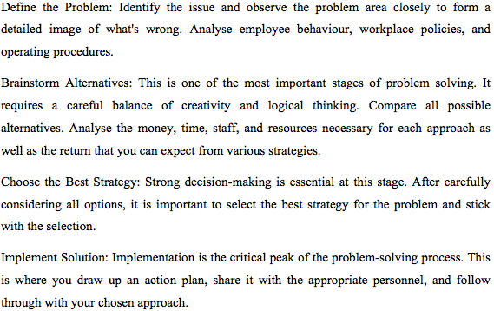

3. PERSONAL SWOT ANALYSIS
SWOT is personal analysis tool, which refers S-Strength, W-Weakness, O-Opportunity, and T-Threat (Manktelow et al, 2018). After analysing the main employability skill required by organisation, the author carried out self-assessment using SWOT analysis.
Strengths
The identified strengths of the author are:
- From present employment and working in groups at university it can be said that the author has good teamwork and organizing skills.
- Author is also good at managing time and self management, can plan tasks, prioritise tasks according to importance, meet deadline and so on.
- Willingness to learn new skills to improve and meet career objectives.
- Long time work experience in the UK.
Weaknesses
The identified weaknesses are:
- Have limited technological skill and need to develop the use of software packages, information process, advance use of information that will be required in the targeted career
- Poor problem solving skill.
- For being introvert in nature I am shy to speak in front of large audience and need to improve communication skill
Opportunities
- Using the job experience and successful completion of the current degree will provide the opportunity to gain the expected career objectives.
- Self management and time management skill will assist to fill up the skill gaps.
Threats
- Extreme competition in the intended career
- Frequent change in the job roles within an organisation

4.PERSONAL DEVELOPMENT PLAN
After identifying personal strengths, weaknesses, opportunities, and threats, this section analyse the personal development plan to improve the employability skills based on SMART objective (Manktelow et al, 2018).
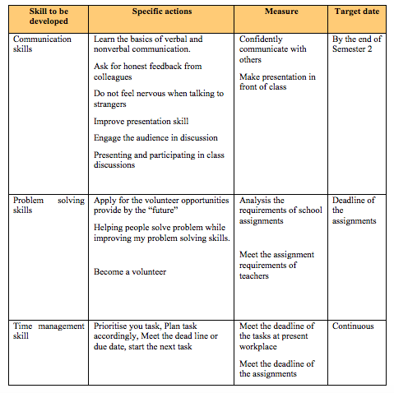
Table 2: Personal development plan (Compiled by author)

5. CONCLUSION
As stated by Bacchus (2010), organisations are continuously looking for new way of doing business and enhancing their efficiency and productivity. Therefore, the organisations are continuously seek for employees who not only have good academic qualification but also poses sound employability skills to gain competitive advantages over their opponents in the severe competitive market.
After conducting a comprehensive research, this report identifies six key employability skills, the importance of those skills from the viewpoint of employers and how graduates can improve those skills. After analysing the main employability skill required by organisation, the author carried out self-assessment using SWOT analysis to improve self-consciousness. The SWOT analysis also assisted the author to develop a personal development plan, which will guide the achieve his carrier objectives.

References:
Aminshayan, S. (2010). Studying of Relationship Between Time Management Organizational Skill with Job Stress Among School’s Principal’s of Khorrambid City. The International Journal of Knowledge, Culture, and Change Management: Annual Review, 10(2), pp.103-114.
Bacchus, E. (2010). Changing your career: How to identify your transferable skills. [online] the Guardian. Available at: https://www.theguardian.com/careers/careers-blog/changing-your-career-how-to-identify-your-transferable-skills [Accessed 6 Jan. 2019].
Chang, A. (2018). 6 Easy Ways to Upgrade Your Technical Skills. [online] ProSky - Learn Skills, Do Projects, Get Hired by Amazing Companies. Available at: https://prosky.co/careerbuzz/articles/upgrade-tech-skills [Accessed 4 Jan. 2019].
Cottrell, S. (2008). The Study Skills Handbook 3rd edition. Hampshire: PalgraveMacMillan.
Cottrell, S. (2011) Critical thinking skills: Developing effective analysis and argument (Palgrave study skills). 2nd edition. Basingstoke: Palgrave Macmillan.
Covey, S. (2017). First Things First. Simon & Schuster.
Fay, D., Shipton, H., West, M. and Patterson, M. (2014). Teamwork and Organizational Innovation: The Moderating Role of the HRM Context. Creativity and Innovation Management, 24(2), pp.261-277.
Gibbs, G. (1988) Learning by doing: A guide to teaching and learning methods. London: FEU
Griffin, M. and Annulis, H. (2013). Employability skills in practice: the case of manufacturing education in Mississippi. International Journal of Training and Development, 17(3), pp.221-232.
Koch, R. (2013). The 80/20 manager. City publication
Maund, A. Schriek, M. and Tinkler, P. (2017). Certificate in Higher Education: Skills for the Workplace Student Yearbook. Sage Publications.
McGuinness, S. and Ortiz, L. (2016). Skill gaps in the workplace: measurement, determinants and impacts. Industrial Relations Journal, 47(3), pp.253-278.
Miller, L., Biggart, A. and Newton, B. (2013). Basic and employability skills. International Journal of Training and Development, 17(3), pp.173-175.
Morgan, P. (2016). The Business Student’s Guide to Study and Employability. Sage Publications.
Page, M. (2018). The importance of good communication in the workplace | Michael Page UK. [online] Michael Page. Available at: https://www.michaelpage.co.uk/advice/management-advice/development-and-retention/importance-good-communication-workplace [Accessed 4 Jan. 2019].
Thomack, B. (2012). Time Management for Today’s Workplace Demands. Workplace Health & Safety, 60(5), pp.201-203.
Wickramasinghe, V. and Perera, L. (2010). Graduates', university lecturers' and employers' perceptions towards employability skills. Education + Training, 52(3), pp.226-244.

