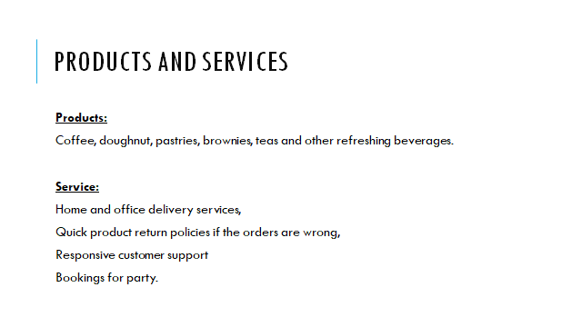
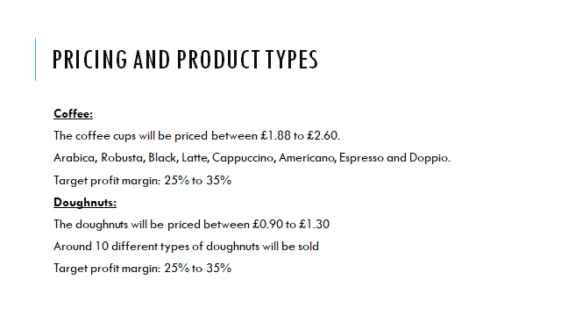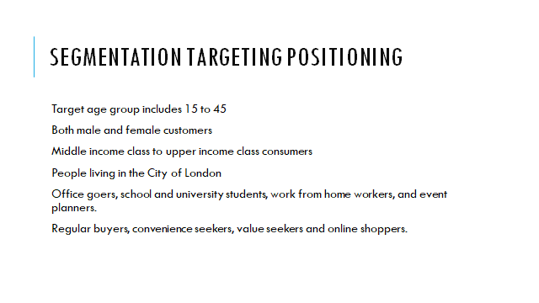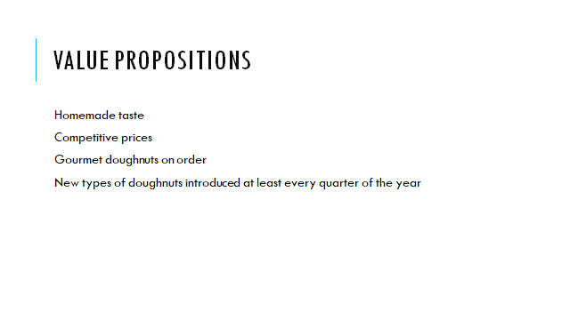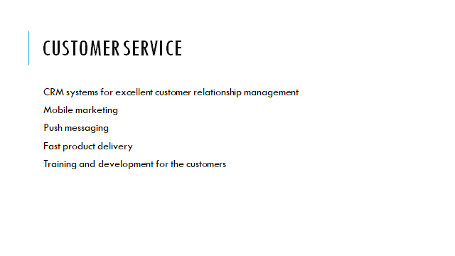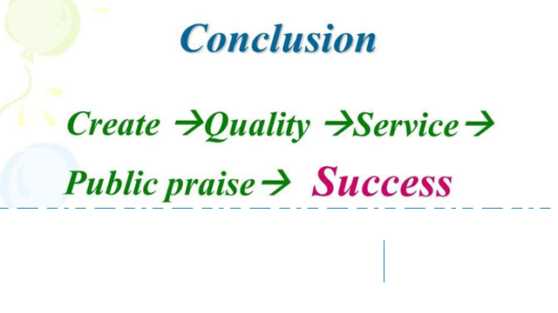

MANAGING ENTERPRISE IN THE 21ST CENTURY

Student name – Antonia Nikolova
Student ID – 1921644
Lecture name – Mohammad Rahman
University of Wales Trinity Saint David

Table of Contents
Products and services 3
Doughnuts 3
Coffee 4
Vegan doughnuts and other items 4
Product levels 4
Product strategy 5
Product innovation 5
USP and value proposition 6
Justification of the product strategy 6
Services 7
References 9

Products and services
Coffee and doughnut Limited will be offering the best doughnuts and coffee in London. The products will be made with ingredients sourced from the local suppliers. By sourcing the ingredients from local suppliers, the company can also keep the prices competitively lower than other café chains in London (Ehrlich and Michael, 2009). Especially considering the fact that most of the Cafes in London, especially the international chains such as Starbucks, Café Nero, Costa Coffee and others, price their products competitively higher, therefore, Coffee and doughnut Limited will be offering products that are greater in quality and yet, competitively lower in prices (Gellatly and Sewell, 2014).
Product range: Coffee, doughnut, pastries, brownies, teas and other refreshing beverages,
Services: Home and office delivery services, quick product return policies if the orders come out wrong, responsive customer support and bookings for party.

Doughnuts
The doughnuts will be priced between £0.90 to £1.30 depending on the different variations. Around 10 different types of doughnuts will be sold at the café including Chocolate Frosted Doughnut, Cruller, Strawberry Frosted Doughnut, Jelly Doughnut, Blueberry Doughnut, Old-fashioned Doughnut, Cinnamon Twist Doughnut, Chocolate Cake Doughnut, Apple-Crumb Doughnut and Glazed Doughnut. However, as part of the product strategy, the company will sell around 5 to 6 types of doughnuts on a regular basis, and other types will be prepared as per the product orders received online or on call (Gellatly and Sewell, 2014).
To be more specific, the company will have a day-to-day production of the regular types of doughnuts that customers tend to purchase every day, while a more gourmet line of doughnuts will be prepared on order (Gevurtz and Gevurtz, 2019). This will help avoid the waste of products. The company will procure advanced machineries for preparing doughnuts so that it can produce doughnuts faster and more efficiently, using the regular sales data. The company targets a 25% to 35% profit margin from the sales of doughnut. The company envisions that by year 2025, it would be selling around 2000 doughnuts every day (Gevurtz and Gevurtz, 2019). Therefore, the quality commitment and customer service will be the core areas of focus for the business.

Coffee
The coffee sold at the café will also be priced similarly. The coffee cups will be priced between £1.88 to £2.60. Different types of coffee that will be available at the café include Arabica, Robusta, Black, Latte, Cappuccino, Americano, Espresso and Doppio. The company targets a 25% to 35% profit margin from the sales of doughnut. The company will maintain two separate lines of coffee making system. Based on sales data, the company will keep several types of coffee ready for quick order processing (Gevurtz and Gevurtz, 2019). On the other hand, a more gourmet line of coffee will be prepared upon receiving order. This will help avoid the waste of products. The company will procure advanced machineries for preparing coffee at the right quantity and at faster rate more efficiently, using the regular sales data (Hill, Schilling and Jones, 2019).

Vegan doughnuts and other items
Veganism is one of the fastest changes taking place in the consumer market right now. Since 2017, there has been more than 290% increase in the number of vegan and vegetarian consumers in the UK. Thus, to keep the products relevant to the market demands, the café will also offer vegan items for the vegan or vegetarian customers (Hill, Schilling and Jones, 2019). The ingredients for the vegan doughnuts and other go to eat food items will be sourced from certified vegan food ingredient suppliers. The products will be priced lower as usual.
The company will try to gain market advantage with this line of products. As per customer reviews, most vegan food-on-the-go items in London are not well made or reasonably priced. Therefore, there is a market gap in the vegan food-on-the-go market that Coffee and doughnut Limited can target (Hill, Schilling and Jones, 2019). By offering vegan doughnuts that taste exactly like the regular doughnuts and offering those at competitively lower market prices, the company can drive more sales of the products by entering the vegan food market segment.

Product levels
The core products to be offered by the company include foods and beverage for refreshments. In other words, the company will be offering food-on-the-go items to the local consumers (Hill, Schilling and Jones, 2019).
The actual product offered by the company include coffee, doughnut and other similar food-on-the-go at the best quality, great selection and competitive prices. The company will use paper-based materials for packaging the products. Both vegan and non-vegan products will be offered to keep the market scope extended.
The augmented product level involves online ordering, fast product delivery, great customer service, various payment options and return policies (S̆kudienė, Li-Ying and Bernhard, 2019).

Product strategy
Now that the product lines have been explained, it is important to describe the product strategy planned by the company:
Who will be the target customers?
The target customers will include office goers, school and university students, work from home workers, and event planners.
Demography-wise, the target customers can be segmented into middle income class to upper income class consumers. Both male and female customers will be targeted by the business. The target age group includes 15 to 45 (S̆kudienė, Li-Ying and Bernhard, 2019). Demographic market segmentation is important for the product’s marketing because the company will launch month-long targeted product marketing campaign on social media.
People living in the City of London will be targeted by the business. The products will be placed both online and in-store so that the company can be benefitted from a diverse distribution network. The store will be placed in a busy part of the city so that a regular flow of customer traffic is ensured (S̆kudienė, Li-Ying and Bernhard, 2019).
In the context of behavioural segmentation, the company’s target market involves regular buyers, convenience seekers, value seekers and online shoppers. In context of attitude segmentation, the target customers will be segmented into consumers who seek great taste and great prices (The Guardian, 2021). The customers with busy lifestyles will be targeted by business.

Product innovation
The company will try to include a custom-made line of doughnuts and coffee in its menu. Using ideas from the customers and the chefs making the doughnuts, the company will occasionally introduce new types of doughnuts that resonate with the English theme (The Guardian, 2021). Also, considering the diversity in the UK society, the company will also occasionally develop doughnuts that are relevant to the cultural themes (Day and Day, 2018). Thus, the company will incorporate innovation and creativity to have a more dynamic product strategy in the food on the go market. The company will introduce new types of doughnuts at least twice every quarter and depending on the popularity of the new doughnuts, the company will decide whether to continue the product line or not. The same strategy will be applied for coffee as well (Day and Day, 2018). The company will prepare new types of coffee at least once every quarter and decide whether to continue the coffee or not depending on the sales data.
This product strategy will have huge impact on the success of the company because given the dynamics of the consumers nowadays, they expect something new every now and then. They expect products that they would be interested about (Day and Day, 2018). Thus, to keep the brand popular among its customers, the company will offer create new types of doughnuts and coffee for its customers. This will help create a buzz around the brand as well (The Guardian, 2021). The founders realize that one of the reasons why many cafes and doughnut shops quickly enter a declining market because they fail to keep the audiences engaged. Coffee and doughnut Limited will keep the customers engaged by innovating new line of products and pushing the sales of new products using social media-based marketing communication strategies (Day and Day, 2018).

USP and value proposition
The USP of the product is that it will be offering the best tasted doughnuts of different types at competitively lower prices, and it will also provide the customers with great service. The company will ensure a purchase experience that the customers wouldn’t find in most other doughnut shops in London (Day and Day, 2018).
The pains that the products will be solving for the customers include lack of customer service at the conventional doughnut shops, limited product ranges at the usual outlets and the lack of innovation issues (Day and Day, 2018). The gain creators for the company will be its competitive pricing strategy, doughnuts that taste unique and have homemade flavour, the online purchase options and a wide selection of products on the menu to choose from.

Justification of the product strategy
The company’s reason for selecting the specific products and product markets is that the doughnuts are some of the highest selling food-on-the-go items in the UK. The market for the product has been growing at a CAGR of 4% in last five years (The Guardian, 2021). The reason why the products are getting more popular recently is that new businesses are entering the market and the existing sellers are making new types of doughnuts by mixing different ingredients. It is a profitable market as well because the companies usually maintain a high profit margin from their sales. However, the main challenge is to acquire the customers (Day and Day, 2018). Some of the new companies in this sector fail to acquire new customers because of the lack of well thought product and service strategy. Coffee and doughnut Limited will have a product strategy to avoid poor market performance (The Guardian, 2021).

Services
Service will play a major role to the success of the company. One of the limitations that most of the conventional food on the go businesses faces is that they don’t offer good customer service (The Guardian, 2021). Coffee and doughnut Limited will make a change to this by innovating customer service to the extent that customers would be intrigued to return to the outlets more frequently (Harris, 2014). In brief, the company will install advanced CRM system, hire two experienced marketing staffs, and have online ordering options and delivery systems to improve the customer service side of the business (Harris, 2014).
The company will use the CRM database for communicating the new product offers to the customers (Hill, Schilling and Jones, 2019). For example, as mentioned earlier, to help the customers celebrate special occasions, the company will contact them through text messages or social media messages to inform them about discounts that they would get if they make orders for custom-made doughnuts (McLean-Conner, 2006).
The product delivery services will be available within a certain location because if the products are delivered to farther locations, the quality of the doughnuts and coffee would be compromised. The delivery charges will be kept bare minimum to encourage the customers to make home delivery or office delivery orders (McLean-Conner, 2006). Social media email and phone calls will be kept available for the customers to contact the store in case if they find that wrong products were delivered to them.
The company will also have refund policies in case of major errors. The customers will be immediately compensated in those cases (S̆kudienė, Li-Ying and Bernhard, 2019). The customer database will be kept secured with proper data security and safety systems. Therefore, any major error regarding data leak or data theft would be avoided properly (McLean-Conner, 2006).
The company will arrange regular training and development programs for the employees so that they are properly trained to deliver the best customer service that any café can offer and more. Great customer service will be one of the key selling points for the company in this market (S̆kudienė, Li-Ying and Bernhard, 2019).
Coffee and doughnut market are quite competitive in the UK. At almost every corner of the streets of London, there are doughnut shops or cafes. Therefore, to mitigate the effects of market competition, the company will be approaching the business differently with its unique product and service strategies.

References
Day, C. and Day, G., 2018. The Artisanal Kitchen. New York: Artisan.
Ehrlich, S. and Michael, D., 2009. Business planning. Newark, NJ: LexisNexis.
Gellatly, J. and Sewell, A., 2014. Bread, cake, doughnut, pudding. London: Fig Tree.
Gevurtz, F. and Gevurtz, F., 2019 Business planning.
Harris, E., 2014. Customer service. Harlow, Essex: Pearson.
Hill, C., Schilling, M. and Jones, G., 2019 Strategic management.
Machado, R., 2019 Customer service.
McLean-Conner, P., 2006. Customer service. Tulsa, Okla.: PennWell Corp.
Paul, D., Cadle, J. and Yeates, D., 2014. Business analysis. Swindon: BCS Learning & Development Limited.
Raworth, K., 2017. Doughnut economics. United Kingdom: Cornerstone.
S̆kudienė, V., Li-Ying, J. and Bernhard, F., 2019 Innovation management.
The Guardian, 2021. Rich cravings: the rise and rise of posh doughnuts. [online] the Guardian. Available at: https://www.theguardian.com/lifeandstyle/2014/jul/18/rise-of-posh-doughnuts-gourmet> [Accessed 23 April 2021].

