Entrepreneurship
Assignment 3
January 2019
Entrepreneurship
Nia James
1705762

Contents

- Executive summary
- Introduction
  - Report remit
  - What is an entrepreneur?
  - Why is Nitin Passi an entrepreneur?
  - Nitin Passi’s biography and what motivated him?
  - Conclusion
- References

- Executive summary

The purpose of this report is to choose an entrepreneur and see whether they are actually an entrepreneur by definition and what motivates them. My chosen entrepreneur is Nitin Passi, I chose him because he is the founder of a clothing website I like called Missguided. He had a turn-over of £87 million in 2015 and has more than doubled that by 2017 which is extraordinary for a business that’s only been open for 8 years.
An entrepreneur is someone who creates their own business by many different factors including motivation. Motivation comes under three different sectors including economic theories, psychological traits, and social behaviours.
Nitin Passi is influenced in a number of different ways which has been a part of his entrepreneurial journey. His family, friends, and experiences have all been a part of his decision making which has lead to him becoming an entrepreneur. Many different theories have also been a part of this, each theory has impacted on him in different ways which have been involved in the reasoning of how he has been a successful entrepreneur.

- Introduction
This report is to choose an entrepreneur and explain why they are considered an entrepreneur. I have chosen Nitin Passi, on the basis that he was ranked joint second for top one hundred entrepreneurs in Britain (Management Today, 2015). Missguided is an online fashion business which set up in 2009 by Nitin Passi. He started off with a loan of £50,000 to express his passion for fashion to come into force online for a new business venture. His mission is to empower females all over the world to be confident in their own bodies and express who they want to be (Missguided, 2018). He also just recently created a men’s section called ‘MENNACE’, he branded this to be the ‘next level’ of menswear with an affordable price, his aim is for every piece of clothing to be a part of his own lifestyle (MENNACE, 2018). As Nitin Passi understood his online brand was doing so well with a £100,00 turnover in just the first 9 months of being open, so decided to open a store inside Selfridges in Manchester in June 2017. In April he opened a store in America and now he’s opening a store in Dubai (Drapersonline, 2015).
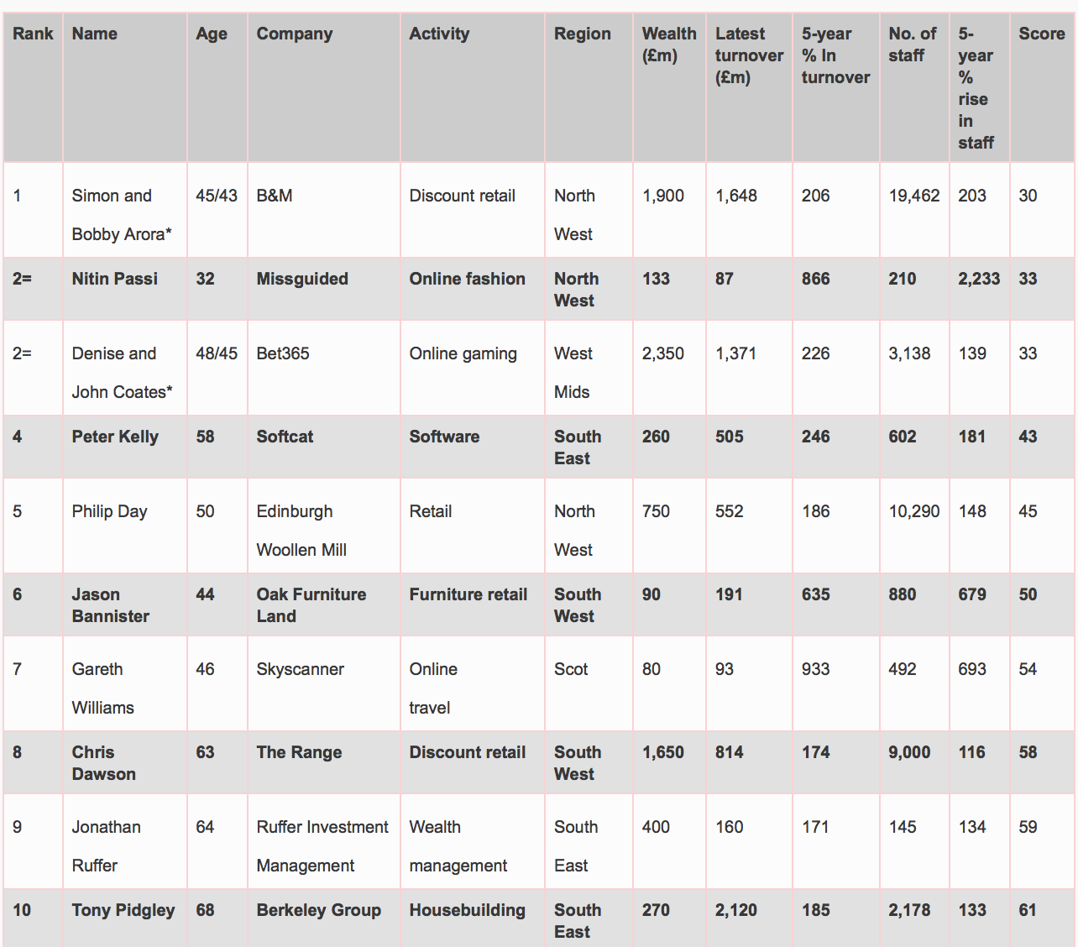
Figure 2-1 Top 100 Entrepreneurs in Britain 2015. Available at: https://www.managementtoday.co.uk/top100entrepreneurs-2015-list. Accessed on the 26th of November 2018.

  - Report remit
This report will provide an in-depth explanation of the different definitions and peoples different interpretations of what an entrepreneur is. It will explain the reasons as to if Nitin Passi is an entrepreneur by different definitions and what motivates him. Furthermore, the impact on key theories including economic theories, psychological trait approaches, and social behaviour approach will be discussed to conclude whether Nitin Passi is an entrepreneur or not. This report really highlights why this entrepreneur has become one and why he is continuing to be one.

  - What is an Entrepreneur?

There are many different definitions to what people think an entrepreneur is. Firstly, there is no universally accepted definition of the term ‘entrepreneur’, meaning everyone is going to have their own definition with the reasons behind it. Harvard Business Review defines an entrepreneur as ‘the pursuit of opportunity beyond the resources you currently control’ meaning entrepreneurs have the opportunity to anything if they want to succeed (2016). However, in the 1800s, the French economist, Jean-Baptist Say, said an entrepreneur is someone who shifts economic resources from low productivity to high productivity (Burns, 2007). The difference between the two definitions isn’t huge, they are on the same track in regards to an individual making money.
According to Hamm (1998), people become entrepreneurs for three main reasons, the first being the individual being able to be their own boss, this is hard to do but gives people strong motivation to build on their business with the only restriction being finance. Secondly, people can pursue their own ideas, this means they have the ability to recognise ideas for new products and services, they will know their business inside and out so will thrive off being able to do what they want with it. Finally, people can pursue financial rewards, as Marc Andreessen, founder of Netscape said, ‘money is the motivator and the measure of success (Hamm, 1998)’. All of these reasons are strong motivators for people to set up and start their own businesses (Barringer, 2010).
Entrepreneurs must consider their organisations values and beliefs which includes ‘ways of doing things, ways of seeing things, ways of feeling things, and ways of communicating things’. Especially for Nitin Passi, his mission statement as mentioned previously is to empower females all over the world to be confident in their own bodies and express who they want to be. He must consider the values and beliefs as it could lead to being a key issue for the business overall as he must ensure his customers are fully satisfied and come first, always (Zimmerer, 2008).
Nitin Passi lived in New York with his father for two years to gain entrepreneurial experience within his fathers own business (insidermedia, 2015). According to The Global Entrepreneurship monitor (2017), the rate of involvement of employees in entrepreneurial activities, including, developing or launching new products or services, or setting up a new business, for the United States in 2017 was 7.59% compared with the global average of 3.30% as you can see from the screen images below.
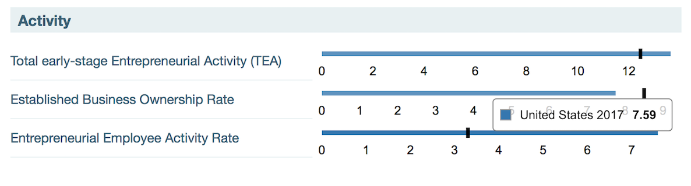
Figure 2-2 United States activity for 2017, Available at https://www.gemconsortium.org/country-profile/122. Accessed 5th of December.
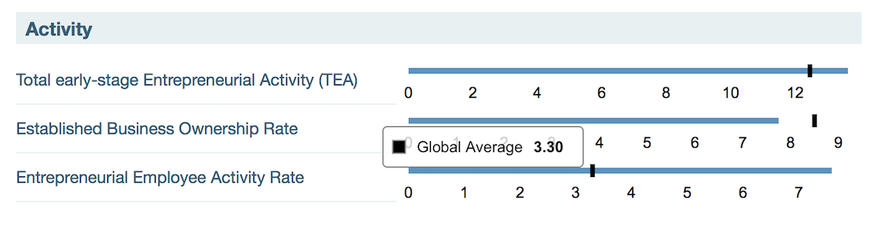
Figure 2-3 Global Average activity for 2017, Available at https://www.gemconsortium.org/country-profile/122. Accessed 5th of December.

This highlights the fact that Nitin Passi’s two years of living in New York would have given himself a lot of entrepreneurial experience as he was out there to get that so would have been easy for him to get it.
According to data set of the 400 wealthiest American people in the 1800’s, 61-80 percent were self-made entrepreneurs (Cagetti et al 2006). Highlighting this data is the statement made saying all of the new jobs created between 1969 to 1976, in a sample of 5.6 million businesses, two-thirds were made up of only twenty or fewer employees (Williams, 2009). This shows that even from the 1800s, that this is what made people go into business alone as it was very hard for them to get jobs because of this, resulting in the interest of becoming an entrepreneur to arise. This fact could have been passed onto Passi whilst living in the states and could have been a motivational factor to him.

  - Why is Nitin Passi an entrepreneur?

Nitin Passi is labelled an entrepreneur for a number of reasons. Passi wanted to start his own business after seeing how well his father did, as mentioned in part 2.2, so learning everything from his father allowed him to go ahead as he knew he had access to support. Decker et al (2014), states that after gaining two years of experience in the states, the fact that the rate of business start-ups has fallen over recent decades and had caused a downward trend in the year 2000, resulting in the share of US employment accounted by young firms has declined by almost 30% in the past 30 years, this encouraged Nitin Passi to make his move back to England to set up there as this is a risk any new start-up can’t afford according to his biography.
Entrepreneurs are thought to be a key factor in a thriving economy today in the United Kingdom (Rae, 2008). Although this comes with characteristics of a successful one, you must have a passion for your business which Nitin does, he explains this in his mission statement as he has a strong passion for making people feel good, he also explains this in his biography in part 2.4. Passion explains why successful people such as Bill Gates, Microsoft, and Google, continue to work even after they’re financially secure. This is exactly what Passi is doing, he had a turnover of £87 million in 2015 but is still continuing to grow his business (Hisrich, 2008).
Another characteristic is continuously having product and customer focus. The cofounder of Apple Inc, Steven Jobs, said ‘the computer is the most remarkable took we’ve ever build…but the most important thing is to get them in the hands of as many people as possible’ (Farrell et al, 2001). This shows he has focus on his product, the computer, and his customers, wanting them all to have access to one. Just like Nitin Passi who explains that he wants his products to satisfy all of his customer base which is why he added a ‘plus size’ collection, to expand on his target market (Vracheva, 2016).
Nitin is also an entrepreneur as he has a tenacity despite any failure, this means that because he’s trying a new thing by setting up business, the failure rate is high in the first year of start-up. For example, Passi could trail and error new styles of clothing to sell to accomplish a certain objective, but, if he does this then he could potentially lose thousands of pounds. This means his marketing research is very important and must be done right to ensure that all products he sells, are what his target customers want and expect from his business (Timmons, 2008).
Finally, the last characteristic is execution intelligence, which to Rob Adams, the senior partner in AV Labs, says is the ability to fashion a solid idea into a viable business (Adams, 2007). Execution intelligence also demands the ability to translate thought, creativity, and imagination. As Jeff Bezos, the founder of Amazon.com, once said ‘Ideas are easy. It’s execution that’s hard’ (Hazleton, 1998). Nitin Passi is a strong entrepreneur as he definitely executed his intelligence from the very start as mentioned before he had an £87 million turnover in just 6 years which doesn’t happen to a lot of business, so this highlights the fact that the executed well enough to capture his target audience.

  - Nitin Passi’s biography and what motivated him?

Nitin Passi had an interview with Insider Magazine in August 2015 to share his biography. He firstly describes how appearance is his on-going biggest motivator, he thrives on allowing women of all shapes and sizes to feel self-confident in themselves by his clothing. Passi adds that by 2016 he wanted to achieve a turnover of £130 million which was an inspiring motivator for the year, he in fact achieved this and the year of 2017 he achieved a turnover of £205.8 million (businessinsider.com, 2017). Finally, he says his other motivator is his mother and father, as they have influenced him with their own background knowledge and his father’s business (insidermedia.com, 2015).
Timmons (2008), says that ‘a successful entrepreneur will be a patient leader, that is capable of instilling tangible visions and managing the long haul’. He adds that one main dominant theme for a successful entrepreneur is motivation to excel. Many approaches implement motivation, including economic theories, psychological traits, and social behaviours. Economic theories are explanations that entrepreneurs focus on such as economic conditions and the opportunities created (Fischer et al, 2009). Two theories that link with Nitin Passi are Kirzner 1997 and Schumpeter 1961.
Kirzner’s theory is that entrepreneurs have the ability to spot opportunities, he says they are people who are alert to profitable opportunities for exchange and, have additional knowledge which allows the recognition and explanation of any opportunities which can discover things. Kirzner suggests that everyone and anyone can be an entrepreneur, there are no barriers, and the only thing that matters is opportunity recognition (Kirzner, 1997). Nitin Passi follows this motivational theory as he sees his potential opportunity, for example, he took risks to collaborate with ‘Playboy’ and it was an instant sell out.

Figure 2-4 Missguided x Playboy sell out. Available at: https://www.missguided.co.uk/about. Accessed 7th of December 2018.
Schumpeter’s theory is that entrepreneurs are huge innovators and agents of change, his theory contrasts with Kirzner’s responder as pro-active instead of re-active. However, Schumpeter argues that within larger organisations, the entrepreneur seems to get lost within as the main influencer is the technological side, as this is more powerful. He adds that the implications are the lack of money which can lead to demotivation (Schumpeter, 1961). As mentioned, one of Passi’s main motivators is to empower women as he states in his mission statement, his stocks sizes range from 4 to 24 which caters for all shapes and sizes (missguided, 2018).
Moving onto psychological traits, this focuses on the entrepreneurs mental and/or emotional elements that drives them to motivation (Gable et al, 2008). There are two approaches that link in with Passi, these include, McCelland 1961 and Meredith 1982. Firstly, McCelland’s theory is that the key competencies that entrepreneurs get motivation from is proactivity, achievement orientation, and commitment (McClelland, 1961). Passi definitely follows this theory as he is very committed to achieve his mission of making women feel body confident.
Meredith on the hand believes that entrepreneurs personality traits involve self-confidence, risk-taking, and need for achievement (Meredith, 1982). As previously mentioned, Passi is highly motivated by his own self-confidence as he mentioned in his biography, he said that his mission meant too much to him, his self-confidence naturally evolved. Also, his need for achievement motivated him as he wanted to achieve a turn-over of more than double of his turn-over, which he exceeded.
Finally, onto the social behaviours of motivation, this means peoples own personal life’s making a motivational impact on their entrepreneurial selves (Peake et al, 2015). Wickham created a social development model describing his beliefs of families having a social impact on others motivation, he explains by saying entrepreneurs have a social phenomenon where-by they interact with others, meaning by sharing life stories, you can learn yourself. Wickham argues that entrepreneurs are always wanting to gain more experience and thinks families make a big impact on this (Wickham, 2006). Nitin Passi explains in his biography that his mother is his biggest motivator. His mother is from Malaysia. K Ahmad (2001) from the International Journal of Commerce and Management writes that in Malaysia, people are educated to believe that leadership is the biggest motivator, this provides evidence of where Passi could have been motivated into becoming an entrepreneur as his mother would have taught him the way she was.

  - Conclusion
After weighing up both the strengths and weaknesses of Nitin Passi’s entrepreneurial self, I can conclude that he most definitely is. He has his targeted customers wants and expectations in his hands and does everything he can to make them feel self-worth which matches up with his mission statement.
- References

Ahmad, K. (2001), Corporate leadership and workforce motivation in Malaysia, International Journal of Commerce and Management, 11, pp. 82-101.
Barringer, B. R. & Ireland, R.D. (2010) Entrepreneurship: Successfully Launching New Ventures, 2nd Ed., Prentice Hall: New Jersey, USA

Burns, P. (2007) Entrepreneurship and Small Business, 2nd Edition, Palgrave Macmillan: Basingstoke

Cagetti, M. and De Nardi, M. (2006), Entrepreneurship, Frictions, and Wealth, Journal of political Economy, 114, pp.835-870.

Chell, E., Spence, L.J., Perrini, F. and Harris, J.D., (2016), Social Entrepreneurship and business ethics: Does social equal ethical?, Journal of business ethics, 133, pp. 619-625.

Decker, R. Haltiwanger, J. Jarmin, R. and Miranda, J. (2014), The role of entrepreneurship in US job creation and economic dynamism, Journal of Economic Perspectives, 28, pp 24.

Drapers online, 2015, Available at: https://www.drapersonline.com/business-operations/digital-/the-drapers-interview-missguideds-nitin-passi-is-taking-it-to-the-street/5075873.article. Accessed on the 26th of November 2018.

Farrell, K. and Farrell L.C. (2001), Entrepreneurial age, New York, Allworth Press.

Fischer, M.M. and Nijkamp, P. (2009), Journal of Entrepreneurship and Regional Development.

Gable, P.A., and Harmon-Jones, E., (2008), Approach-motivated positive affect reduces breadth of attention, Psychological Science, 19, pp. 476-482.

Global Entrepreneurship Monitor, (2017), Available at: https://www.gemconsortium.org/country-profile/122. Accessed 26th of November 2018.

Hamm, S. (1998), The education of Marc Andreessen, Business Week, Industrial Technology edition.

Hazleton, L. (1998), Profile ‘Jeff Bezos’, Success, 60.

Hisrich, R.D., Peters, M.P. & Shepherd, D.A. (2008) Entrepreneurship, 7th Ed., McGraw Hill: New York, NY

Kirzner, I.M., (1997), Entrepreneurial discovery and the competitive market process: An Austrian approach, Journal of economic literature, 35, pp. 60-85.

Management Today, (2015), Available at: https://www.managementtoday.co.uk/top100entrepreneurs-2015-list. Accessed on the 26th of November 2018.

McClelland, D.C., (1961), The achievement society, Princeton, NJ: Von Nostrand.

Meredith, G.G., Nelson, R.E, and Neck, P.A., (1982), The practice of entrepreneurship, volume 30, International Labour Organisation.

MENNACE, (2018), Available at: https://www.mennace.com/uk/about/. Accessed on the 26th of November 2018.

Missguided, (2018), Available at: https://www.missguided.co.uk/about. Accessed on the 26th of November 2018.

Missguided in name only, (2015), Available at: https://www.insidermedia.com/publications/north-west-business-insider/north-west-business-insider-august-2015/missguided-in-name-only. Accessed on the 5th of December 2018.

Peake, W.O., Davis, P.E., and Cox, M.Z., (2015), Being good for goodness sake: The influence of family involvement on motivations to engage in small business social responsibility, Journal of Small Business Strategy, 25, pp. 1-25.

Rae, D. (2008) Entrepreneurship: from opportunity to action, 2nd Ed., Palgrave Macmillan: Basingstoke

Sales at online millennial fashion retailer Missguided jumped 75% last year, (2017), Available at: https://www.businessinsider.com/missguideds-2017-accounts-sales-up-75-swings-to-a-loss-2017-12?r=UK&IR=T. Accessed on the 7th of December 2018.

Schumpeter, J.A., (1961), The theory of economic developments: an inquiry into profits, capital, credit, interest, and the business cycle, Harvard University Press.

Timmons, J. & Spinelli, S. (2008) New Venture Creation: Entrepreneurship for the 21st Century, McGraw Hill:Boston, Mass

Wickham, P.A., (2006), Strategic Entrepreneurship, Pearson Education.

Williams, S. (2009) FT Guide to Business Start Up 2009: The only annually updated guide for entrepreneurs, 4th Ed., Financial Times Press: Harlow

Vracheva, V. Judge, W.Q. and Madden, T (2016) Enterprise strategy concept, measurement, and validation: Integrating stakeholder engagement into the firm’s strategic architecture. European Management Journal, 34, pp. 374-385.

Zimmerer, T.W. & Scarborough, N.M. (2008) Essentials of Entrepreneurship and Small Business Management, 5th Ed., Pearson: New Jersey, USA

List of figures
2.1 Top 100 Entrepreneurs in Britain 2015. Available at: https://www.managementtoday.co.uk/top100entrepreneurs-2015-list.

2.2 – United States activity for 2017, Available at https://www.gemconsortium.org/country-profile/122.
2.3 – Global Average activity for 2017, Available at https://www.gemconsortium.org/country-profile/122.
Figure 2.4 - Missguided x Playboy sell out. Available at: https://www.missguided.co.uk/about.

