LCMB7003-Strategic Management
Virtual Organizations
Strategic management
Student Name: Sagar Mandhan
Student ID:2246016
Subject Name: Strategic Management
Course Name: MBA- Masters of business Administration
Submitted to- Amare Desta (Prof)

Table of Contents
1. Introduction 1
1.1 Virtual Organization 2
1.2 Thesis Statement 2
2. The Emergence of Virtual Organizations 2
2.1 Historical Context and Technological Advances 2
2.2 Advantages of Virtual Organizations 3
2.3 Challenges Facing Virtual Organizations 3
3. Strategic Planning in Virtual Organizations 4
3.1 Setting Strategic Goals 4
3.2 Resource Allocation in a Virtual Setup 5
3.3 Risk Management Strategies 5
4. Designing Virtual Organizations 5
4.1 Structural Design for Virtual Environments 5
4.2 Technology Infrastructure and Support 6
4.3 Collaborative Tools and Practices 7
5. Leading Virtual Organizations 7
5.1 Leadership Styles Suitable for Virtual Organizations 7
5.2 Employee Engagement and Performance Management 7
5.3 Cultural Integration and Management 8
6. Conclusion 8
7. References 9

1. Introduction
The development of technology and globalization has reinvented the very structure of a workplace, leading to the emergence of what is called today a “virtual organization.” Therefore, in this part, it will be explained and the strategic management challenges and opportunities of virtual organization will be highlighted.

1.1 Virtual Organization
A virtual organization can be described as a network of independent entities that brings them together in a virtual environment overcoming the inconveniences of traditional organizational borders or physical location. These organizations capitalize on the technological platforms that facilitates the coordination of people and resources from different places around the globe (Shokri Gazafroudi, Prieto & Corchado, 2019). This allows them to react efficiently to market upheavals and customer preferences. A virtual organization is defined by the major role that communication technologies such as the internet, intranets and other web-based tools play in this organization in terms of facilitation of the collaborative work and processes.

1.2 Thesis Statement
The appearance of virtual organizations in fact, provides the new model to management in strategy operational areas which are adopted in the scenario of planning, designing and controlling. The degree of this syllabus will be a critical assessment of how the concepts of strategic management are applied in virtual organization with the utmost regard to their unique requirements which include the following: flexibility, decentralized decision-making and routing innovation. This assessment builds on this scientific environment of the coursework that is aimed at understanding the applicability of different strategic approaches and leadership styles in the virtual setup, as a result proposing practices that can enhance efficiency as well as cohesion among virtual teams through the practical approach.

2. The Emergence of Virtual Organizations
Virtual organizations used to remain as niche approaches to traditional offline approaches but they have now become mainstream business due to technologic advancements and shifts in economic and social scenarios. This part deals with the historical story, merits, and limitations of the post-modern which includes electronic media, cinema, and television.

2.1 Historical Context and Technological Advances
Although the term virtual organization has been around in the late 20th century business world to find new forms of increased flexibility and reduced operational costs while competing in the world market. The Internet and technologies that became common in the 1990s provided the means that allowed employees to work away from the office rather than in its close proximity and also to send and receive information in real time wherever they were, which characterizes virtual enterprises (Hernández et al., 2019). One key technological progression, like high-speed internet, cloud computing, collaborative software, and complex cybersecurity tools, has played vital role. Such technologies allowed the enterprise to function without having to rely on a single physical corner because of their ability of connecting different entities and sharing information with no delays.
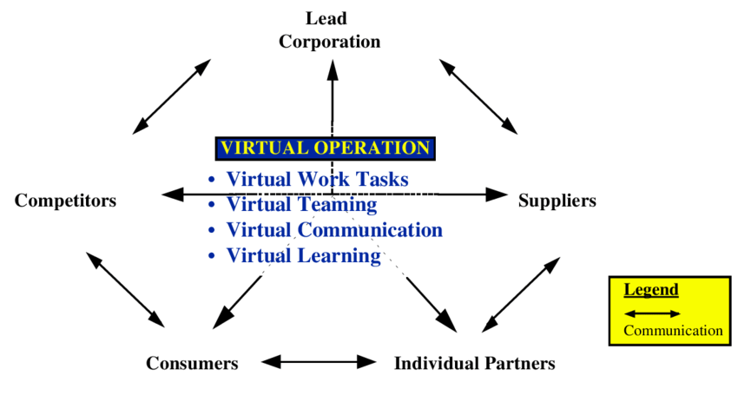
Figure 1: The Heart of a Virtual Organization Adapted from Grenier and Metes (1995)

2.2 Advantages of Virtual Organizations

Virtual organizations offer several distinct advantages that make them attractive in today’s dynamic business environment:
Cost Efficiency: Digitalization of business processes helps in downsizing on physical space of business offices and associated high overhead costs while increasing the business investment on growth and development by releasing these funds.
Flexibility and Scalability: The capability to rapidly and smoothly adapt to any changes in the business and either downscaling or upscaling its operations without the lofty barriers of space (Lee, 2021).
Access to Global Talent: Employment of talent across boundaries and geographical limitations portraying as a diversity inability giving birth to creative and best teams.
Enhanced Responsiveness: This decentralized nature coupled with the ability to quickly implement change thanks to digital communication tools and the use of digital operations will make the organization healthy in the face of market changes or customer needs.

2.3 Challenges Facing Virtual Organizations

Communication and Collaboration Difficulties: Without direct communication, misunderstanding happen more often and the teamwork development becomes a daunting endeavor.
Technology Dependence: The extreme use of technology must be corrected else the collapse of the system will affect the work seriously.
Security Risks: Additionally, organizations face an increased threat to their cybersecurity since they store data broadly across networks and different locations (Pizło & Parzonko, 2021).
Cultural and Management Issues: Working with a team that is made up of different and cultures, time zones, calls for remarkable management strategies to build a team and maintain production.

3. Strategic Planning in Virtual Organizations
In virtual organizations strategic planning tends to be more dynamic than the counterparts in the traditional organizations as these organizations operate in a different manner. So the next part features the details on strategic planning and tactile knowledge management in the remote office.

3.1 Setting Strategic Goals
To follow out strategic goals in a virtual organization, you must specify clear and achievable goals that are in agreement with the mission of organization and the feature of its distributed workforce. The goals that have the best suitability for change and are technologically advanced enough to use the virtual nature effectively have to be created (Cortellazzo, Bruni & Zampieri, 2019).
Clarity and Alignment: Goals must be clearly defined and conveyed so that all team members – whether they work from home or office – are on the same page in terms of the corporate direction.
Flexibility: Goals shall be set in such a way that they will provide for enough flexibility to adjust to technology and market development changes inherent in virtual settings (Bagga, Gera & Haque, 2023).
Performance Metrics: Digital health apps would incorporate specific, measurable, achievable, relevant and time-bound (SMART) metrics that can be monitored digitally to reflect progress to these goals.
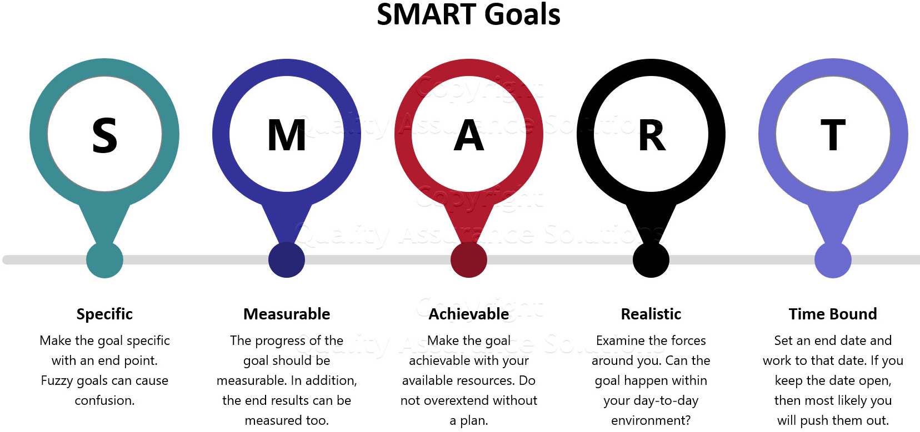
Figure 2: SMART Goals: The Most Powerful Step to Meet Objectives https://www.quality-assurance-solutions.com/

3.2 Resource Allocation in a Virtual Setup
Virtual teams are more than just managers distributing physical allocations to digital systems, equipment, and knowledge. Embracing the right technology stack may play a critical role in this context, which includes superior communication means, projects management programs and dependable cloud services so as to guarantee the organization's flawless operation across different local areas. Equally, or, indeed, more important is the allocation of resources for training and development of team members (Halabian, 2019). This ensures that each of the employees is acquainted with all digital tools and can teamwork unparalleled in the world of digitalization irrespective of their physical locations. In addition, budgeting practices in virtual organizations necessitate a shift towards buying office-related expenses to those that are associated with remote working setting for instance cybersecurity and software among others. This figure of allocating strategic resources is pivotal in operational efficiency and preventing the organization`s digital system from the danger.

3.3 Risk Management Strategies

Risk management in virtual organizations is considered to be a preventative process of spotting the risks in the operations before disrupting. Among the main issues to be resolved is risk of technological failures and, as a solution for this, companies should use cybersecurity infrastructure and reliable backup systems to protect the data and to provide support in the situation of IT failures and ensure business continuity. In addition to operational risks, these require priority and developing sound operational policies are key for timely execution and inter-functional coordination, while ensuring the quality of output (Fu & Zhu, 2019). Moreover, legal dangers and compliance concerns are vital, therefore virtual organizations must keep updated and conform to all of the legal requirements and data protection laws wherever they’re operating. Along with this, human resource risks management should be performed in the work at home environment, including the adoption of policies that deal with the remote work challenges, such as isolation of employees, work-life balance, and preserving the corporate culture strong.

4. Designing Virtual Organizations

Designing a virtual organization requires careful consideration of its structural design, technology infrastructure, and collaborative practices to ensure efficiency and effectiveness in a non-traditional work environment. This section delves into these three critical areas.

4.1 Structural Design for Virtual Environments

The structural organization of virtual organizations are efficiently structured in such a way that they can easily adapt to changes in a fickle business environment and as well take advantage of emerging opportunities. Different from the old-fashioned, rigidly-hierarchical organizations, which are usually slow to make decisions, most virtual organizations run on a relatively flat organizational structure. Thus, team decision-making capacity is notably strengthened when combined with this strategy which helps team members to be more independent (Rumsey & Le Dantec, 2022). This structure is defined by such constituents as centralization, where authority and decision-making are distributed across an organization in order to enhance its ability to respond and adapt quickly. Singularly, scalability takes on a vital role; the workforce is organized into units that are modular and flexible, and can be readily reshaped to reflect particular project tasks. In turn, this promotes adaptability and targeted expertise. Lastly, the network configuration has been set to establish interactions and collaborations with multiple parties outdoors, thereby using different interpreters as well as enhancing the function of the organization.
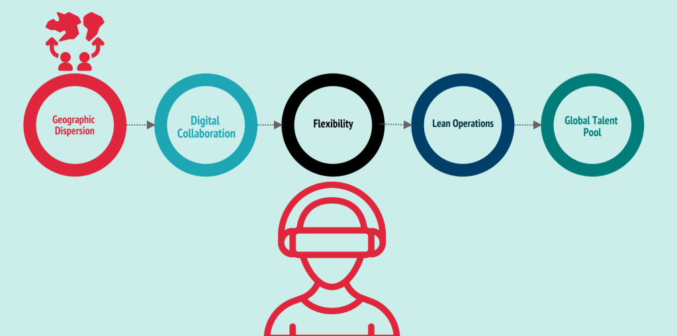
Figure 3: Structural Design for Virtual organizations (Rumsey & Le Dantec, 2022)

4.2 Technology Infrastructure and Support

Modern technology infrastructure is to allow the virtual organization to work properly, making communication, collaboration and business across the teams in the all world smooth. Among the most notable aspects of this framework is the secure connectivity where all our team members can have easy and secure access to organizational networks and data through the use of VPNs, encrypting communications, and employing strong authentication methods. This led us to another important aspect, scalability, where our IT infrastructure can rapidly adapt to the requirements of the organization, keeping performance and security at high levels (Dincelli & Yayla, 2022). Moreover, the IT support system needs to be user-responsive and capable of prompt resolution of technical obstacles so that they can prevent the unnecessary lag in people's productivity. They constitute the technical core, which ensures the agility and adaptability characteristic of such companies.

4.3 Collaborative Tools and Practices

Collaboration in a virtual environment can be made more efficient by employing techniques that are aimed at enhancing teamwork and communication, by means of software tools and identified best practices. That includes, for example, cutting-edge collaborative software that incorporates functions such as video conferencing, real-time convergent, project management, and document sharing to create the effect of a smooth work flow. Henceforth, building a trade mark for virtual collaboration becomes a must. These include, establishing of communication rules, guidelines, documentation best practices, and holding of structured digital meetings which may change from time to time with the aim of keeping everyone in the team aligned and well informed (Morrison-Smith & Ruiz, 2020). Additionally, it is vital to maintain cultural sensitivity when designing the collaborative practices of the global teams to improve their inclusiveness, and that, will make the teams cohesive among their members from diverse cultural backgrounds, thus, better the general effectiveness of the global teams in question.

5. Leading Virtual Organizations

5.1 Leadership Styles Suitable for Virtual Organizations

Direction of leadership in virtual firms must be tailored towards the independence, adaptability and trust paradigm. In such settings, leadership that is truly impactful is usually comprised of transformational and service leadership styles. Transformational leaders lead by example because they not only induce and encourage their team members, but also share the vision and allow creative ideas to prevail which are the fuel of the fire in the remote settings that are not overseen (Sandberg, Pennington & Lindquist, 2022). The Servant Leadership, which focuses on meeting the collective needs of the workers, promotes trust and individual participation, a vital requirement for remotely working teams whose physical management on a daily basis is not possible. Such leadership styles facilitate the environment of accountability and empowerment paramount for the virtual organization’s advancement.

5.2 Employee Engagement and Performance Management

The engagement of remote employees and the kind of performance management they need are presented in a rather unique way. Virtual leaders step up the usage of technologies to keep all networks open and evaluate performances based on facts. Frequent virtual encounters, evaluation sessions, and digital instruments for setting and tracking measures are vital for this purpose (Sanchez-Sepulveda et al., 2019). Aside from these basic elements, it would be advisable for leaders to also acknowledge and include digital platforms in their feedback mechanisms. Furthermore, stimulating a feeling of co-work and network among virtual workers can help increase the level of commitment and motivation, conditioning better performances eventually.

5.3 Cultural Integration and Management

Virtual organizations similarly portray a multi-cultural workforce spreading out other areas' cultural backgrounds, meaning that integration of culture and management becomes a key leadership function. Leadership must be nationally-sensitive and proactive in designing policies that recognize and valorize different cultures (Tadesse & Ayenew, 2023). This may be in the form of training opportunities for all team members where the cultural diversity is taught, developing communication practices that are suitable for all time zones and languages, and creating interactions between different cultures that help to foster mutual understanding and respect. As a result, harnessing this diversity is an asset to the organization by boosting creativity, solving problems, and realizing innovations.

6. Conclusion

The emergence of virtual organizations can be considered as a revolutionary step in the process of the modern business enterprise caused by innovations in technology and international business practice’s changes. These groups demonstrate a number of advantages, including their high adaptability, significant cost efficiencies, and access to a plethora of global talent, but they also come with a share of problems, such as remote workforce management and communication consistency and safety. Strategic planning, consistent design as well as effective leadership is the main pillar of victory through these problems. The styles of leadership that focus on empowering team members, using communication tools that ensure effortless communication, and implementing strategies that create a culture of inclusivity and engagement are paramount elements of virtual teams effectiveness and sustainability. With the shifting trends in the work landscape, virtual organizations are a manifestations of the power that technology has to change how business is done in order to pave the way to new paths to market growth and operations.

7. References

Shokri Gazafroudi, A., Prieto, J. and Corchado, J.M., 2019. Virtual organization structure for agent-based local electricity trading. Energies, 12(8), p.1521.
Hernández, E., González, A., Pérez, B., de Luis Reboredo, A. and Rodríguez, S., 2019. Virtual organization for fintech management. In Distributed Computing and Artificial Intelligence, Special Sessions, 15th International Conference 15 (pp. 201-210). Springer International Publishing.
Lee, M.R., 2021. Leading virtual project teams: Adapting leadership theories and communications techniques to 21st century organizations. Auerbach Publications.
Pizło, W. and Parzonko, A., 2021. Virtual organizations and trust. In Trust, Organizations and the Digital Economy (pp. 61-78). Routledge.
Bagga, S.K., Gera, S. and Haque, S.N., 2023. The mediating role of organizational culture: Transformational leadership and change management in virtual teams. Asia Pacific Management Review, 28(2), pp.120-131.
Halabian, H., 2019. Distributed resource allocation optimization in 5G virtualized networks. IEEE Journal on Selected Areas in Communications, 37(3), pp.627-642.
Fu, Y. and Zhu, J., 2019. Big production enterprise supply chain endogenous risk management based on blockchain. IEEE access, 7, pp.15310-15319.
Rumsey, A. and Le Dantec, C.A., 2022. Escaping the Holodeck: Designing virtual environments for real organizations. In Human-Technology Interaction: Shaping the Future of Industrial User Interfaces (pp. 223-249). Cham: Springer International Publishing.
Dincelli, E. and Yayla, A., 2022. Immersive virtual reality in the age of the Metaverse: A hybrid-narrative review based on the technology affordance perspective. The journal of strategic information systems, 31(2), p.101717.
Sanchez-Sepulveda, M., Fonseca, D., Franquesa, J. and Redondo, E., 2019. Virtual interactive innovations applied for digital urban transformations. Mixed approach. Future Generation Computer Systems, 91, pp.371-381.
Morrison-Smith, S. and Ruiz, J., 2020. Challenges and barriers in virtual teams: a literature review. SN Applied Sciences, 2(6), pp.1-33.
Sandberg, D.S., Pennington, C.M. and Lindquist, M.A., 2022. Virtual Leadership: CEOs and C‐Level Executives of Healthcare Organizations in the United States Reimagined New Roles as Virtual Leaders. Journal of Leadership Studies, 16(3), pp.61-69.
Tadesse, A. and Ayenew, Z., 2023. Managing virtual teams and system thinking: A systematic review. J. Intell Manag. Decis, 2(3), pp.151-159.
Cortellazzo, L., Bruni, E. and Zampieri, R., 2019. The role of leadership in a digitalized world: A review. Frontiers in psychology, 10, p.456340.

Table of Contents
Virtual Enterprises: A Paradigm for Collaborative Innovation 2
Types of Virtual Enterprises 3
References 5

Virtual Enterprises: A Paradigm for Collaborative Innovation
Virtual Enterprises (VEs) are transformative business models that redefine how organisations operate in today’s fast-paced and interconnected marketplace. Traditional business structures often face limitations due to rigid hierarchies and slow response to market dynamics (Rementsov and Lukinov, 2020). In contrast, VEs provide an agile and collaborative framework that enables companies to adapt swiftly to new opportunities and challenges, leveraging various partners' diverse capabilities and resources.
Collaborative Innovation and Flexibility VEs are built on the foundation of collaboration, where multiple entities, possibly from different sectors or geographic regions, join forces to achieve shared objectives. This collaboration is facilitated by virtual engineering, a pivotal aspect of VEs, which integrates digital tools and platforms to bridge the physical distances between partners. This seamless integration allows for a continuous and real-time exchange of ideas, data, and resources, enhancing the enterprises' agility.
The flexibility of VEs is a critical attribute that allows these entities to form, dissolve, or reconfigure according to the market's demands. For example, a VE can quickly assemble a team of specialists from around the globe to tackle a specific project or innovation challenge and swiftly disband or reorganise once the goals are achieved or altered (Anthony, Petersen and Helfert, 2020). This adaptive capability is particularly advantageous in sectors where technology and customer preferences evolve rapidly, such as the tech and consumer electronics industries.
Traditional geographic and sectoral boundaries do not confine Strategic Partnerships and Global Connectivity Strategic partnerships within VEs. These partnerships are driven by a strategic vision to access wider markets, better technologies, and diverse skills. They enable businesses to extend their reach and tap into new and emerging markets more efficiently and effectively. For instance, a startup in Silicon Valley might partner with a manufacturing firm in Asia and a design studio in Europe, each bringing unique strengths to the table and creating an innovative, cost-effective, and globally competitive product.
The intellectual connectivity in VEs goes beyond mere collaboration; it fosters a rich environment for innovation. This is achieved through the partners' collective brainpower and creative synergy (Anthony, Petersen and Helfert, 2020). Each partner contributes different perspectives, experiences, and expertise, which enrich the problem-solving process and lead to more innovative solutions. Moreover, VE partners' shared knowledge and technology transfer can accelerate product development cycles, reduce costs, and enhance output quality.
These strategic partnerships are underpinned by sophisticated digital platforms and tools that ensure effective communication, coordination, and management of resources. These technologies are integral to the functioning of VEs, enabling them to manage complex projects across different time zones and cultural contexts without the need for a centralised physical location.

Types of Virtual Enterprises
Virtual Enterprises (VEs) have emerged as a dynamic and adaptable business model designed to thrive in various market conditions by leveraging disparate organisations' collective strengths and capabilities. These enterprises are categorised into three primary types based on their operational focus and duration: Short-term Virtual Enterprises, Expanded Business Virtual Enterprises, and Consortium Virtual Enterprises (Sari, Sen and Kilic, 2006). Each type has distinct characteristics and strategic advantages tailored to meet specific business needs and objectives.
1. Short-term Virtual Enterprises
Characteristics: Short-term Virtual Enterprises are designed for agility and speed. They are typically established to address immediate market opportunities or to undertake specific projects with a defined timeline. The organisational structure of these VEs is intentionally lightweight, allowing for rapid assembly and equally swift disbandment post-project completion. This minimises bureaucratic overhead and enhances the responsiveness of the enterprise to changing market conditions.
Innovation and Flexibility: The core advantage of short-term VEs lies in their ability to prototype and test new ideas rapidly. This is crucial in industries such as technology and fashion, where market trends can shift unexpectedly, and the window for capitalising on new opportunities is often limited. Short-term VEs excel in environments that require quick decision-making and flexibility, allowing them to innovate continuously and adapt their strategies to meet immediate market demands.
2. Expanded Business Virtual Enterprises

Summary
Characteristics: Expanded Business Virtual Enterprises are more complex and are designed to transcend traditional business boundaries. These VEs involve intricate interactions with various stakeholders and often span multiple industries or sectors (Rementsov and Lukinov, 2020). They are characterised by their need for sophisticated coordination mechanisms to manage a broader scope of activities and ensure smooth interactions among all parties involved.
Strategic Integration: These enterprises leverage various partners' comprehensive integration of resources and capabilities, facilitating a holistic approach to innovation and problem-solving (Alessandro D'Atri and Amihai Motro, 2007). By pooling resources and expertise, Expanded Business VEs can tackle more complex projects and create more sustainable business solutions that might be beyond the reach of a single entity. This strategic integration often leads to the development of new business practices and innovative products or services that significantly impact the market.
3. Consortium Virtual Enterprises
Characteristics: Consortium Virtual Enterprises are formed for long-term collaboration. These VEs focus on maximising the capabilities and resources of each partner over an extended period. They are characterised by distributed control and dynamic resource allocation, essential for managing long-term projects' complexities and scale. This structure allows for flexible management and adaptation to new insights or changes in project scope over time.
Long-term Innovation and Stability: The stability and sustained collaborative nature of Consortium VEs make them ideal for large-scale innovation projects that require long-term commitments from all partners. These enterprises are often involved in extensive research and development initiatives, where the cumulative knowledge and resources of the consortium can lead to groundbreaking innovations(Rementsov and Lukinov, 2020). The long-term nature of these partnerships also provides the financial and intellectual investment necessary to explore new technologies or develop complex solutions that could revolutionise entire industries.
Virtual enterprises represent a modern approach to business that aligns with the needs of an increasingly fast-paced, interconnected, and complex global marketplace. By categorising VEs into short-term, expanded business, and consortium types, organisations can tailor their strategies to the specific needs of their projects and partnerships. This adaptability not only enhances innovation but also provides a strategic edge in navigating the challenges of contemporary markets.

Precis-
Virtual enterprise } organisation, evolution and control M.T. Martinez*, P. Fouletier, K.H. Park, J. Favrel
In the contemporary business landscape, characterized by unprecedented levels of complexity and uncertainty, traditional organizational structures often struggle to keep pace with the rapid changes and dynamic market demands. In response, the concept of virtual enterprises (VEs) has emerged as a transformative paradigm, offering a flexible and collaborative approach to project execution and resource utilization.
At the heart of the VE concept lies virtual engineering (VE), a framework that enables diverse companies to seamlessly collaborate on common projects by leveraging their collective resources and competencies. VE not only enhances adaptability, resource efficiency, and time-to-market responsiveness but also fosters innovation and strategic partnerships in an increasingly interconnected global economy.
Within the realm of virtual enterprises, three primary categories delineate the varying degrees of collaboration and organizational structure:
1. Short-term VEs: These agile entities are designed to capitalize on specific market opportunities or address short-term projects. With a lightweight and adaptable structure, short-term VEs empower partners to coordinate relatively independent sub-projects with minimal need for extensive co-engineering. This flexibility allows them to swiftly respond to emerging market trends and capitalize on fleeting opportunities.
2. Expanded Business VEs: Unlike their short-term counterparts, expanded business VEs transcend traditional organizational boundaries and involve complex interactions with a multitude of stakeholders, including suppliers, consumers, and partners. This type of VE requires sophisticated coordination mechanisms to manage high levels of synchronous and asynchronous cooperative engineering work across diverse stakeholders, ensuring alignment with overarching strategic objectives.
3. Consortium VEs: Consortium VEs represent long-term collaborations aimed at maximizing partner capabilities while retaining internal flexibility. These collaborations are characterized by distributed, non-hierarchical control mechanisms, enabling dynamic resource allocation and adaptation to changing market conditions. Consortium VEs prioritize resilience and adaptability, allowing partners to navigate fluctuations in demand and market dynamics effectively.
Central to the success of consortium VEs is the systematic process of task decomposition and allocation based on product functions. Partners evaluate each other's capabilities through internal bidding mechanisms, ensuring alignment with cost, quality, and timing criteria. A structured product development cycle, encompassing task allocation, co-engineering/manufacturing, co-maintenance, and feasibility pre-study stages, guides concurrent engineering efforts within the consortium.
However, implementing dynamic, real-time control mechanisms presents a significant challenge for consortium VEs. To address this challenge, the paper proposes the adoption of multi-agent systems (MAS) as an architectural solution. MAS leverages autonomous agents to represent production activities, resources, and final goods across partner companies. These agents utilize negotiation protocols to self-organize and dynamically allocate tasks in response to changing circumstances, thereby optimizing resource utilization, and enhancing adaptive capacity.
While MAS offers numerous advantages, including self-organization, distributed decision-making, and real-time reactivity, challenges persist in standardizing interface protocols, information sharing models, and cooperative engineering tools across diverse partner systems.
In conclusion, virtual enterprises, underpinned by virtual engineering principles, offer a promising avenue for collaborative innovation and resource optimization in today's dynamic business environment. By embracing the nuances of different VE types and leveraging advanced technologies like multi-agent systems, organizations can navigate complex collaboration landscapes with agility and resilience, driving sustainable growth and competitive advantage in an increasingly interconnected world.

