WORKSHEET 4 – QUESTION

Generate five random numbers in the range 1-100 and store them in an array.

- Invite the user to guess a number. If their guess matches one of the five numbers, they earn 200 points. For example:

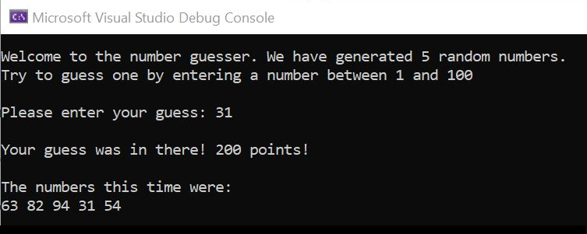

Alternatively, if their guess wasn’t there, let the user know:

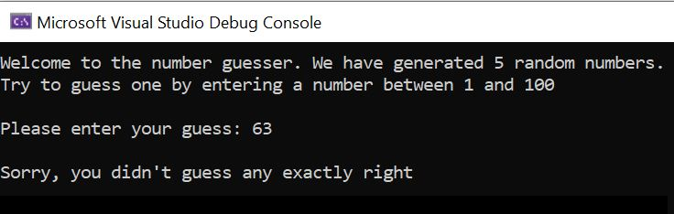

Validate any inputs as required.

- Extend your programme give points for close guesses:

- Where the guess is within 2 (for example, where 20 is one of the numbers and the user guesses 18, 19, 21 or 22) = 100 points

- Where the guess is within 5 = 50 points

Note that the user could gain multiple points in this way – for example, if both 20 and 21 were in the number list and the user guessed 19, they would gain 100 points x 2 because it is within 2 of both numbers.

Example 1: Here the user has guessed 47 and 49 is in the number set (within 2).
The user scores 100 points.

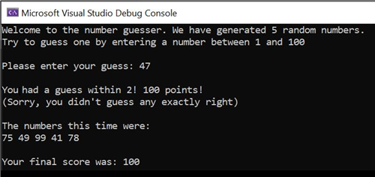

Example 2: Here the user has guessed 23. This is within two of 22 and 24, and also within five of 26. The user scores 100 + 100 + 50 = 250 points:



