

BSc Civil Engineering and Environmental Management
Project Planning, Monitoring and Control
M3X8761

‘Case Study – Portfolio’



Edward Rees
Student No: P057280

Table of Contents
Table of Contents 2
Introduction 3
Background – Resource Optimization Techniques 5
Resource Smoothing 5
Resource Levelling 6
Case Study 7
Solutions 8
Calculations for average workforce per week 8
Bibliography 12
Appendices 14
Appendix A – Gantt Chart – Critical Path schedule 14

Introduction

We have been tasked as a team of construction managers to develop a Commercial building within Swansea City centre with the requirements of having 2 underground floors, and various number of floors for each of the 4 blocks required. Block A is a 5 story building; Block B is 7 stories; Block C is 11 stories and Block D is 15 stories. The area of each block floor is 500m².

Figure 1 - Site Plan

Figure 2 - Site Layout

There has been 5 assigned project managers to complete this project and each manager has had an individual task to complete. Task descriptions and assigned project managers are as follows:

- Programme Gantt Chart – Timothy Stewart & Ioan Chidgey
- Site Layout – Nathan Hunt
- Cash Flow forecast analysis – Mubarik Jama
- Resource Optimization Techniques – Edward Rees

Each team member had their specific roles, but certain task were completed as a group, mainly the Gantt chart, which the initial chart was mapped out during group meetings. It was then fine-tuned and programmed into the ASTA software by Timothy Stewart. Following the completion of the Gantt chart, all the following task were able to be calculated and completed, in essence the production of the Gantt chart is the nucleus of our project. As a result of this it was discussed and analysed in depth during team meetings, where it was scheduled and revised accordingly, this then placed us as a team in a position to deliver the most effective and efficient programme and project possible.

Project manager Nathan Hunt had the task to programme the site layout, this entailed planning all the site logistics, for the programme of works required to construct the site, to include, site offices and welfare facilities, services, earthwork plant, lifting machinery and equipment, all forms of storage facilities, waste disposal and access roads. Considerations included evaluating resources needed during each stage of the construction process and how the site layout will evolve during the duration if the scheme.

Mubarik Jama was the project manager in charge of the Cash Flow forecast analysis. Mubarik had to utilise the Gantt chart to calculate all cost expenses per calendar month. From this information he was then in a position to calculate monthly invoices and payments. We agreed in the pre contract meetings that we would expect a 8% profit for the completed scheme, and apply a 5% retention figure to the budget. One of the more intrigant process Mubarik would have to calculate is the monthly cash flow and locked up capital of the scheme, to calculate this, we had to consider payments will be one calendar month after the valuation. Following these calculations a will be in a position to draw a cash flow diagram. From this diagram we can then calculate interest payable if we needed to borrow capital with an interest rate of 15%. Once all the account calculations were complete we can accurately forecast whether or not that this project would be prove profitable for the company.

My main role within this project was to manage resource optimization, and the techniques available to carry out such tasks. From the information scheduled within our Gantt chart, my main objective was to optimise the workforce with the aim of avoiding peaks and troughs. To be able to calculate my resource optimisation I firstly had to calculate the average workforce per week, and identify where there are potential peaks and troughs within the workforce distribution. Following this analysis I was then in a position to determine whether I could implement any resource levelling and resource smoothing techniques. I collated the entire information that I generated from the previous said processes and was then in a position to identify how other resources are effected during the scheme of the project.

Background – Resource Optimization Techniques

As mentioned previously, my main role within this project was to project manage resource optimisation techniques. I relied heavily on the produced Gantt chart, as this enabled me to calculate what was required to be able to carry out this role, therefore it was integral that the schedule was as accurate as possible.

Firstly I had to calculate the weekly average for workforce utilisation. That was achieved by multiplying a specific task outlined in the schedule by the number of weeks required to complete, then I divided the total hours per week by a 37.5 hours, the average working week, then dividing that by a 8 hour working day to provide me with the number or workforce required.

Following this task I was the in a position to identify peaks and troughs within the workforce distribution and utilisation. From this information I was able to advise on optimisation methods to get the most efficient programme of works possible.
I was also now in a position to analyse the programme as to whether I could implement any resource levelling and resource smoothing. I will discuss these two options individually below.

Resource Smoothing

Resource smoothing is a tool utilised in project management in order to optimise resource. This is a technique that is defined where ‘activities of a schedule model are adjusted so that all requirements for the resources do not go beyond the resource limits already pre-defined during the planning’ (Alby, n.d.)

When conducting any project, there are very few resources that are limitless. As a result of this, relevant time schedules have to be adjusted and imposed to manage the limited availability of the resources. This method of optimising resources is especially useful within the construction industry, where time constraints are a major contributing factor in the success of a project and its planning. ‘The objective of this project management tool is to complete the work or activity within the required date and, at the same time, avoiding peaks and troughs or the resource demand.’ (Alby, n.d.)

My main objective by utilising this optimisation tool was to achieve a smooth resource profile which was done by delaying certain tasks within the schedule. A knock on effect of utilising such method was that it will inevitably reduce the flexibility of the schedule when considering delays to works, but the effectiveness and advantages in the management and utilisation of the resources warrants this approach.

Resource Levelling

One of the most important tasks within project management is not to overload a specific work team with work while another team is not working to their capacity, therefore the allocation of work equally is paramount. Therefore the key to a successful project is to ensure that each resource has work equivalent to the amount of time provided for that given task.

In project management, resource levelling is defined by A Guide to the Project Management Body of Knowledge (PMBOK Guide) as ‘A technique in which start and finish dates are adjusted based on resource constraints with the goal of balancing demand for resources with the available supply.’
(Institute, 2013)

While we are scheduling the work we have scheduled certain tasks that are carried out simultaneously. When carrying out such a process we will have situations where resources such as workforce and machinery etc are required in multiple tasks, due to this these tasks will require to be rescheduled ‘concurrently or even sequentially’ (Drake, 2018) in order to manage this constraint, this process to resolve these conflicts is defined as resource levelling.

The resource levelling method is closely related to the calculated critical path that is generated on our Gantt chart (Appendix A). Because of this the total float, activity sequence and general understanding of the Gantt chart effect the required resource quantities per time. allocated.

Figure 3- Image of Resource Levelling Example
(Anon., n.d.)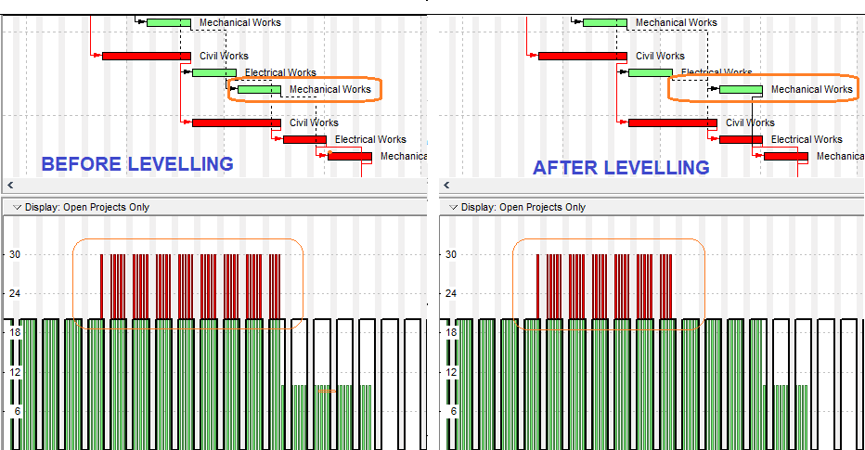

Case Study

The case study, as described briefly in my introduction, was to be a member of a project management team which has the task to develop a commercial building block within Swansea City centre. The requirements were that each of the 4 blocks required (Figure 2) must have 2 underground floors, and varying number of above ground floors. Block A is required to be a 5 story building; Block B a 7 stories; Block C a 11 stories and Block D is 15 stories. The area of each block floor is 500m².

The design of the underground floors (basement) was to be constructed utilising Larson sheet piling as the primary retaining element, with a reinforced concrete slab. The main buildings are to be portal steel frame buildings which will be finished with a specified double skinned cladding.

Being that this is an urban area, there were several constraints that we had to factor in to the initial programming, mainly noise and dust pollution. Due to the issue with noise and being that the site is near a residential quarter, we were limited to normal working day hours which were 09:00am to 17:00pm and a 5 day working week, Monday to Friday. Also due to the construction methods utilised to construct the 2 floor underground basements, sheet piling methods, the piling rigs that drive the sheet piles into the ground produce considerable vibration, as a result of this, anti-social working hours were restricted, which in turn prolonged the scheme duration.

Specifically to my task, there were factors that effected resource optimisation. Mainly due to the restricted working hours, to be able to complete tasks within a specific time scale, more labour was required which answered the need to be able to get the work completed on time, but had a knock on effect with cost.

Solutions

Calculations for average workforce per week

Based from ‘Typical Gang Build Up’ form SPONS Architects and Builders Price Book 2018.

Figure 4 - Typical Gang Build Up
(Aecom, 2017)

Figure 5 - Average workforce per week table

Figure 6 - Total Average Workforce per week Graph
Following the completion of the average workforce per week calculations, it was possible to identify if there were any peaks and troughs within our work force distribution. As you can see from the graph in Figure 6, there is obvious peaks and troughs present.
These however have been smoothed out utilising the critical path generated in our Gantt chart. The critical path produced within the ASTA project management software, as seen in Appendix A, outlined in red, has levelled the resources to minimise the severity of the peaks and length of troughs. The graph in Figure 6 demonstrates this clearly, you can see from the data that resources at the beginning of the project are relatively low, then when simultaneous task are ongoing, the resource level is amplified accordingly. Likewise when the project is nearing completion, resources requirement is reduced and optimum efficiency Is achieved.

The bulk of my analysis has been focused on workforce optimization, but we must consider during construction scheme that several other resources such as machinery, concrete pours, and supply of specific materials can have a major part to play in the overall resource optimisation.

For an example, if a crane is programmed in for 3 weeks in order to lift steel sections to complete task 11 on our Gantt chart (Appendix A), and that crane has a mechanical failure, or weather conditions restrict the operation of the crane, then this will have a knock on effect with the programming of the entire schedule. To cover for these eventualities, we utilise the programmed float days. Similarly for other aspects, as mentioned, such as concreting, a whole host of eventualities must be considered that may unsettle the scheduled programme.

Discussion

The method utilised to produce the data and scheduling required has been a relatively basic approach to project management techniques. Although the data produced in the Gantt chart is accurate and true to form, the methods used to manipulate that information to be able to produce relevant analysis, were not as efficient as we would of liked. Following researching this task in more depth, it was evident that there are certain project management software packages available, such as Primavera P6.

‘It can be easy to delay one task considering the critical path and total float until the resources are available. However in large and complex projects with thousands of activities, it is not possible to make all the adjustments easily. For this reason, project management software’s like Primavera P6, Microsoft Project etc. can be used to balance the workload of primary resources to solve the conflicts.’ (Anon., 2018)

Following research into the available software packages, I feel it could have been possible to produce a more thorough schedule, with more clear illustrations, and analysis. Our resource smoothing and levelling may be optimised more efficiently and the end result may be that we could of generated a greater profit return for the scheme.

Conclusion

Most of our project is resource constrained. Therefore, an efficient resource management schedule should be made in order to complete the project on time and within budget.
It is not possible to achieve the projects goals without levelling and the coordination of limited resources, which is what we have tried to achieve during this task.

The role of resource optimisation is critical in the efficiency and productivity of any construction build, this process is the fine tuning that is required to oversee any unforeseen eventuality that may arise and conflict with the original scheduling, which can prove detrimental to the overall task in hand and provide significant financial implications.

It is evident that the scheduling we have produced as detailed on the Gantt chart (Appendix A) has been programmed successfully, where a critical path and float days have been achieved. As a result of this, we minimised the impact of peaks and troughs in the optimisation of our resources. Resource levelling and smoothing were relatively straight forward and the optimum performance has been scheduled with regards to average workforce per week, as detailed in Figure 6.

Overall we are happy as a team to how the task unfolded, and feel we have delivered a successful project. It was key that we got the Gantt chart was completed as accurately as possible, as this was the nucleus to the success of the task, and I believe this was achieved. From there the remaining tasks were able to be completed accordingly.

Bibliography

- Aecom, 2017. SPONS Architects and Builders Price Book 2018. s.l.:CRC Press Inc .

- Alby, T., n.d. Project Management Knowledge. [Online]
- Available at: https://project-management-knowledge.com/definitions/r/resource-smoothing/

- Anon., 2018. Project Cubicle. [Online]
Available at: https://www.projectcubicle.com/resource-levelling/

- Anon., n.d. [Online]
Available at: https://www.projectcubicle.com/resource-levelling/

- Drake, K., 2018. [Online]
Available at: https://www.projectmanagement.com/wikis/351458/Resource-leveling

- Institute, P. M., 2013. "6.6.2.4 Resource Optimization Techniques". In: A Guide to the Project Management Body of Knowledge (PMBOK® Guide) (5th ed.). s.l.:s.n., p. 179.

Figure 1 - Site Plan 3
Figure 2 - Site Layout 3
Figure 3- Image of Resource Levelling Example 6
Figure 4 - Typical Gang Build Up 8
Figure 5 - Average workforce per week table 9
Figure 6 - Total Average Workforce per week Graph 10

Appendices

Appendix A – Gantt Chart – Critical Path schedule

