NCE
Network Cyber Security Essentials
17/12/2025

Module NaMe: Network Cyber Security essentials
Module Code: ACCA 4024
Lecturer: Dr amit naik
Trinity saint david University of Wales (London Campus)



Student Name: Georgelyn Maximen-Placide
Student ID:2417479
Table of Contents
1. ABSTRACT 2
2. INTRODUCTION 3
2.1 The Global Cyber Threat Landscape 3
2.2 Financial Services as Prime Targets 3
3. UNDERSTANDING MODERN THREATS 4
3.1 Ransomware-as-a-Service (RaaS) 4
3.2 AI-Powered Social Engineering (Vishing) 4
3.3 Supply Chain Compromises 4
3.4 Cloud Adoption and Hybrid Work Risks 4
4. DEVELOPING MODERN SECURITY POLICIES 5
4.1 Zero Trust Policy Framework 5
4.2 Alignment with NIST CSF and ISO 27001 6
5. TECHNICAL MITIGATION MEASURES 6
5.1 Multi-Factor Authentication (MFA) 6
5.2 Security Information and Event Management (SIEM) 6
5.3 Cloud Security Posture Management (CSPM) 7
6. MAPPING RECOMMENDATIONS TO STANDARDS 7
7. PROACTIVE MONITORING AND INCIDENT RESPONSE 8
7.1 SIEM Process Flow 8
7.2 SOAR Integration 8
8. CONTINUOUS TRAINING AND AWARENESS 9
8.1 Phishing and Vishing Simulations 9
9. RECOMMENDATIONS 10
10. CONCLUSION 11
11. Appendixes 12
11.1 Cisco Packet Tracer Certificate 12
11.2 Power Point Presentation 12
12. REFERENCES 18

1. ABSTRACT
This report presents a comprehensive Zero Trust security framework designed to address contemporary cyber threats facing Vigilant Trust & Asset Management (VTAM). Following recent security incidents, including a sophisticated phishing campaign and ransomware infection attempt, this framework synthesises guidance from NIST Cybersecurity Framework (CSF), ISO 27001, CISA, ENISA, and NCSC to establish a modern, resilient security posture. The framework encompasses threat identification, policy development, technical controls, continuous monitoring, and employee training. Implementation of these recommendations will significantly enhance VTAM's ability to detect, prevent, and respond to evolving threats while fostering an organisation-wide security culture. [1][2]

2. INTRODUCTION

2.1 The Global Cyber Threat Landscape
Cybersecurity remains a critical global threat as cybercriminal tactics have evolved to sophisticated, coordinated attacks targeting organisations across all sectors. In the United Kingdom, recent high-profile incidents underscore this reality. The Transport for London (TFL) ransomware attack in September 2024 demonstrated the vulnerability of critical infrastructure to extortion campaigns. Similarly, financial services institutions have faced significant breaches, including the Equifax incident which resulted in an £11.2 million Financial Conduct Authority (FCA) fine for failing to maintain adequate security controls. [3]
These attacks expose weaknesses in traditional perimeter-based security models. Modern threat actors employ sophisticated techniques including Ransomware-as-a-Service (RaaS) models, AI-powered social engineering, and supply chain exploitation. The proliferation of mobile devices, cloud services, and hybrid work environments has exponentially expanded attack surfaces, challenging IT leaders to protect sensitive data and critical infrastructure from both external and internal threats.

2.2 Financial Services as Prime Targets
Financial services firms like VTAM are particularly attractive targets for financially motivated threat actors. These organisations hold valuable assets, maintain sensitive client data, and face significant pressure to pay ransoms quickly to avoid regulatory penalties and reputational damage. Advanced tactics employed by threat groups include multi-staged attacks, persistent lateral movement, and data exfiltration preceding encryption-based extortion. [4]
The FCA has made it clear that regulated financial firms must implement robust cybersecurity controls and report material incidents promptly. Failure to do so may result in enforcement action and substantial penalties. This regulatory expectation, combined with the evolving threat landscape, necessitates adoption of modern security frameworks such as Zero Trust Architecture.

3. UNDERSTANDING MODERN THREATS

3.1 Ransomware-as-a-Service (RaaS)
RaaS has transformed ransomware from a technical barrier into a commoditised threat, enabling less sophisticated cybercriminals to launch professional-grade attacks. Modern RaaS operations, such as those attributed to Storm-0501, employ data exfiltration tactics ("double extortion") to increase pressure on victims. These attacks encrypt critical business data and threaten public disclosure of sensitive information, creating dual financial pressure. Financial impact includes operational downtime, ransom demands (often £100,000+), potential regulatory fines, and reputational damage. [5]

3.2 AI-Powered Social Engineering (Vishing)
Vishing—voice-based phishing—represents an increasingly effective threat vector that bypasses technical controls by exploiting human trust. Attackers use AI voice synthesis to impersonate trusted contacts or authority figures, tricking employees into revealing credentials or approving fraudulent transactions. These attacks prove particularly effective against financial services employees conditioned to respond to authority. Unlike email phishing, vishing cannot be filtered by technical systems, making human training essential.

3.3 Supply Chain Compromises
Threat actors deliberately target third-party vendors and software providers to gain indirect access to larger organisations. The CrowdStrike incident (July 2024) illustrated the cascading effects of supply chain vulnerabilities, impacting financial services globally. Supply chain attacks provide adversaries with credibility and trusted access channels, enabling persistent network presence and lateral movement.

3.4 Cloud Adoption and Hybrid Work Risks
Misconfigured cloud services represent a significant vulnerability class. Common misconfigurations include exposed storage buckets, inadequate access controls, and insufficient monitoring. Hybrid work environments introduce risks through unsecured personal devices, weak network security, and shadow IT deployments. These factors expand the attack surface and complicate security monitoring and enforcement.

4. DEVELOPING MODERN SECURITY POLICIES

4.1 Zero Trust Policy Framework
Zero Trust principles assume all users, devices, and data require continuous verification, regardless of network location.

Key policies include:
Identity and Access Management (IAM): Multi-factor authentication mandatory for all systems; password less authentication preferred. Conditional access policies enforce device compliance checks before granting access.
Least Privilege Access: Users receive minimum permissions necessary for role performance. Privileged access management (PAM) systems enforce time-limited elevation with comprehensive audit trails.
Data Protection: Encryption required both in transit (TLS 1.3+) and at rest (AES-256). Data classification policies mandate appropriate protection levels based on sensitivity.
Incident Response: Defined procedures for detection, containment, investigation, and recovery. Playbooks established for common scenarios including ransomware, phishing, and data exfiltration.
Cloud Security: Cloud usage policies require secure baseline configurations, regular security assessments, and vendor compliance with ISO 27001 and SOC 2 Type II standards. [6]
Third-Party Risk Management: Vendor assessment questionnaires, contractual security requirements, and periodic security reviews ensure supply chain resilience.

4.2 Alignment with NIST CSF and ISO 27001
NIST CSF 2.0 provides a structured risk management framework across five core functions: Identify, Protect, Detect, Respond, and Recover. Zero Trust principles support all five functions by establishing continuous identity verification, enforcing least privilege, and enabling real-time threat detection.
ISO 27001 certification demonstrates comprehensive information security management. Zero Trust implementation supports ISO 27001 compliance by addressing key requirements including access control (A.9), cryptography (A.10), and physical security (A.11). [7]

5. TECHNICAL MITIGATION MEASURES

5.1 Multi-Factor Authentication (MFA)
Implementation: Deploy MFA across all systems including email, VPN, cloud applications, and administrative access. Utilise authenticator applications (Microsoft Authenticator, Google Authenticator) and hardware security keys for high-privilege accounts.
Benefit: Prevents credential-based attacks by requiring second factor verification, effectively mitigating compromised password risks.

5.2 Security Information and Event Management (SIEM)
Implementation: Deploy enterprise SIEM platform to centralise log aggregation from network devices, servers, applications, and security tools. Configure correlation rules to detect known attack patterns and anomalous behaviour.
Benefit: Enables 24/7 threat visibility, reduces mean time to detection (MTTD), and provides forensic capabilities for incident investigation. NIST SP 800-53 specifies SIEM as a critical control.

5.3 Cloud Security Posture Management (CSPM)
Implementation: Deploy CSPM tools to continuously scan cloud environments for misconfigurations, compliance violations, and policy breaches. Integrate with Infrastructure-as-Code (IaC) pipelines to enforce security requirements at deployment.
Benefit: Reduces cloud-native vulnerabilities, ensures regulatory compliance, and enables rapid remediation of identified risks.
5.4 Endpoint Detection and Response (EDR)
Implementation: Deploy endpoint agents to all laptops, desktops, and servers. EDR tools monitor process execution, file system activity, and network connections for indicators of compromise (IOCs).
Benefit: Provides granular visibility into endpoint behaviour, enables rapid threat investigation and containment, and supports forensic analysis.
5.5 Network Segmentation (Micro segmentation)
Implementation: Implement micro segmentation to isolate critical assets, segregate user workstations from servers, and create dedicated zones for payment processing and customer data. Define segmentation policies based on business criticality and risk classification.
Benefit: Limits lateral movement following initial compromise, reduces blast radius during security incidents, and enforces Zero Trust access controls at network level.

6. MAPPING RECOMMENDATIONS TO STANDARDS
CISA KEV Integration: VTAM must prioritise remediation of vulnerabilities listed in the CISA Known Exploited Vulnerabilities (KEV) catalogue within mandated timelines (typically 7-14 days). Current critical entries include authentication bypass vulnerabilities in Fortinet Forti Cloud, remote code execution flaws in Cyber Panel, and file upload vulnerabilities in Cleo products. [8]

7. PROACTIVE MONITORING AND INCIDENT RESPONSE

7.1 SIEM Process Flow
[9] Google Image https://www.google.co.uk/search?q=siem/soar+work+flow+diagram&sca_esv=8617492cf7fa5947&hl=en&source=hp&biw=1272&bih=634&ei=ZF1DaYf

SIEM Process Flow Architecture
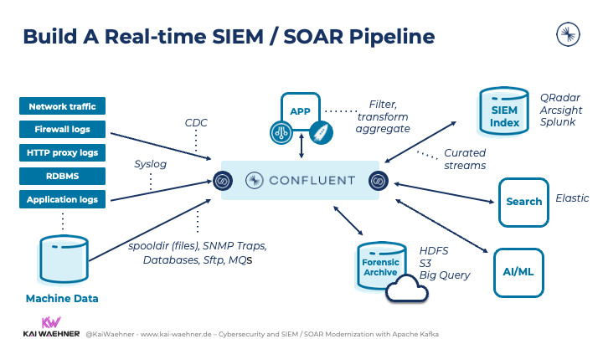

7.2 SOAR Integration
Security Orchestration, Automation, and Response (SOAR) platforms automate routine incident response tasks, reducing mean time to respond (MTTR). SOAR playbooks orchestrate responses including:
Phishing Detection: Automatically quarantine suspicious emails, block sender domains, reset compromised credentials.
- Ransomware Response: Isolate affected endpoints, initiate backup restoration procedures, initiate incident escalation.
- Lateral Movement: Block suspicious lateral connections, alert security team, initiate network isolation protocols.
SOAR integration with SIEM enables autonomous response to low-fidelity events whilst escalating sophisticated attacks to human analysts.

8. CONTINUOUS TRAINING AND AWARENESS

8.1 Phishing and Vishing Simulations
VTAM should implement continuous simulated attack programmes:
Phishing Simulations: Monthly campaigns delivering realistic phishing emails to employees. Personnel clicking links or submitting credentials receive immediate microlearning modules addressing their specific vulnerability. Results dashboard tracks improvement trends by department and role.
Vishing Simulations: Quarterly voice phishing campaigns where trained security staff call employees impersonating IT support or vendors. Scenarios test employees' authentication challenge procedures and credential verification protocols.
8.2 Role-Specific Training
Training tailored to job function and risk level:
- Finance Staff: Payment fraud recognition, invoice verification procedures, wire fraud tactics
- HR Personnel: Social engineering targeting recruitment processes, confidential information handling
- IT/Security Teams: Incident response procedures, forensic collection, threat intelligence analysis
- Executive Leadership: Risk management, board reporting, regulatory compliance
8.3 Gamification and Culture Building
Implement gamified learning platforms with competition, badges, and recognition. Monthly security awareness newsletters highlight lessons learned from incidents across the organisation. Recognise "Security Champion" employees who report phishing attempts or security gaps. Create psychological safety to report incidents without fear of punishment.

9. RECOMMENDATIONS
Based on comprehensive threat analysis and alignment with industry standards, VTAM should implement the following recommendations:
Recommendation 1: Establish Zero Trust Architecture as Organisational Standard
Adopt NIST SP 800-207 Zero Trust Architecture as the guiding principle for all security decisions. This represents a fundamental shift from perimeter-based to identity-centric security.
Recommendation 2: Implement Critical Controls Within 90 Days
Deploy MFA across all systems, activate SIEM centralised logging, and establish EDR on all endpoints within 90 days. These controls directly mitigate current threat vectors.
Recommendation 3: Establish Vulnerability Management Program Aligned with CISA KEV
Implement automated vulnerability scanning and prioritise remediation of CISA KEV-listed vulnerabilities within published timelines. Create security patches as business-critical work items.
Recommendation 4: Establish Proactive Incident Response Program
Build dedicated Security Operations Centre (SOC) capability with 24/7 coverage. Develop incident response playbooks for ransomware, phishing, and data exfiltration scenarios based on recent incidents.
Recommendation 5: Mandate Quarterly Security Awareness Training
Launch continuous phishing/vishing simulation programme. Establish mandatory incident reporting procedures with psychological safety guarantees. Link security training to performance reviews.
Recommendation 6: Conduct Third-Party Risk Assessment
Assess security postures of all critical vendors and SaaS providers. Establish service level agreements (SLAs) incorporating security incident notification and remediation requirements. Require SOC 2 Type II or ISO 27001 certification for critical providers.
Recommendation 7: Establish Regulatory Compliance Program
Align security programme with FCA and PRA expectations. Document evidence of "reasonable security controls" and incident management capabilities. Designate senior management accountability for cybersecurity governance.

10. CONCLUSION
The cybersecurity landscape continues evolving toward sophistication and targeted attacks against financial services organisations like VTAM. Recent incidents demonstrate the inadequacy of traditional perimeter security models and the necessity for modern, comprehensive defence strategies.
Implementation of a Zero Trust architecture grounded in NIST CSF, ISO 27001, CISA guidance, and NCSC recommendations will significantly enhance VTAM's resilience against contemporary threats. This framework addresses the full spectrum of security challenges—from technical controls to human factors—recognising that effective cybersecurity requires integrated approaches spanning technology, process, and people.
The recommendations outlined in this report represent achievable, prioritised steps toward a modern security posture. With board support and resourced implementation, VTAM will transform from reactive incident response to proactive threat prevention. This evolution will protect critical assets, maintain client confidence, and ensure regulatory compliance. More fundamentally, it will establish VTAM as an organisation that takes cybersecurity seriously—a competitive advantage in an industry where trust is paramount.

11. Appendixes

11.1 Cisco Packet Tracer Certificate
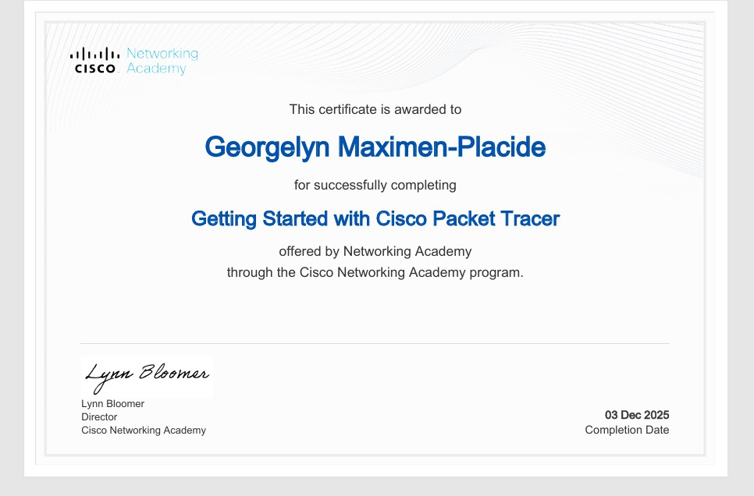

11.2 Power Point Presentation
1.
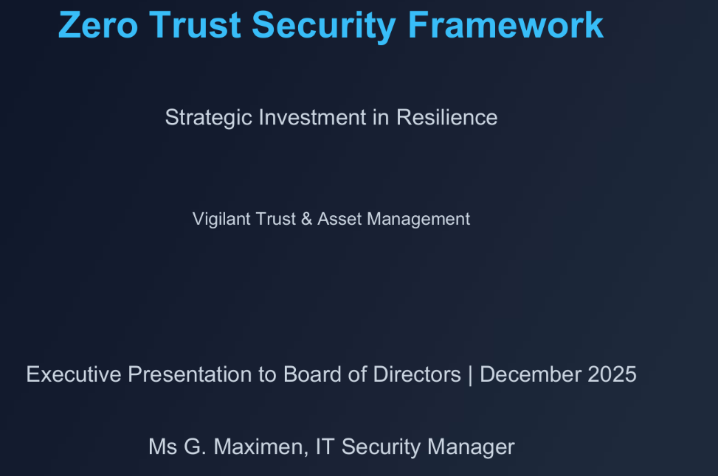
2.
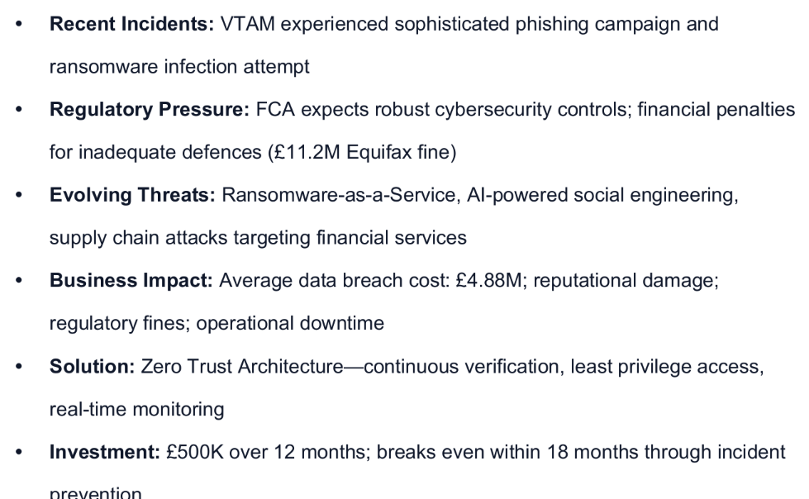

3.
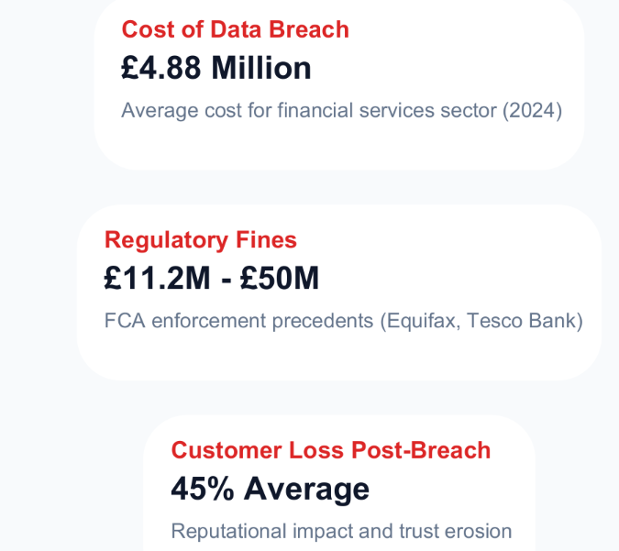
4.
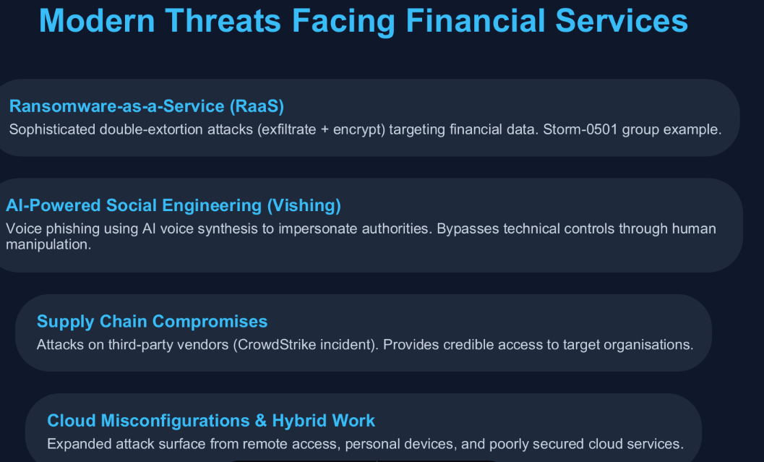

5.
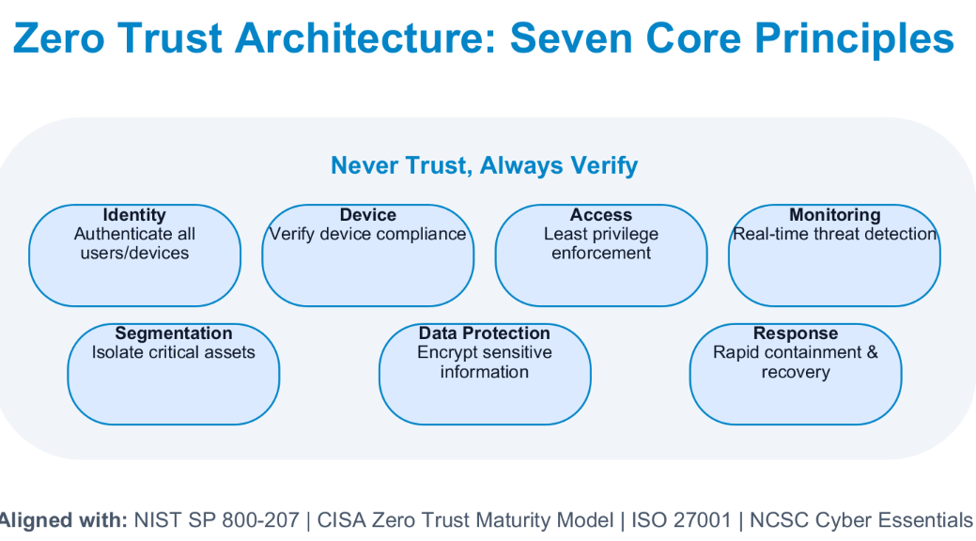
6.
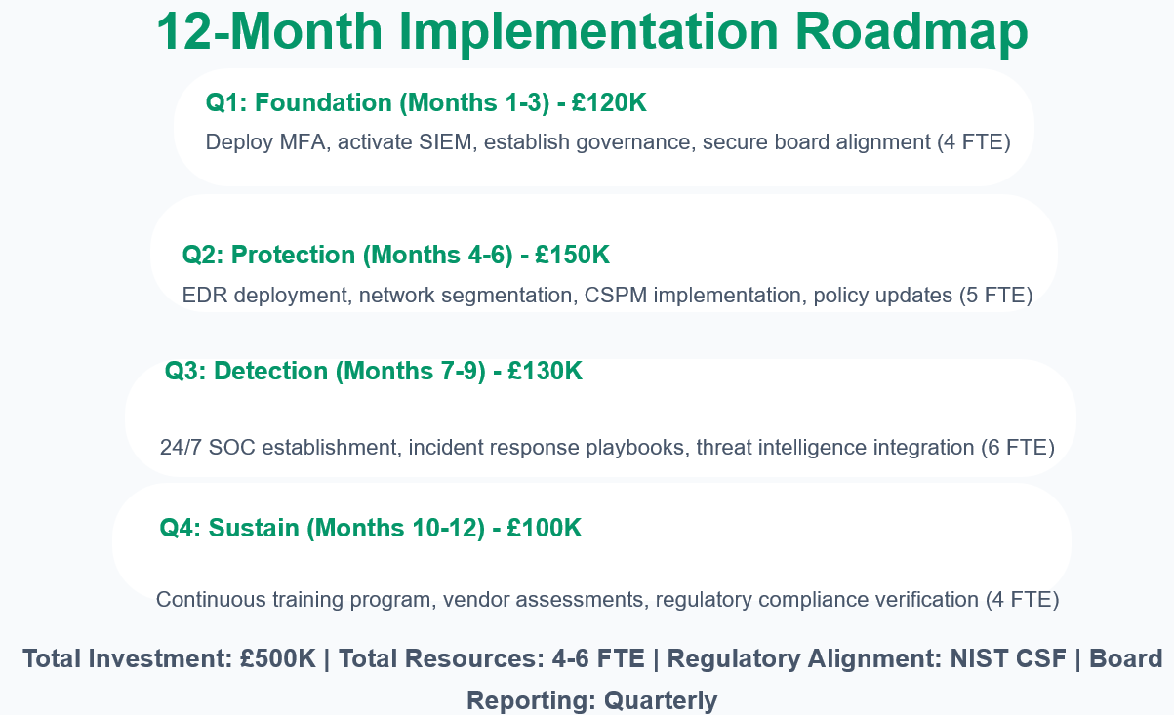

7.
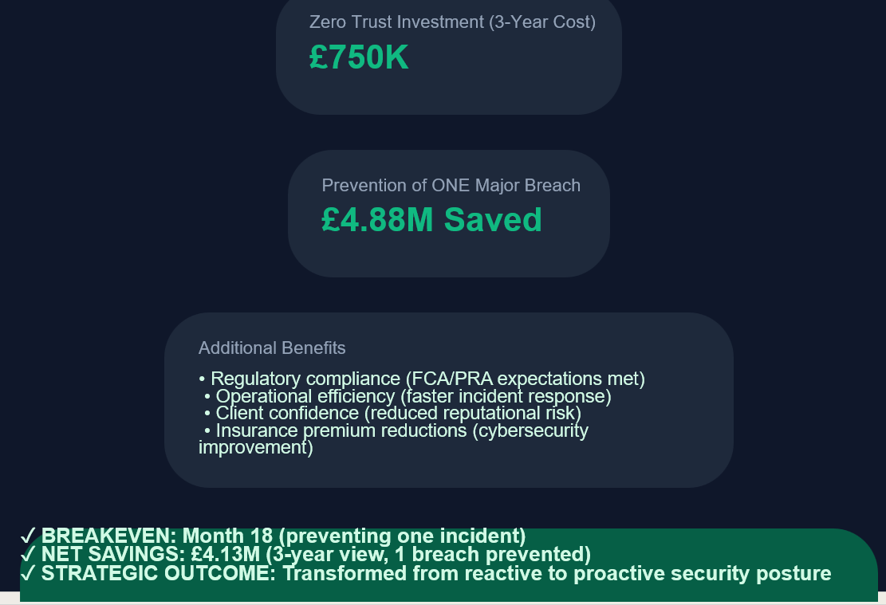
8.
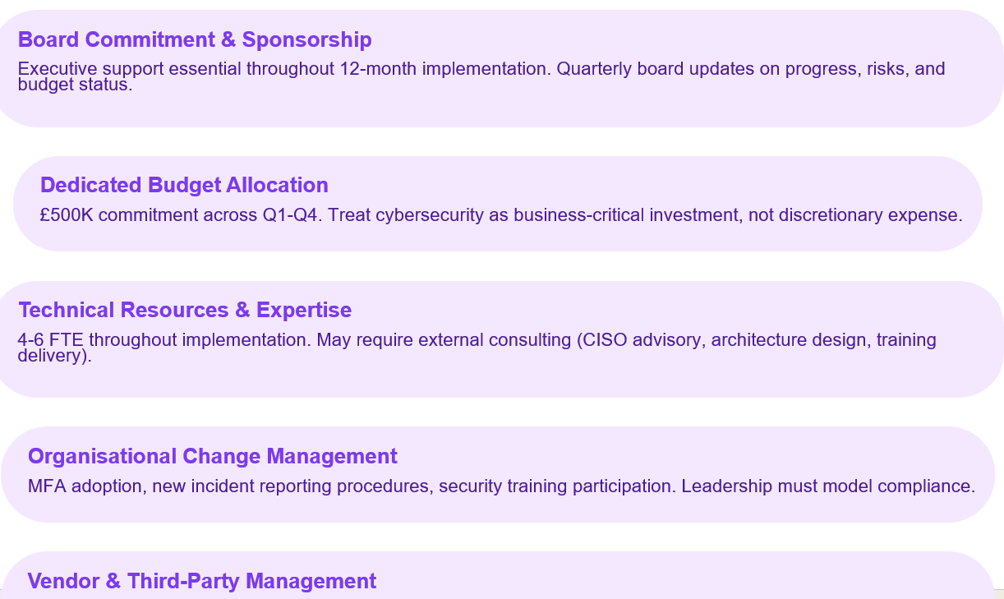

9.
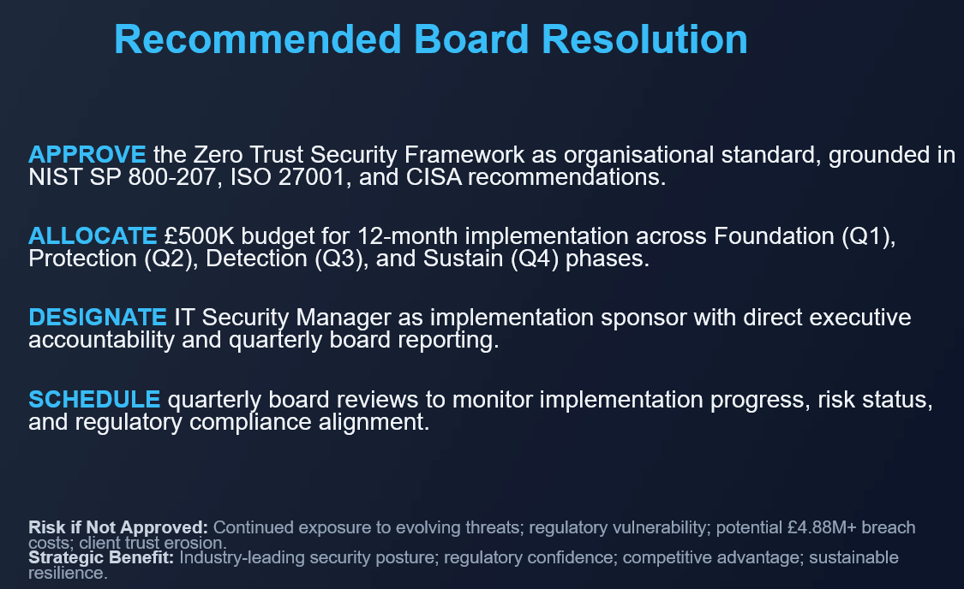

12. REFERENCES
[1] Stallings, W. (2017). Network security essentials: applications and standards (6th ed.). Pearson. p. 45-67.

[2] NIST. (2024). Implementing a Zero Trust Architecture (SP 1800-35). National Institute of Standards and Technology. Available at: https://www.nccoe.nist.gov/projects/implementing-zero-trust-architecture

[3] Financial Conduct Authority. (2024). Operational Resilience Guidance. Available at: https://www.fca.org.uk/firms/operational-resilience

[4] Kumar, G., Saini, D. K., & Cuong, N. H. H. (2021). Cyber Défense mechanisms: security, privacy, and challenges. Routledge. p. 112-145.

[5] Steinberg, J. (2022). Cybersecurity for dummies (2nd ed.). John Wiley & Sons. p. 201-230.

[6] Stewart, J. M., & Kinsey, D. (2021). Network security, firewalls, and VPNs (3rd ed.). Jones & Bartlett Learning. p. 78-110.

[7] ISO/IEC 27001:2022. Information security management systems – Requirements. International Organization for Standardization.

[8] CISA. (2025). Known Exploited Vulnerabilities Catalogue. Available at: https://www.cisecurity.org/cisa/kev

[9] NCSC. (2024). Cyber Essentials: The security controls matrix. National Cyber Security Centre.

[10] Christen, M., Gordijn, B., & Loi, M. (2020). The ethics of cybersecurity. Springer International Publishing. p. 55-89.

