
MANAGEMENT AND ORGANISATIONAL BEHAVIOUR
Student Name:Oana Nicoleta Manta
Student ID: 2124123
Module Number: BMIH5004

Introduction
The contemporary context of business demands a wide array of operations conducted by a commercial entity. A distinct management and a well-defined organisational behaviour are two important ones of those operations. This helps an organisation to achieve the ultimate goal of the company and also fosters its decision-making process (Mullins & Dosser, 2013). The ability to make appropriate decisions at appropriate times is one of the key factors for the overall growth of a company. Effectiveness and efficiency are also fostered in the overall performance of the company fostering operational excellence. A properly constructed organisational behaviour also helps the leadership of a company to understand the behavioural traits of their employees (Mullins, 2020). This improves employee engagement and also establishes a transparent relationship between the employees and the management. Hence, the following essay will analyse various leadership styles as per the Blake and Mouton Managerial Grid and also the major functions of leadership concerning Adair's Model of Action Centred Leadership. The managerial approach of Craig Poole, General Manager of DoubleTree by Hilton in Reading, Pennsylvania will be critically assessed in light of that.

Main Body
Segment 1
This segment of the essay will talk about Craig Poole's management and leadership style with reference to the Blake and Mouton Managerial Grid. However, it requires an in-depth conceptual discussion about the Blake and Mouton Managerial Grid. This is one of the most commonly followed management theories in the modern business landscape as it effectively describes the management and leadership style of managers in leading organisations. This grid was developed in the 1960s decade by Robert R. Blake and Jane S. Mouton (Robbins et al., 2008). This framework is used in various studies in the field of business management to identify the effectiveness of management and leadership styles implemented by senior figures in a company. This grid consists of a 9×9 matrix table in an x-y axis of graphical representation (refer to Appendix 1). The people concerned are plotted on the 'x' or vertical axis and the concern for production is plotted on the 'y' or horizontal axis (Arnold, 2005). There are four distinct quadrants on each side and on the cross section of the quadrants, there is another grid called the fifth grid. The four types of managerial styles placed in each quadrant are impoverished management style, country hub management style, produce-or-perish management style and team management style. The fifth grid is also denoted by a management style called middle-of-the-road management (Huczynski & Buchanan, 2013).
Impoverished management style is also called the indifferent management style which is mostly ineffective for an organisational setup. This type of management style is placed on the low people and low production grid as the involvement of people and production from this style are both less. The second type of management style according to this grid is the country hub style which is placed on the high people but low production quadrant. This suggests that the country hub management style involves a manager with high concern for their employees and their collective well-being (Buchanan And Huczynski, 2007). For this, this type of manager can also sideline the production within the company. However, this management style is considered effective for employee engagement but ineffective for the collective growth of the organisation. Produce-or-perish management style is placed on the high concern for production and low concern for people quadrant. These types of leaders do not think about anything other than achieving the maximum production target for the company. The management style placed on the fifth quadrant is middle on the road which suggests a balanced approach from managers (Bloisi et al., 2007). Managers always care for the well-being of their employees while also emphasising achieving organisational targets. The last management style is the team-leader type of management style which suggests that managers have high concern for both their employees and the production. This is the most followed type of management style in the global business scenario.
Now, the critical analysis of the management style implemented by Craig Poole will be performed here with reference to the Blake and Mouton Managerial Grid. Judging the activities of Poole in the last few years it is safe to say that the person has employed a servant managerial approach in his company DoubleTree by Hilton. The servant managerial approach can be aligned with the team management grid of the Blake and Mouton framework (Arnold, 2005). Hence, it can be safely inferred that Craig Poole has high concerns for both his employees and the production target of his company. However, the scenario is not that linear as there are some points when the managerial approach of Poole is questioned. This type of management style enabled Poole to implement a balanced approach within his organisation which is reflected in the increased organisational performance of DoubleTree by Hilton. On the other hand, there were times when time and resources appeared as constraints in this approach. These difficulties tested Poole's leadership qualities and the overall performance of DoubleTree by Hilton also dropped from its previous position. However, Craig Pool also emphasised team cohesion to manage these difficulties which provided a positive impact on the operations of the company. Hence, it is safe to say that the team-leader approach of management has provided both positive and negative impacts on the leadership qualities of Craig Poole (Armstrong, 2012). There are also other instances where a critical comparison can be drawn about the managerial approach of Craig Poole. Poole always wanted to engage his employees with the extended operations of the company which is also great for the sustainability of a commercial entity. Being a hospitality company, DoubleTree by Hilton needs a bigger sense of sustainability within its workplace to counter natural catastrophes like the Covid-19 pandemic (Boddy, 2014). The pandemic damaged the whole sector hugely and DoubleTree by Hilton was no exception. However, with Poole's potent leadership qualities and employee engagement drives, the company could construct a great fightback. However, this type of approach is not applicable when the demand is high within the market then the concern for the employees needs to be compromised by the company. This action has also drawn criticism towards Craig Poole from his employees but at that time, Poole's approach was the most appropriate for the growth of the company (Mullins, 2016).
Segment 2
The key functions of managerial leadership will be discussed in this segment of the essay. The discussion will be based on Adair's Model of Action-Centred Leadership. This is one of the most popular frameworks to discuss the managerial activities within an organisational setup. John Adair, a renowned expert in business leadership, developed this model in 1973. This model is also called the three circles model which suggests that there is a Venn diagram of three key components of the model and the common area represents organisational excellence (refer to Appendix 2). The key functions in terms of managerial leadership according to this model are task, team and individual (Adair, 2009). Task refers to the wide array of activities conducted within an organisation on a setup by the managerial team and the staff members. The task is a dimension according to this model which focuses on achieving specific objectives and collective goals within the organisation. This dimension also involves setting clear objectives, defining responsibilities and roles and setting the timelines within which the activities need to be conducted (Ellis, 2021). This is also an important job for a leader to plan the dimensions of the tasks, which activities need to be included within a particular task and assign them to the employees. This vast magnitude of activities in the task section suggests that it is one of the most important dimensions according to Adair's Model of Action Centred Leadership. Now coming to the second dimension of the model, the team, it will suggest that this segment was developed based on the importance of teamwork in an organisational setup (Ross, Koneri and Stansell, 2021). The modern workspace needs a higher magnitude of collaboration and cohesion between a group of individuals. This also fosters teamwork within an organisation which works towards a collective goal. This is also a pivotal constituent of the framework as it talks about one of the biggest aspects of the modern business context. Leaders within an organisation need to create a dynamic team with a rich sense of interconnectedness within the team members (Orukwowu, 2022). The internal bond within the team also needs to be strengthened by implementing suitable policies within the workplace. The third dimension of the model is individual which suggests that the leadership team also need to emphasise the individual strengths, needs, aspirations and unique qualities possessed by different staff members. This recognition fosters the motivation of employees which is a major factor in the sustainable growth of the company (Manyuchi, Mbohwa and Muzenda, 2020).
Now, the leadership qualities of Craig Poole in DoubleTree by Hilton will be assessed based on these three key functions. It is safe to say that the leadership qualities of Poole meet the requirements of all three dimensions of Adair's Model of Action Centred Leadership. First and foremost, the balance of leadership possessed by Craig Poole in his company fosters the quality of tasks in DoubleTree by Hilton. This also improves the customer engagement of the hotel chain as the services are smoothly provided to the customers (Daley, 2023). Poole always emphasises completing the tasks before the deadline to maintain sustainability within the workplace. However, the staff members complain that the fulfilment of tasks sometimes requires overtime from the employees which significantly hinders their work-life balance. This is a clear indication of employee discontent due to the demanding nature of Craig Poole. There comes the second dimension of Adair's Model, 'the team'. This suggests that Poole always wants to build a solid team full of competent workers for sound workplace management. The team members are empathetic towards each other which fosters the work efficiency of the team (Ackah, 2019). The company gets a huge market advantage due to that and Craig Poole's leadership traits should be appreciated for that. Craig Poole also emphasises continuous evaluation of the work done by the team members. Poole also suggests his team members self-evaluate their tasks to find out the areas for improvement. The third dimension of Adair's Model, individual qualities, can also be aligned with the leadership traits of Craig Pool. The General Manager of DoubleTree by Hilton always works on flexibility and adaptability. This allows the workers to shine on an individual level showcasing their individual qualities and unique strengths. Poole then addresses those individual strengths and uses them to foster the collective growth of the company. Poole always encourages the staff members to showcase their individual talents within a common work process for their individual growth (Rollinson et al., 2008). However, this is also criticised by some sections of the former workers of the organisation as they thought Poole practises favouritism within the organisation. In a nutshell, it can be inferred from here that Craig Poole has managed to pull off a remarkable job as the general manager of a renowned hotel chain in Reading, Pennsylvania.

Conclusion
It can be concluded from the above essay that management and organisational behaviour hold massive importance in the contemporary business landscape. The project revolves around the managerial traits of Craig Poole, the general manager of DoubleTree by Hilton Hotels in Reading, Pennsylvania. The first segment of the main discussion of the essay contains an in-depth description of Blake and Mouton's Managerial Grid and the leadership attributes of Poole were also aligned with the grid. The obtained data suggests that Poole's leadership traits can be aligned with the team-leader quadrant of the managerial grid. There is a wide array of aspects of Poole's leadership approach that are praised by the experts in this field. However, the leadership approach also has its fair share of criticisms. The second segment of the essay enunciated the three key functions of Craig Poole's management style with reference to Adair's Model of Action Centred Leadership. In a nutshell, it is obtained from the essay that management and behavioural traits of a manager regulate the market performance of a company in the modern business world.

Reference List
Ackah, D., (2019). Models of Leadership and Teamwork: Adairs Action-Centred Leadership Model (1973). Worldwide Journal of Multi-disciplinary Studies, 1(5), pp.01-06.
Adair, J. (2009) The Inspirational Leader (2nd Ed), London: Kogan Page
Armstrong, M. (2012) Armstrong’s Handbook of Management and Leadership (3rd Ed), London: Kogan Page.
Arnold, J. (2005) Work Psychology (4th edition) Harlow: Prentice Hall.
Bloisi, W. et al (2007) Management and Organisational Behaviour, (2nd edition) Maidenhead: McGraw-Hill.
Boddy, D. (2014) Management: An Introduction (6th Ed), Harlow, Pearson
Buchanan, D. And Huczynski, A. (2007) Organisational Behaviour: An Introductory Text (6th edition), Harlow: Prentice Hall.
Daley, E., (2023). Hybrid working: Is it working… and at what cost? Exploring the experience of managers in child protection: Social Work. The British Journal of Social Work, p.bcad080.
Ellis, P., (2021). Leadership approaches for modern nursing practice. British Journal of Cardiac Nursing, 16(2), pp.1-5.
Huczynski, A. & Buchanan, D. (2013) Organisational Behaviour (8th Ed), Harlow: Pearson
Manyuchi, M.M., Mbohwa, C. and Muzenda, E., (2020). Leadership in the Mining Sector: A Functional Approach for Optimum Team Performance in the Fourth Industrial Revolution. In 10th Annual International IEOM Conference, IEOM 2020 (pp. 2932-2936). IEOM Society.
Mullins, L & Dosser, P. (2013) Hospitality Management and Organisational Behaviour (5th Ed) Harlow, Pearson.
Mullins, L. (2016) Management and Organisational Behaviour (11th edition) Harlow: Pearson
Mullins, L. (2020) Organisational Behaviour in the Workplace (12th edition) Harlow:Pearson
Ngo, M.T. and Dang, X.T. (2019) Action-centered leadership model (Adair, 1968) - researchgate. Available at: https://www.researchgate.net/figure/Action-centered-Leadership-Model-Adair-1968_fig1_230734084 (Accessed: 14 October 2023).
Orukwowu, U., (2022). Nursing leadership in healthcare: the impact of effective nurse leadership on quality healthcare outcomes. IPS Interdisciplinary Journal of Social Sciences, 1(1), pp.1-6.
Prabhakaran, S. (2021). Blake-Mouton’s Managerial Grid Theory. [online] Medium. Available at: https://medium.com/the-shadow/blake-moutons-managerial-grid-theory-aa0842e771a.
Robbins, S. Et al (2008) Organizational Behaviour (5th edition) Harlow: Pearson Education Limited.
Rollinson, D. et al (2008 ) Organisational Behaviour and Analysis (4th edition) Harlow: Addison-Wesley Longman
Ross, A., Koneri, L. and Stansell, P., (2021). Experiencing teamship by escaping the leadership lecture. Nurse Leader, 19(4), pp.401-404.

Appendices

Appendix 1
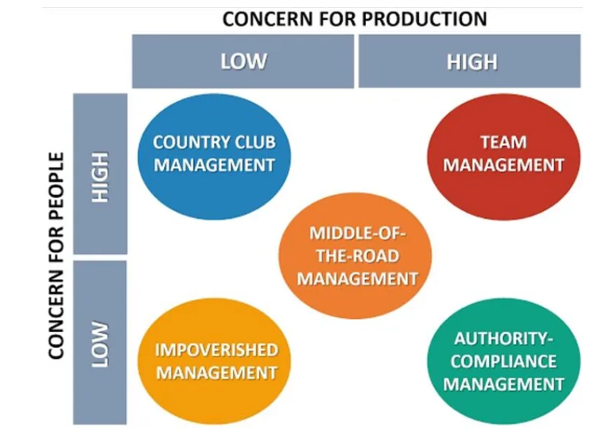
Figure 1: Blake and Mouton Managerial Grid
Source: (Prabhakaran, 2021)

Appendix 2
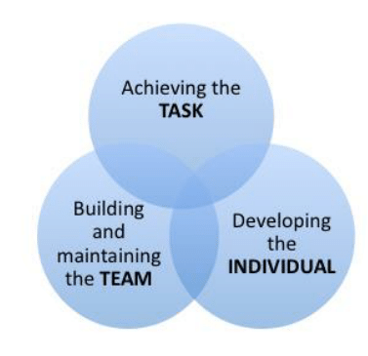
Figure 2: Adair’s Model of Action Centred Leadership
Source: (Ngo & Dang, 2019)

