Roman perceptions of the Gauls and Celts and their sources

I confirm that I have not used AI tools in research and creation of this assignment. I confirm that I have not presented any AI generated materials as my own work. I confirm that have copies of my drafts, notes, and other resources I used, which I may be asked to provide as evidence.

As Rome expanded its influence outwards from the Italian peninsula into the wider European mainland, the Roman legions and citizens alike found themselves coming into contact with new groups of people across the continent. Surviving Roman writings on these groups, particularly groups such as the Celts and the tribes of Gaul are known to have a strong negative reputation with descriptions ranging from violent, uncivilized, and intellectually inferior, compared to the authors belief in the Roman civilization built upon order and discipline. This essay will examine the Roman sources to determine whether these perceptions were valid or merely just useful forms of propaganda, and if so, why the authors may have portrayed them as such. This shall be done by contrasting them both against historical evidence and the actions, practices and customs that Romans themselves followed.

Ancient Greek scholars first began writing about the Celtic people as early as the 4th century BC. However, Roman sources about these same groups of people are mostly dated to have been written much later within the 2nd and 1st centuries BC. Unlike the Greek authors, the Roman writers were mostly men from military backgrounds who faced the Celtic peoples in active conflict. This may be the first potential reason why portrayals of Celts in the authors’ writings were so negative. One of the earliest sources from a Roman perspective comes from Julius Caesar in his collection of writings known as Commentarii de Bello Gallico, (Commentaries on the Gallic Wars) which he wrote during his time as both Governor of the Roman occupied lands of Gaul and General during the Gallic Wars. Caesar’s accounts are likely some of the more vivid in their detail and overall fair in terms of his views on the Gauls, early Germans and the wider Celtic ethnic groups across the continent and the practices they followed. This could be due to his time governing over occupied Gaul, where he would have had first hand contacted with the subjugated tribes and allied tribes working alongside the Romans. In his sixth book, Caesar makes several remarks about Gallic people and their societal structure but some of his more interesting comments are as follows.
They do not go in for agriculture, and their diet is mostly milk, cheese, and meat. Nor does anyone have a set amount of farmland or property of his own. Instead, the officials and leading men give yearly allocations of farmland to the clans and kin of whoever has come to the assembly, the quantity and location as they see fit, and the next year they make them move to another spot. They cite many reasons for this: so that people don’t change their pursuits from warfare to agriculture, prisoners of unbroken habit; so that they don’t go in for acquiring an extensive property and once they’ve become more powerful expel lesser men from their possessions; so, they don’t devote too much care to building to avoid cold and heat;
This remark is very multilayered as Caesar is subtlety reminding the reader that the Gauls are a warlike people and do not hold the same values as Romans, even when discussing unrelated such as in this case with dietary habits. This is a trend Caesar repeatedly used in his writings.
The most praiseworthy thing for communities is to devastate as much territory around themselves as possible and have it remain empty. They think it a sign of courage that their neighbors concede after being expelled from their farmland, and that no one dares to settle near them.
This quote is a more overt example of Caesar being complimentary, whilst also making the Gauls out to be a dangerous threat. Caesar also writes in a similar manner when discussing the druids, who were among the learned members of the tribes besides from the nobles and they handled all matters of the Celtic faiths. Despite showing respect to the druids, Caesar asserts the claim the druids actively participated in large scale sacrifices to their gods which also included humans being sacrificed.
The entire Gallic people is completely devoted to religion. And the reason why those afflicted by the more serious illnesses and involved in combat and danger either sacrifice human beings instead of ordinary victims or vow to do so, and get druids to officiate at such sacrifices, is that they don’t believe that the will of the immortal gods can be placated unless one human life is given for another; moreover, they have instituted official sacrifices of the same sort.
Despite Caesar’s claim, modern historical experts have debated the scale of human sacrifices the druids preformed or if any truly occurred at all. Scholars such as Lincoln argue that Roman sources certainly have spread this idea of human sacrifice and even cannibalism among the druidic orders for propaganda but there exist even older sources from Greek authors who also make similar observations. Lincoln remarks that the older Greek sources were written in a time when there was as not much conflict between the Greeks and Gauls as there would be later when the Romans encountered then, so they would not have needed to make the same claims for propagandic uses. This argument gives weight that Caesar may have been correct or at least partly as academics today still do not know a definitive answer. It could also have been possible that Caesar had written this claim based off second hand accounts without seeing it happen himself, or he could be mistaking this with other actions that Romans saw as barbaric in Gallic society.
Regardless of the validity of Caesar’s claims, the propagandic aspects of his writings were effective enough to justify his invasion of wider Gaul. Tactius, a later Roman writer also demonises the druids in his own retelling of the battle of Ynys Môn, then known as the Island of Mona, to make the Roman assault more justified.
On the shore stood the opposing army with its dense array of armed warriors, while between the ranks dashed women, in black attire like the Furies, with hair dishevelled, waving brands. All around, the Druids, lifting up their hands to heaven, and pouring forth dreadful imprecations, scared our soldiers by the unfamiliar sight, so that, as if their limbs were paralysed, they stood motionless, and exposed to wounds.
In the case of Tactius, the argument that this retelling being propaganda is twofold. The first being that Tactius himself was not present during the battle as he was supposedly just a child when the battle was fought and secondly, this is not the only time he wrote about this event. In one version Tactius makes no mention of druids even being present on the island, leading some to believe they were added in the other version, which was intended more as an exaggerated autobiography of his father-in-law.
Caesar, Tacitus and Roman writers were using this useful form of propaganda for their own ends. Around the time of the Gallic Wars starting, Caesar is mentioned to have been in significant debt. So when some native tribes began advancing on each other for new territory. Under the guise of restoring order and bringing civilization Caesar entered the conflict which saw the entirety of unoccupied Gaul fall to Roman genocide and occupation all the while Caesar’s fortunes and personal glory grew.
The modern stereotype that the Celts were small independent tribes lacking any central leadership is challenged during the Gallic Wars with the appearance of Vercingetorix, who was a noble of the Arverni tribe where he united and amassed a coalition of tribes against the Roman advance. This united front of Gauls and other Celts was almost Caesar’s undone at the battle of Alesia where Caesar believed to have surrounded Vercingetorix in a siege only to find his own forces encircled by Celtic reinforcements. The resulting battle was a Roman victory with Vercingetorix personally surrendering to Caesar where he was taken back to Roman territory before being ceremonially executed six years later. This battle was the decisive moment of the Gallic Wars and personally earned Caesar much glory and influence back in Rome. The Romans would later construct an arch of triumph commemorating the Gallic Wars with depictions of half-naked Gauls fighting Romans and other iconography.

Figure 1 Arch of Tiberius, Orange
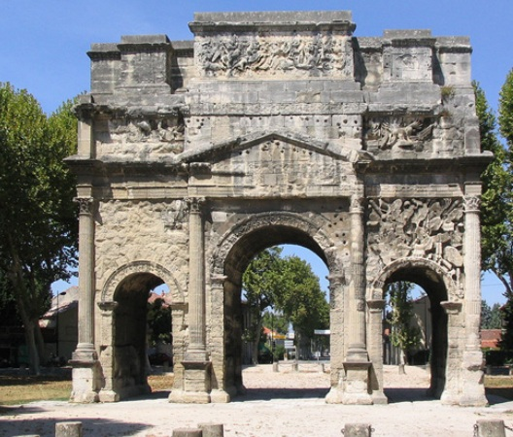
Source: Journal of the Classical Association of Victoria

Figure 2 Vercingetorix Throws Down his Arms at the Feet of Julius Caesar, interpretation painting
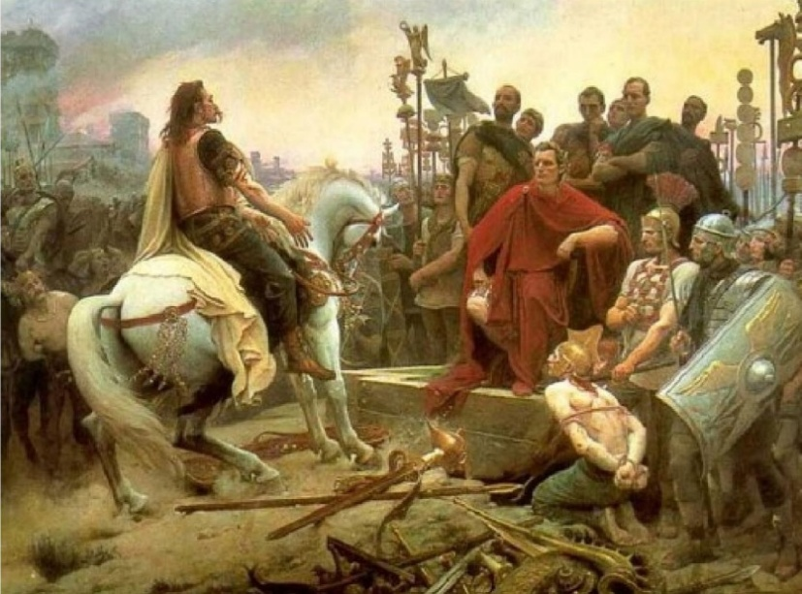
Artist Lionel Royer (1852–1926), Source: The Historian's Hut

We do not have a fair view of the Celts today, given that the only evidence we have of them is archaeological, that can not tell us the full story and sources written by their enemies. Celtic scholar Ellis, remarks that the reason we do not have primary Celtic sources was due to the religious ban forbidding druids from writing about their teachings and customs. Ellis also suggests Romans held a bitter resentment for the Celts ever since Rome itself was taken and temporarily occupied by a tribe known as the Senones in the 3rd century.
Rome’s defeat at the hands of the Senones always rankled with her historians and they frequently tried to rewrite history so as to extricate themselves from the shame of that defeat. From then on, Roman writers would paint the celts as drunken, childlike barbarians, only one step removed from animals…
Despite happening centuries before the time of Caesar, this shows that the Romans were keen on revisionism and negative stereotyping from a much earlier point.
In the Roman sources remains a clear bias against the Gauls and the wider Celtic identity where the authors have skilfully used certain aspects of the Gallic/Celtic society to weave into a for their own agendas. Whilst some of their comments are valid, the Gauls in particular were a warlike people. Authors such as Caesar used the borderline stereotypes of the Gauls to launch his own wars for personal glory and wealth under the guise of bringing civilization to the republics dangerous neighbours. With the religious ban forbidding the learned members of Celtic society from writing about their customs, these stereotypes the Romans voiced became a sole source of knowledge of an otherwise unknown group which are still believed to this day. Modern academics are more sceptical to these claims and are still actively correcting known misconceptions, but there still remains a lot we don’t know about this ethnic group to truly say what is indeed fact or useful fiction.

Image Source

Journal of the Classical Association of Victoria, p.6 https://classicsvic.wordpress.com/wp-content/uploads/2015/06/midford.pdf

The Historian’s Hut
https://thehistorianshut.com/2020/05/18/vercingetorix-throws-down-his-arms-at-the-feet-of-julius-caesar-painted-by-lionel-royer-1852-1926/

Bibliography

Caesar, Julius, Gallic War, ed. by Cynthia Damon (Loeb Classical Library, 2025)
Ellis, Peter Berresford, ‘The Origins of the Celts’, in A Brief History of the Celts (Robinson, 2003), pp. i–233
Fields, Nic, in Alesia 52 BC The Final Struggle of the Gauls (Osprey Publishing, 2014), pp. 6–82
Gilliver, K.M, Caesar’s Gallic Wars 58-50 BC, 1st edn (Routledge, 2004)
Hoffman, Birgitta, ‘Agricola vs Tacitus’, The Roman Gask Project, 2001 <https://www.theromangaskproject.org/agricola-vs-tacitus/> [accessed 1 May 2025]
Lincoln, Bruce, ‘The Druids and Human Sacrifice’, in Languages and Cultures: Studies in Honor of Edgar C. Polomé (Walter de Gruyter, 2010), pp. 381–96
Tacitus, Cornelius, ‘Cornelius Tacitus, The Annals, BOOK XIV, Chapter 30’, Archive, Perseus, n.d. <https://www.perseus.tufts.edu/hopper/text?doc=Perseus:text:1999.02.0078:book=14:chapter=30> [accessed 13 January 2026]
Taylor, Lily Ross, ‘Caesar and the Roman Nobility’, Transactions and Proceedings of the American Philological Association, (Online), 73 (1942), p. 24
Williams, J. H. C., Beyond the Rubicon: Romans and Gauls in Republican Italy (OUP Oxford, 2001)

Peter Berresford Ellis, ‘The Origins of the Celts’, in A Brief History of the Celts (Robinson, 2003), pp. i–233 (p. 1).
J. H. C. Williams, Beyond the Rubicon: Romans and Gauls in Republican Italy (OUP Oxford, 2001), p. 19.
K.M Gilliver, Caesar’s Gallic Wars 58-50 BC, 1st edn (Routledge, 2004), p. 3.
Julius Caesar, Gallic War, ed. by Cynthia Damon (Loeb Classical Library, 2025), p. 321.
Caesar, Gallic War, p. 321.
Caesar, Gallic War, p. 315.
Bruce Lincoln, ‘The Druids and Human Sacrifice’, in Languages and Cultures: Studies in Honor of Edgar C. Polomé (Walter de Gruyter, 2010), pp. 381–96 (p. 381).
Lincoln, ‘The Druids and Human Sacrifice’, p. 382.
Cornelius Tacitus, ‘Cornelius Tacitus, The Annals, BOOK XIV, Chapter 30’, Archive, Perseus, n.d. <https://www.perseus.tufts.edu/hopper/text?doc=Perseus:text:1999.02.0078:book=14:chapter=30> [accessed 13 January 2026].
Birgitta Hoffman, ‘Agricola vs Tacitus’, The Roman Gask Project, 2001 <https://www.theromangaskproject.org/agricola-vs-tacitus/> [accessed 1 May 2025].
Lily Ross Taylor, ‘Caesar and the Roman Nobility’, Transactions and Proceedings of the American Philological Association, (Online), 73 (1942), p. 24 (p. 6).
Nic Fields, in Alesia 52 BC The Final Struggle of the Gauls (Osprey Publishing, 2014), pp. 6–82.
Fields, p. 82.
Ellis, ‘The Origins of the Celts’.
Ellis, ‘The Origins of the Celts’, p. 199.

