Hotel Guest Service Operations
Student name: Slobozian Mariana
Student ID: 2128518
Module leader: Lisa Bassler

Level 6 Hotel Placement — Weekly Journal Entry
(Weekly Journals)
Week
Experiencesrrasks/Challenges/Lessons  (outline hotel department) | Shift  (Daterrime) | Student  Signature | Mentor's  Signature
Food Beverage Management  Leanling How to Reserve a Table & Guiding a Breakfast Service  Spent the day learning how to use the restaurant reservation system to book tables accurately, capturing guest details, preferences, and dietary restrictions. This experience highlighted the importance of accuracy and effective communication with guests.  • Assisted in guiding breakfast service, welcoming guests, managing seating arrangements, and coordinating with the kitchen staff for timely service.  Developed skills in customer interaction and efficient table turnover during peak breakfast hours. | 3rd October  12.00am-8.30pm  (24 hours) | 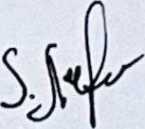 | 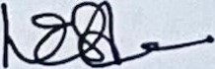  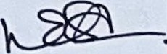
Closing the Restaurant & Preparing the Closing Report  • Assisted in the restaurant | 6th October  3.30pm-close  (24 hours)
2
closing process, which involved cleaning, resetting tables, and securing equipment for the next day's service.  Observed and helped prepare the end-of-day closing report, documenting sales data, inventory counts, staff observations, and any incidents that occurred during the shift. This task emphasised attention to detail and accountability in financial and operational reporting. |  | 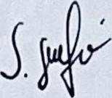 | 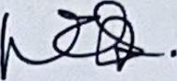  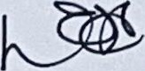
Week 2
Experiencesrrasks/Challenges/Lessons (outline hotel department) | Shift  (Daterrime) | Student  Signature | Mentor's  Signature
Food & Beverage Management  Creating a Work Schedule with the  FMB Manager  • Worked alongside the FMB manager to create a weekly work schedule for employees, balancing business needs, peak service demands, and staff availability.  Learned to address complexities such as covering shifts durin bu times | 8th October  9.30am-6.00pm  (24 hours) | 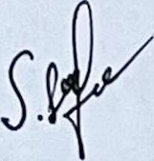 | 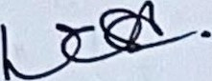
3
accommodating employee preferences and managing staff rotations. This experience developed my understanding of labour management and effective communication to maintain a motivated team. |  | 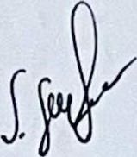 | 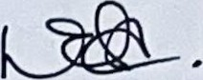
Approving Employees' Hours  Shadowed the manager in reviewing and approving employees' worked hours, ensuring all recorded shifts were accurate and in compliance with hotel policies.  Focused on the importance of fair and transparent timekeeping, addressing any discrepancies in hours worked, and maintaining accurate payroll records. This task provided insights into operational management and staff accountability. | 13th October  9.00am-5.30pm  (24 hours) | 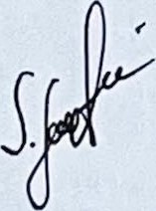  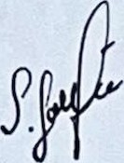 | 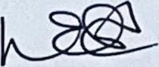  
Week 3
Experiencesrrasks/ChalIenges/Lcssons (outline hotel department) | Shift  (DateÆimc) | Student  Signature | Mentor's  Signature
4
Food & Beverage Management Taking Orders  Gained hands-on experience in taking and processing guest orders, ensuring accuracy and attention to special requests or dietary restrictions.  Communicated effectively with the kitchen and bar staff to ensure timely preparation and delivery of orders, enhancing my coordination and multitasking skills during busy service times.  Encountered challenges with a large party order, which required clear communication and efficient time management to deliver a positive guest experience. | 15th October 12.30pm-  9.00pm  (24 hours) | 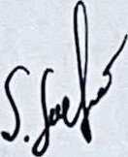  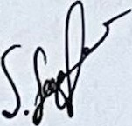  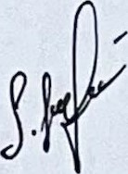 |   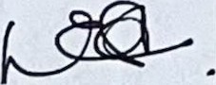  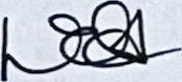
Operational Work with the Manager  Replenishing Stock & Understanding the Il-IG Program for  Employers  • Worked alongside the manager to replenish stock, including glasses, mugs, and other essential items for FMB operations. Conducted inventory checks, placed orders as needed and ensured | 17th October  2.00pm-  10.30pm  (24 hours) | 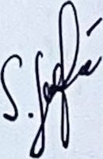 | 
5
that all supplies were in good condition and ready for use.  Learned about the IHG program for employees, focusing on its benefits, and rewards, and how it contributes to staff motivation and engagement. Gained an understanding of how employee programs can foster loyalty, enhance service standards, and align with brand goals.  • This day offered practical insights into maintaining operational readiness and engaging employees through recognition programs. |  | 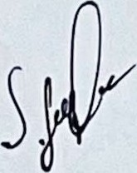 | 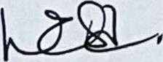  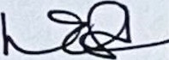
 | Week 4
Experiencesrrasks/ChalIenges/Lessons (outline hotel department) | Shift  (Daterrime) | Student  Signature | Mentor's  Signature
Housekeeping/Maintenance:  Room Inspections with the  Supervisor  Observed room preparation standards, assisted with room inspections, and interacted with the maintenance team. Challenges: Knowledge of the detailed inspection values rapidly. | 23rd October  8.30am— 4.30pm  (24 hours) | 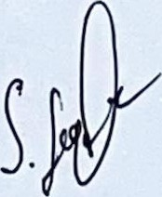 | 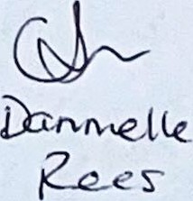
6
• Lessons Learned: Increased insight into the significance of cleanliness and association between sections.
Attending the Manager Towels  • | a Children's Event with  Housekeeper and Assistant  - Creating Oregano from  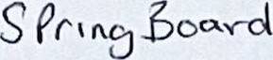  Participated in a special event dedicated to children, organised by the hotel.  Assisted in teaching children how to create oregano shapes and other designs from towels, focusing on making the experience ftln and engaging. This activity highlighted the importance of creativity, guest engagement, and attention to detail in hospitality events.  I gained insights into managing events for young guests, balancing entertainment and safety, and promoting positive interactions that enhance guest satisfaction. | 24th October  8.30am— 4.30pm  (24 hours) | 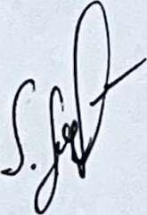 | 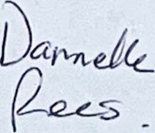
Week 5
Experiencesrrasks/Challenges/Lessons |  | Shift | Student | Mentor's
7
(outline hotel department) |  | (Date/Time) | Signature | Signature
Registering the  • | Housekeeping/Maintenance:  Linen and Rejections in  Operational System  Shadowed the housekeeping manager to observe and participate in the process of registering linen and identifying rejected items in the hotel's operational system.  I leamt the importance of quality control, documentation, and maintaining accurate inventory records for efficient linen management. This task demonstrated the critical role of digital systems in operational efficiency and resource tracking. | 25th October  8.30am— 4.30pm  (24 hours) | 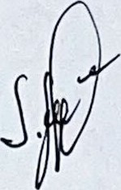 | 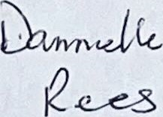
Room Inspections with the  Supervisor  • Assisted the supervisor in inspecting guest rooms to ensure compliance with the hotel's cleanliness and presentation standards.  Focused on identifying maintenance issues, noting an deviations from |  | 5⁰¹ November  8.30am— 4.30pm  (24 hours) | 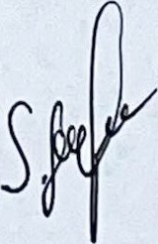 | 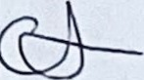  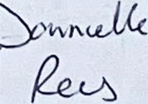
8
housekeeping protocols, and ensuring rooms were guestready. I gained a deeper understanding of the importance of consistency, thoroughness, and communication in housekeeping operations.
 | Week 6
Experiences/Tasks/Challenges/Lessons (outline hotel department) | Shift  (Date/Time) | Student  Signature | Mentor's  Signature
Housekeeping/Maintenance:  Room Checks with the Supervisor  Conducted detailed room checks alongside the housekeeping supervisor, verifying that rooms met all cleanliness, organisation, and aesthetic standards required by the hotel.  Addressed any guest feedback or specific requests, documenting corrective actions and collaborating with maintenance or other departments as necessary. This task reinforced attention to detail, teamwork, and commitment to guest satisfaction. | 6th November  8.30am— 4.30pm  (24 hours) | 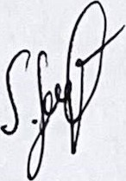 | 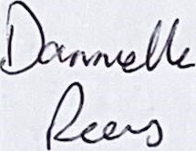
9
Allocating Rooms for Housekeeping  Staff  Assisted in the daily allocation of rooms and tasks for housekeeping staff, prioritising room tumovers, check-outs, and any special guest requests.  Learnt to optimise staff workflow, enhance operational efficiency, and adapt to changing guest needs or unexpected challenges. This task emphasised effective communication, strategic planning, and leadership in coordinating housekeeping operations. | 7th November  8.30am— 4.30pm  (24 hours) | 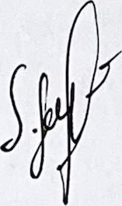 | 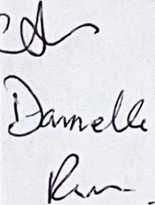
10



