Evaluating the available cross-border digital payment systems in the UK and their impact on the customer experience online selling platforms.

NAME: JINALBEN RAMESHBHAI GUJRATI (2212012)



Module Title: | Dissertation
Module Code: | LCMB7020
Course: | MASTER OF BUSINESS ADMINISTRATION
Dissertation Topic: | Evaluating the available cross-border digital payment systems in the UK and their impact on the customer experience online selling platforms.
Lecturer: Dr Jaya Gopalkrishnan

Master’s Degrees by Examination and Dissertation
Declaration Form.
1. This work has not previously been accepted in substance for any degree and is not being concurrently submitted in candidature for any degree.
Signed: Jinalben Gujrati
Date: 19-10-2023
2. This dissertation is being submitted in partial fulfilment of the requirements for the degree of Master in Business Administration.
Signed: Jinalben Gujrati
Date: 19-10-2023
3. This dissertation is the result of my own independent work/investigation, except where otherwise stated.
Other sources are acknowledged by footnotes giving explicit references.
A bibliography is appended.
Signed candidate: Jinalben Gujrati
Date: 19-10-2023

4. I at this moment give consent for my dissertation, if accepted, to be available for photocopying, inter- library loan, and for deposit in the University’s digital repository
Signed (candidate): Jinalben Gujrati
Date: 19-10-2022
Supervisor’s Declaration.
I am satisfied that this work results from the student’s efforts.
Signed: Dr Jaya Gopalkrishnan
Date:19/10/23
University of Wales: Trinity Saint David
E-Thesis Deposit Agreement

Details of the Work
I would like to deposit the following item in the digital repository maintained by the University, and/or in any other repository authorized for use by the University:

Title: Evaluating the available cross-border digital payment systems in the UK and its impact on the customer experience online selling platforms.
This item is a product of my own research endeavors and is covered by the agreement below in which the item is referred to as “the Work”. It is identical in content to that deposited in the Learning Resources Centre, subject to point 4 below.
I agree that the University of Wales: Trinity Saint David may electronically store, copy or translate the Work to any approved medium or format for the purpose of future preservation and accessibility. The University is not under any obligation to reproduce or display the Work in the same formats or resolutions in which it was originally deposited.
UW: TSD Digital Repository
I understand that work deposited in the digital repository will be accessible to a wide variety of people and institutions, including automated agents and search engines via the World Wide Web.
I understand that once the Work is deposited, the item and its metadata may be incorporated into public access catalogues or services, such as national databases of electronic theses.
I agree as follows:
- That I am the author or have the authority of the author/s to make this agreement and do hereby give the University of Wales: Trinity Saint David the right to make available the Work in the way described above.
- That the electronic copy of the Work deposited in the digital repository and covered by this agreement, is identical in content to the paper copy of the Work.
- That I have exercised reasonable care to ensure that the Work is original, and to the best of my knowledge, does not breach any laws including those relating to defamation, libel and copyright.
- That I have, in instances where the intellectual property of other authors or copyright holders is included in the Work, gained explicit permission for the inclusion of that material in the Work, and in the electronic form of the Work as accessed through the open access digital repository, or that I have identified and removed that material for which adequate permission has not been obtained and which will be inaccessible via the digital repository
- That University of Wales: Trinity Saint David does not hold any obligation to take legal action on behalf of the Depositor, or other rights holders, in the event of a breach of intellectual property rights, or any other right, in the material deposited.
- That I undertake to indemnify the University of Wales: Trinity Saint David against all actions, suits, proceedings, claims, demands and costs occasioned by the University in consequence of any breach of this agreement

Signature: Jinalben Gujrati
Date: 19-10-2023

Acknowledgement
I am extremely grateful to my research supervisor for guiding me through the research project. ‎I like to thank my parents and friends to encourage me to give my best.‎

Abstract:
This study aimed to assess the present cross-border payment systems in the United ‎Kingdom along with their impact on the buyers’ online shopping experience. The research ‎project applied interpretivism philosophy and the inductive approach with the goal of comprehending and evaluating the current cross-border payment systems in the United Kingdom ‎and their impact on consumers' online buying experiences. This study employs a qualitative ‎approach to gather relevant description information. Additionally, a cross-sectional research ‎strategy was adopted in this study. Secondary data collection is the method of data ‎collection employed in this study. Thematic analysis was chosen as the data analysis ‎technique for this study. It is explored that the key benefits of cross-border digital payment ‎systems in international e-commerce transactions are increasing revenue and sales ‎overseas, personalized buyer experience, helping gaining the competitive advantage, quick ‎transactions, offers competitive exchange rate, as well as prioritization of fraud prevention. ‎The key challenges linked to international digital payment system in e-commerce are ‎complex compliance check risks, risk of fraud, and fluctuating currency exchange rates. The ‎available diverse cross-border payment system for customers in the UK to carry out ‎international e-commerce are PayPal, Apple Pay, and credit card. These are easily ‎accessible as well as have better customer support mechanism. The overall impact of the ‎global payment system on the diverse segments of buyers are that the interface of these ‎payment system helps in enhancing the buying experience of buyers, help buyers to choose ‎appropriate shopping platforms, ensure speedy payment, ensure convenience, as well as ‎payment with low transaction fees and exchange rate. There are both positive and negative ‎influence of cross-border digital payment system on the purchasing experience of UK-based ‎buyers on international electronic-commerce platforms. The positive buying experience is ‎gained through hassle-free conversion of currency, wide range of products can be accessed ‎as well as high security and transparency in payment. The negative buying experience is ‎experienced due to the payment failure, hidden charges or fees, delay in payment and ‎technical issues. The recommendations are to improve the payment security against any ‎fraud by using advanced encryptions and authentic verification process, to encourage more ‎transparency in the terms and conditions because there are various cross-border payment ‎systems in the market that charges hidden fees which affect the customer purchasing ‎experience negatively, add feature that updates about the currency exchange rates or easy ‎currency conversion system and improve the interface of cross-border payment systems to ‎give better user experience.‎
Table of Contents
Chapter 01: Introduction 12
1.1 Research background 12
1.2 Problem statement 13
1.3 The rationale for the study 14
1.4 Aims and objectives 15
1.5 Research questions 16
1.6 Structure of the study 16
2.0 Literature Review 17
2.1 Chapter Introduction 17
2.2 What are cross border digital payment systems? 17
2.3 Features and benefits of cross border digital payment systems 19
2.4 Challenges associated with cross-border payment systems 21
2.5 Integration of cross border digital payment system in e-commerce 24
2.6 Impact of cross border digital payment system on customer experience 26
2.7 Literature gaps 27
2.8 Conceptual Framework 28
2.9 Chapter Summary 29
Chapter 03: Methodology 30
3.1 Chapter Introduction 30
Figure: Research Onion (Saunders et al., 2019) 30
3.2 Research Philosophy 31
3.3 Research strategy 31
3.4 Research approach 32
3.5 Research Design 33
3.6 Method of data collection 33
3.7 Selection criteria 36
3.8 Method of data analysis 36
3.9 Ethical Considerations 37
3.10 Chapter Summary 38
Chapter 04: Analysis 39
4.1 Chapter Introduction 39
4.2 Theme 1: Features of cross-border payment systems used by global e-commerce merchants 42
4.2.1 Sub theme 1: Benefits of using cross border digital payment systems in global e-commerce transactions 44
4.2.2 Sub theme 2: Challenges associated with using cross-border digital payment systems in global e-commerce 45
4.3 Theme 2: Impact of cross border payment systems on consumer preferences in e-commerce 47
4.3.1 Sub theme 1: Availability of different cross-border payment systems for UK customers in international e-commerce 49
4.3.2 Sub theme 2: Influence of global payment systems on different customer segments 50
4.4 Theme 3: Impact of cross border payment on consumer shopping behavior 51
4.4.1 Sub theme 1: Impact of cross border payment systems in the UK on the shopping preferences of customers 52
4.4.2 Sub theme 2: Effect of cross Cross-border digital payment systems in the UK on the shopping experience of the customers on international online selling platforms 53
4.5 Chapter Summary 54
Chapter 05: Discussion 56
5.1 Chapter Introduction 56
5.2 Features, benefits and challenges of cross border payment systems in global e-commerce. 56
5.3 Impact of Cross-Border Payment Systems on Consumer Preferences in E-Commerce 58
5.4 Impact of Cross-Border Payment on Consumer Shopping Behavior 59
5.5 Chapter Summary 60
Chapter 06: Conclusion and Recommendations 61
6.1 Conclusion 61
6.2 Linking with the objectives 62
6.2.1 Objective - 1 - To find the overall effectiveness of the cross-border digital payment systems that are available in the United Kingdom 62
6.2.2 Objective - 2 - To determine the key challenges and benefits linked to the cross-border digital payment systems 62
6.2.3 Objective - 3 - To analyse the overall impact of the cross-border digital payment systems on the e-commerce’s buyer experience in the United Kingdom 63
6.2.4 Objective - 4 - To offer the recommendations to the companies into e-commerce on the integration and elimination of the diverse challenges associated to the cross-border digital payment systems 63
6.3 Recommendations 63
6.4 Limitations of the Study 64
6.5 Future Scope of the Study 64
References 66
Appendices 01: 71
Coding table 71
Appendices 02: Survey Results 74

Chapter 01: Introduction

1.1 Research background
International payments have long been an important enabler for cross-border trade and investment, which are extremely necessary for the global economy. In international trade, some of the key requirements include a ubiquitous network of trusted parties, essential regulatory bodies and technical infrastructure spanning the globe, which has made banks the natural owner of cross-border trade and markets (Zhu et al, 2022). Because of this international payment and parcel delivery infrastructure and platform, global e-commerce has become more popular with customers purchasing products and services online regardless of the country they reside in (Gomez-Herrera et al.,2014). With global economies becoming more connected following technological advancement and the internet available, there is an increasing demand for a secure, fast and efficient cross-border digital payment system. Cross-border electronic Commerce heavily relies on certain technological platforms for online transactions connecting international customers with production services (Cardona et al, 2015). In the UK e-commerce sector, multiple companies such as Amazon, eBay, Marks & Spencer, Tesco offers cross-border payment system option allowing customers to purchase products from a foreign country. The same is also evident for numerous international e-commerce companies such as Alibaba and Wish which are continuously used by UK consumers to purchase Chinese goods online and get it delivered to the UK (Jílková & Králová, 2019). These e-commerce companies offer B2B, B2C and C2C services to the customers allowing them to purchase and sell online goods and services safely because of their dedicated and effective cross-border payment system(Hu and Luo, 2018). There are numerous financial institutions and banks in the UK that offers cross-border payments, which are mainly categorized into wholesale cross-border payment and retail cross-border payments. Bank of England has the statutory responsibility to oversee these payment systems such as the Clearing House Automatic Payment System (CHAPS) RTGS system and Bankers Automated Clearing Service (BACS) system. Because of this facility, UK retail customers are able to have a satisfying shopping experience online where we are able to purchase and sell retail goods and services to other clients and customers across borders without worrying about challenges such as foreign exchange rates, conversion process and safety and privacy issues while enjoying the benefits of reaching large customer base and market and diversifying their income (Rep, 2018). However, it is also necessary to identify and consider the potential challenges associated with cross-border payment systems during e-commerce transactions as they may contain high cost, transparency and liquidity challenges where global banks interact with local banks and and delays in payment, which can greatly affect the overall customer experience (Bruno & Shin, 2015). Therefore, research needs to be conducted to analyses the impact of cross-border digital payment systems and their effect on customer online retail experience for better comprehension and inform the decision making.
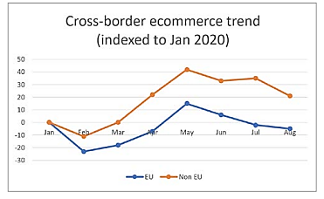
Figure - 1 - Cross-border e-commerce trend
Source - Rupay, 2021.‎
Above graph is showing the sales of European Union and non-European Union presenting the ‎cross-border e-commerce trend from January 2020 to August 2020. The pattern of sales found ‎to be similar but the non-European Union has high e-commerce compared to EU from February ‎‎2020 to August 2020 (Rupay, 2021).‎

1.2 Problem statement
The UK is the second-largest economy in Europe and the third-largest e-commerce market in the world with a market evaluation of over $239 billion. According to the research by Johnson (2023) 89% of customers purchase a retail product through their mobile device at least once a month and 43% do it every week. Mobile commerce and e-commerce are continuously going in the UK and are expected to grow twice the rate as the global E-commerce market. Some of the most common e-commerce goods which are purchased by UK customers include clothing and accessories, groceries, utilities, restaurant take out, home interior goods, media, beauty products, etc. (Johnson, 2023). In order to make these e-commerce payments debit cards and ATM cards have been used the highest followed by PayPal, credit card, Apple Pay and other payment interfaces. All of these payment methods offer cross-border and international payment options allowing customers easily purchase goods and services online regardless of the country they originate from.
However, UK consumers have been facing numerous challenges associated with cross-border payment systems, which mainly include fraudulent transactions, high handling charges, ineffective authentication and support, poor user experience and compliance hurdles (Wilson, 2023). All of these issues tend to repel the consumers in the UK to utilize cross-border payment systems and purchase international goods and services from e-commerce sites (Cardona et al, 2015). Apart from that, there is also a problem of delay in the transaction where the local transactions are verified in less time, cross border payment transactions tend to take a lot of time because of numerous compliances, thus affecting the overall delivery timing of the goods and services. There is currently incomplete and imperfect cross border payment system across market including UK conversion cost, lack of control mechanism, etc (Hu and Luo, 2018) Considering the challenges, it is important to identify whether UK consumers are satisfied with their online shopping experience while using cross-border payment systems for international purchases and sales (Rep, 2018). This would allow the e-commerce companies in the UK and abroad to understand the potential benefits of using cross-border payment systems in the UK and whether it will be feasible for them to invest in the same. Currently, there is little information available on the effectiveness of existing cross-border digital payment systems in the UK and their satisfaction level to the e-commerce customers.

1.3 The rationale for the study
Domestic payment is getting more and more convenient, fast and available 24/7. But the case of cross border payments, shortcomings continue to remain. Limited access to payments is still a major concern in some emerging market and developing economies (Bench and Hancock,2020). As identified above, there are numerous challenges associated with cross-border payment systems including transaction delays, complex processing due to compliance checks, high processing fees and increased security risks (Digiacomo et al, 2018). However, the UK commerce market is also growing continuously and because of technological advancement and the growing relationship of the UK with international economies, there is a significant opportunity for the industry to achieve extensive expansion in the following years (Johnson, 2023). Similarly, the last few years have also witnessed an increase in the international mobility of goods, people and capital, which has also escalated the importance of cross-border payment systems. The overall value of cross border payment system is expected to increase to $250 trillion by 2027 and increase by $100 trillion in just 10 years. Some of the main reasons behind this increment of cross-border payment systems both in the UK and across the world include manufacturers expanding their supply chain internationally, the growing popularity of international trade and e-commerce, migrant workers sending money to home countries through International remittance and cross-border asset management and global investment flows (Wilson, 2023). However, any new technology, which begins to be utilized by a large section of customers tends to have a certain level of distrust until it becomes prominent.
As of now, cross-border payments have been utilized in the UK for remittance purposes, but now the use of cross-border payments in e-commerce transactions is continuously growing and a large customer segment is still skeptical about its efficiency. Therefore, the findings of the current study will be highly beneficial for UK and international e-commerce businesses where they will understand the potential benefits and challenges associated with the integration of an international payment system and begin delivering retail goods and products to the customers internationally (Digiacomo et al, 2018). Certainly, it is going to take a lot of investment because they will require to expand their supply chain and distribution network to different international markets including the UK which will be both costly and time-consuming along with facing other hurdles such as regulatory compliance (Chang et al.,2020). And they can only pursue the cross-border e-commerce and payment system if they have sufficient evidence regarding its benefits and potential experience of the customers, which can be acquired through this study.

1.4 Aims and objectives
The main aim of the dissertation is to understand and evaluate the current cross-border payment system in the UK and its impact on the online shopping experience of customers.
Objectives
- To identify the effectiveness of available cross-border digital payment systems in the UK
- To determine the benefits and challenges associated with cross-border payment systems
- To analyses the impact of cross-border digital payment system on UK e-commerce customer experience
- To provide recommendations to the e-commerce companies on integration and elimination of cross-border payment system challenges

1.5 Research questions
- How effective is the current cross-border digital payment system in the UK?
- What is the overall online shopping experience of UK customers through cross-border digital payment systems?
- What are the benefits and disadvantages of a cross-border payment system? (Taskin, 2022)
- How to overcome the challenges associated with cross-border digital payment systems to support international commerce?

1.6 Structure of the study
- Introduction: In this section, the context of the dissertation will be provided by conducting the research background and identifying the problem statement. Justification for the research and aims and objectives will also be set.
- Literature review: The literature review will focus on collecting and analyzing information from previous studies, specifically peer-reviewed journal articles related to the available cross-model digital payment systems, their features and benefits along with the potential challenges of the same when used in online selling platforms (Taskin ,2022).
- Research Methodology: This section will evaluate and interpret the research approach that will be followed in the dissertation paper. This involves identifying the right strategy, philosophy, design, data collection method and analysis technique along with their proper justification in the paper (Setia,2016). This involves identifying the right strategy, philosophy, design, data collection method and analysis technique along with their proper justification in the paper.
- Data analysis: In the data analysis section, thematic analysis will be performed on the collected information to identify relevant themes and patterns across the data which can be used to answer the research questions (Hakansson, 2013).
- Findings and discussion: Based on the analysis, findings will be evaluated and discussed to determine the potential impact of cross-border digital payment systems available in the UK on customers' shopping experience online.
- Conclusion and recommendation: This is the final section of the dissertation where the report will be concluded by summarizing the findings and linking them with the research objectives. Apart from that, recommendations will also be provided to the e-commerce businesses on improving the influence of international digital payment systems to promote customer shopping behavior.

2.0 Literature Review

2.1 Chapter Introduction
Globalization has been reshaped by e-commerce in today's interconnected world. The cross-border digital payment systems that have revolutionized online shopping are at the center of this transformation (Brunnermeier et al., 2019). An examination of the impact of cross-border digital payment systems on consumer online shopping behavior is presented in this literature review that explores the role of cross-border digital payment systems in facilitating e-commerce. Over the last decade, the demand for fast and effective cross border payment has grown drastically in the international market and ecommerce (Auer & Boehme, 2020). In this section, a literature analysis will be performed on cross-border digital payment systems and their effect on customer experience using online platforms for transactions. To conduct the same, a comprehensive review of past studies related to a similar topic will be performed to identify the existing understanding of the effect of cross-border digital payment systems (Saetang, 2023). Using this literature analysis, a foundation for the dissertation can be set that will help in critically understanding the available cross-border digital payment systems along with their features, benefits and challenges so that further research can be conducted on how it affects consumer experience during online transactions. The literature review will also help in determining the current limitations and boundaries of the research subject and overcome them by conducting a completely new study.

2.2 What are cross border digital payment systems?
Digitization in payment system has greatly reshaped the financial systems’ landscape across the world, especially with the introduction of cross border digital currencies (Maryaningsih et al., 2022). According to the Bank of England, cross-border payments refer to financial transactions between two parties who are based in different countries. Cross-border payments include both retail and wholesale payments along with remittances and cross-border digital payment systems are the platforms which are used for conducting these transactions that allow businesses, institutions and individuals to make electronic financial transactions across international borders (Saetang, 2023). These digital payment systems utilize Technology for facilitating the exchange of money, goods and services between different parties from different parts of the world and play a very significant role in global trade by reducing the complexities and friction related to traditional cross-border payments (Bank of England, 2023). Another article on LinkedIn describes cross-border payments as extremely essential for individuals and businesses who are operating in global markets and wants to diversify their revenue streams. Individuals use the digital payment system for supporting their friends and families abroad by sending remittance money (Linkedin, 2023).
In today's digital age, the cross-border digital payment system has revolutionized the financial service where earlier it was very difficult to access bank account information easily and make financial transactions instantaneously as compared to now (Johnson, 2023). The foundation of contemporary e-commerce is cross-border digital payment infrastructure. ‎They are crucial in overcoming the difficulties and expenses involved in obtaining cash ‎payments for online purchases. Essentially, e-payments make e-commerce both practicable and ‎feasible. The contrast between nations with a large reliance on cash-on-delivery (COD) ‎payment systems and those with a strong digital payment infrastructure is one dramatic ‎illustration of this transition (Zhu et al, 2022). For instance, in regions of South Asia where ‎COD is common, the absence of customers during delivery frequently results in botched ‎deliveries, increasing labour and logistics costs. Logistics payment has always been a major challenges in cross border trade, especially in ecommerce because of complexities associated across nations (Giuffrida et al., 2017). In contrast, in nations such as India, the ‎development of digital payment solutions, as shown by sites such as Paytm Mall, has reduced ‎COD usage to fewer than 1% of all orders. This move has resulted in little wastage on missed ‎deliveries, demonstrating the cost-saving potential of e-payments.‎
With the evolution of the fast-paced internet, the growth in e-commerce was evident when individuals begin to purchase goods and services online for which a reliable, fast and convenient digital payment system was needed (Taskin, 2022). By leveraging different payment interfaces such as credit cards, debit cards, net banking, NEFT, IMPS, etc. However, it was very difficult for global e-commerce companies to receive payments from customers across countries as they have their own payment interfaces (Saetang, 2023). The digital payment system could not be compatible with making financial transactions across borders because of different banking regulations followed by the countries, which led to the emergence of cross-border digital payment systems.
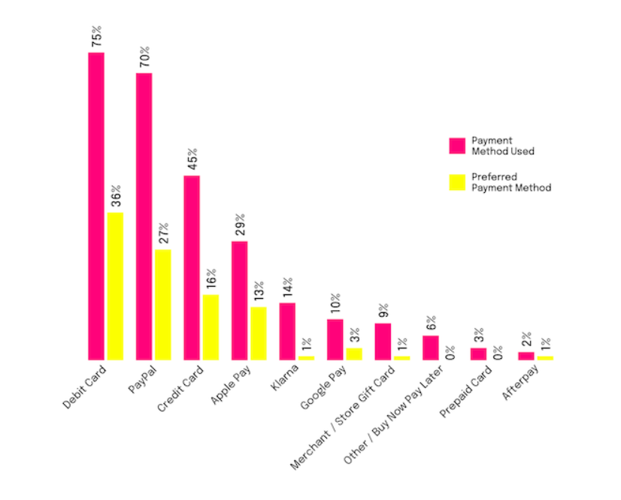
Figure - 2 - Online payment method used in the United Kingdom
Source - Rapyd, 2023‎
Above graph is showing that 75 per cent of the United Kingdom’s respondents stated that they ‎are using online debit card and 70 per cent are using PayPal. The most preferred payment ‎method in the United Kingdom are debit card (29 per cent) and PayPal (27 per cent) (Rapyd, ‎‎2023).‎

2.3 Features and benefits of cross border digital payment systems
Some of the key features of cross-border digital payment systems are the high speed of financial transactions as compared to traditional cross-border payments that involved multiple intermediaries along with cost efficiency (Bech et al., 2020). Cross-border transactions can incur high transaction fees due to intermediate recharge and currency conversion but it is not the case with digital payment systems that perform currency conversion in real-time regardless of the preferred currency making it less costly (Taskin, 2022). There is also high accessibility of these digital payment systems where anyone can access it through online and mobile applications providing more convenience to the users regardless of their location. Cross-border digital payment systems also consist of strong authentication and encryption measures which increases the security of the financial transaction and personal information of the user. One of the best features of digital payment systems across borders is that they can be integrated with other services easily and also offer services such as bill payments, peer-to-peer transfer and payment on E-Commerce platforms (Saetang, 2023). Some of the best examples of cross-border digital payment systems include PayPal, Payoneer, TransferWise, Steller, Skrill, etc. that has revolutionized cross border transactions throughout the world making it more transparent, effective and cost-efficient.
Cross-border digital payment systems play a very significant role in global commerce and trade where they facilitate international trade by offering a seamless and efficient platform for exchanging funds and settling transactions between parties of different countries. This encourages businesses to expand internationally and promote economic growth (Taskin, 2022). One of the major benefits of cross-border digital payment systems is that it promotes financial inclusion among people living in underbanked and remote areas who are excluded from the traditional banking system (Pymnts, 2021). Digital payments system can increase their inclusion in the global economy by making transactions and receiving payments easily. Similarly, the systems also support the growth of the e-commerce industry where customers are able to purchase goods and services from international vendors safely and easily. In this globalized economy, migrant workers working in international countries also benefit significantly from these cross-border digital payment systems for remittance where they can easily send money to their friends and family in their home countries without being concerned about high transaction fees and delays in the transfer process (Zhu et al, 2022). Wherever there is money involved, there is also the risk of fraudulent activities and scams, which is also mitigated through digital payment systems as they integrate advanced security features including encryption and two-factor authentication that prevent users against any kind of fraud and unauthorized access to their financial accounts. As noted by Chang et al., (2020), these systems use blockchain for global supply chain management and decentralization techniques that offer transparency, high security and streamlining for fast settlement making them extremely critical for increasing global economic interconnectedness.

2.4 Challenges associated with cross-border payment systems
Despite the benefits provided by cross-border digital payment systems, a number of obstacles ‎prevent their widespread adoption, particularly for small enterprises seeking to grow their ‎global e-commerce presence Cross-border digital payment systems have certainly made it ‎easier to perform financial transactions globally, however, it also comes with certain ‎challenges that need to be considered by the users. These issues range from regulatory ‎challenges, security issues, interoperability, data privacy, etc. ‎
Regulatory risks
According to Taskin (2022), barriers and risks such as financial regulators, operational and technical requirements and the emergence of multi-currency payment Infrastructures are greatly affecting the expansion of digital payment systems. For example, legal and regulatory frameworks along with supervisory authorities can limit banks' direct access to digital payment systems because of their limited eligibility (Chavan, 2013). There are numerous policies and legislations across the European Union such as the EU Settlement Finality Directive preclude different non-bank payment service providers from becoming direct participants of central bank operated services such as the RTGS system that facilities digital payment (Jílková & Králová, 2019). The same thing is also evident in Canada where non-bank PSPs are not eligible for membership of the payment associations that facilitate the national payment system. In the UK, small FMIs are not provided access to the RTGS system as it is limited to Systematic FMIs only.
Due to these uneven integrations of regulatory requirements for the purpose of better screening and safety from financial crime, the digital payment system also goes through the same process of verification that can sometimes cause delays in transactions and inconvenience to the user (Jílková & Králová, 2019). The complexity of cross-border transactions, which includes differences in currencies, rules, and financial systems, is one major obstacle. There are also issues of banks using different sources for performing verifications leading to payments incorrectly being flagged and increasing the complexity of the financial transaction (Bank of England, 2023). Then there are also issues of missing of certain elements needed for conducting verifications as per different National policies which cannot only increase the cost but also hamper the overall automation process leading to delay and even rejection of payments.
Data structure issues
Apart from compliance issues, cross-border digital payment systems also face the ‎challenges of fragmented and truncated data formats. According to a poll of e-services ‎exporters, international e-payments are the most critical barrier in the process chain, even ‎more than creating an online presence (Zhu et al, 2022). International payments are ‎performed by messages sent between the financial institution to the account of the center ‎and recipient where the messages consist of sufficient information that confirm the identity ‎of both parties and ensure the legitimacy of the payment. Because of the different ‎requirements for confirming ‎ national identity in distinct countries, the data formats and standards can vary significantly which can create challenges in verifying payment (Linkedin, 2023). Some of these formats differences can include Latin characters, date of birth format, addresses in different scripts, etc. which can create a divergence in spellings. All of this act as a barrier to set up the automatic process to make digital payments across borders.
Interoperability concerns
As per the report by World Economic Forum 2018, interoperability of banks and non-bank financial service providers, divergence in know your customer along with anti-money laundering processes are some major hurdles in digital payment systems worldwide. A lack of interoperability can lead to major barriers to trade across networks, especially across nations (Brunnermeier et al., 2019). In most of the banks, the balance in bank accounts is updated during working hours and this is when the settlement systems are also available. The operation of the underlying settlement system is also aligned with the normal business hours of the banks in most countries (Pymnts, 2021). Therefore, payments requested after operating hours can be delayed due to clearance and settlement time differences between the two countries. Even if extended hours are implemented, it is only done for specific critical payments (Zhu et al, 2022). This problem becomes more visible in countries that have large time zone differences and since the foreign exchange rate also fluctuates daily, the cost of the transaction can also differ when the actual exchange of the money takes place. This is also called trapped liquidity. Therefore, it can be said that cross-border payment contains obstacles that include fragmented data formats, complex compliance checks, limited working hours, high finance costs, and entry hurdles. These difficulties can hinder businesses, particularly smaller ones, from engaging into global e-commerce.
Technical concerns
Technology challenge is also a major concern for cross-border digital payment systems because in order to support transactions using the system, the payment service providers should possess similar technology to successfully process the transaction. Then there is also the concern of legacy platforms, which uses the paper-based payment process and does have the limitations of high dependability on batch processing (PWC, 2021). This creates challenges of low data processing capacity and lack of real-time monitoring in the transaction that further leads to delays in settlement and trapped liquidity. These limitations impact domestic operations but can be even more challenging for cross-border automation of payments especially when different legacy infrastructures are integrated between the financial institutions of the two countries.
Increased funding requirements
The high investment cost is another major obstacle in global digital payment systems, where funds are required for different purposes such as technology integration and advance payments. For quick settlement of finances across borders, financial Institutions are required to deliver funds in advance and often in different currencies for better access to foreign markets (Chen et al, 2021). This increases the risk to the bank where they had to put a site some capital to cover advance payments, which means that the capital cannot be used for other important activities. Then there is also uncertainty regarding the timing of the acquisition of funds, which can also lead to overfunding of positions that further increases the overall cost. Another reason that causes delays in cross-border transactions as compared to domestic transactions is the long transaction chains making it very costly for banks to develop relationships in every jurisdiction. Banks utilize the correspondent banking model to manage the same that leads to longer transaction chains, which in turn escalate the time and cost taken for the transaction and increase the requirement for additional funds (PWC, 2021). The banks require these funds for covering unpredictable fees, conduct multiple verification checks and resolve the concern of corruption of data during the transition. Apart from these concerns, there are very limited cross-border digital payment systems available which weaken the competition and create significant barriers for financial institutions to deliver the same services (ACI Worldwide, 2023). Users are also reluctant in using these payment systems because they do not know the accurate cost of initiating the payment which affects their ability to measure the value of money provided by other service providers. Because of these barriers, the overall cost of cross-border payments can be increased for both the user and the company.
All of these challenges make cross-border digital payment systems very uncertain which creates doubt among the users. It represents trust and adoption issues among the end users where people are more afraid of negative experiences and security breaches as compared to high transaction fees.

2.5 Integration of cross border digital payment system in e-commerce
A cross-border digital payment system is extremely vital for e-commerce businesses that are operating globally. It offers a lot of benefits to e-commerce companies including access to new markets and customers, enhancing consumer experience and loyalty along with improving competitive advantage in the market. By integrating cross-border payment systems, they can reach a higher customer base and grab growth opportunities in emerging markets. As discussed by Jain (2021), global digital payment systems allow E-Commerce businesses to attract more customers all over the world by providing them with the service of purchasing goods and products from anywhere in the world by reducing the hindrance associated with currency conversion. Since there are different cross-border payment systems such as bank transfers, credit card and debit cards, digital currencies, international wire transfers, electronic fund transfers, digital wallets, etc., e-commerce is able to use the systems to provide convenience to the user in making payments for the retail products using avoid a range of payment gateways (Linkedin, 2023). Due to this diversity, they are able to accommodate the preferences of different customers regardless of their geographical location and influence their purchasing behavior. This is also the case with currency conversion, which was earlier a major hurdle for ecommerce companies to provide delivery of their retail goods to different nations. There were many obstacles such as the inability of digital payment systems such as credit cards, internet banking, etc. to make international payments but because of the globalization of trade and expansion of the e-commerce industry, this issue has been eliminated with real-time currency conversion provided by cross border digital payment systems (Jílková & Králová, 2019). It allows the customers to see the prices of transactions and make payments in their local currencies making the entire process extremely transparent that reduces confusion and enhancing trust.
Trust is a fundamental factor that bridges the gap between consumer intentions and behaviors ‎in cross-border e-commerce. Establishing trust is the cornerstone of all consumer activities in ‎this space, as it mitigates uncertainty in online business interactions. Trust is built through ‎various means, including website design, visual content, brand reputation, and even machine ‎learning-based trust models. One of the key reasons behind the integration of cross-border ‎payment systems in the e-commerce industry is the low transaction cost allowing the ‎companies to provide goods and products at very competitive rates (PayU, 2023). Consumers ‎need to intuitively trust international shopping websites, overcome language concerns and ‎cultural barriers (Gomez-Herrera et al., 2014). Detailed visual content and positive brand associations can enhance consumer ‎trust. Additionally, the "halo effect" dictates that items from well-known brands are perceived ‎to have superior quality, further bolstering consumer trust (Jain, 2021). However, trust remains ‎a challenge in the multicultural and multiregional context of cross-border e-commerce, and ‎consumers are unlikely to complete transactions if they perceive any reason for suspicion.
For a customer, it is always cost-effective to purchase goods from their own country as retail products purchased from an international country will attract significant delivery costs and currency conversion fees. However, with the emergence of cross-border payment systems, the exchange rates and transaction fees have become minimal as compared to the traditional payment methods providing competitiveness to the global e-commerce companies to compete in different foreign markets and attract customers globally. As identified by Fatonah et al (2018), an electronic payment system is extremely beneficial for e-commerce as it promotes fast transactions of money between the buyer and seller, reducing time for ordering products, resulting in cost savings, better tracking and delivering transparent transactions that increases the trust and relationship between buyer and seller.
The digital payment system also implements a robust safety and security measure that includes multi-factor authentication, fraud detection and encryption which makes these online transactions secure and contributes to building customer trust (ACI Worldwide, 2023). Because of fast settlement and secure transactions, customers are also persuaded to use global ecommerce platforms to order retail products online without being concerned about the delay in delivery, fraudulent activities, etc. E-commerce companies also benefit from the cross-border digital payment system where they can successfully expand their market reach without establishing their presence in the foreign market. It means that they do not need to set up offices in the new market, recruit staff and workers, and perform documentation to begin delivering retail products to customers (PayU, 2023). They can simply utilize their existing resources to target audiences from new markets and significantly increase their sales and revenue by providing a payment interface to make international payments. The only requirement necessary for these e-commerce organizations will be to integrate with the shipping and logistic systems of the market for streamlining the tracking and updating of the international delivery orders that improve overall customer experience (Fatonah et al, 2018). The digital payment system can also facilitate cross border returns and refunds that will further and hands the trust and satisfaction level of the customers.

2.6 Impact of cross border digital payment system on customer experience
Cross-border payment systems have not only benefited e-commerce companies to go global, but it has also provided a significant impact on the customer experience. Because of these digital payment systems, customers are not limited to purchasing goods and products from their own country and can order their preferred items regardless of the geographical boundary (Fatonah et al, 2018). This enhances their choice and provides them access to a much larger product portfolio to select from without much difference in the transaction cost, which influences the overall shopping experience. Since e-commerce platforms that integrate cross-border payment systems provide transparency regarding the conversion rates and transaction costs, customers are able to make better and more informed decisions regarding their purchase after evaluating the overall value they will get from the order.
Consumer purchasing behavior is a critical component of the cross-border e-commerce ‎landscape, and multiple factors influence the way consumers engage in online shopping ‎internationally (PayU, 2019). Consumer behavior in this context can be categorized into ‎planned and impulsive behavior. Understanding these behaviors is vital for businesses ‎seeking to bridge the gap between consumer intentions and actual purchasing decisions in ‎the cross-border e-commerce arena. Consumer experiences also play a significant role in ‎shaping intentions and driving repurchases. Long-distance uncertainties in cross-border e-‎commerce can lead consumers to develop strong attachments to specific platforms, ‎impacting their loyalty and subsequent purchase behaviors (World Economic Forum, 2018). ‎A seamless and secure transaction experience, including reliable logistics and safety ‎measures, is vital in influencing consumers to convert intentions into actual purchases.
Payment convenience and security provided by these payment systems also deliver a ‎positive effect on customer satisfaction trade while shopping on global ecommerce ‎platforms because these systems provide a variety of payment methods from digital wallets ‎and wire transfers to credit cards and digital currencies that increase the lightly hood of ‎successful transaction and minimizing cart abandonment rates (Fatonah et al, 2018).‎ And because of robust security measures that research customers regarding their personal and financial information being safe, the customers are able to trust the entire process and engage in international transactions that provide them with the similar shopping experience as in the domestic market (PayU, 2019). The features and benefits provided by cross-border digital payment systems simplify and streamline the entire shopping experience of the customers where they not only get an expanded product choice to choose from but also receive personalized offers with tailor recommendations from international e-commerce companies and make payments simply by using mobile commerce applications. It greatly increases the convenience to the customers in shopping for retail goods from a foreign country and the order tracking feature provides the real-time status of the international order, which further enhances the overall shopping experience.

2.7 Literature gaps
In the current literature review, there are numerous limitations which are mainly associated with a lack of sufficient research conducted on the efficiency of cross-border digital payment systems. For instance, the study conducted by Jílková and Králová (2019) only focused on Western markets and there was no exploration of the emerging Asian and African markets for understanding the impact of cross-border payment systems on customer shopping experience. Similarly, the paper by World Economic Forum (2018) describes that a more critical analysis of cross-border digital payment systems is needed where analysis from multiple countries can be useful to determine the effectiveness of the system and how it influences the overall satisfaction rate and stopping experience of the customers. There is very limited primary research conducted on the topic which reduces the credibility of the findings as most of the retail products are easily available in every country and very few people utilize international payment systems for purchasing goods and products online.

2.8 Conceptual Framework

Features & benefits of cross-border digital payment systems -
- High-speed transaction
- Authentication
- Encryption
- Real-time currency conversion
- Transparent
- Effective
- Cost-efficient.

Cross border digital payment systems -
- COD
- Paypal
- Google Pay
- Apple Pay
- Credit card
- Payoneer
- TransferWise
- Steller
- Skrill

Assess the present cross-border payment systems in the United Kingdom along with its impact on the buyers’ online shopping experience
Impact of cross border digital payment system on customer experience -
- Shopping experience
- Consumer behavior
- Payment security and convenience
Challenges associated with cross-border payment systems -
- Increased funding requirements
- Technical concerns
- Interoperability concerns
- Data structure issues
- Regulatory risks

Figure - 3 - Conceptual Framework
Source – Self-developed

2.9 Chapter Summary
Cross-border digital payment systems have piloted in a new era of international e-commerce, ‎making it very possible and practical. These have the potential to overcome the challenges of ‎cash-based transactions and reshape the online shopping landscape. However, these systems are ‎not without their complexities, and businesses must navigate various challenges to harness ‎their benefits fully. Consumer behavior is a pivotal component of cross-border e-commerce, ‎and trust remains a central driver in bridging the gap between intentions and actual purchases. ‎Understanding the factors that influence consumer behavior, such as trust, purchase intentions, ‎satisfaction, and impulse buying, is critical for businesses seeking success in the global e-‎commerce market. Future research in this area should focus on the dynamic and region-specific ‎aspects of consumer behavior, as well as the evolving marketing methods and strategies that ‎can enhance cross-border e-commerce experiences. In conclusion, cross-border digital payment ‎systems and consumer online shopping behavior are intrinsically linked, and businesses that ‎prioritize understanding and addressing consumer needs and trust issues will be better ‎positioned to thrive in the global e-commerce landscape.‎

Chapter 03: Methodology

3.1 Chapter Introduction
This section will provide a comprehensive analysis of the research approach that will be integrated into the study to evaluate the available cross-border digital payment systems in the UK and their impact on customer experience on e-commerce platforms. Acquiring valuable knowledge and answering research questions successfully need suitable and effective application research methodologies. The below research onion paradigm developed by Saunders in 2007 that discusses the stages that needs to be conducted during research strategy. It acts as a guide for the research methods that will be followed in the current dissertation where a systematic approach will ensure proper analysis to achieve research objectives (Melnikovas, 2018). The model provides a hierarchical structure that describes how the research will go through top to bottom making it easier to carry out the analysis.
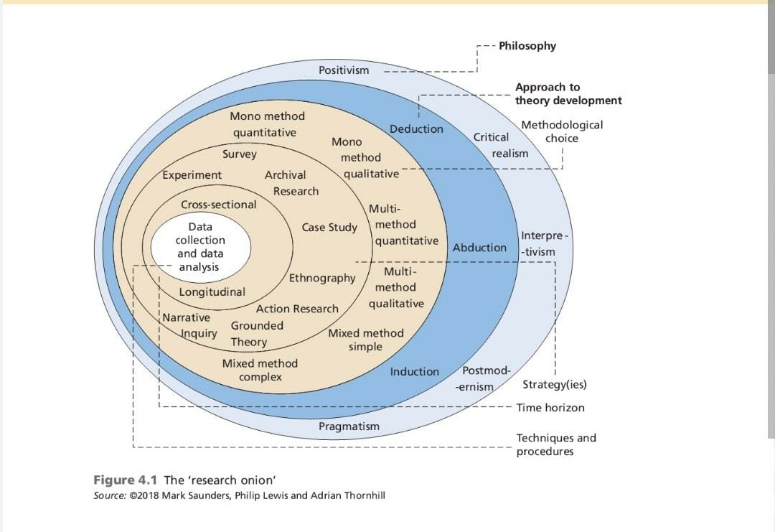

Figure: Research Onion (Saunders et al., 2019)

The methodology section will provide a discussion of different aspects of the research process, which will be used in the study such as research philosophy, strategy, approach, design, criteria and data collection and analysis method. Apart from these, ethical considerations will also be provided while conducting the study with proper justification on each of the methods selected in the dissertation.

3.2 Research Philosophy
Research philosophy is set of principles, assumptions and beliefs that guide the researcher to conduct a methodological approach in the study and generate knowledge. IT acts as a foundation based on which research methods, strategies and techniques are selected and incorporated into the study. It also influences how the researcher perceives and analyses the world, the nature of the reality and the relationship between the author and the research topic. There are four types of research philosophies that are used by authors that include positivism, philosophy, interpretivism philosophy, critical realism and pragmatism philosophy (Alharahsheh & Pius, 2020). In the current research study, it is highly suitable to use interpretivism research philosophy that emphasizes the contextual and subjective nature of human experience and believes that knowledge regarding the topic can only be acquired by analysing the unique experiences and perspectives of individuals. Using this philosophical approach can be useful for the author to explore different viewpoints and perceptions of individuals using distinctive cross-border payment systems in the real world and determine whether it has affected their shopping experience online in a positive or negative manner. This will also allow the author to explore existing literature related to the topic to acquire multiple meanings and interpretations through qualitative data and narratives and evaluate underlying themes and concepts (Lester & Lochmiller, 2020). Another reason to choose the interpretivism philosophy in the study is that it is highly suitable for secondary research where there is no need to collect new data but focus on analysing and synthesizing existing data available from numerous secondary resources.

3.3 Research strategy
A research strategy outlines the entire research plan describing the steps on how the study will be performed and concluded. This involves the data collection approach including the data format, analysis and interpretation approach to answer the research questions and how it will be presented. Every study is different from each other and one research strategy cannot be integrated into every research. It offers the right direction for the researchers to properly plan and execute the research process and ensure the credibility of the findings (Alharahsheh & Pius, 2020). This dissertation will follow a quality research strategy with involves collecting theoretical data and exploring the intricate understanding of different variables such as cross-border digital payment systems and online shopping experiences in the UK (Basias & Pollalis, 2018). The reason why qualitative research strategy has been selected in the current study is that it will provide a more in-depth comprehension of the relationship between the two variables and also identify the key factors related to the cross-border digital people system that seems to influence the online shopping experience of the customers, which is not possible using quantitative strategy (Asenahabi, 2019). There will be no need to collect information based on multiple-choice questions and closed questions where the responses can be evaluated using graphs and charts but themes and trends can be observed related to the research topics that will be beneficial for the stakeholders including the e-commerce companies in the UK to understand whether the payment system will be useful for them to improve customer satisfaction.

3.4 Research approach
A research approach offers a general perspective and framework to the researcher in conducting the study. It consists of the overall philosophy, methods and strategy that will be used for accumulating and interpreting qualitative data. There are different types of research approaches that are used by the authors based on the specific nature, requirement and characteristics of the research (Lester & Lochmiller, 2020). These include the deductive approach, inductive approach, and abductive approach. In this dissertation, an inductive approach will be followed as it involves collecting data and analyzing the same to develop theories and insights and determine patterns and concepts that have not been explicitly discussed in original sources (Hakansson, 2013). It does not involve analyzing data to test and confirm any theory and hypothesis nor it use the existing information to generate plausible explanations regarding some phenomena (Braun& Clarke, 2022). The reason why this approach is selected in the dissertation is that it also aims to develop new theories and insights regarding the impact of cross-border digital payment Systems on the online shopping behavior of consumers and identify likely patterns and themes associated with the topic, which have not been covered previously in any research (Asenahabi, 2019). The fact that this approach also uses qualitative research to understand complex human behavior and experience also makes it a suitable approach for the study.

3.5 Research Design
Research design encompasses the overall plan and structure created by the researcher to guide the complete research process, which includes defining the research problem and objectives to the collection of information and interpretation of the results through analysis (Lester & Lochmiller, 2020). A Research Design is extremely critical for a study as it consists of various choices and decisions made by the researcher regarding the methods, techniques, procedures and tools that will be utilized to address the research questions the best. The selection of a research design is based on the characteristics and nature of the research, available resources along with the expected outcome and some common types of research designs include experiment design, descriptive design, longitudinal design, cross-sectional design, case study design, grounded theory design, etc. (Alharahsheh & Pius, 2020). The dissertation to analyses the impact of cross-border digital payment systems on the online shopping behavior of customers in the UK will use a cross-sectional research design, which involves the collection of data from sources at a single point in time (Setia, 2016). The data collected from participants or other sources provide a snapshot of the behavior, characteristics and attitudes of interest associated with different variables and will be beneficial in answering the research objectives easily (Asenahabi, 2019). Some advantages of using a cross-sectional research design in the study involve saving a lot of time and cost in the research as the information can be collected quickly and trends can be identified based on the impact of cross-border payment systems on e-commerce using qualitative data fluently to determine the change in consumer behavior.

3.6 Method of data collection
Data Collection involves the process of accumulating relevant information related to the research topics from different sources. It is a crucial element of the research methodology and study where the researcher is required to identify sources for information as per the research strategy and approach selected that provides the foundation for evaluation and interpretation of the data to answer the research questions. In conducting research studies, there are basically two forms of data collection methods which include the primary method and the secondary method (Lochmiller, 2021). In the primary data collection method, information or collected directly from original sources such as respondents while secondary data involve searching for information from already published sources and have been previously explored in other studies. This dissertation will utilize secondary data sources for information gathering. The use of secondary data in the current study will be extremely beneficial as it will help the result save significant time and cost that would be needed otherwise in recruiting participants and designing questions for collecting information (Vaismoradi & Snelgrove, 2019). Secondary sources do not require many resources to conduct the analysis and it will also allow the researcher to acquire information from a large database that will improve the interpretation of the research objectives. Another reason to use secondary data is that it is easily accessible from the internet and the author can also ensure high creativity of the collected information.
The key secondary sources that will be used to derive information on cross-border digital payment systems and their impact on the online shopping behaviour of consumers include:
Peer-reviewed articles: Peer-reviewed journal articles are an essential data source and are considered the most important source for data collection in secondary research similar to the current study. It is also referred to as a scholarly publication which is written by experts in the field and reviewed by the editorial board of subject experts before accepting them for publication in the journal (Lochmiller, 2021). The rationale for these journal articles in the current dissertation is because of their capacity to deliver an in-depth comprehension of research variables and the topic. Since they have already been reviewed by subject matter experts in the field, they are well-interpreted and provide properly collected and documented evidence that increases the quality of the data. Because of the rigorous evaluation process, these articles undergo before publication, which ensures that the validity, accuracy and quality of the research presented. Peer-reviewed journal articles are also published in journals specifically dedicated to a key subject area and discipline which also ensures that the information acquired from the articles is directly pertinent to the current subject matter (Vaismoradi & Snelgrove, 2019). They also follow a systematic structure with an abstract that provides a concise summary of the entire study including its findings which can also assist the researcher in quickly determining the relevance of the study to the current research topic of cross-border payment systems (Lester & Lochmiller, 2020). In order to find the most appropriate journal articles to be used for data acquisition, specific keywords have been employed. These keywords include, "cross border digital payment system", "online customer shopping behaviour", "global payment system", "impact of online payment on e-commerce", etc.
Publicly available databases: Apart from the journals for identifying and selecting peer-reviewed articles, public databases will also be used to find the most suitable studies to be included in the current research for data collection which include Google Scholar and Research Gate. The above-mentioned keywords will also be used in these databases to find articles where Boolean operators such as 'OR' and 'AND' will be integrated for better results.
Website articles: These refer to the blogs and articles published on different websites which can be found by searching the same keywords in the Google search engine. Website articles and blogs are not reviewed by subject matter experts but they do provide the latest and up-to-date information related to the research topic, which is the main reason behind the selection of this secondary source in the current study (Pilbeam et al, 2022). These articles can involve government websites, annual reports available on businesses' websites, news articles and other highly credible portals that are well-known for publishing articles and blogs related to the research field. The use of website articles can also provide a distinctive perspective from the findings of peer-reviewed articles based on personal experience, which will be significantly beneficial to developing an argument regarding the research objectives (Vaismoradi & Snelgrove, 2019). Another reason to use this source in the current study is that website articles are also written by experts in the field with real-world experience and are also quite short but deliver key insights on the subject matter saving a lot of time and effort for the researchers (Braun& Clarke, 2022). Website articles and blogs from only credible websites have been used in the study, which include LinkedIn, PayU, PWC, Bank of England, etc. that describes the features and benefits of cross-border digital payment system and how they influence the purchasing behaviour of online shoppers.
In addition to the primary approach of thematic analysis based on secondary sources, questionnaires were used as a supplemental primary data gathering method. These surveys sought quantitative insights from a varied sample of participants on their preferences and experiences with cross-border digital payment systems in the United Kingdom. Surveys were delivered online via numerous platforms and organizations, with consumers and e-commerce businesses targeted. The use of this primary approach enriches the study by giving actual data to support and supplement the conclusions from thematic analysis of existing literature. This addendum strengthens the research's findings on the influence of cross-border payment systems on customer behavior and preferences. Following the theme analysis, surveys were undertaken to verify that study questions were guided by the existing body of knowledge.

3.7 Selection criteria
In secondary research, the selection of the right source of information is the key to making a difference in the quality of the findings and results. The selection refers to the process of evaluating the subset of data to determine meaningful information from a large data set (Braun& Clarke, 2022). The process involves the author analysing and selecting a representative of big data by evaluating visible trends and patterns that seem to focus on the research objectives and answer the research questions. The selection criteria for the secondary sources that will be used in the dissertation include:
Date of Publication: It is one of the most important criteria for the selection of the source in the current study where the article, whether it is a website article or a peer-reviewed journal article. It is important that the articles are published after the year 2013 and those articles which have been shortlisted based on the findings of the keywords and abstract analysis but are published before 2013 will be rejected for further evaluation (Pilbeam et al, 2022). This will ensure that the information collected from these sources is as recent as possible because of the characteristics of the research variables. Cross-border digital payment systems have been available in the market for a few years now and selecting old articles may have unauthenticated or false information that could impact the findings.
Cost efficiency: This is another major criterion for the selection of articles in the study where it is important that the sources are available at a very low cost or for free. There will be a high emphasis on the free availability of secondary sources where the author can easily find and download the article for analysis (Vaismoradi & Snelgrove, 2019). These include peer-reviewed studies, government statistics, annual reports, newspaper articles, etc. as it will provide more convenience to the researcher. Finances can be a major hurdle in the current study and using easily accessible sources will ensure that funds will never be the issue in conducting the study.

3.8 Method of data analysis
The data analysis process involves using logical and statistical methods to transform large amounts of unstructured data into valuable insights. The process encompasses applying systematic methods to illustrate and describe the collected data for the purpose of answering the research questions and objectives. Thematic analysis is a data analysis process that will be integrated into the current paper (Pilbeam et al, 2022). It is a qualitative analytical technique that aims to identify and evaluate similar patterns and themes from a range of sources and derive comprehensive findings that can be used to fulfil the research objectives. With the help of thematic analysis, the author will be able to uncover different layers of variables in the study, which include cross-border digital payment systems and the shopping experience of online customers (Lochmiller, 2021). In addition to theme analysis, this study made use of NVivo, a robust qualitative data analysis program. NVivo was critical in collecting and organizing the massive quantity of secondary data gathered from diverse sources, allowing for a more systematic and efficient analytical procedure. This program enabled the discovery of major themes and patterns among the collected data, enhancing our understanding of the link between cross-border digital payment systems and online shopping experiences. Additionally, in addition to peer-reviewed publications, internet articles, and publicly available databases, secondary data sources such as industry reports, market studies, and regulatory documents were investigated to guarantee a thorough analysis of the research issue. These sources were carefully chosen for their relevance and dependability, which contributed to the research findings' robustness.
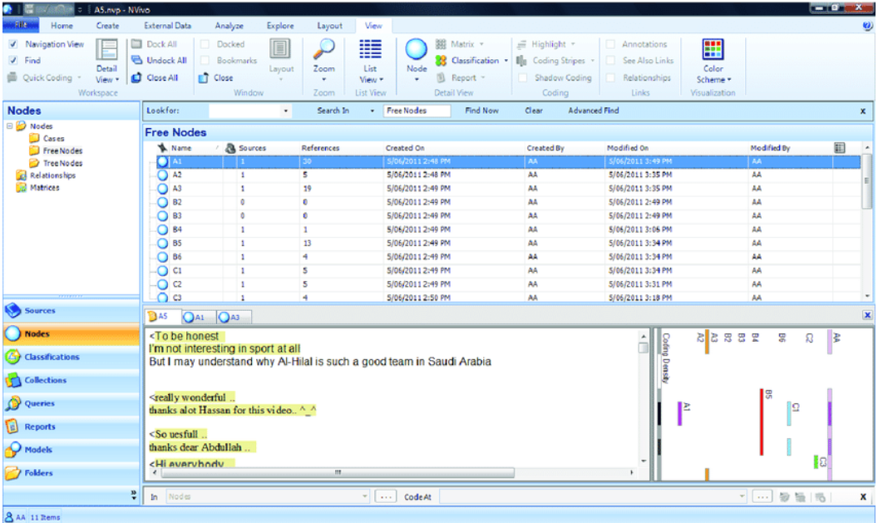
Figure 4: Selecting coding using NVivo Software
‎3.9 Ethical Considerations
For gaining the reliable data and right secondary data and conduct the data analysis, the ‎ethical research policy and plagiarism guidelines of the university are followed to avoid any ‎research biasness. All the used data in from of literature, as well as secondary data are ‎referenced with citations to avoid any chances of plagiarism or discredit the actual authors. ‎The outdate data are not considered for this study and data are derived from the authentic ‎sources to ensure that there is reliability and validity in research.‎
‎3.10 Chapter Summary
In order to understand and assess the present cross-border payment systems in the United ‎Kingdom along with its impact on the buyers’ online shopping experience, the study used ‎interpretivism philosophy along with the inductive approach. This study involves the use of ‎qualitative strategy in order gain description information on topic. This study also used the ‎cross-sectional research design. The data gathering method that is used for this study is ‎secondary data collection. While the data analysis method that is selected for this research ‎is thematic analysis.‎

Chapter 04: Analysis

4.1 Chapter Introduction
After successfully collecting the necessary information from secondary sources, analysis will be performed regarding the available cross-border digital payment systems in the UK and their impact on the customers' online shopping experience. In this section, thematic analysis will be performed on the collected information where recurring themes will be identified from different sources to validate the data and use them to answer the research questions (Vaismoradi & Snelgrove, 2019). Here, multiple themes will be discussed that including features and benefits associated with cross-border payment systems, the impact of the global digital payment system on consumer preferences and their shopping behavior online.
Source | Date | Theme 1: Features of cross-border payment systems used by global e-commerce merchants | Theme 2: Impact of cross border payment systems on consumer preferences in e-commerce | Theme 3: Impact of cross border payment on consumer shopping behavior
Are UK banks already sitting on the solution to the biggest challenges in digital payments? | 2023 | Security concerns, complex nature of payment, high cost of transactions, compliance hurdles
What are Cross-Border Payments? Types, Benefits & Tips | 2020 | Easy currency exchange, high flexibility, fraud prevention, expanded customer base,
Deep Dive:How Emerging Digital Payment Options Impact Cross-Border Customer Experience | 2021 | Better security, | Less hurdles and real time payments influence behavior | High transparency leads to more trust and better adoption
The evolving landscape of cross-border payments | 2021 | Faster payments, significant delays, real time payments, high cost of transaction, lack of regulations, data format issues, | Customer experience varies in different countries, | Easy currency conversion, high availability,
Online payments in cross-border e-commerce | 2019 |  | Simple transaction process, wide range and flexibility, convenience
THE TOP ECOMMERCE AND PAYMENT TRENDS IN THE UNITED KINGDOM | 2023 | Types of cross border payment systems, | Most preferred payment in UK for online shopping,
Cross-border payments | 2023 | Fragmented data formats, high complexity, limited operating hours, high cost of funding, long transaction chains,
Everything You Need to Know About Cross-Border Payments | 2023 | High security, | Regional payment methods, mobile enabled, | Personalized customer experience, high transparency,

In this chapter, we build on our research methods to give a thorough examination of cross-border digital payment systems in the United Kingdom and their impact on online shopping experiences. We used NVivo, a strong qualitative analysis program, to go deeper into our data and unearth subtle insights. NVivo enabled us to do thematic analysis on a multitude of secondary source material, allowing us to identify recurrent themes and patterns across several research publications and reports. This analytical technique helped us validate the data and offered a formal framework for properly answering our study objectives (Vaismoradi & Snelgrove, 2019).
In addition to NVivo, we used secondary research approaches to generate a complete dataset for our study. To get a comprehensive knowledge of the characteristics, benefits, problems, and effect of cross-border payment systems in the context of e-commerce, we gathered data from a number of credible sources, including studies, journals, and industry publications. These secondary approaches gave us access to a diverse spectrum of perspectives, confirming the trustworthiness and validity of our findings. Surveys were the major data collecting strategy in this study, allowing for the collection of quantitative data from a varied spectrum of individuals. Surveys were created to investigate and quantify customer attitudes and behaviors about cross-border digital payment systems in the United Kingdom. The quantitative data acquired through surveys gave useful insights that supplemented the qualitative findings from secondary source theme analysis. This research produced a full comprehension of the topic matter by using both primary and secondary methodologies. The study of survey data supported and expanded on the themes discovered in the previous research, providing a more comprehensive view of the influence of cross-border payment systems on consumer behavior and preferences.

4.2 Theme 1: Features of cross-border payment systems used by global e-commerce merchants
Cross-border digital payment systems play a very crucial role in shaping the customer experience and satisfaction in online shopping. It is mainly because these systems provide an efficient and seamless payment process, which greatly stimulates the overall shopping experience (Maryaningsih et al., 2022). This is mainly because global digital payment systems are highly reliable and easy to use which removes the frustration of the customers during the transaction process and minimizes abandonment rates (Saetang, 2023). There are numerous features of these payment systems which include a user-friendly interface that makes it easy to navigate, a smooth and fair currency conversion rate that offers transparency and diverse payment options and preferences and a high level of security by complying with industry standards (ACI Worldwide, 2023). Because of these features, it has become extremely easy for e-commerce customers to use the services of global e-commerce platforms and order goods and items from different countries, which are not available in their own domestic market (Auer & Boehme, 2020). There are different types of cross-border payment systems available such as bank transfers, credit and debit card payments, digital currencies, international wire transfers, blockchain-based payments, mobile wallets, global ACH payments, etc. and all of these payments have made it very easy for customers to make global online transactions for purchase of retail products without being worried about exchange rate, security and errors (Chang et al. 2020). For example, mobile wallets have become one of the fastest-growing payment methods all over the world, especially South-Southeast Asia where the numbers are expected to increase by 300% from 2020 to 2025. Similarly, credit cards are highly preferred in North America as per the report by JP Morgan where more than 47% of E-Commerce transactions are done from this payment mode. This indicates that different cross-border payment systems have different features and benefits making it preferable for distinctive audience in the world.
In response to the survey question addressing desired features and improvements in cross-border payment systems to enrich the online shopping experience, a clear preference surfaced among survey participants. An overwhelming majority, comprising 98%, expressed a strong desire for "More diverse payment options." This indicates the high demand for a broader array of payment choices to cater to diverse consumer preferences, reflecting a crucial aspect of payment system evolution. In contrast, a minimal percentage, at 2%, cited the interest in "Real-time transaction tracking." Although less common, it signifies the importance of enhanced transparency and real-time updates within payment systems for select users. These results harmonize with the research theme, emphasizing the significance of features within cross-border payment systems used by global e-commerce merchants. They underscore the pressing need for expanding payment options to enhance user satisfaction and the desire for real-time transaction monitoring among a smaller subset of respondents, which can be valuable for payment system development. These survey results can be shown below:
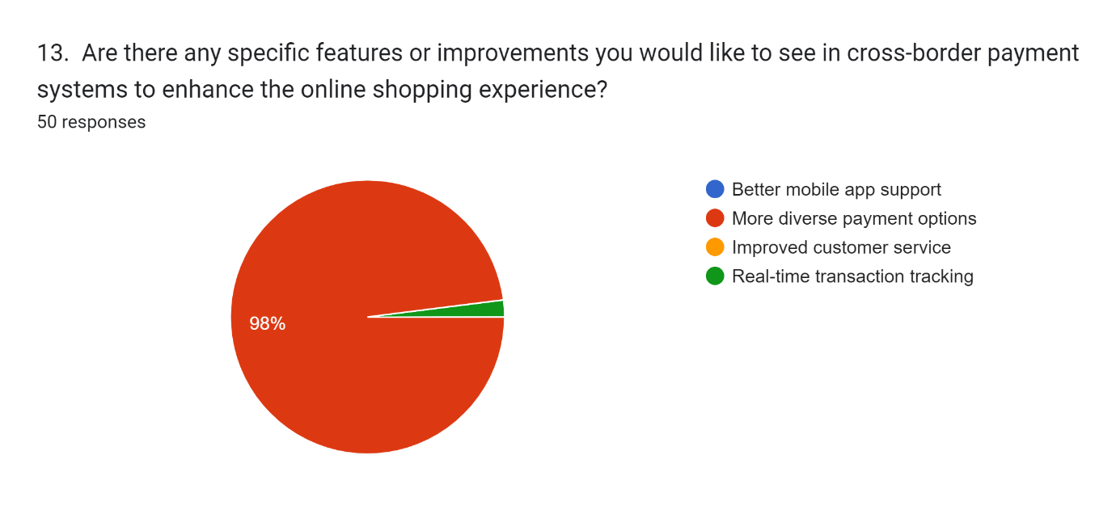

4.2.1 Sub theme 1: Benefits of using cross border digital payment systems in global e-commerce transactions
The analysis identified a number of benefits associated with cross-border payment systems in e-commerce. As per ACI Worldwide (2023), cross-border payments allow merchants to capitalize on the increasing global e-commerce market which is estimated to cross over $4000 billion in 2027. This will enable The E-Commerce business to greatly expand their customer base beyond its domestic country and capital international markets leading to higher sales and revenue. Similarly, these global payment systems also help businesses to provide personalized customer experience by presenting customers with a wide range of payment methods to choose from (ACI Worldwide, 2023). Since most of the cross-border payment systems are mobile-enabled, the customers are able to use the same to make payments through different mediums se such as credit and debit cards, mobile wallets, digital currencies, etc. and thus improves the shopping experience. It also allows the merchants to pay invoices for the suppliers using any mobile device and location through intelligent scheduling (Saetang, 2023). Because of this capability, the e-commerce businesses are also able to expand their partners and suppliers to a global scale. All of this provides both merchant and customers with a lot of convenience to perform their activities with ease and deliver a satisfying overall shopping experience. This factor is also acknowledged in the LinkedIn article, which states that cross-border payments improve customer experience leading to high loyalty and a better competitive advantage to the merchant (LinkedIn, 2023). By providing a seamless and convenient payment experience to the customers, the merchant is also able to deliver transparent and accurate pricing including the exchange rates and additional fees that greatly reduce the risk of cart abandonment, refunds and chargebacks (ACI Worldwide, 2023). Because of fast transactions and currency conversion enabled through cross-border digital payments, customers across the world became less hesitant to use these payment Systems on global e-commerce websites as they provide competitive exchange rates and also simplify the overall process of checkout (Saetang, 2023). Reputable cross-border payment systems also prioritize security by using robust encryption and fraud prevention measures that protect the sensitive data of the customers and secure transactions.
In response to the survey question about the benefits of using cross-border payment systems for international online shopping, the survey results indicate that a significant majority of respondents (70%) reported experiencing "Access to a wider range of products." This finding underscores the key advantage of access to a global marketplace that cross-border payment systems offer, allowing consumers to explore a broader spectrum of products from around the world. While a smaller percentage of respondents (26%) highlighted "Convenience," this result still emphasizes the convenience factor as a considerable benefit. The ability to make international transactions seamlessly contributes to an enhanced online shopping experience. In contrast, a smaller proportion (4%) mentioned "Faster transaction processing" as a benefit. While this was less commonly cited, it underscores the significance of efficiency in transaction processing when using cross-border payment systems.
Overall, these findings from the survey align with the thematic focus on the benefits of cross-border digital payment systems in global e-commerce transactions, showcasing the advantages of increased product accessibility, convenience, and, to a lesser extent, faster transaction processing. These survey results can be shown below:
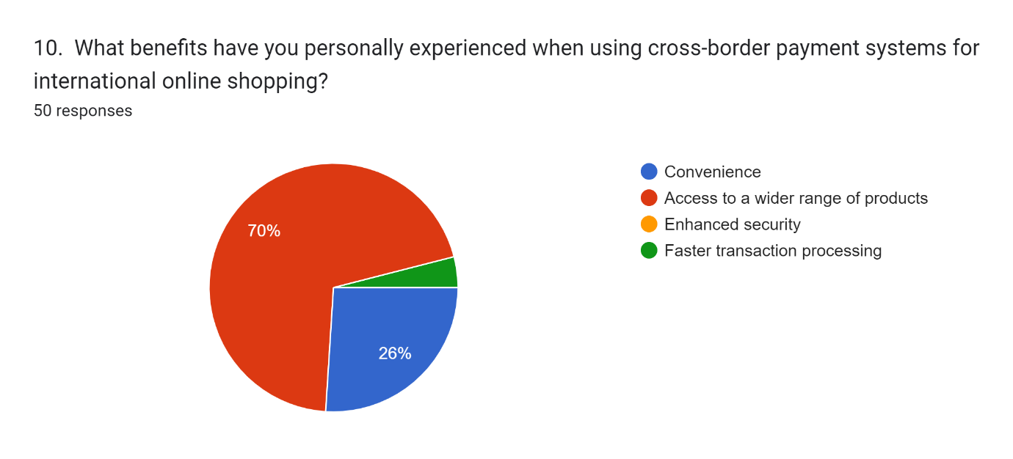

4.2.2 Sub theme 2: Challenges associated with using cross-border digital payment systems in global e-commerce
Even though there are a lot of benefits involved in the use of cross-border digital payment systems in global e-commerce platforms, it also comes with certain levels of challenges that need to be considered by the merchants. Tonzer (2013) identified systematic risks and contagion risks in cross border interaction between banks. As discussed by the Bank of England 2023, fragmented and truncated data formats are a major concern in the payment systems as these contain sufficient information about the customer and Merchant to confirm their identity and legitimize the payment (Rep, 2018). However, distinctions in the data format and Standards across different jurisdictions, and Systems can make it difficult to confirm this identity. For example, some countries use Latin characters as a format for names and addresses along with birth dates while others use English making it difficult to set up automated processes that can cause delays in payment processing (ACI Worldwide, 2023). There are also a risk of complex compliance checks where different regulations by distinctive regimes for sanctioning and preventing financial crimes can result in transactions getting checked multiple times affecting the overall process. There are also challenges related to limited operating hours between the transactions of two different countries which can impact the settlement during the e-commerce transaction and can delay the overall process of product delivery. This can also require the banks to hold extra cash to cover fluctuating exchange rates also known as trapped liquidity. High funding costs are also a problem with global payment systems in e-commerce where Financial Institutions will need funds in advance for quick settlements that can lead to risks such as unable to use the capital to support other activities and uncertainty regarding the incoming funds (PWC, 2021). There are also high barriers to entry and difficulty in analyzing the actual cost of done from cross-border payment systems which also makes them more challenging and less feasible for e-commerce merchants to integrate in their systems.
In response to the question regarding challenges and disadvantages faced when using cross-border payment systems, the survey results reveal a predominant concern among respondents, with 76% identifying the "Risk of fraudulent transactions" as a significant issue. This highlights the pressing need for enhanced security measures and awareness to mitigate the potential risks associated with international online transactions. A notable proportion of respondents (24%) also expressed concern over "High transaction fees." This finding underscores the financial burden imposed by cross-border payment systems, necessitating a closer examination of the cost implications for consumers and potential strategies for fee reduction or transparency.
These results align closely with the research theme, emphasizing the challenges associated with cross-border digital payment systems in global e-commerce, particularly in terms of fraud risk and financial costs. These survey results can be shown below:
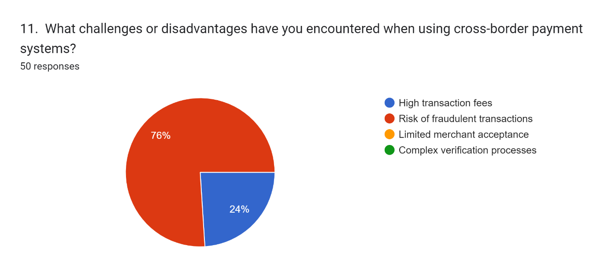

4.3 Theme 2: Impact of cross border payment systems on consumer preferences in e-commerce
There are different types of cross-border digital payment systems used in the UK which include PayPal, credit and debit cards, Apple Pay, prepaid cards, after-pay, etc. and the availability of these payment interfaces also influence the shopping experience of customers in the global e-commerce market (PayU, 2019). With multiple payment options, customers get choice and convenience when searching for products and items on global e-commerce platforms which provides them with flexibility and ultimately leads to a better shopping experience (Rep, 2018). This is mainly because different countries and regions have their own preferred payment methods and currencies and with localized payment options available on global e-commerce platforms, consumers feel more comfortable with the checkout process (Saetang, 2023). The shopping experience and preferences of customers are also influenced by factors such as speed and efficiency, cost considerations, accessibility and security while purchasing products from different countries online. For instance, the availability of different payment systems affects the cost of the transaction as some methods tend to have higher fees and currency conversion rates (Linkedin, 2023). Similarly, the efficiency of cross-border payment systems also varies where some methods enable faster transactions while others may take a longer time to process (Wilson, 2023). Most of the customers tend to prefer global Payment methods that are reputable and secure, which instills trust and security in the customers and will be more likely to make the purchase from e-commerce websites that use these trusted payment options.
In response to the survey question regarding the factors influencing the decision to shop internationally online using cross-border payment systems, several key insights emerged from the survey. The majority of respondents (56%) emphasized the paramount importance of "quality of products" in their choices, underscoring the significance of product quality in international shopping decisions. A substantial portion (40%) placed great weight on "product availability," indicating that the accessibility and variety of items play a pivotal role in their decisions. Moreover, 24% cited "unique items" and an equal percentage considered "brand reputation" as influential factors. While these results reflect a diverse array of preferences, they collectively shed light on the intricate interplay of product quality, availability, uniqueness, and brand reputation in guiding consumers' decisions when using cross-border payment systems for international online shopping. This understanding contributes to a comprehensive view of consumer behaviour in the e-commerce landscape. These survey results can be shown below:
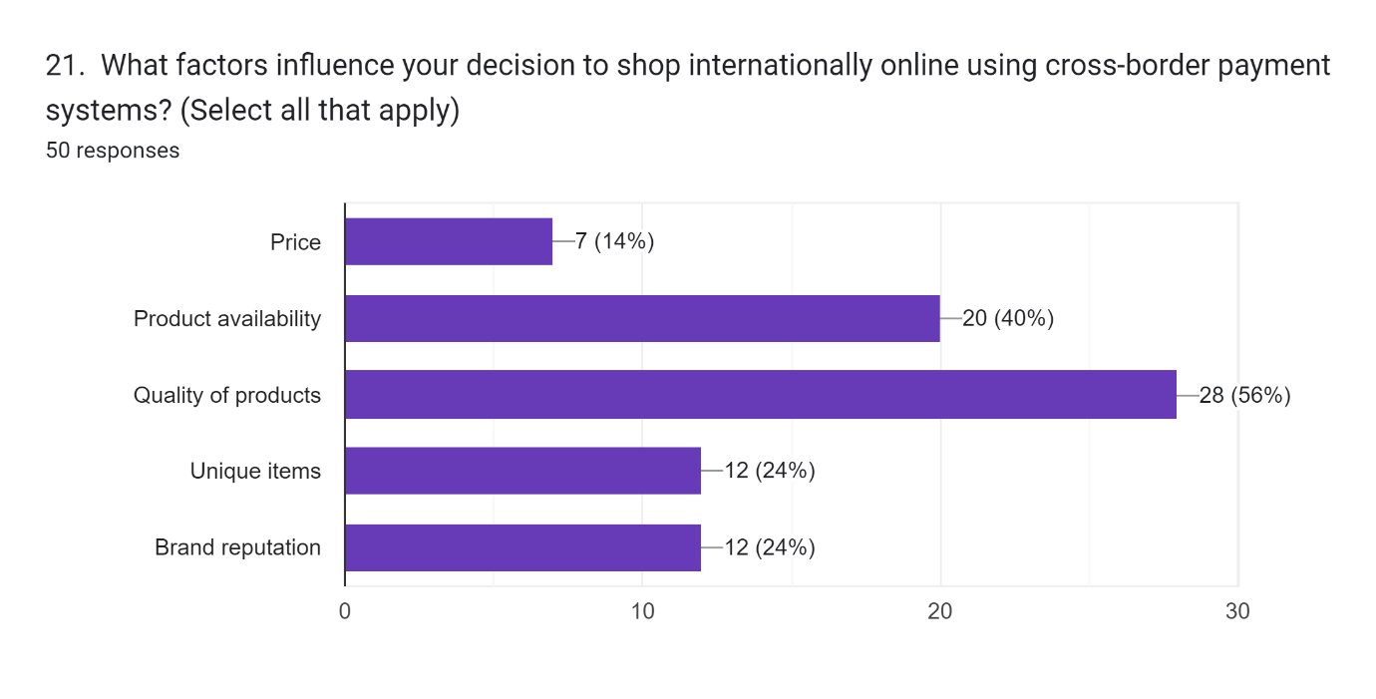

4.3.1 Sub theme 1: Availability of different cross-border payment systems for UK customers in international e-commerce
The analysis has found certain trends in the purchasing behavior of UK consumers in the global e-commerce market while using different cross-border payment systems. It is noted that the use of mobile wallets in purchasing products from international e-commerce platforms has increased significantly in the country because of the ease of the process. According to the article by Johnson (2023), 89% of UK customers use mobiles to make a purchase at least once in a month and the rate is expected to grow twice in the upcoming years. However, it is also found that 75% of the customers also use debit cards as the payment method on e-commerce platforms while only 36% prefer this method. It is followed by PayPal, credit card and Apple Pay which are some of the most common and popular cross-border digital payment systems used by UK customers in online transactions. The main purpose of using these payment systems is because of their user-friendliness, mobile accessibility, global reach, effective customer support and low cross-border transaction fees (PWC, 2021). Customers have easy access to these payment methods along with them to participate in global e-commerce and the limited currency exchange rate and transaction fee also encourage them to use these payment systems (PWC, 2021). Since they are highly reputable methods throughout the world, the preference of the customers in the UK is also high for these payment methods because of the excellent customer support and dispute resolution mechanism they offer whenever encountering payment-related issues.
In response to the inquiry about the primary cross-border payment systems used for international online shopping, a clear preference emerged among survey participants. An overwhelming majority, 76.6%, indicated that they primarily rely on traditional "Debit or Credit Card" systems for their cross-border transactions. This finding underscores the continued dominance of these established payment methods among UK consumers. In contrast, a smaller but notable portion (18.4%) favoured "PayPal" for their international online shopping, highlighting the significance of digital payment platforms in facilitating cross-border transactions. Additionally, a minimal percentage (1%) cited "Apple Pay" as their primary choice. These results align closely with the research theme focused on the availability of different cross-border payment systems for UK customers in international e-commerce. They reflect the prevailing choices among consumers and offer valuable insights into the prominence of traditional card systems and the emerging role of digital payment platforms in the UK's international online shopping landscape. These survey results can be shown below:
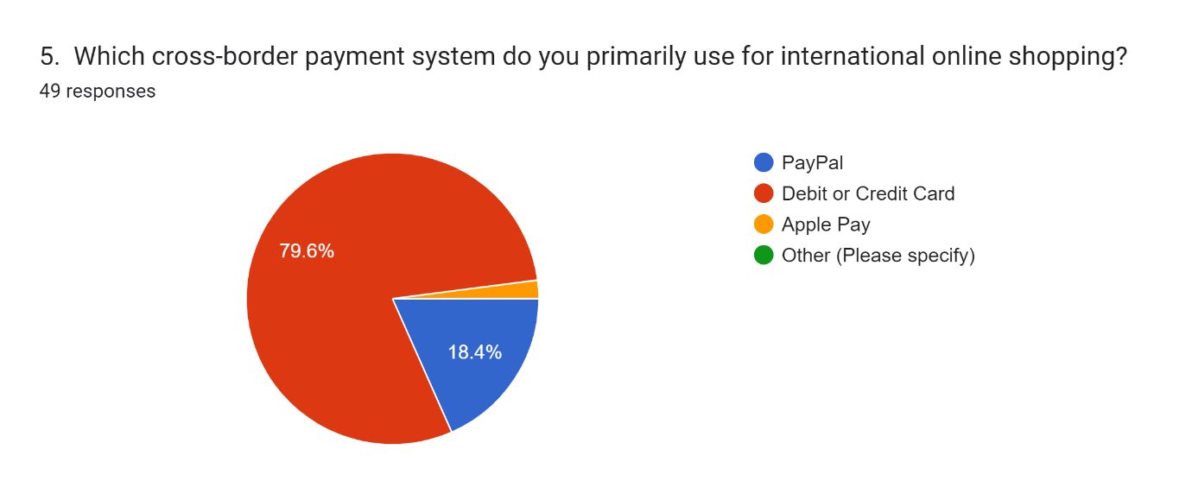

4.3.2 Sub theme 2: Influence of global payment systems on different customer segments
According to PayU (2023), consumer preference plays a very crucial role in the selection of cross-border digital payment systems for online purchase of products internationally. There are various global payment interface available and used by e-commerce merchants all over the world that simplifies the overall shopping experience for customers. The availability of these payment systems on the e-commerce platform greatly influences the customers to select platforms for shopping. For example, baby boomers highly prefer (74%) credit cards for making global payments on e-commerce websites with only 21% of them using debit cards and just 7% for cash on delivery (PayU, 2023). Similarly, tech-savvy millennials and Generation Z customers in the UK prefer using digital wallets and mobile payments such as PayPal, Apple Pay, Google Pay and cryptocurrency for cross-border transactions as they value speed and convenience. These customers are comfortable with the use of technology and smartphones and also prefer contactless and seamless payment options. Similarly, business professionals prefer corporate credit cards for making cross-border transactions as they are better at tracking expenses and reporting. Consumers in the UK who are constantly ordering products from e-commerce websites prefer alternative payment methods such as debit and credit cards, Alipay, PayPal and e-wallets because of their high accessibility and trustworthiness (Wilson, 2023). This is not the case with elderly people who are less tech-savvy where they prefer traditional payment methods such as credit and debit cards or even cash on delivery when making cross-border purchases. They are not comfortable with technology and also have concerns regarding the security and familiarity of the payment options (PWC, 2021). Apart from that, the lifestyle and preferences of UK customers such as cost-conscious customers, high-value shoppers and regular shoppers have distinctive payment preferences. For instance, cost-conscious customers would choose payment methods with the lowest exchange rate and transaction fee to get the most value while high-value consumers would prefer premium credit cards to purchase luxurious brands to get additional perks and rewards.

4.4 Theme 3: Impact of cross border payment on consumer shopping behavior
Cross-border payment systems offer a significant impact on the shopping behavior of consumers. This is mainly evident with the availability of different global Payment interface options available on the e-commerce merchant's website. For instance, UK customers are highly influenced in making online purchases on global e-commerce platforms because of the availability of multiple cross-border payment options. These include credit and debit cards, PayPal, Apple Pay, Alipay and e-wallets, which makes it easier for them to shop from international websites. It makes them explore and purchase from these online stores because of the easy access and convenience for payment (Wilson, 2023). Similarly, customers also get an expanded and wide range of product choices through international e-commerce platforms, which are not available in the UK-based online selling portal. The diversity in product offerings further influences the shopping behavior of consumers as they seek unique and niche products which are not available locally (PayU, 2019). On these global e-commerce platforms, customers are not only able to compare product features from different international retailers but also compare the overall price as well after the transaction fee and currency exchange rate. Different global payment options have distinctive charges which the customers are able to see in real-time and make a better and more informed decision of selecting the payment method that provides the lowest fee for a particular product. This also attracts more cross-border shoppers in the UK because of the high level of transparency.
64% found their cross-border digital payment system online shopping experience "satisfactory," while 36% had a "neutral" perspective. Reflects diverse views on the impact of global payment systems on customer segments in international e-commerce. These survey results can be shown below:
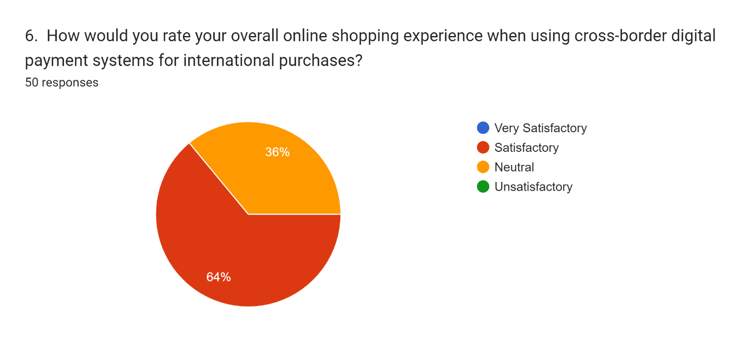

4.4.1 Sub theme 1: Impact of cross border payment systems in the UK on the shopping preferences of customers
The availability of different international payment options on global e-commerce websites influences the preference of UK customers to make a purchase as well. As identified by PayU (2023), UK customers prefer global Payment options such as bank credit cards, PayPal, Google Pay and digital wallets, therefore, e-Commerce merchants providing these payment systems on their platforms will get more orders from the UK. It was noted that the younger generation, especially Generation X and Z prefer PayPal, Apple Pay and Alipay as they attract lower transaction fees and support fast processing (PayU, 2023). The refund process among these payment systems is also more efficient and quit as compared to credit and debit cards which increases their shopping preference on e-commerce platforms that provide such payment systems. Other payment options such as credit cards also offer loyalty and membership programs with Benefits including discounts, exclusive offers and cashback rewards (Taskin, 2022). These features of cross-border digital payment systems also influence the preference of UK customers in using them for online shopping including international ecommerce. These incentives tend to encourage consumers to shop more frequently using the specific payment method that improves the overall customer shopping experience on online selling platforms. Other available payment systems on these international selling platforms that support multiple languages also increase customer preferences to use the methods during online purchases in the UK (Wilson, 2023). For instance, Apple Pay and Alipay support different languages including English, Chinese, Cantonese, French, etc. where UK customers are easily able to make payments from e-commerce portals of other countries operating in their local languages (Gomez-Herrera et al., 2014). This localization feature consists of currency and language options further increasing the customer preferences to use them during international online shopping.

4.4.2 Sub theme 2: Effect of cross Cross-border digital payment systems in the UK on the shopping experience of the customers on international online selling platforms
The availability of cross-border digital payment systems in the UK greatly impacts the overall shopping experience of customers on e-commerce platforms. However, this impact can be both positive and negative based on the distinctive requirements and Expectations of UK customers while engaging in international e-commerce activities. For instance, the high level of convenience offered by global payment options with hassle-free currency conversion and dealing with foreign payment methods certainly offers a positive experience. By using international e-commerce platforms, they also get access to a vast selection of products which are not available locally and have high transparency and security in making payments globally reducing the concern of data breach and fraud (PayU, 2023). Similarly, the flexibility offered by cross-border payment systems to choose from the best option available as per their needs and preferences along with fast and efficient checkout complements their shopping experience. However, the shopping experience can also be affected because of certain aspects of cross-border payment systems such as hidden fees, payment failures and delays. There can be unfavorable exchange rates and hidden fees involved in international payment while technical issues such as legacy technology, limited operating hours, long transaction chains and complex compliance checks can delay the overall transaction process making the entire purchase process more frustrating for the customers (PayU, 2023). Many customers in the UK, especially the older generation people can have trust issues with these global payment options as they have a lack of confidence in the legitimacy of the online retailer and the payment options provided by them, which can prevent them from shopping further.
In response to the question evaluating the effectiveness of the current cross-border digital payment systems in the UK, a substantial majority of survey respondents (78%) expressed a positive view, perceiving these systems as "Effective." This suggests a generally robust payment infrastructure in the UK that contributes to a favourable shopping experience for international online customers. A smaller percentage of respondents (22%) indicated a "Neutral" stance. While these respondents neither strongly affirmed nor criticized the system's effectiveness, their feedback provides a balanced perspective on the cross-border payment system's impact on the shopping experience. These findings align with the research theme, illustrating the positive effect of cross-border digital payment systems in the UK on the experience of customers engaging with international online selling platforms. The majority's perception of effectiveness highlights the importance of a reliable payment ecosystem in facilitating international e-commerce transactions. These survey results can be shown below:
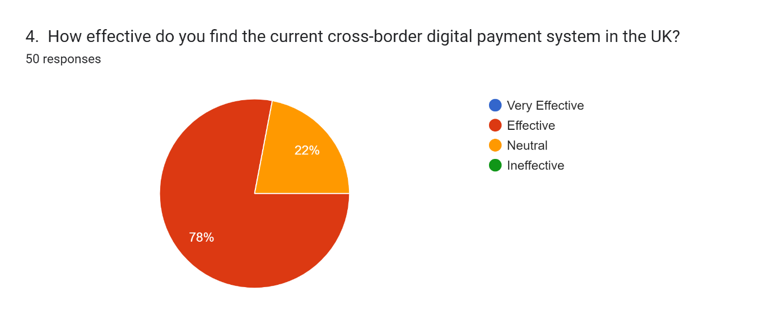

‎4.5 Chapter Summary
The key benefits of cross-border digital payment systems in the international e-commerce ‎transaction are increasing revenue and sales overseas, personalized buyer experience, helping ‎gaining the competitive advantage, quick transactions, offers competitive exchange rate, as ‎well as prioritization of fraud prevention. The key challenges linked to international digital ‎payment system in e-commerce are complex compliance check risks, risk of fraud, and ‎fluctuating currency exchange rates. The available diverse cross-border payment system for ‎customers in the UK to carry out international e-commerce are PayPal, Apple Pay, and credit ‎card. These are easily accessible as well as have better customer support mechanism. The ‎overall impact of the global payment system on the diverse segments of buyers are that the ‎interface of these payment system helps in enhancing the buying experience of buyers, help ‎buyers to choose appropriate shopping platforms, ensure speedy payment, ensure convenience, ‎as well as payment with low transaction fees and exchange rate. There are both positive and ‎negative influence of cross-border digital payment system on the purchasing experience of UK-‎based buyers on international electronic-commerce platforms. The positive buying experience ‎is gained through hassle-free conversion of currency, wide range of products can be accessed as ‎well as high security and transparency in payment. The negative buying experience is ‎experienced due to the payment failure, hidden charges or fees, delay in payment and technical ‎issues.‎

Chapter 05: Discussion
‎5.1 Chapter Introduction
This chapter presents the detailed interpretation of explored findings in the previous chapter. It ‎will describe the clearly interpretation of the diverse features, challenges and benefits of ‎different cross-border payment systems. The overall influence of cross-border payment ‎systems on the buyer preferences in the electronic-commerce. The influence of cross-border ‎payment on the buyer shopping behavior to be analyzed.‎

5.2 Features, benefits and challenges of cross border payment systems in global e-commerce.
Cross-border digital payment systems are essential in global e-commerce, positively impacting the UK's thriving online shopping trends (Vaismoradi & Snelgrove, 2019). They expand the customer base, enabling businesses to target both domestic and international markets, capitalizing on the expected $4,000 billion global e-commerce market by 2027. These systems offer diverse, mobile-enabled payment options like cards, digital currencies, and mobile wallets, attracting international customers (ACI Worldwide, 2023). They streamline supplier payments, enhancing relationships, expanding global networks, and simplifying activities for a satisfying shopping experience. They ensure pricing transparency, reduce cart abandonment, chargebacks, and refunds, and offer fast transactions, real-time currency conversion, and robust security (Saetang, 2023). Yet, challenges include fragmented data formats affecting payment credibility, complex regulatory checks causing transaction delays, variations in operating hours, trapped liquidity, and barriers in measuring the actual cost of these systems (PWC, 2021). These concerns need careful consideration for proper integration into e-commerce business models.

5.3 Impact of Cross-Border Payment Systems on Consumer Preferences in E-Commerce
The availability of cross-border digital payment systems shapes UK consumer preferences in international e-commerce. Commonly used methods include debit/credit cards, PayPal, Apple Pay, and mobile wallets, with mobile wallet use rising due to its ease of use. Over 90% of consumers use mobile devices monthly for online purchases, expected to grow by 100%. Debit/credit cards remain dominant, with 75% of UK customers using them, followed by PayPal and Apple Pay, thanks to mobile accessibility, customer support, user-friendliness, global reach, and low fees, instilling trust as identified ‎by Johnson (2023).
However, these systems affect online shopping behaviour differently across customer segments. Baby boomers prefer credit cards, millennials and Gen Z lean towards mobile payments and digital wallets, while corporate professionals favour corporate credit cards for expense management. Cost-conscious customers opt for payment options with the lowest fees, such as digital wallets, while high-value shoppers use premium credit cards for added perks. Elderly customers Favour traditional methods due to tech and security concerns.

5.4 Impact of Cross-Border Payment on Consumer Shopping Behavior
The availability of cross-border payment systems in the UK significantly impacts shopping preferences on e-commerce platforms. Generation X and Y favour digital wallets like Apple Pay, PayPal, and Alipay for lower fees and faster transactions (Wilson, 2023). Credit cards offer loyalty program benefits, encouraging more frequent shopping (PayU, 2019). Payment options supporting multiple languages, like Apple Pay, enhance localization and attract customers from different countries.
However, these systems have both positive and negative impacts. They offer convenience, access to a wider product range, transparent pricing, and currency exchange rate comparisons. Hidden fees, unfavourable exchange rates, and payment failures can cause dissatisfaction and trust issues, particularly among older UK customers (PWC, 2021).
‎5.5 Chapter Summary‎
This discussion helped to interpret that the final findings on the present cross-border payment ‎systems in the United Kingdom along with its impact on the buyers’ online shopping ‎experience. It is interpreted that the positive buying experience by the cross-border payment ‎systems by easy currency exchange and better transaction security. It also interpreted that ‎negative buying experience is observed due to the payment failure, hidden fees and technical ‎problems.‎

Chapter 06: Conclusion and Recommendations
‎6.1 Conclusion‎
This study aimed to assess the present cross-border payment systems in the United ‎Kingdom along with its impact on the buyers’ online shopping experience. The research ‎project applied interpretivism philosophy and the inductive approach with the goal to ‎comprehend and evaluate the current cross-border payment systems in the United Kingdom ‎and their impact on consumers' online buying experiences. This study employs a qualitative ‎approach to gather relevant description information. Additionally, a cross-sectional research ‎strategy was adopted in this study. Secondary data collection is the method of data ‎collection employed in this study. Thematic analysis was chosen as the data analysis ‎technique for this study. Through findings, it is explored that an increased revenue and sales ‎overseas, a personalized buyer experience, assistance in gaining a competitive edge, speedy ‎transactions, competitive exchange rates, and a focus on fraud prevention are the main ‎advantages of cross-border digital payment systems in international e-commerce ‎transactions. Complex compliance check risks, fraud risk, and variable currency exchange ‎rates are the main issues with worldwide digital payment systems in e-commerce. ‎Customers in the UK can conduct international e-commerce using a variety of cross-border ‎payment systems like PayPal, Apple Pay, and credit cards. These payment systems offer ‎excellent customer support systems and are easily available. The interface of these payment ‎systems helps in improving the buying experience of consumers, assists consumers in ‎selecting the best platforms for shopping, ensures quick payment, ensures convenience, as ‎well as payment with low transaction fees and exchange rates (Chen et al, 2021). These are ‎the main effects of the global payment system on the various segments of shoppers. Cross-‎border digital payment systems have an impact on the shopping experience of UK ‎customers on global e-commerce platforms in both positive and negative ways. Easy ‎currency conversion, easy access to a large selection of products, strong payment security, ‎and transparency all contribute to a positive shopping experience (Asenahabi, 2019). ‎Negative shopping experiences are brought on by payment failure, unreported fees, payment ‎delays, and technical difficulties.‎

‎6.2 Linking with the objectives‎
‎6.2.1 Objective - 1 - To find the overall effectiveness of the cross-border digital ‎payment systems that are available in the United Kingdom
This objective has been achieved as this study; it is found that the UK consumer is using ‎various online payment system to buy products from another country using e-commerce ‎platforms. Some of international payment system which is used by UK-based buyers are ‎PayPal, Apple Pay, and credit card for purchasing on e-commerce sites (Rapyd, 2023). This ‎payment systems are easily available and use for buyers. This international payment system ‎also provides the customer with easy and better interface in order to offer better purchasing ‎experience to the its users. Even this payment system providers also have effective ‎mechanism for customer support. It is found that the existence of different cross-border ‎payment systems also gives buyers the options to select the best e-commerce sites to buy ‎products from the global market.‎
‎6.2.2 Objective - 2 - To determine the key challenges and benefits linked to the cross-‎border digital payment systems ‎
This second objective is also achieved as the different challenges, as well as benefits ‎associated to the international digital payment system. It is explored that the main ‎advantages of the different cross-border digital payment systems available to the consumers ‎in the United Kingdom for purchasing products through e-commerce platforms are that it ‎helping the global e-commerce brand to grow business with increased sales and revenue ‎from international market and for buyers it helps in gaining the customized buying ‎experience and gain the competitive advantage. Other advantages are that it helps in making ‎the oversea transaction quick, gain the competitive currency exchange rate, lower ‎transaction fees and provide the convenience and security against financial frauds. Other ‎than this, some of the challenges associated to the diverse international digital payment ‎systems available to the consumers in the United Kingdom for purchasing products through ‎e-commerce platforms are also explored. It is found that the major challenges are to deal ‎with the financial fraud risk and risk related complicated compliance check (PayU, 2023). ‎Even the changing currency exchange rate develops the barriers for the buyers to buy the ‎products from the global market online.‎
‎6.2.3 Objective - 3 - To analyze the overall impact of the cross-border digital payment ‎systems on the e-commerce’s buyer experience in the United Kingdom
This third research objective is also met as it is explored that there are favorable, as well ‎as unfavorable impact of the international digital payment systems on the customers’ ‎buying experience from the global e-commerce sites. The buyers in the United Kingdom ‎experiences positive purchasing experience using the cross-border payment system, when ‎the different payment system gives the problem-free exchange of currency, better payment ‎security, accessibility to the different products from different international e-commerce ‎sites, as well as transparency in the transactions (PayU, 2023). But the adverse impact on ‎the purchasing experience of buyers using the cross-border payment system is observed due ‎to the failure of any transaction, technical problem affecting the transaction, as well as ‎charging the hidden fees.‎
‎6.2.4 Objective - 4 - To offer the recommendations to the companies into e-commerce ‎on the integration and elimination of ‎ the diverse challenges associated to the cross-‎border digital payment systems
This last research objective is also achieved as better understanding is gained on the ‎international digital payment systems which are employed by the UK-based consumers to ‎buy products. Based on the issues related to digital payment systems for international ‎transaction to buy product through e-commerce sites, it is suggested to focus on improving ‎the user experience with the payment system and the resolve the technical problems. It is ‎recommended for the cross-border digital payment systems offering company to have ‎transparency in the currency exchange rate, as well as ensure there is a clear transparency in ‎processing fees in order to avoid any hidden charges. There should be a separate department ‎to manage the customer complaints related to transactions such as delay in payment, ‎payment struck issues, etc. There should be instant customer problem resolution mechanism ‎to avoid any kind of payment related issues. It is also suggested to ensure there should be ‎proper authentication and encryption system to provide the security against online financial ‎fraud (Saetang, 2023). The currency conversion system should be made easier.‎
‎6.3 Recommendations‎
The recommendations to the companies offering the cross-border payment systems in the ‎market of United Kingdom for e-commerce transaction are as follows -‎
‎1. It is recommended that company should emphasis on improving the payment security ‎against any fraud by using advanced encryptions and authentic verification process. This ‎necessary to develop trust among the users towards the company and payment system.‎
‎2. It is suggested to encourage more transparency in the terms and conditions because there ‎are various cross-border payment systems in the market that charges hidden fees which ‎affect the customer purchasing experience negatively. There should be clear guidelines and ‎policies for customer to make decision to select any payment system for transaction on e-‎commerce sites internationally.‎
‎3. It is also recommended to add feature that updates about the currency exchange rates or ‎easy currency conversion system. This will help to deal with the issue faced by users while ‎making the payment internationally to buy products.‎
‎4. The interface of cross-border payment systems needs to be improved in order to give ‎better user experience. It should include the consumer resolution support to resolve anu ‎payment-related issues or technical problems.‎
‎6.4 Limitations of the Study
This study is limited to use of secondary research method which restricted in gathering the ‎real-time data on the cross-border payment systems in the United Kingdom along with its ‎impact on the buyers’ online shopping experience. The primary research method is not in ‎this research used because of time and cost constraints. This study is broad, as it focuses on ‎all type of cross-border payment systems used in the UK which need to be narrow down to ‎particular payment system. The use interpretivism philosophy is a subjective and it can ‎affect the finding. This study does not incorporate quantitative data. Even the paid ‎secondary data sources are used for this study due to cost constraint.‎
‎6.5 Future Scope of the Study‎
There is scope in the future to conduct the study to assess the cross-border payment system ‎like PayPal in the United Kingdom along with its impact on the buyers’ online shopping ‎experience to make study narrower. There is scope to conduct primary and quantitative ‎research using the survey method in order to gather real-time data. Even there is a great ‎scope in the future to carry out the mixed research on this topic using both survey and ‎interview methods. In future, there is a potential to explore in-depth knowledge of the ‎different types of cross-border payment systems used in the United Kingdom.‎

References
ACI Worldwide 2023, ‘Everything you need to know about cross-border payments’, ACI Worldwide, viewed August 22 2023, <https://www.aciworldwide.com/cross-border-payment-processing>.
Alharahsheh, H.H. and Pius, A., 2020. A review of key paradigms: Positivism VS interpretivism. Global Academic Journal of Humanities and Social Sciences, 2(3), pp.39-43. Available at: https://gajrc.com/media/articles/GAJHSS_23_39-43_VMGJbOK.pdf [Accessed 28 August 2023]
Asenahabi, B.M., 2019. Basics of research design: A guide to selecting appropriate research design. International Journal of Contemporary Applied Researches, 6(5), pp.76-89. Available at: http://ijcar.net/assets/pdf/Vol6-No5-May2019/07.-Basics-of-Research-Design-A-Guide-to-selecting-appropriate-research-design.pdf [Accessed 28 August 2023]
Auer, R., & Böhme, R. (2020). The technology of retail central bank digital currency. BIS Quarterly Review, March. https://www.bis.org/publ/qtrpdf/r_qt2003j.htm?source=content_type%3Areact%7Cfirst_level_url%3Aarticle%7Csection%3Amain_content%7Cbutton%3Abody_link
Bech, M. L., & Hancock, J. (2020). Innovations in payments. BIS Quarterly Review, March. https://www.bis.org/publ/qtrpdf/r_qt2003f.htm
Bech, M. L., Faruqui, U., & Shirakami, T. (2020). Payments without borders. BIS Quarterly Review, March. https://www.bis.org/publ/qtrpdf/r_qt2003h.pdf

Bank of England 2023, ‘Cross-border payments’, Bank of England, viewed August 22 2023, <https://www.bankofengland.co.uk/payment-and-settlement/cross-border-payments>.
Braun, V. and Clarke, V., 2022. Conceptual and design thinking for thematic analysis. Qualitative Psychology, 9(1), p.3.Available at: https://edisciplinas.usp.br/pluginfile.php/7429720/mod_resource/content/2/Braun%20%20Clark_Conceptual%20and%20design%20thinking%20for%20thematic%20analysis_2022.pdf
Brunnermeier, M. K., James, H., & Landau, J. P. (2019). The digitalization of money (No. w26300). National Bureau of Economic Research. https://www.nber.org/system/files/working_papers/w26300/w26300.pdf
Bruno, V., & Shin, H. S. (2015). Cross-border banking and global liquidity. The Review of Economic Studies, 82(2), 535-564. https://www.academia.edu/download/45777568/shin_RES.pdf
Cardona, M., Duch-Brown, N. and Martens, B., 2015. Consumer perceptions of (Cross-border) ecommerce in the EU Digital Single Market. Available at SSRN 2668597. https://joint-research-centre.ec.europa.eu/system/files/2015-11/JRC97231.pdf
Chang, Y., Iakovou, E., & Shi, W. (2020). Blockchain in global supply chains and cross border trade: a critical synthesis of the state-of-the-art, challenges and opportunities. International Journal of Production Research, 58(7), 2082-2099. https://arxiv.org/ftp/arxiv/papers/1901/1901.02715.pdf
Chavan, J. (2013). Internet banking-benefits and challenges in an emerging economy. International Journal of Research in Business Management, 1(1), 19-26. https://www.academia.edu/download/37989966/--1371887005-3.Manage-Internet-Jayashree_chavan__1.pdf
Chen, T.C., Liang, Y.S., Ko, P.S. and Huang, J.C., 2021. Optimization model of cross-border E-commerce payment security by blockchain finance. Wireless Communications and Mobile Computing, 2021, pp.1-9. https://www.hindawi.com/journals/wcmc/2021/9192219/
Digiacomo, N., Denecker, O., Höll, R., Niederkorn, M., Meurant, L., Newman, H. and Raymaekers, W., 2018. A vision for the future of crossborder payments. Global Banking Practice October. https://www.mckinsey.com/~/media/McKinsey/Industries/Financial%20Services/Our%20Insights/A%20vision%20for%20the%20future%20of%20cross%20border%20payments%20final/A-vision-for-the-future-of-cross-border-payments-web-final.ashx
Fatonah, S., Yulandari, A. and Wibowo, F.W., 2018, December. A review of e-payment system in e-commerce. In Journal of Physics: Conference Series (Vol. 1140, No. 1, p. 012033). IOP Publishing. https://iopscience.iop.org/article/10.1088/1742-6596/1140/1/012033/pdf#:~:text=These%20benefits%20can%20lead%20to,trust%20between%20sellers%20and%20buyers.
Giuffrida, M., Mangiaracina, R., Perego, A., & Tumino, A. (2017). Cross-border B2C e-commerce to Greater China and the role of logistics: a literature review. International Journal of Physical Distribution & Logistics Management, 47(9), 772-795. https://re.public.polimi.it/bitstream/11311/1045912/2/Final_CBEC_to_Greater_China_and_the_role_of_logistics-a_literature_review.pdf
Gomez-Herrera, E., Martens, B., & Turlea, G. (2014). The drivers and impediments for cross-border e-commerce in the EU. Information Economics and Policy, 28, 83-96. https://www.econstor.eu/bitstream/10419/202185/1/jrc-dewp201302.pdf
Hu, B., & Luo, Q. (2018, July). Cross-border E-commerce Mode Based on Internet+. In IOP Conference Series: Materials Science and Engineering (Vol. 394, No. 5, p. 052014). IOP Publishing. https://iopscience.iop.org/article/10.1088/1757-899X/394/5/052014/pdf
Jílková, P. and Králová, P., 2019. E-customer behavior and cross border shopping development. Open Economics, 2(1), pp.109-123. https://www.researchgate.net/publication/338939678_E-customer_behaviour_and_cross_border_shopping_development
Johnson , VL 2023, ‘The top ecommerce and payment trends in the United Kingdom’, Rapyd, viewed August 22 2023, <https://www.rapyd.net/blog/the-top-ecommerce-and-payment-trends-in-the-united-kingdom/>.
Lester, J.N., Cho, Y. and Lochmiller, C.R., 2020. Learning to do qualitative data analysis: A starting point. Human resource development review, 19(1), pp.94-106. Available at: https://journals.sagepub.com/doi/full/10.1177/1534484320903890 [Accessed 28 August 2023]
Linkedin 2023a, ‘How do you ensure the security and privacy of your cross-border payments data?’, Benefits of Cross-Border Payments and Data Security, viewed August 22 2023, <https://www.linkedin.com/advice/0/how-do-you-ensure-security-privacy-your-cross-border#:~:text=One%20of%20the%20main%20benefits,conversion%20fees%2C%20and%20hidden%20charges.>.
Linkedin 2023b, ‘How can cross-border payments boost your e-commerce sales?’, Cross-Border Payments: How to Boost E-Commerce Sales, viewed August 22 2023, <https://www.linkedin.com/advice/0/how-can-cross-border-payments-boost-your-e-commerce#:~:text=Cross%2Dborder%20payments%20can%20bring,and%20tap%20into%20emerging%20markets.>.
Lochmiller, C.R., 2021. Conducting thematic analysis with qualitative data. The Qualitative Report, 26(6), pp.2029-2044.Available at: https://pdfs.semanticscholar.org/e8eb/90dd8b21ae34045c78287df44956bffaf66d.pdf [Accessed
PayU 2019, ‘Online payments in cross-border e-commerce’, System płatności online dla Twojego biznesu, viewed August 22 2023, <https://poland.payu.com/blog/online-payments-in-cross-border-e-commerce-why-are-they-a-key-to-success/>.
PayU 2023, ‘Cross-border e-commerce: What consumers want - payu global’, Cross-Border E-Commerce: What Consumers Want - PayU Global, viewed August 22 2023, <https://corporate.payu.com/cross-border-e-commerce-what-consumers-want/#form>.
Pilbeam, C., Anthierens, S., Vanderslott, S., Tonkin-Crine, S. and Wanat, M., 2022. Methodological and ethical considerations when conducting qualitative interview research with healthcare professionals: reflections and recommendations as a result of a pandemic. International Journal of Qualitative Methods, 21, p.16094069221077763. Available at: https://journals.sagepub.com/doi/pdf/10.1177/16094069221077763 [Accessed 28 August 2023]
PWC 2021, ‘The evolving landscape of cross-border payments - Pwc.in’, PWC.in, viewed August 21 2023, <https://www.pwc.in/assets/pdfs/consulting/financial-services/fintech/point-of-view/pov-downloads/the-evolving-landscape-of-cross-border-payments.pdf?ref=indiatech.com>.
Pymnts 2021, ‘Deep Dive: How emerging digital payment options impact cross-border customer experience’, Pymnts.com, viewed August 22 2023, <https://www.pymnts.com/news/cross-border-commerce/cross-border-payments/2021/deep-dive-how-emerging-digital-payment-options-impact-cross-border-customer-experience/>.
Rapyd, 2023. THE TOP PAYMENT METHODS IN THE UNITED KINGDOM 2022. [Online] Rapyd. Available at https://www.rapyd.net/blog/the-top-payment-methods-in-the-united-kingdom/ [Accessed on 29 September 2023]
Rep, W.E.F., 2018. Addressing E-Payment Challenges in Global E-Commerce. In World Economic Forum. https://www3.weforum.org/docs/WEF_Addressing_E-Payment_Challenges_in_Global_E-Commerce_clean.pdf
Rupay, 2021. Cross-Border Payments and Ecommerce Report 2020 – 2021. [Online] Rupay. Available at https://www.rupay.co.in/pdf/rupay/cross-border-payments-and-ecommerce-report-20202021.pdf [Accessed on 29 September 2023]
Saetang, S 2023, ‘What are cross-border payments? types, benefits & tips’, Statrys, viewed August 22 2023, <https://statrys.com/blog/tips-for-handling-cross-border-payments>.
Taskin, B., 2022. Improving access to payment systems for cross-border payments: best practices for self-assessments. Bank for International Settlements (BIS). https://www.bis.org/cpmi/publ/d202.pdf
Tonzer, L. (2015). Cross-border interbank networks, banking risk and contagion. Journal of Financial Stability, 18, 19-32. https://www.econstor.eu/bitstream/10419/121130/1/N_129.pdf
Vaismoradi, M. and Snelgrove, S., 2019. Theme in qualitative content analysis and thematic analysis.Available at:https://nordopen.nord.no/nord-xmlui/bitstream/handle/11250/2627867/Vaismoradi.pdf?sequence=4 [Accessed 28 August 2023]
Wilson, M 2023, ‘Are UK banks already sitting on the solution to the biggest challenges in digital payments?’, Finextra Research, viewed August 22 2023, <https://www.finextra.com/blogposting/23894/are-uk-banks-already-sitting-on-the-solution-to-the-biggest-challenges-in-digital-payments>.
Zhu, Q., Ruan, Y., Liu, S., Yang, S.B., Wang, L. and Che, J., 2022. Cross boarder electronic commerce's new path: From literature review to AI text generation. Data Science and Management. https://www.sciencedirect.com/science/article/pii/S2666764922000467
Alharahsheh, H. H., & Pius, A. (2020). A review of key paradigms: Positivism VS interpretivism. Global Academic Journal of Humanities and Social Sciences, 2(3), 39-43. https://gajrc.com/media/articles/GAJHSS_23_39-43_VMGJbOK.pdf
Basias, N., & Pollalis, Y. (2018). Quantitative and qualitative research in business & technology: Justifying a suitable research methodology. Review of Integrative Business and Economics Research, 7, 91-105. https://sibresearch.org/uploads/3/4/0/9/34097180/riber_7-s1_sp_h17-083_91-105.pdf
Håkansson, A. (2013). Portal of research methods and methodologies for research projects and degree projects. In The 2013 World Congress in Computer Science, Computer Engineering, and Applied Computing WORLDCOMP 2013; Las Vegas, Nevada, USA, 22-25 July (pp. 67-73). CSREA Press USA. https://www.diva-portal.org/smash/get/diva2:677684/FULLTEXT02
Setia, M. S. (2016). Methodology series module 3: Cross-sectional studies. Indian journal of dermatology, 61(3), 261. https://www.ncbi.nlm.nih.gov/pmc/articles/PMC4885177/

Appendices 01:

Coding table
Source | Date | Theme 1: Features of cross-border payment systems used by global e-commerce merchants | Theme 2: Impact of cross border payment systems on consumer preferences in e-commerce | Theme 3: Impact of cross border payment on consumer shopping behavior
Are UK banks already sitting on the solution to the biggest challenges in digital payments? | 2023 | Security concerns, complex nature of payment, high cost of transactions, compliance hurdles
What are Cross-Border Payments? Types, Benefits & Tips | 2020 | Easy currency exchange, high flexibility, fraud prevention, expanded customer base,
Deep Dive: How Emerging Digital Payment Options Impact Cross-Border Customer Experience | 2021 | Better security, | Less hurdles and real time payments influence behavior | High transparency leads to more trust and better adoption
The evolving landscape of cross-border payments | 2021 | Faster payments, significant delays, real time payments, high cost of transaction, lack of regulations, data format issues, | Customer experience varies in different countries, | Easy currency conversion, high availability,
Online payments in cross-border e-commerce | 2019 |  | Simple transaction process, wide range and flexibility, convenience
THE TOP ECOMMERCE AND PAYMENT TRENDS IN THE UNITED KINGDOM | 2023 | Types of cross border payment systems, | Most preferred payment in UK for online shopping,
Cross-border payments | 2023 | Fragmented data formats, high complexity, limited operating hours, high cost of funding, long transaction chains,
Everything You Need to Know About Cross-Border Payments | 2023 | High security, | Regional payment methods, mobile enabled, | Personalized customer experience, high transparency,

Appendices 02: Survey Results


