ASSIGNMENT 1 - ESSAY
ACBA4002
DIGITAL SURVEYING

Contents Page
1.0 History of Surveying 3
2.0 Ancient – Modern: Surveying Techniques & Equipment 4-5
3.0 List of Surveyed Listed Buildings 6
3.1 Important Information 7
3.2 Tools & Equipment 7-8
References 9

- History of Surveying
The definition of surveying is the study and practice of measuring angles, altitudes and distances of a piece of land and its features to produce a map where they can be accurately plotted.
Surveying dates back to ancient times, roughly in 3000BC there are records of the re-establishment of farm boundaries after floods from the Nile River and construction of the Great Pyramid of Giza.


The Great Pyramid of Giza was constructed in 2560BC by Pharaoh Khufu with each side averaging 230m and the original height being 147m. In ancient times the Egyptians used to measure in cubits, palms and fingers; the cubit was the equivalent to 7 palms, 1 palm was the equivalent to 4 fingers. Thus, making the pyramid 280 cubits high and the side bases are 440 cubits each.

Image 1 – Great Pyramid of Giza

Due to the lack of technology, the only instrument the Egyptians knew for levelling was an isosceles triangle which was made of wood with a plumb-line and plumb-bob. If the plumb bob points to the middle of the crossbeam, this meant that the surface area on which the two legs stand is level. (https://www.cheops-pyramide.ch/khufu-pyramid/pyramid-alignment.html)

Image 2 – Ancient Levelling Equipment
They also used ropes to accurately measure points by stretching a piece of rope between two stakes and rubbing it down with resin and beeswax so it would hold its length. Around 120BC, the development of the science of geometry was discovered and used for precise land division by the Greeks. Further down the line in 300AD, the Romans then considered land surveying as a profession where the Roman Empire was divided as they established the basic measurements to complete this.
Electronic Distance Measurement (EDM) instruments then followed on in the 1950’s and subsequently Global Positioning System (GPS) devices are in the modern era. A total station is now used, which is an optical instrument used in surveying and civil engineering used to measure vertical and horizontal angles and distances by analysing the slope between the total station and the surface point required. (https://www.icsm.gov.au/education/fundamentals-land-ownership-land-boundaries-and-surveying/surveyors-and-surveying-0#:~:text=The%20history%20of%20surveying%20dates,recorded%20about%20the%20same%20time.)

- Ancient – Modern: Surveying Techniques & Equipment
As previously mentioned, four thousand odd years ago the Egyptians were able to use measuring ropes, plumb bobs, ranging poles to establish the farm boundaries after the flooding of the Nile River and then continued to use this method to build the pyramids. According to ancient times, the surveying crew tied knots in the measuring ropes which were equally spaced to create the right angle triangles.
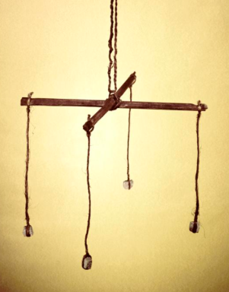
The Roman Groma was a surveying instrument which used to lay out the right angle triangles. This consisted of ‘two sight rules crossing at right angles with plumb lines at the four extremities’. The instrument was supported by a centre pole and was used to set out the lines of roads at right angles, the construction of buildings and the division of big plots of land into smaller ones in the 1st and 2nd centuries. (Surveying through the Ages: Part 1. Early Developments, Vol. 46, No. 310(March-April 1954), C.J.Meringer, pp. 99-102)

Image 3 – The Roman Groma
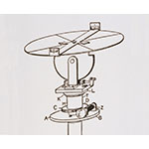
The dioptre was then founded around 120BC by the Greeks and was described as a portable instrument which consisted of a cogwheel, a screw and the water level. This piece of equipment took terrestrial and astronomical measurements. Due to similarities, Hero’s Dioptre is known to be the ancestor of the modern theodolite. (The Geographical Journal Vol. 121, No. 1 (Mar., 1955), pp. 1-7)

Image 4 – Hero’s Dioptre

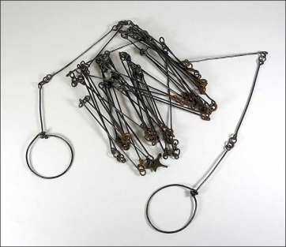
In the early 1620s, a distance measuring device known as Gunter’s chain was invented to undertake land surveys. This device was created by Edmund Gunterlong and it was a 66ft long chain divided into hundred links which were marked by ten brass rings. Due to a link being 7.92inches in length, an acre was able to be measured as ten of the square chains were equivalent to one acre.

Image 5– Gunter’s Chain

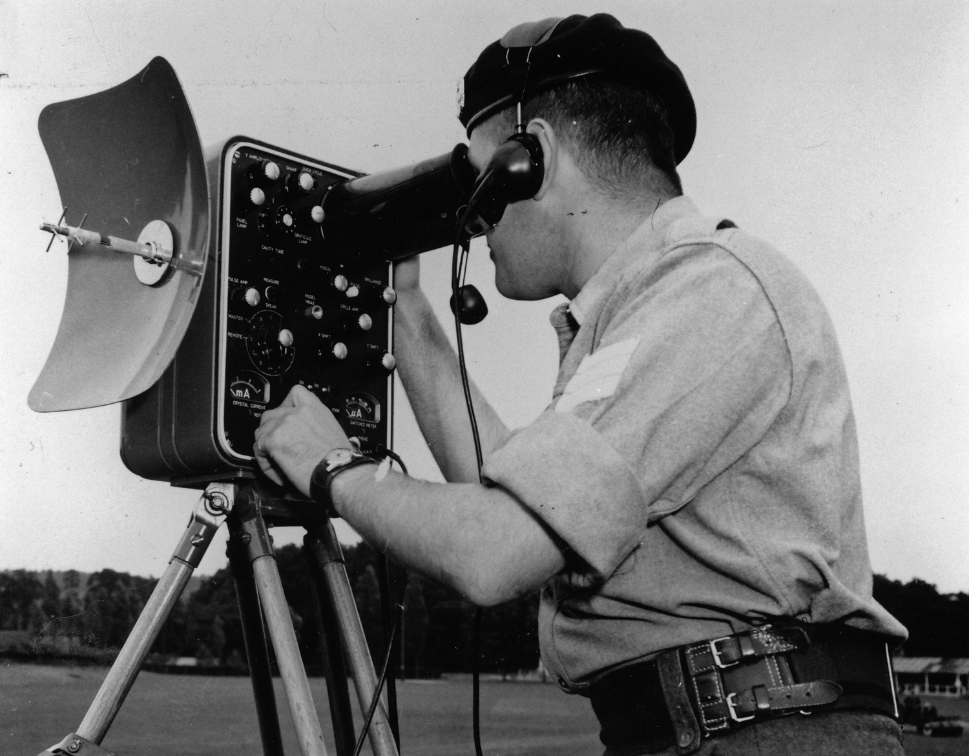
Further down the line in the 1900’s, EDM was invented and the first successful type of equipment using this was the Tellurometer. It works by emitting electronic waves: ‘the remote station reradiates the incoming wave in a similar wave of more complex modulation, and the resulting phase shift is a measure of the distance travelled.’ A marine version was later made to undertake coastal surveys and used by the Army of the Republic of Vietnam in the late 1960s. (https://www.satpalda.com/blogs/evolution-in-surveying-techniques)
Image 6 –Tellurometer

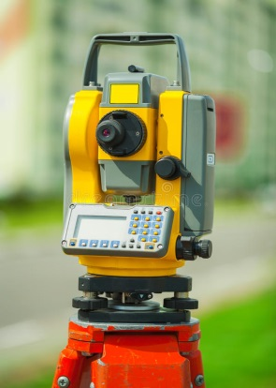
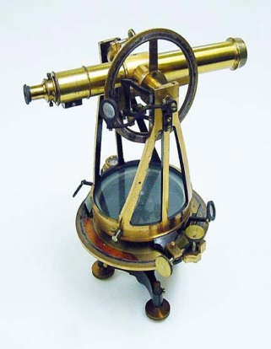
The theodolite was introduced in the 16th century by and English mathematician named Leonard Digges and it is used to measure horizontal and vertical angles. In the modern era, the telescope is mounted on a tripod with adjustable legs and is worked with in the field to obtain precise angular measurements for triangulation in various surveying and civil-engineering works. (https://www.britannica.com/technology/theodolite)
Image 7 –Leonard Digges Theodolite
Image 8 –Modern Theodolite

In the 21st century major advances were made to surveying equipment such as data recorders, tilt compensators, calculation programs etc. Thus, meaning that there are greater instruments such as the modern theodolite, total stations and Global Positioning Systems (GPS) which have allowed for more accurate and quicker surveys to be undertaken. In 1978, GPS was introduced which uses ‘a larger constellation of satellites and improved signal transmission to provide more accuracy’. (https://www.satpalda.com/blogs/evolution-in-surveying-techniques)
Due to the advanced technology in surveying equipment, it is now possible to survey various things on one instrument such as:
- Preparing navigational maps for land, sea and air
- Establishing boundaries of public and private lands
- Producing maps of the earth both below and above sea level
- Providing data bases for natural resources
- Providing engineering data for land development and engineering constructions such as bridges, roads, buildings etc.

3.0 List of Surveyed Listed Buildings
The definition of a listed building survey is the survey of older buildings, typically those with historical and architectural importance which maintain a certain level of protection. These surveys are undertaken to; produce building plans and elevations, produce any renovation plans, obtain the buildings existing conditions, address any possible defects etc.
There are 1000s of listed buildings throughout Wales which fall in three different grading categories; Grade l, Grade ll* and Grade ll being deemed as of exceptional interest, more than special interest and special interest only respectively. A couple of examples of these are as follows;
- Swansea New Guildhall
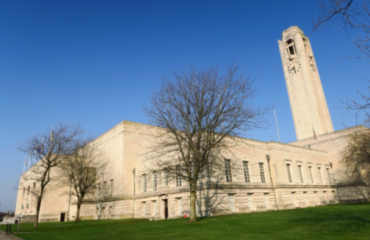
The Swansea New Guildhall was listed on the 25th July 1994 and is located on Guildhall Road. It has been graded as Grade l as it is the most important building in Wales of its period (1930s). (https://britishlistedbuildings.co.uk/300014594-swansea-new-guildhall-uplands#.YJUnArVKhPY)

- Morfa Bridge
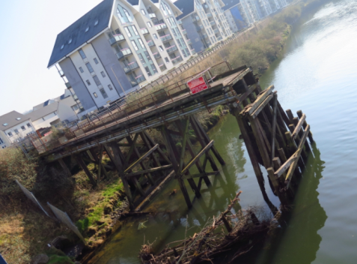
The Morfa Bridge was listed on the 22nd October 2003 and is located across the River Tawe in Swansea. It has been graded as Grade ll as it is described ‘as a rare survival of the historically important lifting and swivelling bridges on the lower Afon Tawe’. (https://britishlistedbuildings.co.uk/300081960-morfa-bridge-bonymaen#.YJUmpbVKhPY)

- Clyne Castle
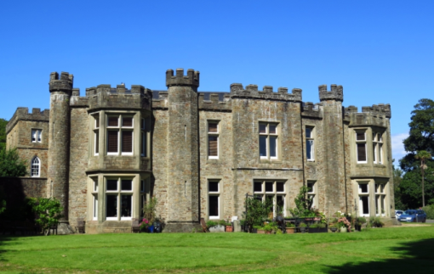
The Clyne Castle was listed on the 20th October 1994 and is located approximately 600m from the junction with Mumbles Road, Swansea. It has been graded as Grade ll* ‘as a large early C19 castellated mansion with particularly important interiors installed by William Graham Vivian’. (https://britishlistedbuildings.co.uk/300014931-clyne-castle-also-known-as-neuadd-gilbertson-mumbles#.YJUmz7VKhPY)
3.1 Important Information
Building surveying is typically undertaken following a generic process of:
- Planning – research and decision making
- Field Work – observation and data collecting
- Office Work – data processing and calculations
- Mapping – sketches and CAD (Computer Aided Design) drawings
- Report – analysis and conclusions
Listed building surveys are undertaken to gather valuable information about the property to produce a full technical survey report to go alongside any other documentation required. To undertake this survey all legislation, such as Planning (Listed Buildings and Conservation Areas) Act 1990, that protects listed buildings needs to be understood and followed. The information gathered from the survey should be sufficient for the following generic topics:
- Providing information on the overall property condition
- Examining any environmental issues encountered
- Addressing any heating, ventilation and air conditioning issues
- Highlighting areas of failure or concern
- Addressing any damp issues
- Estimate costs of any works required
- Identifying past or on-going deterioration
- Identifying issues which need attention
- Providing maintenance recommendations
(https://www.designingbuildings.co.uk/wiki/Building_survey)
Other information that needs to be gathered from building surveys are level of detail typically for; the materials, construction, and condition of floors and walls and the materials, finish type and condition of roofs. Measuring of any other features and internal and external details is also required to produce the most accurate and most recent plans.
3.2 Tools & Equipment
Extensive surveys can now be undertaken due to the recent advances in surveying technology such as laser scanning, GPS, digital photogrammetry, total stations etc. Regardless of any other equipment, the very basic tools needed to undertake a building survey is suitable PPE (Personal Protective Equipment) such as: Hi-Vis, Hard Hat, Safety Goggles, Safety Boots etc. Typically, a notebook and pen are taken to copy down any important information.
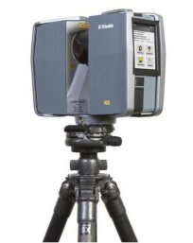
Laser scanning produces a digital file which can contain millions of surface points in terms of X, Y and Z and can use this to produce surface models which can be important in listed building survey documentation. Using this piece of equipment can help gather information for the any management and maintenance plans required and to help with the preservation of historic buildings.

Terrestrial photogrammetry uses traditional techniques ‘of using ground based photography for measuring architectural details of a building’. Metric cameras are used to take overlapping images of an object from established control points which are then processed. The advances in digital surveying technology has allowed for digital photogrammetry which can produce higher resolution images which are required for building documentation and preservation.
(Modern Surveying Technology: availability and suitability for Heritage Building Surveying and Heritage Building Information Models, Dr A Bayyati)
To obtain linear dimensions, surveying tapes can be used and are available in lengths up to 100m. The two different types are: steel and fibreglass tapes, both have their advantages and disadvantages over each other. Table 1 shows the comparisons:
Tape Type | Lighter | Flexible | Accuracy
Steel |  |  | 1 in 10,000 (3mm for 30m distance)
Fibreglass |  |  | 1 in 1,000 (30mm in a 30m distance)
Table 1- Tape Comparisons
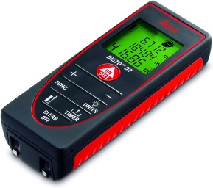
Most likely to be used in building surveys today are hand held laser measuring equipment such as the one shown in Image 9. They provide digital readings of linear dimensions and other versions can calculate room areas, volumes and angled slopes. The accuracy is +/- 3mm with a range of up to 200m but they do require calibration and errors may occur in poor weather conditions.
Image 9 –Leica Disto
Another useful building surveying instrument is a thermal imaging camera which visually show the surface temperatures which can then identify any thermal anomalies which can cause defects. A protimeter is also usually used as it is a pin type moisture meter which can be utilised to measure the surface moisture of building structures. (Lecture Notes)
All equipment should be calibrated before works commence and the equipment used should be fit for purpose. It is important to use the correct piece of equipment to survey different parts of the building to ensure; accurate data is recorded, to minimise the risk of missing data and to maximise the safety of the personnel.

References
https://www.icsm.gov.au/education/fundamentals-land-ownership-land-boundaries-and-surveying/surveyors-and-surveying-0#:~:text=The%20history%20of%20surveying%20dates,recorded%20about%20the%20same%20time.
Image 1 - https://www.historyextra.com/period/ancient-egypt/facts-great-pyramid-giza-how-built-when/
Image 2 - https://www.johnsonlevel.com/news/HistoryoftheLevelHowtheBu
https://www.icsm.gov.au/education/fundamentals-land-ownership-land-boundaries-and-surveying/surveyors-and-urveying-0#:~:text=The%20history%20of%20surveying%20dates,recorded%20about%20the%20same%20time.
https://www.satpalda.com/blogs/evolution-in-surveying-techniques
Image 3 - https://collection.sciencemuseumgroup.org.uk/objects/co53187/groma-groma
Image 4 - https://catalogue.museogalileo.it/indepth/Diopter.html
The Geographical Journal, Vol. 121, No. 1 (Mar., 1955), pp. 1-7

Surveying through the Ages: Part 1. Early Developments, Vol. 46, No. 310(March-April 1954), Charles.J.Meringer, pp. 99-102
Image 5 - http://www.colonialsense.com/Society-Lifestyle/Signs_of_the_Times/Gunter%27s_Chain.php
Image 6 - http://www.militarysurvey.org.uk/Historic%20Archive/Equipment%20&%20Techniques/Field%20Survey/EDM.html
Image 7 - https://madeupinbritain.uk/Theodolite
Image 8 - https://www.dreamstime.com/photos-images/digital-theodolite.html
https://britishlistedbuildings.co.uk/wales#.YJUl6rVKhPZ
https://britishlistedbuildings.co.uk/300014594-swansea-new-guildhall-uplands#.YJUnArVKhPY
https://britishlistedbuildings.co.uk/300081960-morfa-bridge-bonymaen#.YJUmpbVKhPY
https://britishlistedbuildings.co.uk/300014931-clyne-castle-also-known-as-neuadd-gilbertson-mumbles#.YJUmz7VKhPY
https://www.designingbuildings.co.uk/wiki/Building_survey
Modern Surveying Technology: availability and suitability for Heritage Building Surveying and Heritage Building Information Models, Dr A Bayyati
Image 9 - https://www.amazon.co.uk/Leica-DISTO-Laser-Distance-Measurer/dp/B001AOUQXG
Lecture Notes

