Chris Hine
P139976
Powertrain and sustainability
NOx model
Malcolm McDonald
11/01/2018



Contents
1. Introduction 3
2. NOx Formation 4
3. Boundaries for the NOx Model 5
4. Building the NOx Model 6
4.1 Enthalpy tables 6
4.2 Flame Temperatures 9
4.3 Zeldovich Model 11
4.4 Results 17
5. EGR 19
5.1 Flame Temperatures 19
5.2 Results 20
6. Analysis 21
6.1 Assumptions 21
7. Conclusion 22
8. References 23
9. Bibliography 24
Appendix A NASA Enthalpy Tables 25
Appendix B Standard Enthalpies of Formation 26
Appendix C EGR Results Tables 27

Introduction
The report will explain the construction and analyse a NOx model to ascertain the effects of burning lean on NOx production during a typical load experienced during the NEDC test. Then the effects of adding EGR at a fixed level of fuel equivalence ratio, to analyse NOx production.

NOx Formation
NOx is the grouped term for nitric oxide (NO) and nitrogen dioxide (NO₂) emissions, the principle source of NO is the oxidation of atmospheric nitrogen (N₂). During combustion, at high temperatures, CO₂ and H₂O dissociate to produce free radicals of single O atoms that are unstable and attack N₂ to create NO or NO₂. It is accepted that in combustion of near stoichiometric fuel-air mixtures, the principle reactions governing the formation of NO are:
$$O+N2=NO+N$$
$$N+O2=NO+O$$
$$N+OH=NO+H$$
These reactions are the basis for the Zeldovich model that will be used for building this model. The Zeldovich model is given as:
$$\frac{d\left[NO\right]}{dt}=4.17*{10}^{13}*\left[N2\right]*{\left[O2\right]}^{0.5}*exp*(-\frac{67837}{T})$$
The dependence of $\frac{d\left[NO\right]}{dt}$ on temperature in the exponential term is evident. High concentrations of oxygen and high flame temperatures result in high NO formation rates. (Heywood, 1988)

Boundaries for the NOx Model
The engine studied:
- 1600 cc, naturally aspirated.
- Fixed engine speed of 1800 RPM to simulate a typical load during the NEDC test.
- Volumetric efficiency of 40%
Model boundaries:
- Region analysed will be the start of combustion from a cylinder pressure of 10 bar, assuming linear pressure increase of 2 bar per degree of crank rotation, from 10 – 50 bar. Covering 20° of crank rotation, in increments of 1°.
- NOx concentration ([NOx] – KMOLS/m³) will be calculated from a fuel equivalence ratio (ф) from 0.6 to 0.99, on the lean side of stochiometric. This will be in 0.5 increments from ф = 0.6 to 0.95, the 0.01 increments from 0.95 to 0.99, assuming the same pressure increase for each ratio.
- Analysis of adding EGR will be taken at ф = 0.95 in 1% increments from 0 to 30% by molar proportion.

Building the NOx Model

4.1 Enthalpy tables
From the NASA tables, the amount of enthalpy required to heat 1 Kmol of a molecule by 1 Kelvin at constant pressure can be determined. Appendix A. These figures are converted to MJ/Kmol for consistency of units. To accurately interpolate between the quoted figures a polynomial trendline is created from the data available. Figure 4.1.1

Figure 4.1.1 Polynomial trendline of the 6th order at 30 decimal places.
From here a table of temperatures ranging from 200 K to 5000 K can be made in increments of 1 K, for each molecule, by using the polynomial equation to multiply by each temperature figure. Figure 4.1.2 for example of $N_{2}$ at 204 K.
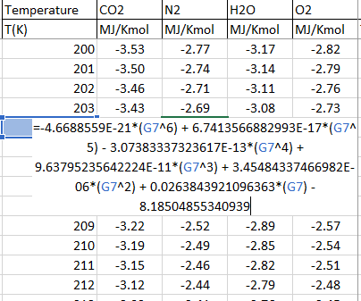
Figure 4.1.2 Polynomial equation to interpolate temperature values.

The net amount of enthalpy realised from Iso-octane is calculated in Excel using an enthalpy calculator, Figure 4.1.3 This is assuming the enthalpy released using the HHV and an enthalpy of formation figure of 208.45 MJ/Kmol, see Appendix B.

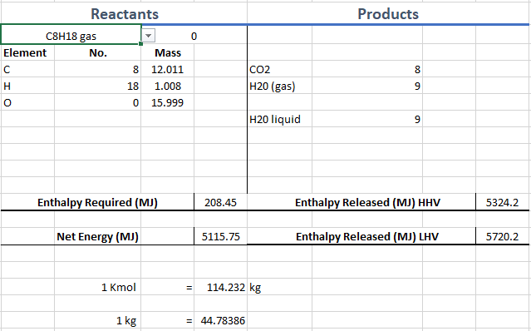
Figure 4.1.3 Enthalpy calculator

A table can now be made to calculate the temperature of the products using the enthalpy available for each ф from stoichiometric to ф = 0.6. assuming that all heat released goes to warming the products, or where the error column reaches zero. Figure 4.1.4
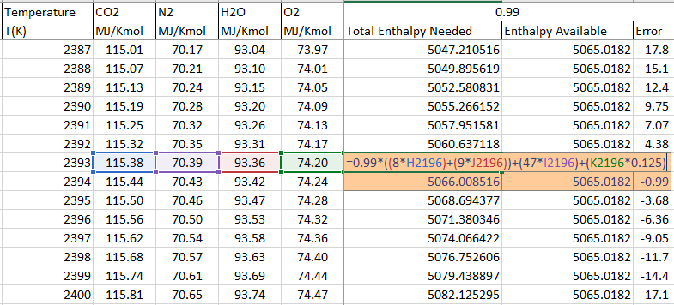
Figure 4.1.4 Enthalpy tables to determine TB1 flame temperatures.
For ф = 0.99
T | Enthalpy Needed | Enthalpy Available | Error
2393 | 5063.323 | 5065.018 | 1.695
2394 | 5066.009 | 5065.018 | -0.99

4.2 Flame Temperatures
Exact flame temperature is calculated from these figures using:
$$T=2393+\frac{5065.018-5063.323}{5066.009-5063.323}*(2394-2393)$$
This gives adiabatic flame temperatures for all functions of ф.
Φ | Flame Temp
1 | 2409.5336
0.99 | 2393.631271
0.98 | 2377.66079
0.97 | 2361.621536
0.96 | 2345.512894
0.95 | 2329.334243
0.9 | 2247.368152
0.85 | 2163.55114
0.8 | 2077.790543
0.75 | 1989.983987
0.7 | 1900.017952
0.65 | 1807.7661
0.6 | 1713.087272
Figure 4.2.1 TB1 flame temperatures.
For T₂ onwards use:
$$T2=T1*{\left(\frac{P2}{P1}\right)}^{n-\frac{1}{1}}$$
Where n is the polytropic index at n = 1.2

Ѳ | P | TB 1 (K) | TB 0.99 | TB 0.98
0 | 10 | 2409.5336 | 2393.631271 | 2377.66079
1 | 12 | 2483.875692 | 2467.482744 | 2451.019522
2 | 14 | 2548.517708 | 2531.69814 | 2514.806467
3 | 16 | 2605.871404 | 2588.673316 | 2571.401501
4 | 18 | 2657.531374 | 2639.992344 | 2622.378125
5 | 20 | 2704.609996 | 2686.760259 | 2668.834001
6 | 22 | 2747.915854 | 2729.780309 | 2711.567018
7 | 24 | 2788.056196 | 2769.655735 | 2751.176393
8 | 26 | 2825.499323 | 2806.851747 | 2788.12423
9 | 28 | 2860.614407 | 2841.73508 | 2822.774818
10 | 30 | 2893.69792 | 2874.60025 | 2855.42071
11 | 32 | 2924.991753 | 2905.687552 | 2886.300596
12 | 34 | 2954.695988 | 2935.195747 | 2915.611909
13 | 36 | 2982.97811 | 2963.291214 | 2943.519921
14 | 38 | 3009.979809 | 2990.114709 | 2970.164448
15 | 40 | 3035.822076 | 3015.786424 | 2995.664879
16 | 42 | 3060.609096 | 3040.409855 | 3020.124022
17 | 44 | 3084.431258 | 3064.074797 | 3043.631069
18 | 46 | 3107.367517 | 3086.859683 | 3066.263932
19 | 48 | 3129.487269 | 3108.83345 | 3088.091089
20 | 50 | 3150.851851 | 3130.057031 | 3109.173065
Figure 4.2.2 Flame temperature tables with increasing pressure from FER =1 to FER = 0.6

4.3 Zeldovich Model

These flame temperatures allow reaction rates to be calculated using chemical kinetics. The reaction rate to produce [NO] can be found using the Zeldovich model, [ ] denotes concentrations.
$$\frac{d\left[NO\right]}{dt}=4.17*{10}^{13}*\left[N2\right]*{\left[O2\right]}^{0.5}*exp*(-\frac{67837}{T})$$
To compete the Zeldovich model, the Exponent, [N₂] and [O₂] to determine the rate at which [NO] is produced.
EXP is derived using the T values from the flame temperature tables, figure 4.3.1
Ѳ | P | EXP 1 | EXP 0.99 | EXP 0.98
0 | 10 | 5.93E-13 | 4.918E-13 | 4.066E-13
1 | 12 | 1.37723E-12 | 1.149E-12 | 9.550E-13
2 | 14 | 2.75331E-12 | 2.307E-12 | 1.927E-12
3 | 16 | 4.94637E-12 | 4.161E-12 | 3.489E-12
4 | 18 | 8.20464E-12 | 6.925E-12 | 5.827E-12
5 | 20 | 1.27947E-11 | 1.083E-11 | 9.141E-12
6 | 22 | 1.89976E-11 | 1.612E-11 | 1.365E-11
7 | 24 | 2.71054E-11 | 2.306E-11 | 1.956E-11
8 | 26 | 3.74186E-11 | 3.190E-11 | 2.712E-11
9 | 28 | 5.02437E-11 | 4.292E-11 | 3.656E-11
10 | 30 | 6.58914E-11 | 5.639E-11 | 4.812E-11
11 | 32 | 8.46749E-11 | 7.258E-11 | 6.205E-11
12 | 34 | 1.06909E-10 | 9.178E-11 | 7.859E-11
13 | 36 | 1.32908E-10 | 1.143E-10 | 9.798E-11
14 | 38 | 1.62985E-10 | 1.403E-10 | 1.205E-10
15 | 40 | 1.97455E-10 | 1.702E-10 | 1.463E-10
16 | 42 | 2.36626E-10 | 2.042E-10 | 1.758E-10
17 | 44 | 2.80806E-10 | 2.426E-10 | 2.091E-10
18 | 46 | 3.303E-10 | 2.857E-10 | 2.465E-10
19 | 48 | 3.8541E-10 | 3.337E-10 | 2.882E-10
20 | 50 | 4.46432E-10 | 3.869E-10 | 3.345E-10
Figure 4.3.1 EXP table.

[N₂] and [O₂] being the concentration of either/m³ in the burned zone, are given by:
$$\left[N2\right]=\frac{α*47}{Vcyl}$$
$$\left[O2\right]=\frac{α*X}{Vcyl}$$
- X = Free O₂
- Vcyl = 0.00004 m³ assuming burning volume is 40cc
- α = multiplying constant
$$α=n/number of Kmol$$
n = No. of Kmols in the engine is calculated form the ideal gas law:
Where Ru is the universal gas constant at 8316 J Kmol⁻¹ K⁻¹

$$PV=n*Ru*T$$
This is transposed to:
$$n=\frac{PV}{Ru}*T$$
$$n=\frac{({10}^{5}*160*{10}^{-6})}{(8314*293)}=6.57*{10}^{-6}$$
No. of Kmol in the reactants:
$$\left(x*C_{8}H_{18}\right)+12.5\left(O2+3.76N2\right)$$
$x=$ ф
This gives:
$$No. Kmol=x+(12.5*\left(1+3.76\right))$$
A table of No. Kmol, α, [N₂], [O₂] and X can now be made as functions of ф. Figure 4.8

Φ | Flame Temp | No. Kmol | α | [N2] | [O2] | X
1 | 2409.5336 | 60.5 | 1.08538E-07 | 0.127532353 | 0.000000000 | 0
0.99 | 2393.631271 | 60.49 | 1.08556E-07 | 0.127553437 | 0.000339238 | 0.125
0.98 | 2377.66079 | 60.48 | 1.08574E-07 | 0.127574527 | 0.000678588 | 0.25
0.97 | 2361.621536 | 60.47 | 1.08592E-07 | 0.127595624 | 0.001018050 | 0.375
0.96 | 2345.512894 | 60.46 | 1.08610E-07 | 0.127616728 | 0.001357625 | 0.5
0.95 | 2329.334243 | 60.45 | 1.08628E-07 | 0.127637839 | 0.001697312 | 0.625
0.9 | 2247.368152 | 60.4 | 1.08718E-07 | 0.127743500 | 0.003397433 | 1.25
0.85 | 2163.55114 | 60.35 | 1.08808E-07 | 0.127849335 | 0.005100372 | 1.875
0.8 | 2077.790543 | 60.3 | 1.08898E-07 | 0.127955346 | 0.006806135 | 2.5
0.75 | 1989.983987 | 60.25 | 1.08989E-07 | 0.128061533 | 0.008514730 | 3.125
0.7 | 1900.017952 | 60.2 | 1.09079E-07 | 0.128167897 | 0.010226162 | 3.75
0.65 | 1807.7661 | 60.15 | 1.09170E-07 | 0.128274437 | 0.011940440 | 4.375
0.6 | 1713.087272 | 60.1 | 1.09261E-07 | 0.128381154 | 0.013657570 | 5
Figure 4.3.2 Calculations table
The rate of NO production can now be calculated for each increment of ф as a function of crank angle through the combustion phase. This is done in 2 stages, first implementing the Zeldovich model as a function of time, then per degree by multiplying by, $\frac{1}{6*RPM}$ to calculate the total Kmols made during combustion.
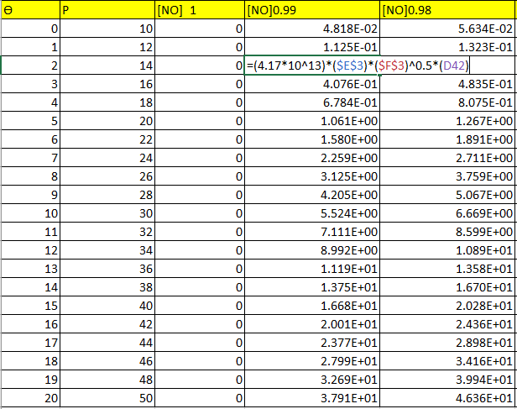
Figure 4.3.3 Zeldovich model to calculate [NO] production.
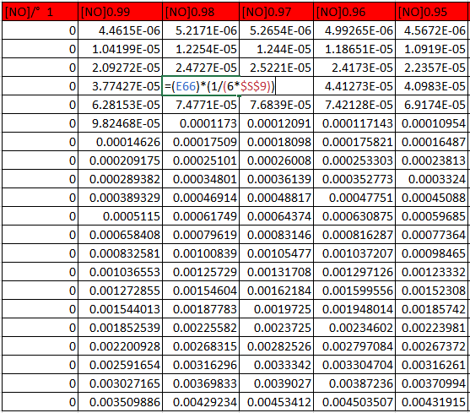
Figure 4.3.4 Zeldovich model for [NO] production for every degree of crank rotation.

The amount of Kmols produced per degree is then determined by multiplying the rate of [NO] production by the effective cylinder volume for combustion of 0.00004 m³. The total amount of Kmols produced over the 20° of crank rotation is then totalled and this figure used to establish the total NOx PPM produced.
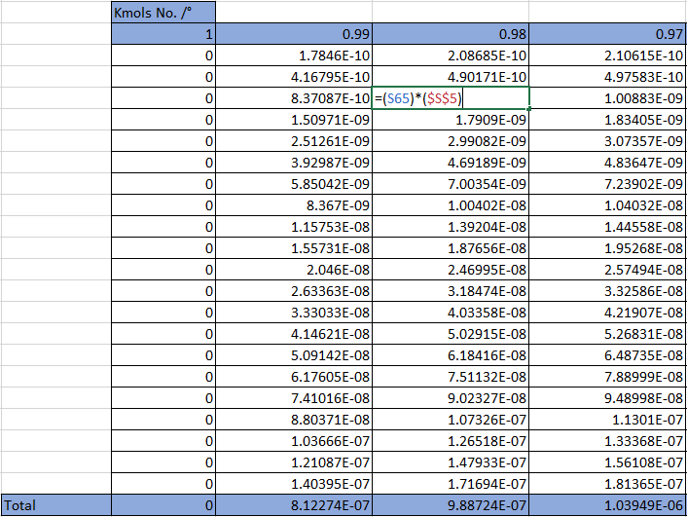
Figure 4.3.5 Kmols of [NO] produced through the combustion cycle for each value of ф.

$$NOx PPM=\frac{Kmols NO.}{(Kmols exhaust*α)}*10^6$$
$$Kmols exhaust=α*Kmols Product$$Kmols Product is calculated for each ф to give Kmols exhaust, this value can then be used to calculate the total NOx produced. Figure 4.3.6
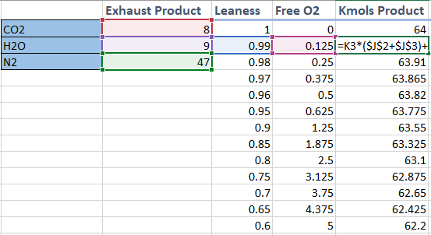
Figure 4.3.6 Kmols of the combustion products.
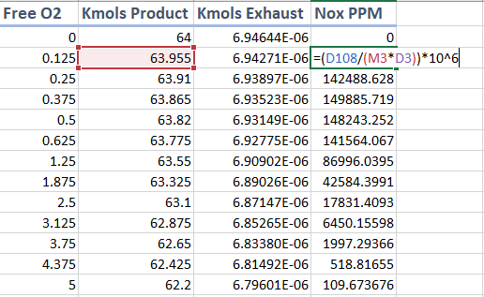
Figure 4.3.7 Total NOx produced for the subject combustion cycle.

4.4 Results

Figure 4.4.1 Flame temperature as a function of fuel equivalence ratio.

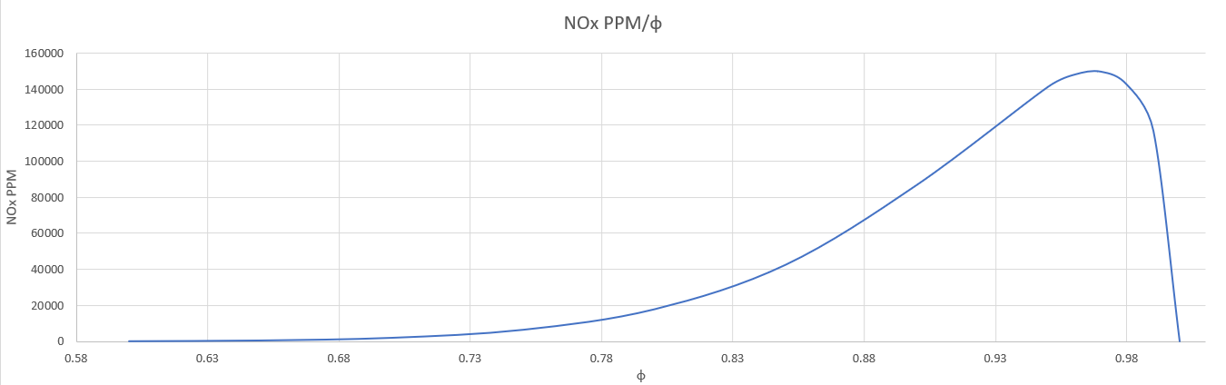
Figure 4.4.2 NOx PPM/ф

EGR
To calculate the effects of adding EGR, a percentage of the products on molar ratio to the must be added in increments of 1% from 1 – 30%. The extra products are added at the enthalpy table stage to readjust the TB1 flame table from which all the components of calculating NOx PPM are then derived to give a table of NOx PPM as a function of EGR %. The FER is fixed at 0.95% lean.

5.1 Flame Temperatures
EGR | Flame Temp
0 | 2329.219921
0.01 | 2311.087919
0.02 | 2293.297895
0.03 | 2275.840079
0.04 | 2258.705051
0.05 | 2241.883754
0.06 | 2225.367452
0.07 | 2209.147745
0.08 | 2193
0.09 | 2177.565967
0.1 | 2162.188555
0.11 | 2147.077015
0.12 | 2132.22432
0.13 | 2117.623715
0.14 | 2103.268665
0.15 | 2089.152855
0.16 | 2075.270184
0.17 | 2061.614764
0.18 | 2048.180905
0.19 | 2034.963098
0.2 | 2021.956015
0.21 | 2009.154507
0.22 | 1996.553593
0.23 | 1984.148458
0.24 | 1971.934426
0.25 | 1959.906975
0.26 | 1948.061733
0.27 | 1936.39445
0.28 | 1924.901033
0.29 | 1913.577481
0.3 | 1902.419945
Figure 5.0.1 New TB1 flame temperatures in K after adding EGR.

5.2 Results

Figure 5.1.1 The graph shows the effects of adding EGR to TB1 flame temperatures at Φ=0.95

Figure 5.1.2 NOx PPM / percentage of EGR added, the levels of NO production drop significantly even with 1% EGR seeing a drop of over 23,000 PPM

Analysis
The results show that increasing temperatures do increase the rate of NOx production in lean mixtures. NO production is higher in lean mixtures close to stoichiometric where the availability of O₂ is higher combined with slower burn times allowing for higher post flame gas temperatures where the majority of the NO will be formed. The flame reaction zone is very thin, around 0.1mm so the time the molecules reside within this zone is very short. As the cylinder pressure causes the post flame gas temperature to increase as the combustion process continues, most of the NO will be produced in this region. (Heywood, 1988)
The addition of EGR increases the mass of the combustion reactants, lowering the temperatures significantly, therefore lowering the production of NO during combustion.
$PV=mRT$ $T=\frac{PV}{mR}$

Add more mass to lower temperatures.

6.1 Assumptions
The simple model assumes a homogeneous mixture throughout, where in reality there would be a heterogeneous mixture, where lean and rich patches of the A/F would be spread. Lean patches would feed free O₂ to hotter neighbouring stoichiometric, and lean patches. This is something that plagues diesel and GDI engines due to the lower atomisation of fuel before combustion. A more complex model that accounts for heterogeneous mixture would expect to see a higher rate of NO production.
Adiabatic flame temperatures assume that all heat released will go into heating the products, this will give higher predicted temperatures than normal as it does not account for heat loss through the engine. This will result in slightly higher NO production for the simple model.
Concentrations of NO and O₂ are modelled as constant through combustion, where they would actually be varied and changing as the combustion event progressed.

Conclusion
The model indicates the mechanisms for NOx formation, and the effects of increasing temperatures on the rate of NO production during combustion. The introduction of EGR even at small percentages has a profound reduction on the total NOx formed, through the effects of lowering the combustion temperatures.

References
Heywood, J. B. (1988). Internal Combustion Engine Fundementals . McGraw-Hill Education.
Sorathia, H. R. (2012). EFFECT OF EXHAUST GAS RECIRCULATION (EGR) ON NOx . International Journal of Advanced Engineering Research and Studies.

Bibliography
Goodger, E. M. (2000). Transport Fuels Technology . Norwich: Landfall Press.
Heywood, J. B. (1988). Internal Combustion Engine Fundementals . McGraw-Hill Educatio.
Sorathia, H. R. (2012). EFFECT OF EXHAUST GAS RECIRCULATION (EGR) ON NOx . International Journal of Advanced Engineering Research and Studies.

Appendix A NASA Enthalpy Tables
CO2 |  |  | N2 |  |  | H2O |  |  | O2
T(K) | Enthalpy |  | T(K) | Enthalpy |  | T(K) | Enthalpy |  | T(K) | Enthalpy
200 | -3.423 |  | 200 | -2.841 |  | 200 | -3.227 |  | 200 | -2.836
298 | 0 |  | 298 | 0 |  | 298 | 0 |  | 298 | 0
300 | 0.069 |  | 300 | 0.054 |  | 300 | 0.062 |  | 300 | 0.054
400 | 4.003 |  | 400 | 2.973 |  | 400 | 3.458 |  | 400 | 3.031
500 | 8.301 |  | 500 | 5.92 |  | 500 | 6.947 |  | 500 | 6.097
600 | 12.899 |  | 600 | 8.905 |  | 600 | 10.528 |  | 600 | 9.254
700 | 17.749 |  | 700 | 11.942 |  | 700 | 14.209 |  | 700 | 12.503
800 | 22.81 |  | 800 | 15.046 |  | 800 | 18.005 |  | 800 | 15.838
900 | 28.047 |  | 900 | 18.222 |  | 900 | 21.93 |  | 900 | 19.25
1000 | 33.425 |  | 1000 | 21.468 |  | 1000 | 25.993 |  | 1000 | 22.721
1100 | 38.911 |  | 1100 | 24.77 |  | 1100 | 30.191 |  | 1100 | 26.232
1200 | 44.488 |  | 1200 | 28.118 |  | 1200 | 34.518 |  | 1200 | 29.775
1300 | 50.149 |  | 1300 | 31.51 |  | 1300 | 38.963 |  | 1300 | 33.35
1400 | 55.882 |  | 1400 | 34.939 |  | 1400 | 43.52 |  | 1400 | 36.955
1500 | 61.681 |  | 1500 | 38.404 |  | 1500 | 48.181 |  | 1500 | 40.59
1600 | 67.538 |  | 1600 | 41.899 |  | 1600 | 52.939 |  | 1600 | 44.253
1700 | 73.446 |  | 1700 | 45.423 |  | 1700 | 57.786 |  | 1700 | 47.943
1800 | 79.399 |  | 1800 | 48.971 |  | 1800 | 62.717 |  | 1800 | 51.66
1900 | 85.392 |  | 1900 | 52.541 |  | 1900 | 67.725 |  | 1900 | 55.402
2000 | 91.42 |  | 2000 | 56.13 |  | 2000 | 72.805 |  | 2000 | 59.169
2100 | 97.477 |  | 2100 | 59.738 |  | 2100 | 77.952 |  | 2100 | 62.959
2200 | 103.562 |  | 2200 | 63.36 |  | 2200 | 83.16 |  | 2200 | 66.773
2300 | 109.67 |  | 2300 | 66.997 |  | 2300 | 88.426 |  | 2300 | 70.609
2400 | 115.798 |  | 2400 | 70.645 |  | 2400 | 93.744 |  | 2400 | 74.467
2500 | 121.944 |  | 2500 | 74.305 |  | 2500 | 99.112 |  | 2500 | 78.346
2600 | 128.107 |  | 2600 | 77.974 |  | 2600 | 104.524 |  | 2600 | 82.245
2700 | 134.284 |  | 2700 | 81.652 |  | 2700 | 109.979 |  | 2700 | 86.164
2800 | 140.474 |  | 2800 | 85.338 |  | 2800 | 115.472 |  | 2800 | 90.103
2900 | 146.677 |  | 2900 | 89.031 |  | 2900 | 121.001 |  | 2900 | 94.06
3000 | 152.891 |  | 3000 | 92.73 |  | 3000 | 126.563 |  | 3000 | 98.036
3100 | 159.116 |  | 3100 | 96.436 |  | 3100 | 132.156 |  | 3100 | 102.029
3200 | 165.351 |  | 3200 | 100.148 |  | 3200 | 137.777 |  | 3200 | 106.04
3300 | 171.597 |  | 3300 | 103.865 |  | 3300 | 143.426 |  | 3300 | 110.068
3400 | 177.853 |  | 3400 | 107.587 |  | 3400 | 149.099 |  | 3400 | 114.112
3500 | 184.12 |  | 3500 | 111.315 |  | 3500 | 154.795 |  | 3500 | 118.173

Appendix B Standard Enthalpies of Formation

Species | State | MJ/Kmol
O₂ | Gas | 0
N₂ | Gas | 0
H₂ | Gas | 0
C | Gas | 0
CO₂ | Gas | -393.52
H₂O | Gas | -241.83
H₂O | Liquid | -285.84
CO | Gas | 110.54
CH₄ | Gas | 78.87
C₃H₈ | Gas | 103.85
CH₃OH | Gas | 201.17
CH₃OH | Liquid | 238.58
C₈H₁₈ | Gas | 208.45
C₈H₁₈ | Liquid | 249.35
(Heywood, 1988)

Appendix C EGR Results Tables
EGR | Flame Temp | Nox PPM
0 | 2329.219921 | 141190.1252
0.01 | 2311.087919 | 117905.6106
0.02 | 2293.297895 | 98526.64308
0.03 | 2275.840079 | 82387.11891
0.04 | 2258.705051 | 68936.42153
0.05 | 2241.883754 | 57719.07164
0.06 | 2225.367452 | 48358.02097
0.07 | 2209.147745 | 40540.93248
0.08 | 2193 | 33981.2431
0.09 | 2177.565967 | 28547.09987
0.1 | 2162.188555 | 23977.28992
0.11 | 2147.077015 | 20151.35044
0.12 | 2132.22432 | 16946.17774
0.13 | 2117.623715 | 14259.37403
0.14 | 2103.268665 | 12005.71238
0.15 | 2089.152855 | 10114.2054
0.16 | 2075.270184 | 8525.691258
0.17 | 2061.614764 | 7190.832017
0.18 | 2048.180905 | 6068.455439
0.19 | 2034.963098 | 5124.179357
0.2 | 2021.956015 | 4329.277658
0.21 | 2009.154507 | 3659.732371
0.22 | 1996.553593 | 3095.449591
0.23 | 1984.148458 | 2619.610091
0.24 | 1971.934426 | 2218.124049
0.25 | 1959.906975 | 1879.183797
0.26 | 1948.061733 | 1592.886696
0.27 | 1936.39445 | 1350.923028
0.28 | 1924.901033 | 1146.316368
0.29 | 1913.577481 | 973.2054316
0.3 | 1902.419945 | 826.6635541

